SACSAS Academy, Maovam

Churchandpur District. Manipur
I have visited SACSAS Academy, at Maovam village mostly inhabited by the tribes of the hill people living in Manipur. Their main occupation is jhumming cultivation and collecting fire- wood from the dense forest with poor route communication for transportation where they had to carried their goods and loads all down from their village. It is 53 km from Imphal .
The road is dusty, solid and muddy during the rainy season.

The SACSAS academy on the other hand is helping in such a way for the benefit of this underprivileged people specially children by setting up a school in this village. Presently the SACSAS Academy , Maovam having 86 (eighty six ) students from nursery to class (IV) with 4 (Four) teachers.

Name of teacher:-
- Mangboi vaiphei Head Master
- Sheiboi vaiphei Asst. Head Master.
- Mrs. Meneo haokip Asst. Teacher
- Miss. Kim Haokip Asst. Teacher.

View of SACSAS Academy, Maovam
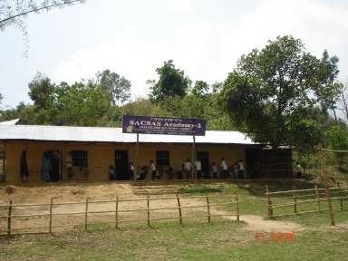

Students of SACSAS Academy, Maovam
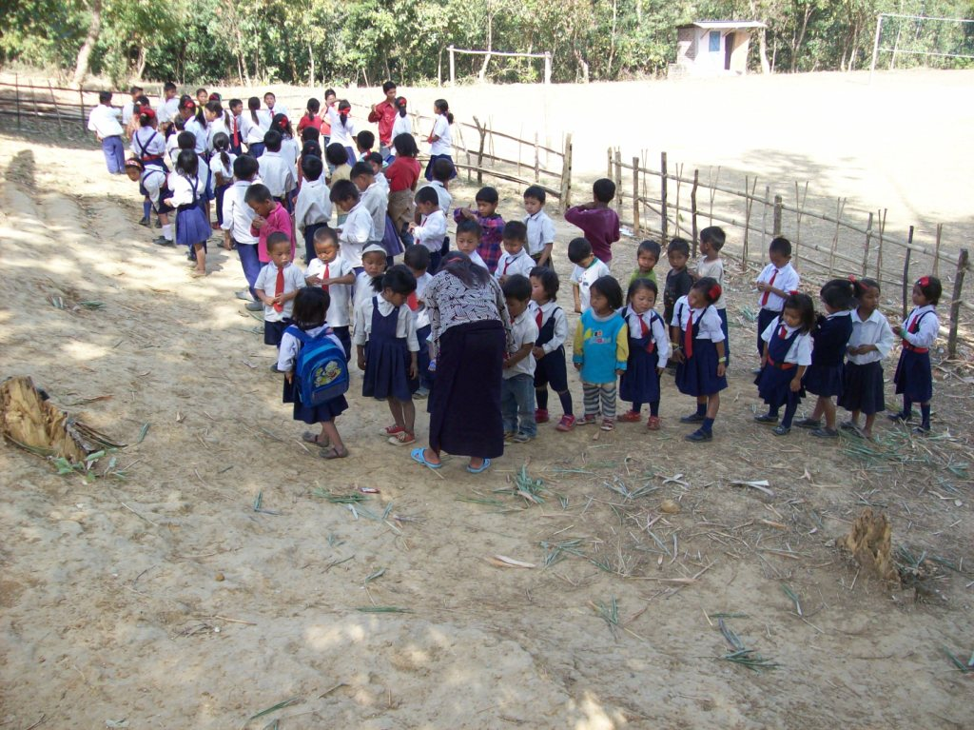

During school class.
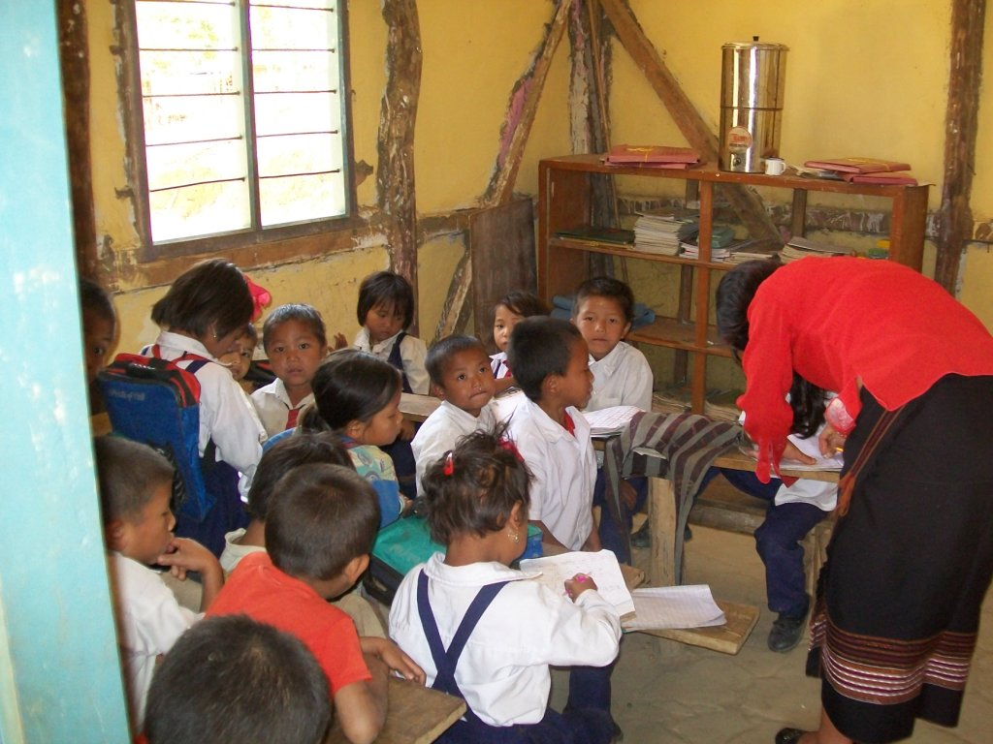

K. Jeeten (Social Worker)with his team.
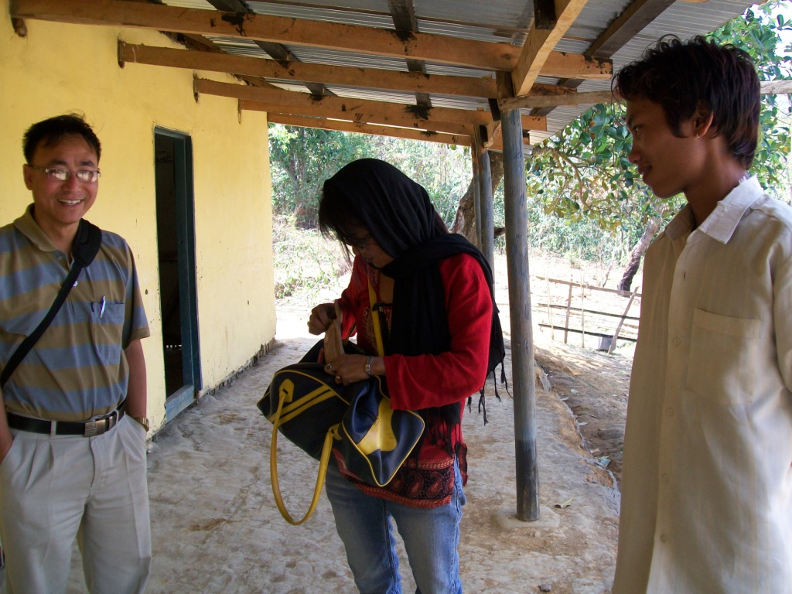

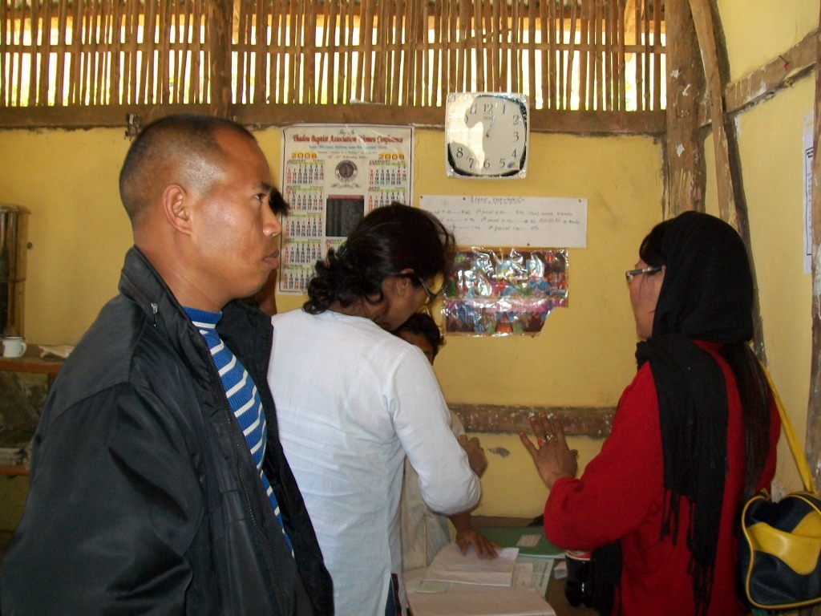

During school class
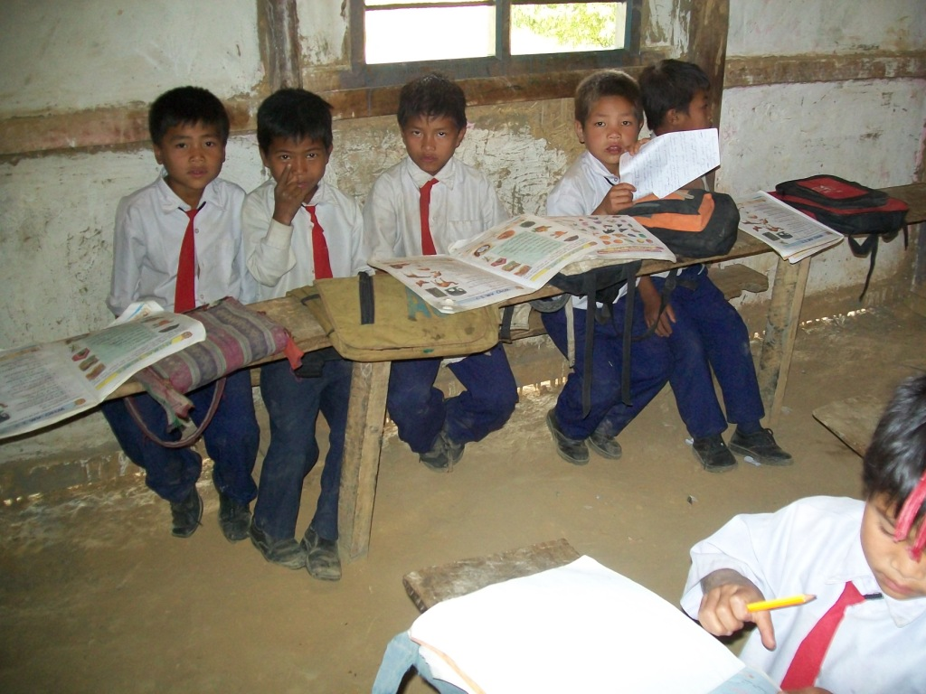

Village life of Maovam
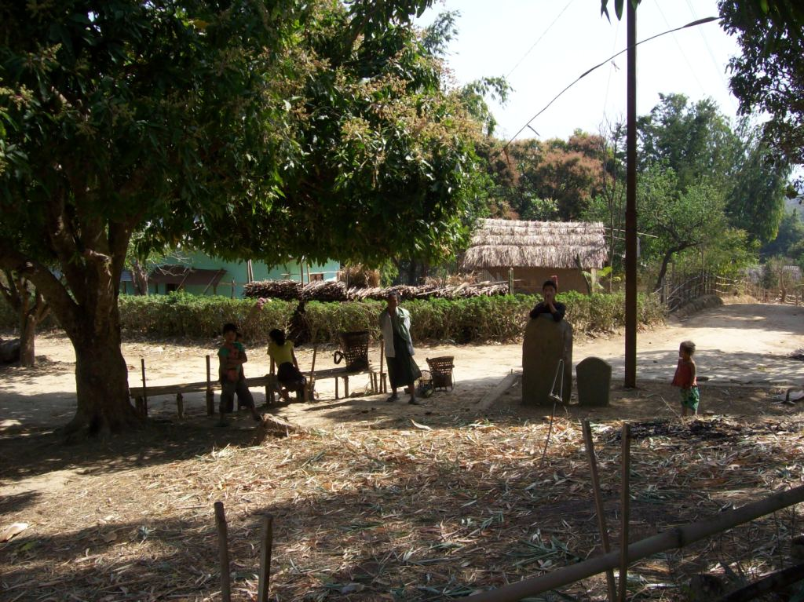
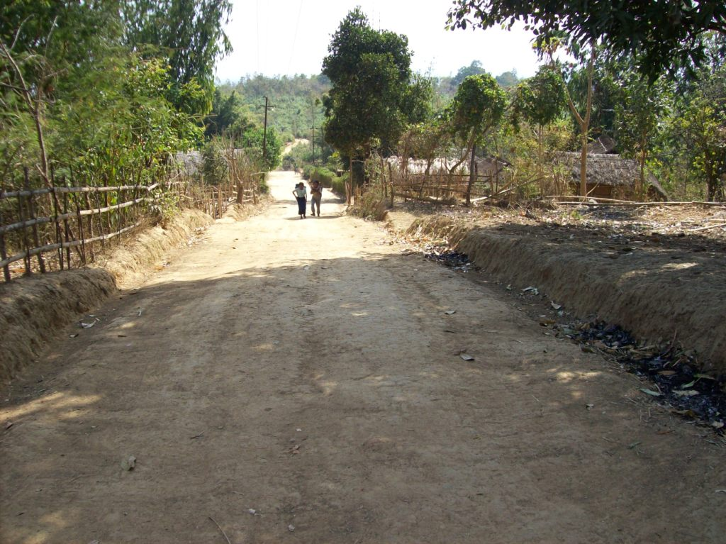
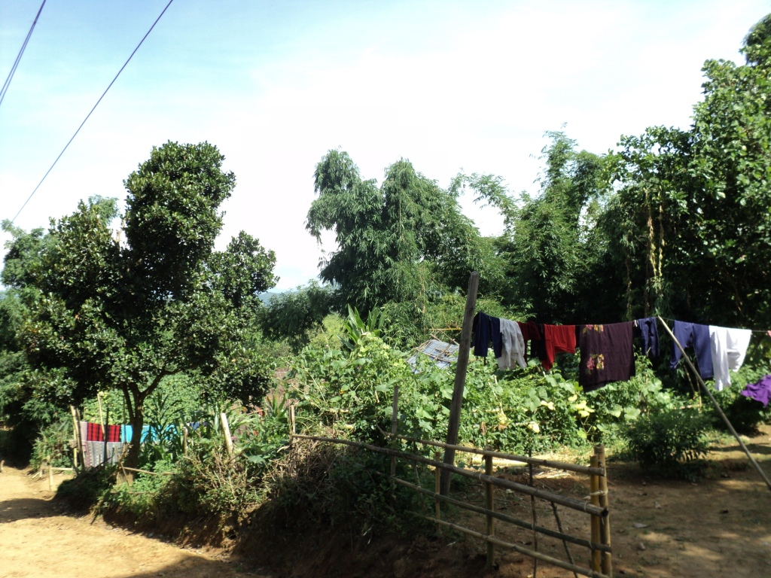
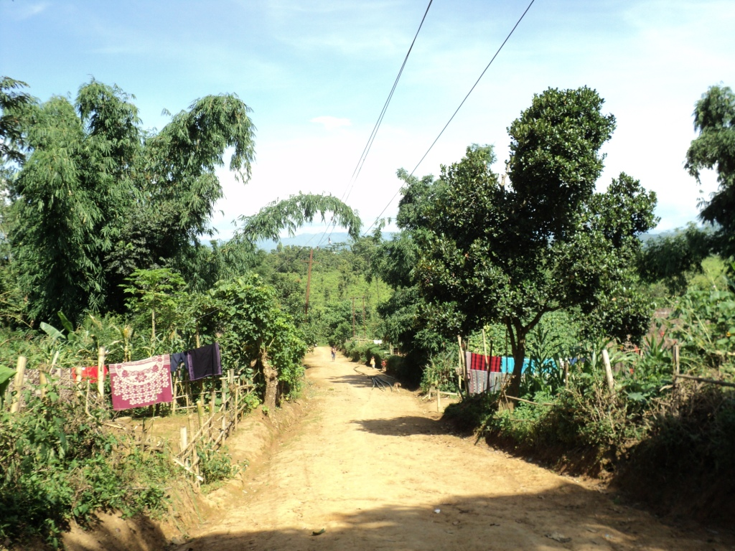

Residence of a student of SACSAS Academy, Maovam.
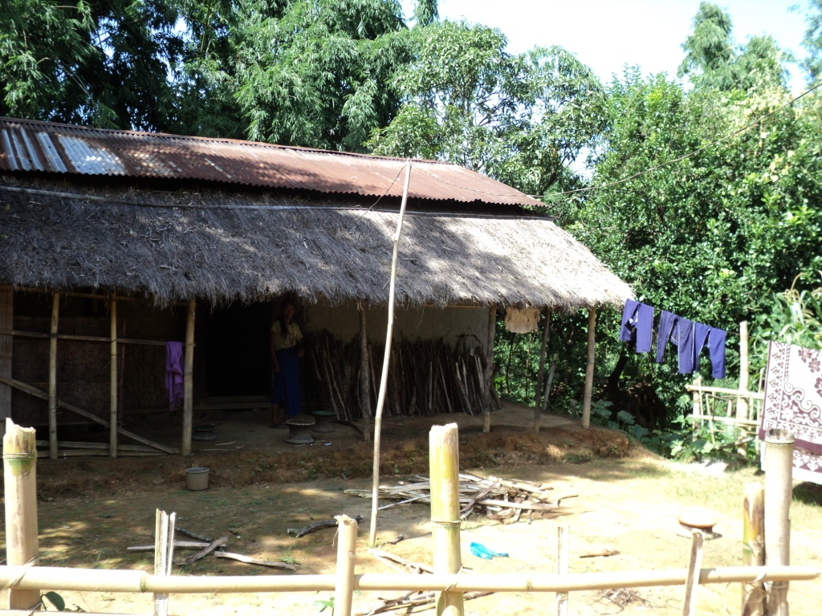

School children playing during school half.
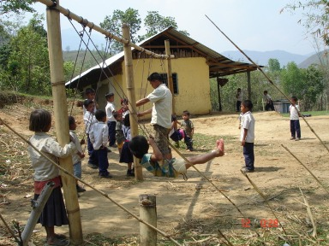

School children playing during school half.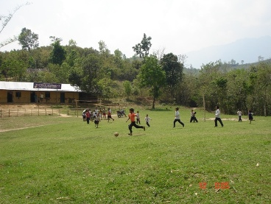

Regard
K. Jiten Singh

