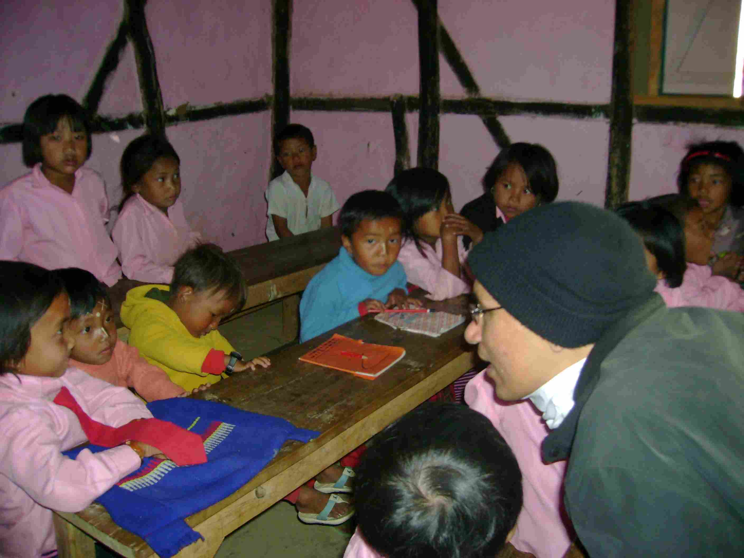
SACSAS Academy – Laishoi Branch Classroom (Shantikumar with kids)

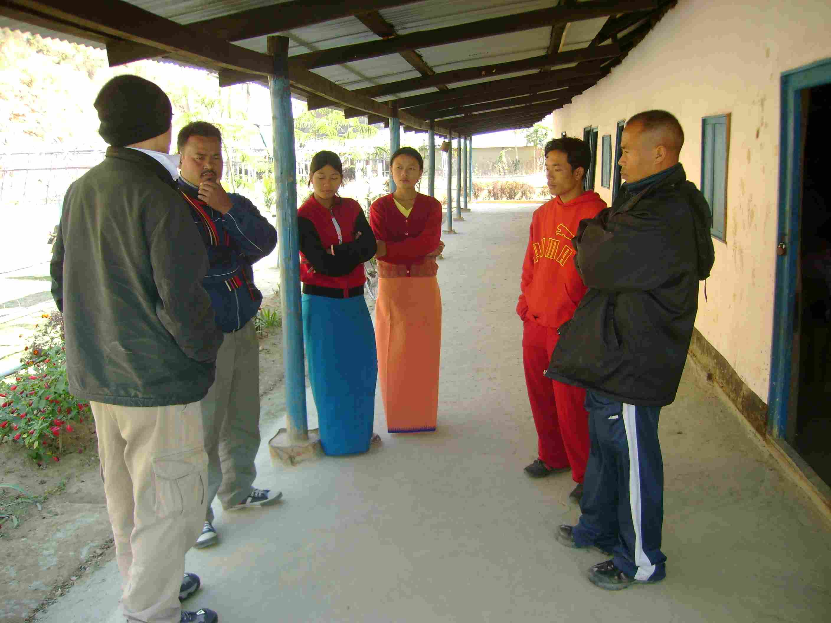
SACSAS Academy – Laishoi Branch (Shantikumar and Surjit with teachers)
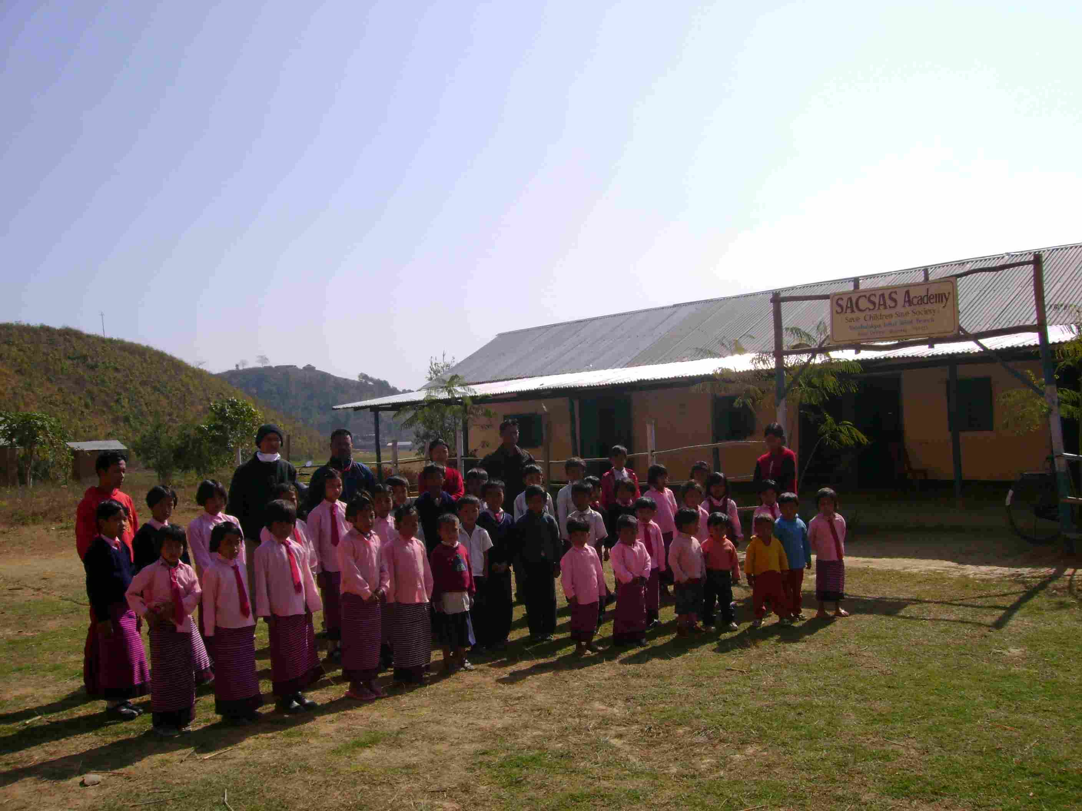
SACSAS Academy – Laishoi Branch

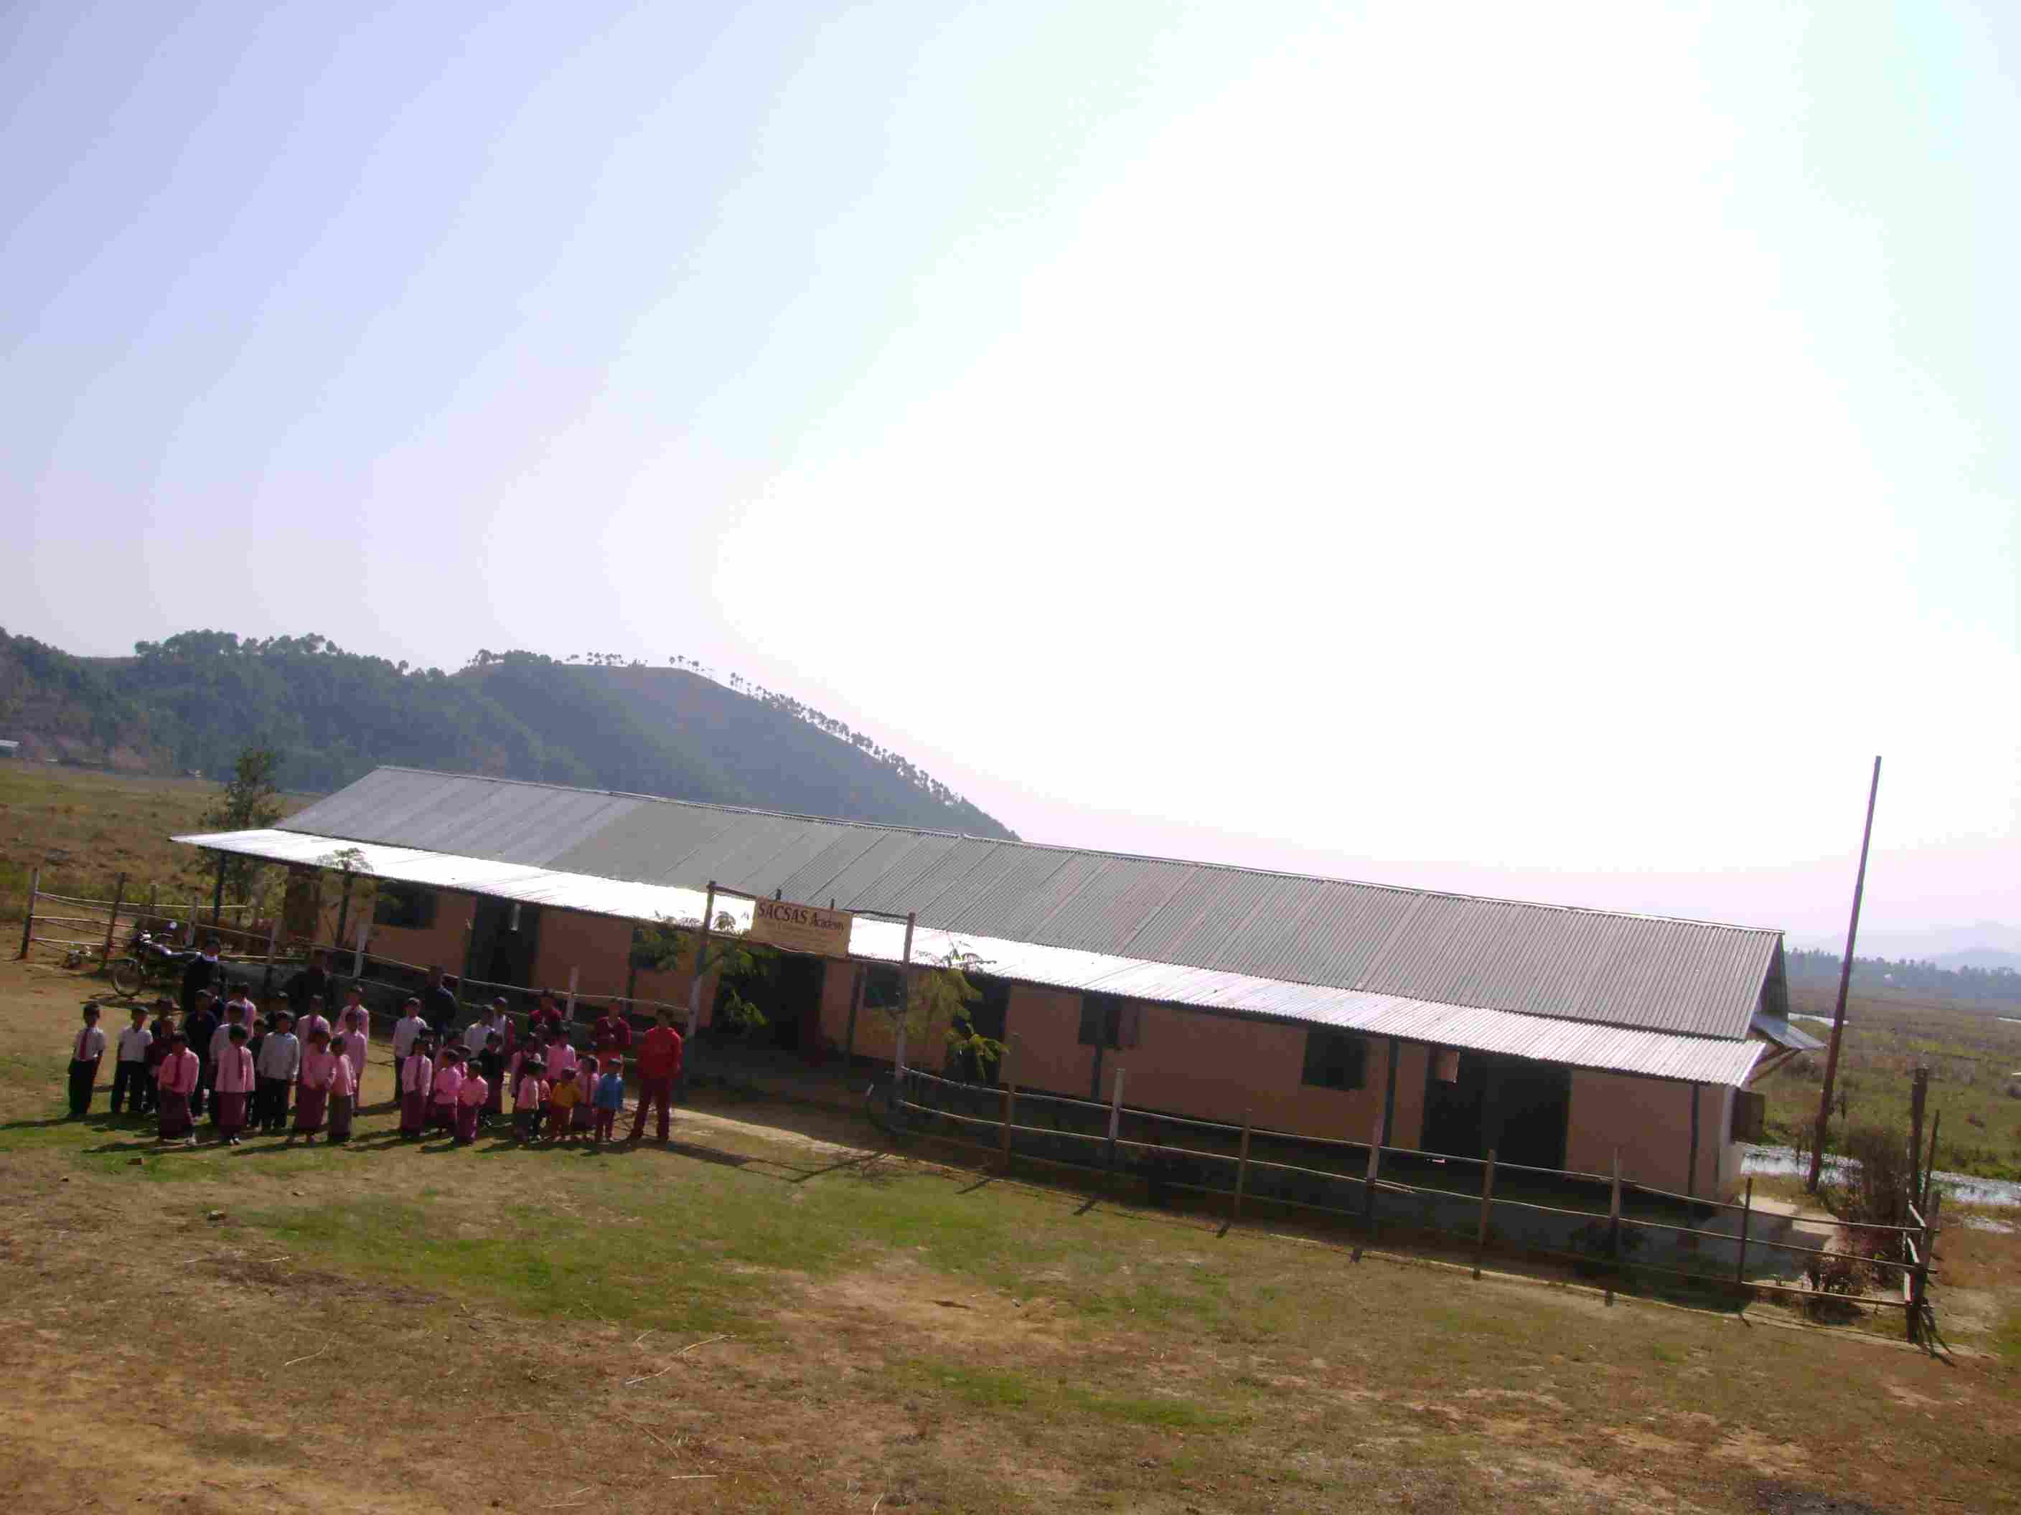
SACSAS Academy – Laishoi Branch
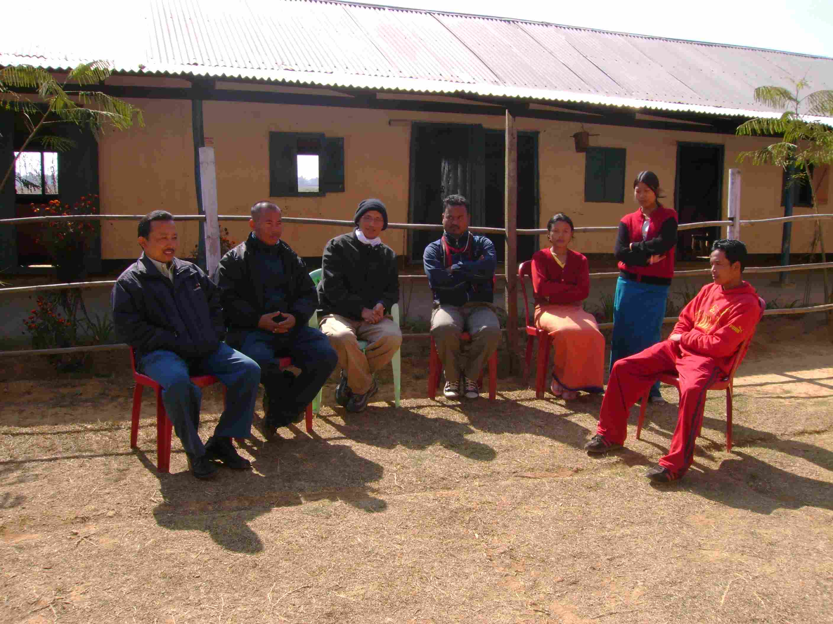
SACSAS Academy – Laishoi Branch (Guardian, Surjit, Shantikumar, and teachers)

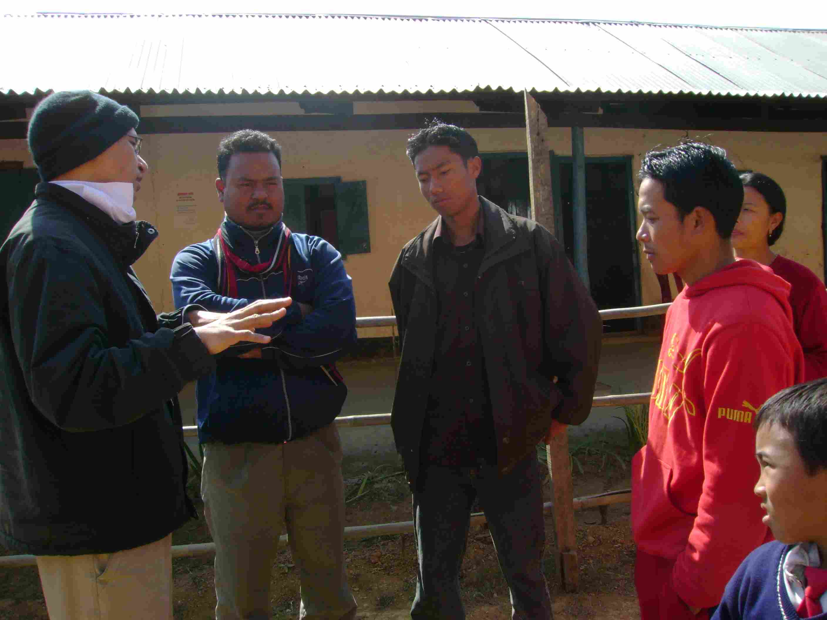
SACSAS Academy – Laishoi Branch (Shantikumar with teachers)
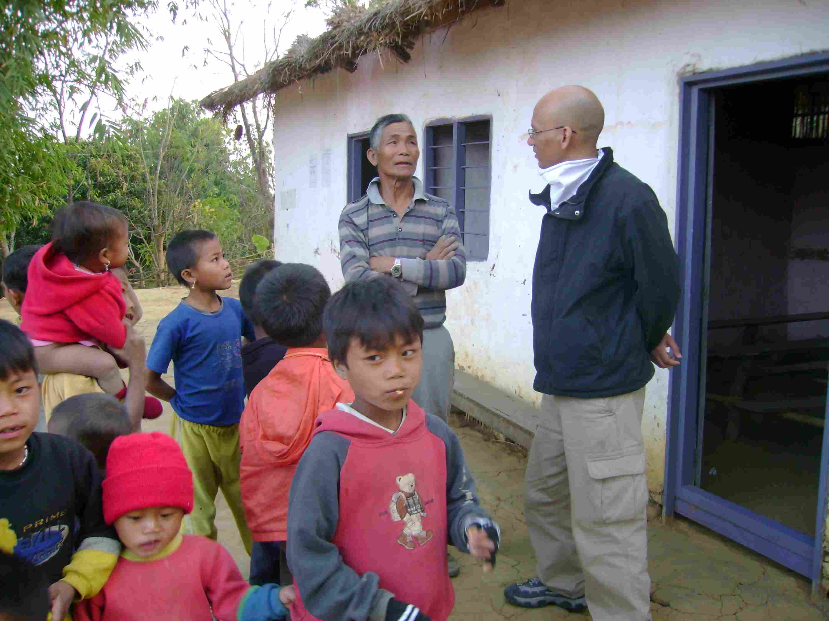
SACSAS Academy –Maovam Branch (the village king, Shantikumar, and kids)

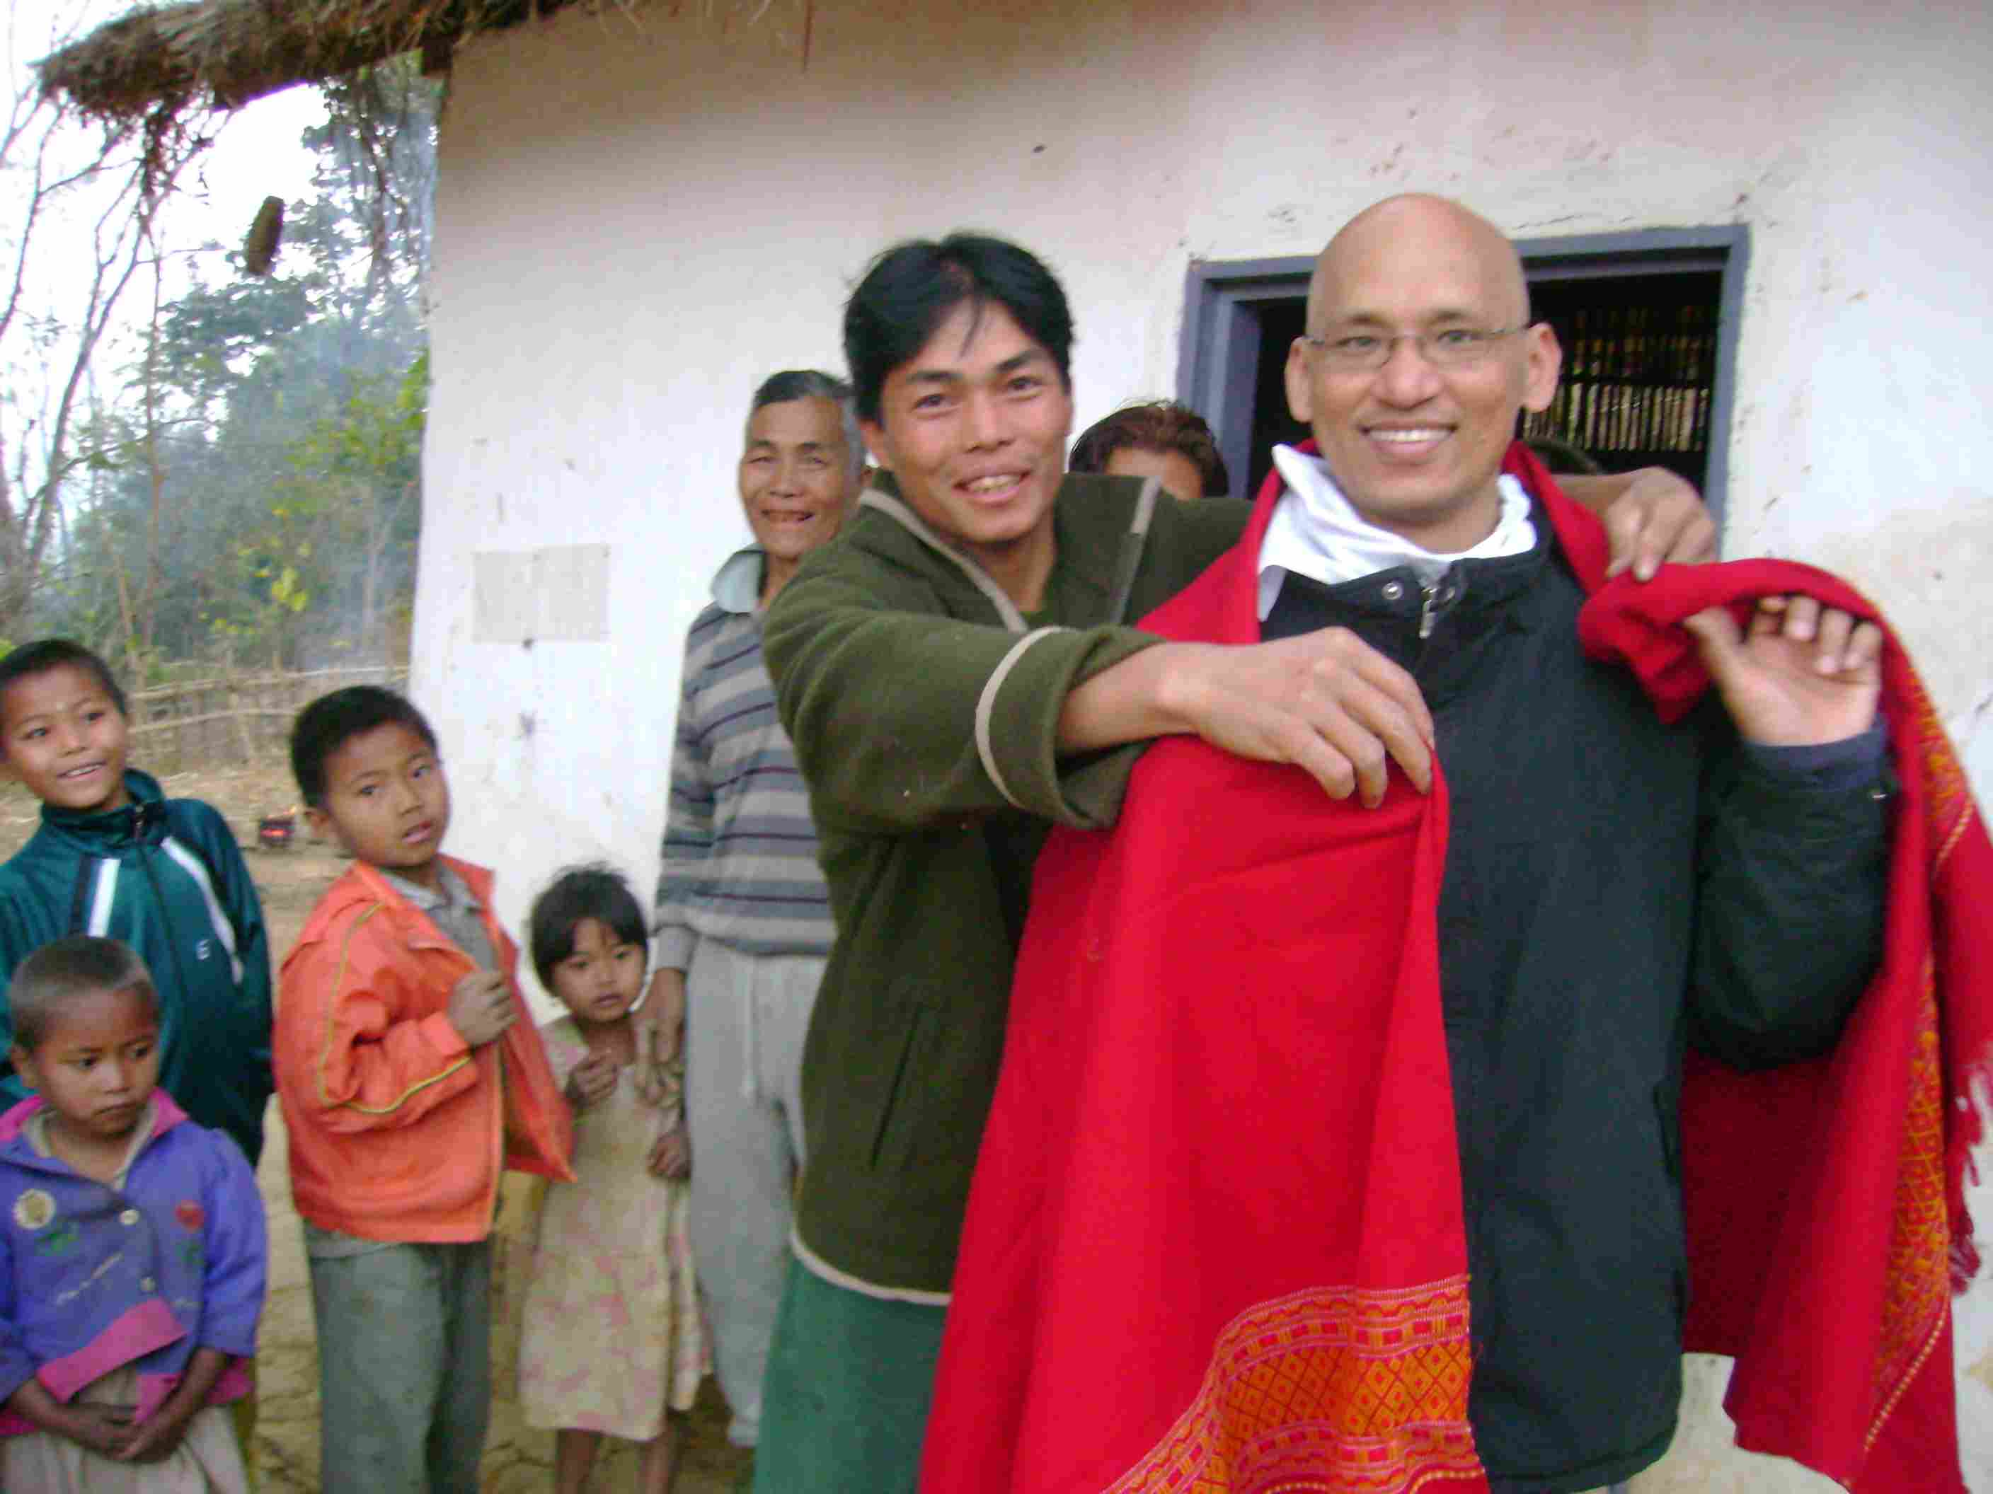
SACSAS Academy –Maovam Branch (Shantikumar receiving a gift from the headmaster)
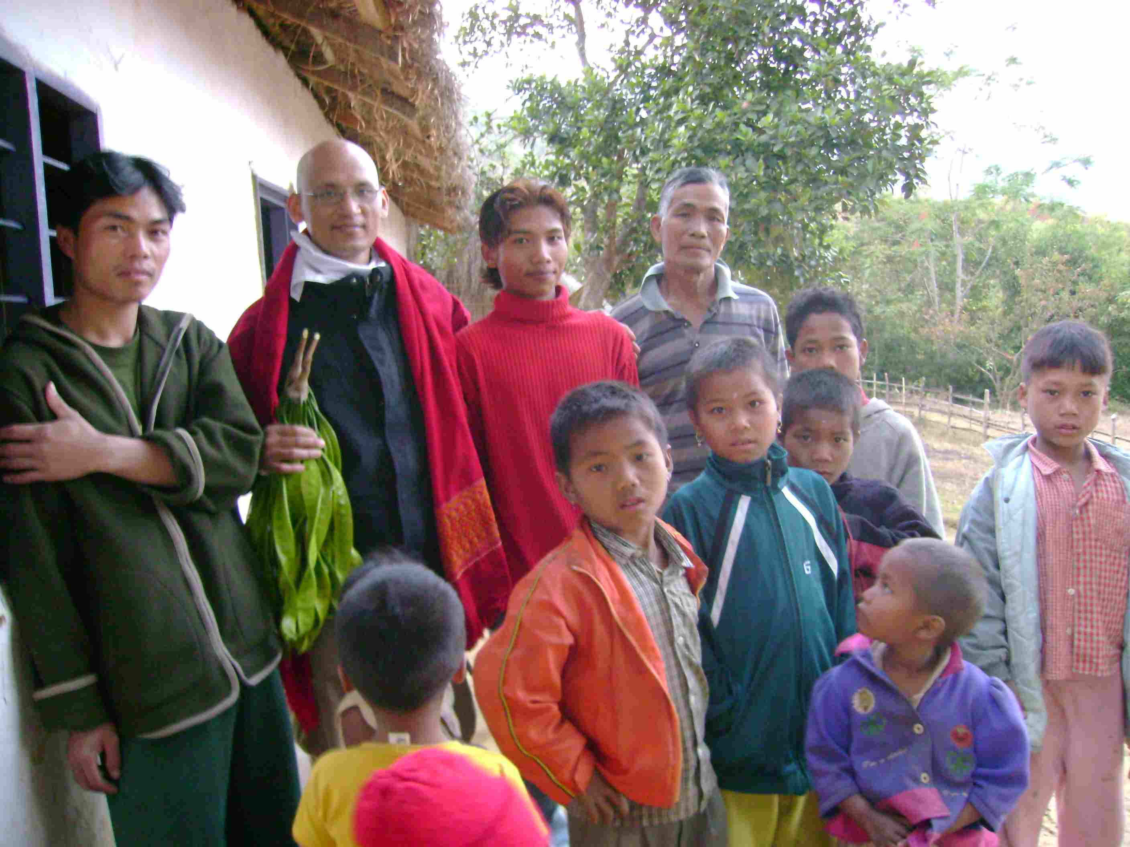
SACSAS Academy –Maovam Branch (Shantikumar with teachers and kids)

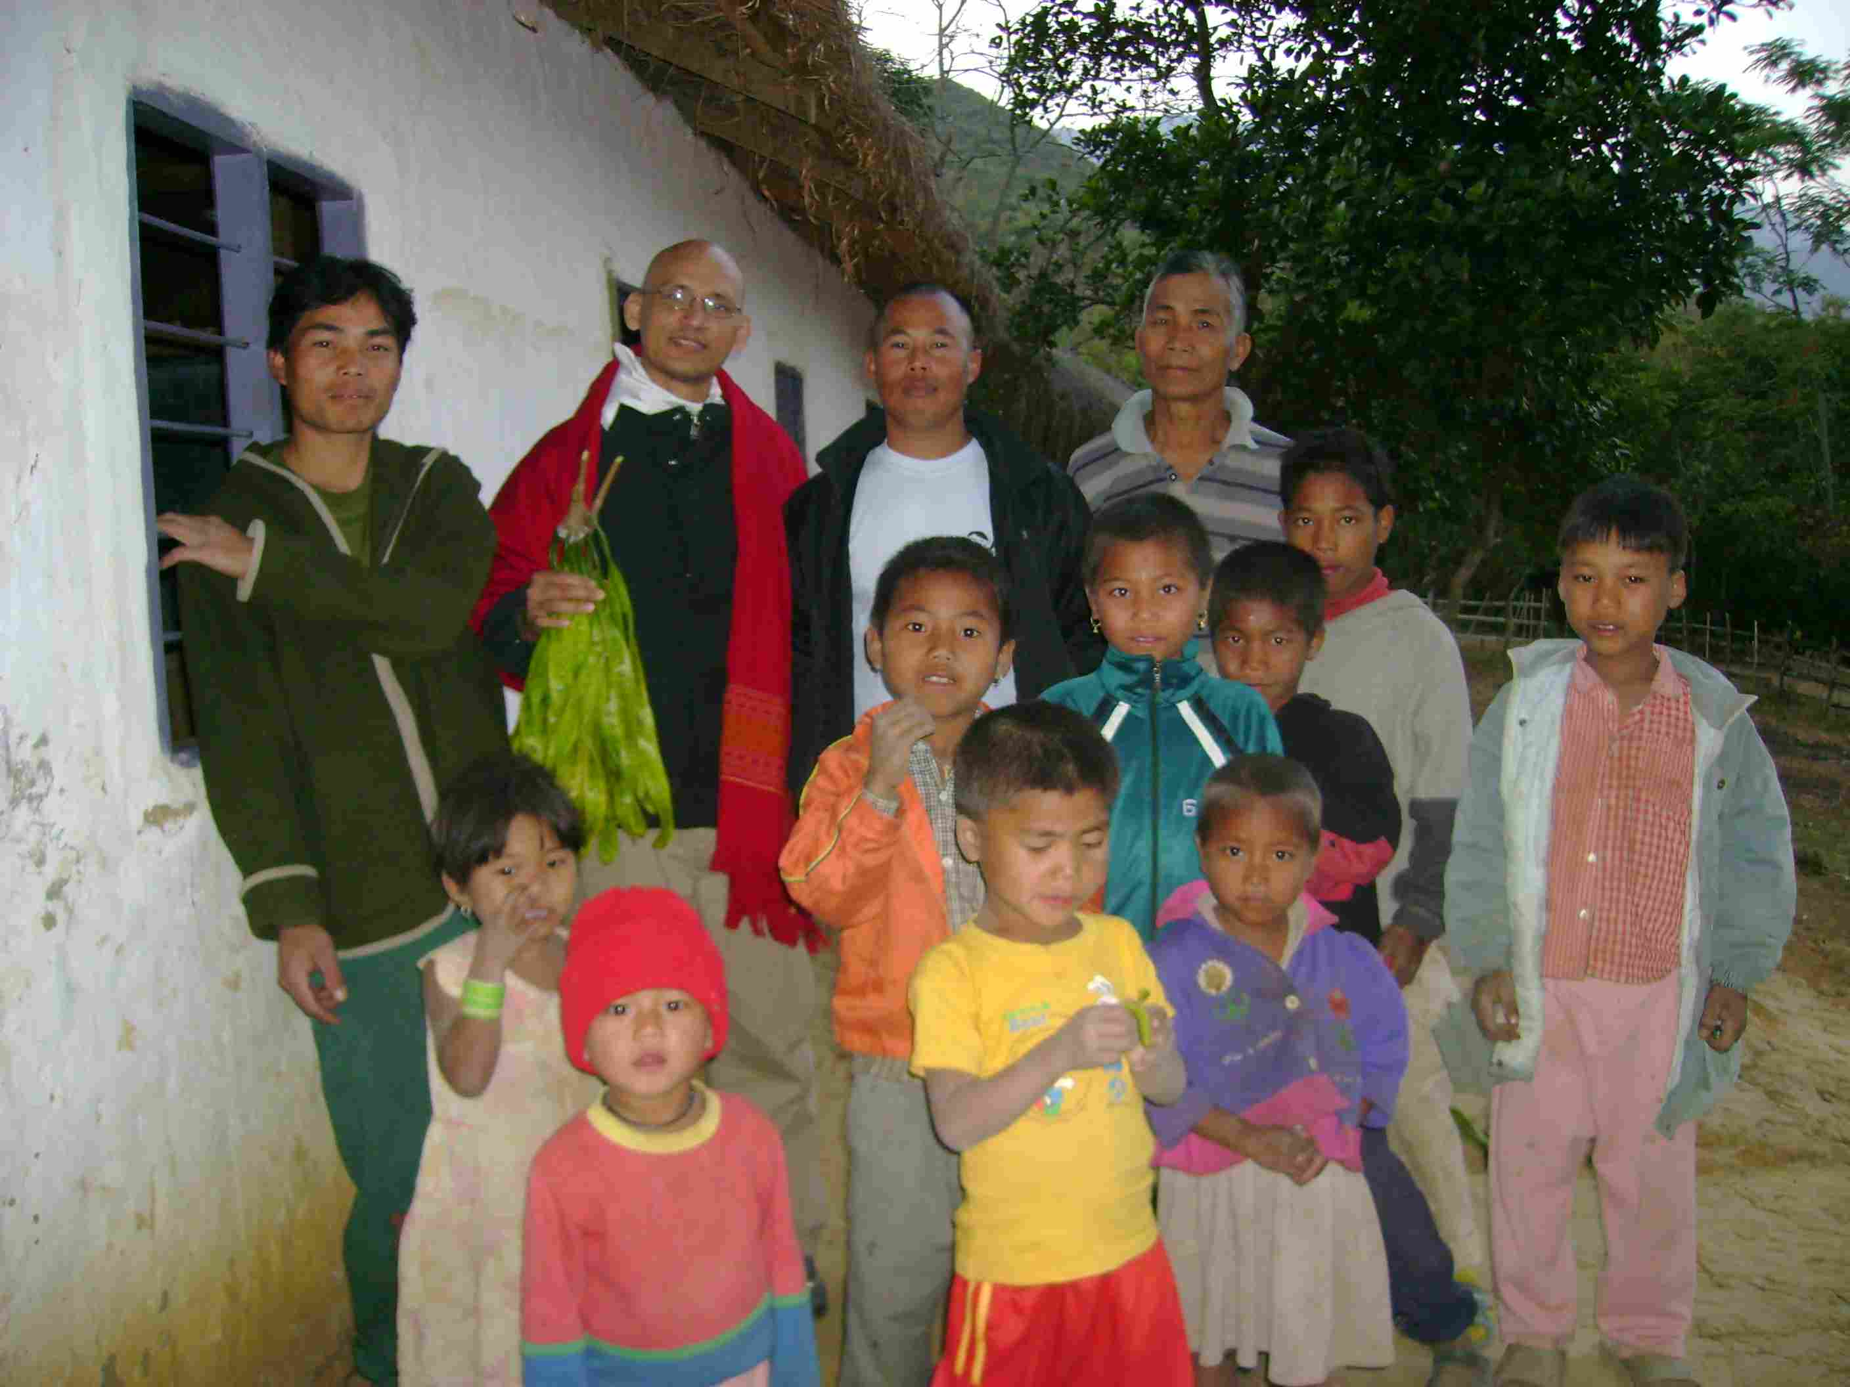
SACSAS Academy –Maovam Branch (Headmaster, Shantikumar, Surjit, guardian and kids)
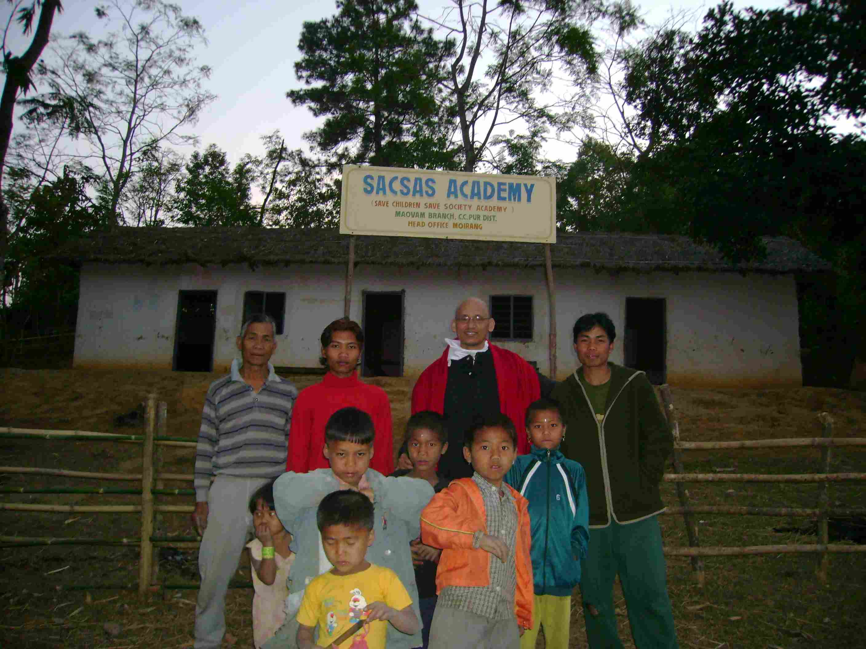
SACSAS Academy –Maovam Branch

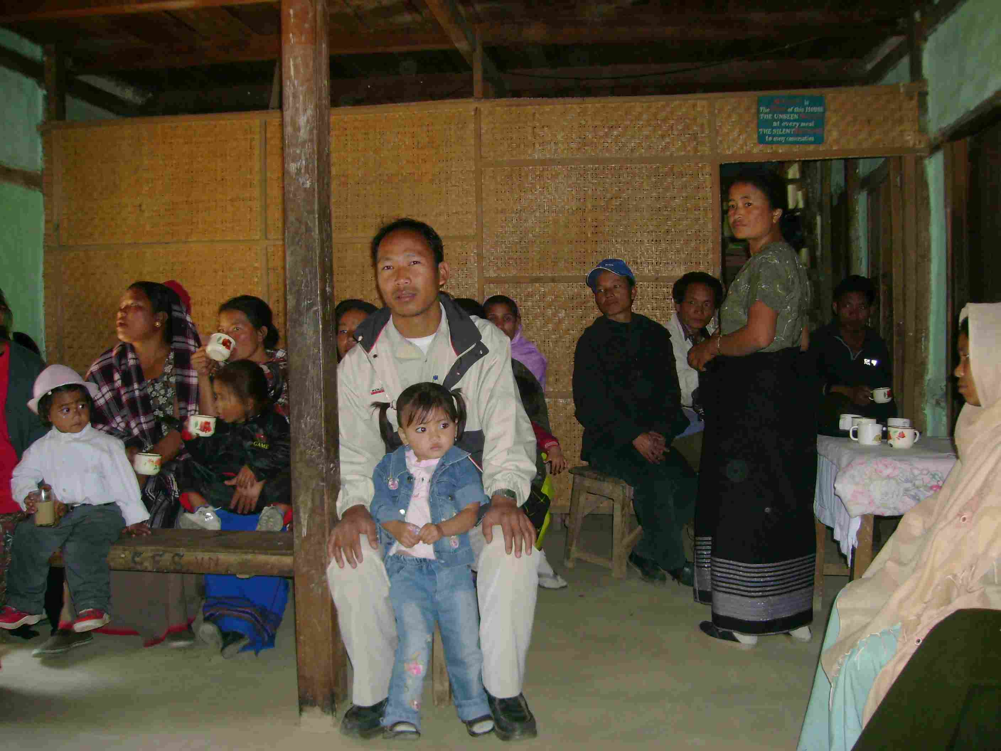
The V.N Model English Junior High School, Ukhatampak (meeting)
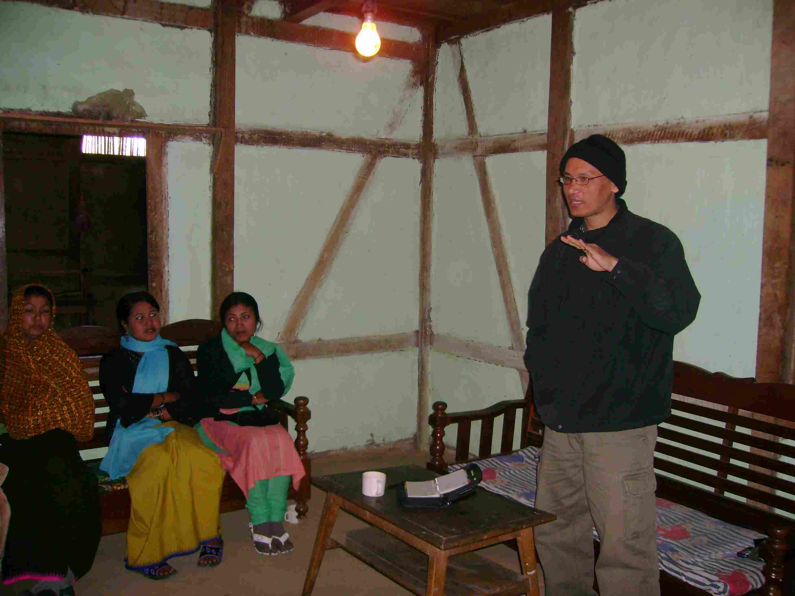
The V.N Model English Junior High School, Ukhatampak (meeting)

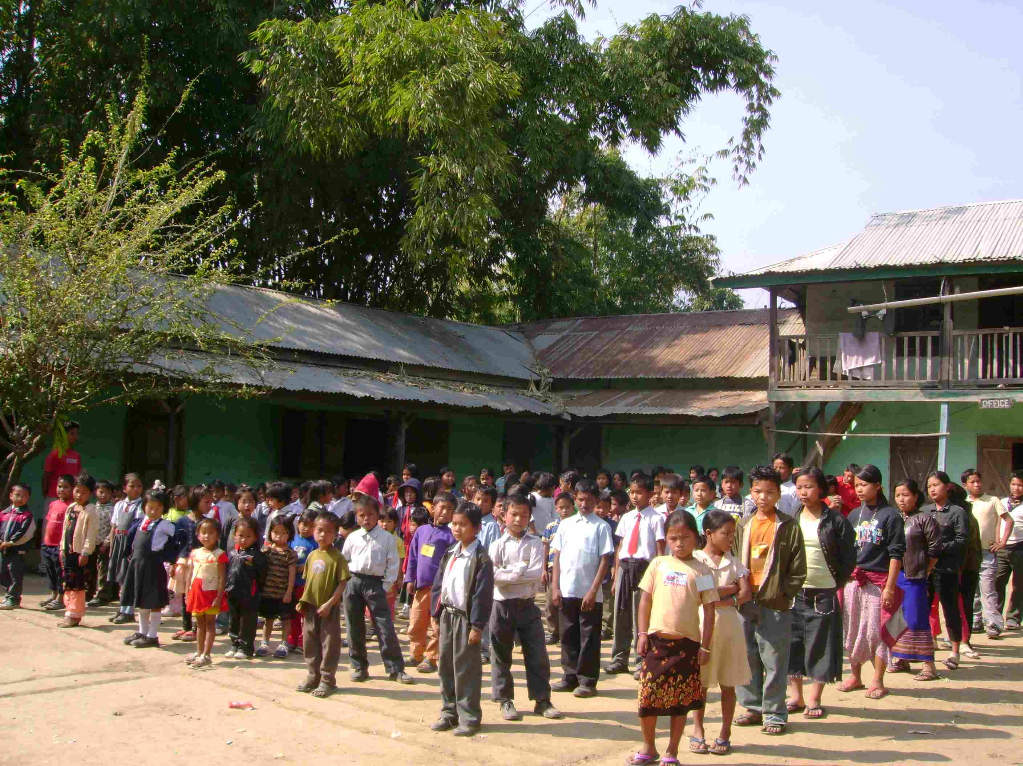
The V.N Model English Junior High School, Ukhatampak (students)
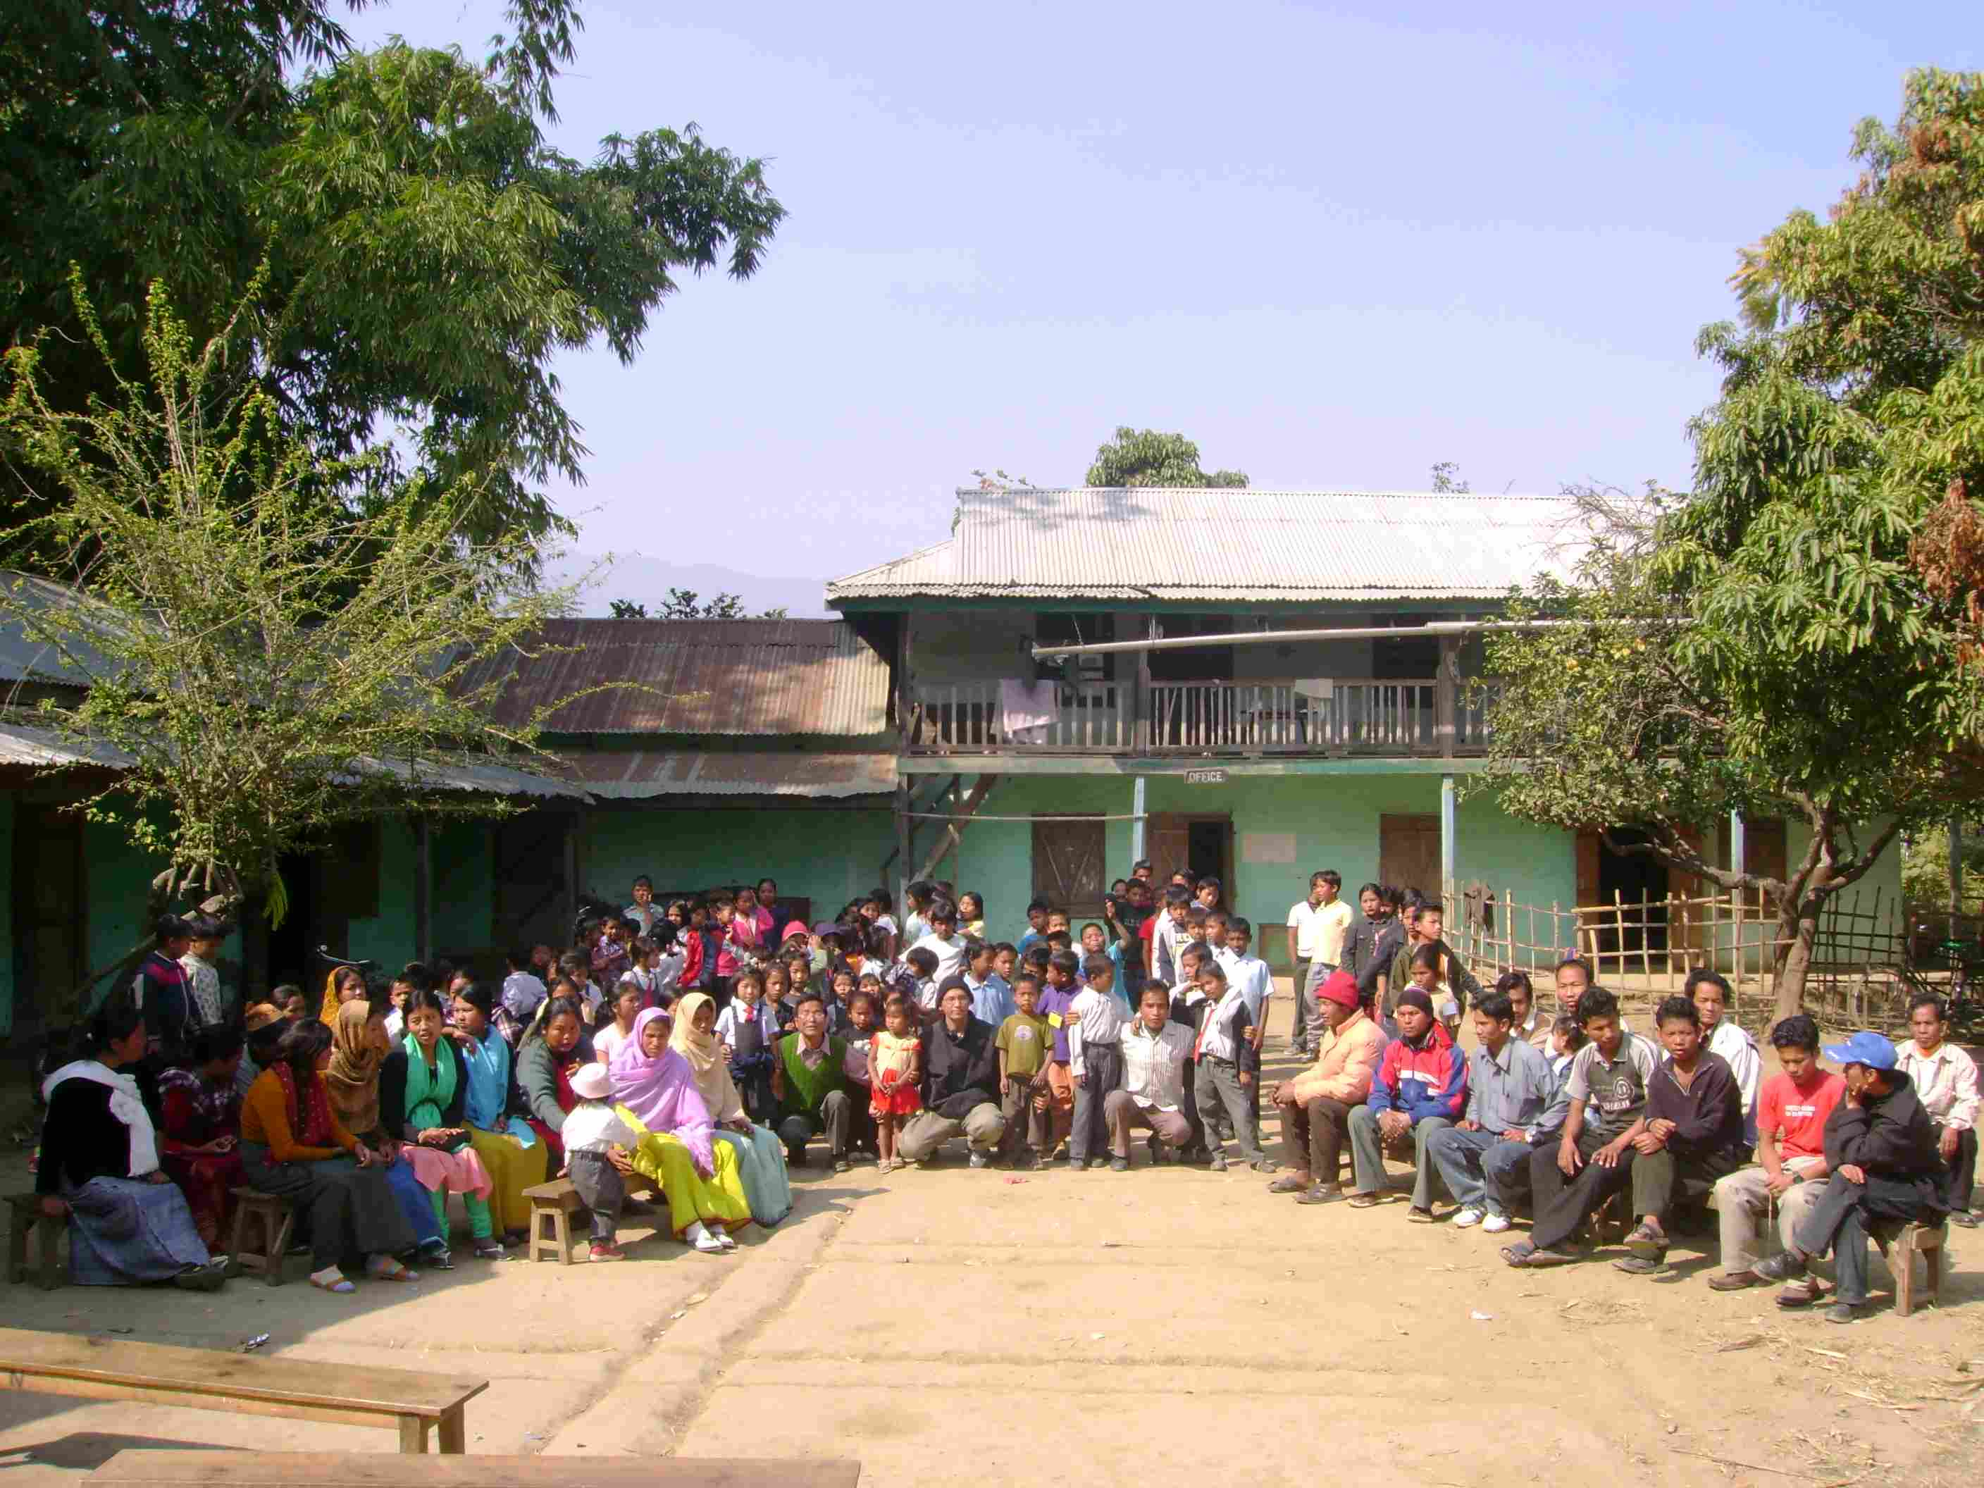
The V.N Model English Junior High School (students, guardian, teachers and Shantikumar)

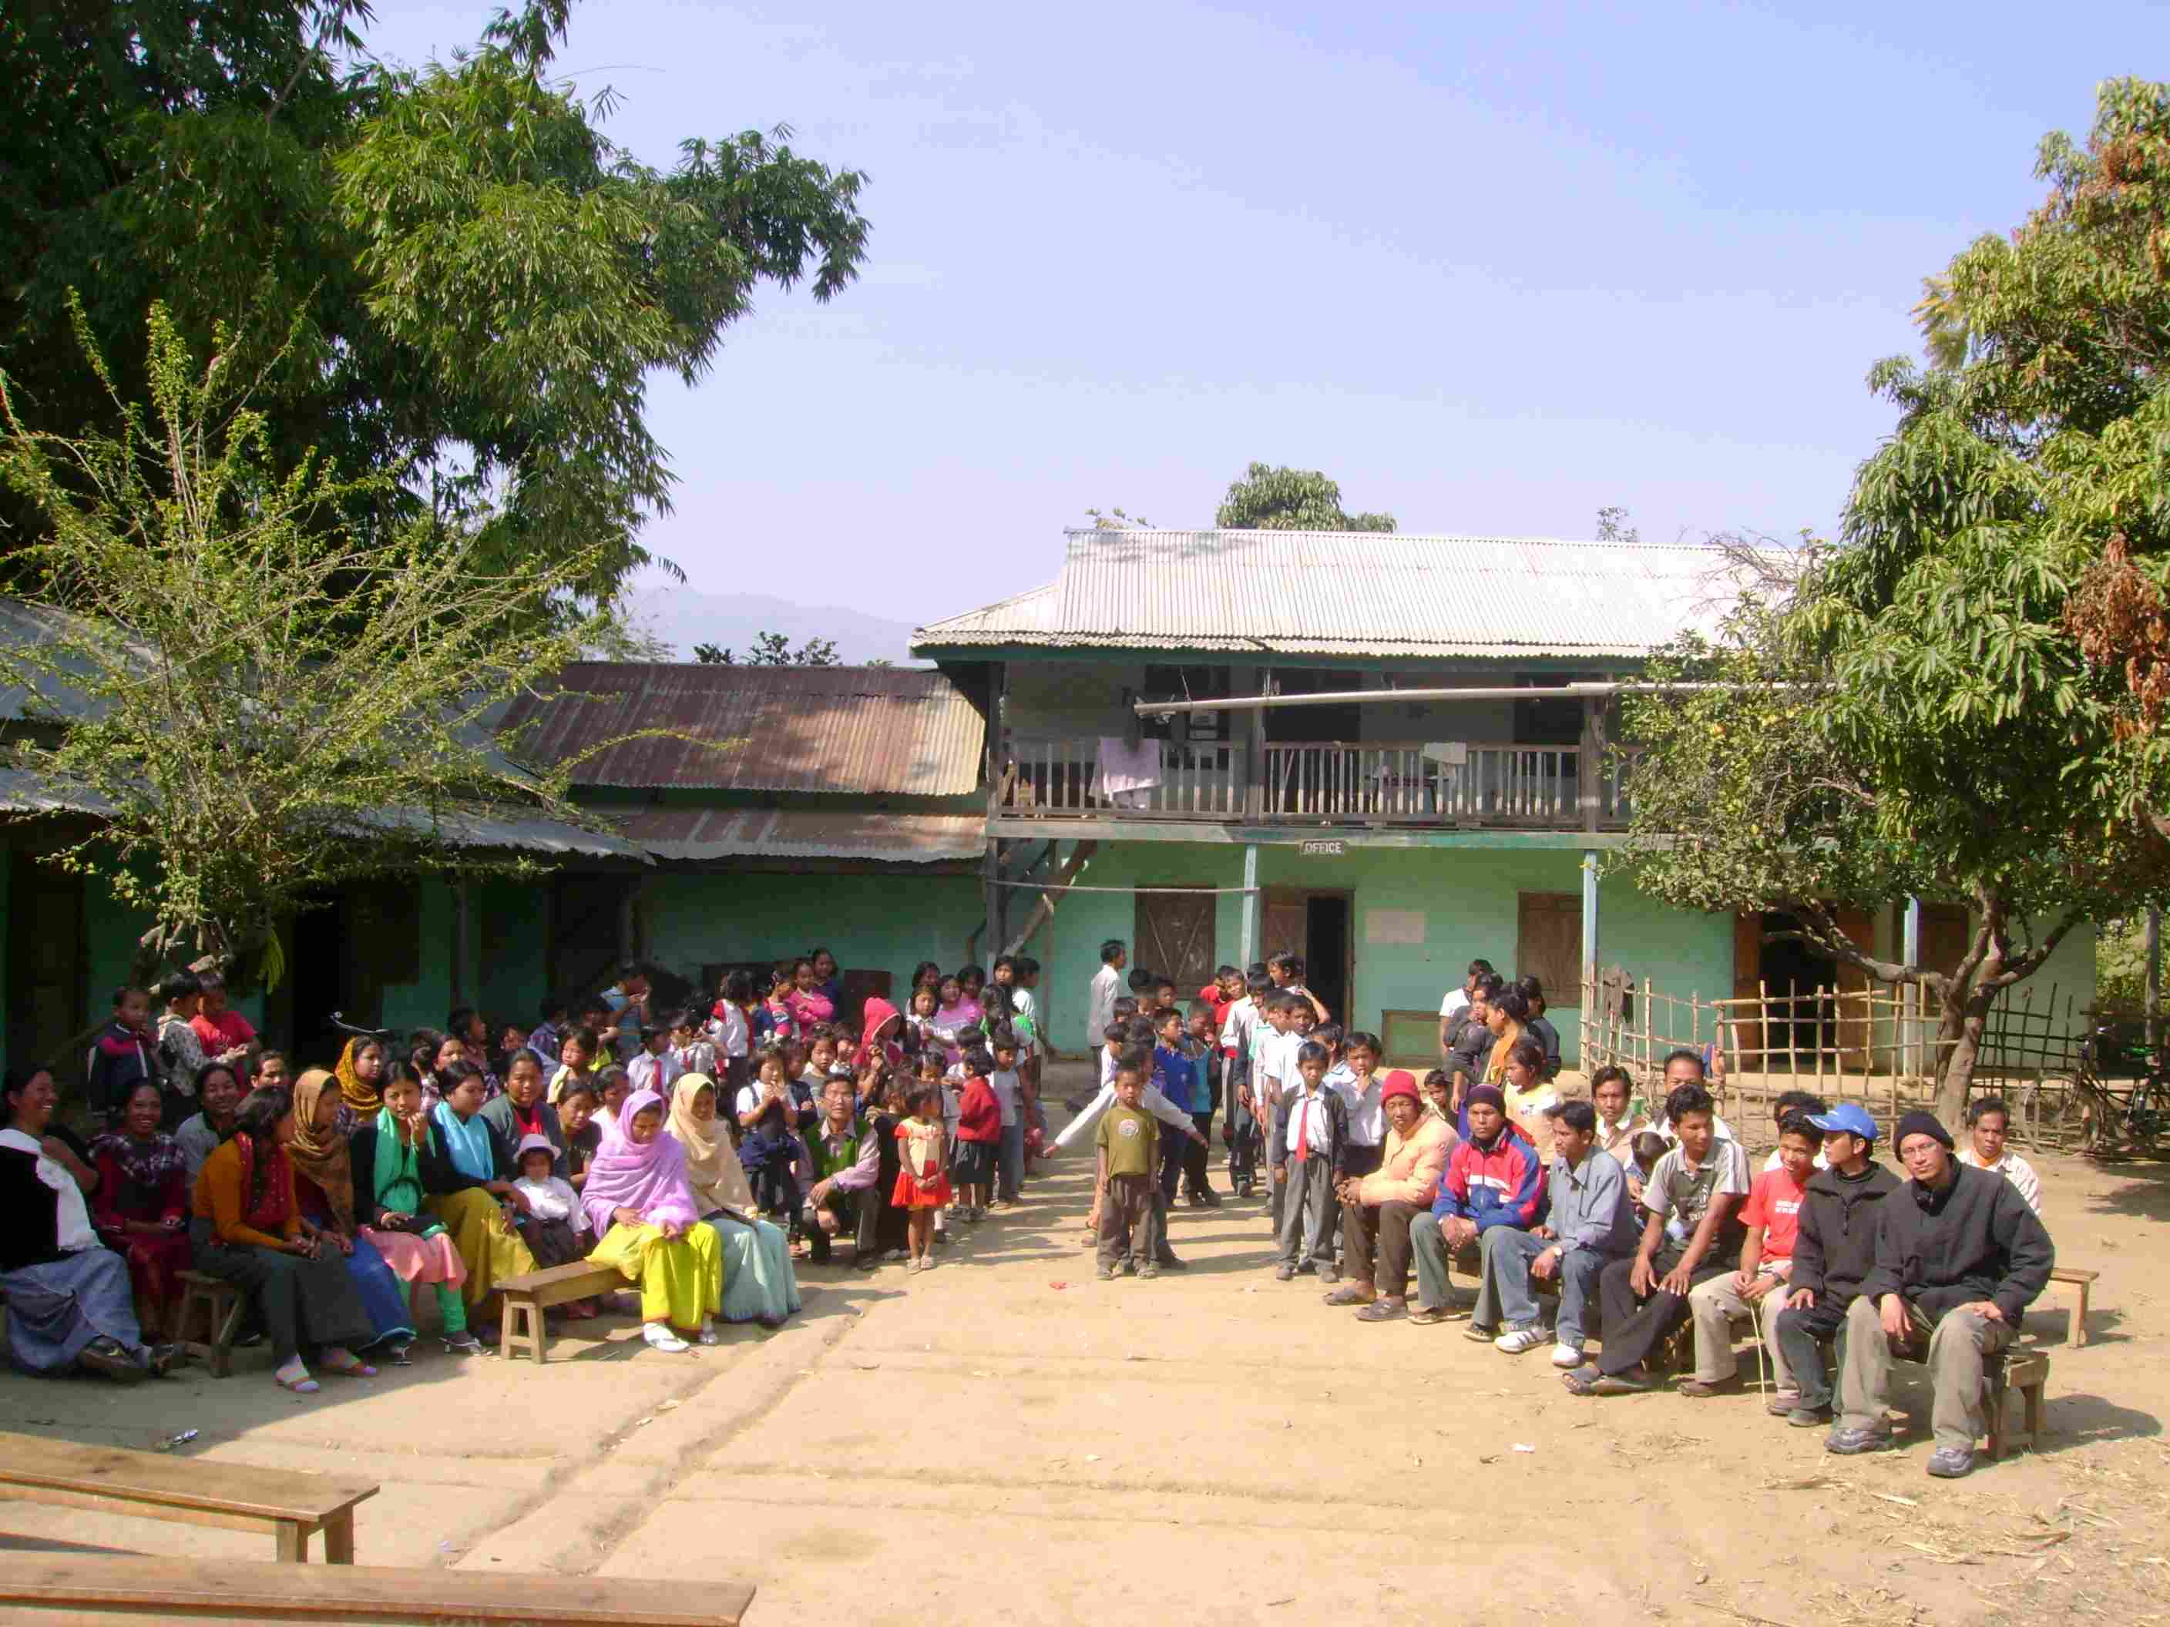
The V.N Model English Junior High School (students, guardian, teachers and Shantikumar)
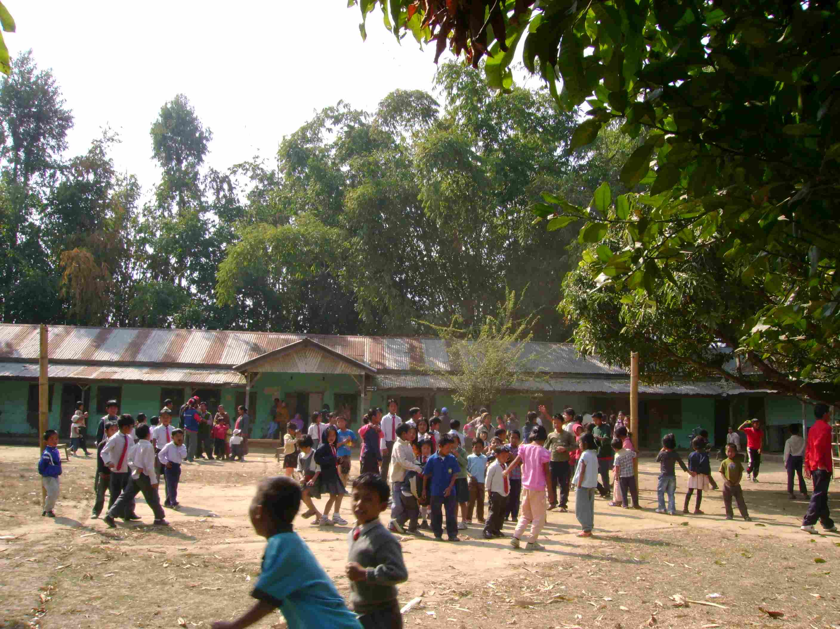
The V.N Model English Junior High School (playground)

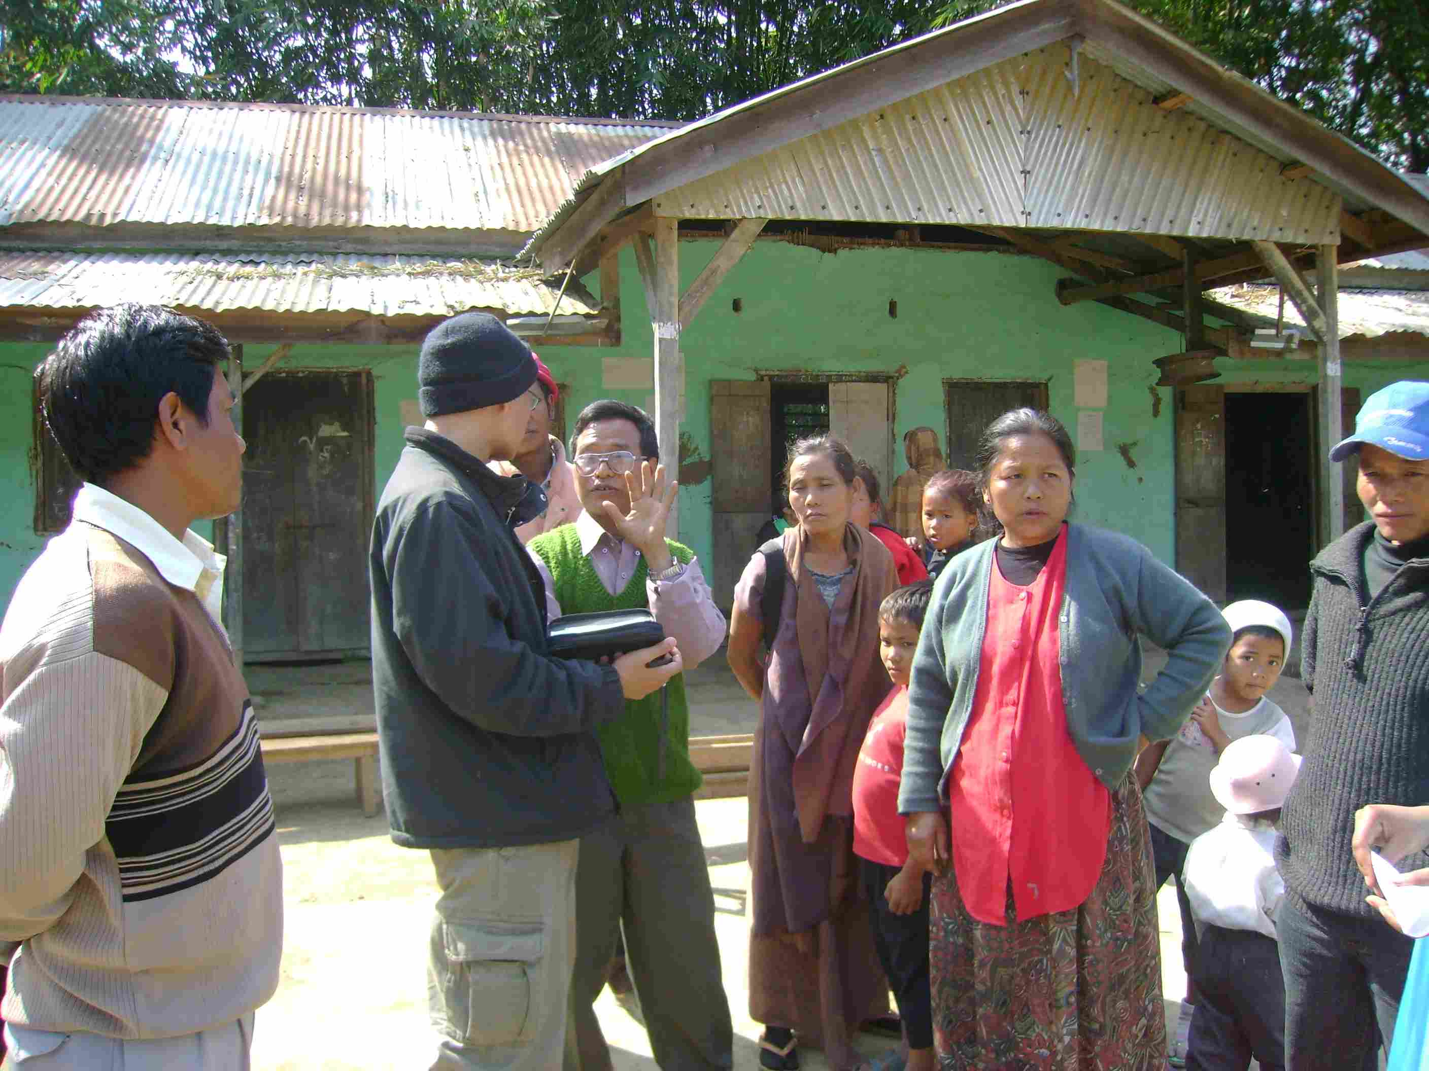
The V.N Model English Junior High School (Shantikumar with teachers and guardians)
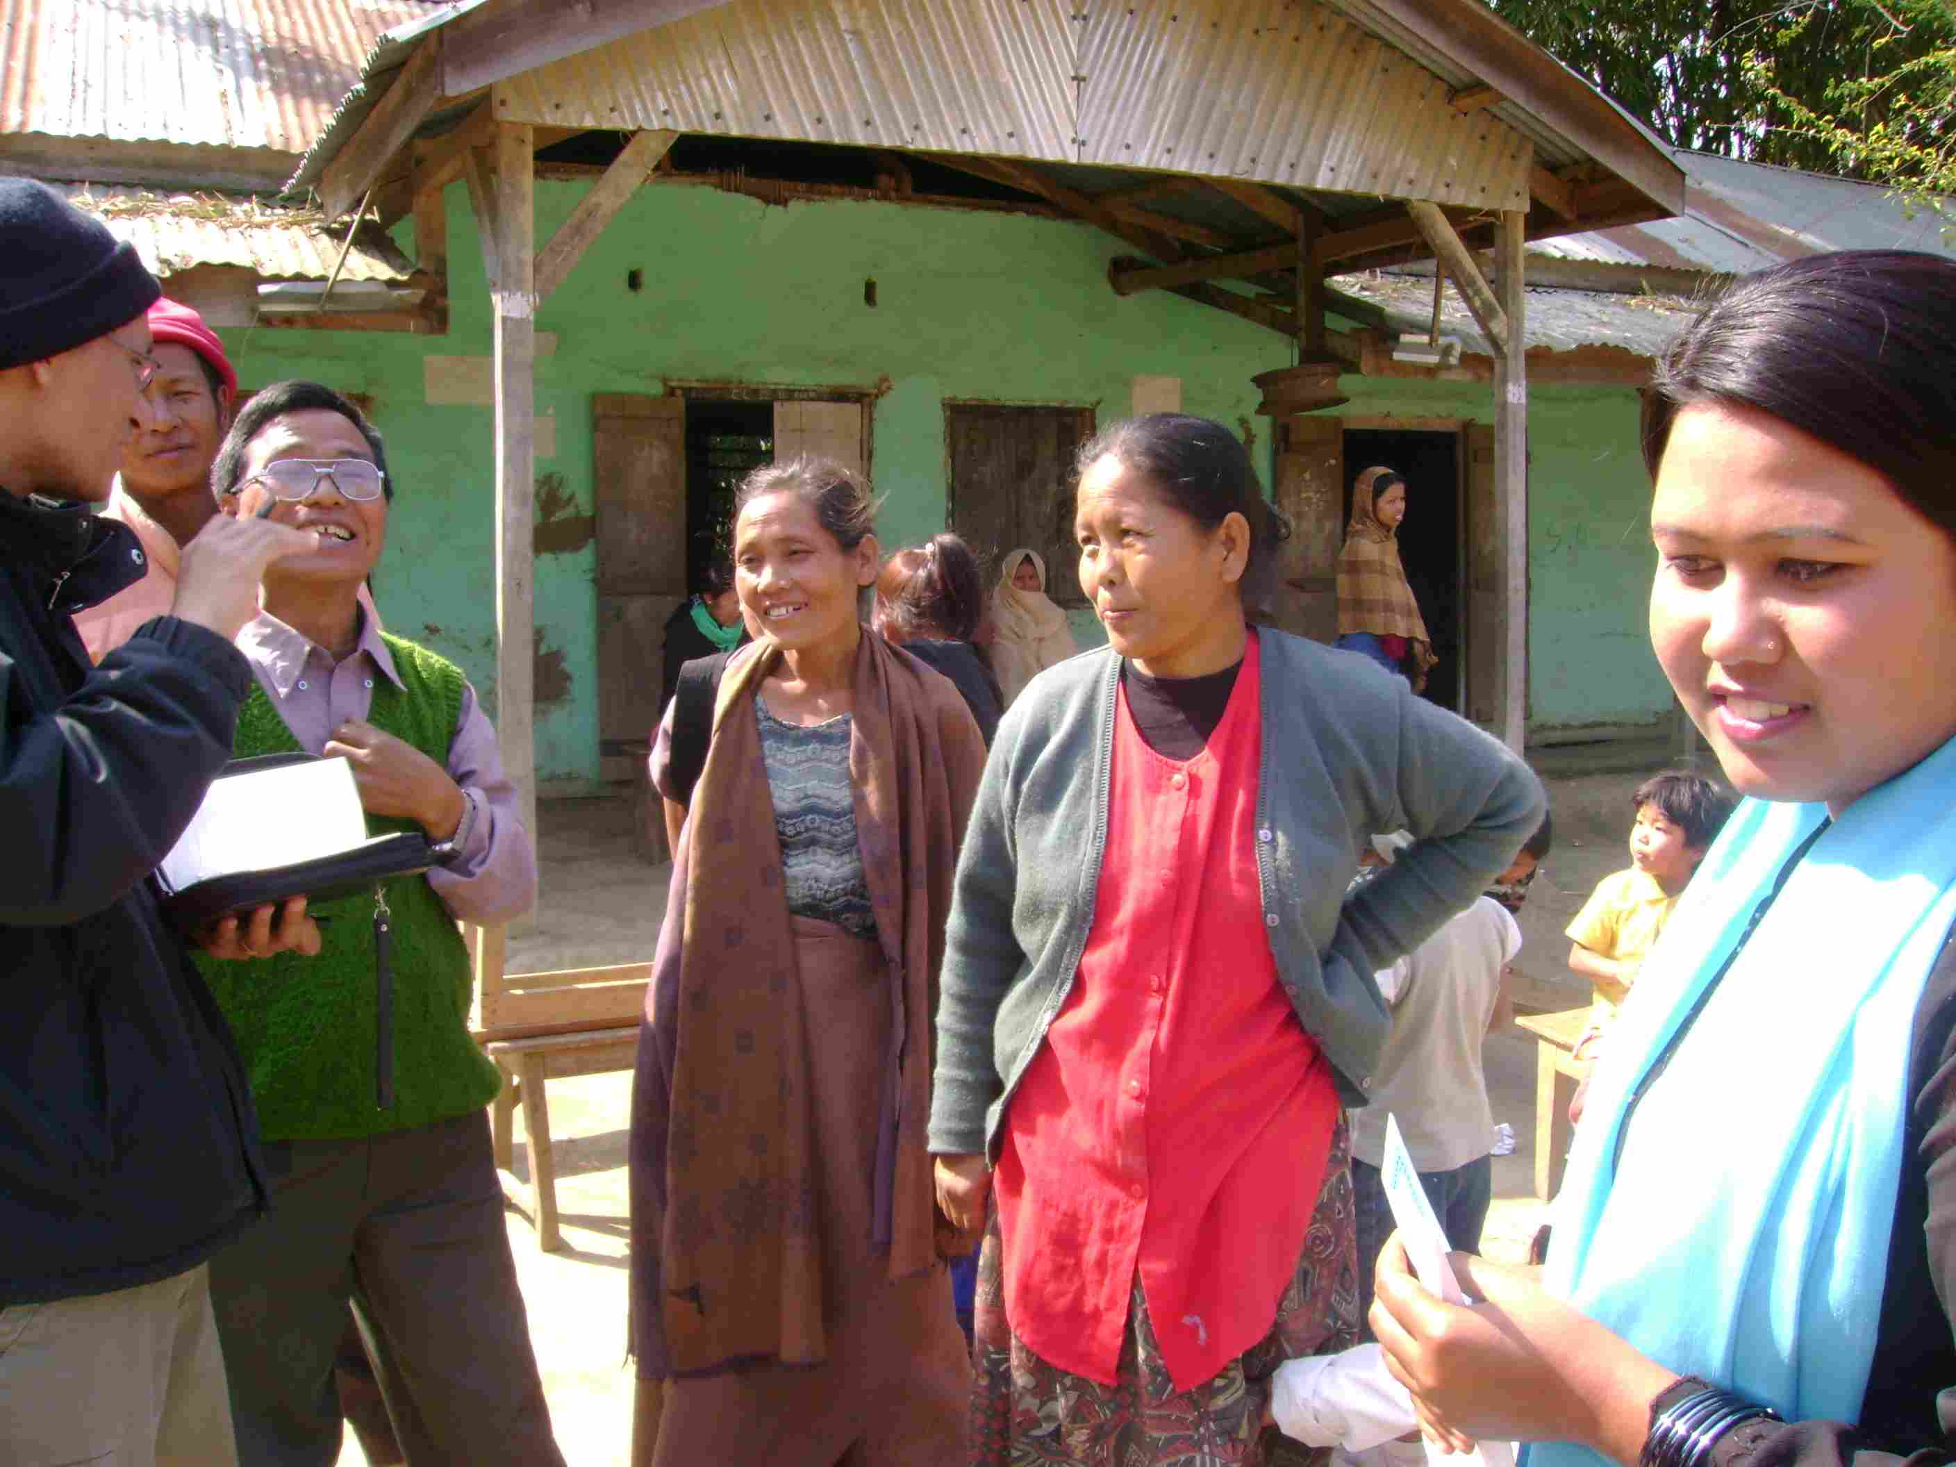
The V.N Model English Junior High School (Shantikumar with teachers and guardians)

