Site Visit of Champa Mahila Society (CMS)

6th – 8th September 2013

Aparajita Durga

I left for CMS from Kolkata with my mother on 6th September 2013, on the 7:30am train from Sealdah. We reached Canning around 9:00am. It was about an hour’s drive from here to Shibganj in Basanti, where CMS main office is located. Amal da sent CMS’s vehicle, an ambassador, to the Canning station to take us.
We were about half way towards Shibganj when we were blocked by locals. A high profile politician was murdered brutally the night before, so his supporters were calling for a “bandh” (road block). The situation was extremely grim in the entire Basanti block. Our driver tried talking to the locals but of no use. All around people had to abandon their vehicles, rickshaws etc. and walk. Finally, after a long time of trying to figure out alternative means to travel, 2 CMS people came in motorbikes from Shibganj and we were able to leave the blockade area.
This is the sad state of affairs here in West Bengal, especially in the Sundarban areas in South 24 Parganas district. “Bandh” is an everyday affair, and political unrest, murder etc. is way of life here.

Non-formal Education Centers (NFE)
I left with Swapan Naskar to visit 2 NFEs. Swapan Naskar is one of the four NFE supervisors. NFEs usually run from 6:30am or so, till 10:00am or so. Today two of them were asked to stay open late since I was visiting.
The first NFE was run by Sumita Maity. She had been running this center for about 20 years. There were about 25-30 kids, from toddlers to class 2. The class was taking place in the verandah of Sumita’s house. The children recited was some poems they had learnt. Almost all of them had their own school bag and water bottle. Though for many, the school bag contained only their plate to have the midday meal. Today they were given a cooked meal – “khichudi” (rice and pulse cooked together) prepared by some of the kids’ mothers. Every Friday they are given a cooked meal; other days they are given dry food like puffed rice. As the kids started having their food, I left for another NFE.
This second one was run by Sravanti Naskar. She was running this center for 8 years or so. Similar to the first one, this was in the verandah of Sravanti’s house with mud floor and temporary roof. The NFE had some charts of flowers, animals etc. hung on the wall. And the children and hung their paintings too. They recited poems and sang songs. I noticed one boy was quite naughty and it turned out he was Sravanti’s son who was part of the NFE class. The kids had made some figures from clay which they showed enthusiastically.
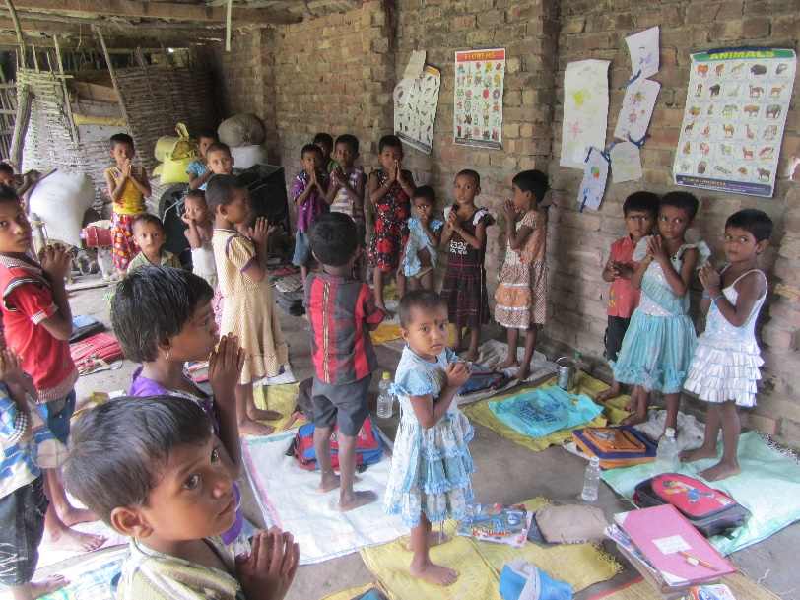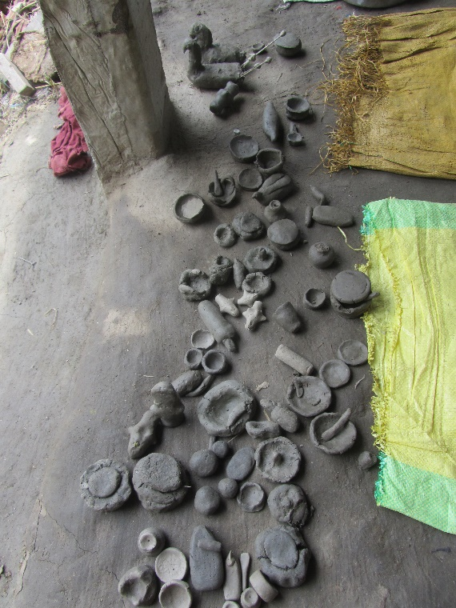
While chatting with Swapan, who is the NFE supervisor, he said the four supervisors visit each NFE about twice each month. They take turns and rotate the centers, so each month he has about 15 NFEs to visit. I also met briefly Karthik Manna, another NFE supervisor. Since the NFEs are spread over several villages in 2 blocks Basanti and Gosaba, and the NFE teachers are mostly home makers with little or no means of commuting, the supervisors’ job, was to visit each NFE and see that they are running smoothly. All supervisors, except Rama Mandal, had bicycles or motor bikes.
Only 5 or 6 NFEs had their own building. I was also told that the Kalidanga NFE (which had its own building) lost its roof during Aila in 2009. So that NFE was temporarily running elsewhere till they have funds to repair the original building.
Concerns:
- Govt.-run Integrated Child Development Scheme (ICDS) centers have come up in all locations where NFEs are located. ICDS teachers get paid about Rs. 4000 per month, compared to Rs. 400 given to the NFE teachers. CMS claims that kids don’t study in ICDS centers – only thing good about them is their midday meals. Whereas in NFEs, the kids actually learn something. So the local people still want their NFE centers.
My concern is how do we know ICDS centers are non-functional? If ICDS centers function well, CMS NFE centers wouldn’t exist.
- I recall we have funded the bicycles for NFE supervisors. Not sure how Swapan Naskar was able to obtain his motorbike. It could be from his personal savings, but we need to know if it was CMS funds.

Hospital
My next stop that morning was the hospital. The doctor (Dr. Burman) who visited bi-weekly, was not in this weekend. I looked at the hospital log book – when the doctor comes, he sees approx. 50 – 60 patients in one day.
Ranjita Mandal is the full time nurse who lives in one of the rooms in the hospital itself. Siwani Das is the night time nurse. There are a couple of part time nurses. Ranjita said she had not received any formal training or degree in nursing. By assisting the doctor, she has learnt some nursing work.
The hospital building and facilities had expanded a lot from what I’d seen about 5 years ago. The lower floor had a room for the doctor, an operation room, and a dispensary room with medicines. Another large room was used by the nurses for their stay. 2 rooms had a total of 6 beds for patients – that morning there were patients in all the beds. I saw the new operation table and equipment CMS had bought with some German funding they received. All of this was on the lower floor.
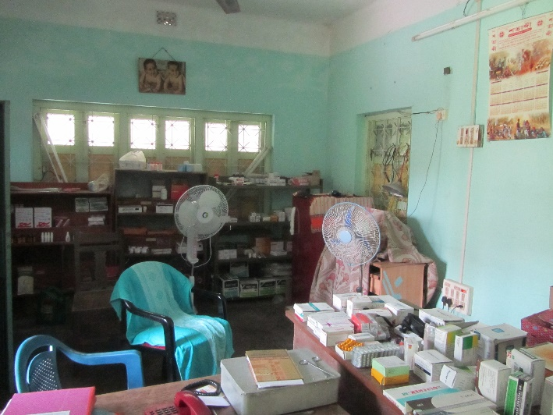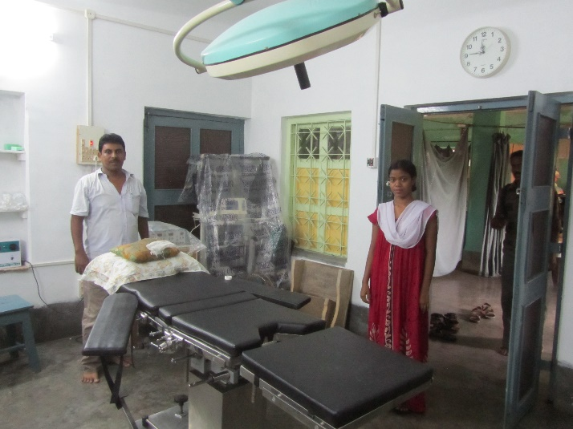
The top floor was newly completed with several rooms. A couple of rooms had beds and I was told that they were used by out-of-town guests. A few rooms were empty. One room had been designated as the computer room with a single computer.
Prashant Karali works full time in the hospital and he is the health project coordinator, and superintendent. He lives next door. His job in the hospital is to give medicines prescribed by the doctor, and keep the medicine inventory. I asked him about his regular working hours and got a vague reply.
Concern:
- It seemed to me (looking at the medical log book) that the work of giving medicines is mostly done when the doctor visits biweekly. At other times, there are hardly any patients. So the question is, whether a full time job of a superintendent just for keeping the medicine inventory is required? There is a full time nurse who stays in the hospital who could take up the medicine handling job as well. I feel there may be a conflict of interest in creating this position of superintendent, given that Prashant Karali is Amol Nayak’s brother in law.

Sarada Balika Bidyamandir(SBB) & Girls Home
I had planned to have the afternoon lunch with the girls in SBB. So my mother and I left for SBB with Prashant Karali around noon. SBB and Girls home are in one complex, walled on all sides, about 10mins walk from CMS main office. The road to SBB had changed a lot – it used to be mostly fields, but now both the road sides had buildings.
The land right next to SBB belonged to CMS earlier; it was given to the Govt. where now a “model school” was being built. The entrance to SBB was very disappointing to me. Right in front of SBB wall, there is a small pond between the wall and the road – that pond had filled up with garbage and plastics on one side. There was a narrow lane to enter from the back entrance – that lane was strewn with garbage and plastic packets, most likely coming from the school.
I walked around while the classes were taking place. SBB has classes from class 1 to class 8 for girls only. The SBB building had been extended to have more rooms. The lower floors had SBB classes, and the 2nd and 3rd floors was the Girl’s Home. The girls had created a news board where they stuck newspaper cuttings of news that they found interesting. I noticed that our (Asha Seattle’s) annual budget was stuck in a wall so everyone could see it.
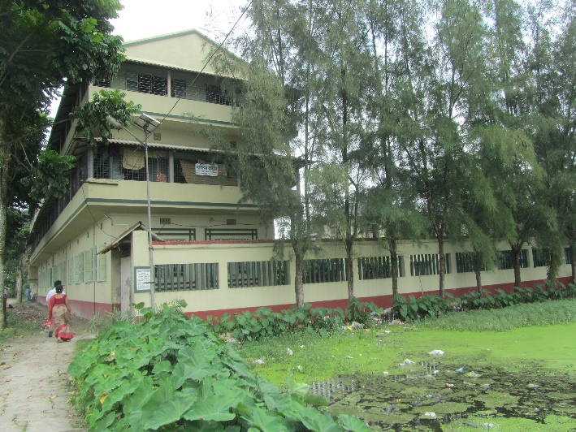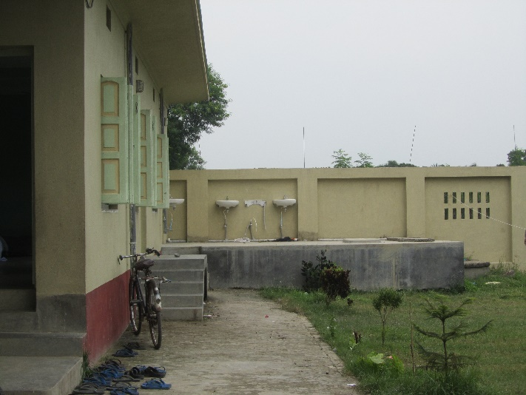
What was most heartening to me was to see that many of the old teachers were still teaching here – Allauddin, Minati, Alo and Shikha. Allauddin is still the headmaster. I met all the teachers in the teacher room and we chatted for a while before heading for lunch. What is also commendable is the sincerity of the teachers. 2 new male teachers had joined, for Science and English – this is a change since earlier the teachers were almost all female teachers in this girls’ school. The teachers talked very highly about a training they had attended in Pondicherry about 2 years ago. They would love to have more such trainings. SBB & SSB teachers meet about twice a year for internal training, given by Amal da and others.
I saw some of meeting minutes of sub-committee meeting with parents and teachers. They discussed issues like the new year curriculum, cultural events etc. It was not possible to get a sense whether these sub-committee are really helping in transparency and accountability.
Lunch was simple but very flavorful – daal, rice and egg curry. After lunch, I sat and chatted with Allauddin for some more time. We had a photo session, and by then it was past the school closing time. The SBB teachers left and I went to visit the Girl’s Home.
There were 2 floors above SBB where the girls lived. Pratima Malick is one of the supervisors and there was another elderly lady whom I didn’t get a chance to meet. We spent some time talking to the girls in the home, and they surrounded us and asked many questions. Most of these girls are from extremely poor and dysfunctional families, and for them, this place is their home.
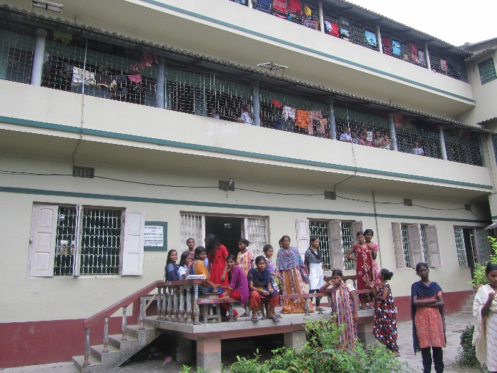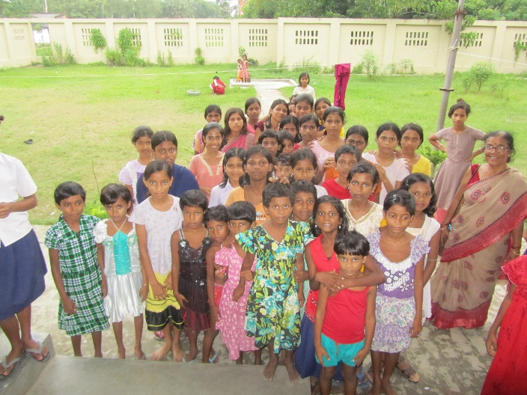
Concerns:
- Toilets
Asha had funded new toilets to be built, which I saw they did. But one of the school teachers told me that they didn’t use them. On inspecting, that statement seemed valid to me since the new toilets didn’t look to be in use at all. The toilets were located far from the tube well, which was the source of water for the toilets - one teacher said that that was the reason for low or no usage. Another teacher also said that there was no separate toilet for the teachers. However, when I mentioned this situation to Allauddin, he simply denied and claimed that the new toilets were totally in use. This seemed strange to me.
- Benches
Classrooms had benches for students earlier. Now they were all stashed away in one of the temporary rooms near the kitchen. All the students in SBB were now sitting on the floor. I was told they did this as a recommendation from Swati, a past Asha volunteer. However, to me this seemed a regression for the students, especially for those in higher classes. The students were now reading and writing the entire day, bent over, heads almost touching the floor – a very bad posture for learning. On expressing my opinion, many teachers agreed that they too felt that taking away benches was detrimental to the children’s learning.
- Partition in classrooms
Most SBB rooms are long hall rooms with 2 or 3 classes taking place at the same time. Each class is noisy and it is hard to hear when all classes are on full swing – especially the children in the back rows definitely could not concentrate. In my last visit I had seen temporary partitions between the class rooms. This time there were none. I was told those partitions needed repairs, so were removed. I recommended that they bring back the partitions, which should not expensive considering they are made of bamboo and local materials.
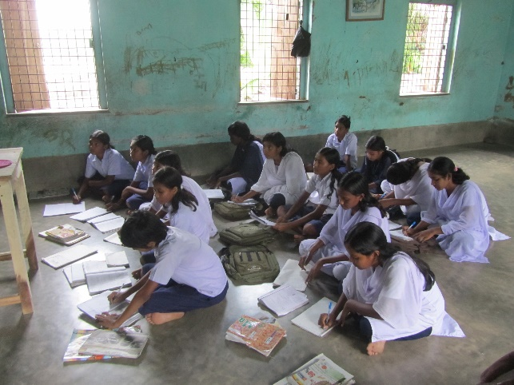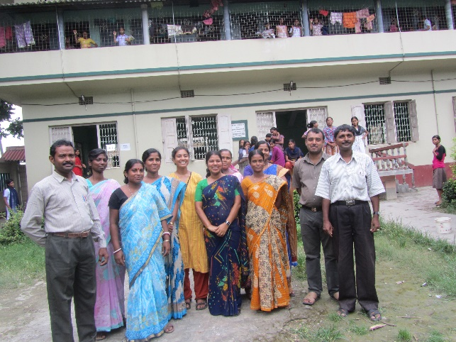
- Decision making
This is a concern in general across projects. Here in SBB, I am not sure if only Allauddin and Amal da hold the decision making power, or how much empowered the teachers and students are.
- I observed that the subjects of Math, Science and English in higher classes were taught by the 2 male teachers. Surely, there are female teachers qualified to do the same?

Agriculture center
CMS runs an agriculture center where I stopped briefly. The funding for this comes from some of the Govt. schemes. They work with some villages to develop organic farming and distribute seeds, teach farming methods etc.

Boys’ Home
The boys’ home hasn’t changed much from what I had last seen about 5 years ago. The 2 buildings housed about 200 boys. There had been an outbreak of small pox and few boys had been sent home; some were still here who didn’t have a home to be sent to. Amal da said 4 or 5 boys had small pox, but according to Nibash it was about 35 of them.
Nibash Kharati was the boys’ home supervisor. He grew up in the home itself. He has a touching story of why he couldn’t complete his graduation studies. His father is dead and he has an aged mother who is almost bed-ridden. His sister takes care of his mother at home. She is now completing her MA, and after that Nibash plans to continue his studies.
The boys in the home are of all age ranges from kinder garden to those going to college (2 of them). The Govt. funding per child in the home is only till class 12. There are about 12 boys in classes 11 and 12. These boys take turns to teach and help the younger boys in studies.
The land in front of the boys’ home was open/unclaimed earlier. Now a Govt. primary school is being built there. So the field for the boys to play has now reduced. That area seems much smaller now that it is enclosed by walls on all sides.
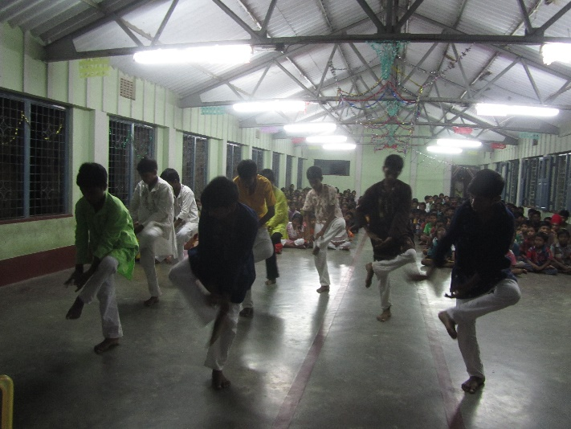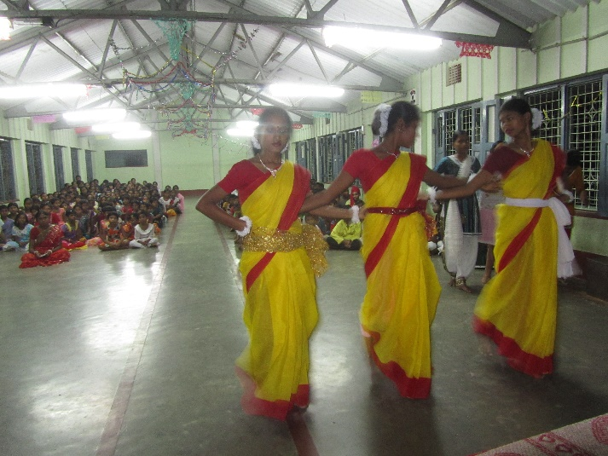
The girls and boys of the home are very talented. Every time someone comes to visit, they love to put up a performance in the big hall on the top most floor of boys’ home. That evening too, the girls came from their home, and along with the boys, they put up a splendid show of dance, music, drama and poetry.

Surendra Smriti Bidyaniketan (SSB)
The next day morning, the plan was to visit SSB in Amlamethi. Amlamethi is a separate island in Gosaba block (one of the 12 islands in the block), separated by the Vidyadhari river and normally takes about 2 hours each way from Shibganj in auto rickshaw, boat and van. However that day was declared “bandh” due to the murder the day before. We reached the ghat (boat dock) around 9:30am to find that the ferries were no longer running. The political goons had closed everything. Amlamethi was not connected through land, and these ferries were the only link to the world. Several people came to the ghat and turned back, and some waited like us. It was extremely aggravating to me to see how such “bandhs” (a regular occurrence) affected the lives of common people who depend on daily income to meet their basic needs.
We sat at the ghat not knowing whether we’ll cross the river that day and when. Swapan Mandal (SSB supervisor and principal of the school) was making arrangements to get us a private boat from the Amlamethi side. That boat finally arrived around 11:30am and we left. Since we had rented the entire boat, we took it around the island to get as near as SSB school as possible. The journey took us past other Sundarban islands with mangroves surrounding them with a glimpse of the local birds. I was awed as always with beauty of the fragile landscape, and impending devastation from climate change.
From the Amlamethi ghat, it was a short 10-15mins walk to the school. I was greeted by many teachers who remembered me from my previous visit. The school building was new to me (the old one was completely destroyed). The main building had 2 floors and held most of the classrooms. There was another building on the side which they had started construction but ran out of money – this was used for 3 of the lower classes. Students had made a nice flower bed and had planted trees along the boundary.
I went around the school, dropping into some of the classes and talking to the students and teachers. Some of the teachers are very sincere and interested in improving teaching skills. They mentioned the training they took in Pondicherry (4 SSB teachers had attended it) and would like to have more of these. One teacher showed me a material he had prepared using the skills he learnt there. It was good to see that there were 2 female teachers now in the school, though still a long way to go among a total of 12 teachers.
There was one tube well for the school. The kitchen was in a mud house, a bit far from the school. The plan was to develop the land in front of the school and move the kitchen there. I spoke with the two cooks in the kitchen – their kids studied in this school.
We had lunch in the school. And after chatting with all the teachers and staff, it was evening by the time we left Amlamethi. Similar to my previous trip, the main request from the teachers was to increase their salary.
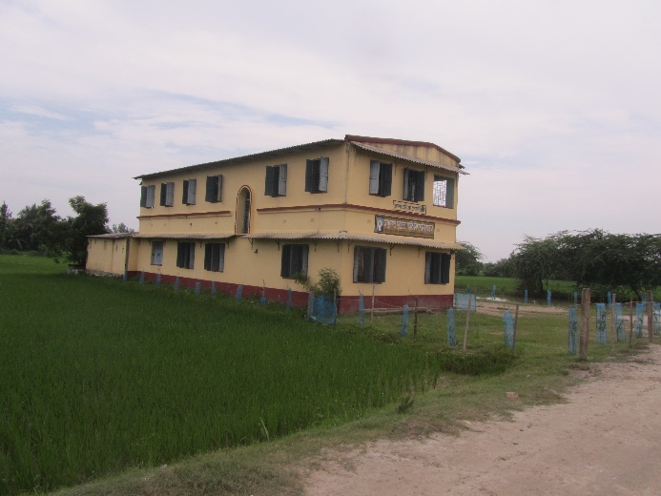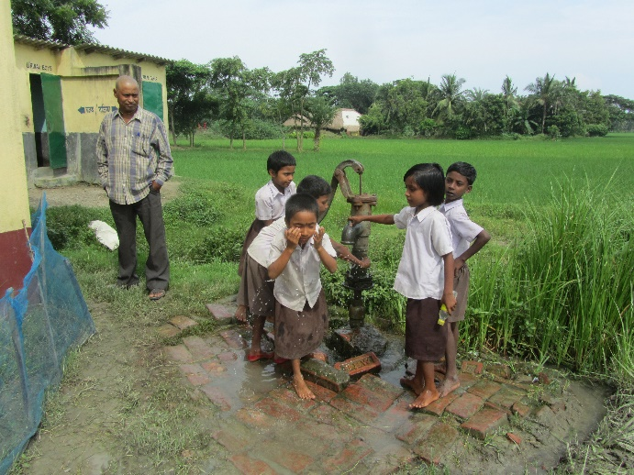
Concerns:
- Quality of education
Though there is no Govt. school nearby, and the teachers are sincere, I have some doubts on the education quality. In class 5 or 6, when I asked someone to tell me a story in their own words, one kid recited entire stories from their text book, completely by-heart. Another kid did the same! In another case, when I asked a simple question on general knowledge, but probably not in their books, no one was able to answer. Though my judgment is very preliminary given the limited time I spent with the kids, I was concerned.
This issue may be the same for SBB but I didn’t get a chance to judge the kids closely there.
- Toilets
Swapan told me that there were more girls than boys in the school. They had built 6 toilets, but 4 were used by boys and only 2 by girls. The access to the girls toilets was also tricky; a slippery path during the rains. Water had to be taken from a hand pump nearby. I was sad to see this discrimination. I mentioned this to Swapan and stressed how the one of biggest factor for girls’ education is proper toilets.
- Sub-committee
I looked at the records of sub-committee meetings. One issue which Swapan said was, here in Amlamethi, where many of the kids are first generation learners, it is hard to find parents who will contribute meaningfully to the sub-committee meetings. Also, it was the same set of SSB teachers in the committee year after year – I suggested that they should rotate so everyone gets a chance to be part of it.
In general, the effectiveness of sub-committees needs a closer look. Amal da said it is hard to find parents who are interested on being part of this.

Computer Center
After returning from Amlamethi, I dropped into the computer center where some kids (from girls and boys home) were practicing their computer lessons. Their computer teacher, who came twice per week was also present. He had finished his graduation and wasn’t employed anywhere yet. The kids showed one by one what lessons they had learnt. A couple of them were really sharp. They showed word docs, excel sheets and fancy power point presentations. I gave them a software chess game to play and a camera.
All the kids that were learning computer were “special children”. Most had minor physical disabilities except a couple of them like Krishno. Krishno, who was a special child in class 12, seemed very bright and responsible, and he MC-ed the performance the night before.
Concern:
- There was only one computer which perplexed me since I knew CMS had about 3 or 4 computers. On mentioning this later to Amal da, he gave an explanation on their status. I insisted that at least one should be placed in the girls home, so that they can use it and not have to rush back to their hostel when its 5pm in the evening.
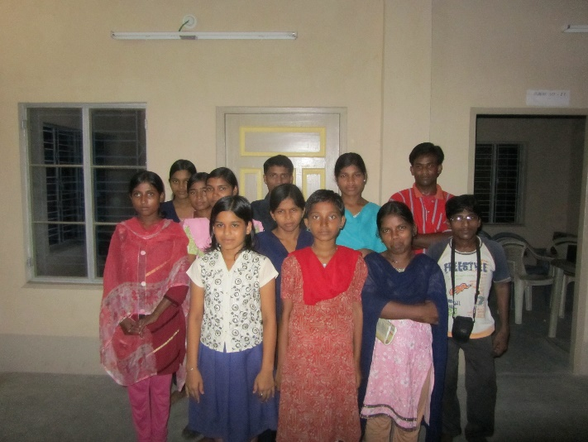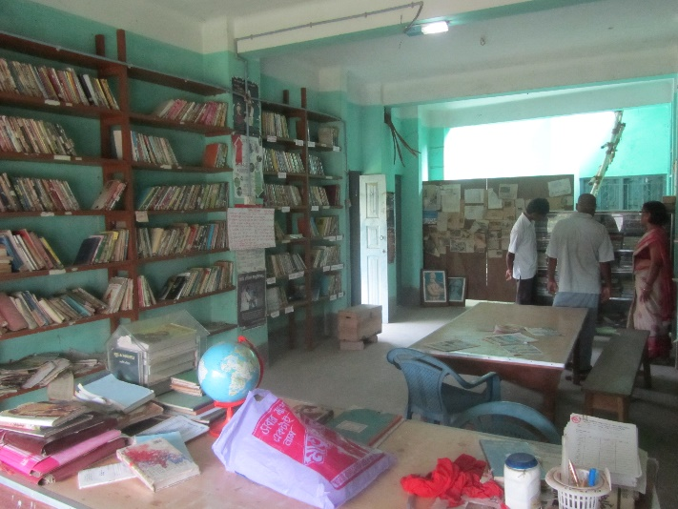

Library
The last day early morning before leaving CMS, I dropped into the library. The library had a good collection of books in Bengali. There was a small registration fee per year and penalty for not returning books. The register showed that both girls and boys used it regularly. There were also good posters on the walls. However, the room and the books were in a sad state. The room was dusty, unkempt, and hadn’t been swept in ages. Same went for the table chairs – the entire room needed serious cleaning if someone wanted to sit there to read. In many shelves the books were kept nicely and labeled, however for the rest of the shelves, they were simply stacked on top of each other, catching dust.

Other Concerns
Trash/waste management:
Seeing the way CMS school grounds are kept sadden me. They have absolutely no concern or idea or concept of what is trash, effects on environment, etc. I feel all across all subprojects, and across all levels – starting from Amal da, the teachers, students and the helpers, a consciousness needs to be built on waste management. This needs to be a part of the regular teachings in the schools.
Decision making:
Overall, Amal da is still in charge and the absolute authority in running CMS. The results of decentralizing the decision making to different sub project leads are yet to be seen.

