Champa Mahila Society Site Visit, 12/7/11 to 12/9/11
I arrived at CMS headquarters in Basanti early in the afternoon of the 7th. The last time I visited was the last time I went to India, in 2006, and that time it took me 6 or 7 hours to reach there. Thanks to the new bridge to Canning, the nearest rail station, the journey has been reduced to less than 3 hours. Gopal-da, officially CMS’ clerk but in practice their jack-of-all-trades, met me at the station and drove me to Basanti.
The area certainly has become more outwardly prosperous in the past five years, despite the Aila cyclone. (Luckily, Basanti was not too badly affected by Aila other than some flooding. Rural areas like Amlamethi were hit much harder.) Throughout the area, there are more cars, more mobile phones, and more houses. When I arrived, CMS headquarters had just gotten connected to the power grid for the first time, though they still didn’t have electricity. The only power is a diesel generator that they run for a short time at night; diesel is expensive, and since they have solar lights, there is no need to use it more often. The 30 minutes of power a day certainly helps explain why it takes a very long time for them to type up budgets, etc.
There is new construction everywhere. There is a new junior high under construction immediately adjacent to the boys’ home. The central government has chosen Basanti as the site for a model school, a walled-in residential primary school with teachers and students from across India. In fact, CMS contributed some land for this project, and it will be built immediately next to the girls’ home. CMS has not been left out of the building boom; they have built several new buildings for the girls’ home, a new floor on the health clinic, and some facilities in Amlamethi as well. The day I arrived, CMS was also hosting an ICDS-sponsored polio vaccination clinic for infants.
All of these government schools and jobs, though, are a mixed bag. Because of the high relative salaries, many people commute from as far away as Kolkata to teach in these schools. In Amlamethi, for example, the high school’s new principal is a local success story; he is originally from Amlamethi himself. Nevertheless, now he commutes daily from Kolkata by car, two or three hours each way. At least he is local, but many other teachers are not. Mid-day meals in schools are also not working very well in practice, despite the recent expansion up to class X. Logistics are often botched. Rice and money for other food often arrive months apart, requiring schools to sell some of the rice to buy vegetables and vice versa. The result is that meals are regularly canceled. All of this external money, of course, contributes to local inflation. The government pays NREGA workers more to build roads than CMS can afford to pay its schoolteachers.
Geographically, CMS is spread out over a large area that is not well connected by roads. As a result, it is impossible to cover more than a few non-formal education (NFE) centers in one site visit. I spent the first day at the boys’ home in Basanti and the nearby Sarada Balika Bidyamandir (SBB) girls’ school. The second day I traveled by motorcycle and ferry to Amlamethi, where I saw a few NFE centers and the Surendra Smriti Bidyaniketan (SSB) primary school. The third day, Swati arrived in the morning, and we spent most of the day at the girls’ home and SBB talking to the children and teachers. The health sub-project’s doctor, Dr. Burman, now works in Siliguri in northern West Bengal, but he still visits every two weeks. He happened to be visiting the area on a family vacation, so we talked to him briefly on the third day. I also looked around the health clinic, though it was closed.

Boys’ Home
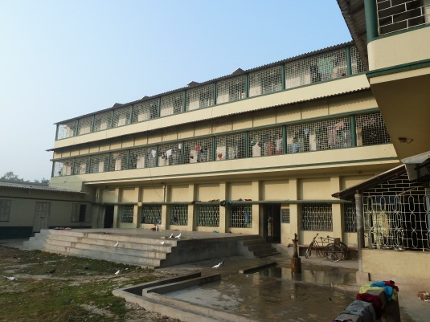
The boys’ home currently has 178 children. The supervisor is Nibash Kherati, a former resident. He dropped out of his B.A. program for financial reasons and went to work in Rajasthan for three years, but came back after contracting typhoid and/or malaria. (This is all secondhand information from Gopal-da.) The home is quite crowded, with areas designed for storage stuffed with beds. There are even a few cots in the corner of the common room, which is mostly used for tutoring. Nibash says the official capacity is 150 or so. The kids were mostly done with exams aside from classes I and IV, so many of them were wandering around, playing, and distracting the ones who still had exams to come. Some of the older kids were already studying for class XI and XII exams early the next year.
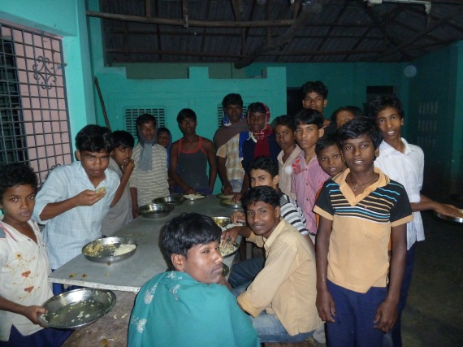
The lunch the day I arrived was shrimp (they have fish of some kind every Wednesday). There was a prominent, freshly printed sign in English displaying the weekly menu. They grow eggplants, tomatoes, and other fruits and vegetables in the nearby garden; most sections of the garden grow food only for the homes.
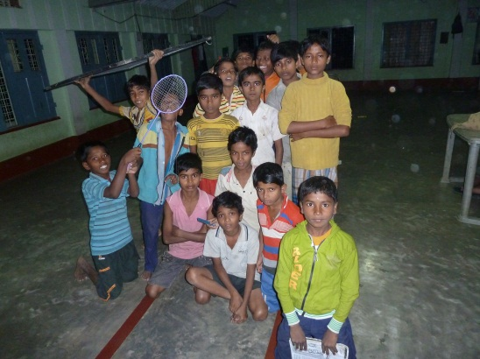
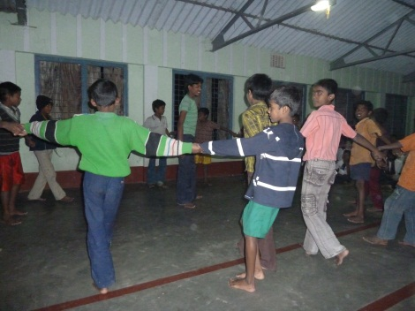
The children were pretty shy at first. There were new kids of all ages, some of whom came to stay as late as class IX or X. They seemed more or less content overall. In front of Nibash, the kids performed some group rhymes and songs for me that they had learned from tutors. After the supervisor left, we hung out a little less formally, and some of the boys sang and danced to music they had heard on the radio. There were a few mobile phones with music on them, though these are officially prohibited in the home. Thanks to technology, the boys certainly did not seem nearly as isolated as they did the last time I visited, though this may just be because I spent more time with them on this visit.
The boys told me that there is a lack of tutoring resources for higher classes and particularly in English. Many of them mentioned that they would love computer training. They talked about, and are proud of, doing well in school as a group. One of them even talked about competing with Amol-da’s (the CMS coordinator’s) son in class rank despite getting much less private coaching. They also would like some more sports equipment like soccer balls and badminton gear. They have some, but it is in poor condition. The new buildings, notably the junior high, constrain the play space available. There is only one small yard for 180 children.
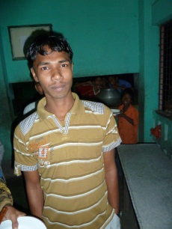
There were a few oddities about the home that stood out to me. Every morning, all of the kids, regardless of religion, are required to participate in a quasi-prayer invocation (surya pranam). The kids also told me, matter-of-factly, that the current and previous supervisors all resorted to corporal punishment on occasion. They are also very wary of Dr. Burman, the doctor who visits the health clinic, for this reason. Finally, the boys seemed to resent Nibash, the supervisor, to some extent because he has gone from just being one of the boys to a position of power in just a few years. He is not very popular, though that is not necessarily a bad thing for one man who has to supervise nearly 200 children.

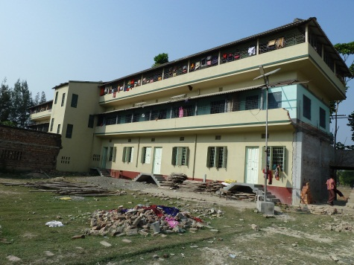
Girls’ Home
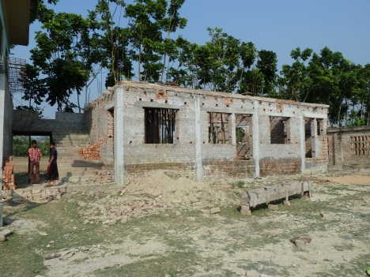
The girls’ home is just a few hundred meters down the road from CMS headquarters. The home is in the same walled compound as SBB and will soon be adjacent to the model school I mentioned earlier. CMS has started a new building in the back of the compound that is to be split between the home and SBB, though it looked like the construction was stalled when I visited.
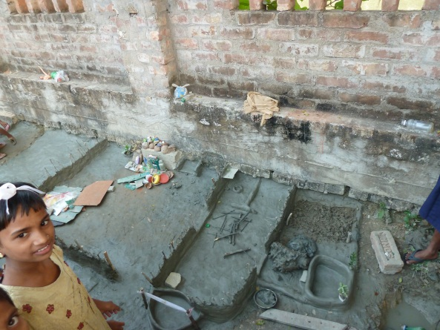
Mine was the first Asha visit to the girls’ home since we approved funding for the school in 2011. (Previously, we only funded the boys’ home, which CMS started several years earlier.) On the first day I visited the home, the supervisor Pratima was strangely absent, though the rest of the staff was there. I did find her briefly on my next trip there, though we couldn’t have a long conversation, and she didn’t seem particularly eager anyway. The children, on the other hand, were much more interested. They were very excited to show me their handicrafts; many of them had built little clay houses in the back of the yard, complete with miniature furniture, appliances, and dishes. Everyone was also quite taken with my camera.
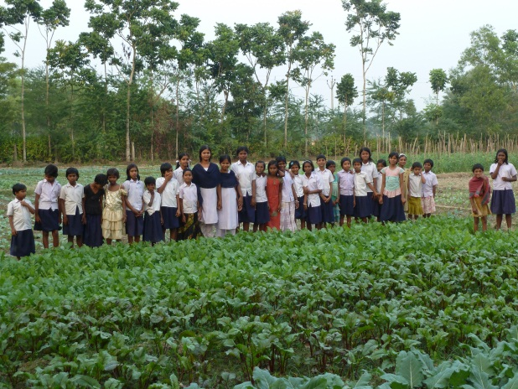
I asked the girls to show me the vegetable garden. We walked past the neighboring big field where the model school will be built. The kids play there now, but it will soon be walled off for the school. On the way, we stopped by the CMS nursing home, where some (fewer than 10) elderly women stay. The kids told me Amol-da operates this project out of pocket. When we got to the garden, the girls were proud to show it off to me and pose for photos in it. Just like the boys, they insisted they did the bulk of the work themselves. This kind of ownership was very good to see.
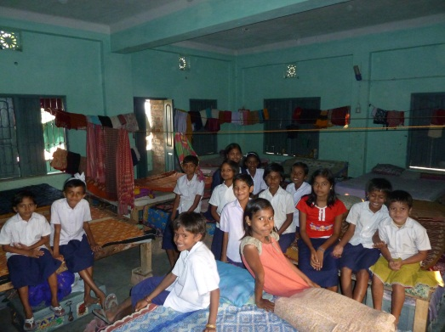
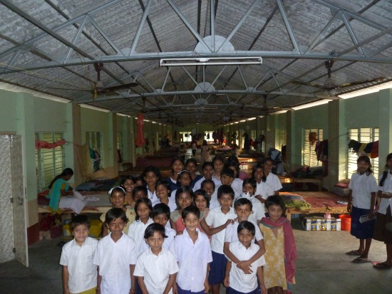
Otherwise, the home was clearly operating in full swing, with or without Asha funding. (CMS gets about Rs. 1000 a child a month from the central government.) There was no one to ask at the home itself, but according to budget documents and Amol-da nearly 200 girls stay there. The facility is just as crowded as the boys’ home, if not more so, because this was a much more ad-hoc effort. (Asha funded construction of the boys’ home building almost ten years ago.) CMS has slightly expanded the SBB buildings and converted some of the old classroom space into living spaces by cramming in as many beds as possible. Similarly to the boys’ home, some of the larger common areas have beds in the corner. I didn’t get a chance to eat a meal at the girls’ home, but Amol-da told me that the meals are the same at both homes. There is a conflict between the lunch times at the home and the government primary school. Some of the girls who attend that school eat lunch twice, while others don’t get to eat at all.
Less tangibly, the SBB teachers told me that the creation of the girls’ home has created a strong sense of community and a culture of education among the children. I too felt that the children, most of whom were SBB students like the ones I met on my last visit, have become much more self-confident. The teachers said the home has a made a huge difference in the girls’ outlook, especially compared to the prevailing environment in the community. They also boasted that they have successfully prevented quite a few child marriages. One young woman, a former SBB student, came to visit the home while I was there. After some prodding from the SBB teachers, she told the children that she wished she had finished high school and not gotten married so early. The girls soberly promised they would take her lesson to heart.

Sarada Balika Bidyamandir
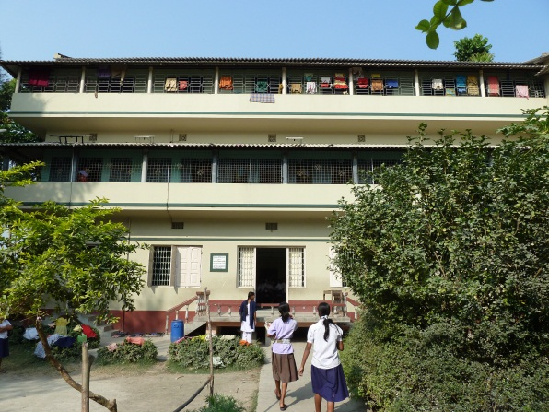
I went to SBB, the girls’ school, twice during my visit; the second time Swati came with me. Overall, the school seemed to be running smoothly, though I did get the impression that not much changed year over year. The head teacher, Alauddin Laskar, has been a teacher for some time but was promoted to head teacher only recently after the previous one left. On my first visit, the teachers (and I) were a little nervous to start. Some of this was mutual unfamiliarity and some was due to what I felt was a very hierarchical mindset. After a little while, though, they were fairly outspoken about what they felt the school needed. Unfortunately, the teachers were much more reserved on my second trip—I felt that they may have even been rebuked for speaking out of turn—so I went to talk to students while Swati (who knew them much better) talked with them about the progress of the school and pedagogical methods.
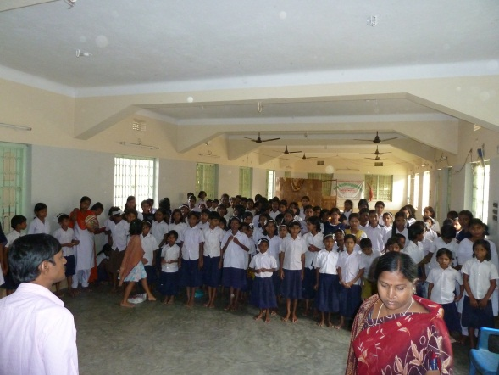
When I arrived on December 7, the written exams had ended, and the oral sections were ongoing. The schedule was new for the 2011 school year; in previous years exams didn’t take place until January or February. As a result, this school year was compressed, and students had less time to prepare. Officially, there were 225 students enrolled at the school, exactly at the limit they had set due to costs and space. (I found out later that the actual number was 244.) The kindergarteners and class I students had left for the most part because their exams were over.
SBB does have some vocational training periodically, such as wax work and handicrafts. They also teach the students about farming, including its application in the vegetable garden, but the school has reduced their weight in the curriculum since students are a little less interested. Other practical skills they teach are first aid for snakebites, drowning, etc. They try to take the whole student body to Amlamethi for a field trip at least once a year. Even if the students can’t go, the teachers do to meet their counterparts at SSB.
The teachers expressed some of the same concerns I heard on previous trips. Despite high demand from the children, they have not had computer training since the computer they had stopped working. There were also power issues before, but now that they have been connected to the main power grid, keeping a computer running should not be a problem. The school could also use more playground space. They have an annual sports program, scheduled for January 23, and it uses a field nearby that will eventually be taken over by the model school. A new tube well would reduce the strain on the one they have. They could also use more equipment for the children to play with, such as carrom boards (though they have one, it is in poor shape) and badminton gear.
Teacher salaries, as always, are a hot topic. They are now at Rs. 1500 monthly, up from Rs. 1200 a few years ago, but Rs. 2000 would be better. There is a lot of turnover among teachers—about three in four of them were new since my last visit five years before—partly because ICDS and government primary schools are hiring heavily and pay much more. They were also interested in more teacher training exercises. All the teachers at the time together attended training sessions in Medinipur (West Bengal), and three of them went to another training activity in Pondicherry.
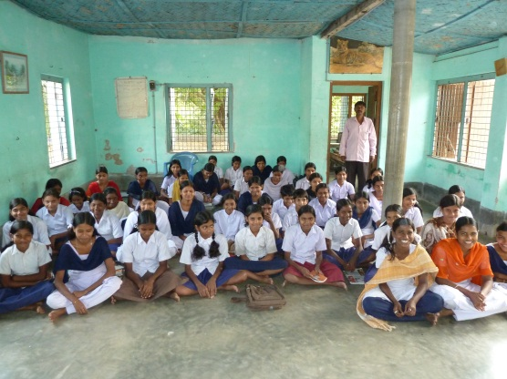
Academically, though they do not keep aggregate numbers, the teachers were proud of the students’ accomplishments. In the class X final exams in 2011, the top-ranking student in the district was from SBB, while the second-place student was at the boys’ home. I asked about the kids who had graduated. While the teachers did keep in touch with individual students, they had no real statistics, but they said some are in school still and do pretty well as a group. Some do get married after finishing class X.
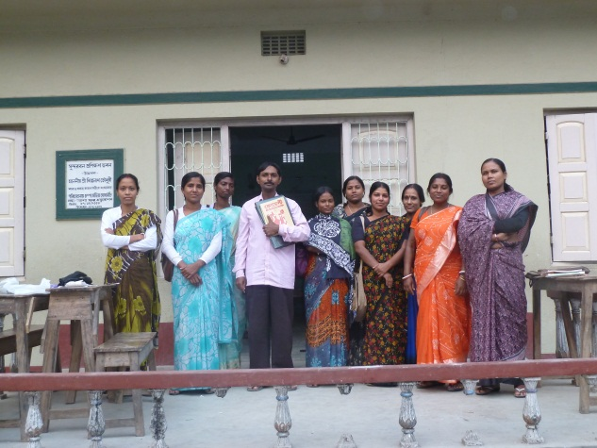
SBB has been fairly successful over the years in preventing child marriages and promoting awareness of the issue in the area. They told some horrific stories about child brides dying of malnourishment since they are the last in their families to eat. However, they have faced some backlash from the community for their activity. For example, the SBB teachers intervened to stop the marriage of a student named Manohara a few years back. She is an adult now and is working as a cook at SBB, but is still not married, and some people are saying that this is the teachers’ fault. Despite all their efforts, over the last few years, they have had maybe five or six children leave the school to get married. All were older than 14 or 15, at least.

Non-Formal Education Centers
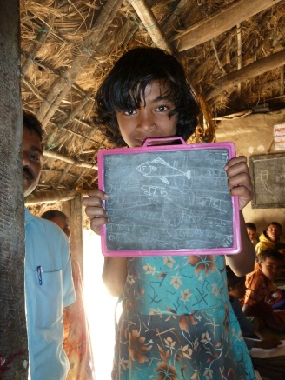
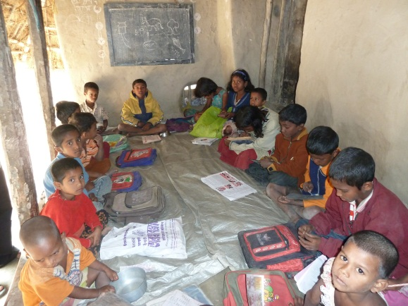
I visited two NFE centers, both in Amlamethi. Gopal-da accompanied me to Amlamethi, as did one of the special coordinators, Rama. The first was a small center (Saradamayee NFE) that had about 15 students in attendance who varied in age from about 3 to 8. Many of the students attend government primary schools, and some of them weren’t at the NFE center because they were studying for or taking exams. This center was operating in the back of the teacher’s (Buddhadeb Basu) house, which was damaged by Aila but repaired just enough to be usable for this purpose, with a tarp over a small patio. The center had some very simple teaching materials and slates. The teacher asked the children to draw something on their slates to show me, and many of them obliged with nice drawings of fish and flowers.
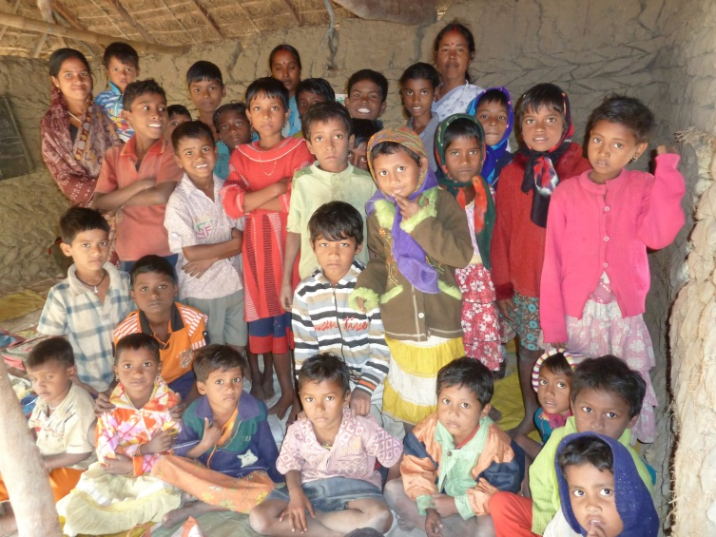
The second center, Rani Rashmani NFE in Mathurakhanda village, was much bigger. There were 41 kids at the center that day, most of them adivasis according to Rama and Gopal-da. This NFE center was held in a club that was not quite big enough to accommodate them. The teacher, Subhadra Poira, was new. The previous teacher had left after a child fell into a nearby pond and had to be rescued. The teacher was elderly and didn’t want the responsibility. The new teacher is married, so some of the parents worry what will happen if and when she has children, but she assured me that her family will take care of them. The center only has funding for 25 children, but they have to split the food and TLM budget among almost 50 who show up some days. There is no tuition, not even a nominal amount, so parents keep dropping their children off and the teacher can’t just send them away. The teacher and a parent who was there both said that an extra teacher would be very helpful. There are many children who are “overage”, some old enough that they are in class IV. At the teacher’s request, the children demonstrated a nursery rhyme.

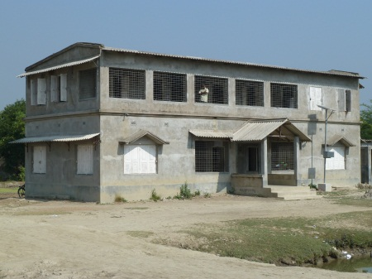
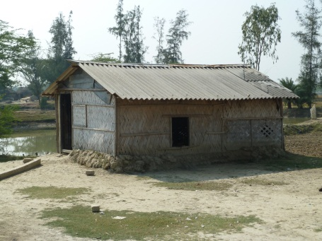
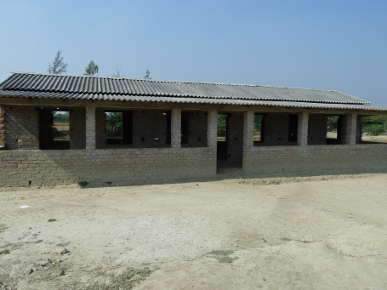
Surendra Smriti Bidyaniketan
I visited SSB on the second day of my trip after I stopped by a few nearby NFE centers in Amlamethi. Even in Amlamethi, SSB is fairly isolated; many of the students attend it because the government school is too far away. This was my first trip there, but I had seen pictures from previous site visits. The new buildings struck me immediately. The original school building was destroyed in the Aila cyclone, but luckily CMS had constructed (with some Asha funding) a new, larger building that many people used at the time as a shelter. Since that time, CMS has also built a separate cooking shed and another classroom building. All of these surround a medium-sized yard with a well and a small stage for cultural programs. There is still room for expansion as well. The main classroom building has the structural strength and the room to support a third floor; the newer classroom building has neither windows nor much internal structure. The day I visited, a government-sponsored tailoring class for local (adult) women was using one of the classrooms in the main building.
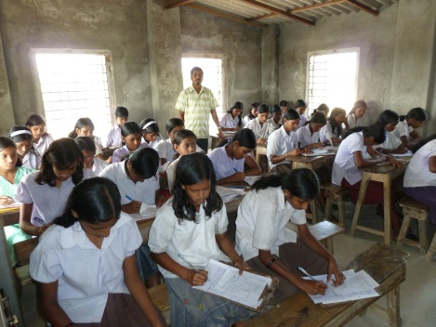
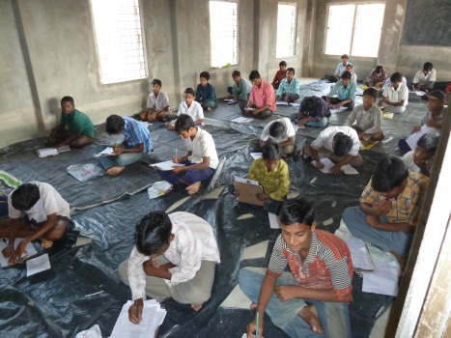
The school, under the direction of longtime headmaster Swapan Mandal, is in full swing. Most of the children, having finished their exams, were gone when I arrived. Only students from class VI through VIII remained to finish their written exams for history and environmental science. Most of the children come from illiterate, agricultural families, so the teachers are proud of their academic accomplishments. Class VIII graduates mostly enter high school, and all the former SSB students who took the class X final exam passed it. The students have earned prizes in local science competitions and quiz contests. When a few students tried to transfer to a government school, one of them finished first in the entrance exam. Kids did have issues for some time with certification because SSB is not a government school, but as the school has become established in the community this happens much less now.
Even though Gopal-da and the headmaster Swapan-da were there, the teachers were very outspoken, and they were clearly committed to the school. They pointed out some structural problems. First is that because the high school is so far away from SSB, and parents are not convinced of its quality, many of them stop sending their children to school after class VIII. Class IX and X education at SSB would help address that. Even the children who do graduate from class X often end up working in manual labor because higher secondary (class XII) education is required for most white-collar jobs, and there is no higher secondary school in Amlamethi. Especially after Aila, most children at that age want to leave Amlamethi, but this and financial pressures make it difficult for them. Parents sometimes pull even younger children out of school because for financial reasons.
The teachers also expressed some more basic concerns. Here as at SBB, the teachers feel that the salary of Rs. 1500 a month is too low. In contrast to SBB, the teachers at this school are almost all men, and they explained that that is not enough to provide for a household when day laborers earn Rs. 130 to 150 daily through NREGA. Most of them have to tutor children on the side. Also, while children in government schools get allowances for clothing and books, SSB has not been able to provide the budgeted clothes for several years because of the constant increase in the number of students. This has prompted some parents to pull their children out of SSB in favor of enrolling them in government schools. Kindling for cooking is a problem, partly because there are 26 ICDS centers and 7 primary schools competing for it, so a gas cylinder stove would be useful. Solar lights would help the school expand the free tutoring they provide at night. Other budget items the teachers proposed included bookcases; windows and paint for the new building; health camps for children; another field trip to Kolkata (the last one was a few years ago); a home for homeless children; more money for sports equipment; farming-related vocational training; and land for a vegetable garden for the children.
We discussed teacher training at some length. A few years ago, three of the teachers went to Pondicherry for a teacher training course, where some teachers from Auroville and an Italian woman gave English-medium lessons on a variety of subjects. They also attended teacher training provided by Swanirvar in Baduria and have periodically gotten primary school training from Vikramshila. However, they would like more spoken English and other higher-level, subject-specific training.
We also talked about whether the school has enough space to accommodate the student body. The higher classes use the main building. The space there is sufficient and the building is well equipped. KG to class III are in the new building. The KG class sits outside on the veranda, where they have to use a makeshift tarp sometimes in the rainy season; they need funds (either from CMS or from us) to construct a real roof over the veranda. Also, there are no partitions inside the building, so class I to III sit in different sections of one large room.
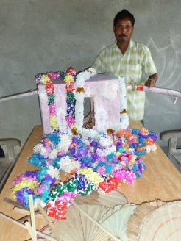
Despite all the limitations, the teachers have done what they can. Every January there is a sports program with competitions for the children. They have an annual cultural program to celebrate Rabindranath Tagore’s birthday, though they often have to move it up to February from May for better weather. People from all around Amlamethi attend these events. The teachers showed me many handicrafts the students had made as well as props from a play they had performed at the cultural program.
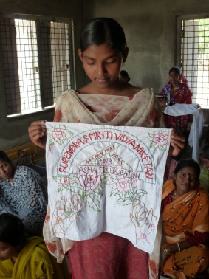
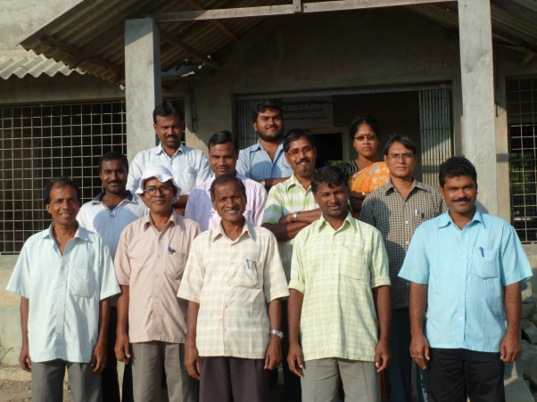
My overall impression of the school is good. It is clear from talking to them that the teachers are diligent and dedicated. The culture felt more egalitarian than at SBB, which is a positive for me given my Asha background. I wish that I had more opportunity to interact with the children. They were much shyer than the children I met in Basanti, partly because I could not spend much time with them, partly because they are more isolated than the children in Basanti, and partly, I suspect, because they were older. A few of them did give me some beautiful handkerchiefs they had made in a tailoring class, which make a perfect set of mementos for the visit.

Health
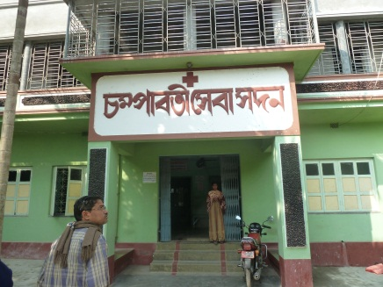
I didn’t get to see the health clinic in operation while I was there. I did talk briefly with the coordinator, Prasanta Korali, and with the visiting doctor, Dr. Dushmanto Burman, though he was there on a family outing and was not seeing patients. Dr. Burman still comes once every two weeks, even though his government posting is hundreds of kilometers away in Siliguri in northern West Bengal. He told us that he still takes the effort to come regularly because he knows he is the only good doctor the area has. (The government doctor, whom everyone calls T.K., is notoriously awful. He made a mistake setting Gopal-da’s broken leg and he still walks with a limp. Even random ferry passengers were commenting on his incompetence.) Dr. Burman also commented on the lack of thought leadership in CMS in general, but he urged us to continue supporting it since the organization does good work as a whole and something is better than nothing.
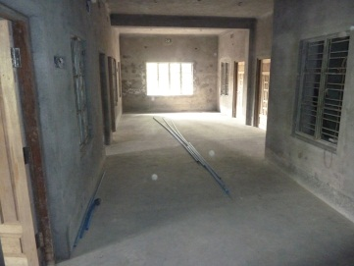
CMS is building a second floor to the health clinic, mainly in an effort to attract an ICDS class that will pay them rent. There will also be a few new patient rooms on the second floor. When the doctor comes, the clinic is completely packed, so the extra space will be useful. When I visited, the structure was complete, but they were still putting in the toilets and furniture.

Special Children
The special children coordinator is Pini Mondal, a disabled woman who has recently gotten a full-time job with ICDS as part of their handicapped quota. She still officially does the work to coordinate the special children subproject, though Gopal-da hinted that he has to do much of it himself. It wasn’t clear to me what that involved, or why we even need a separate subproject, since the children are all residents at the homes. I wanted to meet with Pini, so I asked Amol-da to ask her to stop by after work in the afternoon. Unfortunately she couldn’t make it.
I did ask about building ramps at the homes so that CMS could qualify for the extra government funding they would get for housing disabled children. The extra cash from the central government would more than make up for the initial cost. It turns out that the problem is not the cost, but the space; there is simply nowhere to put the ramps.

