Site visit report – Borkuchi High School
The Executive Director of ACRD Prerna Changkakati visited Borkuchi High School, along with Mr PP Changkakati, former board member of ACRD, Umesh Deka, Executive Engineer and Apurba Sharma, Project Coordinator of CBR programme, ACRD on January 25, 2019.
A meeting was held with the SMC members of Borkuchi High School. Prafulla Rahang, President of SMC discussed with the ACRD members about the on-going construction of the school building. He informed that because of monsoons , the construction work began late. The foundation stone of the school building was laid in the presence of the SMC members on November 14, 2018. The SMC members also informed that because the school hasn’t been provincialised by the government, and the teachers were not getting salary regularly, they are facing problem in maintaining the school. However, despite some of these challenges the teachers are regularly coming to school and regular parent-teacher meeting, staff meeting and SMC meetings are held. They appealed ACRD to propose ASHA to release their salaries on time.
As of today, the construction of the school building is almost over. Painting and wiring work is pending and will be done before end of this month. The school building will be formally inaugurated during the Assamese New Year in April, 2019.
A few photographs
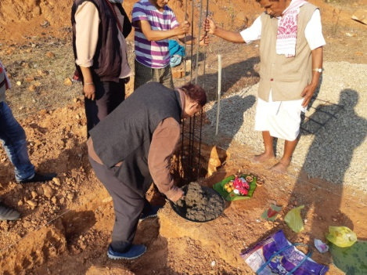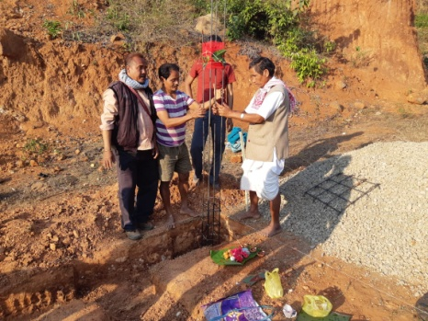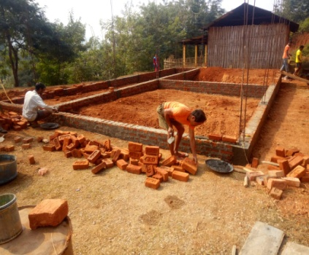
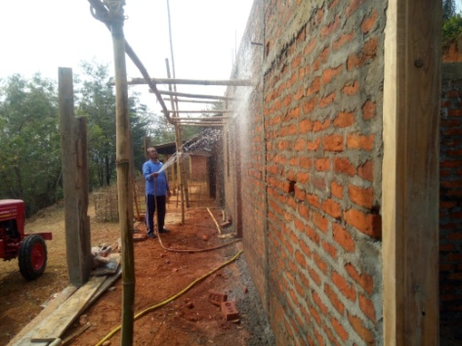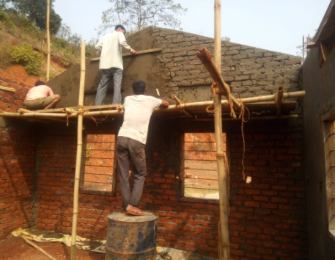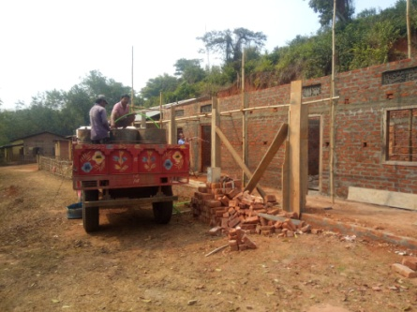
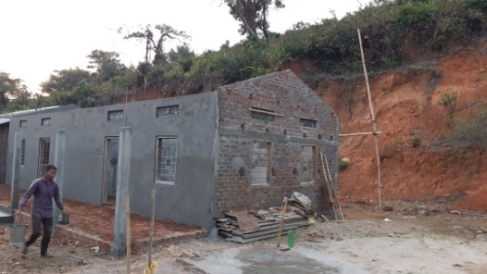 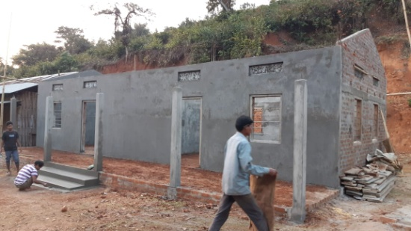
Construction of the school building
Site visit report – Bonpura Primary School
The Executive Director of ACRD Prerna Changkakati visited Bonpura Primary School on October 26, 2018 with Documentation Officer Sonakshi Goswami. A small meeting was held with the school teachers to discuss about the current status of the school and any issues faced. The headmaster informed the that the students in the school are regular and various extra-curricular activities are organised from time to time. A free health camp was being planned to be organised in the school in collaboration with the Block Primary Health Centre in the month of January, 2019. However, as informed, the camp was postponed to a later date. Play materials, story books and some stationary items were handed over to the teacher which was distributed among the school children later.
The assistant teacher, Namita Rai, is in touch with the Executive Director and has been calling regularly to share updates of the school.
A few photographs
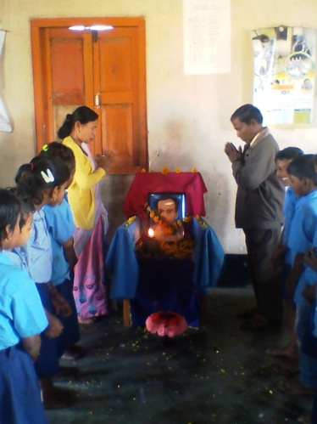 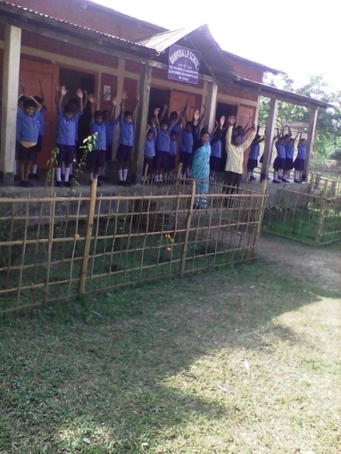 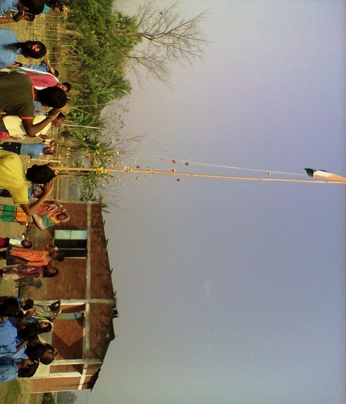 Jyoti Prasad Agarwala’s death anniversary (Silpi Diwas), PT activity, and Republic Day celebrations

