NICE School Visit Report (Asha for Education) – 22nd Mar, 2018
(By Mythili Vadali, AfE San Diego volunteer, along with ex-AfE Hyderabad volunteers: Giri, Pradeep and Ithi)
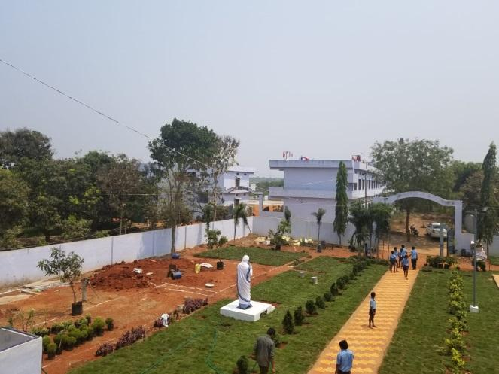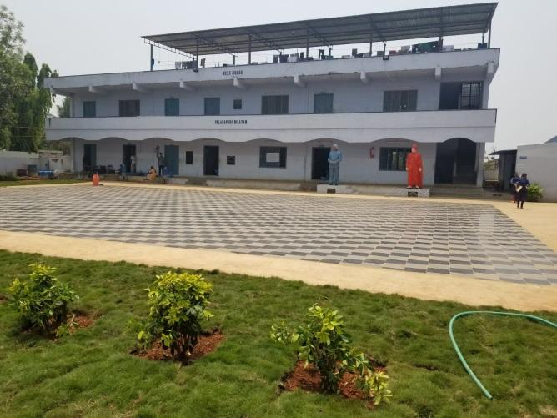
Entrance to NICE school
Summary of visit:
NICE is a project from Andhra Pradesh. AfE SD Chapter sent a one-time funding of ~$5000 in 2017. The amount of ~$5000 was donated to AfE SD by an individual with a restriction to fund project NICE. At the time it was agreed and voted to make this one-time transfer and made future funding contingent upon establishing a formal relationship with the project partner, having a steward etc.
There is a new 1-time funding request from the project partner in Feb 2018. I had volunteered to do a visit in March to evaluate the status of the organization and for establishing a formal relationship with the school management. Another purpose was to gather information about previously released funds and discuss the proposal for new funds. These objectives were achieved during the visit.
Earlier funds were used for teacher salaries and I have obtained teacher salary payment details. New funding request is towards solar water heaters that were setup for students during December 2017-February 2018.
Useful links:
https://nice-india.org/
Detailed Visit Report:
The school is located in Mynampadu Village of Guntur district in Andhra Pradesh, about 250 km (~155mi) from Hyderabad. It is a residential school consisting of 220 students for classes 6-10.
We had informed the school founder Mr. P. Purnachandra Rao (PCR) about our visit the night before. He asked if it was okay for him to inform the school principal Ms. Sridevi about our coming or if we wanted it to be a surprise visit and it was left to his discretion.
I was accompanied by ex-Asha Hyderabad volunteers Giri, Pradeep and Ithi. We started from Hyderabad at 6 am, and reached the school at 11.50am. The visit lasted till 3pm.
We were received by Ms. Sridevi madam and were seated in her office for about 20 min when I explained the purpose of the visit:
- A general understanding about the school, residential facilities etc. Interact with students there.
- Gather information on usage of funds released from Asha SD in 2017.
- Discuss needs for new funds.
Student demographics:
The school has 220 students (~140 boys +80 girls). There are 12 teaching staff and 15 non-teaching staff.
Sridevi madam escorted us to the school buildings.
School structures:
- There are 4 buildings, an open assembly area, and two play grounds.
- The school is divided into two campuses. Each campus has 2 building structures, 2 floored each.
  - Campus 1: The buildings includes
    - Principal office and staff room
    - boys change/storage room
    - kitchen and kitchen storage
    - dining hall
    - ~4 classrooms
    - Biology lab
    - Physics/chemistry lab
    - Computer lab
  - Campus 2 consisted of
    - Girls storage room
    - Girls toilets
    - Library
    - ~4 classrooms
    - Projector room
    - Staff dormitories
    - Basketball court
    - Bathing/laundry area next to playground
- Few months back the assembly area was laid with granite. The playground was leveled with gravel, and a basketball court constructed. Solar water heaters were installed.
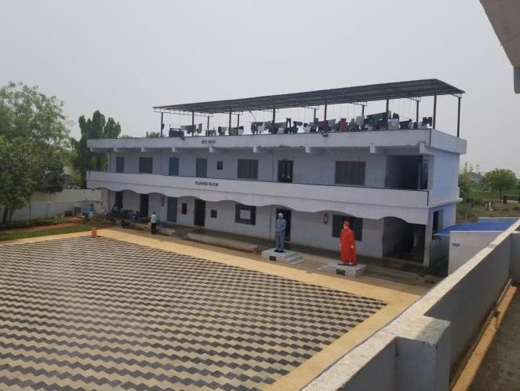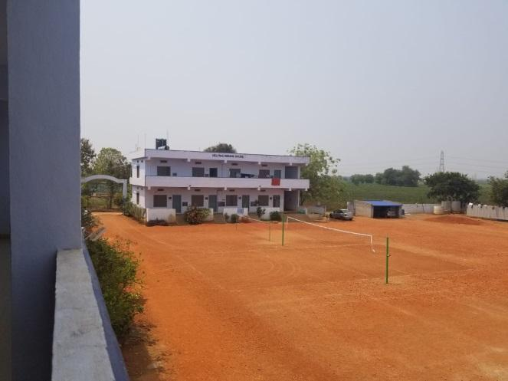
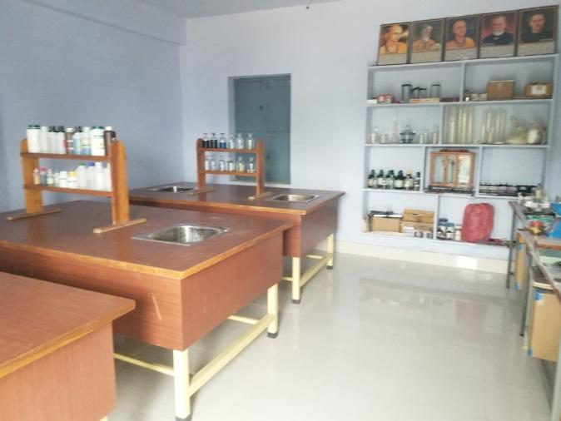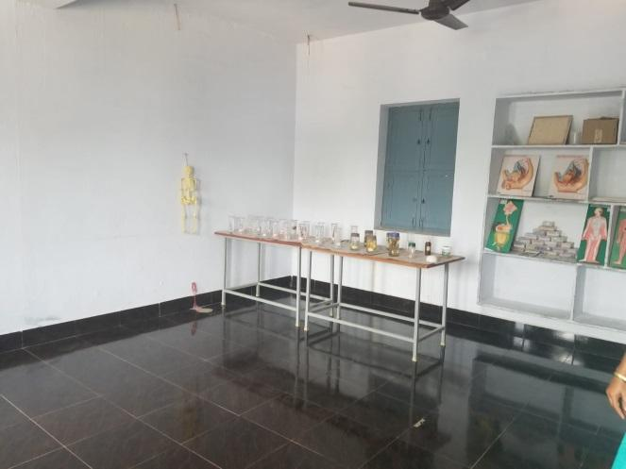
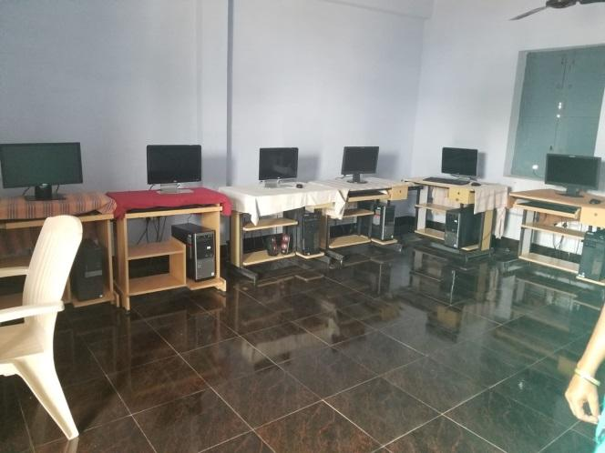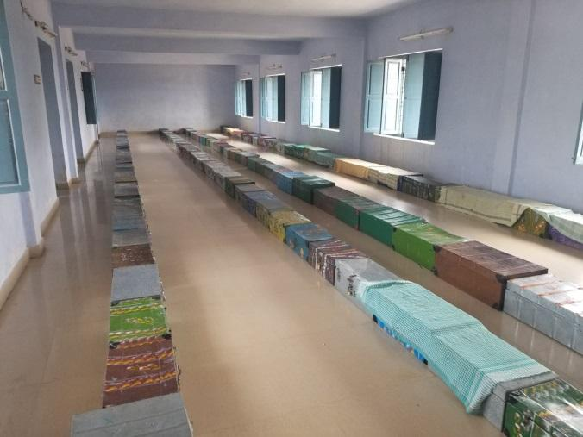
Interaction with students:
- As we were doing the visit students were finishing up final exams (9.30am-12.30pm).
- Some interactions with students and observations during the visit:
  - There was some Intermediate (+2) students preparing for entrance exams to Satya Sai institutions in the open verandah outside the staffroom.
  - Ithi and I talked to 4 girls from class 6 as we saw them sweeping a classroom floor. They said they just finished their Hindi exam. So I started to converse with them in Hindi to check their language skills in Hindi. They only responded to basic questions such as “Aapka naam kya hain?” (What is your name?), but could not converse in Hindi. Later on, I asked Sridevi madam about this, and she said that the kids study in Telugu medium with SSC board till class 5, so learning Hindi is challenging to these kids. They learn Hindi, Telugu and English in classes 6-8, in classes 9 and 10 students opt out Hindi as they are required to learn only 2 languages post class 9.
I asked the girls if they like food, stay and if they prefer living in school or at their home- 3 of them responded positively and one of them responded apprehensively that school is okay. I asked her if she had any issues, but she didn’t speak much. I did not probe her more as she was feeling uncomfortable. She seemed to be shy, so it is not necessarily to be considered as a bad remark. Given that it’s just been a year since class 6 students joined this school, some of them might still be home sick.
  - Then we moved to the second campus, when we came across class 9 students who finished their social exam. I had asked them to introduce themselves in English, and they all did. I asked for their question paper, and randomly asked a couple of quiz questions from it. They all responded correctly.
  - There were some students of class 8 seated in a classroom after their exam and before the lunch was served. I interacted with them and went through their class notes that were well written. I asked the students what their favorite subject was and many of them replied it was Maths. So I asked them if someone knows about Pythogorous theorem. As far as I remember it is taught in class 7 to me in CBSE. Few students mumbled the answer but when I asked them to raise hands no hands went up. I asked a boy who was mumbling earlier, he said “side square” but couldn’t say the right answer. I asked a girl who said Maths was her favorite subject and she said “side square + side square + hypotenuse square”. I prompted is she is missing an equal-to, and she came up with the right answer.
- Some conversations with Sridevi madam:
  - Student’s career path after graduating from NICE: As we were visiting boys change/store room, we saw some intermediate (+2) level boys who graduated from the school. They were preparing for entrance examinations. A discussed started between volunteers and Sridevi madam on what students do after graduating from the school and completing intermediate. She replied that the founder-Mr. PCR decides the recommended courses for graduating students in a government college or other institutions having low fee. Another volunteer Pradeep asked if student preferences are considered in the selection of courses at intermediate level and beyond, and she clarified that this is not the case.
    - To justify, Sridevi madam gave example of a student who wanted to opt for a course different from the school’s recommendation due to the preference of the parents and the student struggled to cope with the chosen course. So the student had returned to NICE for guidance.
    - Some students also opt for skill development courses like carpentry, electrician, plumbing etc. to quickly make themselves employable.
    - Majority of students go for B.Sc. courses as the school management thinks this field has more opportunities.
  - Criterion for selection of students for admission to the school: The school selects under-privileged orphan (no parents)/semi-orphan (single parent) kids, who have a guardian. The school refrains from orphans without guardians as “the school management will be held responsible if the kid runs away”.
  - When looking through girl student dorms, we inspected the bathroom and toilets. They were mostly clean. Later in the day I noticed that a girl was seen using open field next to school instead of the toilets.
  - Next we looked at the teacher’s dorm room which was modest. The room was similar to the ones provided in residential tribal school I visited earlier through a different NGO.
  - I asked about heater for which they are expecting new funds. Sridevi madam said the solar water heaters were installed as the water was cold last winter and this makes the students lethargic-- with hot water they are more excited to get up in the morning and get on with the morning activities.
  - Observation period for students: The students in classes 5-8 are considered to be in observation stage, where they are still coping from the Telugu medium government schools they come from. Class 9-10 students are treated more seriously with their performance. I asked if they drop students who don’t perform up to the mark. Sridevi madam said it mostly doesn’t happen. I asked how they are able to achieve 100% pass percentage in class 10 board examinations, and she said since 20% weightage in the exam comes from school due to notebook writing and labs, and if the students are able to secure at least 15 % in the examination, they are eligible to pass.
  - We were invited to join them for lunch. The lunch/dinner hall was serviced and cleaned by the students—for which students take turns. All students maintained silence and ate their lunch in disciplined manner. Food is clean and tasty.
  - I asked if students pursued any hobbies. They have 1 hr each to pursue hobbies or anything they like. Students participate in inter-school competitions for drawings, sports etc.
  - The students have Sunday off, when the parents/guardians can come speak with the students. The teachers also have periodic parent/guardian-teacher meetings.
Overall impression:
The school would classify as a mature NGO with established management and procedures in place. The teachers are working in a demanding job requiring being present with students 24x7 and ~340 days/ year. That said, it seemed like the students are required to be disciplined at all times, and are subject to strict rules. The school has library, labs, toilets, computers and other facilities, but it doesn’t seem like students have proper access to these. The students’ performance in exams, especially in senior levels, is definitely commendable, given the backgrounds they hail from.
Other documents attached:
- School annual report
  - 2017-2018: http://nice-india.org/files/NICE_Annual_Report_Apr_2018.pdf
  - 2016-2017: http://nice-india.org/files/NICE_Annual_Report_Apr_2017.pdf
- School expenditure statements categorized expenses for few months(bank_transactions.pdf)
  - This shows the expenditures towards solar water heaters.(Page 9, S.No. 23)
- Teacher payments for few months (teacher_salary.pdf)
- Marksheets for classes 7-10 (student_marks_sheet.pdf)
- Proposal for funds (ASHA - NICE proposal 2018.doc)
- Check records showing payments made towards solar water heaters (solar_heater_check_statement.pdf)
- Summary shared by Asha Hyd volunteer- Giri who accompanied in the visit.

Feedback by Giri: It was definitely a good visit yesterday and I observed that there has always been infrastructural development all the time. This time the new addition (in the last 7 months as my previous visit was on Aug 15, 2017) is that new tiles and decorative plants with grass lawn in the area. I had a comment that (and also told the same to Sridevi madam that instead of decorative plants and grass lawn, they could have fruit or vegetable trees or plants grown and the responsibility could be given to the students itself so that they also learn through growing trees and plants. The tiles were very quality ones and only concern that I had was that these tiles may get hotter during summer and when I asked the same, the children are sprinkling water in the evening to cool the tiles and be able to sit and have dinner there.
There are good labs (computer, physics, chemistry, biology) and library. But it looked as if they are hardly being used. May be because the children are in the phase of writing final exams and they are focusing more on subjects. The lunch we had with children was as usual delicious.

