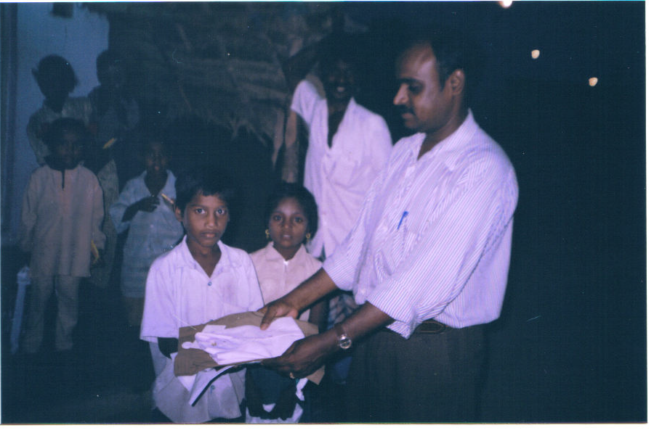
Mr. Murthy our Director Pasumai Trust Issuing a uniform to a Boy in Vigneshwara Brick kiln – Neamam

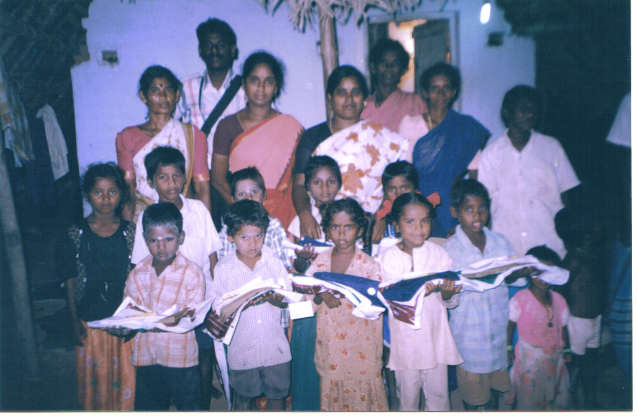

Pasumai Trust Staff Logammal and Sumithra working Area Neamam – Vigneshwara Brick kiln with Children received the Uniform and their parents.

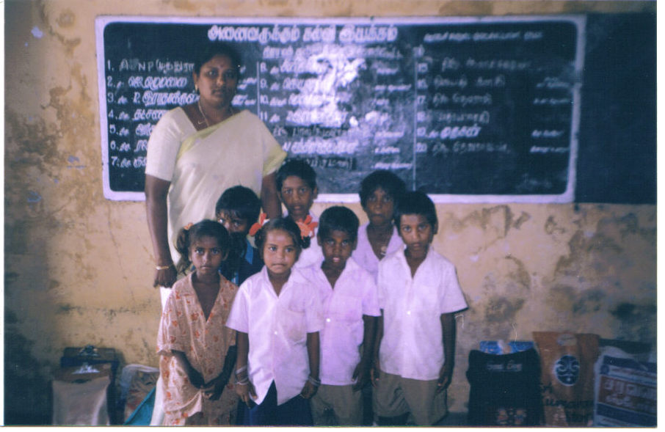
Vigneshwara Brick kiln children in Neamam Govt. School with school teacher. Some Children have not came to school due to Small pox. And the un-uniform children are not were the uniform due to un clean. They gave for Washing.

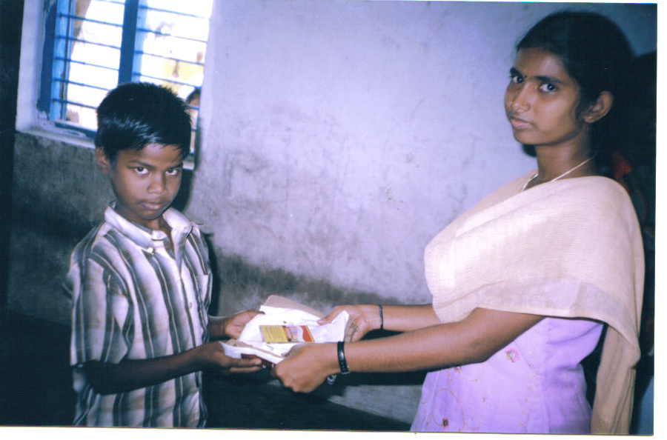
Our Animator Victoriya issue the uniform set to Brick Kiln children enrolled in Pudhuchithram Govt. School.

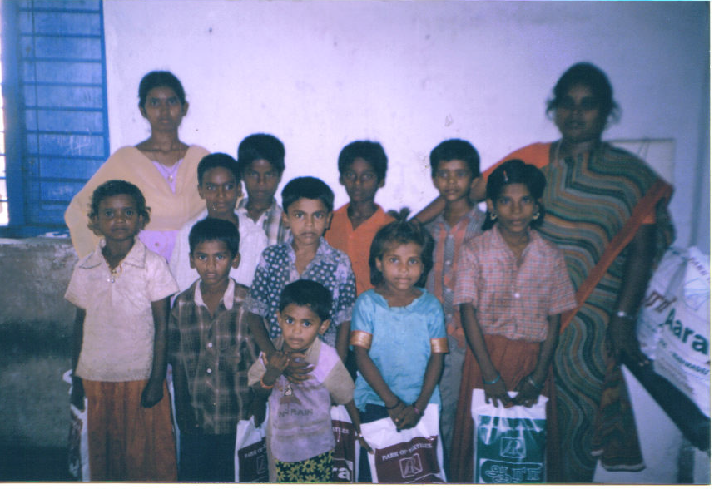
Our Animator Victoriya and Community organizer Logammal with children after issuing the uniform set – pudhuchithram Govt. School.

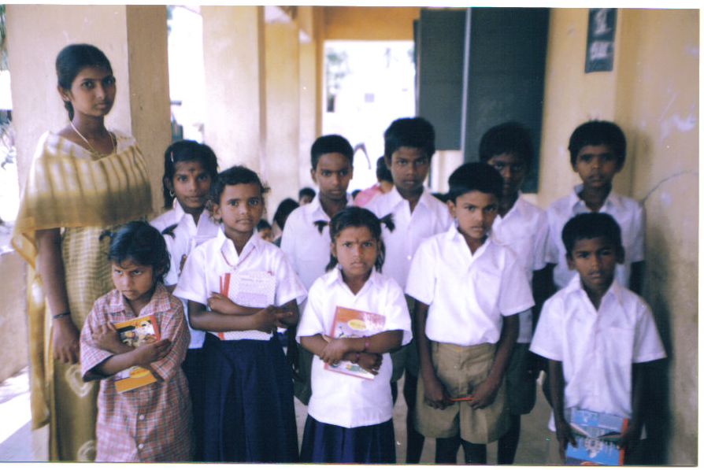
Animator victoriya with Children after wearing new uniform and some of the children were absent and one girl to un clean. She gave for Washing.

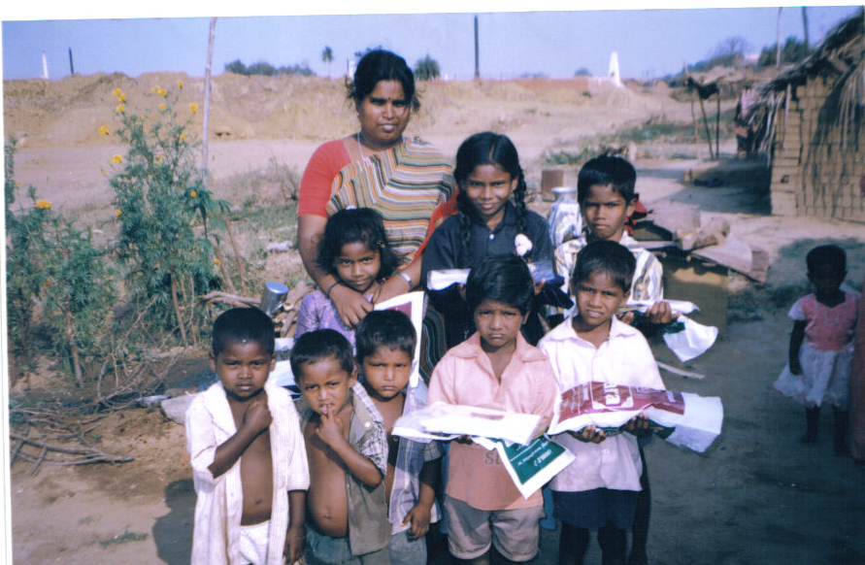

Our Community organizer Logammal with Kalanjiyam Brick kiln children enrolled in Jameen korattur Govt. School.

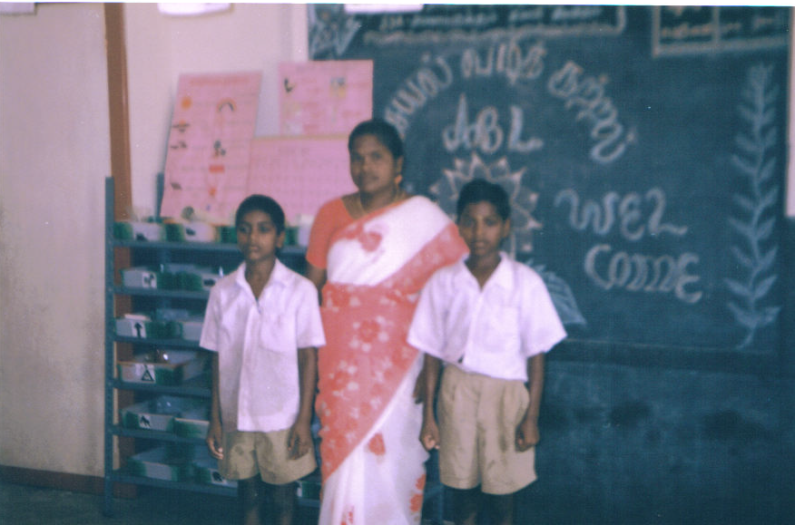

Our Animator Arokiya mary with Brick kiln Children – enrolled in Andersonpet Government School.

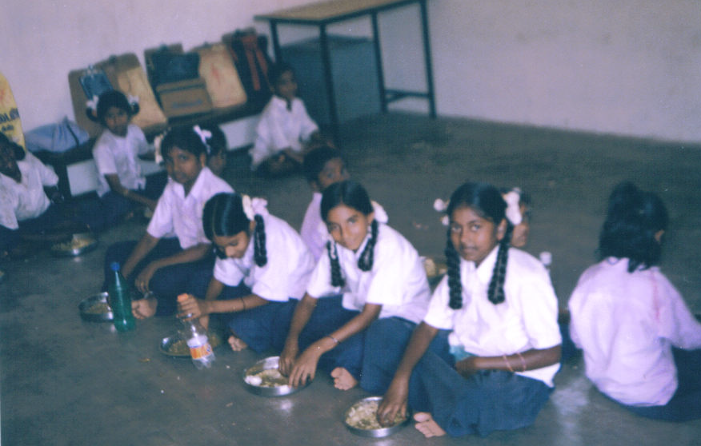

Anderson pet Government School.

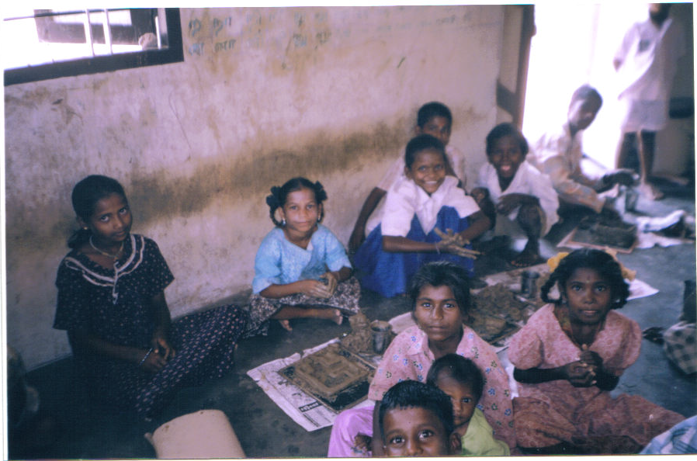

Sunflower School – Rajankuppam Brick kiln children making the articles with Clay

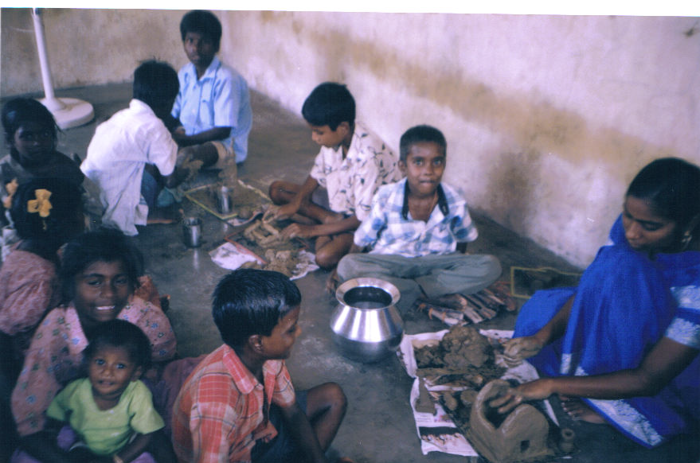

Our Animator Thangamani with MSD & LM Brick kiln children making the articles with Clay Sunflower School – Rajankuppam

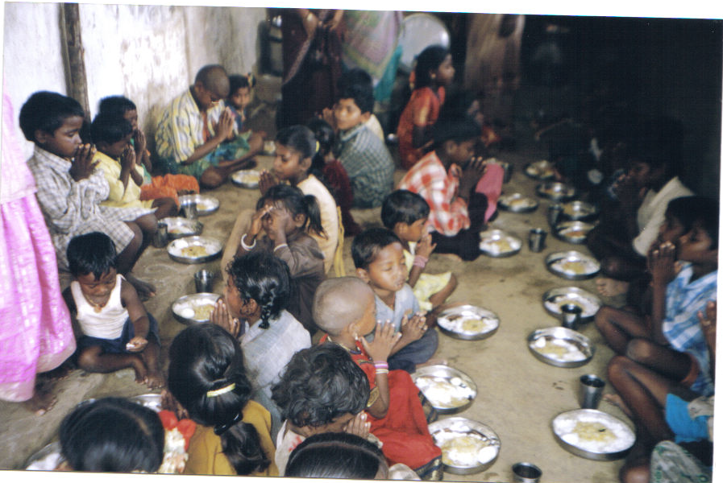

Mid – day Nutrition with eggs have been provided for Brick Kiln children in Sunflower school - Rajankuppam

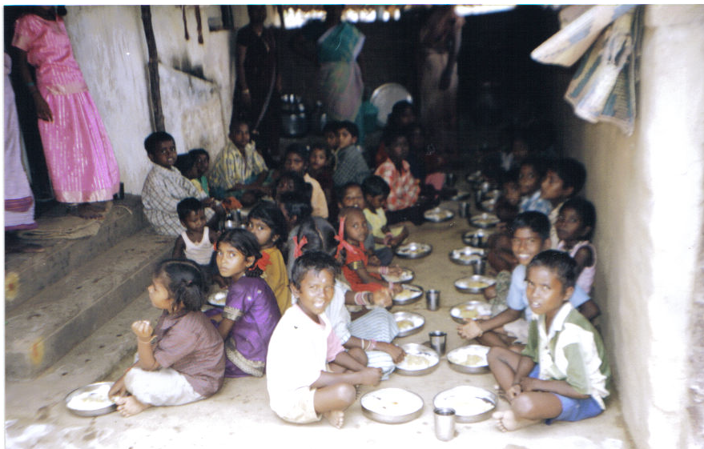

Mid – day Nutrition with eggs have been provided for Brick Kiln children in Sunflower school - Rajankuppam

03.05.07
To
Ms. Vijaya Ramachandran – 9415307196.
Jagriti Bal Vikas Samiti
C/o Dr. Pranab Mohapatra
Dept. of Civil Engineering
I.I.T. Kanpur, Kanpur – 208 016.

Respected Madam,

Greetings from Pasumai Trust.

Sub: Submitting Donation Receipt – Reg:-

Please find here with enclosed a Receipt for of Rs. 1000 /- (Rupees One Thousand only) as Donation for uniform. Receipt Number: 65. Dated: 29.03.07. Thank you very much for your Co-operation and Solidarity. And also we send uniform distribution photos through E - Mail with Attachment
Thanking you,
Yours sincerely,

K. Murthy
Director
Pasumai Trust

