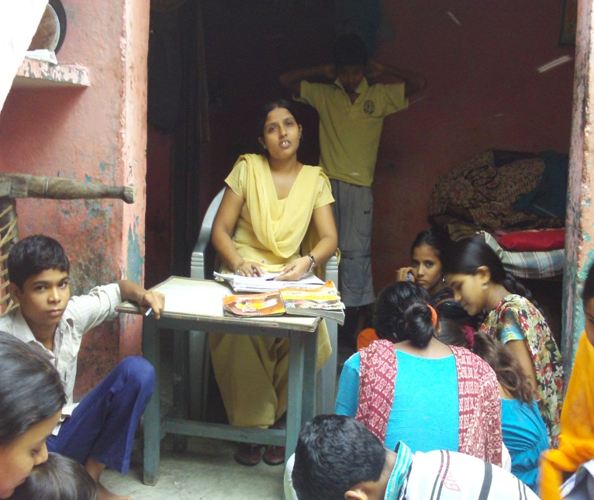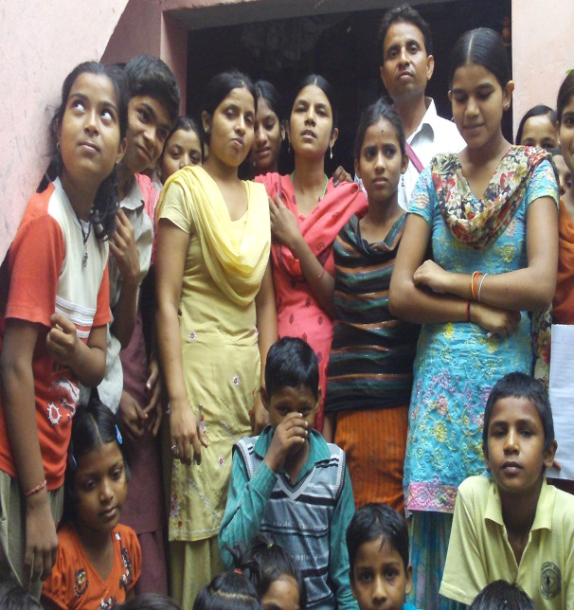
Date-6th July to 8th July 2011
-It was sudden inspection
-when I reached Moradabad, Bilari then I call Mr Prem
-I visited two sites immediately
-First site was Balmikibasti in Bilari
-it is running in a home, not rented
-Teacher name is Priti she is teaching part time in Balmikibasti, time 4pm to 6 pm daily, she is teaching in a privet school in morning.
-Near about all students go to in privet school, or government school.
-At this centre I dint find any child who is not going any school, it seems a tuition class,
-Though in Balmikibasti all people are SC, they don’t know their rights, need to work on awareness.
-In Balmikibasti I saw children’s parent, they can educate their children, they can afford for privet school also, but due to lack of awareness they are nominated their kids in government school,
-No need to running such type of centre. They can support few children for further studies.
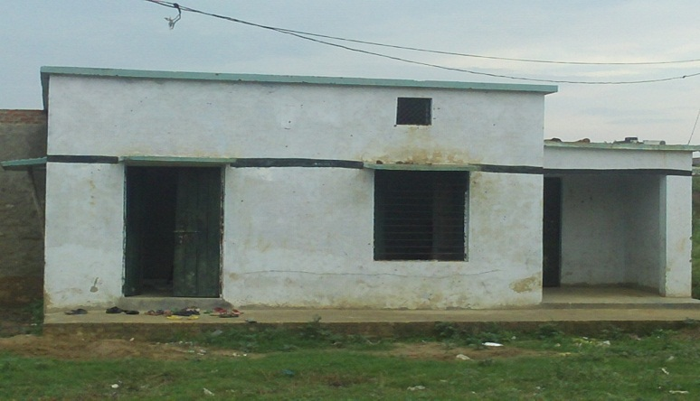Second centre is bakmikibasti at Sahaspur.
-Teacher name is Monika, who is 12th class student.
-she is not able to manage this centre, and can’t arrange extra activities.
-At this centre I found only 4 or 5 student who is only coming at this centre for studies,,,,but while talking them I found that they will take admission in any privet school ,,,and rest of child studies in privet or government school ,it is also a tuition class, and no need such type of centres.
-In this Balmikibasti need to work on awareness for rights and education.
-I went most of the student’s home also, they are well maintained,,,, and though this Basti is backward so their living style is not hygienic,
-ILM can talk about sponsorship for few students for further studies.
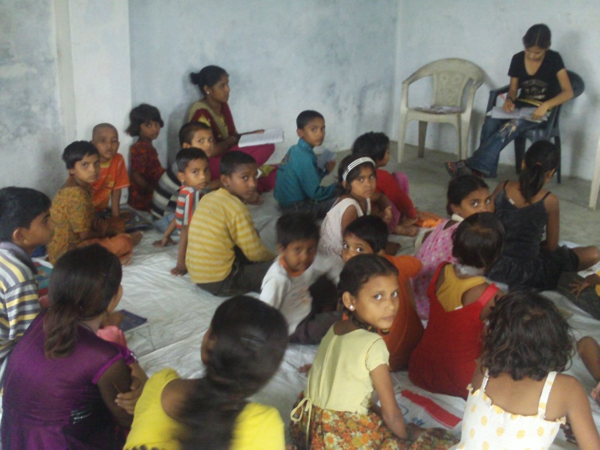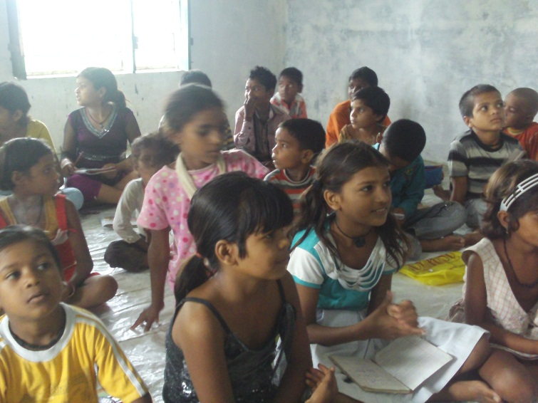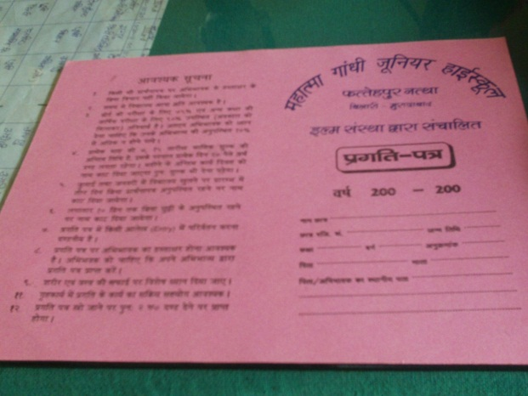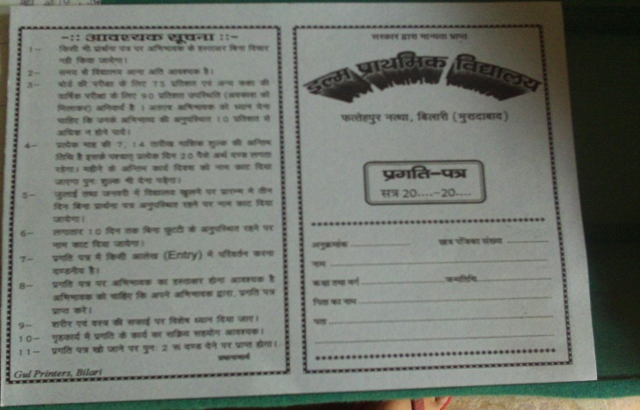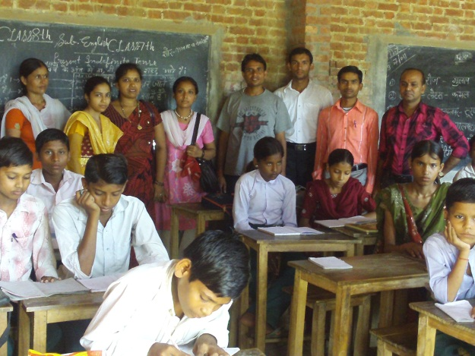-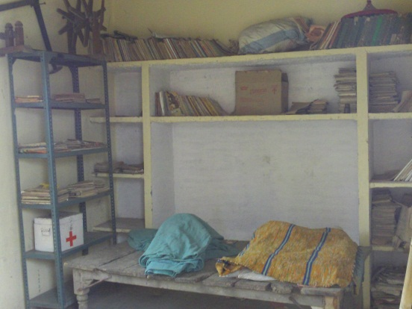
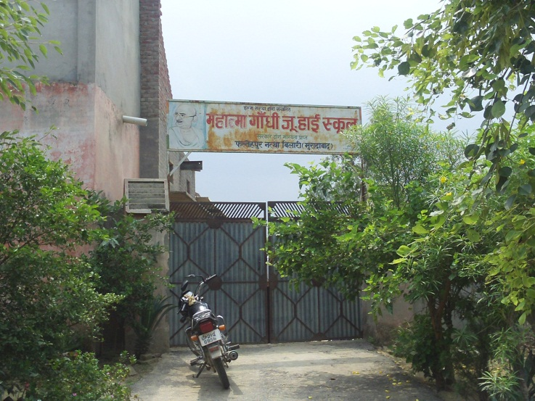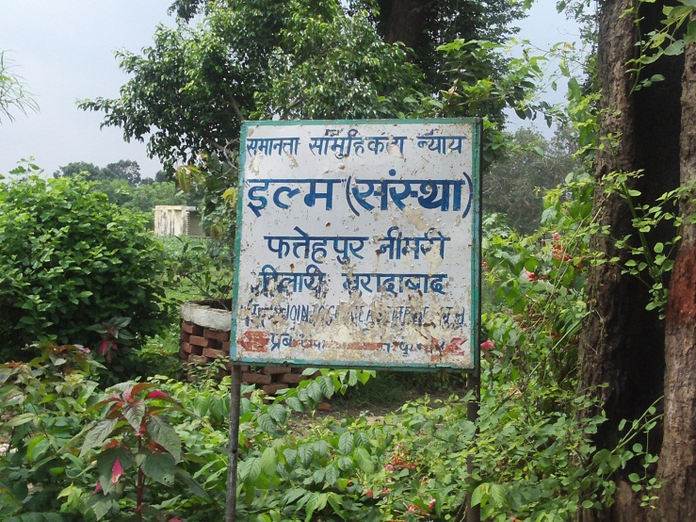
-Another day I visited school which is run by ILM organisation.
-ILM prathmik school and mahatma Ghandi junior high school, running by ILM organisation.
-ILM provide mark sheet till 8th class which is affiliate by government.
-Per student fee is 30 rs
-total student till now is 225.
-There are 7 teachers in this school.
-when I went school there is two class running, and in one room two class is running,4 teachers was in class and rest of the teacher wondering here and there .
-library was in very bed condition seems no body reading books.
-This school need to good management,

