Progress in the Kanakapura schools - First Cluster under Asha
2009-10 Activities & their Impact (All clusters including Asha Schools )

The year 2009-10 was an exciting year for Sikshana Foundation as it grew from 135 to 250 schools by inducting all 34 high schools in Kanakapura along with new higher primary schools in the Kanakapura, Anekal, Hoskote, Chikballapur Taluks and a cluster of schools in Madanapalle, Andhra Pradesh. With this all the higher primary schools and high schools in the Kanakapura taluk are now nurtured by Sikshana. A number of activities were held through the year with specific expectation of outcomes and are listed as below. The impact of such activities as measured by Quantitative assessments is listed after the activities list.

Expected Outcome | Date | Activity Description | Impact
TQM Concepts in Sikshana Schools | 21st Jun to 30th Jul 2009 | TQM Trainings for Higher Primary school teachers at Kanakapura. | 400 teachers
TQM Concepts in Sikshana Schools | 29th Jun 2009 | TQM Training for High school teachers at Kanakapura | 90 teachers
TQM Concepts in Sikshana Schools | 30th Jun 2009 | Sikshana Orientation & TQM training for teachers in Chikballapur cluster. | 40 teachers
TQM Concepts in Sikshana Schools | 9th Jul 2009 | Sikshana Orientation & TQM training for teachers in Hoskote cluster. | 50 teachers
TQM Concepts in Sikshana Schools | 27th Jul 2009 | Sikshana Orientation & TQM training for teachers in Chikballapur cluster. | 40 teachers
TQM Concepts in Sikshana Schools | 30th Jan 2010 | Sikshana Orientation & TQM training for all teachers in Anekal cluster. | 150 teachers
Teachers are Motivated | 20th Jun 2009 | Sikshana program Inauguration at Chikballapur taluk. | 90 teachers
Teachers are Motivated | 9th Jul 2009 | Sikshana program Inauguration at Hoskote taluk. | 50 teachers
Teachers are Motivated | 31st Aug 2009 | Book fair for teachers in Chikballapur | 18 teachers
Teachers are Motivated | 23rd Jan 2010 | Sikshana Annual Day at Kanakapura | 800 teachers
Teachers are Motivated | 27th Jan & 11th Feb 2010 | Kanakapura school visit by principals from all Chikballapur schools. | 18 teachers
Teachers are Motivated | 26th Feb 2010 | Chikballapur cluster principals sharing meeting at Kuppalli school. | 18 teachers
Teachers are equipped to handle Sikshana Tech Initiative | 8th Aug - 29th Aug 2009 | Computer Training for teachers in Kanakapura 4 batches | 300 teachers
Teachers are equipped to handle Sikshana Tech Initiative | 18th Feb & 19th Feb 2010 | Computer training for teachers in Anekal cluster | 60 teachers
Teachers are equipped to handle Sikshana Tech Initiative | 13th Mar 2010 | Awareness on Linux & Open source software | 30 teachers
Children and Community are Motivated | Jul – Aug 2009 | Laptop and Memory Chip Distribution Program | 120 schools, 6500 children
Children and Community are Motivated | 5th Jul 2009 | 2008 Batch Scholarship Distribution Program | 277 children
Children and Community are Motivated | 8th Aug 2009 | Delhi Trip Quiz – conducted by Amurth Foundation at Kanakapura | 1504 children
Children and Community are Motivated | 15th Aug 2009 | Delhi trip Quiz- conducted by Amurth Foundation in Chikballapur | 240 children
Children and Community are Motivated | Oct 14/19 2009 | Delhi trip 2009 two batches | 99 students & 13 teachers.
Children and Community are Motivated | 24th Oct 2009 | Dell Day at Kanakapura | 400 children
Children and Community are Motivated | 13th Mar 2010 | Qualcomm Science Exhibition | 200 children
Empower children | 3rd Nov 2009 | Book fair at Hoskote and Bangalore city schools. | 70 children, 14 teachers.
Empower children | 6th Nov 2009 | Book Fair at Anekal. | 150 children, 30 teachers.
Empower children | 7th Nov 2009 | Book Fair at Chikballapur. | 90 children, 18 teachers
Empower children | 10th to 14th Nov 2009 | Book Fair at Kanakapura. | 840 children, 168 teachers
Empower teachers | Jun 2009 - Mar 2010 | HM Committee meeting at Kanakapura ( Monthly once) | 12 teachers
Empower teachers | 3rd Feb 2010 | HM Committee formation and Meeting at Anekal. | 12 teachers
Empower teachers | 18th Feb 2010 | HM Committee formation and Meeting at Hoskote | 10 teachers
Sports and Music | Jun 2009 - Mar 2010 | Sports Training and Music Class, Every Saturday | 30 and 60 children
Sports and Music | 6th to 27th Dec 2009 | Deccan Athletic Sports Meet at Bangalore 5 days sports meet. | 10 children,1 teacher
Assessments | Aug / Sep 2009 & Feb, Mar 2010 | Assessment by Amruth Foundation at all Karnataka schools | 3150 children
Assessments | Feb 2010 | Assessment of Madanapalle schools | 237 children
Assessments | 31st Mar 2010 | Writing Speed & Reading Comprehension Assessment | 59 children
Assessments | 31st Mar 2010 | Dell Laptop and Memory Chip Project Assessment | 80 children, 40 teachers
Outcome: TQM Concepts in Sikshana Schools

Sikshana mandates the application of Total Quality Management (TQM) concepts by teachers in their schools. In the pursuit of this goal at least one teacher and the school principal from all the schools nurtured by Sikshana in Kanakapura, Chikballapur, Anekal, Hoskote and Madanapalle blocks were trained on the concepts. The teachers in Kanakapura taluk have attended this training the previous years and therefore a minimum of two teachers representing a school was deemed sufficient to revisit the concepts along with all new teachers in the taluk. In the remaining blocks, all teachers were covered by the training program along with the initial orientation to Sikshana.

Introduction to TQM

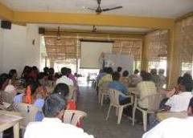
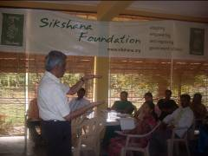
A one day TQM workshop was held for all the nearly 360 teachers from the 120 higher primary schools and 90 teachers from 34 High school Teachers had participated in the program. The training itself was one in groups of around 50 and focused on working with goals, importance of planning and also had some team building activities. The external facilitator focused on Quality and Sikshana staff talked on what Sikshana is all about.

There was a one day Sikshana orientation program for all the school teachers at Chikballapur. Mr. Ramamurthy, Founder Sikshana Foundation and Mr. Prasanna, Program Director, Sikshana, facilitated the training in this cluster.

A similar program was held in Hoskote taluk for the 10 schools where after the formal inauguration of the program in the morning the afternoon session was dedicated to training. All the principals and teachers from the 10 schools attended the program.
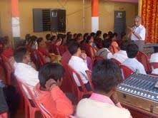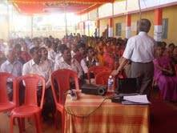

As Sikshana expanded into Anekal Taluk, a new approach was tried as the mentor in charge of the cluster was empowered to conduct the training at the school level using the same tools as used by the Sikshana trainers. This was an attempt to test the ability of Sikshana to scale up using decentralized approach for transfer of concepts. More details on this can be found at http://sikshana.blogspot.com/2010/04/experiment-at-anekal.html. Towards the end of the academic year a two hour orientation program for all teachers was conducted by Mr. E.S. Ramamurthy, Founder Sikshana Foundation in January 2010. After the orientation an open discussion between teachers and Prasanna (Program Director) was held to help both Sikshana and teachers to discuss the current year program implementation and thoughts on improving for year two of the program.

Outcome: Teachers are Motivated

Sikshana conducts an annual day program, awards best school of the year and sends teachers on educational tours with an expected outcome of motivating them to perform better. Teachers are selected based on their performance and their specific interests for the tours and this has created a sense of competition among them.

New schools in Chikballapur, Hoskote and Anekal

June / July saw the induction of 18 primary schools in Chikballapur, 10 schools in Hoskote and 30 schools in Anekal taluk. Since these were new areas Sikshana as part of the PR effort had inauguration programs with local department heads and other dignitaries. The goal of any of these formal or informal functions are to let the teachers know that we are there to work with them and appreciate their efforts in delivering quality education.

Teacher’s library at Chikballapur

Six teachers from select schools in Chikballapur visited the Sapna book store in Bangalore and selected the books to setup a teacher’s library for use by teachers of the 18 schools in Chikballapur. In a new cluster a powerful statement was made to the teachers that Sikshana is there to empower and equip teachers to improve themselves with a view of improving the schools.

5th Sikshana Annual Day at Kanakapura
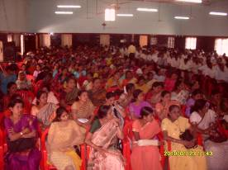
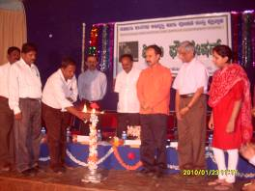

The Fifth Annual Day of Sikshana Schools in Kanakapura was held on 23rd January 2010. It was also the day on which the newly inducted 34 High schools were brought into the fold under the High school initiative. With all teachers from 134 primary schools and few teachers from Anekal and Hoskote participating this turned out to be the largest such function in Kanakapura for Sikshana ever. The other unique feature of this years program was that it was completely coordinated by a group of Taluk HM Committee teachers who worked tirelessly round the clock for a week to make it a memorable success.

The function was attended by Senior Officials of the Department of Education, with Project Director Mr. Manjunath from Rashtriya Madyamika Shikshan (RMS) Bangalore, Kanakapura Block Education Officer and Block Resource Coordinator along with board of directors from Sikshana.

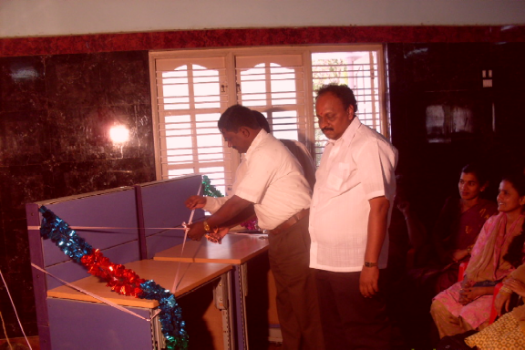 | 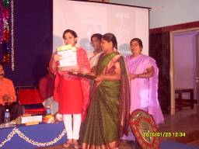

This year Sikshana Nudi Magazine was inaugurated by the Indira Sharma, board member of Sikshana Foundation. Hundred selected schools got a nice table for their new laptops which were made of recycled office cube surplus donated by Societe General in Bangalore. The tables were designed by Mr. Prakash and more info on him can be found at (http://www.nandiprakash.blogspot.com/)
Sikshana School of the Year 2009-10 – Hosadurga GMHPS
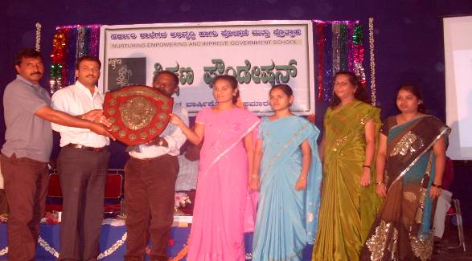

This school belongs to the second cluster nurtured under Sikshana at Kanakapura; it is now emerging as a role model for the rest. Hosadurga is a village in Kanakapura Taluk, 28 Kms from the Kanakapura Town. The school is well laid out with enough class rooms and nice garden which is maintained by the students. The school has 261 students supported by a team of 8 teachers.
This school was ranked at near bottom among 36 schools three years ago and with new staff who took keen interest in implementing Sikshana the school zoomed all the way to the top. This year each of the schools were ranked based on a set of parameters which includes the school academic performance, Sikshana assessment scores, implementation of Sikshana activities, performance in interschool quiz, sports and cultural competitions, community support etc. The school ranking methodology and the ranking for the 120 schools is listed in Appendix 1 .
Rank | School Name | No. of Students | Total Points | Award
1 | Halugondanahalli | 203 | 837 | Sikshana School of Excellence
2 | Hulibele | 154 | 825 | Sikshana School of Excellence
3 | Hosadurga | 330 | 824 | Sikshana School of the Year
4 | Harohalli | 399 | 820 | Best Large School of the Year
5 | Kamsagara | 107 | 814
6 | Vaderahalli | 92 | 805 | Best Small School of the Year
7 | Halasuru | 174 | 802 | Best School in Computer Application
8 | Sathanuru | 278 | 800
9 | Kaggalahalli | 145 | 800 | Most Improved School of the Year
10 | Acchalu | 177 | 787
11 | Erandyapanahalli | 188 | 784
12 | Malligemettilu | 80 | 782
13 | Kachuvanahalli | 107 | 782
14 | Anedoddi | 178 | 776
15 | Chikkamuduvadi | 208 | 776
16 | Gabbadi | 101 | 771
17 | P.Rampura | 85 | 769
18 | Thotahalli | 127 | 768
19 | Kottagalu | 111 | 764
20 | Doddalahalli | 301 | 763
21 | Boohalli | 122 | 758
22 | Arekere | 71 | 752 | Special Award - Most inquisitive children
23 | Kokkarehosahalli | 74 | 751
24 | Kodihalli | 528 | 751
25 | Sasalapura | 134 | 749
This year the top 25 schools were recognized by name and various categories of awards were instituted in addition to the Best School of the year. Last year’s best school Halugondanahalli schools topped again and Hulibele which topped 3 years in a row stood second and both were recognized with “School of Excellence” award.
Kanakapura schools visit by teachers from Chikballapur cluster
At least one teacher from each of the 18 schools in Chikballapur cluster visited the schools in Kanakapura to understand the best practices of these schools in implementing Sikshana programs. After these visits the had a cluster level meeting to discuss what could be adopted in their cluster and how to improvise certain programs to make it more effective in their cluster.
Outcome: Motivate Teachers to embrace technology in classrooms
Fundamentals of Computer Training

Sikshana conducted basic computer handling and usage training for all teachers in the Kanakapura and Anekal taluk government higher primary schools. Over 300 teachers were trained this year by software professionals. The course covered basic Computer Hardware, Operating System Ubuntu Linux, Folder structure, Open office documents and spreadsheets and educational software like eToys and Stellarium. The focus of the training was on how best to use the available software to motivate children and also to aid them in school management. Many of the teachers have expressed interest for an in-depth training with willingness to participate even on a Sunday or other holidays. Mr.Srivatsa founder CEO of Vigyan Labs and trustee, Sikshana Foundation, managed the whole training process.

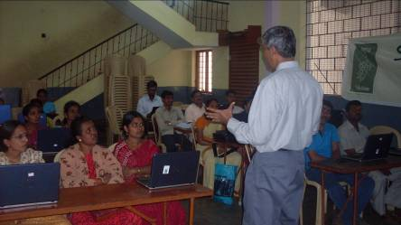

Linux and its advantages
On March 13th, during the science fair programme, a few volunteers from Qualcomm held a 2hr training program for nearly 30 teachers on the advantages of using the Linux operating system. They had system demos, comparison table with other operating systems, quick tips for people used to windows operating system etc. They also had demo on open source software in mobile phones and had a demo of 3G video service. The teachers were amazed at the possibilities of the using technology in the class rooms and left the session with a promise to embrace Sikshana technology initiative even more vigorously.

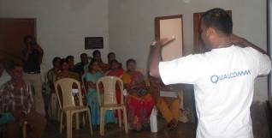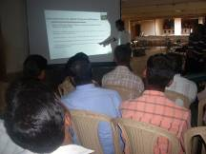
Outcome: Children Motivated to Perform Better
Sikshana at its core is a child centric motivational program and towards that end a number of activities are done throughout the year to create interest in the children to attend schools regularly and to take greater interest in learning. In addition to activities conducted in the schools like awarding spot prizes to children, annual day celebrations etc., Sikshana also conducts a number of events which are common to all schools to create a sense of competition among Sikshana schools.
DELL Laptop and Memory Chip Distribution Program:

Laptop and Memory chip Distribution was started at July and August Month 2009 children from 120 schools got their pen drives at their school in the Month of August. The distribution of memory chips to the children was done with an eye of getting the parents into the schools.

Memory Chip Distribution

Around 6500 students from 120 schools received their memory chips, sponsored by Dell, in their schools. The parents of the students were called to the school and they distributed the memory chips to the students. Essentially the opportunity was used to engage with the parents and make them aware of the importance of their role in the child’s education.

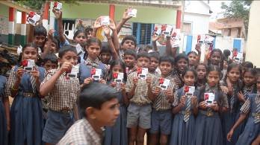
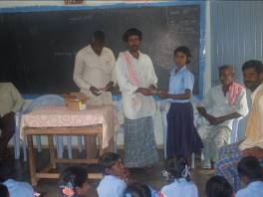

Scholarship Program

277 children from the 120 higher primary schools nurtured by Sikshana were rewarded with a scholarship of Rs. 1200/- per year for three years of their high school studies. Savings bank accounts were opened for the children in Vishweshariah co-operative bank across two weeks in September. The mentors for the schools were on hand to oversee the proceedings and to advise the students and their parents on the importance of maintaining high academic excellence, completing 16 years of education and not to use the scholarship money for any other purpose but higher / technical education.
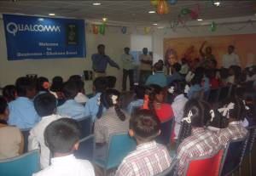

The scholarship students from the 30 schools that Qualcomm supported received their awards at the offices of Qualcomm in Bangalore. The 94 children with a few parents and teachers came to Qualcomm and were given a tour of the campus. The children were treated to two special mobile phone technology demonstrations which they found extremely interesting. After lunch the children showed off their artistic talents to employees of Qualcomm and all in all it was an experience of a lifetime for these children. After having experienced the touch and feel of a technology company most children said that they would like to work there someday.

Delhi Trip Quiz

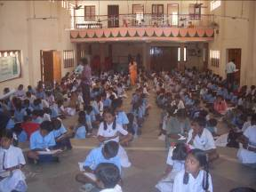

1504 students from the 6th and 7th standard participated in the quiz competition held on August 8th at Kanakapura across three different locations and on August 13th at Chikballapur at a central location where 240 children took part in the quiz.

The quiz as usual was conducted by the Bangalore based Amruth Foundation. The quiz questions were a combination of general knowledge and academic subjects.

88 students from Kanakapura and 11 from Chikballapur were selected for the trip.

Delhi Trip

The 99 children who won the quiz competition went to Delhi in two batches of 50 and 49 respectively. The first batch left Bangalore on Oct 9th and the second batch left on Oct 15th. The duration of the trip including travel was 7 days. The children were accompanied by 7 and 6 teachers in each batch and they all stayed at Birla Mandir in Delhi.

For more than 90% of the children train ride itself is a first time experience and along with learning values of being independent, mixing with people of other backgrounds, understanding different languages and food habits, it is more than an educational tour by itself. This trip is also found to be creating an increased awareness in the villages back home and stories of these events can be found on our blog at http://sikshana.blogspot.com/2008/10/delhi-trip-what-happens-back-home.html and the typical impact can be found at http://sikshana.blogspot.com/2009/02/delhi-trip-impact-on-children.html

Dell Day at Kanakapura:
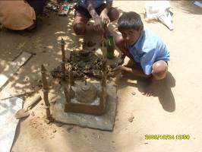
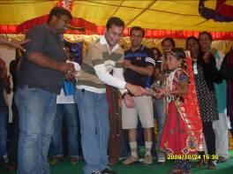

The Dell Day was organized on 24th of October 2009 at Kanakapura, in this program all 120 HPS and 34 High schools sent their most talented kids to take part in various competitions. There were contests in computer programs, clay modeling, yoga, singing, dancing, pick and speech, drawing craft and sports. All the dell volunteers who had come to Kanakapura had a good time with children.

Science Exhibition

On 13th of March Science Exhibition and workshop for teachers and children was organized by Qualcomm at Kanakapura. 18 schools were selected for the exhibition by the Qualcomm Volunteers. Acchalu School won the first prize, Hulibele won second prize and Yalchavadi won third prize. Another 30 schools under Qualcomm support sent their children to visit the science fair and take part in career options program held by Qualcomm Volunteers.

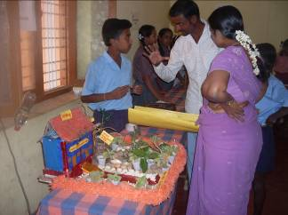

Outcome: Empower Children

Book Fair

From November 4th to the 14th Book Fairs were organized at Hoskote, Anekal, Chikballapur and Kanakapura where over 1500 children from the 220 schools took part along with their teachers. In Hoskote, Anekal and Chikballapur the book fair was held in a centrally located school. In Kanakapura the book fair was held in the four clusters of Harohalli, Sathnur, Kodihalli and Kanakapura. This time the students selected books based on their interest and gave the list to the mentors in charge. This was later ordered from the publishers in December. Navakarnataka Publishers and Sapna Publishers, Bangalore displayed more than 4,000 titles at the book fair.

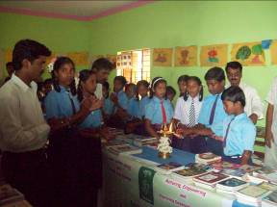
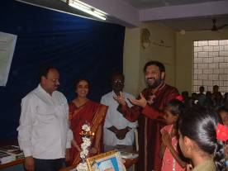

Empower Teachers

Teachers Committee to run Sikshana at Kanakapura

The first Friday of every month is earmarked for a meeting of a representative selection of Headmasters / Headmistresses to discuss upcoming events and to suggest changes to the program based on the feedback from the teachers and their perceptions. The committee proposed and initiated the printing of a newsletter called Sikshana Nudi with articles from students and teachers disseminating news and best practices amongst the different schools.

All the 120 HMs met in late August to allocate setting the questions paper and blueprint between the different schools for the different classes. At least three schools prepared the questions paper for the same subject and class. In a later meeting of expert teachers in those fields, the best question papers were selected, collated and sent for printing.

The teachers committee for Kanakapura schools was very active this year and planned and executed all the inter school programs in the taluk this year.

A three member committee has been formed in Chikballapur and is functioning reasonably well for a first year effort. The other two clusters Hoskote and Anekal is showing promise of forming a group on their own with a small group of teachers taking increasing initiative in Sikshana programs in the last two months of the academic year.
Outcome: Sports and Music

Weekly Athletics Training

Based on the success of the sports initiative last year partnering with Aata Odanata Sikshana decided to expand the program to all primary and high schools in Kanakapura. Every Saturday a training session was held at the Kanakapura municipal grounds with sport coaches from Bangalore brought in periodically by Aata Odanata to bring about a sense of discipline to the whole training program. Like last year this year also our kids participated in the elite Deccan Athletic Meet and won prizes and accolades.

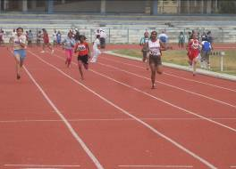
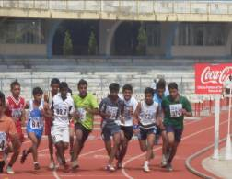

Music Classes

As part of the music initiative Sikshana has employed the services of a music teacher from a nearby private school to conduct music classes every saturday afternoon at Kanakapura. Students were initially selected by their school teachers for their talent and a subsequent selection done by the music teacher in September. The children are being trained in Carnatic and Bhavageethe music.

Outcome : Assessments

Assessments form a key component of the measure of performance of Sikshana schools. In addition to various quantitative and qualitative measures that are compiled by Sikshana staff and volunteers to come up with a school score, the twice yearly assessment by Amruth foundation based on the APF model of testing forms a critical part of measurement.

Assessment by Amruth Foundation

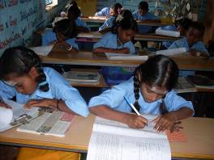

In the month of Aug / Sep students in the 5th standard were assessed in Kannada and Mathematics in an examination conducted by Amruth Foundation using as resource the students of the Degula Mutt B.Ed college. The students were trained by Mr. Vasudev Rao of Amruth foundation who evaluated the answer papers. The results were then compiled by Amruth foundation and shared with the Sikshana staff and the respective schools. Similar tests were held in all other clusters. Again during Feb / Mar the second assessment was done and the results of the same are as shown in the “Impact of Sikshana” section.

Dell Laptop and Memory Chip Project Assessment

The “Dell Laptop and Memory Chip Project” assessment was conducted in Kanakapura for the 120 schools to assess the end of the year performance by children and teachers.

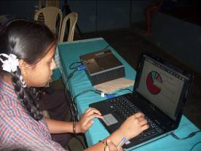
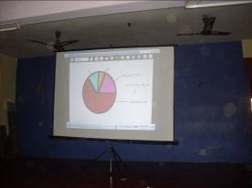

.

While most children demonstrated their eToys projects a few like Mamatha of Kodasikoppa school was very comfortable with using open office spreadsheet. Prizes were awarded for the best projects in various categories. The teachers who were present talked about the impact the laptops have had on their children. For example Sasalapura school principal talked about how in his school, three below B grade students got interested in academics through laptop and are all now scoring A+ grade. Other over whelming feedback from most teachers was that they all observed improved English reading skills among children which they attribute directly to the computers.

Writing Speed & Reading Comprehension Assessment:

This was test for Kanakapura schools students to examine the speed and neatness in writing.

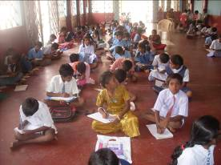

The big push this year among all the initiatives was the supply of writing sheets to children with a view of improving the speed and quality of writing. All schools have reported improvement in both categories and in the interest of quantifying the result we conducted a writing speed – reading comprehension test at Kanakapura. 59 students from 6th class from the 123 schools were selected for the final round and prizes were awarded both for speed and the ability to comprehend a standard paragraph in Kananda and English. No student took more than 30 minutes to fill up one A4 size paper and the result of the competition is shown in the graph below.

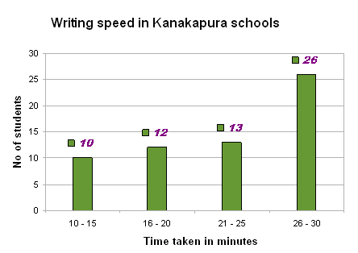

In Anekal since we were starting new this year we were able to do a baseline test on writing speed of 227 children of class 6 in 12 schools once in September 2009 and again in March 2010. The result shown below has shown remarkable improvement in speed of writing and is in line with the general observation across all the 250 schools under Sikshana.
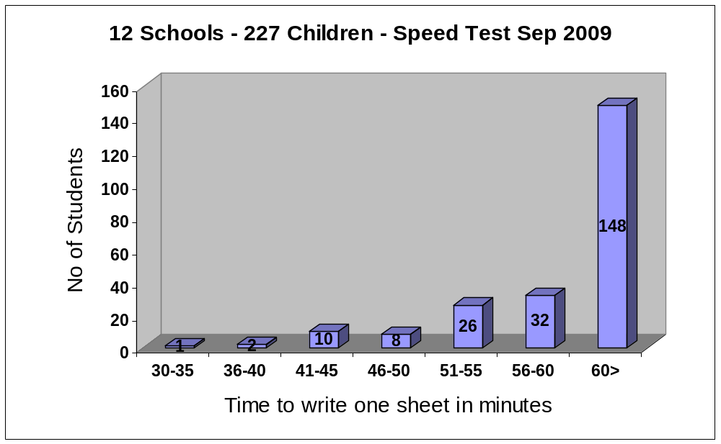

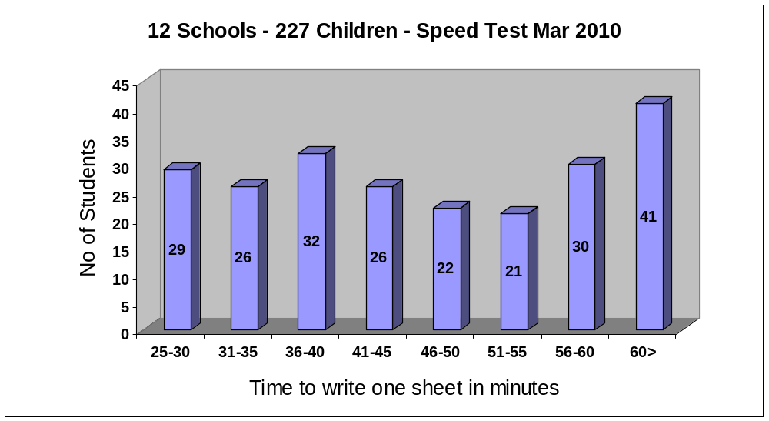

Impact of Sikshana
2009-10 Assessment Scores

Block | School Name | 1st Assessment | 2nd Assessment | Change
KP | Hegganuru | 86 | 95 | 9%
KP | Narayanapura | 96 | 94 | -2%
KP | T.Hosahalli | 86 | 93 | 7%
KP | Bannimakodulu | 61 | 90 | 29%
KP | Shivanahalli | 88 | 89 | 1%
KP | Arekere | 82 | 88 | 6%
KP | Kallahalli | 93 | 88 | -5%
KP | Kadushivanahalli | 69 | 87 | 18%
KP | Mullahalli | 65 | 87 | 22%
KP | Chikalegowdanadoddi | 78 | 86 | 8%
KP | Krishnayyanadoddi | 78 | 86 | 8%
KP | Halugondanahalli | 88 | 84 | -4%
KP | Hukunda | 72 | 84 | 12%
KP | Thungani | 81 | 83 | 2%
KP | Kotekoppa | 72 | 81 | 9%
KP | Maralebekuppe | 82 | 76 | -6%
KP | Nallahalli | 64 | 74 | 10%
KP | Acchalu | 60 | 71 | 11%
KP | Kachuvanahalli | 72 | 67 | -5%
KP | Alanatha | 65 | 66 | 1%
KP | Doddakabbahalli | 62 | 62 | 0%

All schools except Doddakabbahalli under phase 1 assigned to Asha has scored over the minimum required score of 65 in the APF model of testing. The reason for Doddakabbahalli will be analyzed and corrective action will be taken for the next academic year by the mentor and the school staff. Results of all primary schools under Sikshana in Karnataka is listed in Appendix 2

The second measure of performance which is the academic performance of children in 7th grade is listed below.

2009-10 7th class below B grade list

Block | School Name | 7th Strength | 1st Sem | 2nd Sem | 7th % below B
KP | Doddakabbahalli | 20 | 3 | 0 | 0%
KP | Kachuvanahalli | 18 | 0 | 0 | 0%
KP | Kallahalli | 30 | 2 | 0 | 0%
KP | Kotekoppa | 20 | 0 | 0 | 0%
KP | Narayanapura | 25 | 0 | 0 | 0%
KP | T.Hosahalli | 14 | 0 | 0 | 0%
KP | Hukunda | 46 | 3 | 3 | 7%
KP | Krishnayyanadoddi | 29 | 3 | 2 | 7%
KP | Thungani | 42 | 8 | 4 | 10%
KP | Halugondanahalli | 38 | 3 | 4 | 11%
KP | Maralebekuppe | 23 | 4 | 3 | 13%
KP | Hegganuru | 14 | 6 | 2 | 14%
KP | Nallahalli | 35 | 4 | 5 | 14%
KP | Kadushivanahalli | 19 | 2 | 3 | 16%
KP | Bannimakodulu | 41 | 8 | 7 | 17%
KP | Shivanahalli | 48 | 15 | 9 | 19%
KP | Arekere | 10 | 4 | 2 | 20%
KP | Acchalu | 53 | 7 | 11 | 21%
KP | Mullahalli | 34 | 15 | 8 | 24%
KP | Alanatha | 25 | 14 | 7 | 28%
KP | Chikalegowdanadoddi * | 0

With a goal of at least 80% of the children in class 7 scoring grade B or above 3 out of 21 fell short of the goal. The three schools highlighted above will be observed closely by Sikshana in the next academic year.
* Chikalegowdanadoddi is a lower primary school and hence has no students in 7th class
Appendix 1

School ranking methodology and school list for year 2008-09

Criteria

Academics | Sikshana Metrics | Community
Jul 08 Assessment for 5th  Mar 09 Assessment for 5th  1st Sem C Grade 7th  2nd Sem C Grade 7th  KSQAO Exam 2007-08  KSQAO Exam 2008-09 | Annual School Plan  Delhi Trip Winners  Spot Prize Distribution  Library Book Usage  Diary Usage  Computer Usage  School Environment  School Achievement  Funds Usage  Mentors Observation | SDMC or Community Cooperation  Community Investment in the school  Grama Panchayat fund

The schools were awarded points on the metrics as show above with the maximum possible points for each category as shown below.

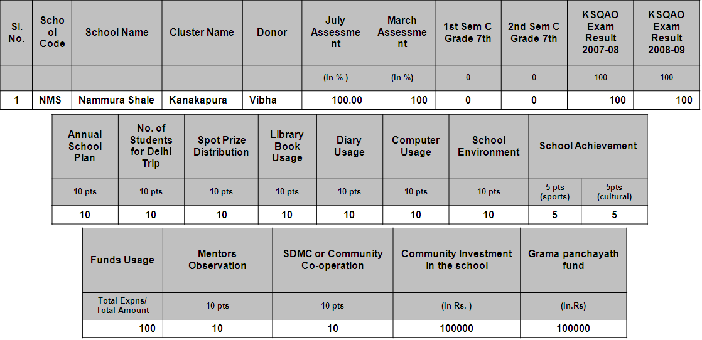

Based on weights given to each category the totals are computed and added up to get a maximum of 960. The school ranking shown below for all the schools is out of a total of 960.

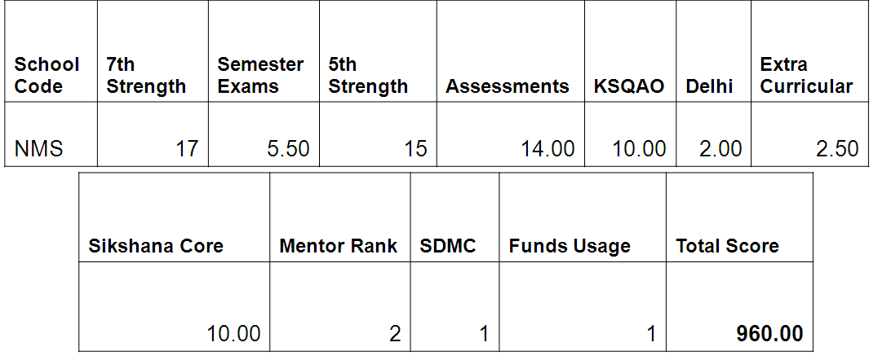

Rank | School Name | School Strength | Total Score | Award
1 | Halugondanahalli | 203 | 837 | Sikshana School of Excellence
2 | Hulibele | 154 | 825 | Sikshana School of Excellence
3 | Hosadurga | 330 | 824 | Sikshana School of the Year
4 | Harohalli | 399 | 820 | Best Large School of the Year
5 | Kamsagara | 107 | 814
6 | Vaderahalli | 92 | 805 | Best Small School of the Year
7 | Halasuru | 174 | 802 | Best School in Computer Application
8 | Sathanuru | 278 | 800
9 | Kaggalahalli | 145 | 800 | Most Improved School of the Year
10 | Acchalu | 177 | 787
11 | Erandyapanahalli | 188 | 784
12 | Malligemettilu | 80 | 782
13 | Kachuvanahalli | 107 | 782
14 | Anedoddi | 178 | 776
15 | Chikkamuduvadi | 208 | 776
16 | Gabbadi | 101 | 771
17 | P.Rampura | 85 | 769
18 | Thotahalli | 127 | 768
19 | Kottagalu | 111 | 764
20 | Doddalahalli | 301 | 763
21 | Boohalli | 122 | 758
22 | Arekere | 71 | 752 | Special Award - Most inquisitive children
23 | Kokkarehosahalli | 74 | 751
24 | Kodihalli | 528 | 751
25 | Sasalapura | 134 | 749
26 | Gollahalli | 115 | 744
27 | Picchanakere | 78 | 741
28 | Kadujakkasandra | 116 | 739
29 | Doddakalbalu | 102 | 734
30 | Venkatarayanadoddi | 150 | 731
31 | Chikkenahalli | 110 | 729
32 | Arekattedoddi | 94 | 729
33 | Koothaganahalli | 114 | 728
34 | Uyyambahalli | 143 | 727
35 | Karikaldoddi Gate | 86 | 724
36 | Bijjahalli | 143 | 724
37 | Somedyapanahalli | 62 | 724
38 | Therubeedi | 116 | 723
39 | Nayakanahalli | 83 | 720
40 | Nallahalli | 252 | 719
41 | Chikkalhalli | 54 | 717
42 | Mullahalli | 168 | 713
43 | Bannimakodulu | 162 | 711
44 | Thokasandra | 190 | 707
45 | Anamanahalli | 95 | 706
46 | Gerahalli | 106 | 706
47 | Narayanapura | 101 | 706
48 | Chikkalbalu | 118 | 705
49 | Cheeluru | 113 | 704
50 | Maralavadi | 342 | 702
51 | A.Rampura | 97 | 701
52 | Banavasi | 139 | 701
53 | Ambedkar Nagara | 135 | 699
54 | Nagarasanakote | 98 | 699
55 | Dyavasandra | 84 | 698
56 | Thungani | 153 | 697
57 | Kolagondanahalli | 401 | 695
58 | Elagahalli | 172 | 695
59 | Bilidale | 92 | 694
60 | Thimmegowdana Doddi | 78 | 693
61 | Hunasanahalli | 242 | 693
62 | Guruvinapura | 117 | 692
63 | Yadamaranahalli | 102 | 691
64 | Kanakapura - G.G.M.S | 229 | 690
65 | Bandiganahalli | 88 | 690
66 | Kolliganahalli | 80 | 689
67 | Kallanakuppe | 118 | 688
68 | Doddakabbahalli | 98 | 683
69 | Thattekere | 89 | 682
70 | Harihara | 106 | 682
71 | Doddasadenahalli | 78 | 682
72 | Kadushivanahalli | 105 | 680
73 | Doddamuduvadi | 76 | 679
74 | K.P.L. Colony | 174 | 679
75 | Honniganahalli | 86 | 677
76 | Gowdahalli | 125 | 676
77 | Medamaranahalli | 109 | 675
78 | Hukunda | 153 | 673
79 | Kadasikoppa | 98 | 673
80 | Aralalu | 116 | 673
81 | Dhalimba | 90 | 667
82 | Kanakapura - 02 | 574 | 666
83 | Shivanahalli | 150 | 663
84 | Biliganakuppe | 75 | 662
85 | Goduru | 64 | 662
86 | Thippuru | 65 | 662
87 | Keralalusandra | 106 | 658
88 | Algadakalu | 83 | 658
89 | Kallahalli | 127 | 651
90 | Kebbare | 76 | 645
91 | Kothunuru | 73 | 644
92 | Hallimaranahalli | 117 | 641
93 | Shivanegowdanadoddi | 110 | 635
94 | Maralebekuppe | 105 | 634
95 | Salabanni | 107 | 634
96 | Krishnayyanadoddi | 97 | 627
97 | T.Hosahalli | 77 | 616
98 | Konasandra | 73 | 612
99 | Yalachavadi | 133 | 612
100 | Paduvanagere | 103 | 609
101 | Halasuru | 74 | 608
102 | Hegganuru | 75 | 607
103 | Mavathur | 71 | 606
104 | I. Gollahalli | 181 | 605
105 | Kabbalu | 78 | 604
106 | Alanatha | 105 | 604
107 | Kadahalli | 64 | 601
108 | Baradanahalli | 59 | 601
109 | Athihalli | 90 | 598
110 | Kotekoppa | 109 | 597
111 | T. Bannikuppe | 98 | 595
112 | Kanakapura - G.K.B.M.S | 225 | 591
113 | Haroshivanahalli | 87 | 587
114 | Gattigunda | 69 | 578
115 | Horalagallu | 114 | 578
116 | Hulugondanahalli | 77 | 575
117 | Chikalegowdanadoddi | 41 | 569
118 | Seegekote | 96 | 557
119 | Gulaganahalli | 70 | 545
120 | Chowkasandra | 47 | 538

Appendix 2

2009-10 Assessment scores for all primary schools in Karnataka

Block | School Name | 1st Assessment | 2nd Assessment | Change
KP | Hulibele | 93 | 99 | 6%
KP | Kanakapura - G.G.M.S | 91 | 98 | 7%
KP | Cheeluru | 82 | 97 | 15%
KP | Venkatarayanadoddi | 63 | 97 | 34%
KP | Hulugondanahalli | 83 | 96 | 13%
KP | Malligemettilu | 88 | 96 | 8%
HK | Medimallasandra | 71 | 96 | 25%
KP | Halasuru | 73 | 95 | 22%
KP | Hegganuru | 86 | 95 | 9%
KP | Guruvinapura | 75 | 94 | 19%
KP | Narayanapura | 96 | 94 | -2%
HK | Anogondana halli | 68 | 93 | 25%
KP | Doddalahalli | 62 | 93 | 31%
KP | K.P.L. Colony | 71 | 93 | 22%
KP | T.Hosahalli | 86 | 93 | 7%
KP | Chikkenahalli | 73 | 92 | 19%
KP | I. Gollahalli | 66 | 92 | 26%
KP | Anedoddi | 75 | 91 | 16%
KP | Gerahalli | 78 | 91 | 13%
CB | Gidnahalli | 61 | 91 | 30%
KP | Harihara | 60 | 91 | 31%
KP | Haroshivanahalli | 60 | 91 | 31%
KP | Kadasikoppa | 88 | 91 | 3%
KP | Kokkarehosahalli | 67 | 91 | 24%
KP | Konasandra | 72 | 91 | 19%
CB | Yalavahalli | 80 | 91 | 11%
KP | Anamanahalli | 67 | 90 | 23%
KP | Bannimakodulu | 61 | 90 | 29%
KP | Bilidale | 79 | 90 | 11%
KP | Gabbadi | 88 | 90 | 2%
KP | Hanchuguli | 75 | 90 | 15%
CB | Kanjenhalli | 87 | 90 | 3%
KP | Kottagalu | 94 | 90 | -4%
KP | Gollahalli | 66 | 89 | 23%
KP | Picchanakere | 61 | 89 | 28%
KP | Shivanahalli | 88 | 89 | 1%
KP | T. Bannikuppe | 88 | 89 | 1%
KP | Arekere | 82 | 88 | 6%
KP | Halasuru B | 87 | 88 | 1%
KP | Kallahalli | 93 | 88 | -5%
KP | Sathanuru | 66 | 88 | 22%
KP | Kadushivanahalli | 69 | 87 | 18%
KP | Koothaganahalli | 65 | 87 | 22%
KP | Kothunuru | 78 | 87 | 9%
KP | Mullahalli | 65 | 87 | 22%
CB | Patrenahalli | 61 | 87 | 26%
KP | Sasalapura | 87 | 87 | 0%
KP | Thimmegowdana Doddi | 77 | 87 | 10%
KP | Chikalegowdanadoddi | 78 | 86 | 8%
KP | Kamsagara | 88 | 86 | -2%
AK | Koppa gate | 74 | 86 | 12%
KP | Krishnayyanadoddi | 78 | 86 | 8%
KP | Banavasi | 79 | 85 | 6%
KP | Hallimaranahalli | 66 | 85 | 19%
KP | Kaggalahalli | 78 | 85 | 7%
CB | Kuduvathi | 57 | 85 | 28%
KP | P.Rampura | 80 | 85 | 5%
KP | Aralalu | 82 | 84 | 2%
KP | Athihalli | 76 | 84 | 8%
KP | Dyavasandra | 74 | 84 | 10%
KP | Halugondanahalli | 88 | 84 | -4%
KP | Harohalli | 72 | 84 | 12%
KP | Hukunda | 72 | 84 | 12%
KP | Kadahalli | 81 | 84 | 3%
KP | Kallanakuppe | 88 | 84 | -4%
KP | Kanakapura - G.K.B.M.S | 79 | 84 | 5%
KP | Thokasandra | 86 | 84 | -2%
KP | Doddamuduvadi | 77 | 83 | 6%
KP | Elagahalli | 63 | 83 | 20%
KP | Hosadurga | 72 | 83 | 11%
KP | Hunasanahalli | 66 | 83 | 17%
KP | Kabbalu | 63 | 83 | 20%
KP | Medamaranahalli | 82 | 83 | 1%
KP | Nayakanahalli | 66 | 83 | 17%
KP | Thungani | 81 | 83 | 2%
KP | Ambedkar Nagara | 57 | 82 | 25%
KP | Biliganakuppe | 79 | 82 | 3%
KP | Chikkalahalli | 81 | 82 | 1%
KP | Erandyapanahalli | 76 | 82 | 6%
CB | Kuppahalli | 56 | 82 | 26%
HAL | Vibuthipura | 57 | 82 | 25%
KP | Arekattedoddi | 67 | 81 | 14%
AK | Bingipura | 48 | 81 | 33%
KP | Goduru | 81 | 81 | 0%
KP | Kadujakkasandra | 71 | 81 | 10%
KP | Keralalusandra | 78 | 81 | 3%
KP | Kotekoppa | 72 | 81 | 9%
AK | Malenallasandra | 75 | 81 | 6%
KP | Vaderahalli | 85 | 81 | -4%
KP | Baradanahalli | 76 | 80 | 4%
KP | Bijjahalli | 78 | 80 | 2%
KP | Dhalimba | 78 | 80 | 2%
KP | Honniganahalli | 61 | 80 | 19%
KP | Kanakapura - 02 | 58 | 80 | 22%
KP | Karikaldoddi Gate | 69 | 80 | 11%
KP | Kebbare | 85 | 80 | -5%
CB | Mailappanahalli | 66 | 80 | 14%
KP | Melekote | 65 | 80 | 15%
KP | Maralavadi | 82 | 79 | -3%
KP | Thippuru | 76 | 79 | 3%
HK | Thiruvaranga | 61 | 79 | 18%
HAL | Vimanapura | 71 | 79 | 8%
KP | Gulaganahalli | 76 | 78 | 2%
KP | Kolliganahalli | 74 | 78 | 4%
KP | Nagarasanakote | 83 | 78 | -5%
KP | Paduvanagere | 60 | 78 | 18%
KP | Salabanni | 70 | 78 | 8%
KP | Doddakalbalu | 77 | 77 | 0%
AK | Hulimangala | 62 | 77 | 15%
KP | Kodihalli | 82 | 77 | -5%
KP | Mavathur | 63 | 77 | 14%
HK | Mutkur | 66 | 77 | 11%
KP | Somedyapanahalli | 76 | 77 | 1%
KP | Aregadakalu | 55 | 76 | 21%
KP | Bandiganahalli | 78 | 76 | -2%
KP | Chikkalbalu | 70 | 76 | 6%
KP | Doddasadenahalli | 80 | 76 | -4%
KP | Maralebekuppe | 82 | 76 | -6%
KP | Algadakalu | 75 | 75 | 0%
KP | Chowkasandra | 75 | 75 | 0%
KP | Gattigunda | 78 | 74 | -4%
KP | Gowdahalli | 74 | 74 | 0%
KP | Nallahalli | 64 | 74 | 10%
KP | Seegekote | 74 | 74 | 0%
KP | Uyyambahalli | 61 | 74 | 13%
KP | Horalagallu | 58 | 73 | 15%
KP | Marale | 65 | 73 | 8%
HK | Narayanakere | 57 | 73 | 16%
KP | Therubeedi | 68 | 73 | 5%
CB | Andarlahalli | 74 | 72 | -2%
KP | Boohalli | 52 | 72 | 20%
KP | Shivanegowdanadoddi | 71 | 72 | 1%
KP | Thattekere | 75 | 72 | -3%
KP | Acchalu | 60 | 71 | 11%
AK | Dyavasandra | 69 | 71 | 2%
AK | Harappanahalli | 65 | 71 | 6%
CB | Kandavara | 67 | 71 | 4%
CB | Kanganahalli | 52 | 71 | 19%
HAL | Nellurpura [T] | 62 | 71 | 9%
KP | Sarahaddinadoddi | 71 | 71 | 0%
HK | Bhaguru | 60 | 70 | 10%
AK | Byatarayana Doddi | 59 | 70 | 11%
KP | Chikkamuduvadi | 70 | 70 | 0%
CB | Nayanahalli | 65 | 70 | 5%
AK | Nosenoor | 70 | 70 | 0%
HK | D.Hosahalli | 59 | 69 | 10%
AK | Krishna Doddi | 49 | 69 | 20%
CB | Agalagurki | 56 | 68 | 12%
AK | Kallubalu | 57 | 68 | 11%
KP | Yadamaranahalli | 67 | 68 | 1%
AK | Yarandahalli | 68 | 68 | 0%
AK | Bannerugatta | 57 | 67 | 10%
AK | Begihalli | 68 | 67 | -1%
HK | Doddadunnasandra | 57 | 67 | 10%
CB | Doddamarali | 56 | 67 | 11%
KP | Kachuvanahalli | 72 | 67 | -5%
CB | Nandi | 44 | 67 | 23%
KP | Yalachavadi | 51 | 67 | 16%
KP | Alanatha | 65 | 66 | 1%
AK | Konasandra | 64 | 66 | 2%
AK | Sakalavara | 76 | 66 | -10%
AK | Vabasandra | 59 | 66 | 7%
HK | Gunduru | 58 | 65 | 7%
AK | Koppa | 59 | 65 | 6%
AK | Ragihalli | 54 | 65 | 11%
AK | Madapattana | 44 | 64 | 20%
KP | Bettegoudana doddi | 49 | 63 | 14%
HK | Devanagundi | 42 | 62 | 20%
AK | Liganapura | 37 | 57 | 20%
AK | Hennagara | 46 | 57 | 11%
KP | Attiguppe | 37 | 53 | 16%
AK | Bilvardhanahlli | 39 | 52 | 13%
AK | Kannayakanagar | 55 | 64 | 9%
KP | Kolagondanahalli | 62 | 64 | 2%
CB | Kolaganahalli | 55 | 63 | 8%
AK | Mantapa | 60 | 63 | 3%
HAL | Nellurpura [K] | 62 | 63 | 1%
AK | Samipigehalli | 62 | 63 | 1%
CB | Ajjavara | 55 | 62 | 7%
AK | Rajapura | 58 | 62 | 4%
KP | Doddakabbahalli | 62 | 62 | 0%
AK | Maragondanahalli | 67 | 62 | -5%
KP | A.Rampura | 55 | 61 | 6%
AK | Jigani | 50 | 57 | 7%
AK | Haragadde | 47 | 55 | 8%
KP | Thotahalli | 49 | 55 | 6%
CB | Beedaganahlli | 46 | 54 | 8%
CB | Shrirampura | 48 | 53 | 5%
AK | Anayanadoddi | 39 | 44 | 5%

