Uthnau: 2017-2018
- Enhancement of communication skill in English and Bengali. Giving emphasis on logical understanding of Math as compared to techniques of calculations by using TLM.
- One girl student from Mr. Arnab Sen’s house has been back home and is being admitted in class VIII in a local high school close to Garia, because she is not able to coup up with the city life. However, her ability in learning got increased due to tutorial special care and urban exposure. Two boys are doing well and scoring 72 – 75% marks in annual evaluation. They teaches young students of Mach Awrah (Uthnau’s School cum Day care Center) at the time of their visits during long vacations and share their studies and experiences with other same age students of the village. Other girl student’s class gradation result has been average but showing much interest on sports and painting and performing well.
- Engagements in Food processing (Pickle, Jam, Dried vegetables, Turmeric powder, Rice noodle etc.) Marshal art and craft making have become popular among the Self-Help Groups of Gogo-Gaonta from drop out girls and out going girl students of Mach Awrah. Uthnau is now enlisted in Paschim Banga Skill Development Society, under Ministry of Technical Education and Skill Development, Govt. of West Bengal as an approved institution for vocational trainings on (i) Food processing, (ii) Needle works and embroidery stitching, (iii) DTP and Date entry, (iv) Basic Health support, (v) Organic Farming and (vi) Gardening. Uthanu failed to open its Vocational Training Center by March, 2018, because of its land related trouble, perpetrated by a group of agents of stone quarry owners. The case will be waved by end of June, after opening of Court. Uthnau is getting support from local Panchayet, Santal self-rule bodies and local Police. Trust, by July 2018 Uthnau will be able to open its vocational training center and it is eyeing to provide trainings for more than 1000 trainees in different courses in one year.
- Uthnau is receiving invitations from Ministry of Women and Child and different Industrial fora to sell its organic products through its self-help groups. Recently women of Uthnau participated one festival cum fair in Mumbai and other one in Kolkata.
- Uthau is engaged in documentation of the Bio-diversity in the entire lateritic terrain of Western part of Birbhum and its adjacent part of Jharkhand.
- Running the existing evening coaching center for adolescent students, especially for the girls from class VI to IX.
- The interim orders from National Green Tribunal over the operations and expansion of the illegal stone mines have been positive, which have given order to Jharkhand and West Bengal Govt.s to appoint National Institute of Forest Research, Derrahdoon with view of assessing the loss of Nature and human health by 90 days. At the same time, Hon’ble court has directed ban of operation of stone mining without the clearance certificates issued by Central Pollution Control Board.

Total enrolment of students in the Mawj-orah day care center has been 48 (25 girls and 23 boys) and the enrolment of students in the evening tutorial center has been 12 (7 boys and 5 girls).

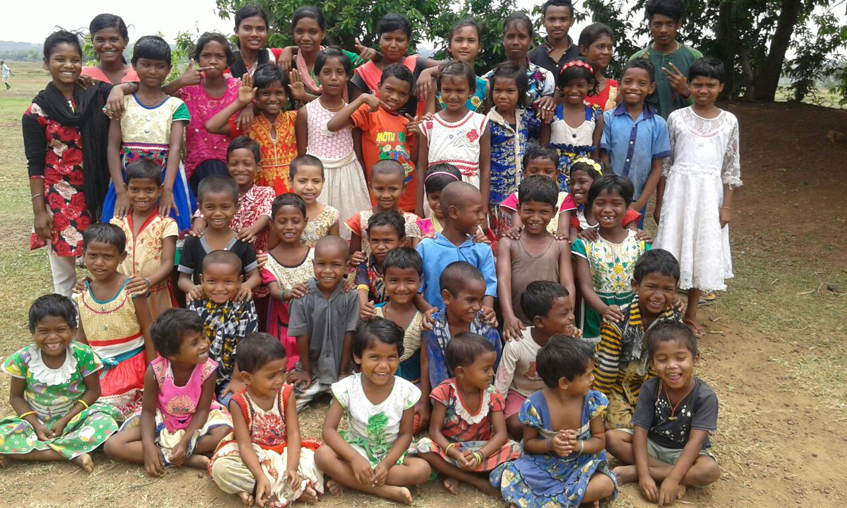

- Construction material are being stored in the main class room of Mach-Awrah for months, which caused displacement of Students from indoor classes.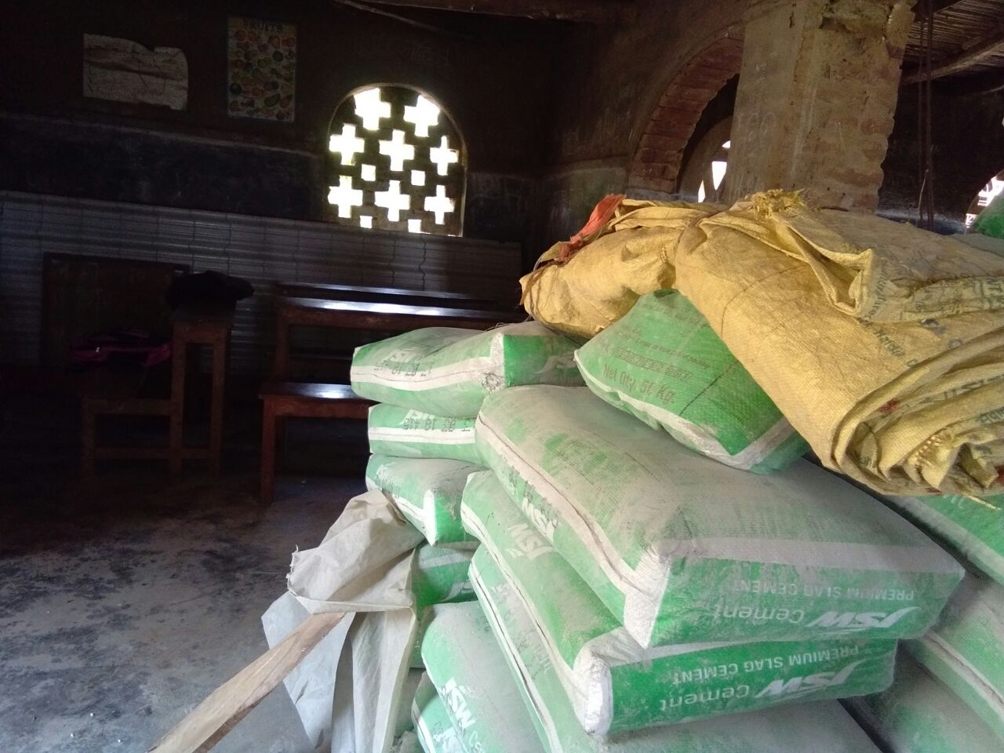

- Students used to enjoy Mach-Awrah by drawing and scribbling everywhere in the class rooms.
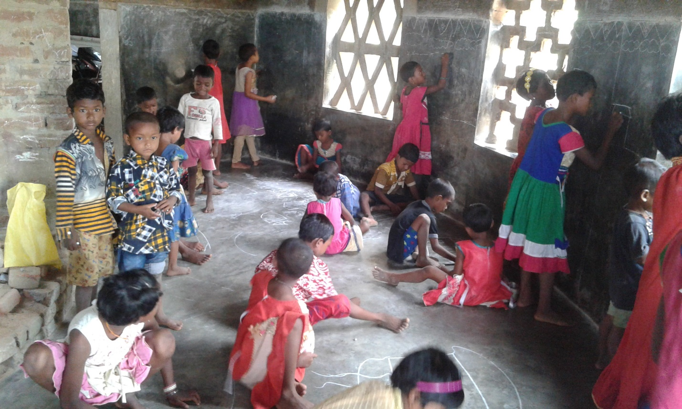

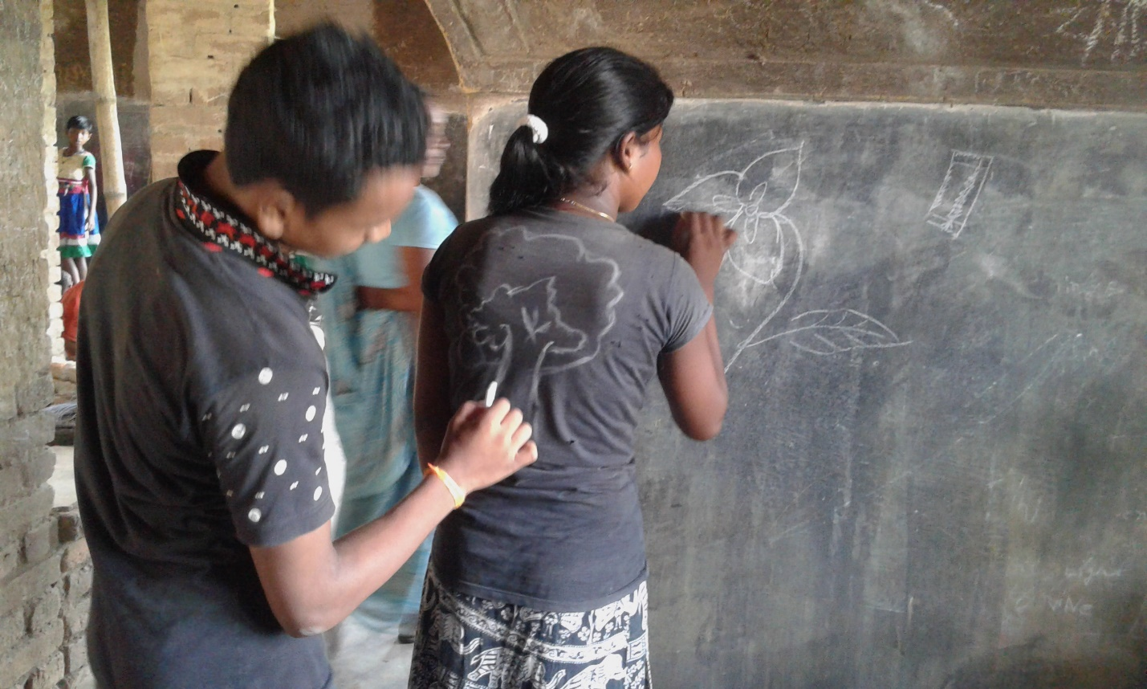
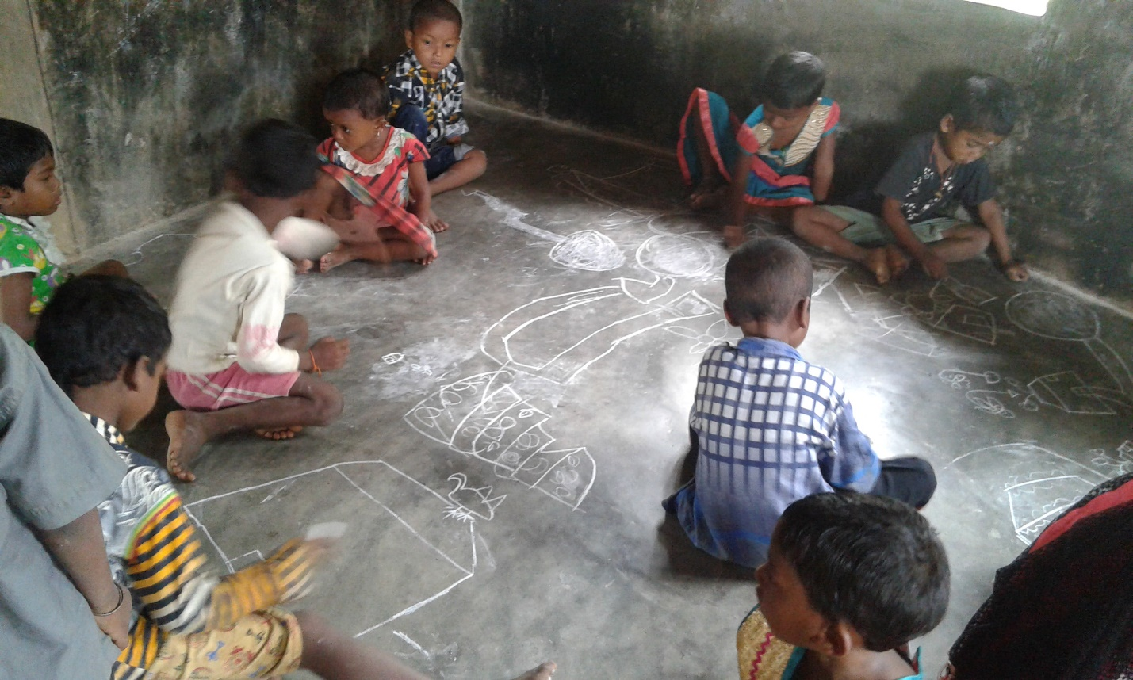

…Spreading TLMs on floor
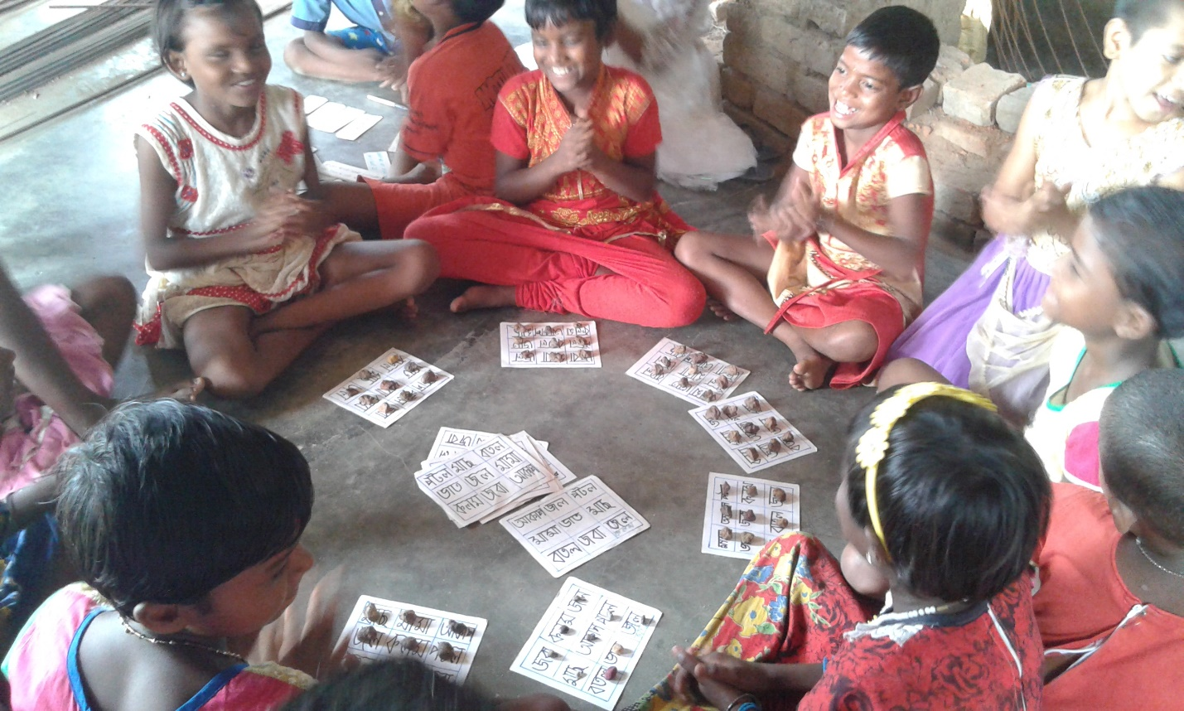

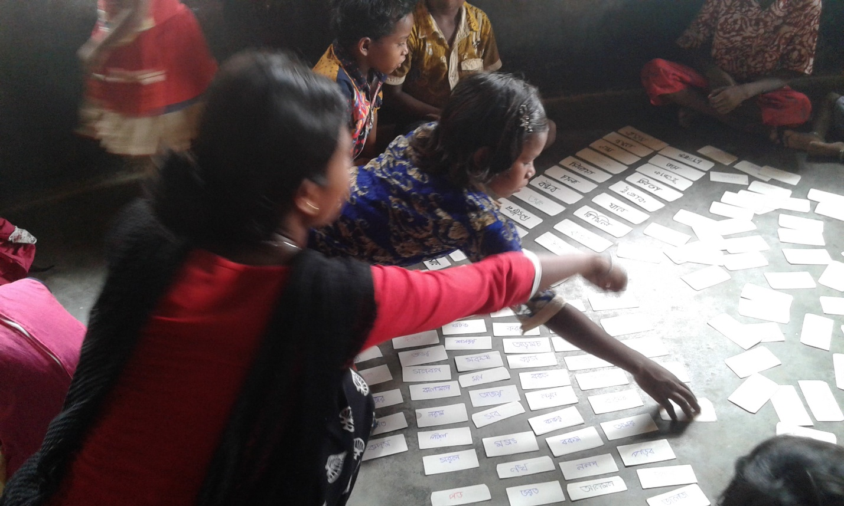

- Their space got clasped

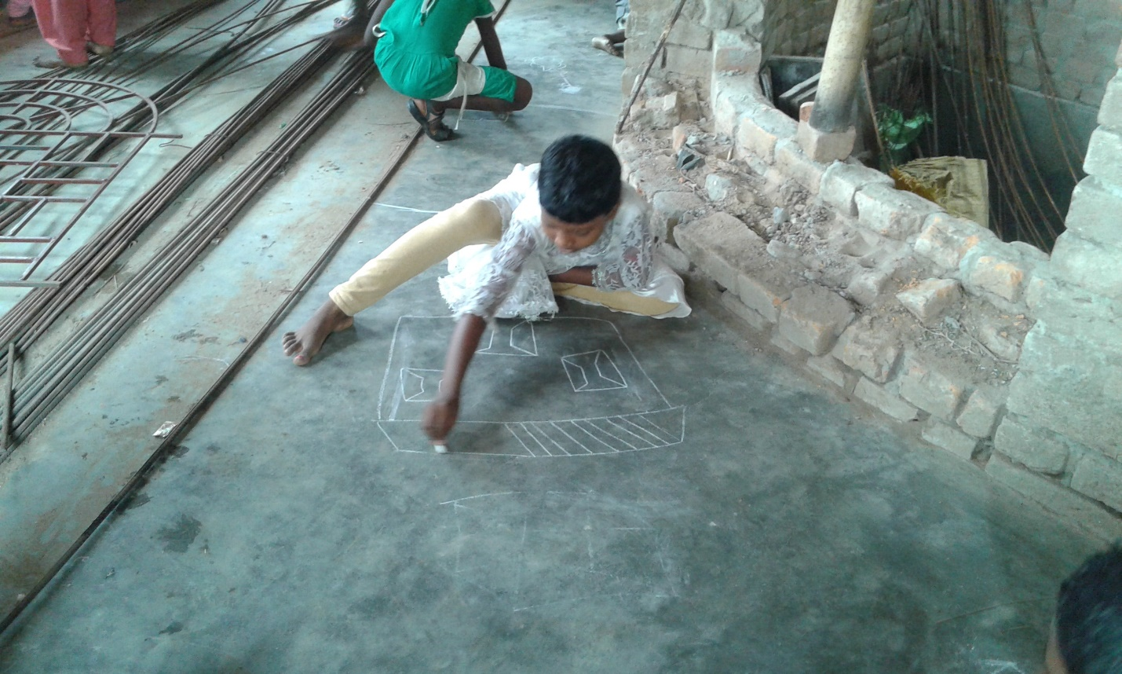
- Under the Sun…

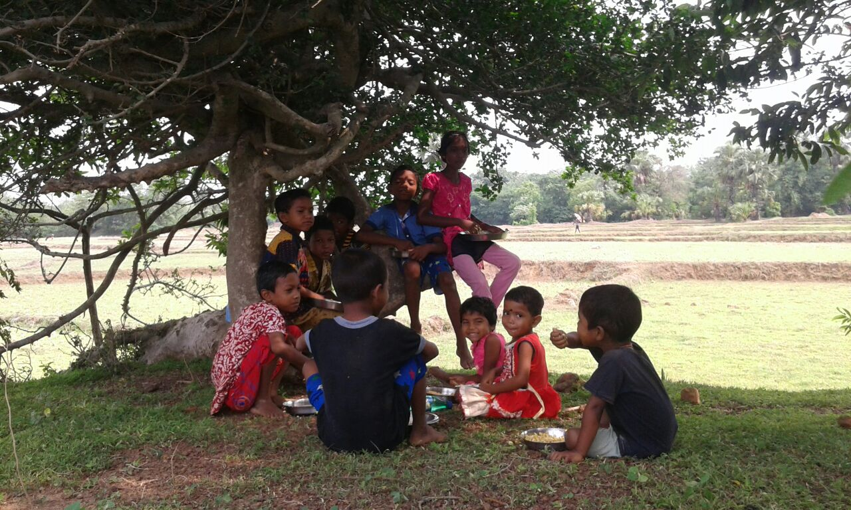

- Got a new building and a new look of Mach-Awrah..
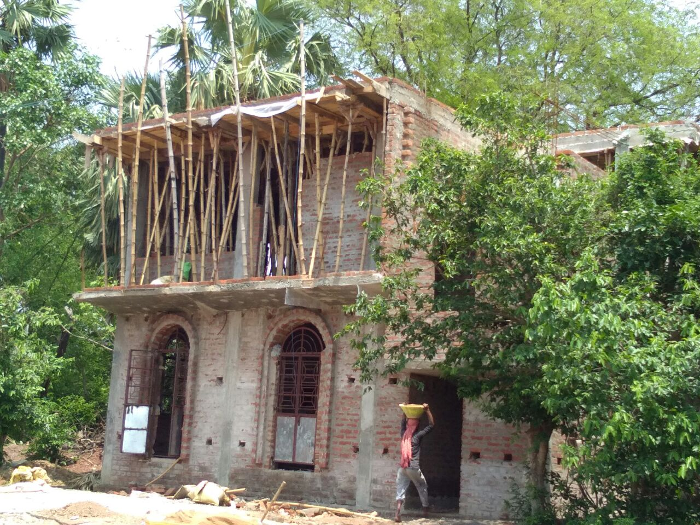

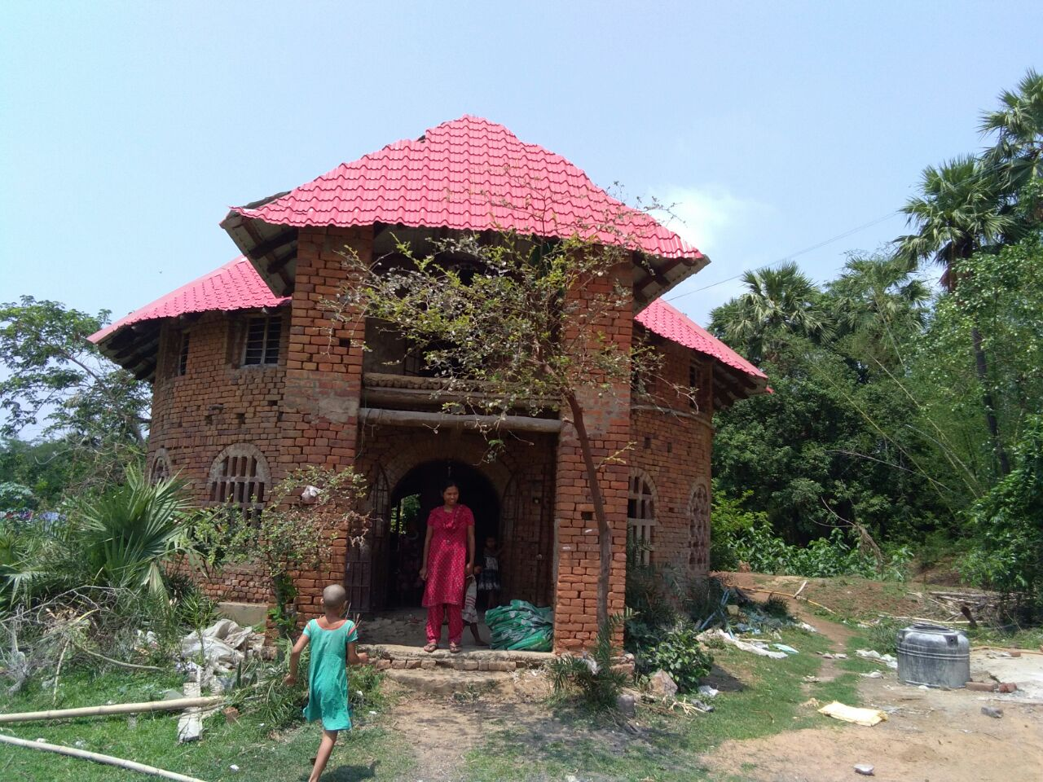

- A new class room…for time being
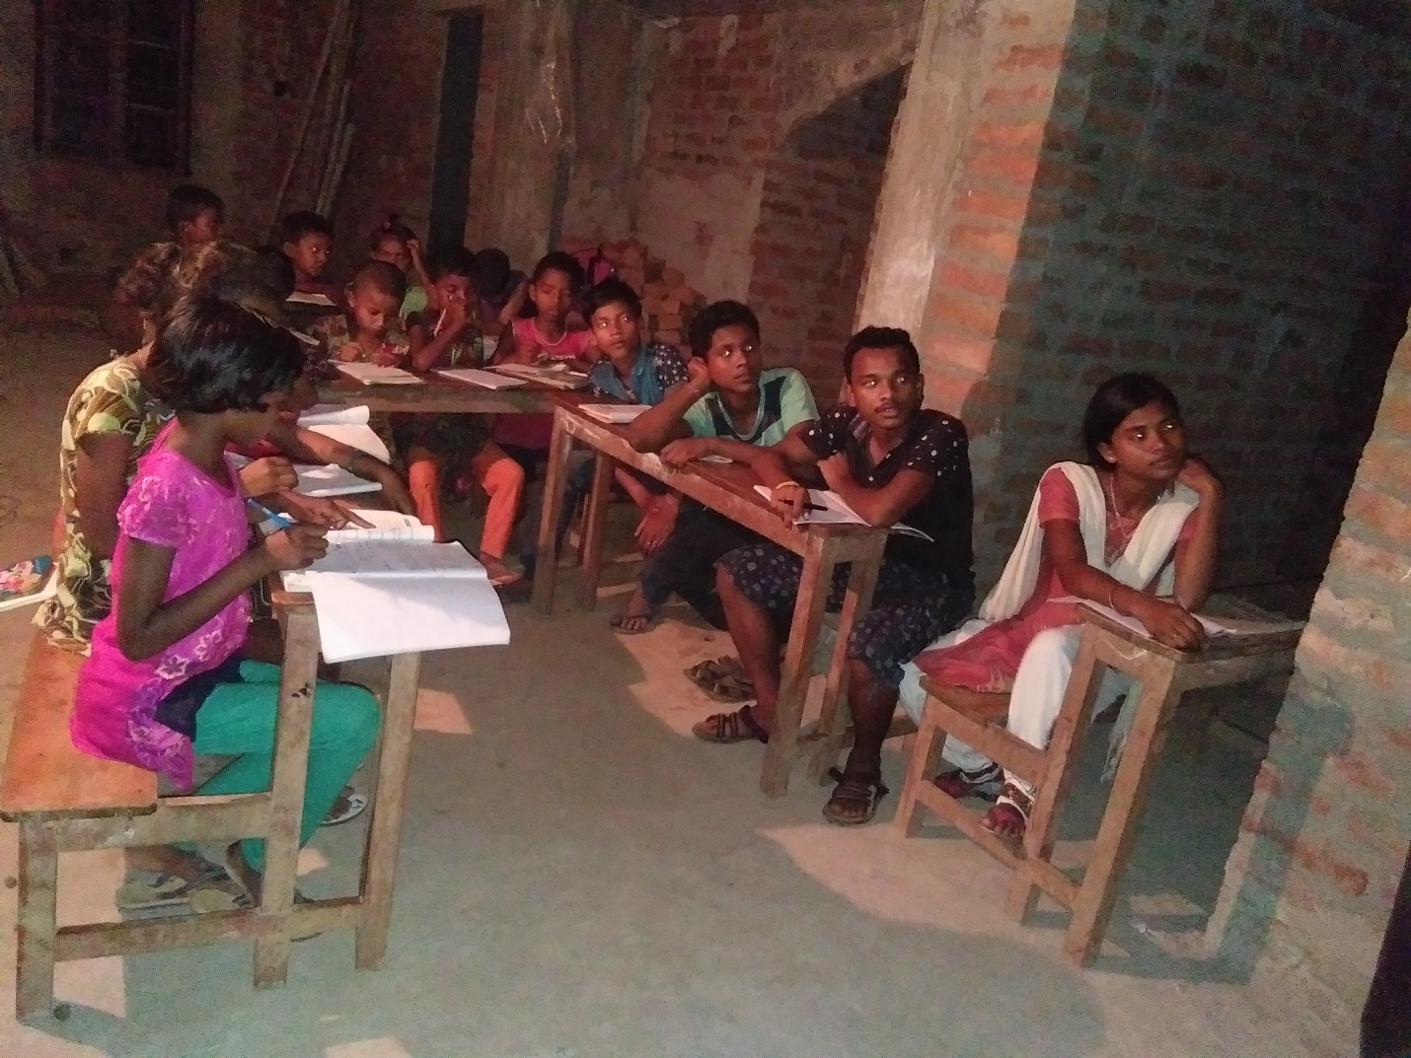

- Learning English conversations and basic operations of Computer
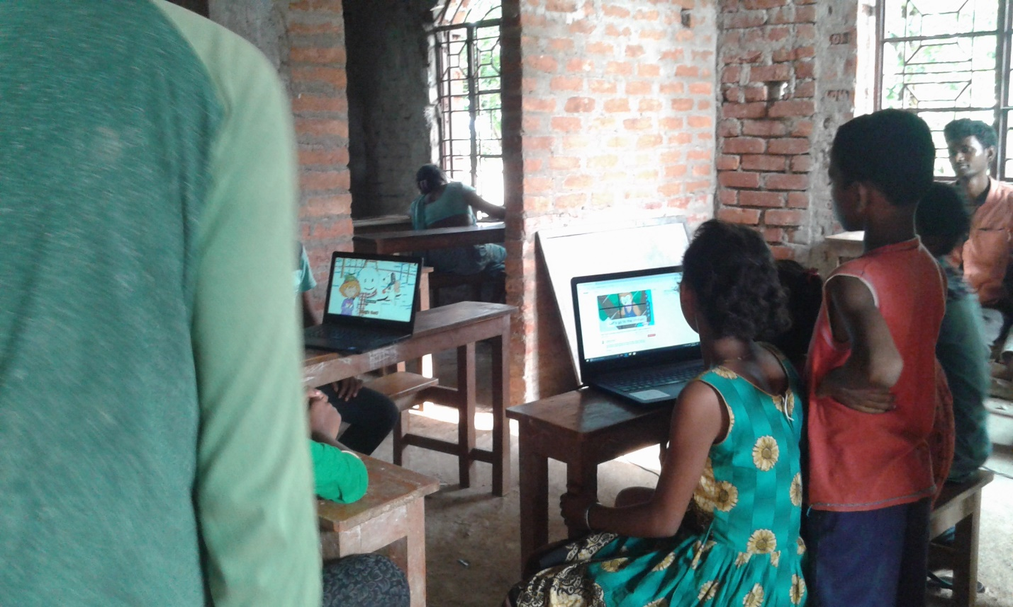

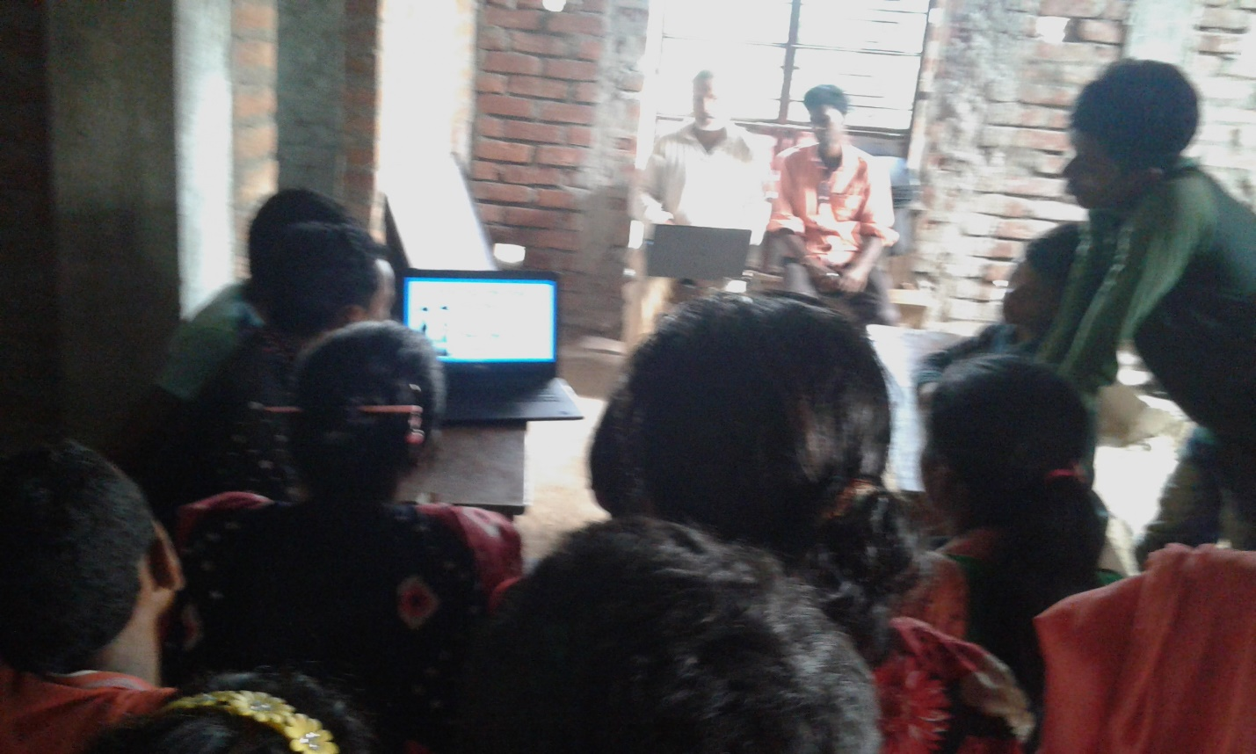

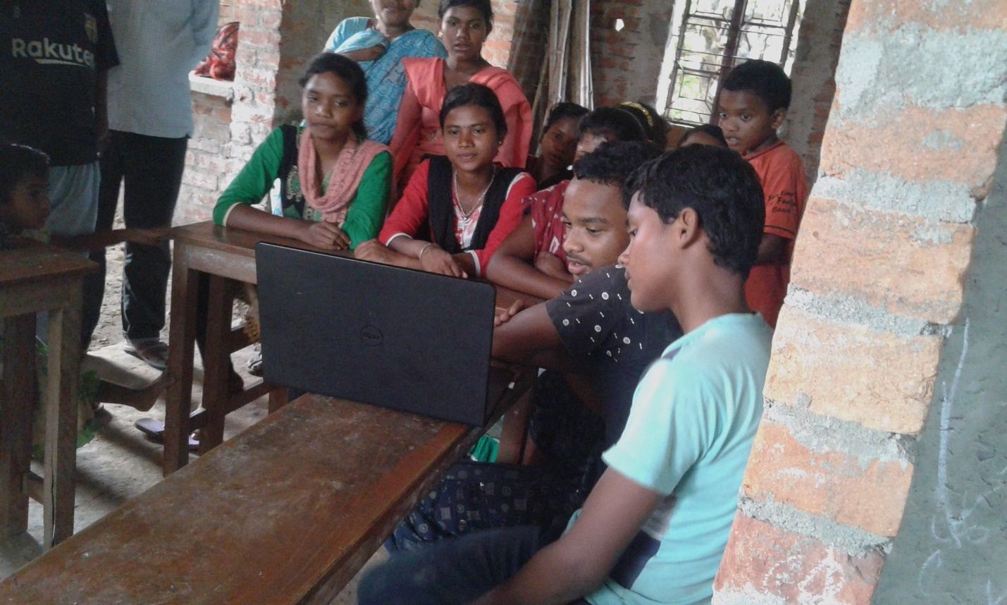

- Evening Tutorial for high school students…
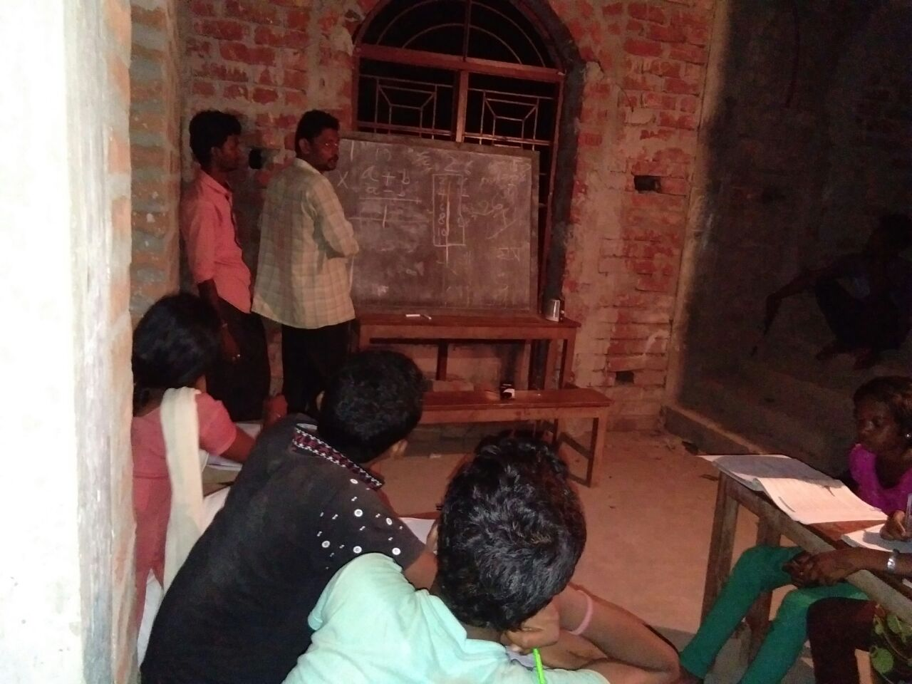
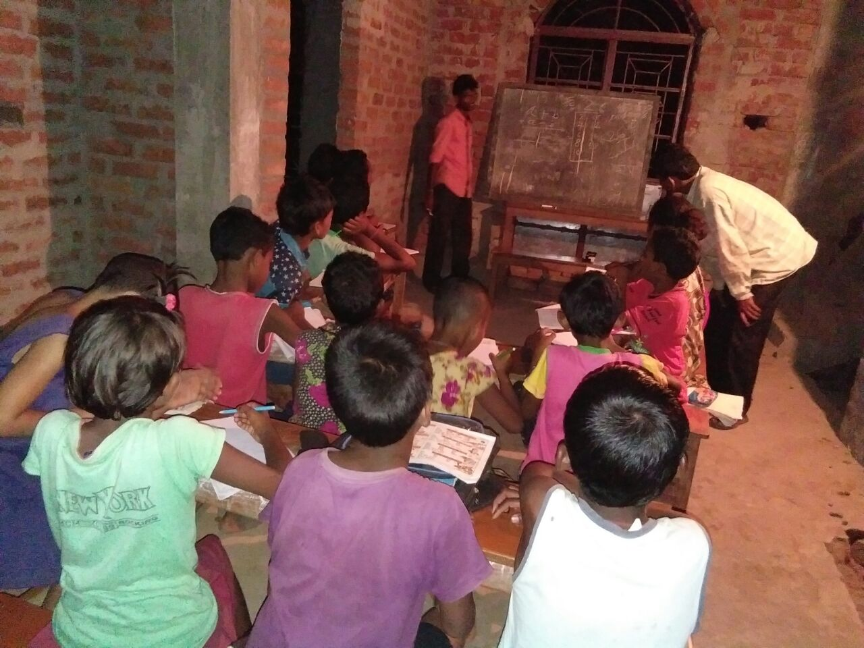

- Out of total six, here, four students of Uthnau are present in picture bellow who have appeared in the School final exam this year. Two of them were not present in the village…went out to enjoy post exam vacation. All the School final candidates from the village (six out of six) are the students of Uthnau school.
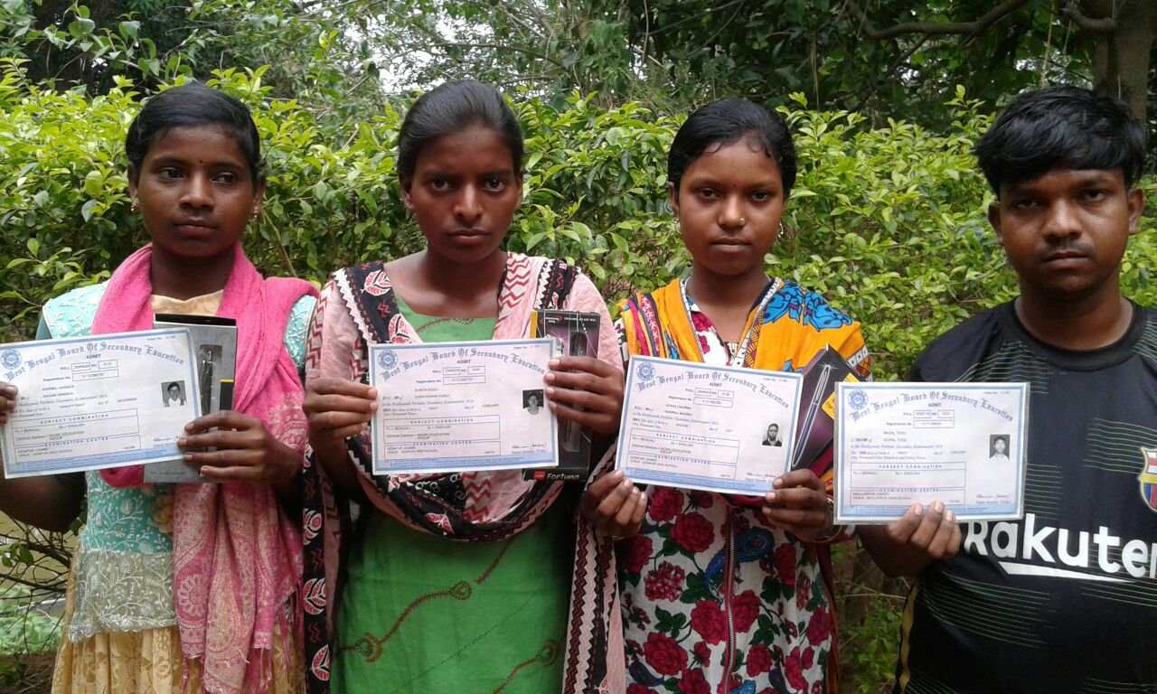

- Organic Kitchen Garden of Mach-Awrah…
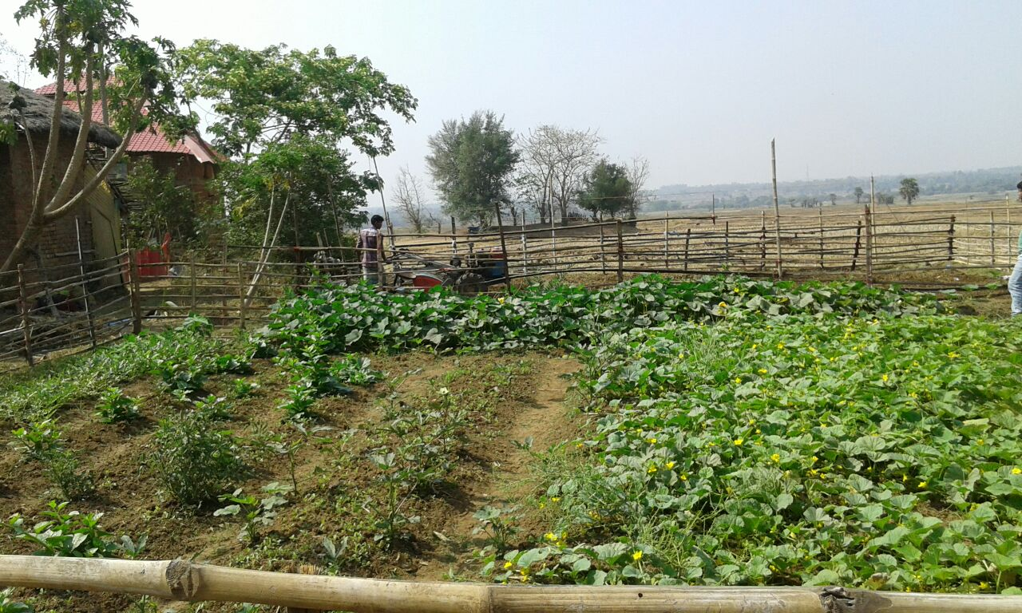
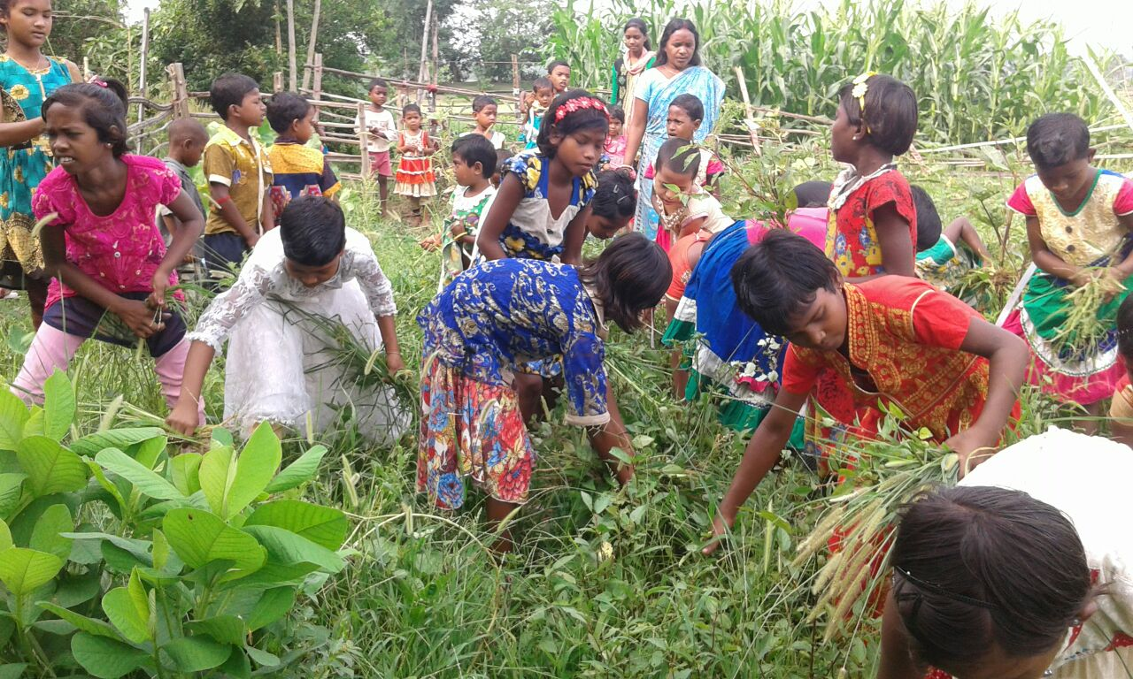

- Uthnau students are performing their skill at the time of National level assessment of Tang-soo-do marshal art in Hooghly, West Bengal.
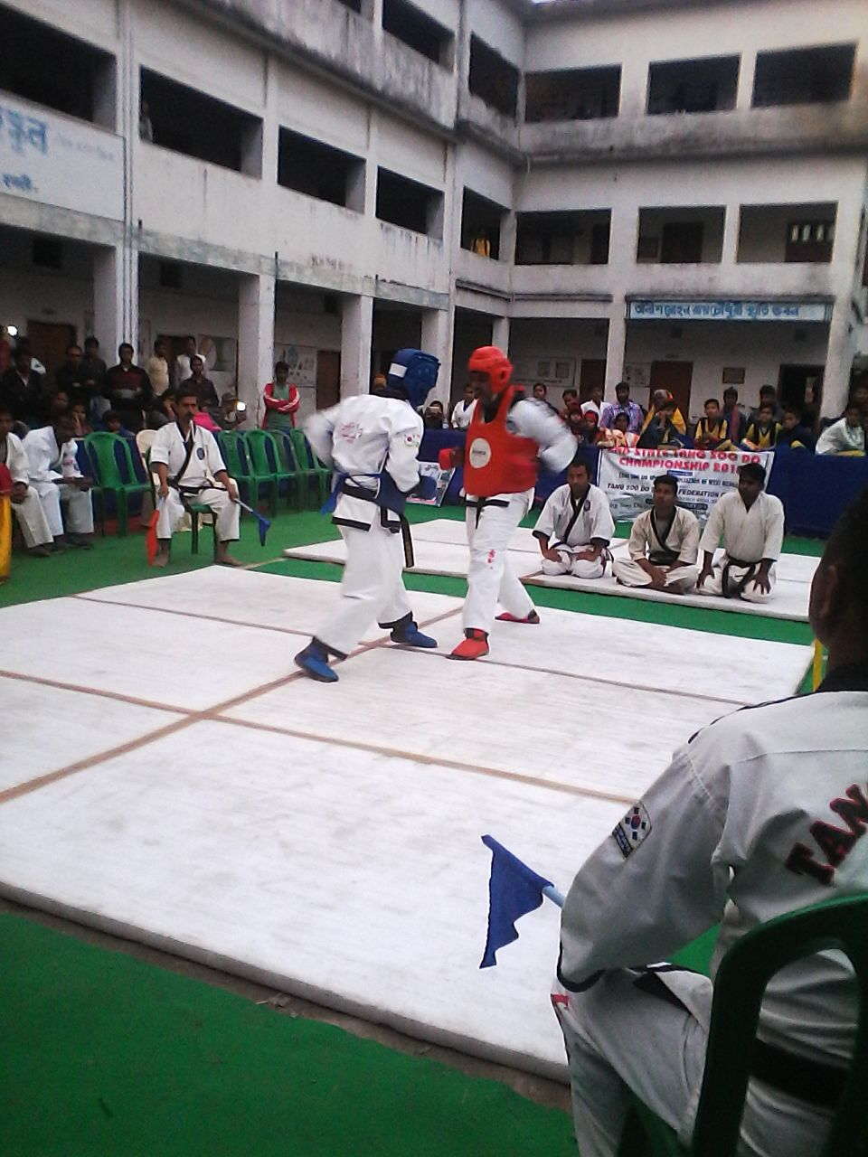
Five students and one teacher of Mach-Awrah with the master trainer. Students were being upgraded from Yellow belt to Blue belt and the teacher who used to follow up the practice as per instructions of the master trainer, achieved Purple belt. They received a special award from the organizing body for showing fastest upgradation of skill…within the period of ten months.
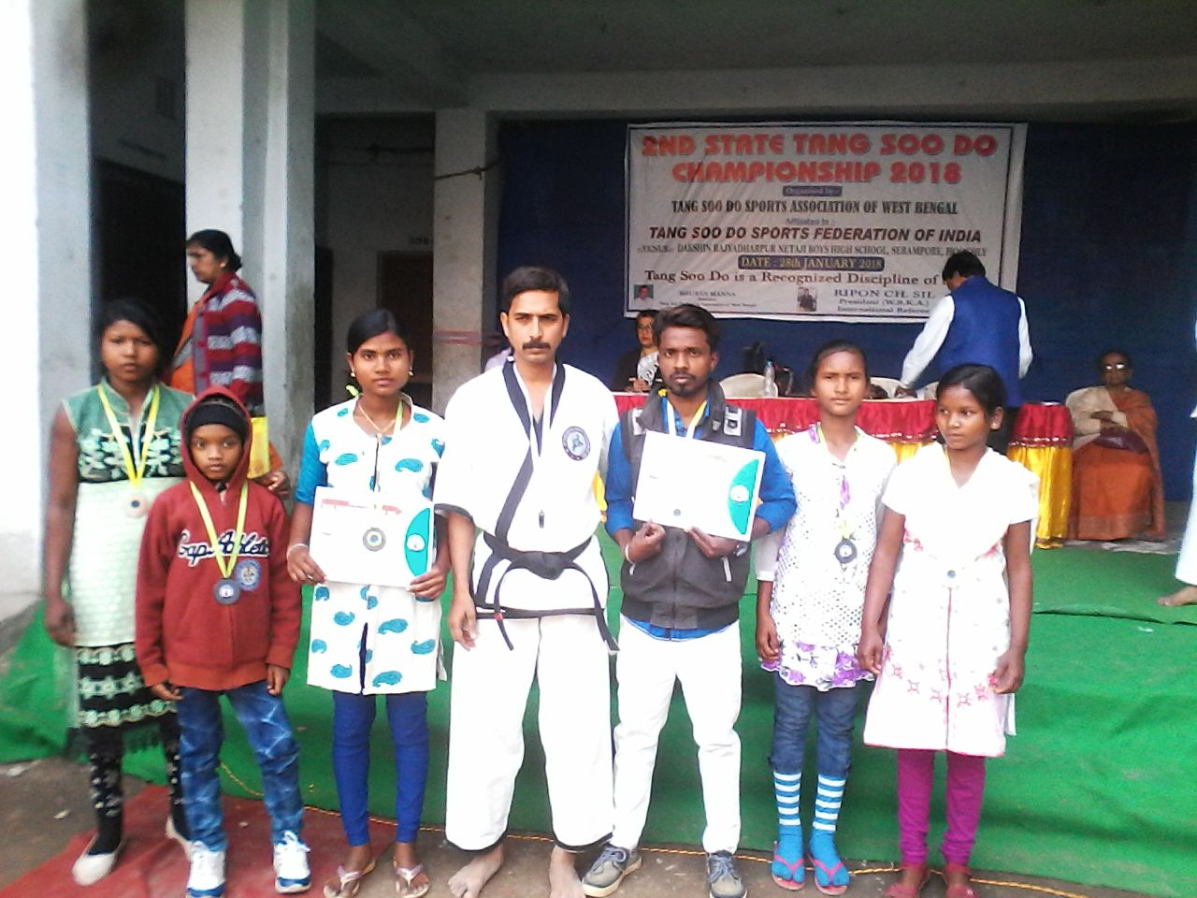

- Uthnau’s participation in an Organic Food Festival at World Trade Center, Mumbai.
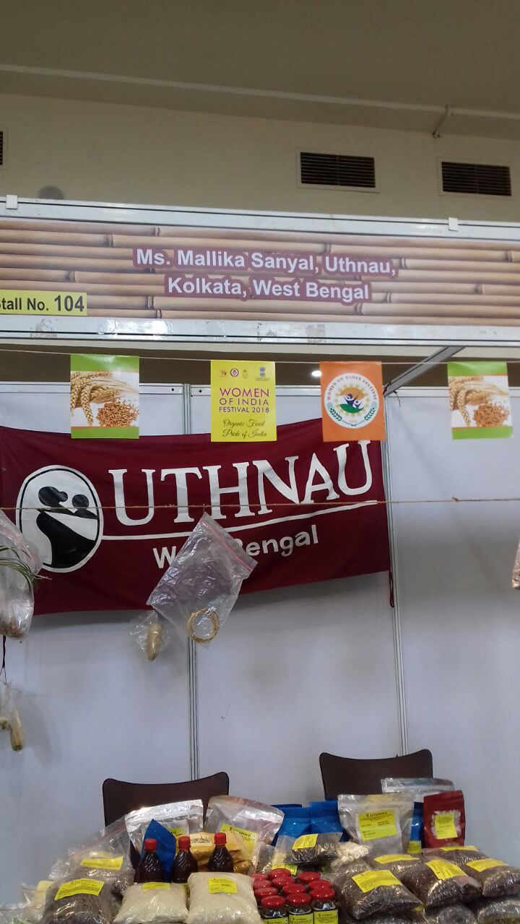

- Two students, who are studying in a residential school are showing their prize after winning an event in annual sport.
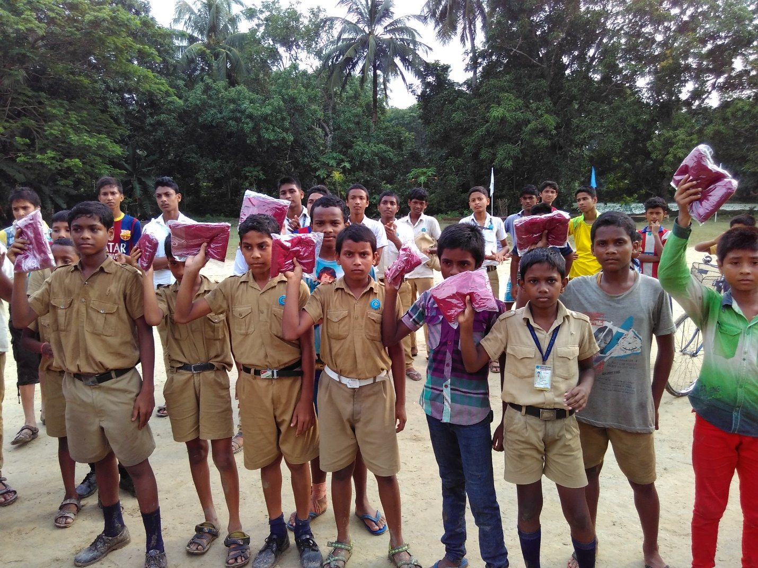

- Uthnau has got approval for commercial power connection.

. 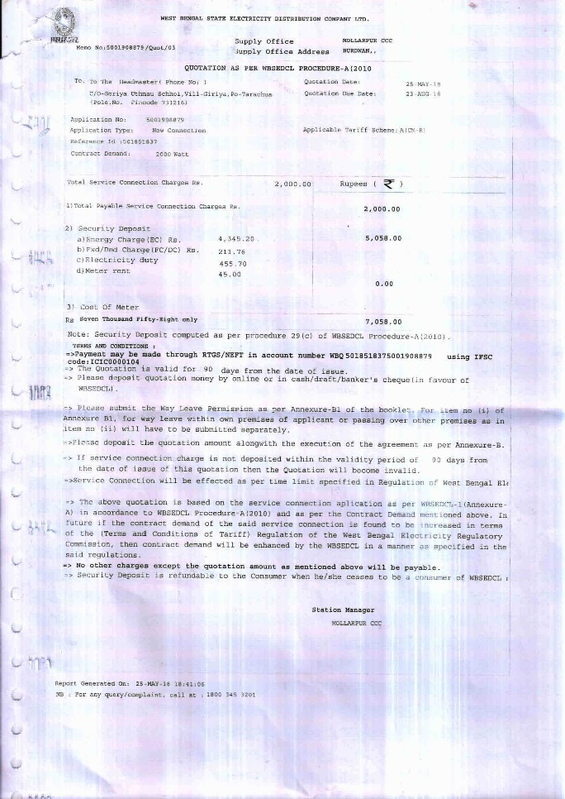

- Two exclusive processed food items of Uthnau: (i) hand milled scented variety of Black rice and (ii) Gluten-free Rice Noodle made of Black Rice. Uthnau is looking forward to having contacts on cloud funds for these Medicinal Rice Products.

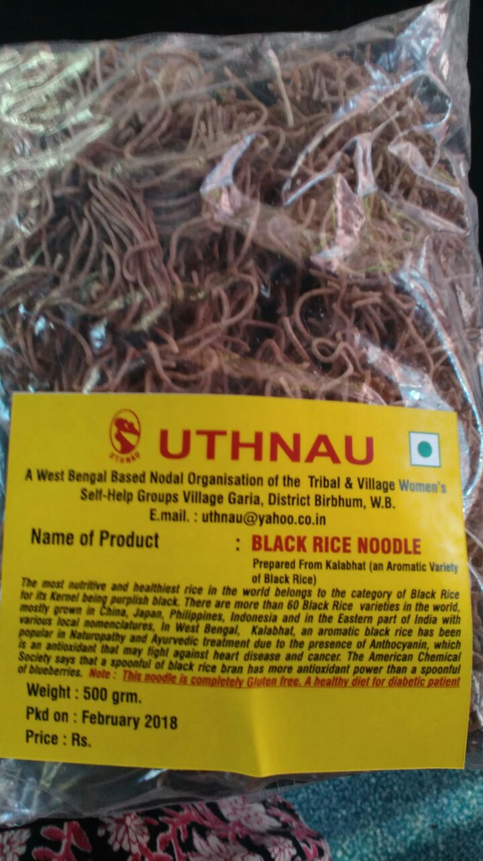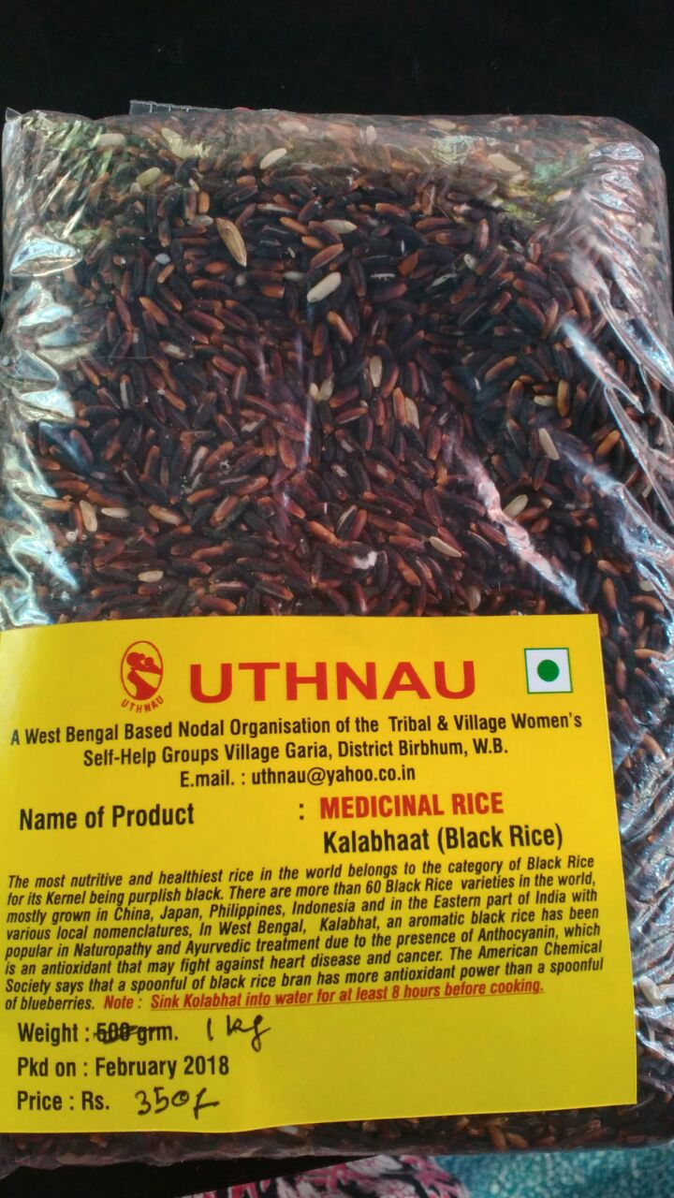
Uthnau innovated a material something like a rope or wire prepared from ‘no-use’ waste by twisting aluminum-layered plastic packets after shredding in pieces. This item has been strong and durable, and by adding its use vale, some stubborn non-recycle-able waste became recycle-able. NTPC has shown interest to procure this wire from Uthnau. But nothing has been finalized, so far.
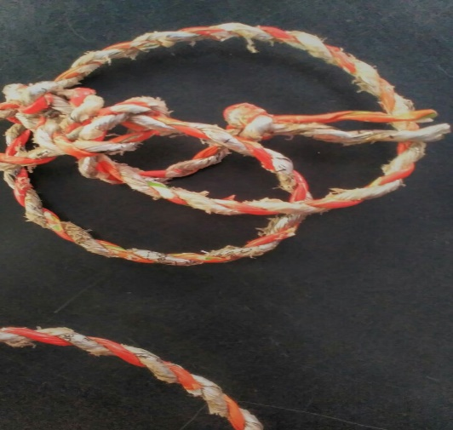
- Uthnau is opening its potentials in the field of Social Entrepreneurship by harvesting its decades long experiences on different life-enriching skills. It has developed a space saving multi layered tower planter for soil-free organic vegetable grow. In the month of March 2018, Uthnau installed successfully four tower planters in the rooftop of a Government owned building. HMIC, Govt. of west Bengal, Mr. Purnendu Bose is watching the growth of vegetables within four weeks after sowing the seeds.

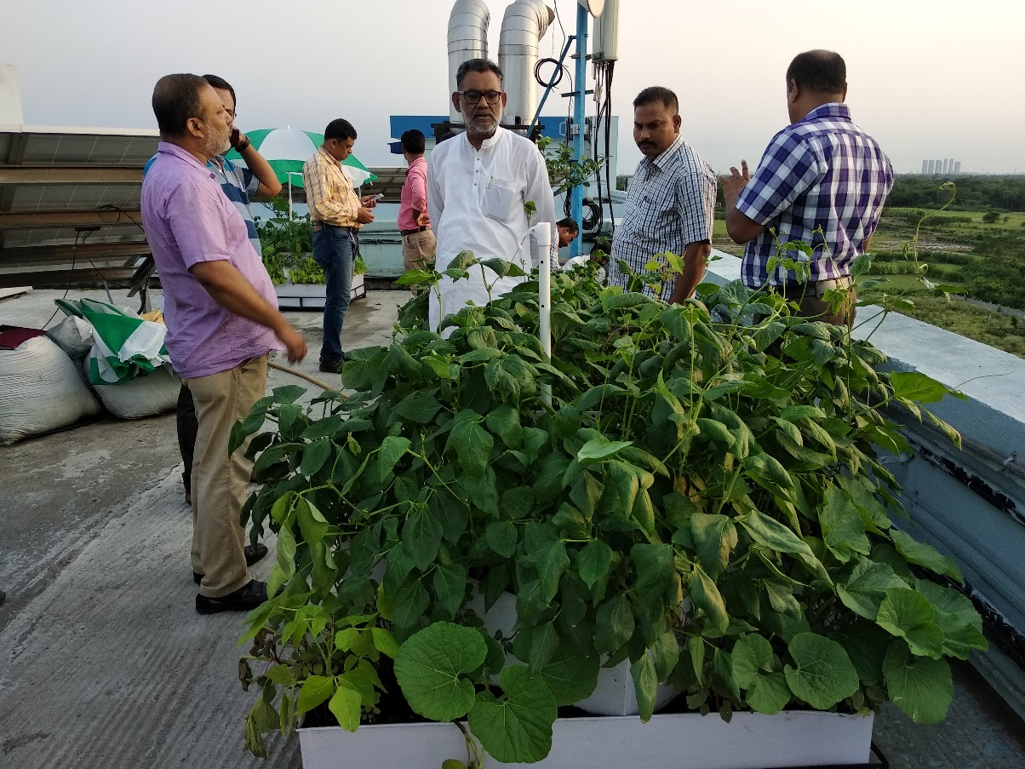

Greetings from Uthnau
