Adhikar (Rights) Site Visit Report
Dec. 28, 2004

Visit conducted by Mona Sehgal (Asha-DC) accompanied by her husband (Kirk Campbell) and father (Lt. Col. R. S. Sehgal).

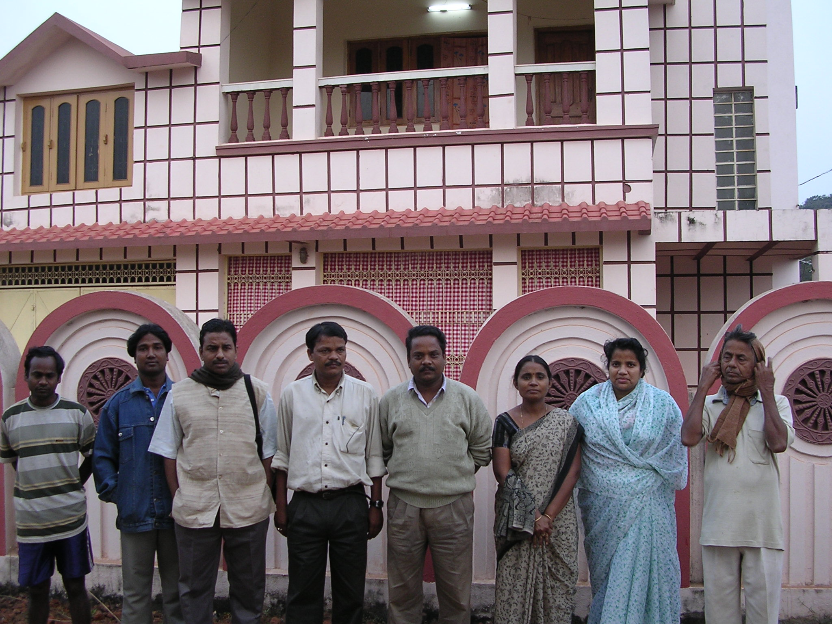
Brief background: Adhikar is an NGO that has been in operation in Orissa since 1993. It is engaged in various activities that are focused on the rights of the weaker and marginalized sections of the society. These activities include women’s self-help groups, education in the tribal areas of eastern Orissa, human rights and legal awareness camps, cyclone and flood relief work, training of social activists etc. In October 2002, Asha for Education committed $16,990 to fund Adhikar’s 15 Non Formal Education (NFE) centers for a 2-year period (Nov. 2002 to Nov. 2004). The funds primarily came from Asha’s Work An Hour fund drive. Asha-DC and Asha-Star (Kamala and Suresh) also contributed funds for this project. Adhikar has been providing regular feedback via written evaluation reports and telephonic conversations. The centers seem to be functioning well and have been catering to some 360 students (short of the 420 students in the original proposal) between ages 6 to 14.
From Right: Staff, Azad, Amin, Subhash, Govind, Madya, Simi, Staff at Adhikar’s Bhubaneshwar office.

The site visit was conducted to observe on-the-ground conditions, including meeting students, teachers and parents; observing student-teacher interaction; getting information from teachers and other Adhikar staff on progress and challenges in running the NFE centers; getting a sense of the area (remote, tribal, needy) in which Adhikar NFEs operate; spot checking Adhikar’s record keeping and management of the program. The visit was announced over a month in advance.

Funding situation: Since Asha’s 2-year commitment ended in Nov. 2004, we wanted to know how the NFE centers would continued to operate. Mr. Mohammad Amin, President of Adhikar, (who goes by “Amin”) said that Adhikar will “mobilize funds” from the local people, especially the parents, because the NFE program has been running for 7 years (2 years funded by Asha and prior to that funded by the government). He said that locals have been paying Rs. 50 to Rs. 100 for self-help group (SHG) maintenance activities in which the NFE teachers are involved. The SHGs started after Asha began funding the NFE centers as Adhikar felt that promoting of income-generating activities among local population, especially women, was important to prevent migration of locals to cities and to ensure that parents would have more resources to pay NFE center fees. Since the teachers are from the local villages, and are often the most educated, Adhikar utilized their skills in helping manage the meetings of the SHGs. Because of the extent of teacher involvement in both NFE and SHGs, Amin expects that teachers will be able to persuade parents to fund the NFE centers. The schools are depending on the villagers for materials, which is not a large amount. If some villages are not able to fund the schools, Adhikar will step in to help for up to 3 months.

Future Asha involvement: Although Adhikar did not request further funding from Asha, Amin was genuinely interested in continuing to maintain a relationship between Adhikar and Asha. I said that Asha also wanted to keep in touch. I encouraged him to contact us in case of any questions or needs. I also promised to notify him of any Asha resources, conferences, or contacts that Adhikar would benefit from.

Getting to the Project site: We undertook a 26-hour train ride from Delhi to Bhubaneshwar. We rested for a few hours in the Adhikar office in Bhubaneshwar (which has a simple but neat guest room; the office doubles as Amin’s residence – top floor – and office), and started for Chandhandi block in Nawrangpur District at 6:30 am. The drive from Bhubaneshwar to Chandanhandi took about 17 hours, an extra 2 hours due to an accident en route. Amin was with us all along and had made arrangements for our travel and lodging.

Organizational structure: Adhikar has 11 members who constitute the General Body, which elects the executive members from amongst them.

Before starting for Chandanhandi, Mohamad Amin (President and one of the founders of Adhikar) held an early morning meeting where I was introduced to some key Adhikar officers, who consisted of:

Subhash – is Adhikar’s secretary. He is a practicing lawyer but provide pro bono service to Adhikar’s human rights and civil cases. Adhikar has helped set up a parallel court system (similar to alternative dispute resolutions system in the US which is faster and cheaper than going to a law court) to resolve civil cases.

Govind – is the coordinator for Adhikar’s livelihood program, whereby farmers are provided assistance including supplying seeds, water harvesting techniques, etc. This program is supported by a Japanese foundation whose members skip a meal to contribute funds.

Madaya – is the CEO of the Association of Cooperatives, now an autonomous microfinance institution, which includes 8 cooperatives that have some 2,500 members. Two cooperatives made a provide of Rs. 5,000 and Rs. 3,000.

Simi – has been working part-time with the cooperatives and is Mr. Amin’s wife.

Site visit observations:

Once we reached Chandanhandi block, we met with two key Adhikar staff:

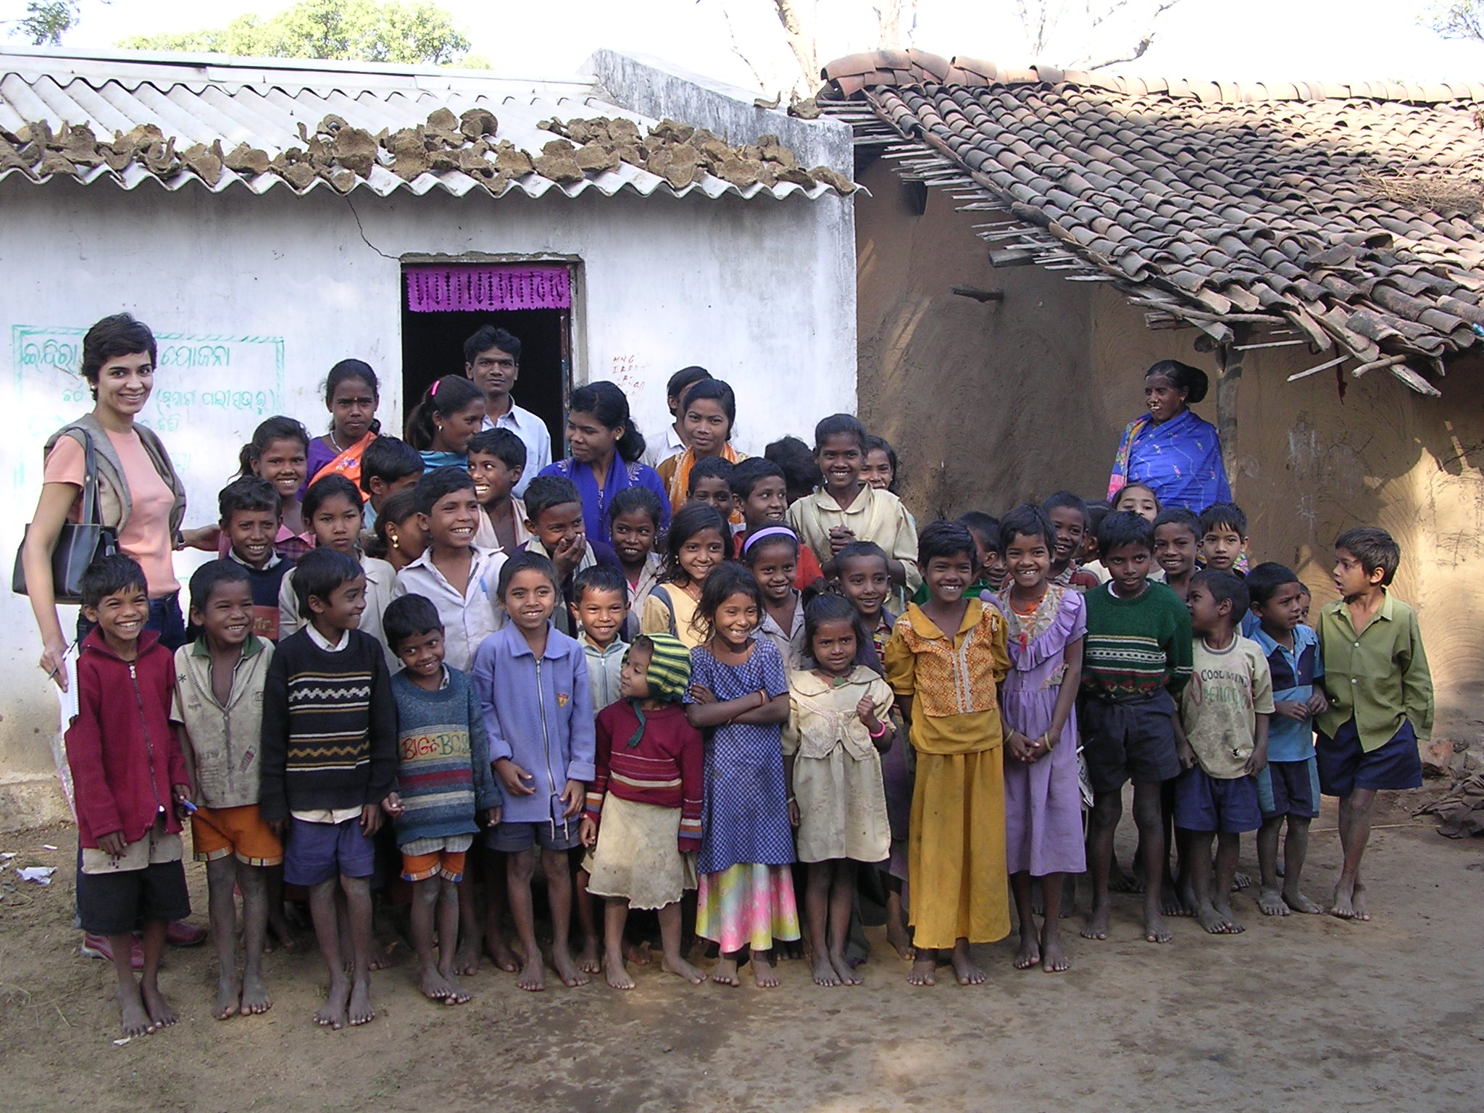
Promod Padhi, Assistant Project Coordinator for NFEs, who is from Chandanhandi and is credited by Mr. Amin for being the energy and drive for various projects in the area.

M.K. Bhanjdeo, the Accounts Cleark, who is a genial person with more English language skills than other Adhikar staff at Chandanhandi.

- We visited 2 NFE centers on Dec. 28, 2004: Bandhakana and Phatki.
Top: Bandhakana NFE center. Teacher in blue salwar kameez in the center of picture.
Due to our late arrival the previous day, we had to visit the centers in the morning, even though they usually operate in the evening at 6:30 pm. Typically children leave their homes at 8:00 am in the morning to work as cowherds and goatherds.

NFE centers | Bandhakana | Phatki
Teacher | Hansuli Bisoi (female); high school pass; very young (16 years old) but seemed competent in handling children. | Pratap Nayak (male); +2 pass; fairly young (22 years old) and seemed a bit heavy handed in treating the children.
Classroom | Sigle room in teacher’s house; was packed with children with ages ranging from 6 yrs to 14 years; about 25 – 30 children were present. | 2 rooms in an unused government building that Adhikar was also using for Village Education Committee meetings; children from grade 1 and 2 were separated into two classrooms; Teacher had one other person to assist him. About 25-30 children were present.
Children | Generally confident and happy; a few could speak in Hindi because of the proximity of their village to Chattisgarh. | Seemed a little tense when they were examined.
Questions asked | I randomly asked children some simple math questions (2 digit addition and multiplication); a younger child read the Oriya alphabet from a chart; asked one child to read words in English alphabet (e.g., APPLE, CAT) later all the kids stood up and animatedly counted numbers sung to a local folk song about a hunter | Asked the 2nd grade children some 3 digit multiplication and division problems (e.g., 126 / 3), about which some children were clueless while others jumped in and answered; then asked all 2nd grade children to write the question, suggested by the teacher, “What name is your village?” A few children automatically wrote the answer instead of the question (this was a tricky question); others struggled to write the full sentence; one child managed to write the sentence without any help.  The 1st grade children recited the alphabet, counted numbers, and one sang a local tribal song.

Parents

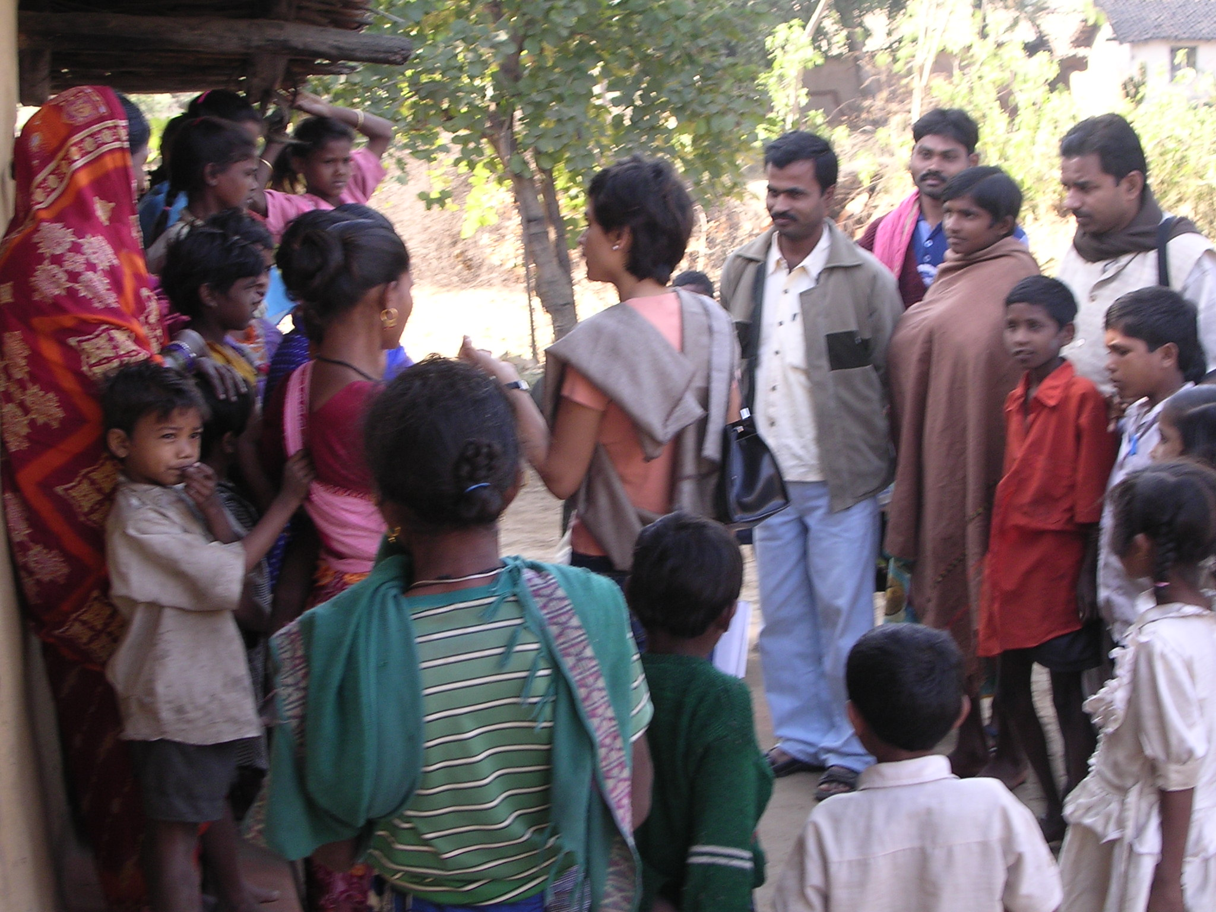
- One parent in Bandhakana said that her child comes home and teaches her what she learns at the NFE center. Adhikar staff claimed that this happened at a larger scale, which has helped increase literacy in the villages from ~20% to 80% as parents can sign their names and read letters. [This percentage seems a bit too high.]

- One parent said that her child cries if he cannot go to the NFE center due to work on certain days.
Top: Mona talks to parents at Bandhakana center. Promod Padhi (Mona’s right) looks on.

Overall assessment & observations

- Considering that almost all of these children have never been to a school, their progress seems remarkable in the 2 years at the NFE school. I was told of one case in the village of Logapada where parents withdrew their boy from the government school and wanted to admit him to the NFE center as children there had learnt more in 2 years than their son had in 4 years at the government school.

- The strain on the children seems high since they go to work at about 8:00 am, eat ‘bhat’ at 1:00 pm, and come home by 4:00 pm or 5:00 pm. They arrive at the NFE centers at about 6:30 pm and study for 2 to 3 hours. They do not get any food at the center. But from talking to the parents and children it seemed that school is a welcome place and children like to go to the NFE centers.

- The NFE centers had some board games, which children play once a week. I also saw a video of an annual day organized by Adhikar where children competed in sports events in an inter-village competition. To encourage students, ‘best student’ certificates were also awarded to students from each village.
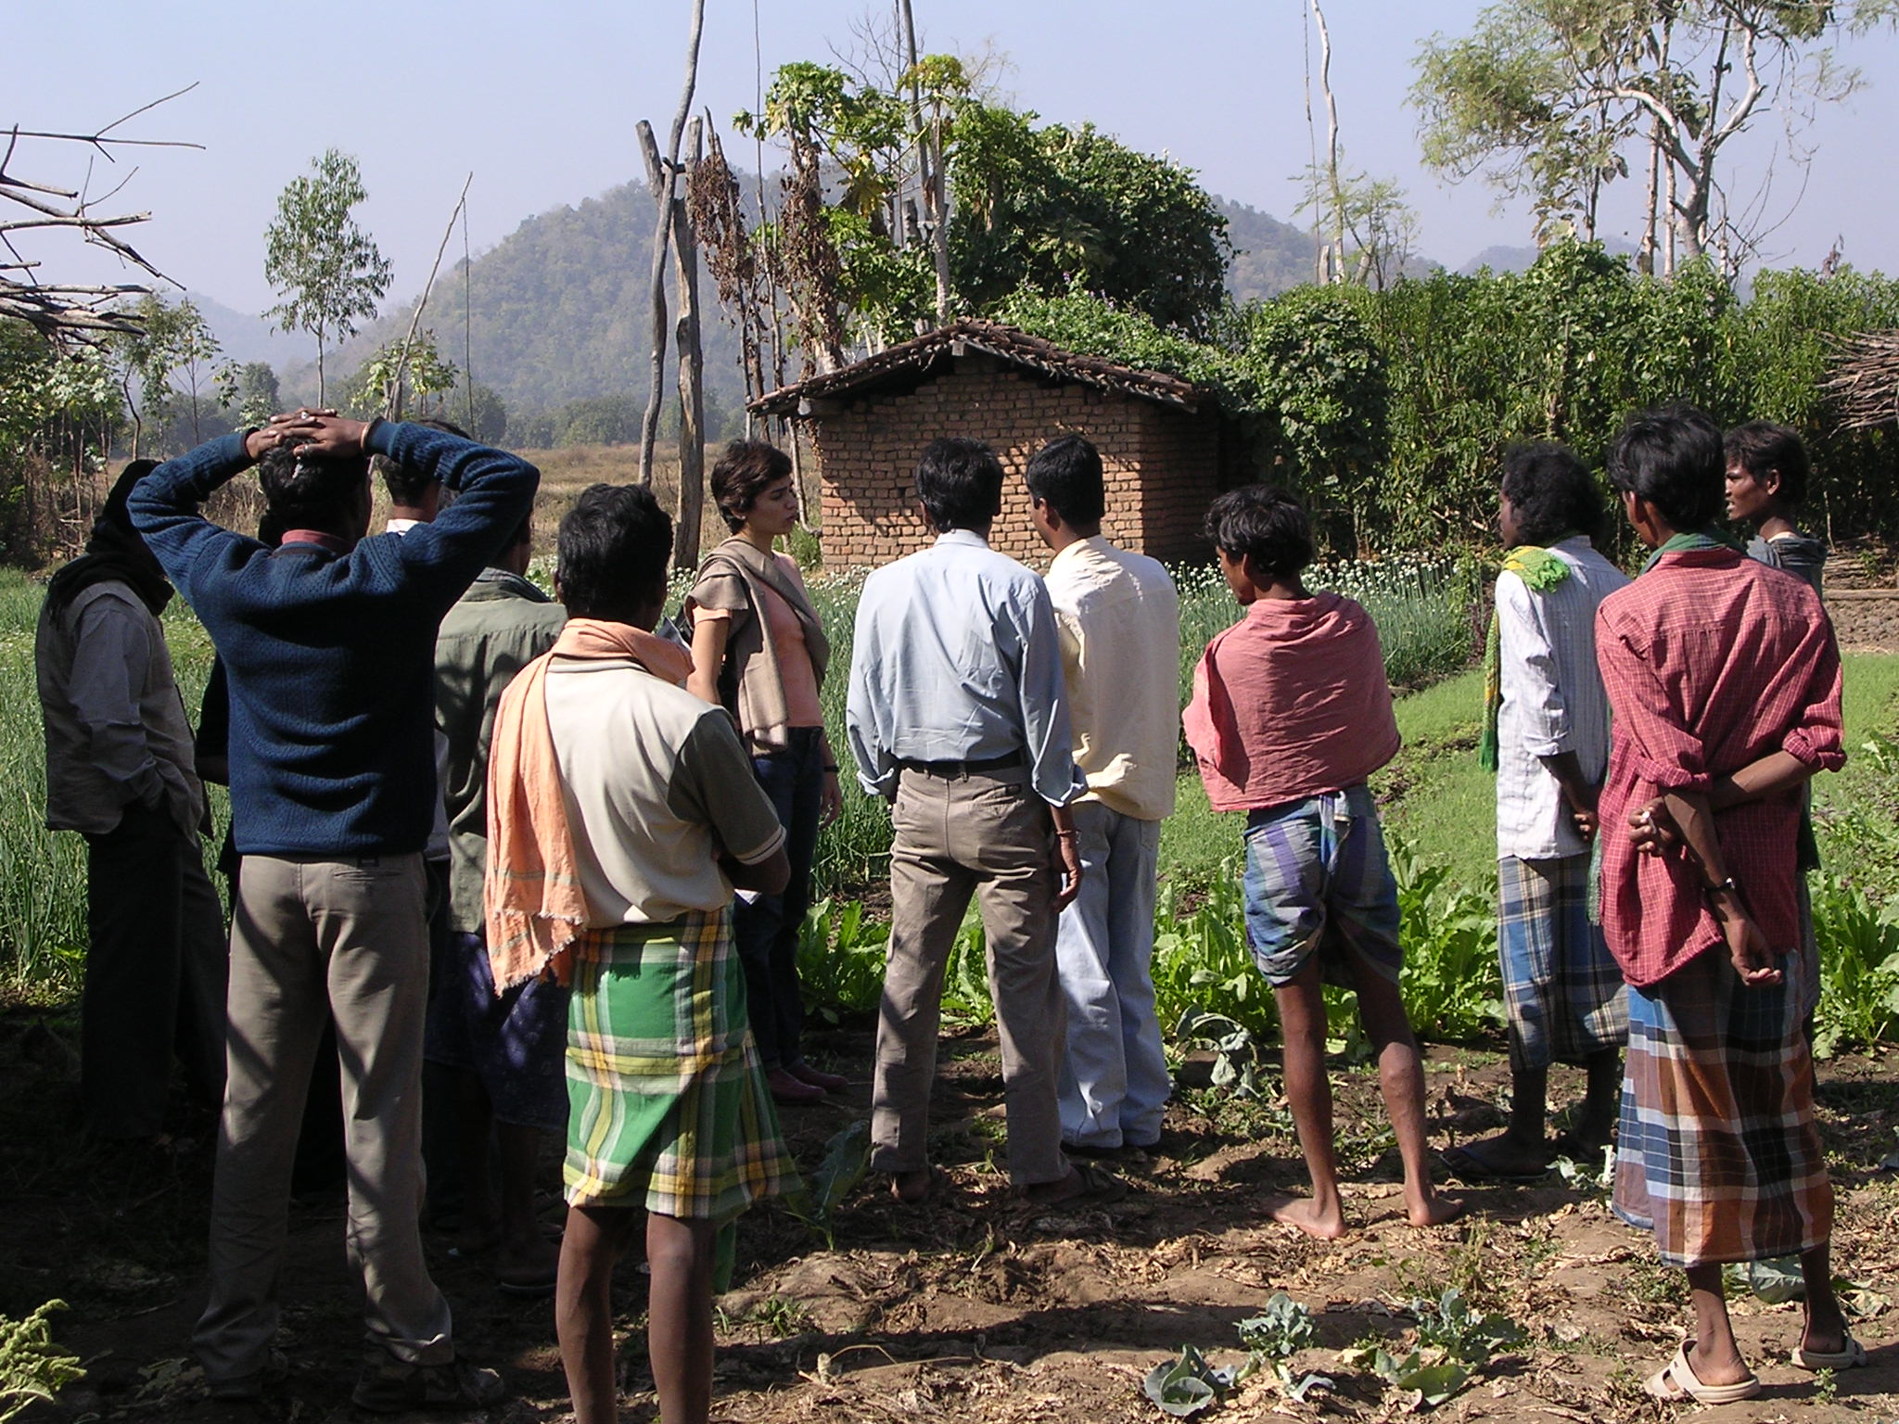
- Chandanhandi block is extremely remote and has extreme poverty – starvation deaths are not uncommon. High migration rates among villagers who tend to move from village to forests or go to other areas in search of work – this affects children’s attendance of NFE centers. Farming methods seem primitive – very small land holdings that are watered/irrigated through an old (but sustainable and environmentally friendly) mechanism. Paddy fields are common when agriculture is possible, there is land is covered with forests (protected under law), huge tracts of land are too rocky to be cultivable. Rice, though commonly grown, is still considered a luxury. Locals consume variety of daals and dried fish.
Top: A small farm with various vegetables grown by members of Adhikar SHG in Phatki village.

- Adhikar has encouraged cultivation of other crops such as onions, radish, etc. through loans to SHGs.

- The homes of the villagers looked neat and clean, but the government building (where we stayed) was extremely dirty and unkempt.

- On our way from Bandhakana to Phatki we saw the local shaman in a small procession. Adhikar staff considers him extremely most exploitative, and villagers try to appease him rather than spending money, e.g., for medical help in case of a health problem.

NFE center teachers and staff

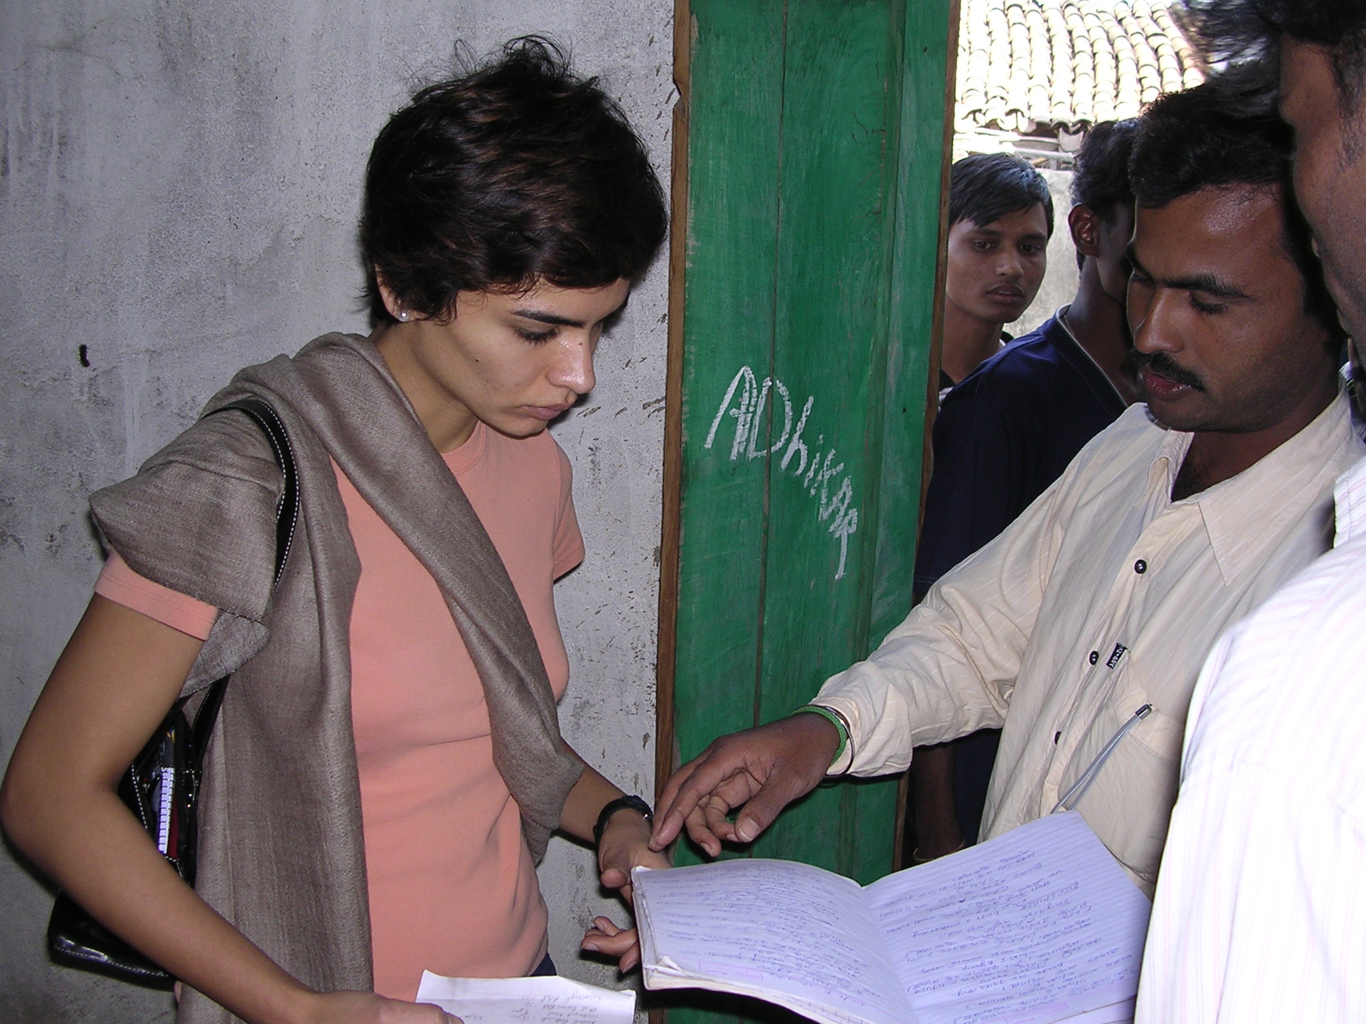
Toward the end of our half-day visit, we met with 14 NFE teachers (one was sick), 3 supervisors, the Assistant Project Coordinator and Accounts Clerk. Most of the teachers were relatively new, but a few had been with Adhikar since 1997. All the teachers introduced themselves and provided the number of students in their class. Some spoke a little English. There were 4 female teachers. All of the seemed sincere and committed. Some were very more outspoken and spoke enthusiastically about their desire to improve conditions in their village. On the teachers’ insistence, my father, my husband and I also said some words. My father, being an ex-army officer and a believer in working with ones hands, asked them to create a congenial physical environment around the school by involving the children in keeping it clean and planting flower-bearing plants.
Top: Mr. Promod Padhi shows records of students maintained at Phatki center.

- All NFE Centers submit a monthly 2-page progress report that summarizes key events including student attendance, drop out, etc. I have requested Amin to provide us a translated copy.

- Teachers also meet with the Village Education Committee regularly and try to resolve school related issues. For example, asking parents to send their children regularly. In one village, someone had died and the parents did not want to send children to school in the evening believing that the dead person’s soul was still wandering in the area. The teachers had to work with the VEC to convince the parents that the children would not be harmed and that they should be sent to school.

While driving from Bhubaneshwar to Chandanhandi, I asked Amin about a host of issues, which are enumerated below.

- Social and economic conditions: According to Amin, corporations such as ALCOA and Hindalco were engaged in bauxite mining in Kolapur district. The Government has not conducted land survey, so people have been unable to establish legal rights to the land on which they have been staying. Amin felt that the government has provided support to mine owners in the name of development. For example, roads have been built to facilitate mining activities rather than help the villagers. Because of these inequities Naxilites have been very active in the area, especially in Malkangiri district that is virtually controlled by them.

Amin added that many people have been displaced by river dams, such as Hirakud (1956) and Indravati. The government claims to have given advance notice to the people, but people have not received compensation. Some cases in more recent times have been offered compensation amounts that were decided decades ago.

- NGOs in India: Amin said that there are 2 main types of NGOs, those who are close to the government and those who operate by mobilizing foreign funds. The former often end of working with the government and getting funds to implement projects. Some of these organizations pay money to bureaucrats to get projects. He said that NGOs often do not have good relationships with each other. Some of the differences are based on ideological differences, such as those who agree with the current model of development vs. those who don’t.

- Orissa government’s approach to NGOs: He said that the Orissa government is trying to exert more control on the NGOs based on the allegation that NGOs are corrupt. Amin said that there are already existing laws to regulate NGOs, so there is no need to create more laws. Amin suspects that the government’s actions are inspired by the work of some NGOs who have mobilized local people against mining and dam projects. Amin also felt that the state’s actions have also been at the behest of corporations that provided funds for elections. To fight government’s attempts to formulate a new law regulating the NGOs, the latter have organized themselves collectively under Orissa Vikas Manch, which is publicizing the work done by NGOs through methods such as organizing exhibitions in Bhubhneshwar. However, since the formation of the Manch there has also been a lot of police inquiries and harassment of NGOs.

- Accountability and transparency: On the questions that the government can be held accountable by the people, where as NGOs are not under as such scrutiny and may be less transparent: Amin said that government’s accountability to people should come forth in its actions, however government allows for corruption. For example, community development blocks collect a percentage of funds allocated by government for development work. The NGOs are bound by laws and systems that ensure accountability and transparency. For example, NGOs have to produce annual audit reports; in case of any complaints against NGOs the Department of Home Affairs can conduct audits. Amin acknowledged that NGO’s greater flexibility in operations gives bad NGOs a way to make money. But there are few such groups. Further, many bad NGOs have been punished – for example, their registration has been revoked. He said that development use to be the purview of just the government, but is also share by civil society now.

- How can groups like Asha help: Amin said that poverty is not about lack of resources. For example the forests are rich in Non Timber materials such as anwala (a fruit). These resources should be left to the people by protecting the forests. He said that higher incomes may not necessarily help as there are leakages such as the need to bribe, liquor consumption, etc. To address these issues there is a need for all round development approach. He said that groups like Asha can play a coordinator/liaison role. Amin gave the example of help extended by AID in a case where an activist was murdered and no action was taken by the police. Amin talked to some AID volunteers on the phone, who then organized a petition which was signed by over 100 AID volunteers across the world and was sent to India’s Human Rights Commission (HRC). Within 24 hours of receiving the petition, HRC took action that resulted in the capture of the murderers. Amin said that NRIs can exert a lot of influence and pressure on the government, because the government does not want certain issues to get too much external publicity.

Amin also said that a number of groups are working on model education schemes. Tribal culture is very different from coastal culture, so the stories and pictures needed for education in these cultures will be very different. Amin said that groups like Asha can fund NGOs that create books and cultures sensitive to local cultures. Agragami, based in Raigarh, Korapur District in Orissa, has been involved in providing training to Adhikar staff. [Amin mentioned the name of Paulo Frier (?) a German philosopher who wrote a book on adult education.]

- NFEs vs. formal schools: Amin said that NFE centers are better than no schools, but the formal schools are the only recognized system. He said that people need to mobilize local village institutions including education committees. However, it takes very long to influence the system, hence the need to have a parallel system that can have a demonstrative effect. Once people see a system functioning outside the government, then they will hold government responsible.

- Village Education Committees (VECs): When asked about the effectiveness of VECs, Amin said that some VECs are functioning well but on a large scale VECs tend to be very politicized. The problem is exacerbated in certain villages where male members of the family migrate out for months in search of work, leaving women-headed households. He said that in many villages people are so poor that education is of a secondary concern to them.

***

