Mandra Lions Club Visit – Asha for Education – September 29-30, 2016
By Padmanava Sen (Asha Bangalore volunteer, padmanava.sen@gmail.com)

Summary of visits to Asha projects with Mandra Lions Club:
- Visited pre-primary centers at Ghorabadha and Sindhri (29th, 8 am to 10 am)
  - Interacted with students in the age group 3-6
  - Noted their teaching methods
  - Asked simple questions and watched how teachers teach the students

- After school center visit - Susnidhi in Ayodhya hills (29th, 2 pm to 4 pm)
  - A remote village more than one hour away from Bagmundi
  - Focus on bridging the language barrier between Bengali and their mother tongue (Saotali)
  - Interacted with students via simple academic games and questions

- Meeting past students of Pre primary and after school (29th, 7 pm to 9 pm)
  - Asked about their current status and career aims
  - Discussed how the centers helped them
  - Played chain math games

- Meeting teachers of pre-primary and after school centers at MLC Bagmundi center (29th, 9 pm to 11 pm)
  - Discussed the current requirements and what can be better

- After school center at Nischindipur and Pardi (30th, 8 am to 10 am)
  - Interacted with students via simple academic games and questions
  - Discussed with Teachers about scope of improvements

- Meeting mothers of Sindri Pre primary center (30th, 2 pm to 3 pm)
  - Discussed their take on Government ICDS versus the pre-primary centers
  - Role of teachers in creating awareness among mothers and getting students into the center (who are not going to ICDS or ppc)
Apart from all these, visited NREGS related villages and sites for projects supported by AID USA.

Detailed Visit Report:
I have reached BBM Station around 4 pm and reached Bagmundi by 5-30 pm. I was received by Somnath Singha Roy from MLC. I have met other MLC members at their office of Bagmundi. We went through the plans of visit and Mr Roy gave a detailed account of how MLC was started in 1980s and their work has spread in the areas of Ayodhya hills in 1990s with the help of CRY. He also explained the need at ground and how Asha and AID got involved. He mentioned his involvement in national campaign for inclusion of students beyond the 6-14 age groups.
Main goals of the pre-primary centers are to overcome the shortcomings of ICDS and bring the needy students at par with others in primary schools. The after-school programs run mostly to train students for formal schools after their school hours. Most of after-school students have mother tongue as Saotali (tribal) and have considerable difficulties following their classes (in Bengali) in Govt School. Government regulations started employing one teacher with local language expertise but that is not enough. MLC observed the Class 3 and 4 students needing most attention and their para-teachers are from the same villages trained to bridge the gap. They follow books in alchiki scripts (saotali language) and the after school teaching focus a lot on Bengali. I have noticed the Class 4 students being much more fluent in Bengali than Class 3, which shows the effectiveness of this program. In other areas, where Bengali is mother tongue, the after school centers are run to speed up the weak students and among them, some are admitted to schools after others (age 6,7..).
Pre-primary centers:
On September 29th, first, I visited the pre-primary center of Ghorabadha. The teachers were telling poems to them and the kids were counting numbers using beads.The teachers showed me the reading materials.
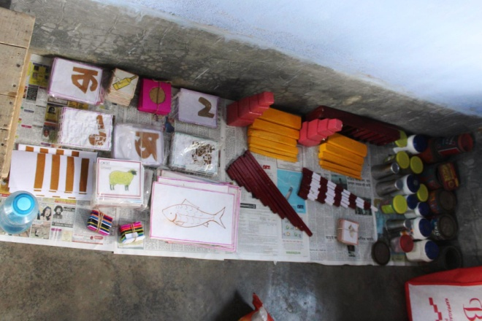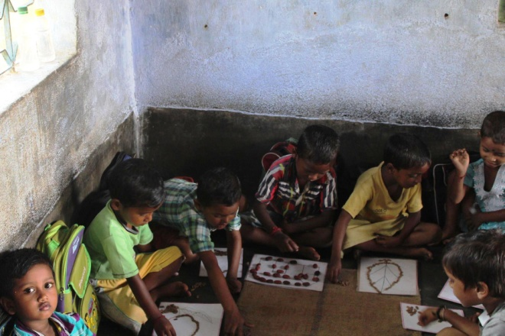
Teaching tools and students at Ghorabadha Pre-primary Center
They use flash cards for languages. Numbers are introduced via Beads as well as striped sticks (check the picture). Via different blocks, small-big, long-short and other concepts are introduced. I later came to know, some of these teaching methods are given by Bikramshila and Swanirvar. I reviewed all the teaching items including the small & big alphabet cards, picture cards to introduce to words. I asked the names of age group 3, colors/alphabets with names in age group 4-5. Before 10 am government primary school, they run the center. Some government teachers initially resisted but with local intervention, everything is working well now.
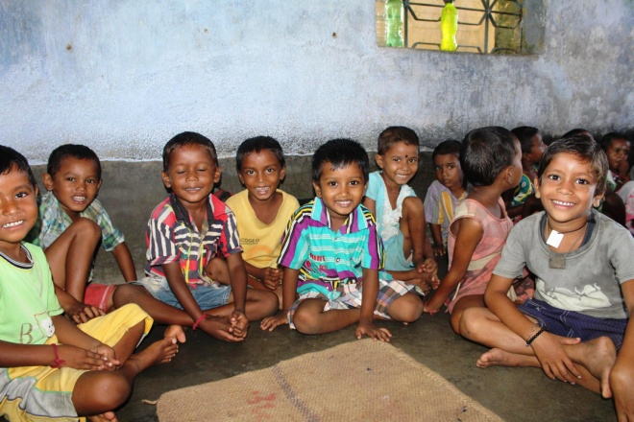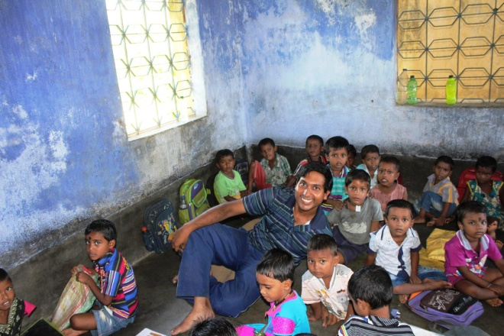
Ghorabadha center kids smiling and they pose with me (Padmanava)
Next I visited the Sindri center. This is in someone’s house. The materials are same and I played simple games with them (like pointing the alphabets and simple counts). Also, I told them to tell their names which almost everyone did. I saw around 40 kids. I talked to a teacher who is working in this Sadarpar Aloke Kendra since 1998. In this centers, usually biscuits are given to kids.
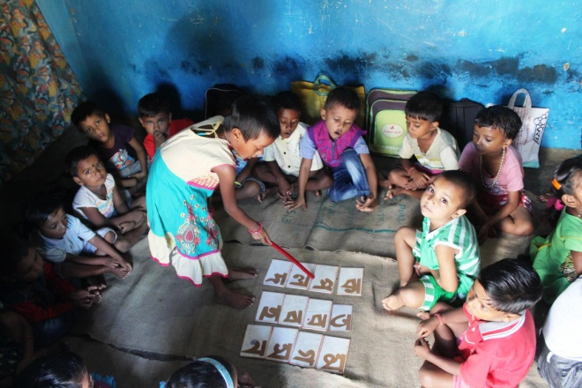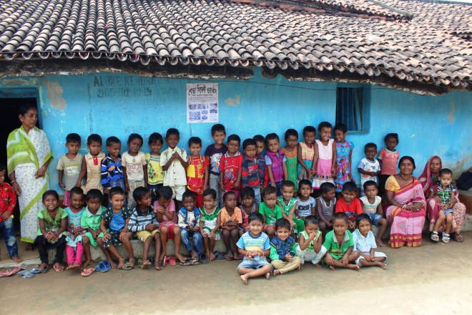
Some demonstration of alphabets and the group of students at Sindri center
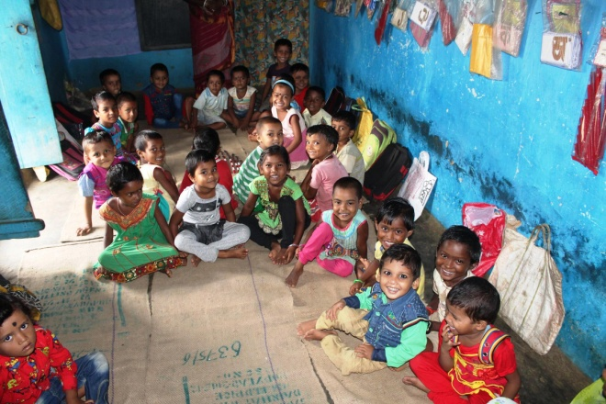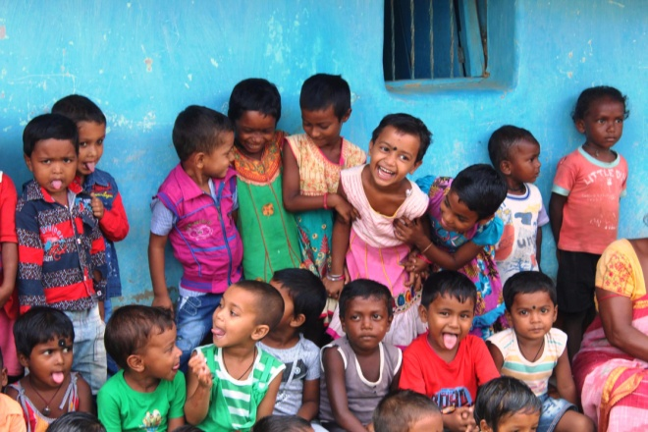
Smiles all around in the center
Next day, 30th September, I discussed with mothers of Sindri pre-primary center. Their main request is to give nutritious food as ICDS gives good food (Khichdi most of the times). Even with the difference, they still want to send their kids to MLC centers because
- The parents understand the difference in quality of education. The kids find these way of learning fun and love to come to this center
- In ICDS, they do not teach and they do not take care of health of kids as well. In MLC centers, they not only teach alphabets, numbers but other things like cleanliness, health awareness.
- The teachers of center take exception care of kids and sometimes bring the kids from their homes as well. They encourage everyone to send their kids to schools.
- Due to the creation of mothers group, lot of things improved in villages like regular tika, better maternal health, getting birth certificate for all kids and making sure the ration shop is open 3 days instead of 1. MLC has played a good role in this.
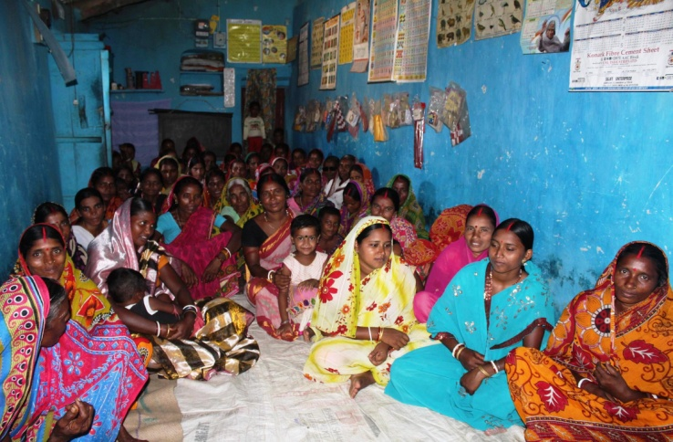
Discussion with Mothers of Sindri Pre-primary center
On September 29th, I have also met students in Bagmundi village who have studied in the pre-primary centers running for more than 10 yrs. They are in class 7 to 10 mostly with 2 being in colleges. First I played memory game and chain mental math games as icebreaker. I asked them few questions like their career goals, the subject they love the most and the subject they hate the most. Asked a few questions in an informal way about their favorite subjects and told them to understand what troubles them in the most hated subject. I stressed on the fact that without knowing the root cause of their problem with Math and English (most troubling subjects for the students), they may never excel in them. I also enquired if they know the formalities of their career path like how they can become nurse, crpf, police or engineers as they mentioned. Most of them know the path. Then I discussed about the importance of education and all the subjects taught (connecting the subject to their career skill-set requirements).
Then I asked the kids what they learnt well from the pre-primary center. They learnt colors, numbers, alphabets, environment, games, concept of weight, discipline, cleanliness, respecting elders, how to cross roads etc.
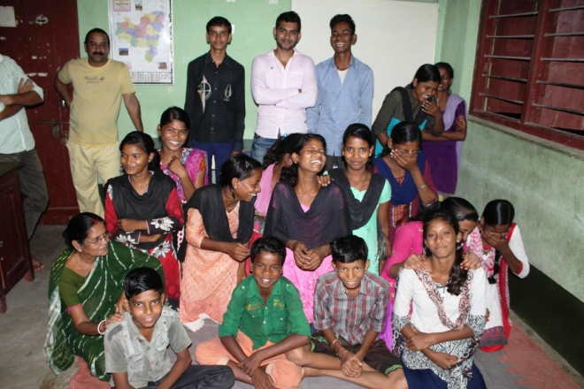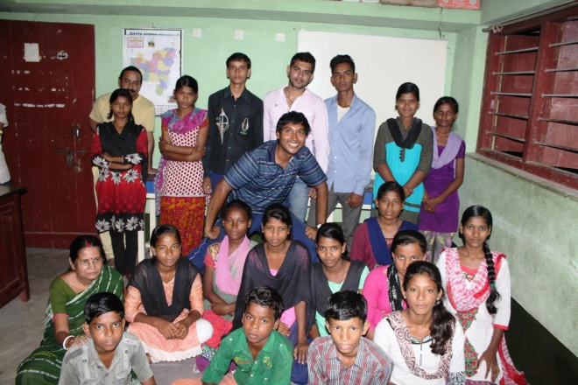
Smiling children & Somnath Singha Roy without and with me (Padmanava)

After school centers:
On September 29th, I visited the after-school center at Susnidhi. Susnidhi is more than one hour away from Bagmundi, crossing the upper and lower dam at Ayodhya hills. Only recently the roads are built in the interior. It used to be a tedious motorcycle ride in early days of center. Most of the families depend on dry wood selling as the farm land is not much. Their mother tongue is Saotali and that is why MLC is taking active role in bridging the gap. They teach from books written in Alchiki script and teachers are from the same village. The school happens in the same building after the Government school hours. The students come from neighboring villages like Ghoradi, Dongridi, Saramchaki etc. Then I told them to say A to Z opposite order, math tables in opposite orders, naming things in classrooms in Bengali and English, words with first letter in English, simple phonic senses.
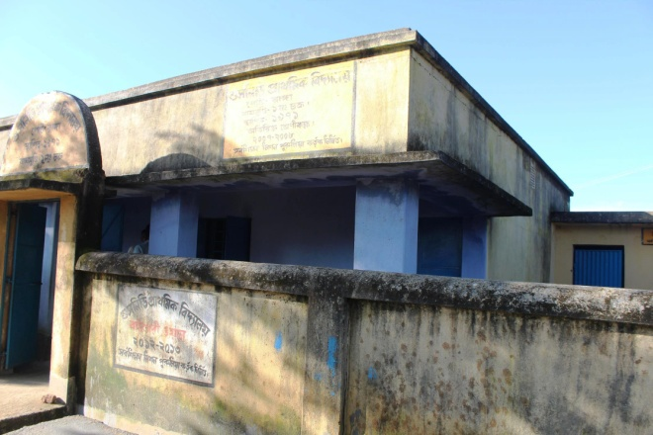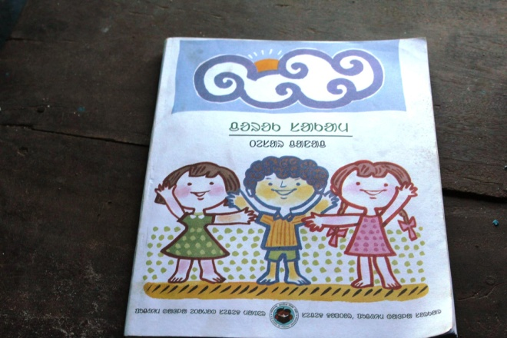
The School Building and the Saotali book taught
The class 4 kids seem to be more fluent in Bengali than the Class 3 kids which shows the improvement due to one yr in the center. The Government teachers use to teach only in Bengali and that is causing a lot of backlog for the kids. After some government rules, there is one local teacher who can speak Saotali but the gap still remained. I spent some time with the kids, asking them to name 4 trees, animals etc. Plus I gave them simple math problems to solve; they read Bengali prose and some English games. Few students sang songs.
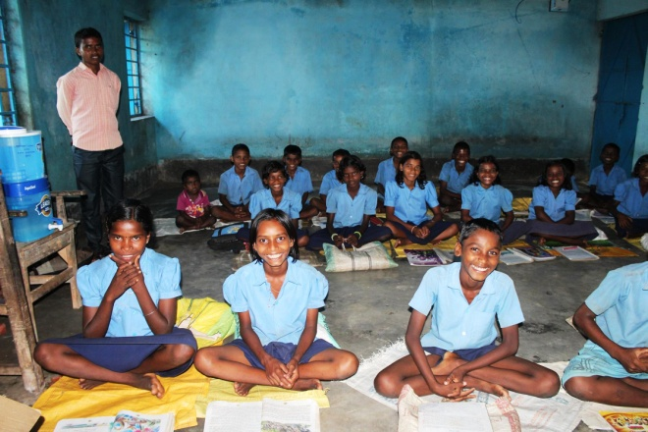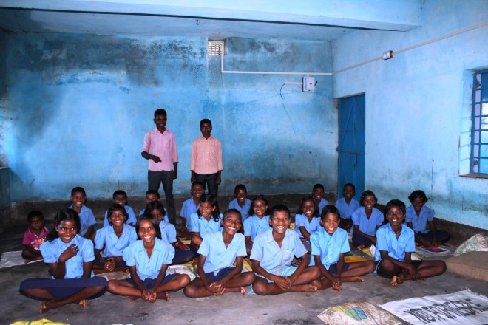
Smiling Children with their teachers
On September 30th, I visited the after-school center at Nischintapur (close to Bagmundi) and Pardi (40 min drive from Bagmundi towards Balarampur). Kids in Nischintapur center being close to Bagmundi seem to know a little more than the remote centers. Pardi is a remote village where almost everyone seem to hail from families with very less means. Without a sustainable NREGS work income, they have to depend on selling dry woods and small vegetable farming (Not all). Almost in every center the numbers of Class 4 kids are less due to some age rule change of Government 3 yrs back. Pardi school building has a good playground in front of it. Nishchintapur has Bengali speaking population whereas Pardi has mostly Saotali speaking students. Nischintapur Kids can read Bengali well though slow, their English knowledge is limited to alphabets (for class 3).
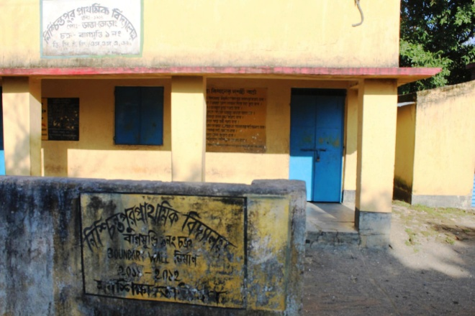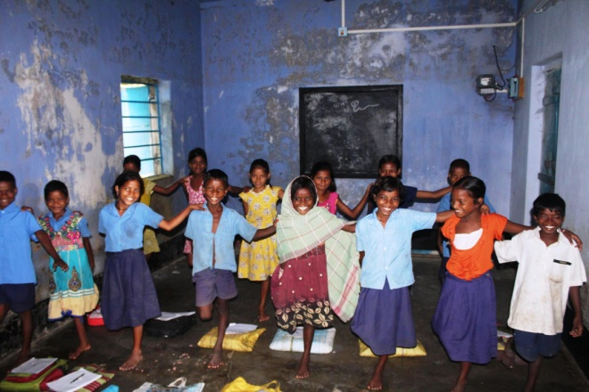
Nishchintapur Center and Kids
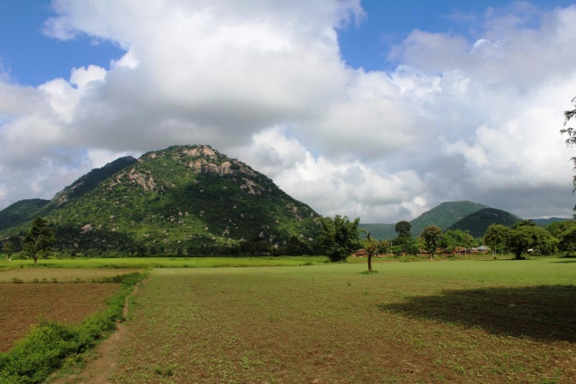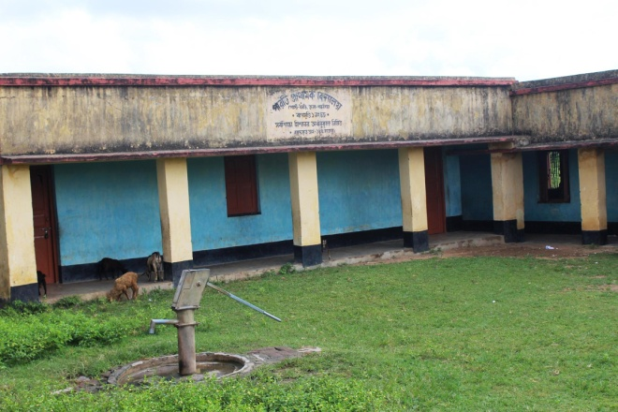
Pardi Landscape and the school building
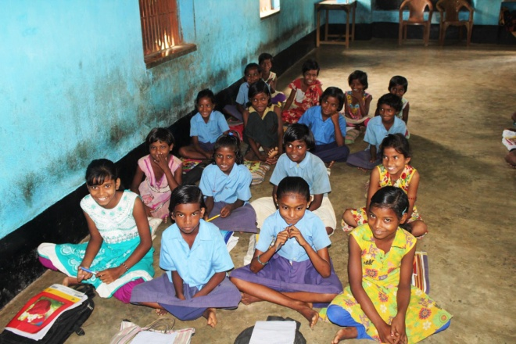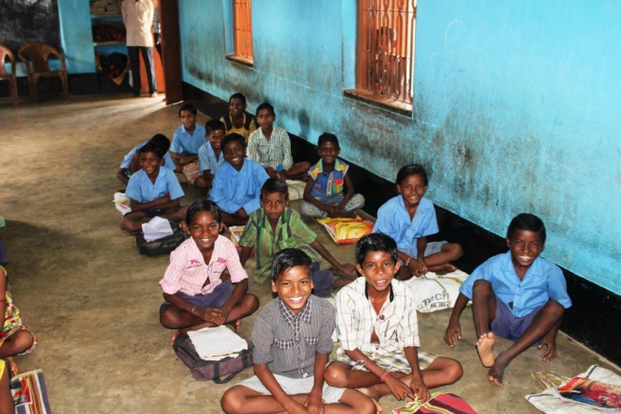
Class 3 Kids in Pardi
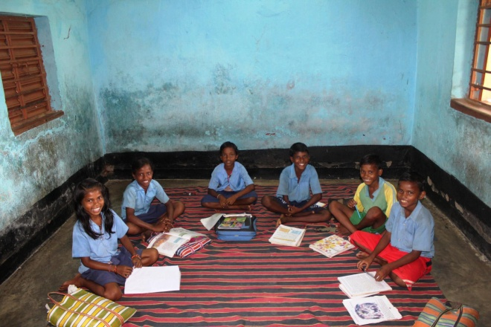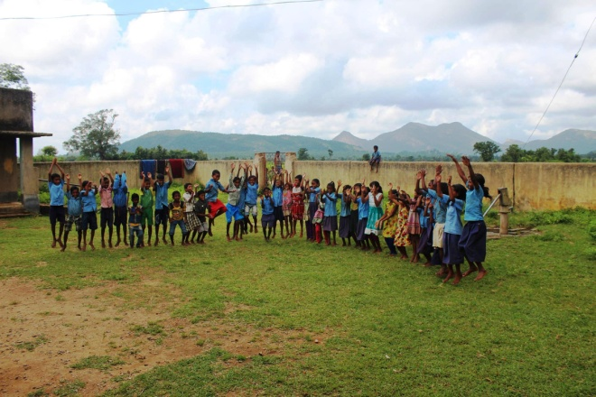
Class 4 kids and all kids jumping in Pardi
Some of the after school centers run before School hours and the teachers ask for simple snacks as otherwise there will be a gap till 1pm. The teachers at these centers are in touch with the Government school teachers. The Saotali books are available till Primary (Class 4) but there is minimum scope beyond that to continue studying in Alchiki. Also, the Government school teachers follow Bengali books and the after school centers follow the saotali books to connect them with the materials.

Discussion with Teachers:
On September 29th, I have met 10 after-school center teachers and six pre-primary center teachers in the MLC campus. We discussed their efforts and anything needed to strengthen the current program. Also they mentioned the good out comings of teacher- parent meetings. Also it has created better awareness among the parents of villages with higher illiteracy rates. The residents of remote villages are facing a lot of financial constraints due to Government ruling against woods cutting or stone breaking, alternative options to wood burning for cooking, dearth of arable lands in hills as well as intermittent assignment of NREGS work.
The pre-primary teachers mentioned:
- Food at par with ICDS should be given.
- Some centers may need simple improvements to host more kids

The families mostly depend on farming and nregs work. Some of them do not have toilet at home. I personally believe giving good nutritious food (at par with ICDS food) to these kids will be a good add-on.

The after-school teachers mentioned the following:
- If possible extend the classes to Class 2 as well since some students are directly admitted to schools like Class 2 and 3. For them these bridge classes will be very essential before they enter upper primary at Class 5 (Bengali medium)
- Teacher training once a year
- Food for the centers that run in the morning
- Need of materials development in Saotali language (since Bengali is like a second language for them, it is better to develop more materials to bridge these two languages).
- One excursion if possible with the students
- Need of a program for students from those villages to help them continue education as after reaching legal age of work, the needs of family force them to leave education at Class 7/8 (40% overall). The drop-out rates are evened out across genders in those remote villages and girls are not getting married under-age.

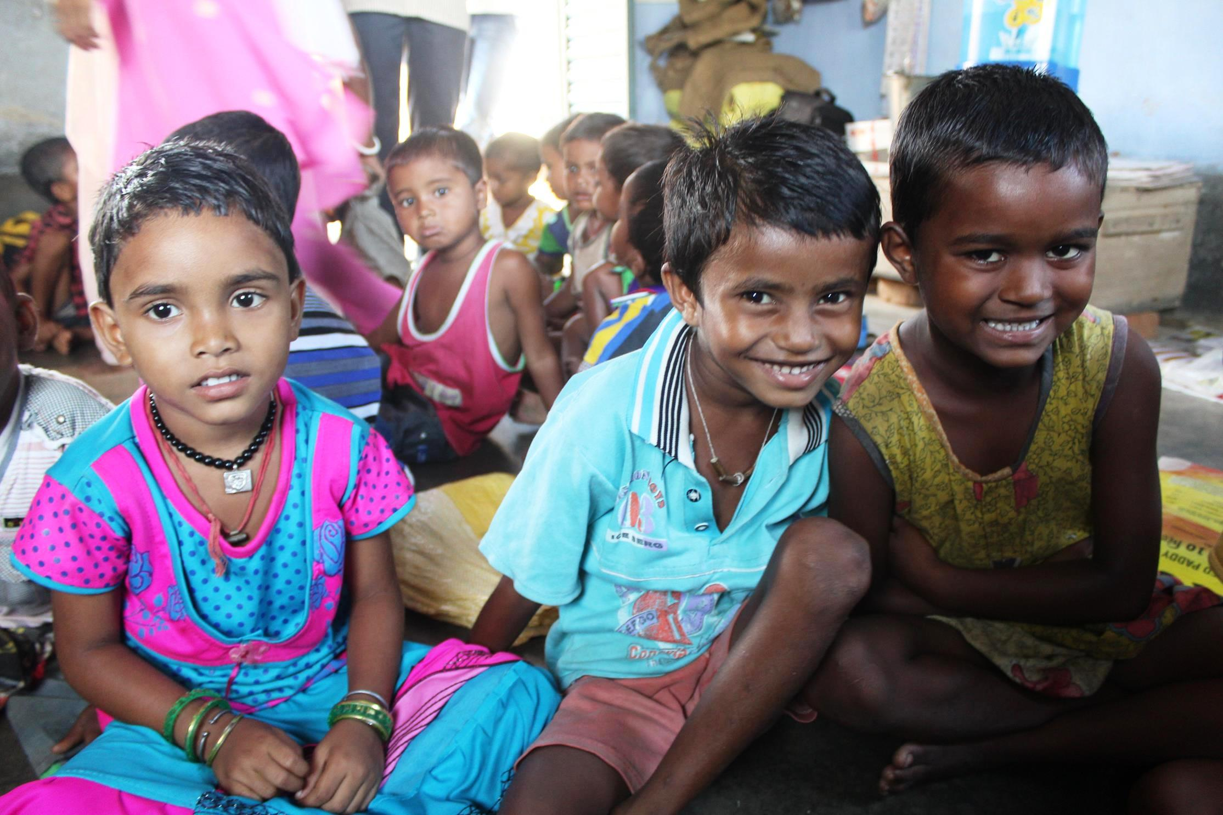
I left Bagmundi, but their smiling faces did not leave my mind.
- Padmanava Sen (padmanava.sen@gmail.com)

