Half Yearly

April 2018 to September 2018

Supported by:

USA

Implemented by:

Saradapally
Baghmundi, Purulia
Pin no. 723152
E-mail – mlconline@rediffmail.com

MANDRA LIONS CLUB honoured by Spirit of Humanity for their SCHOOL IN BAG initiative for the tribal children on education category for the year 2018

EDUCATION
General Information:-
No. of students sex wise (Class III)
Sl. No | Name of the centre | Student |  | Avg. Attendance |  | Working days | % of attendance
 |  | Boys | Girls | Boys | Girls |  | Boys | Girls
1 | PARDI | 12 | 13 | 1033 | 1121 | 132 | 65.21 | 65.32
2 | SUSNIDI | 05 | 03 | 434 | 275 | 132 | 66.00 | 69.44
3 | HATINADA | 05 | 07 | 452 | 632 | 133 | 68.00 | 68.00
4 | JILLINGSERAG | 04 | 07 | 333 | 582 | 129 | 64.16 | 64.45
5 | USULDUNGRI | 09 | 05 | 786 | 449 | 131 | 66.00 | 69.00
6 | VITPANI | 03 | 04 | 275 | 372 | 132 | 69.44 | 70.45
7 | NISCHINTOPUR | 05 | 05 | 461 | 471 | 130 | 70.00 | 71.36
All over status |  | 43 | 44 | 3774 | 3902 | 131 | 67.00 | 68.28

No. of students sex wise (Class IV)
Sl. No | Name of the centre | Student |  | Avg. Attendance |  | Working days | % 0f attendance
 |  | Boys | Girls | Boys | Girls |  | Boys | Girls
1 | PARDI | 07 | 06 | 618 | 556 | 132 | 67.00 | 70.20
2 | SUISNIDI | 11 | 06 | 979 | 541 | 132 | 67.72 | 68.30
3 | HATINADA | 10 | 07 | 913 | 648 | 133 | 69.00 | 70.60
4 | JILLINGSERANG | 01 | 08 | 87 | 625 | 129 | 67.44 | 60.56
5 | USULDUNGRI | 08 | 08 | 721 | 730 | 131 | 68.79 | 69.65
6 | VITPANI | 04 | 06 | 342 | 527 | 129 | 66.27 | 68.08
7 | NISCHINTOPUR | 07 | 05 | 634 | 410 | 130 | 69.67 | 63.04
All over status |  | 48 | 46 | 4294 | 4037 | 131 | 67.98 | 67.20

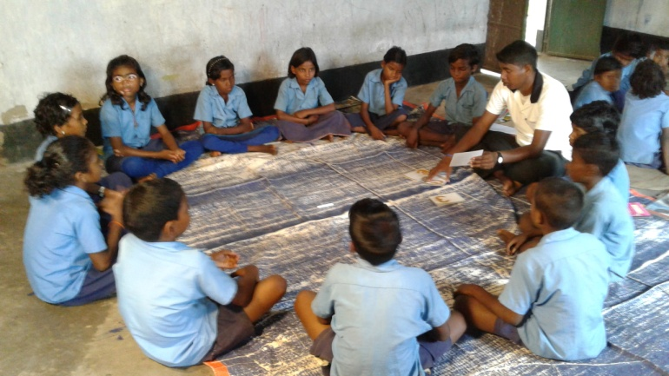
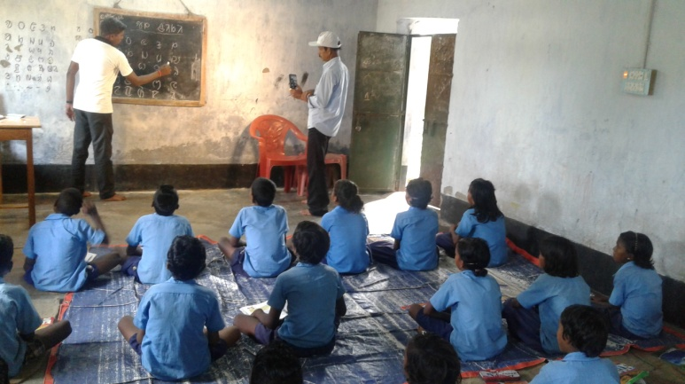

Class Room Education
In- house meeting/ Training/ Workshop:
Sl. no | Activity | Venue | Date & duration | Participants
1 | Project level Monthly staff meeting | MLC meeting hall | 4 months 4nos. | Teacher- 14  Supervisor & coordinator
2 | Quarterly review meeting | MLC meeting hall | 2 quarters 2nos. | Teacher- 14  Supervisor & coordinator
3 | Teachers Training(Primary level ) 1st phase | MLC Training hall | 19.4. 2018 to 21.4.2018 | Teacher- 14  Supervisor, coordinator & Resource person- 2nos.
4 | In-house training for knowledge base development of the of basic Health, basic Education & Livelihood | MLC Training hall | 3.5.2018- 4.5.2018 | Teacher- 14  Supervisor & coordinator
5 | Orientation for staff skill development on menstrual hygiene management | MLC Training hall | 10.5.2018 to 12..2018 | Teacher- 14  Health worker- 7  Supervisor, coordinator & Resource person
6 | Workshop on teaching learning material development | MLC Training hall | 13.6.2018- 14.6.2018 | Teacher- 14  Supervisor & Coordinator

ACTIVITY REPORT (Present status of the program):
Program | Activity | Achievement/ Non Achievement
Education:  After School program  (Primary level class III & IV) | Total running centre – 7  children of class III admitted in April 2018 - boys - 43, Girls - 44, Total = 87 | Total children in class Iv = 94.  Guardians awareness about their children education has been increased than before, yet the attendance of children in the class has been decrease for the period of July 15 to August 15 because the engagement of guardians in agricultural works. Children have to stay to look after the younger or other work.
Teachers’ Training (Primary level) | Three days Residential training program for the teacher has been arranged in the first phase. Emphasis has given on the teaching method of language, math and general knowledge. As most of the village of the operational area are tribal dominated so importance has given for teaching through their mother tongue Santali. | By this training the teachers have gain the idea on the proper teaching method and the children also easily follow the lesson.
Orientation for staff skill development on menstrual hygiene management | Short term training on menstrual hygiene management for the adolescent girls in school and at their home during periods. | Teachers/ Animators have develop their skill to focus the matter to the adolescent girls and as well as to their mothers.
In house training for knowledgebase development of the staff on Basic health, basic education and livelihood.- | Arrange training on immunization of child and mother, vector born diseases like malaria, dengue, filarial control program, basic education, and NREGS for livelihood. | Teachers/ Animators have developed their skill to aware the community about their basic health, basic education of their children and how they can get NREGS work from the Panchayets.
Project level monthly staff meeting. | Monthly staff meeting is held in every month for review the progress of the project work. Teacher / animators prepare and submit their achievement report to the coordinator. Planning for the next month also prepared and submitted in the meeting. Any difficulties faced during work also shared and tried to solve by discussion. | Evolution of achievement and failure is done in the meeting. The causes of failures are shorted out and tried to solve through the  Next planning.
Quarterly review meeting | Evolution of progress of last three months activities has done | After analyzing the reports the next quarter planning has prepared.
Parents/ community meeting and home visit. | As per the planning parents/ community meeting has been done. The animators have done home visits. Importance is given on the issue of NREGs, School management committee and Menstrual health management of adolescent girls in the discussion. | During home visit the teachers /animators contact with the guardians/ community members about the meeting date and time, as a result the participation in the meeting has been increased. The awareness on menstrual health is very poor in this area. Nobody feel free to discuss the issue openly in this area.  Firstly we are trying to aware the mothers about the issue as we can discuss the issue with the adolescent girls through their mothers.
Monitoring and supervision | Monitoring of the education centre and other work of the organization is done regularly. The supervisor, coordinator, secretary and accountant take part in monitoring. Moreover the district youth officer of Nehru Yuva Kendra, Purulia has visited some education centres and other works of our organization on 9th & 10th August 2018. | The After School centres run regularly. Attendance of kids in the centre is 65 to 70% in average.  But in the rainy season attendance  Decrease in comparison of the other season.
Community meeting | Aware community people about the importance of School management committee in the light of right to education act 2009. | The community people realized the importance of formation of SMC in school began to discuss about SMC formation with the school teacher.
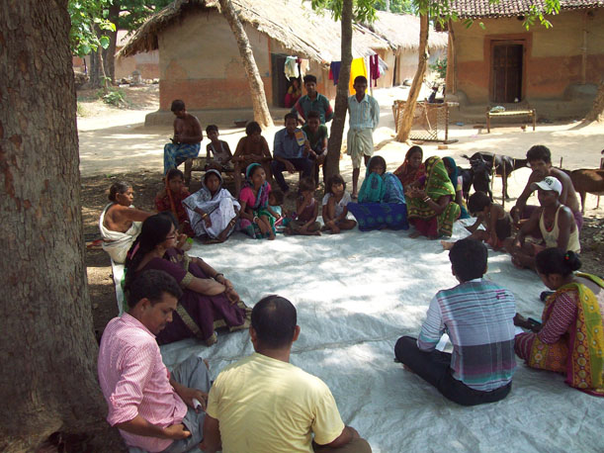
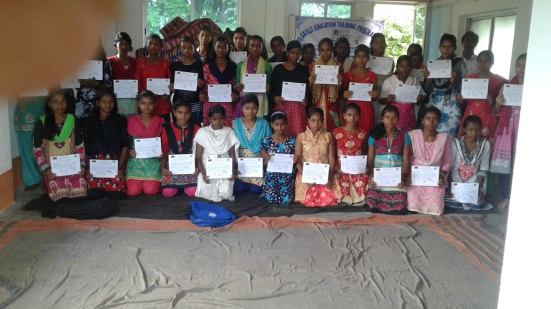
Community Meeting
Life Skill Development Program

Activity Report
For the Program
``promotion of Water Sanitation and hygiene Education (WASH) among children of Basic learning centres as well as other children especially girl children below eighteen years (Adolescent)’’
Activities | Plan result | Progress
1. Teaching hygiene behavior in the class regularly. (personal hygiene, Hand washing with soap, Safe use of toilets)  2. Outreach to families and wider community  a)Home visit  b)Parents meeting  c) community Meeting | - Healthier Children  - Batter attendance and performance in class.  - Positively influence hygiene practices in their homes , among family members and in the wider community  - Learn to observe, communicate, cooperate, listen and carry out decision s about hygienic conditions and practices for themselves, their friends and younger siblings whose hygiene they may care for (skills they may apply in other aspect of life)  - Change their current hygiene behavior and continue better hygienic practices in the future.  - Learn about menstrual hygiene and physical and emotional changes during puberty | 1. Both In the pre primary centers and in the After School centers our teachers regularly teach the children about hygiene and how to protect themselves and their families from infectious diseases.  Every day the teachers cheek every kid’s teeth tongue, nail, hair and dress and encourage them to develop healthy behaviors for life. In Tiffin hours the teacher help every kids for hand washing with soap before taking Tiffin and also advice to wash hands after using toilet and before taking any food. In this way the children will learn about hygiene and how to protect themselves and their families from infectious diseases.  2. After the centre hours the teachers do home visit and consult with the parents about the progress of their kids and mobilized them about the importance of involvement of parents, communities, governments and institutions to work together to improve hygiene, water and sanitation condition in the community. And how the parents can play a pro active role to help the children to learn about menstrual hygiene and Physical and emotional changes during puberty. During the parents and community meeting the teachers do the same.  So far 10387 no’s Home visits, 15 nos. parents meeting, 5 Nos. of community meeting and 4 no’s meeting with the adolescent girls have been done.
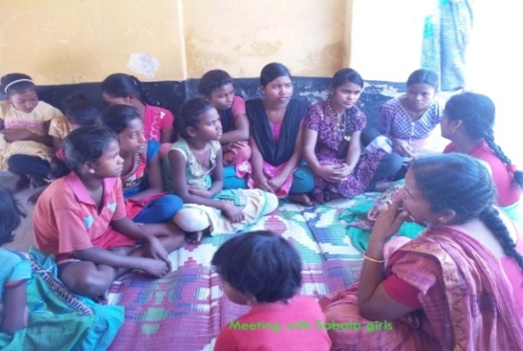
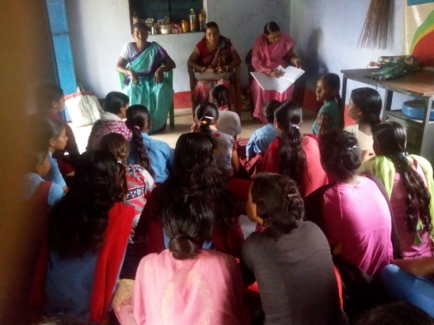
Meeting with Adolescent Girls
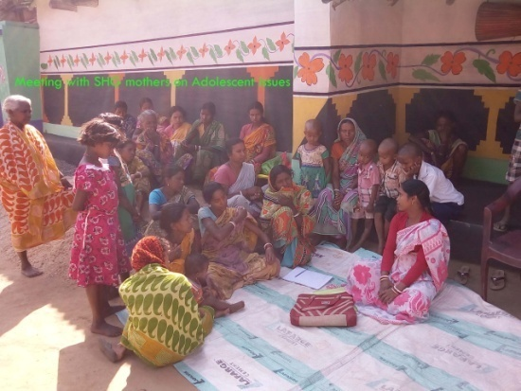
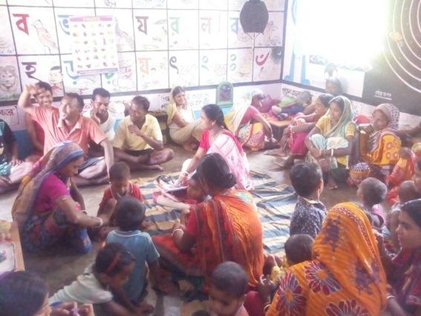
Meeting with Mothers

