Activity Report
After School Program
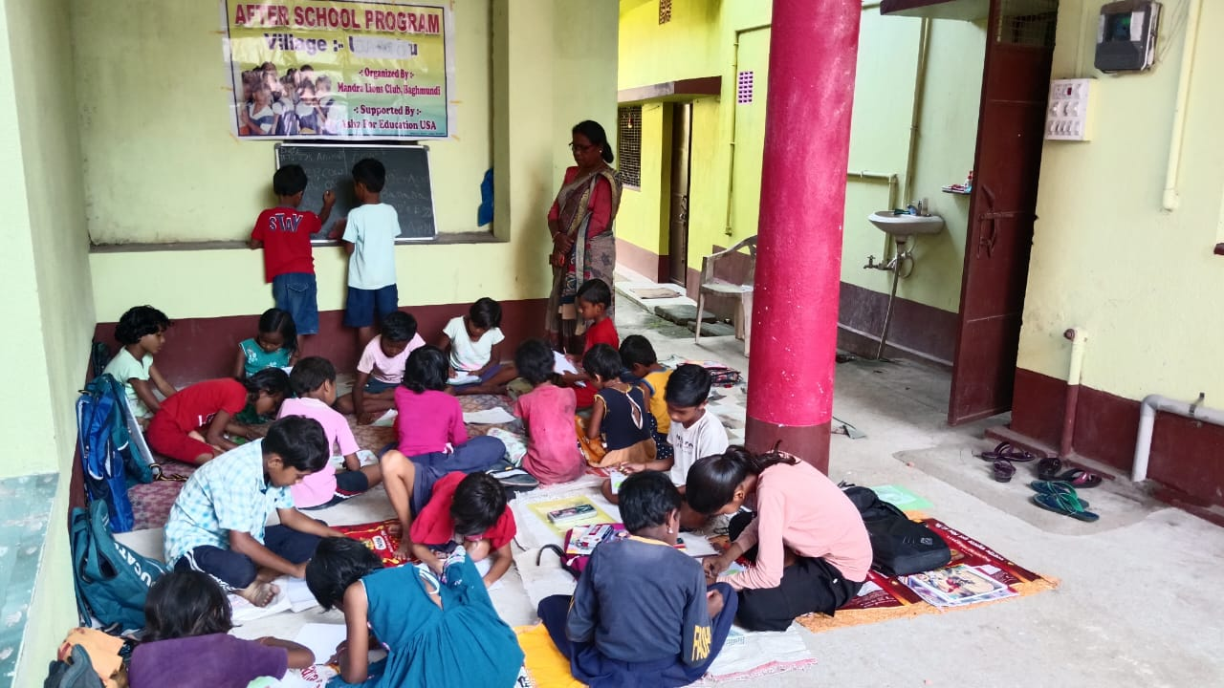
Period --- July 2025 to September 2025

Supported by:
ASHA FOR EDUCATION
Implemented by:

Saradapally
Baghmundi, Purulia
723152
Email: mandralionsclub20@gmail.com

General Information:-
For after school coaching centre we use the formal books used at schools to fill up the gaps in school based learning process so that they can achieve the class appropriate qualities and do not get drop out in the next higher classes. And as in some centers the students are tribal and their mother tongue is Santali so in those centre we appoint tribal teacher who can teach them through their mother tongue Santali. We use work card, chart, and pocket board to do so. For the other subject we used the usual classroom apparatus like blackboard, map, and chart etc and also take helps from nature. We also help them to achieve moral values of life, cast and culture, Health & Hygiene behavior, general knowledge, Arts, Painting, music, dancing and environmental awareness.

Sl. no. | Name of the centre | Class -I |  |  | Class- II |  |  | Class -III |  |  | Class - IV |  |  | Grand
Sl. no. | Name of the centre | Boys | Girls | Total | Boys | Girls | Total | Boys | Girls | Total | Boys | Girls | Total | Total
1 | Burda | 10 | - | 10 | 7 | 8 | 15 | 6 | 5 | 11 | 6 | 3 | 9 | 45
2 | USULDUNGRI | 2 | 4 | 6 | 4 | 2 | 6 | 2 | 2 | 4 | 3 | 1 | 4 | 20
3 | JILLING SERENG | 4 | - | 4 | 5 | 1 | 6 | 5 | 5 | 10 | 2 | 2 | 4 | 24
4 | DHASKA | 8 | 8 | 16 | 6 | 5 | 11 | 8 | 5 | 13 | 14 | 2 | 16 | 56
5 | JARGO | 2 | 4 | 6 | 2 | 7 | 9 | 1 | 5 | 6 | 1 | 1 | 2 | 23
Over all status |  | 26 | 16 | 42 | 24 | 23 | 47 | 22 | 22 | 44 | 26 | 9 | 35 | 168
Status of After School centers for 2025 -26 Season

Class & Sex wise attendance status of the After School centers.
class | Student |  | Working days –July to Sept 25 | Total attendance |  | Average attendance |  | % of attendance
class | Boys | Girls | Working days –July to Sept 25 | Boys | Girls | Boys | Girls | Boys | Girls
I | 26 | 16 | 62 | 1136 | 819 | 18 | 13 | 70 | 82
II | 24 | 23 | 62 | 1383 | 1199 | 22 | 19 | 93 | 84
III | 22 | 22 | 62 | 1149 | 1151 | 18 | 18 | 84 | 84
IV | 26 | 9 | 62 | 1519 | 498 | 25 | 8 | 94 | 89

Programme of community participation:-
Sl. no | Item | Topics discussed | No. Meeting/home visit | Participants
 |  |  |  | Male | Female | Total
1 | Guardian meeting | Regular attendance of children, Sanitation and hygiene, learning progress of the children ,awareness of teaching methodology. Kitchen garden for self nutrition | 15 | 0 | 375 | 375
2 | Community meeting | Forest protection, Planting tree and maintaining,  Kitchen garden ,  Uses of compost for sustainable agriculture,  Public distribution system. | 5 | 85 | 55 | 140
3 | Home Visit | Regular attendance of children, promote hygiene practices and kitchen garden for self nutrition, home learning of children, cleanliness of children | 1350
4 | Celebration of special days | Martyrs day of Khudiram Bose,Independence day,Raksha bandhan day & Teachers day

in-house Training/ Meeting/ Workshop:-
Sl. No | Activities | Venue | Date & duration | Participants
1 | Monthly staff meeting | MLC meeting hall | 14-7-2025,6-8 to 7-8-2025,20-9-2025. 3 nos | Teacher-6,menstruation hygiene educator 7, Supervisor 2 & coordinator
2 | Quarterly review meeting | MLC meeting hall | 19.09.2025 | Teacher-6,menstruation hygiene educator 7, Supervisor 2 & coordinator
3 | Refresher training(primary level) | MLC meeting hall | 11-7-2025 to 13-7-2025 | Teacher-6, Supervisor 2 & coordinator

Centre wise learning progress:
After School centre Burda
Village - Burda | Burda
No. of Children in class - I and - II | 25 (boys- 17, girls -8)
Current learning level | The children are reading in class – I & class – II  Class – I children -10( boys -10)
Reading writing  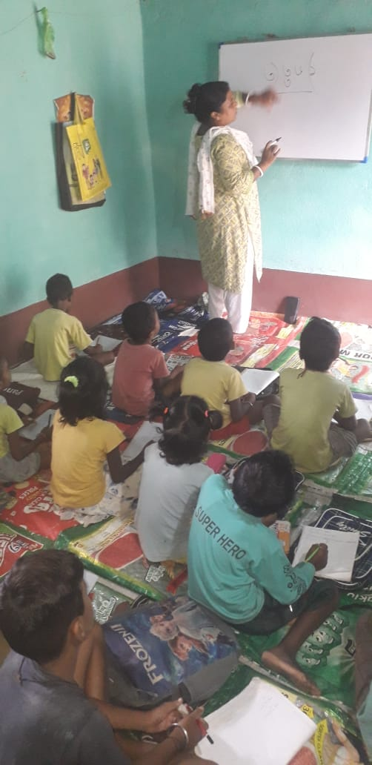  After School class is running | Bengali: 6 children can read and write Bengali ward with all swar matra and 4 children can read and write three & four letters ward without swar matra.  Math: 8 children can do addition & subtraction of two digits and 3 children can do multiplication table ( 1- 5) and multiplication of two digits and 2 children can do addition & substraction`  English: 8 children can read and write wards and 2 children can read and write capital and small letters.  Class – II Total children -15( Boys -7, Girls -8)  Bengali – 4 children can read and understand paragraph of their text book and 11 children can read and write sentences.  English: 12 children can read and write wards of their text book and 3 children can read and write sentences of their text book.  Math: 8 children can do addition & subtraction and multiplication table ( 1- 5) and multiplication of two digits and 4 children can do small division.3 children can do addition , substraction & multiplication table ( 1-3)

Village | Burda
No. of Children class - III and - IV | 20 (boys- 12, girls -8)
Current learning level | The children are reading in class –III & class – IV  Class – III children -11( boys -6, girls -5)
Reading Writing  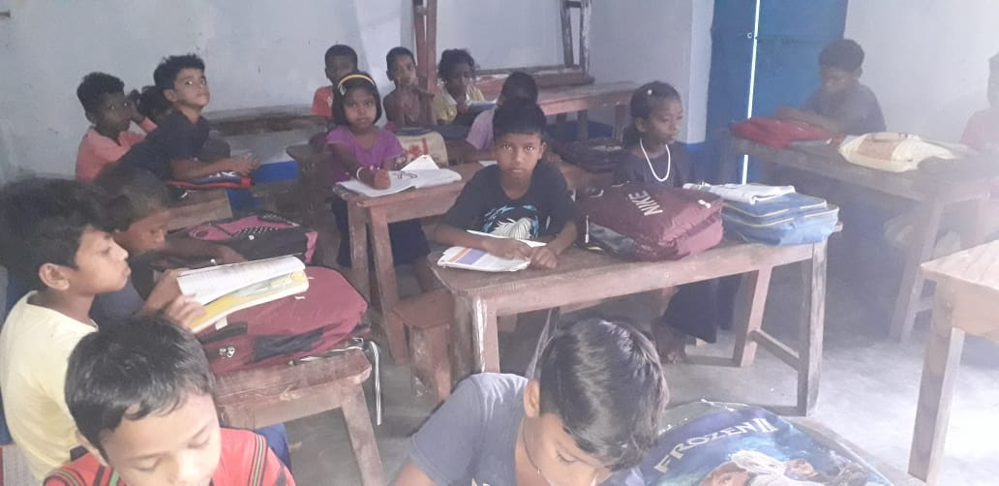 | Bengali 3 children can read comprehend and can answer related questions,6 children can read and write sentences with proper pronounciation of their text book. Other 2 children can read and write ward, and sentences but not reading joint letter words.  English – 4 children can read and comprehend paragraph of the English text book clearly other 7 children can read & write sentences of their text book.  Math - 3 children can do division with written mathematics & simplification.8 children can do addition, subtraction, multiplication table and 2 digits multiplication.  Class –IV children –9 ( boys-6, girls -3)  Bengali – 6 children can read and write sentences with proper pronounciation but the other 3 are weak to read and understand paragraph , they can read & write sentence.  English -7 children can read and write sentences , 2 children can read and comprehend paragraph.  Math. 7 children can do addition, subtraction, multiplication and division confidently and 2 children can do division & simplification with written mathematics .

After School centre Usuldungri
Village | Usuldungri
No. of Children in class - I and - II | 12 (boys- 6, girls 6)
Current learning level  Reading writing: | The children are reading in class – I & class – II  Class – I children -6( boys -2, girls -4)
Bengali: children can read and write ward consisting two without swar Matra.
Math: Children can read and write number 1 to 100 in Bengali and can do small addition & subtraction in single digit
English: All the children can read and write a capital letters`
Class – II Total children -6 ( Boys -4, Girls -2)
Bengali – children can read and write two and three letter word with Swar-Matra & joint Vanjanbarna.
English: 5 children can read and write capital and small letters and read small words from their text book.1 children can read & write capital letters.
Santali: (alchiki) 6 children Can read and write alchiki letters.
Math: 3 children have a concept of place value & actual value of nos. Other 3 children can do addition and subtraction of three digit and also read multiplication table one to eight.

Village | Usuldungri
No. of Children in class –III & IV | 8 (Boys-5 , girls-3)  Class –III Children -4 (Boys -2 Girls – 2)
Current learning level  Reading  writing  After school class  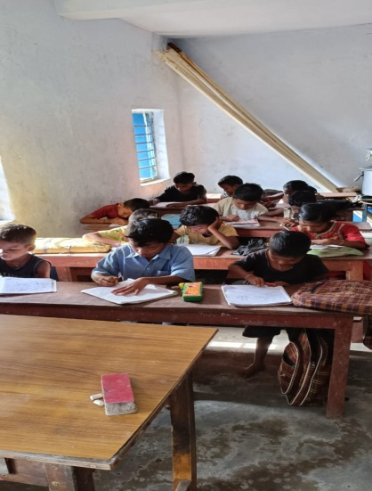 | Bengali - 2 children can read and write sentences with proper pronounciation.2 children can read & understand paragraph  English All children can read and write small sentences of the English text book.  Santali – (Oalchiki script) all children can read and write Oalchiki ward. As Santali is their mother tongue all of them can speak in Santali.  Math – All children can do addition ,subtraction ,multiplication & multiplication table (1- 7)  Class – IV children – 4 (boys – 3 girls –1)  Bengali –All children can read and write story properly and can answer story related question of their text book.  English children can read and write sentences of their text book.  Santali - (Oalchiki script) all children can read and write Oalchiki letter, ward & paragraph. As Santali is their mother tongue all of them can speak in Santali.  Math. All children can do addition, subtraction, multiplication and division ,simplification of their book.

After School centre Jilling Sereng
Village | Jilling Sereng
No. of Children in class - I and - II | 10 (boys- 9, girls -1)
Current learning level  Reading writing: | The children are reading in class – I & class – II  Class – I children -4 ( boys -4, girls -0)
After School class is running  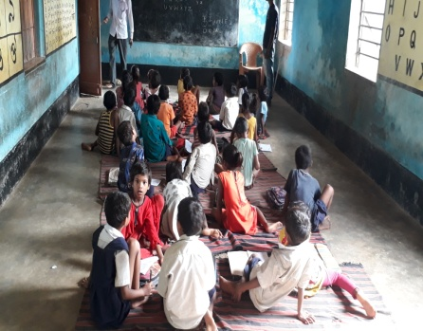 | Bengali: All children can read and write three & four letters ward without swar matra.  Math: children have the concept of less-More, heavy –light and can read and write number 1 to 100 in Bengali .2 children can do addition & subtraction of single digit.  English: children can read and write capital & small etters.2 children can read & write small ward.  Santali : (Oalchiki script) Children can read Oalchiki letter. As Santali is their mother tongue all of them can speak in Santali.  Class – II Total children -6( Boys -5, Girls -1)  Bengali –All the children can read and write ward with swar matra and joint vanjanbarna, 3 children can read and understand paragraph with punchuation.  English: All the children can read and write small words .  Santali: (alchiki) Children can read and write alchiki letter and ward.  Math: the children have a concept of place value & actual value of nos. They can do addition and subtraction of their book. They can memorise the multiplication table up to 12.

Village | Jilling Sereng
No. of Children in class –III & IV | 14 (Boys- 7, girls-7)  Class –III Children -10 (Boys -5 Girls – 5)
Current learning level  Reading  writing | Bengali - children can read and write story of their text book and also can answer related question of the story.  English children can read sentences of the English text book .  Santali – (oalchiki script) all children can read and write olchiki ward and sentences. As Santali is their mother tongue all of them can speak in Santali.  Math - children can do addition, subtraction multiplication and division of their math book.  Class – IV children –4 (boys – 2, girls –2)  Bengali – children can read & write Bengali paragraph and story well.  English children can read and write English word and sentence of their English text book.  Santali - (olchiki script) all children can read and write olchiki letter and word, As Santali is their mother tongue all of them can speak in Santali.  Math. 2 children can do addition, subtraction, multiplication and division . 2 is week in division.

After School centre Dhaska
Village - Dhaska | Dhaska
No. of Children in class - I and - II | 27 (boys- 14, girls -13)
Current learning level | The children are reading in class – I & class – II  Class – I children -16 ( boys -8, girls -8)
Reading writing  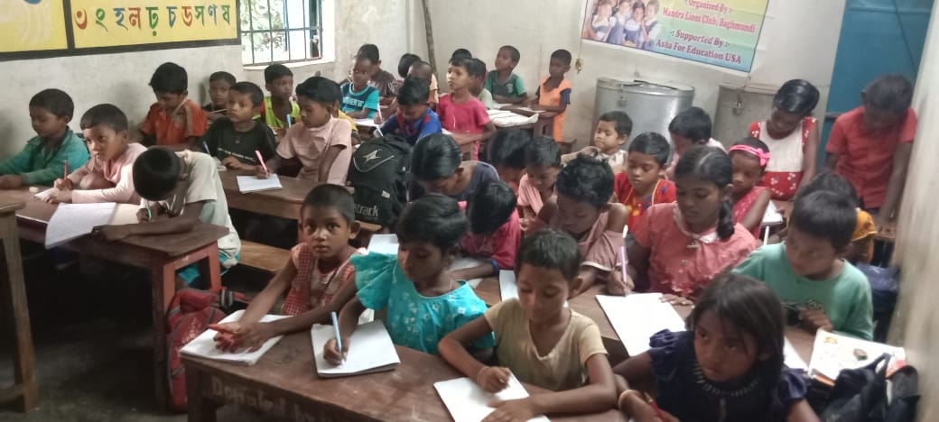 | Bengali: 10 children can read and write letter both swarvarna and vanjanbarna and can read and write two letters ward all swar-matra. 6 children can read and write ward without swar matra  Math: All children can do addition, subtraction of two digits . They can read Multiplication table 1 to 8.  English: 13 children can read and write wards .3 children can not read wards.  Santali: All children can read letter & wards. As Santali is their mother tongue all of them can speak in Santali.  Class – II Total children -11 ( Boys -6, Girls -5)  Bengali – All children can read and write ward from their text book with swar-matra & joint vanjanbarna  English: All the children can read and write ward of their English book.  Santali: All children can read and write letter & wards. As Santali is their mother tongue all of them can speak in Santali.  Math:  The children have a concept of place value & actual value of nos . children can do addition and subtraction of three digits.
After School centre Dhaska
No. of Children in class –III & IV | 29 (Boys- 22, girls-7)  Class –III Children -13 (Boys -8 Girls – 5)
Current learning level  Reading  writing | Bengali - 13 children can read and write ward sentence and paragraph of their text book.  English –All children can read and write ward and sentence of the English text book.  Santali – (olchiki script) all children can read and write olchiki ward & sentences. As Santali is their mother tongue all of them can speak in Santali.  Math – All children can do addition, subtraction, multiplication and division.  Class – IV children – 16 (boys – 14, girls –2)  Bengali – All children can read Bengali paragraph and story and can answer related questions from the text.  English 14 children can read and write English ward and sentence of their text book. 2 children can read & comprehend paragraph.  Santali - (olchiki script) all children can read and write olchiki letter, word and sentences , As Santali is their mother tongue all of them can speak in Santali.  Math. All children can do addition, subtraction multiplication , division and with written mathematics of their math book.

Village - Jargo | Jargo
No. of Children in class - I and - II | 15 (boys - 4, girls 11)
Current learning level | The children are reading in class – I & class – II  Class – I children -6 ( boys -2, girls -4)
Reading writing  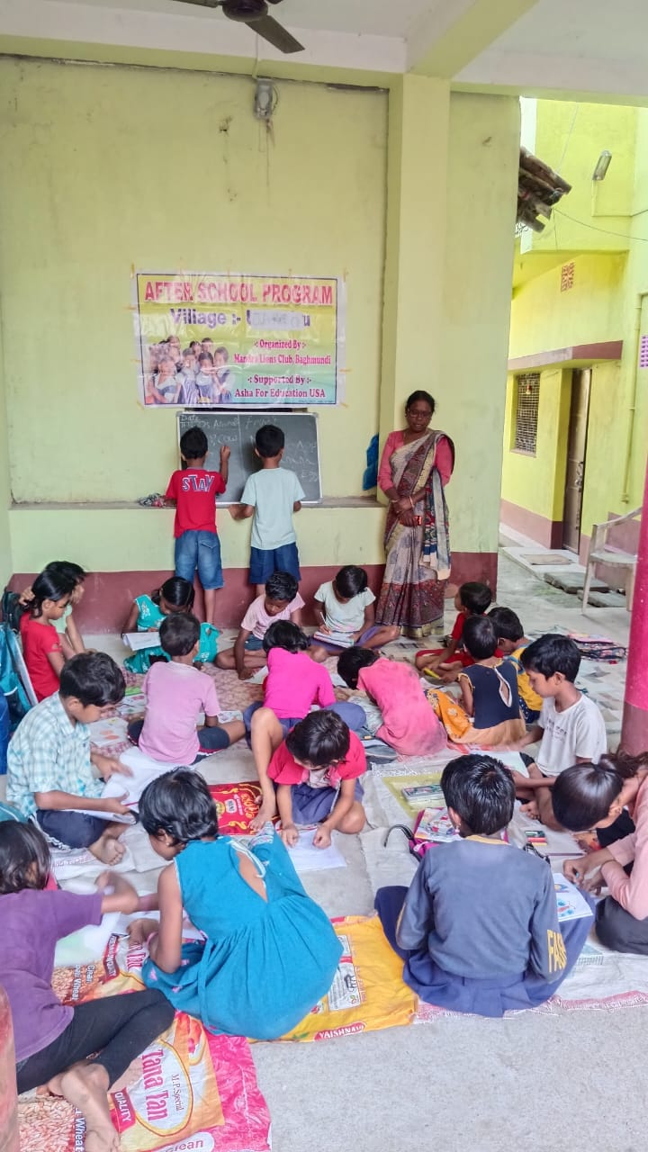 | Bengali: children can read and write Bengali alphabets both swarvarna and vanjanbarna and three & four letter wards without swar- matra.  Math: children can read multiplication table ( 1- 5).  English: children can read and write capital and small letters and small wards .  Class – II Total children -9( Boys -2, Girls -7)  Bengali – all children can read and write ward with swar matra & joint vanjanbarna from their text book.  English: All the children can read and write sentences from their English text book.  Math: the children have a concept of place value & actual value of nos. 8 children can do addition and subtraction of four digit.

Village Jargo | Jargo
No. of Children in class - III and - IV | 8(boys- 2, girls - 6)
Current learning level | The children are reading in class –III & class – IV  Class –III children -6 ( boys -1, girls -5)
Reading writing | Bengali: children can read and write Bengali sentences with proper pronounciation of their text book  Math: children can do addition, subtraction,multiplication & division of their text book.  English: All children can read and write sentence from their text book.  Class –IV Total children -2( Boys -1, Girls -1)  Bengali – children can read and write sentences with proper pronounciation from their text book.  English: All the children can read and write story & can answer related question from their text book.  Math: the children can do addition, subtraction; multiplication and division with written mathematics.
1. Every day the teachers observe every kid’s teeth tongue, nail, hair and dress and encourage them to develop healthy behaviors for life. In Tiffin hours the teacher help every kids to wash hand with soap before taking Tiffin and also advice to wash hands after using toilet and before taking any food at their home also.
2. They consult with the parents about the cleanliness, proper nutrition and progress of their kids during home visit and in the guardians meeting and mobilized them about the importance of involvement of parents, communities, governments and institutions to work together to improve hygiene, water and sanitation condition in the community. And how the parents can play a pro active role to help the children to learn about menstrual hygiene and Physical and emotional changes during puberty. They also advice the parents to keep the environment clean.
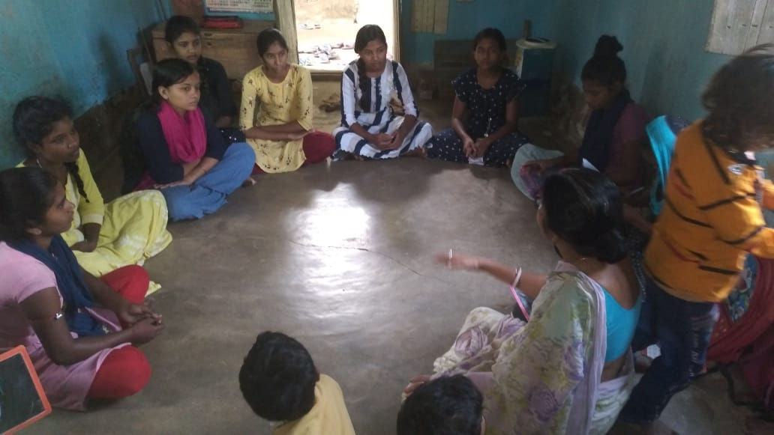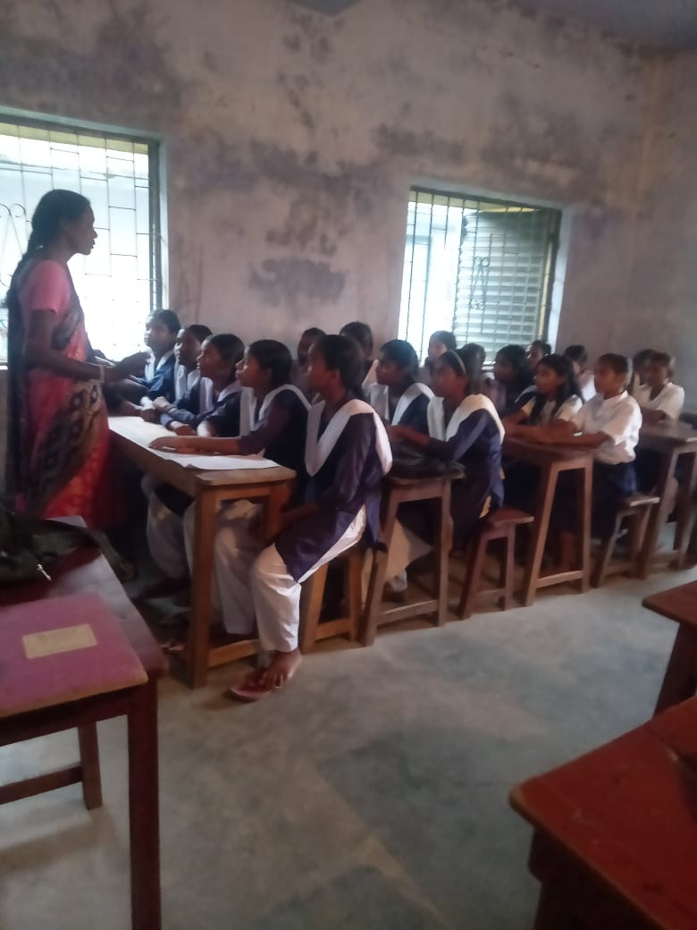
Meeting with Adolescent girls on MHM
3. Our female health workers do regular home visit and meeting with the adolescent girls and mothers on the issue of Regular immunization of pregnant mothers and children, WASH and Menstrual Health Management to encourage them to use sanitary napkins during their periods and about proper disposal of used napkins. They also do meeting with the school girls on WASH & Menstrual Hygiene Management
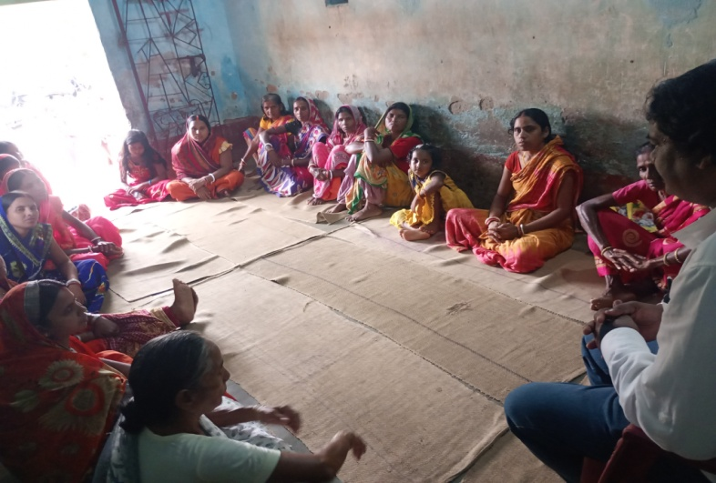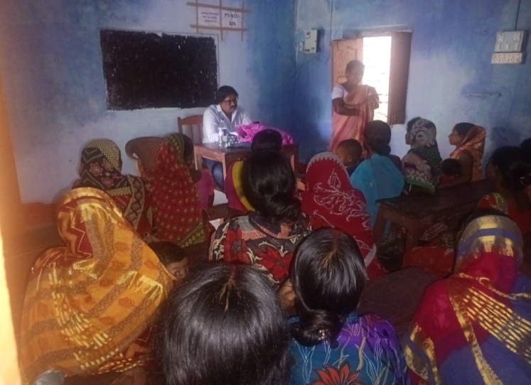

Meeting with Guardians

Outreach to families and wider community by our health and hygiene educator from July 2025 to September 2025

Sl. No. | Activities | Accomplishment | Accomplishment | Accomplishment | Accomplishment
Sl. No. | Activities | April to June, 2025 | July to September 2025 | October to December 2025 | January to March, 2026 | Total | Total coverage/ participant
1 | Home visit | 490 | 1680
2 | Parents meeting | 14 | 21
3 | Meeting with community mothers & adolescent girls | 28 | 63
4 | Meeting with School Girls on WASH and MHM | 3 | 21
5 | Sub Centre Visit | 21 | 42



