Summary of Asha Darshan Trust Visit (November 9th -16th , 2016)
By Padmanava Sen (Asha Bangalore Volunteer and Asha Central Team member- padmanava.sen@gmail.com)
The visit snapshot is given below –
- Visit of Shantipur1 Lower Primary, Satyanarayanpur Lower Primary and Satyanarayanpur Middle Elementary school (November 9th)
- Visit of Nagapur LP and ME schools – Assamese and Boro Medium (November 10th)
- Discussion about Computer training and meeting with Teachers from all schools (November 11th)
  - I met teachers from all the schools
  - Many teachers are given the basic training and more teachers are being interested. During the training, fear has reduced and they got exposure to paint, ppt, xls as well as Assamese typing. Distance from some villages to the Kumarikata training center is an issue. Giving training after the exams will help. Once the teachers are aware, they can plan something for kids.
  - Teachers have expressed their requests (higher salary, once a year training, exposure visit, excursion for kids to Tezpur, summer camp)
  - A guideline for English and math discussed
- Visit of Shantipur2 Lower Primary, Debinagar Lower Primary and Simliguri (Boro Medium) Middle Elementary school (November 12th)
- Singing and Dance competition at Bogajuli (acted as Judge and did tally as well) –November 13th
- Children’s day program at Bogajuli – November 14th
- Visit to Sonmani LP school and English teaching at Satyanarayanpur ME school – November 16th
  - Tried to stress on the importance of correct pronunciation so that every spelling does not need to be remembered. Gave many examples asking words starting with letters.
  - Demonstrated the action verbs to teachers and how they can make simple sentences
  - Many students from Government primary school do not know alphabets and for them, different goals are discussed with teacher.
- Things checked during school visits
  - The reading standards of Assamese (Assamese medium), English and Hindi (Boro medium)
  - Checking the alphabet, vocabulary and spelling in English
  - Checking addition, subtraction and multiplication skills based on standards
  - Confidence while writing name
  - Every student is asked
  - In most classes brought to the board for Math
  - Books from different classes are used for reading
  - Academic games are played like word antakshari, Math table games, chain math with real life buying examples in market.
- Misc items
  - Attending Asha US-India call on November 12th with Biju
  - Checking the condition of current Asha Darshan building construction status at Tamulpur
  - Checking the vocational and computer training center at Bogajuli
  - Checking the weaving center at Tamulpur
  - Collecting the results of Class 10 Nagapur school students
  - Discussed the areas of improvements in Teaching and Asha US funding
- Promised from my end
  - Providing English teaching materials for LP (like flash cards with pictures)
  - After discussions with teachers, set a rough goal for English standard in the highest classes of LP and ME school based on my survey across students and my teaching experience
  - Additional guidance in English for teaching via simple phonics, action verbs, common nouns
- Short term Action items
  - Release of GF of 12500 USD for Asha Darshan building completion
  - Providing the teaching materials of English
  - Get them in touch a Government led group in Guwahati (SLAC) who work for employability training and assistance for students Class 9 onwards
  - One time support for building of permanent walls in some school buildings
  - Revisiting the infrastructural support for some schools (urinal, class partition wall, dresses, drinking water facilities)
  - Reconsidering Mid-day meal program since it is vital to have a good attendance
- Long term Action items
  - Working with the teachers to improve English and Mathematics knowledge of Kids (Use an ASER test midterm)
  - Sending Asha US funds in a systematic matter at the start of the financial year (April)
  - Priority 1- Revisit the salaries of teachers and coordinators to match local salary standards
  - Priority 2- Track the students after ME school and if possible start a support a child initiative of Asha students as sometimes they drop out for as little as 3000 INR at higher classes.
  - Priority 3- Requests are coming from some villages where there is no ME school (e.g. Paharpur near Bhutan border)

Detailed suggestions regarding the English Teaching (Padmanava):
ENGLISH

English should have defined goals in these three departments.

a) Vocabulary -
Most students can not write 5 words from their memory, starting from common alphabets. Some of them can not read the text books. Related to vocabulary, they have spelling mistakes as well. Unless the pronunciation is correct and phonics knowledge is solid, they will not be able to get the spelling right as everything cannot be memorized. Hence, in my class in SNP ME school, I stressed on the pronunciation.
Why? - No English reading beyond textbooks, no English culture at home or anywhere else. No listening to English. It may help to use some children books in English. < It is said even listening to English can improve the vocabulary and hence some schools in TN have started radio classes in school>

b) Grammar and Sentence construction -
I have checked most students. There are 4 basic issues -
i) The difference between English and mother tongue grammar (teachers can explain it to them)
ii) Knowing the difference between me, my etc
iii) The order of sentence - students can be introduced to this by asking question like (where did you eat, what did you eat, when did you eat)
iv) Preposition in general (The reason being there is no separate word for prepositions in most Indian languages)

Why? - No culture of writing or speaking at home or anywhere else. Just reading classroom books does not teach grammar. If they can do fast translation in their mind, they will be able to write as well (thinking in English is next to impossible for now).

c) Writing skills -
If one has limited vocabulary and sentence construction skills, writing won’t be possible.

Now I suggest the following goals to change this situation over next 5 years. We can make it a goal based on the class. I have discussed it with teachers already.

Goals at the end of

- Class 5 > LP SCHOOL
  - A to Z writing- small & capital
  - Writing name and address in English
  - Simple phonics (CAT, RAT, CUT etc)
  - Vowels and their sounds
  - Use of a/an
  - Common words using Flash cards
- Class 6>
  - Simple verbs that they can show (action verbs)
  - Pronouns
  - Common words in life (home, school and outside) - their spellings
  - Reading speed of unseen passages
- Class 7>
  - Reading speed improvement
  - Detailed phonics (the proper pronunciation of vowels and how to detect spelling of common words)
  - Vocabulary 100+ nouns and 50+ verbs (use text book and then ask the other way i.e. ask the meaning and tell them to translate)
  - Simple sentence construction using the above
- Class 8> ME SCHOOL
  - Simple translation and taking dictation
  - (s/es) after verbs and proper usage of have/has
  - Identifying tenses and proper –ing usage
  - Identifying article, adjective , verb, adverb in sentences
  - Opposite words and positive-negative
- Class 9>
  - Give unseen passages from Class 10 papers and ask them to identify and note the new words. Help them with spelling via Phonics (+ breaking long words into small ones).
  - Translation full speed (no matter how much we stress, the students being introduced to English at higher classes, can only think in Bengali and then translate)
  - Do simple games (antakshari with words) when someone visits.
  - Play audio file and see if they can take dictation and explain the meaning
  - Vocabulary should be able to cover all unseen passages of Class 10
  - Grammar book should be followed in Class
  - Speaking a bit in English and taking dictation
- Class 10>
  - Writing exercises since the beginning
  - Translation practice
  - Vocabulary practice
  - Grammar book should be followed
  - Rigorous usage of the model questions or questions from their text books

MATH
Regarding math, it is decided that
Every student, passing out of LP schools should know
- Counting 1 to 100
- Know the numbers
- Operations – plus, minus, multiply, divide
- Tables till 9
Every student, passing out of ME schools should know
- LCM/HCF, factors and prime numbers
- Angle, circle, rectangle
- Graph
- Algebra ideas

Pictures: https://drive.google.com/open?id=0BzQwy2wYOq01cFlQSEFYNE1uM0U

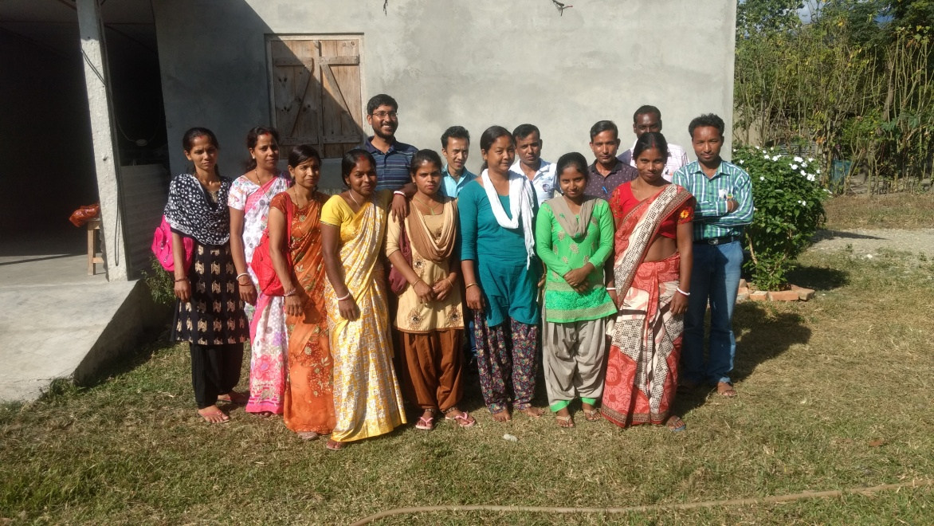
With teachers from Different schools

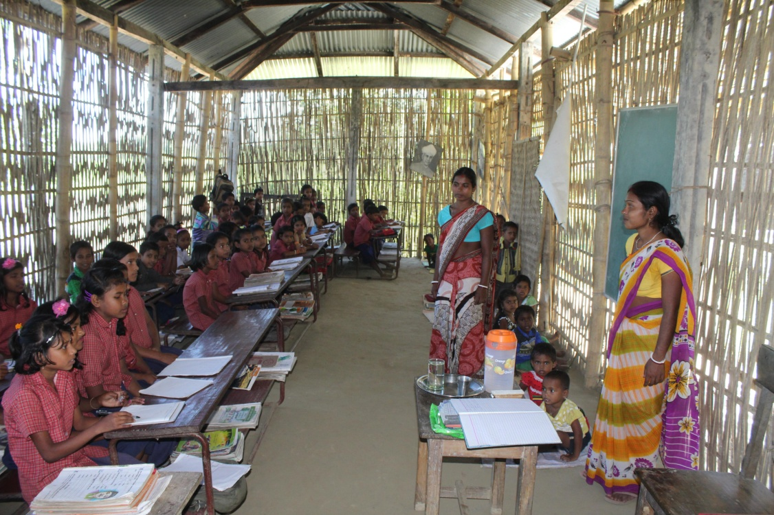
Shantipur1 students and Teachers

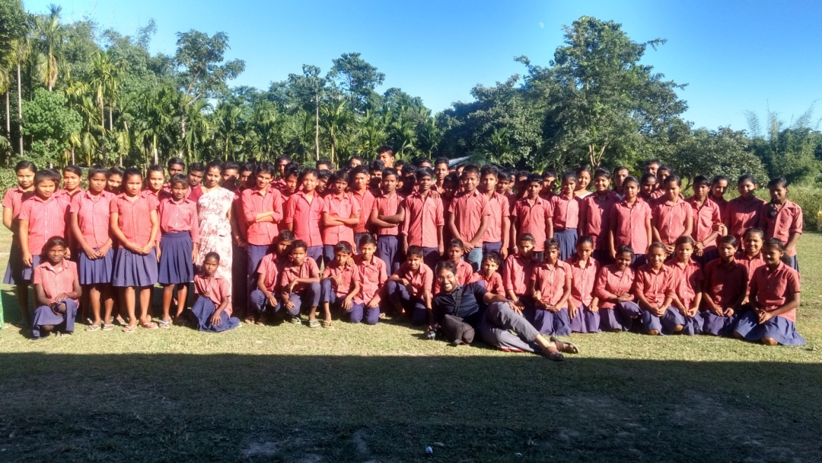
With students from Satyanarayanpur ME school

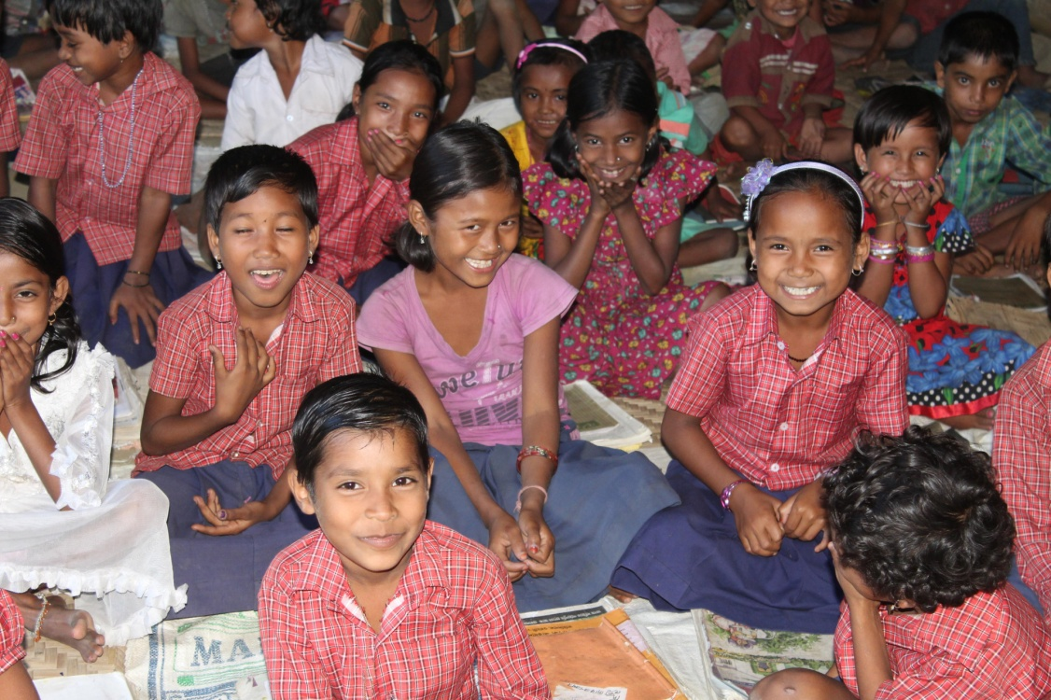
Some fun-filled moments at SNP LP school
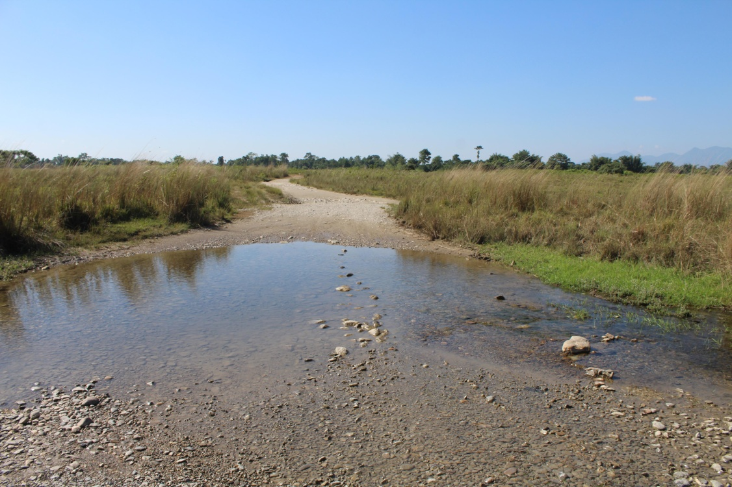
Road to Nagepur school (An area frequented by elephants)
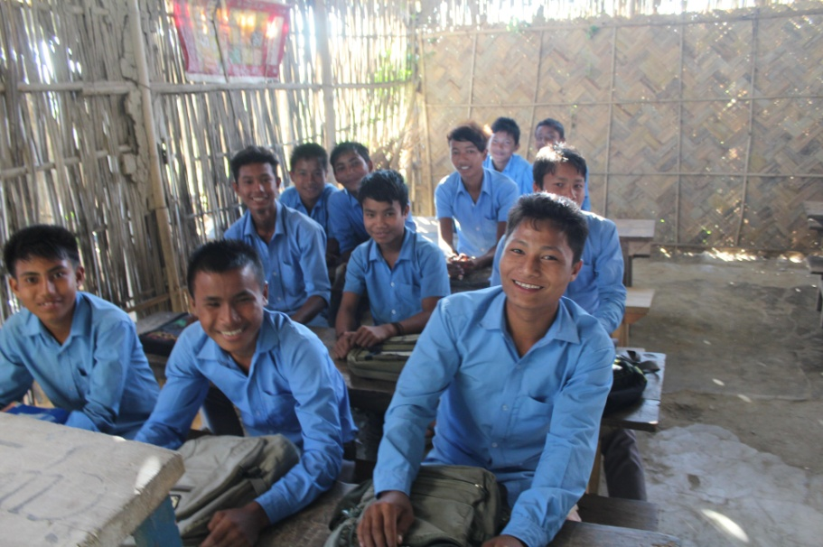
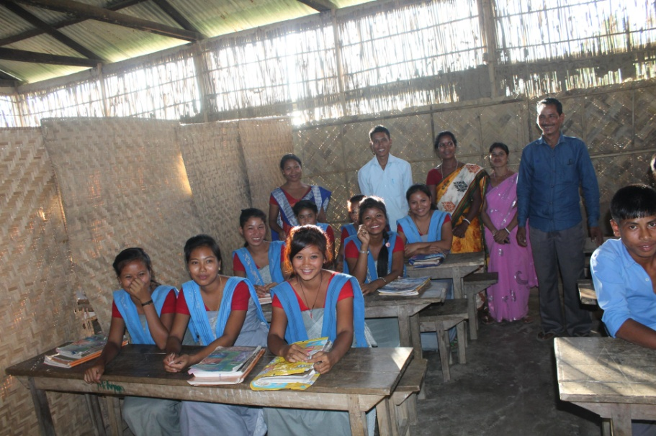
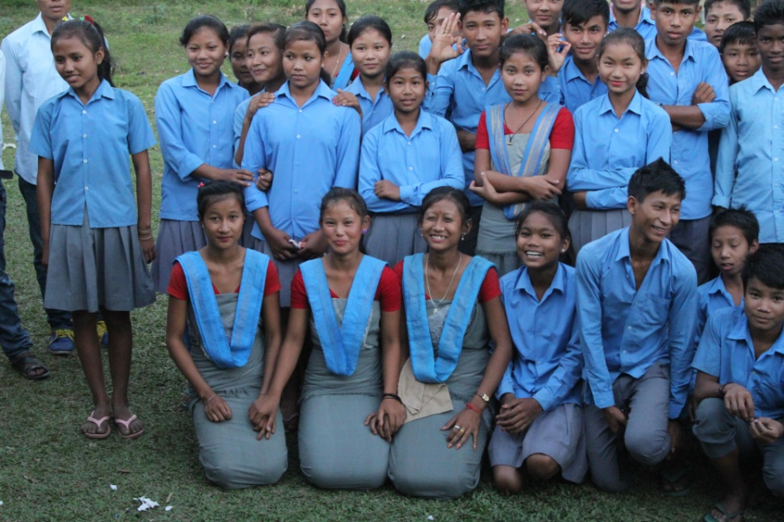
The smiling students of Nagepur School
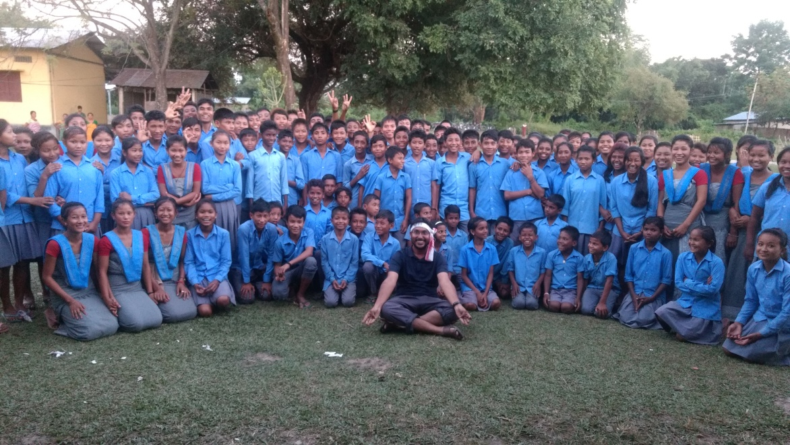
With students from Nagapur School
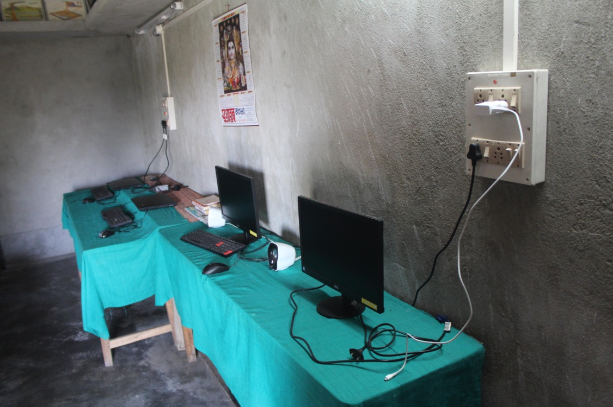
Computer Lab at Kumarikata
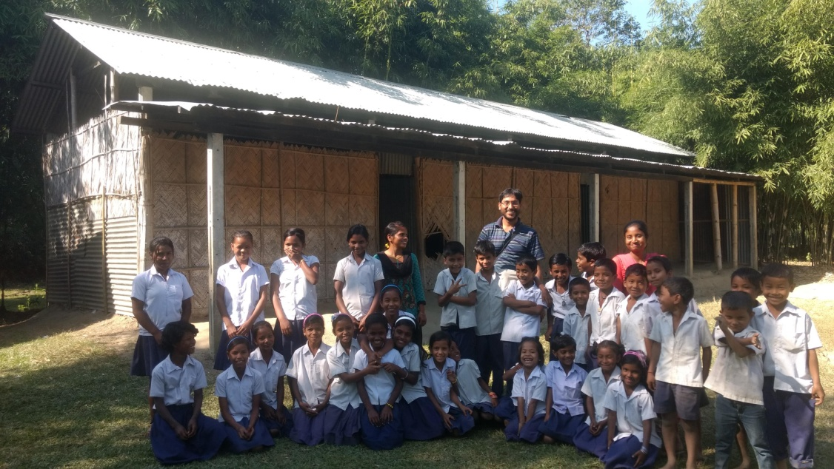

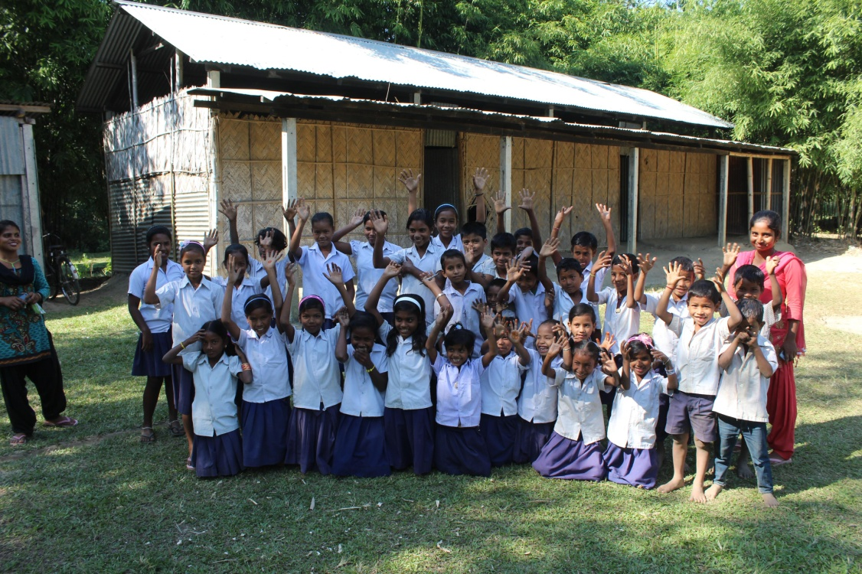
Meet, greet and bye bye at Shantipur 2 school
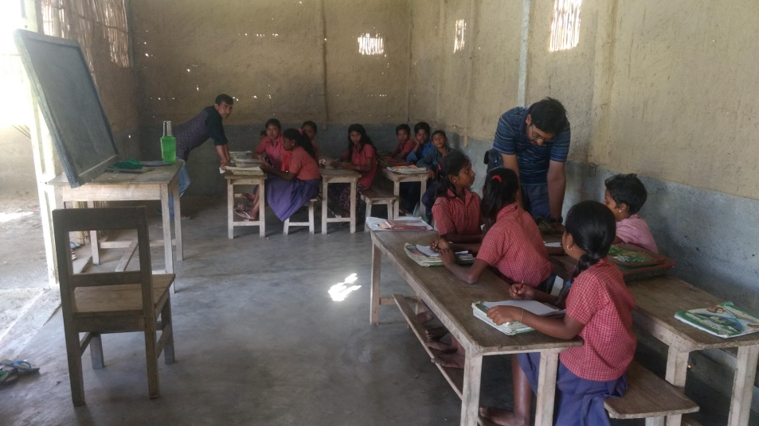
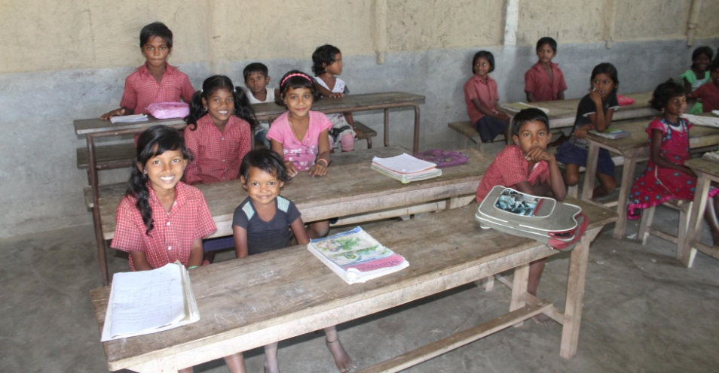
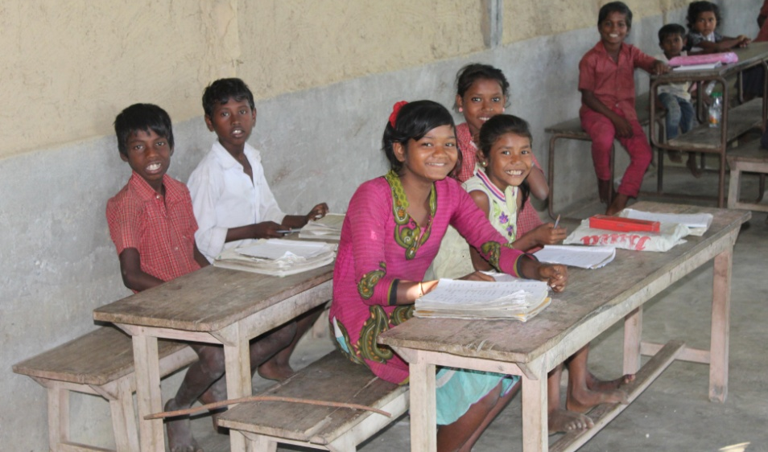
Moments at Debinagar school
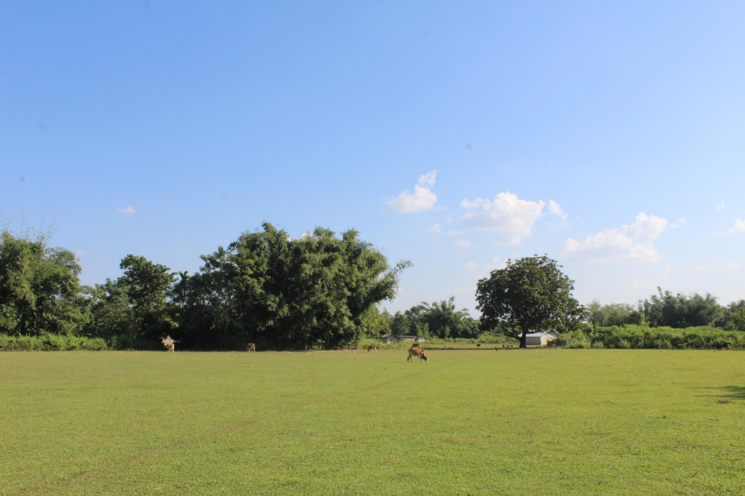
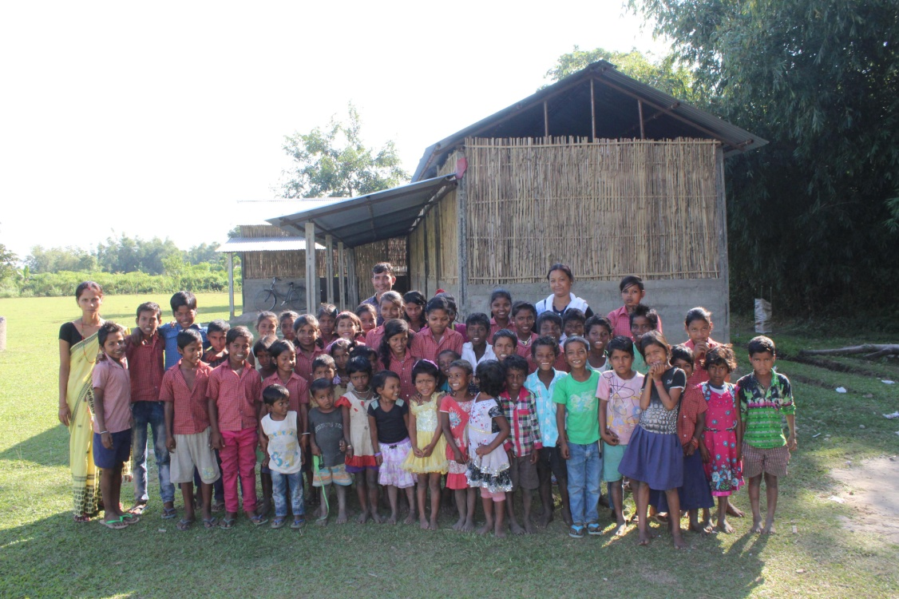
Surroundings of the school and the kids

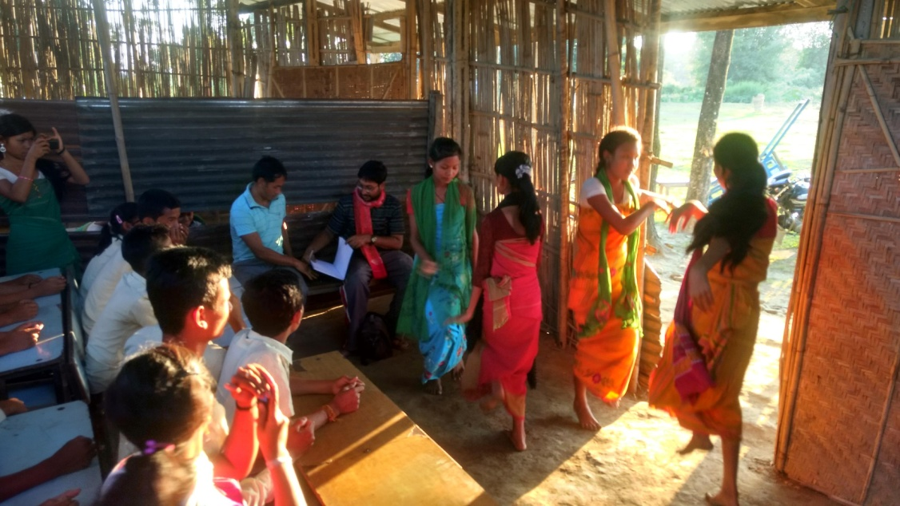
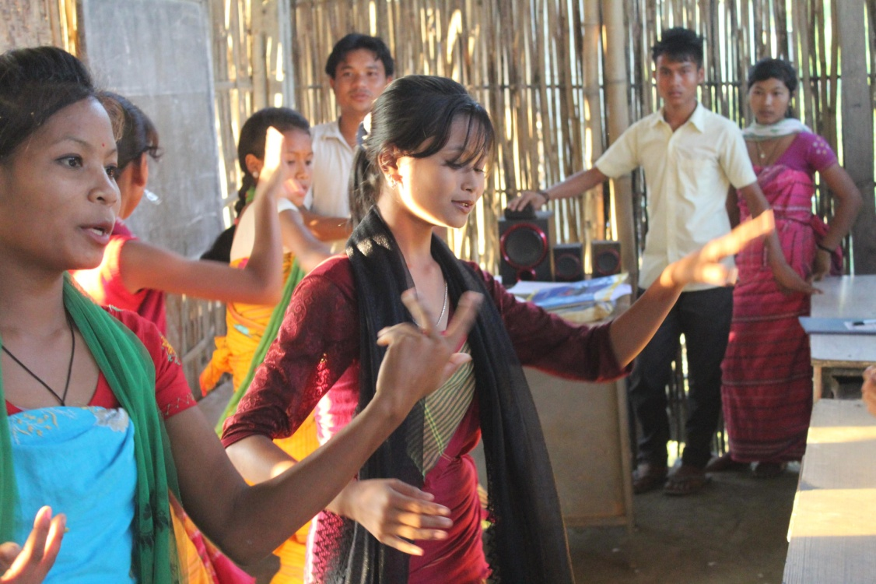
Those moments of practice before the competition at Simliguri
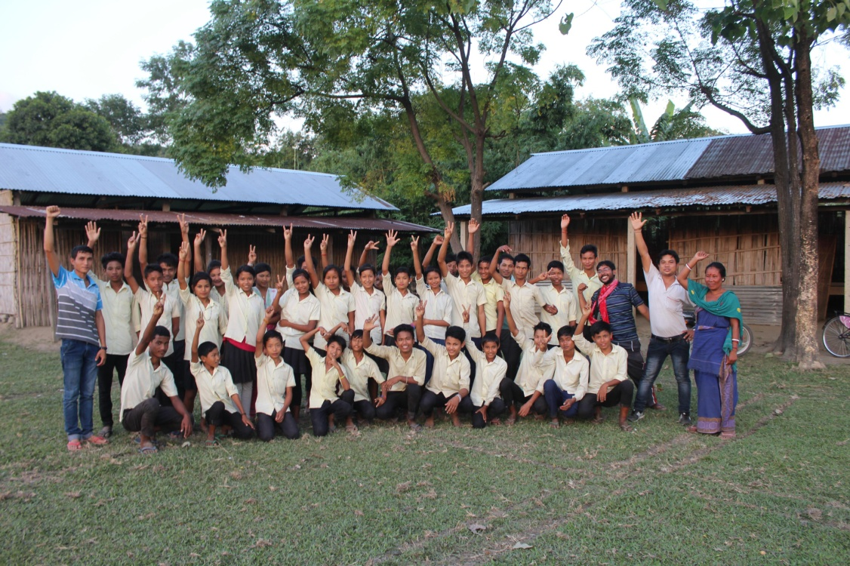
Posing with Simliguri school students
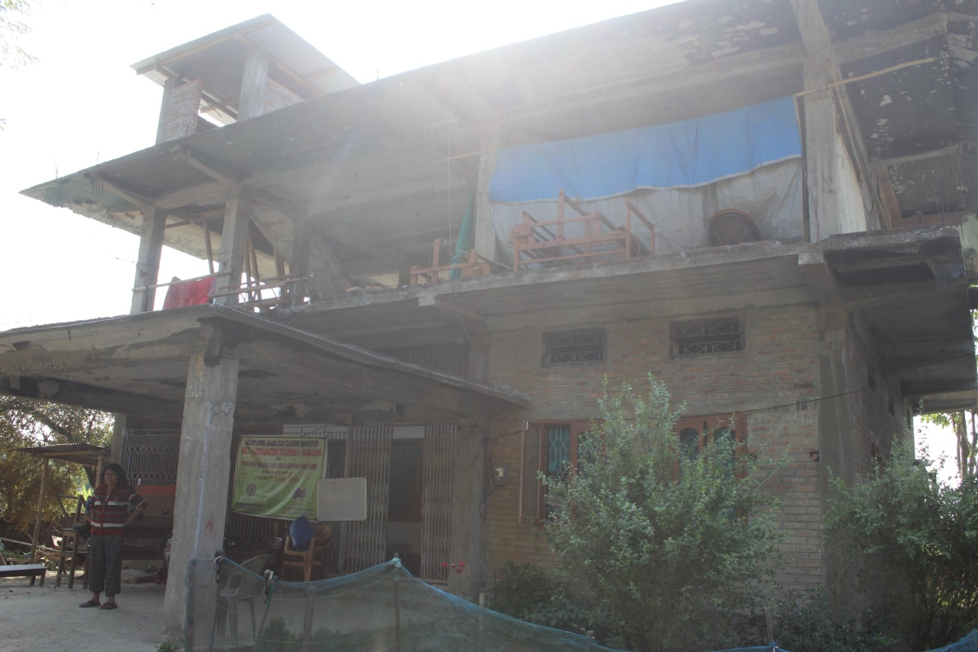
Asha Darshan office building construction status
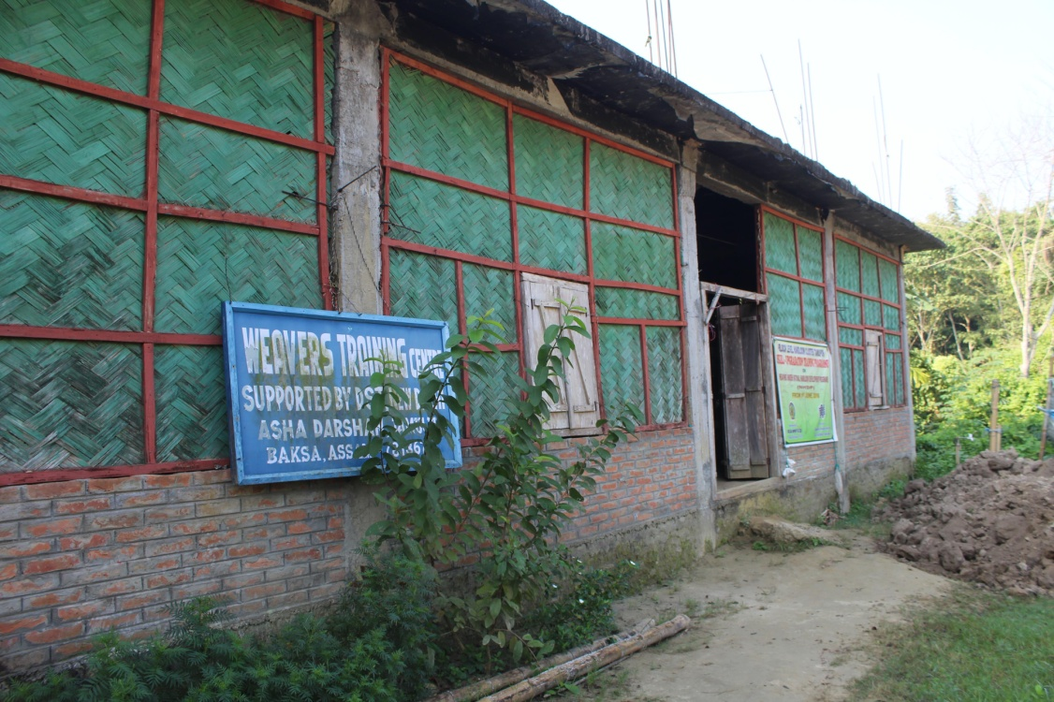
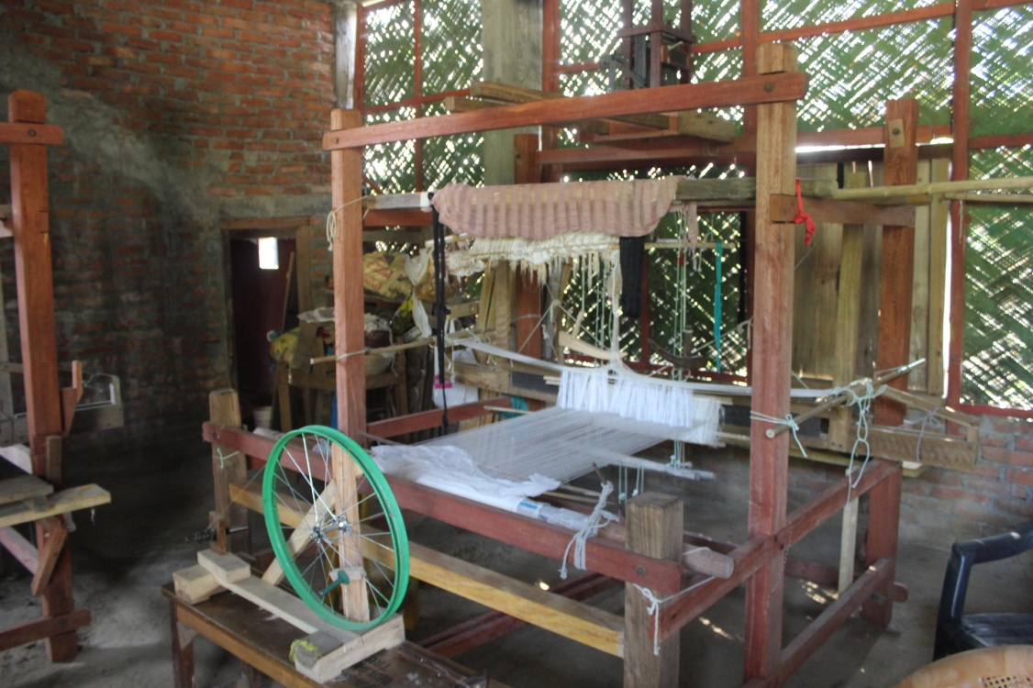
The weaving center next door
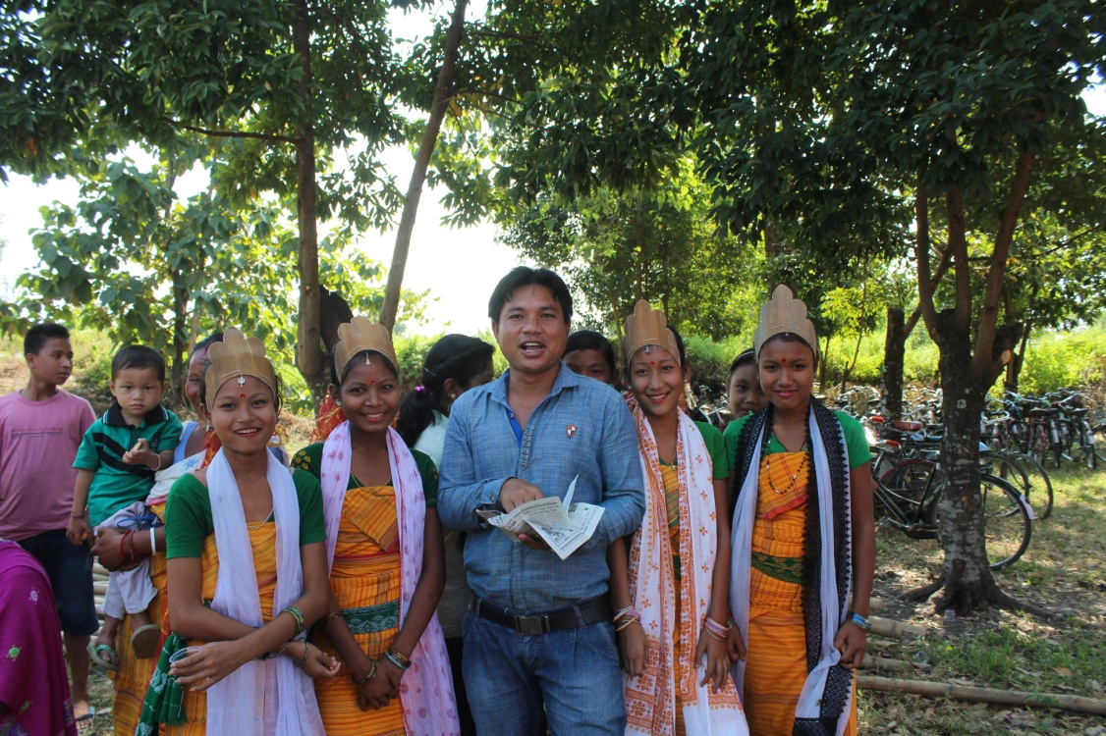
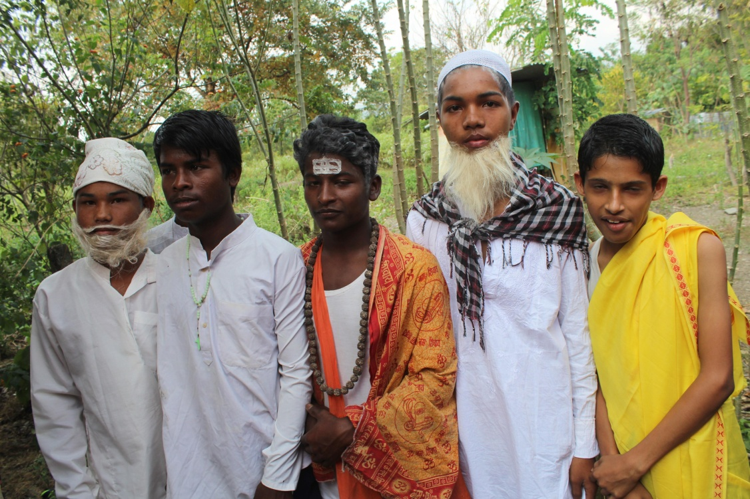
NOV 13/14 dance event celebration
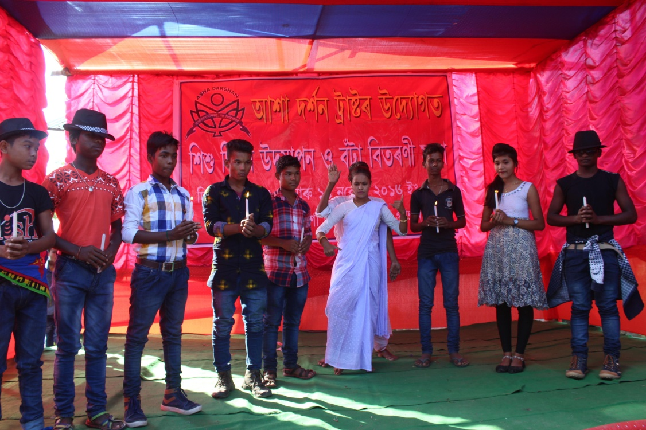
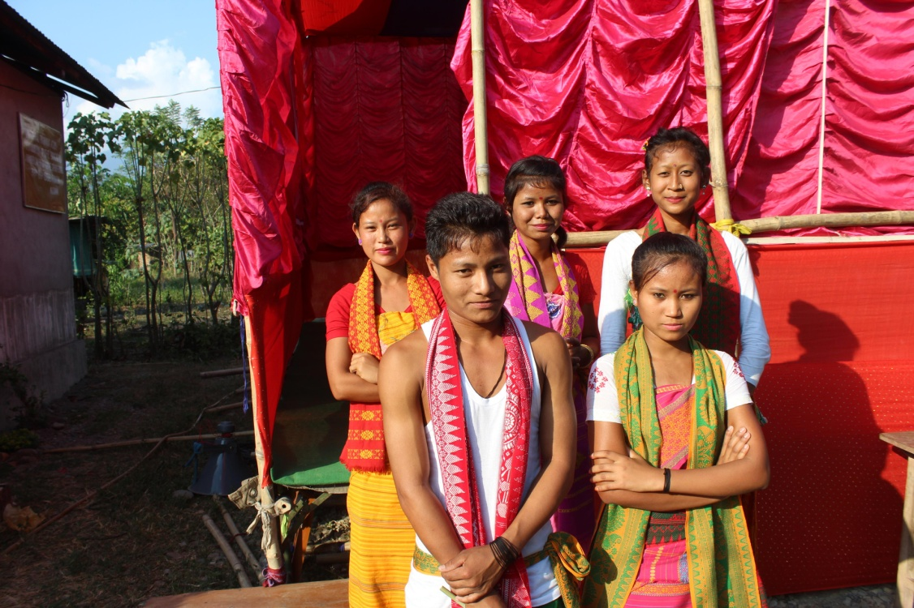
Time for group dances and drama
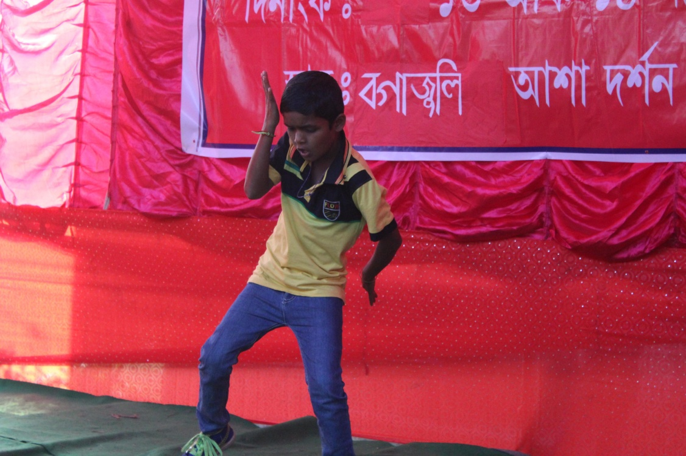
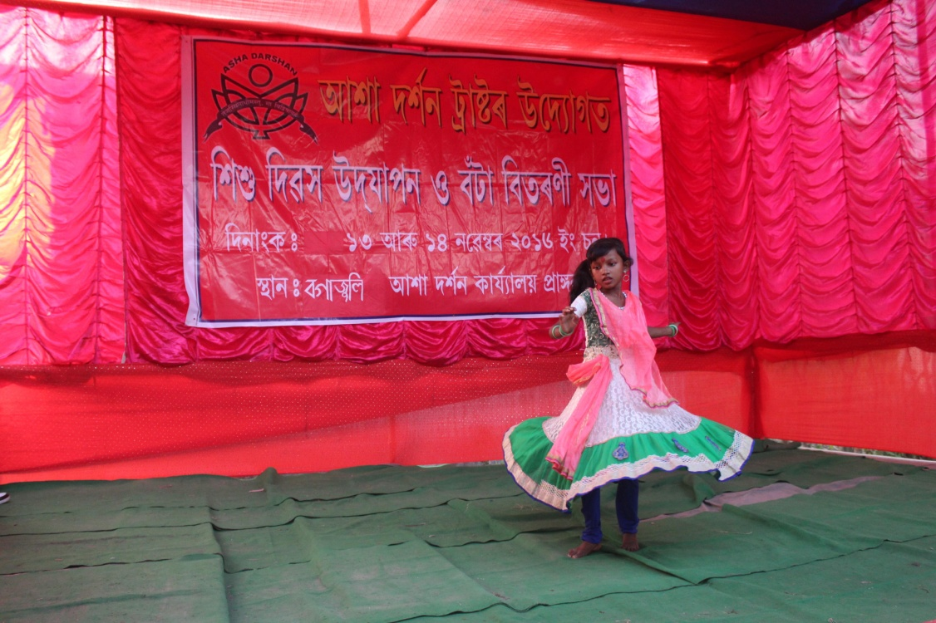
Times for solo performances
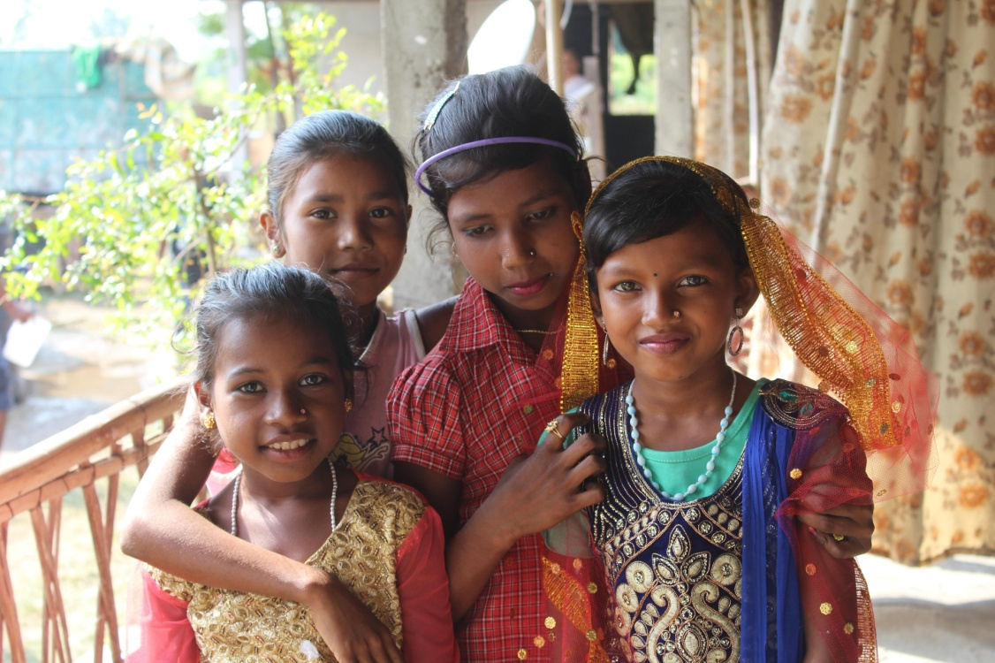
Wonderful Children’s day

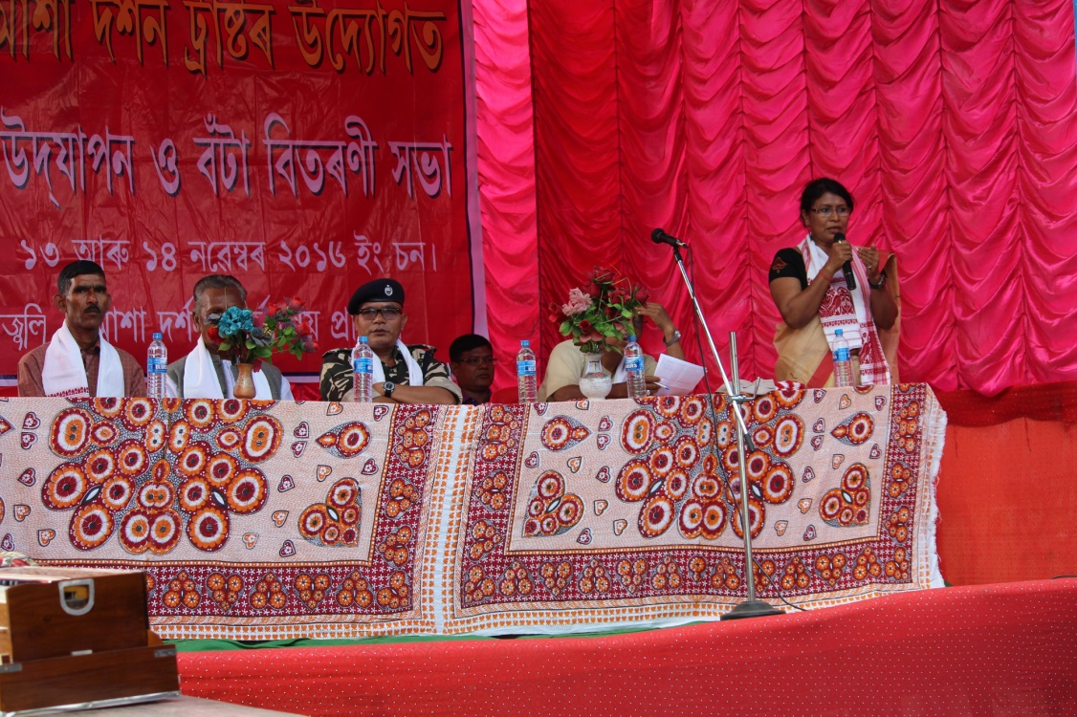
BIju’s inspirational talk during Children’s day event
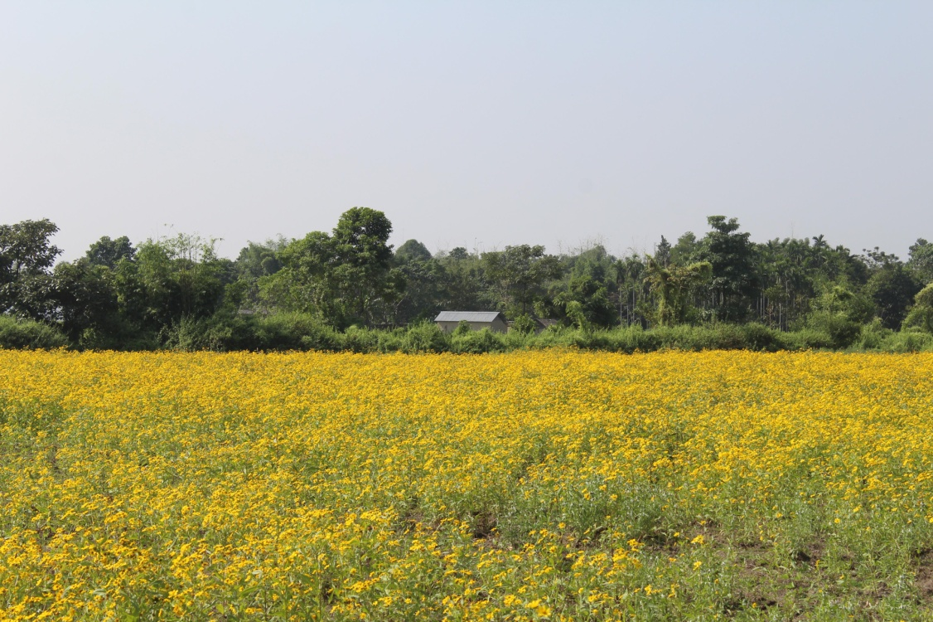
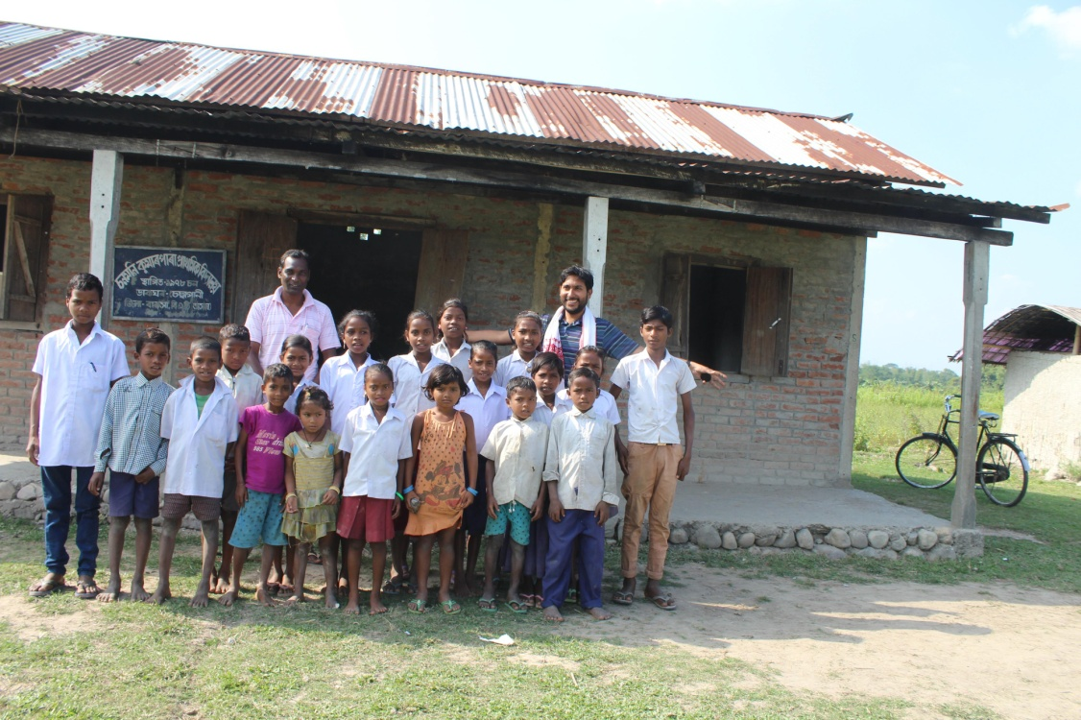
Sonmoni village and the kids
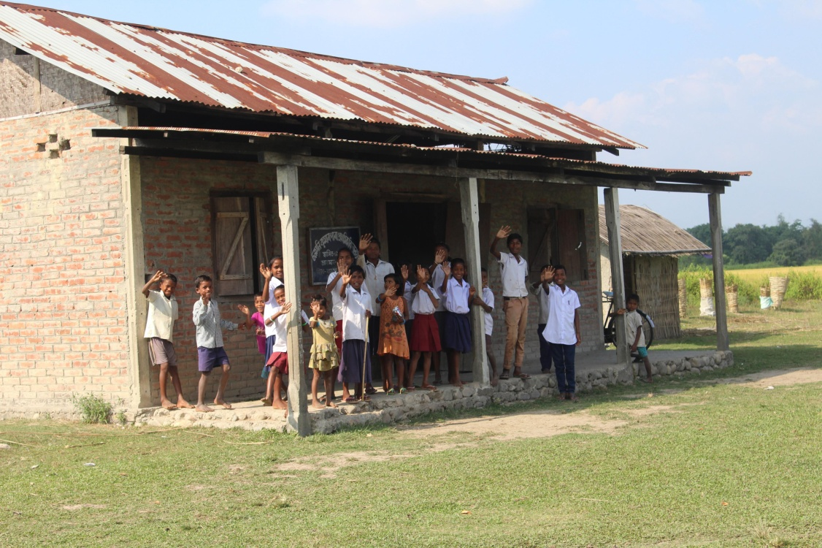
Bye bye from Sonmani students
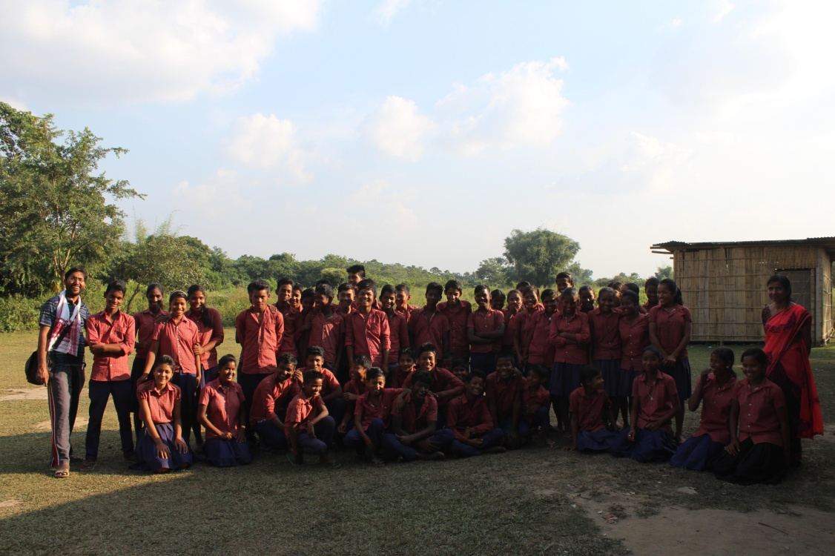
After the class at SNP ME school

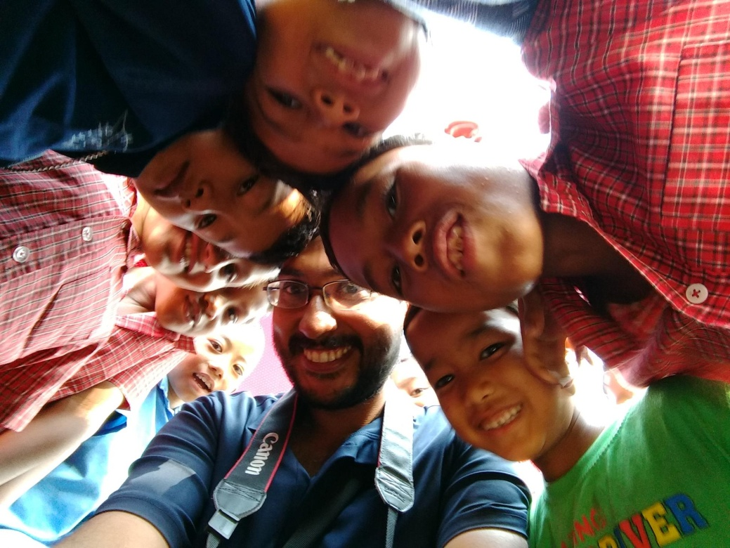
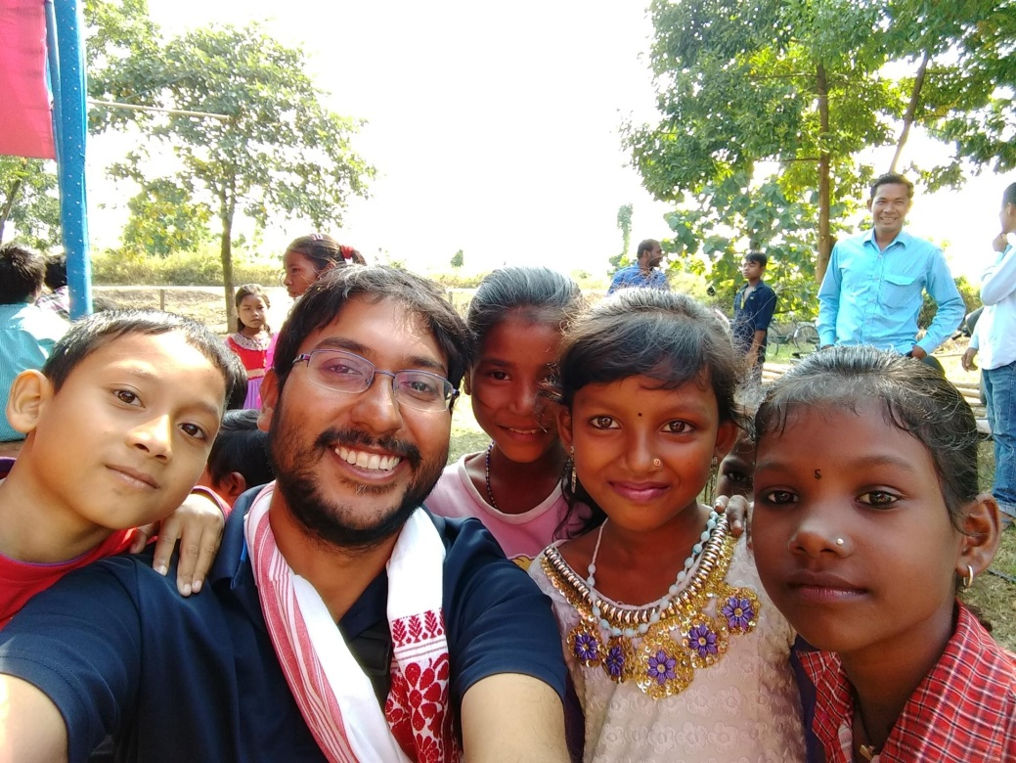
While I look back at these selfies with kids, I feel the positive energy created by Asha Darshan among these kids. Not only kids from different languages, different cultures are dancing in the same stage changing the history of conflicts and differences, they are creating a better world every moment they smile. - Padmanava Sen

