Vikasana Rural Centre for Education
Annual Report
2013-14

Greetings from Vikasana!
This year we had 10 new admissions (5 from local and 5 from previous location). There were 5 dropouts due to shift to native place or due to family crisis.

Transportation
Children travel independently using the local bus (BMTC). Most of them have student concession pass from the road transport, which subsidizes the travel. They handle day-to-day issues faced efficiently. It is a learning situation.

What we did…….
- Gates and the inner compound walls were painted with distemper. Children enhanced this by doing creative paintings using oil paints.
- We have panchayat water supply to the school.
- We built a septic tank.
- We now have a 24 hours watchman (Sangote) and this has minimized breakages and trespassers during non-school hours to a large extent.

Who supported us……
Continued support from old and new Volunteers has helped the children immensely in broader exposure and enriched learning.
- Sarang (Environment and nature), Aarthi( Maths) and Deepa(Art and Craft) continued from last year.
- Hemanth started volunteering twice a week. He exposed the older kids to the concepts of science using interesting experiments and supported them in using the computer effectively.
- Reshma who is a trained counselor extended her time in counseling the kids as well as the adults (Teachers) on sex education. Various workshops and one on ones were held.
- Yasmin from CFL, Bangalore took two science sessions and conducted experiments for the older children.
- Samvartika, a student of Ajim Premji Foundation did her six weeks internship at Vikasana. During this time she took several social studies and English classes for the children. A wonderful person who was a catalyst for lot of learning at Vikasana.
- Veena, A Ballet dancer came for some sessions. With her wonderful, special and integrated approach she taught the kids some warm up exercises. We do hope that these sessions will continue.
- Vibha, a 10th Standard student from Kumarans school came with an request to do a project on social work and ended up teaching a few steps in Kathakali.

Who Visited us……
- Shailesh Vaishnavi from ‘ASHA for Education’ came for a site visit and interacted with the children and observed the classes.
- Aarthi’s Father-in-law and Grand father went back impressed after seeing the school.
- Sanjiv Sadana, an old friend of the school revisited us.
- A Group of 16 (13 students, 1 warden and 2 teachers) from Mahila Samakya, Chikkaballapur village visited us for a day to understand the teaching methodology and practices followed.
- Narasimhan and Usha (old friends) visited us.
- A group of IT professionals, NGO’s and Govt employees who call themselves “Common Purpose” visited us from Fire Flies (A place close by). They were impressed and happy to see a school like Vikasana.
- Few people from “Responsys Business Solutions India Pvt. Ltd (Ex company of Deepa) also visited us. They contributed funds for the Mid-day meals (ISKON) for whom we all sincerely thank them.

Workshops and courses our teachers did…….
- Nagaveni attended a session on Creative Leadership (addressed by Dr. Gururaj Karjagi) during the Adyapan Meeting at RV College.
- Two of our teachers attended a talk on “How to bring up children” by Dr. Gururaj Karjagi and Ram Mohan.
- Nagaveni completed B.Ed course successfully.

Where we went…….
- Few children and 2 teachers attended the inauguration of “Koothuhala”- Parent Musing center, a Children’s book and toy shop and activity center.
- The middle group visited Lalbagh Flower show.
- On children’s day we took the middle and older group for a trip to Maddur. One of our Ex students , Suresh joined us and helped immensely. We visited many ancient temples. The kids visited a Puffed rice-manufacturing factory and learned the process. We also visited various sugarcane and paddy fields. Children enjoyed eating the sugarcane that was generously shared by the farmers and had fun splashing and playing in Vaidyanathapura Hole.
- During the Christmas holidays, 7th and 8th class children visited Deepa’s Grandparent’s place in Kumta (a place in North Karnataka) via train. Children had a wonderful time playing on the beaches and seeing the amazing Western Ghats region.
- The younger children and 2 adults visited Bannerghatta National Park. We are thankful for the transportation provided by a parent for this outing.
- The younger group attended the Annual Day function of G R School.
- Few children and 2 adults attended the Saraswathi Pooja and annual day celebration at Govt. Higher Primary School, Tathaguni.

What we celebrated…
- Independence Day – Children did pyramids, dance, songs and skits.
- Ganesha Festival – With full zeal and enthusiasm the kids made Ganesha and Gowri using clay. Few ex students (Suri, Bhanu, Harshitha and Venki) visited us during this time.
- School birthday- On 12th November few children and teachers stayed back in school. We lit up lamps and enjoyed the beautiful ambience together.
- Christmas- the year ended with celebrating Christmas. A Christmas tree made of palm leaves, innovative decorations for the tree and a wonderful plum cake and a surprise visit by Santa (dressed by Veena Pandit). Singing Christmas Carrols and performing skits made this day memorable for all.
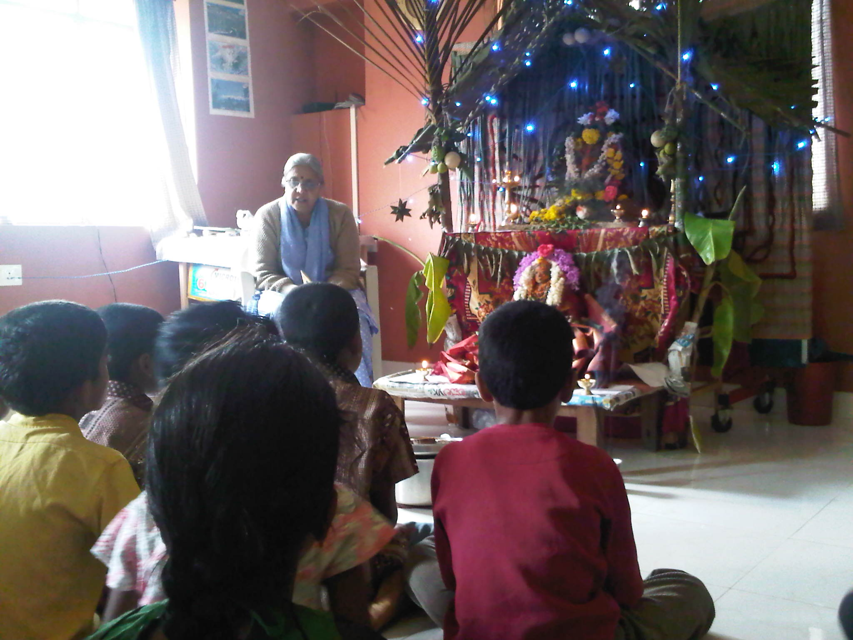
Gouri Ganesha celebration – chanting shlokas

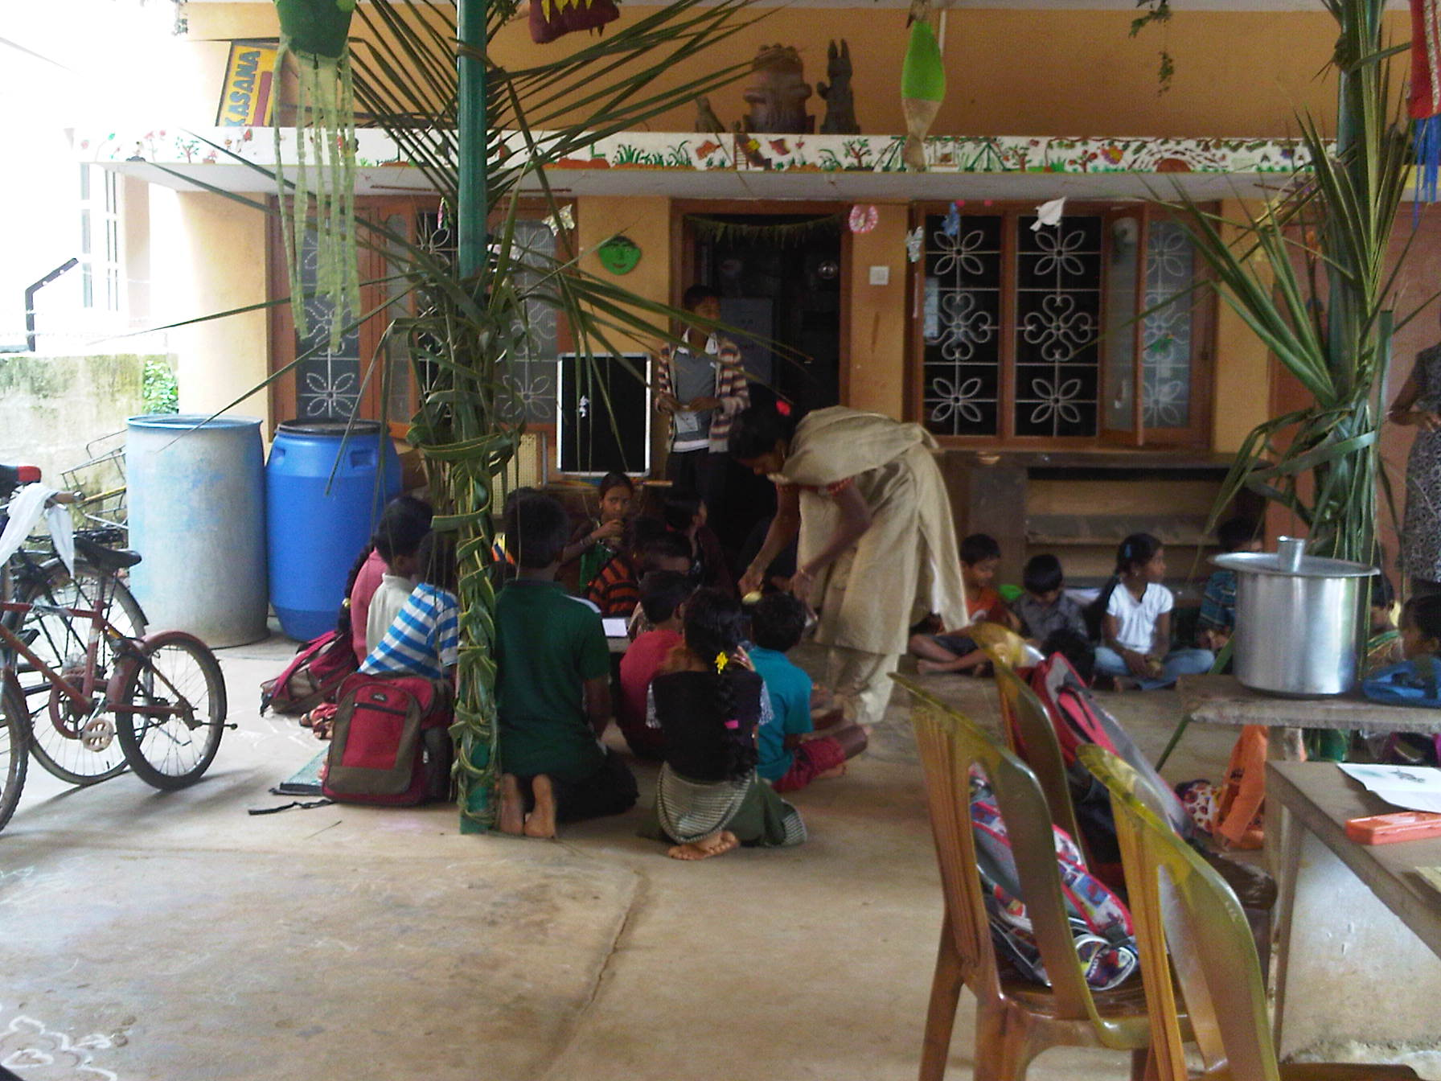
Ganesha festival prasada distribution

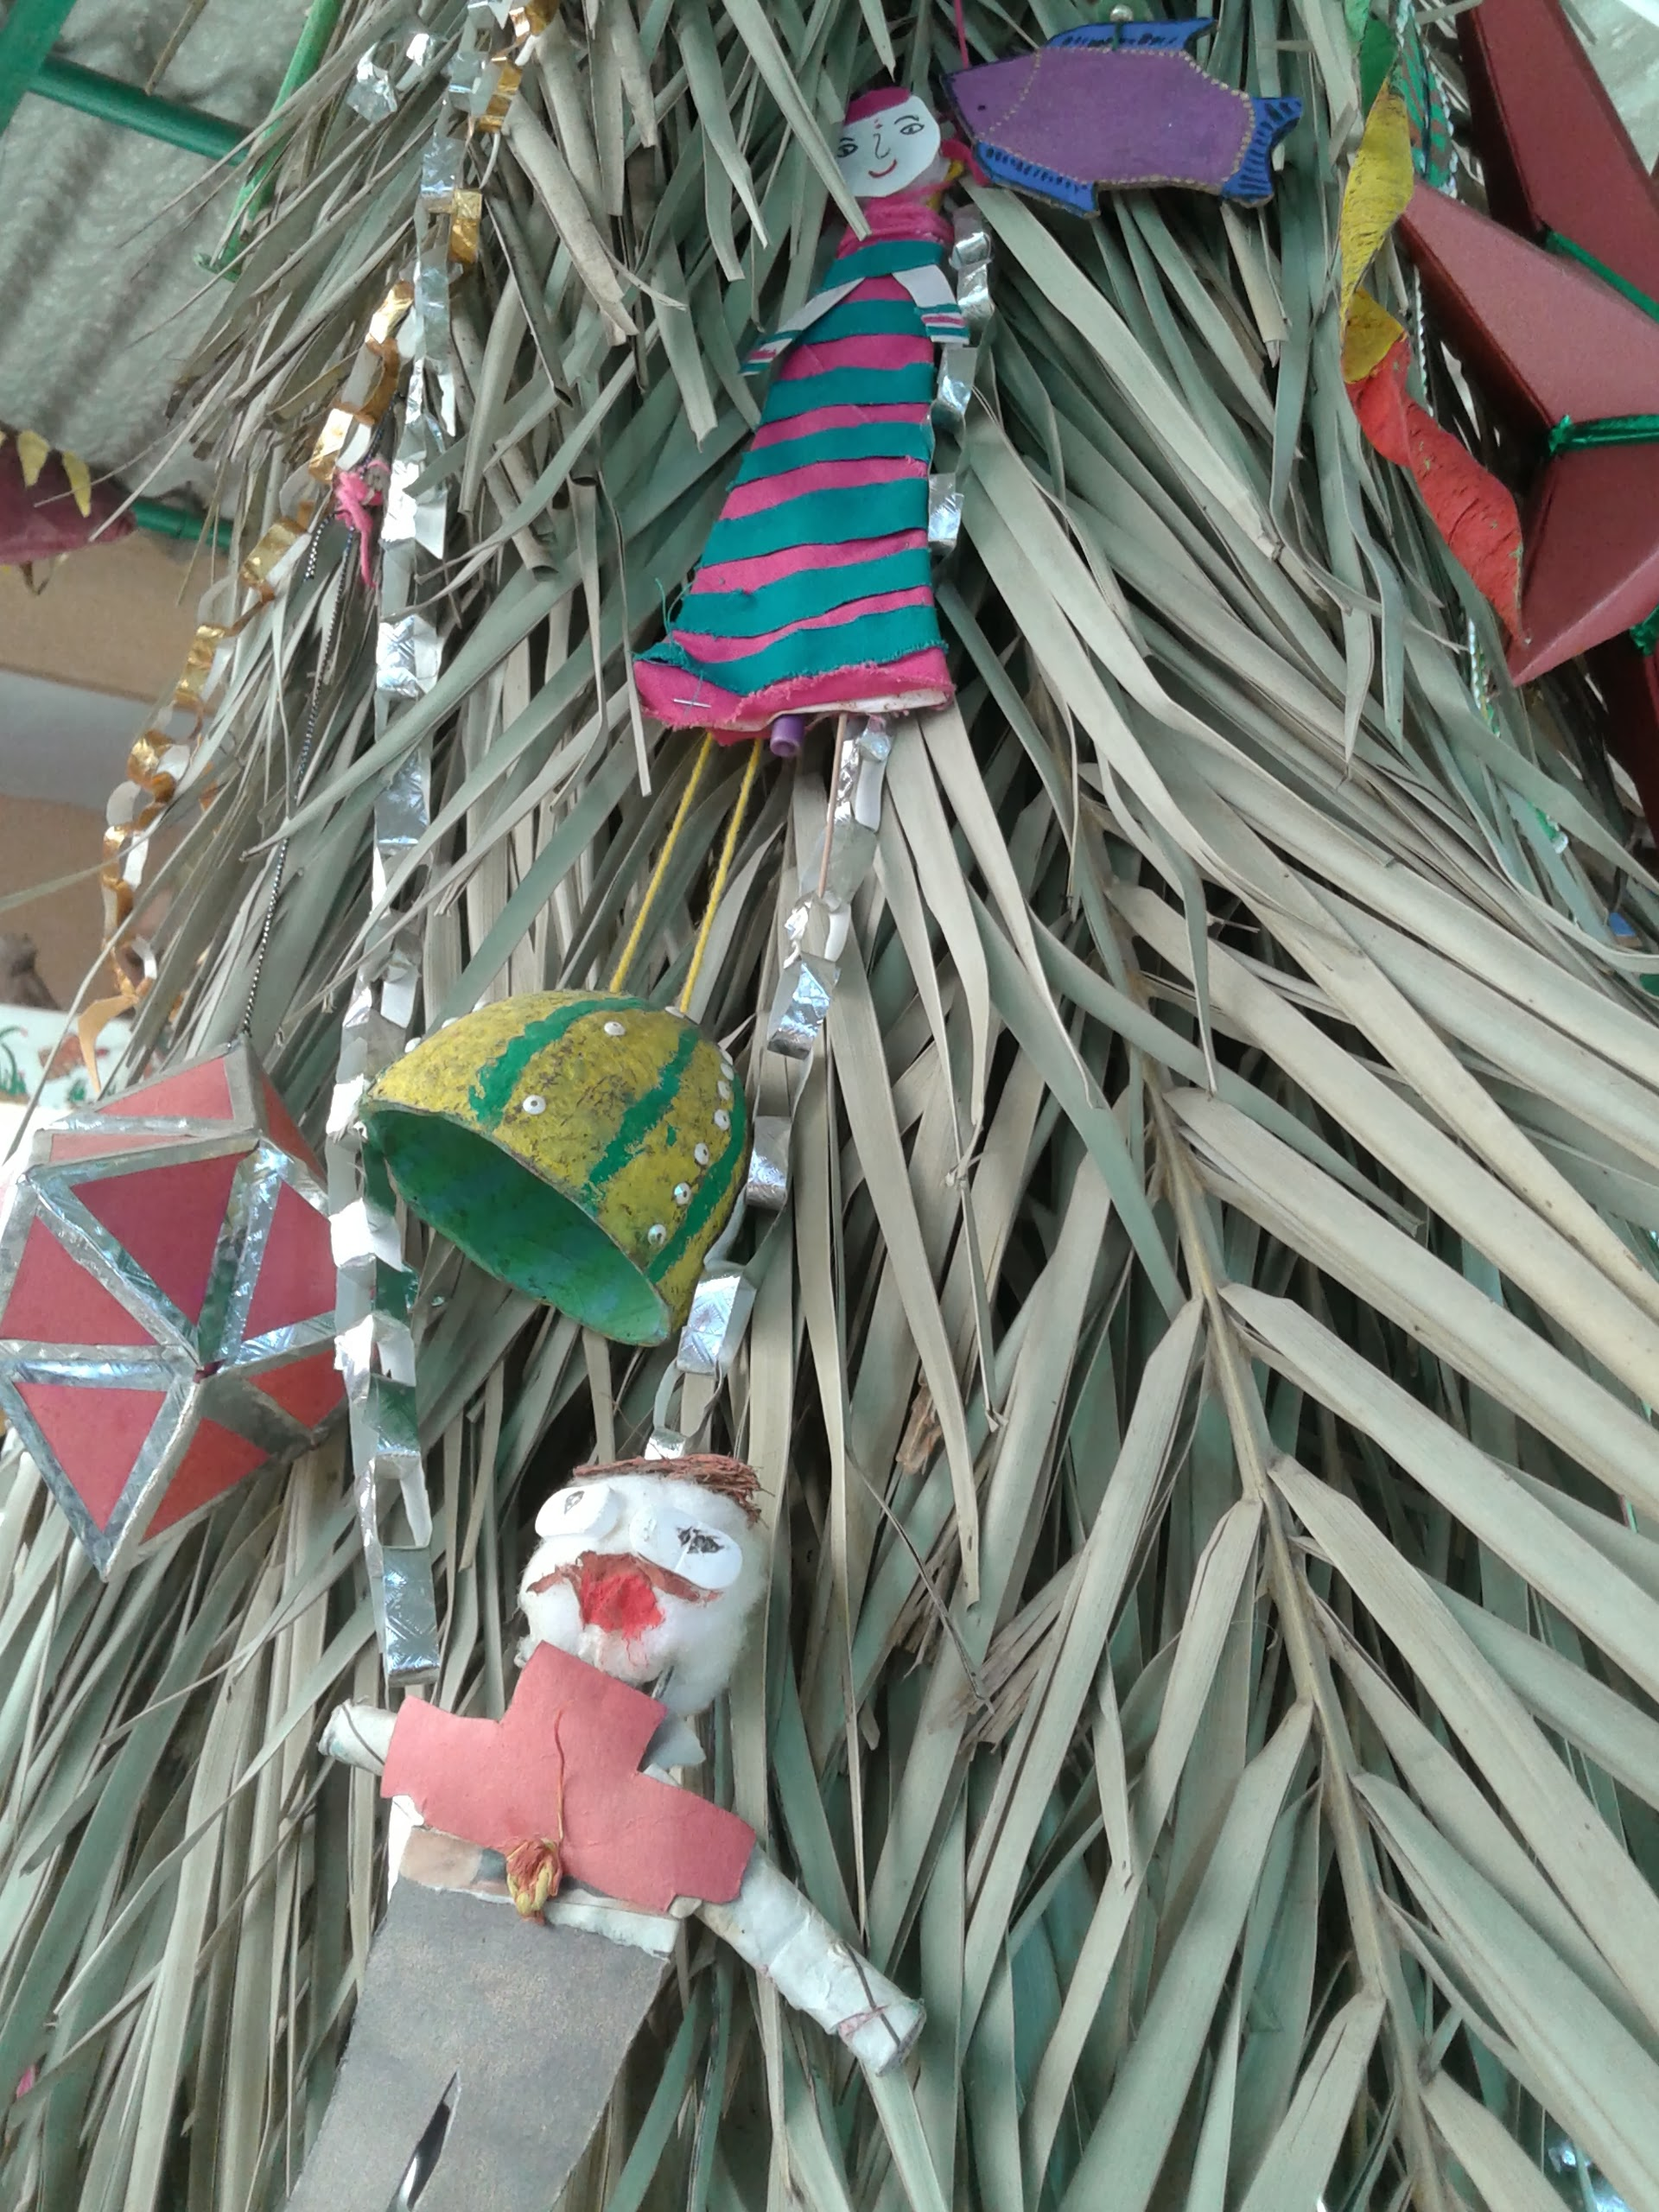 | 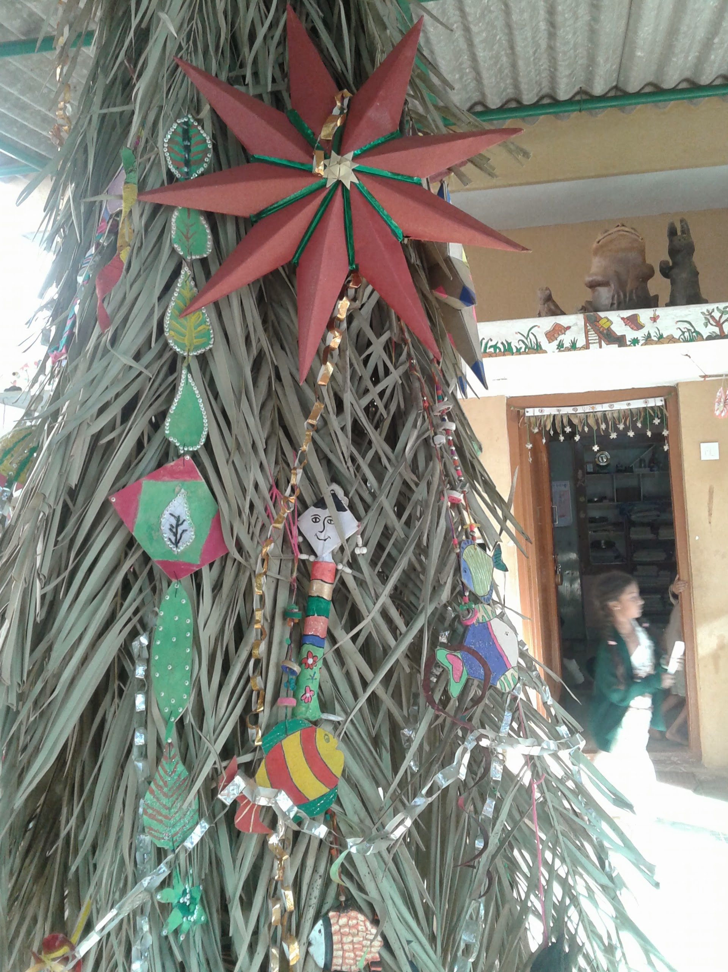
Christmas tree with decoration by the children

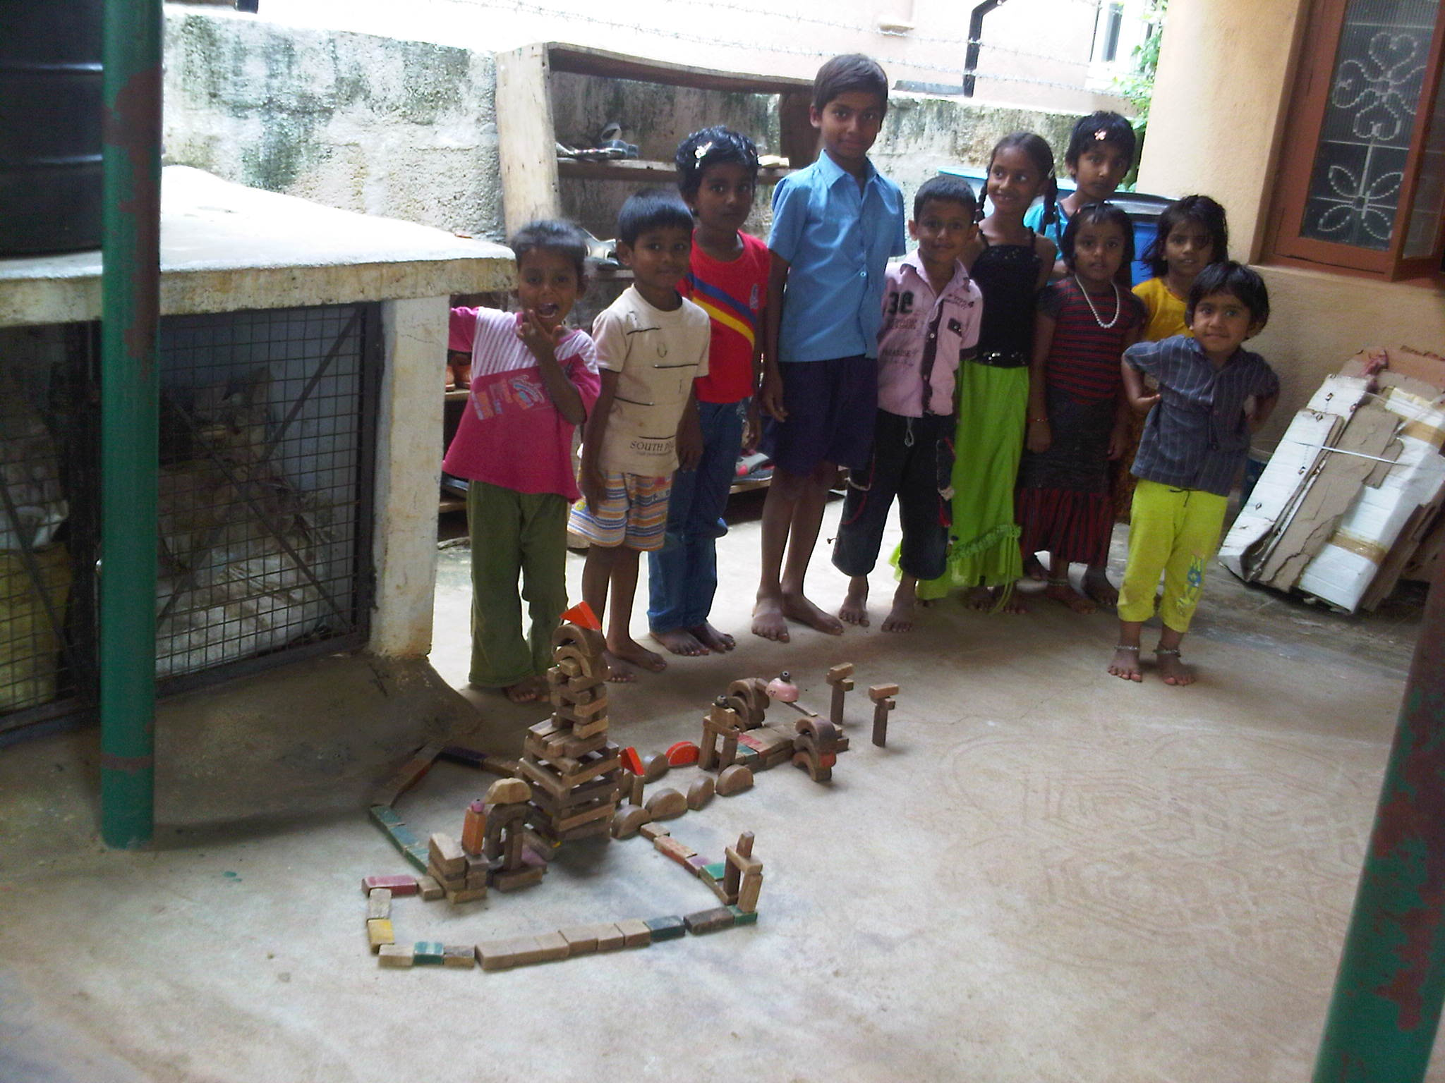
Wooden block structure done as a team work by small group children

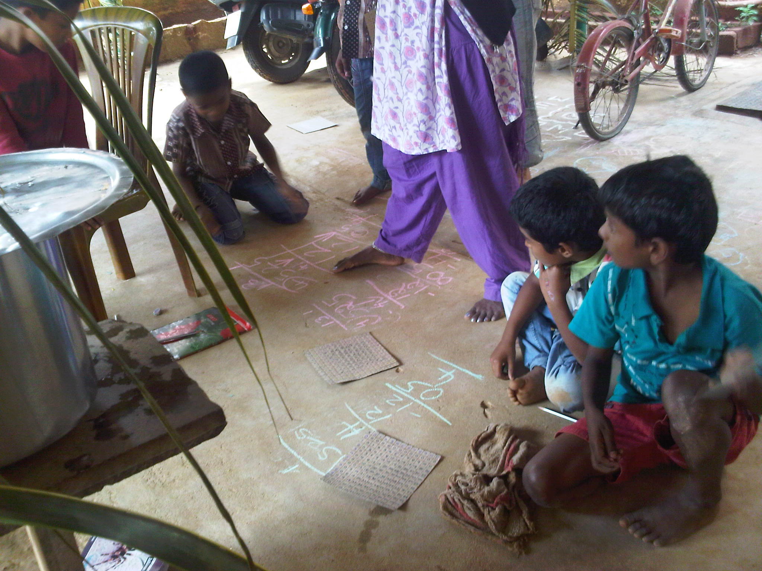
A setup of effective and simple open class.
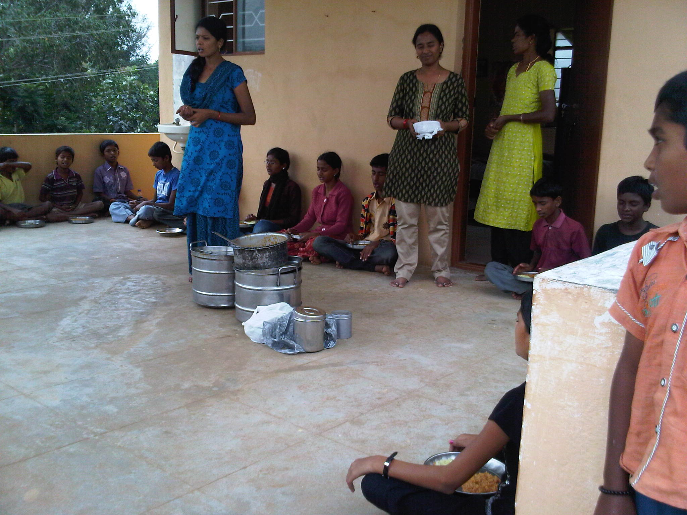
Prayer before meals
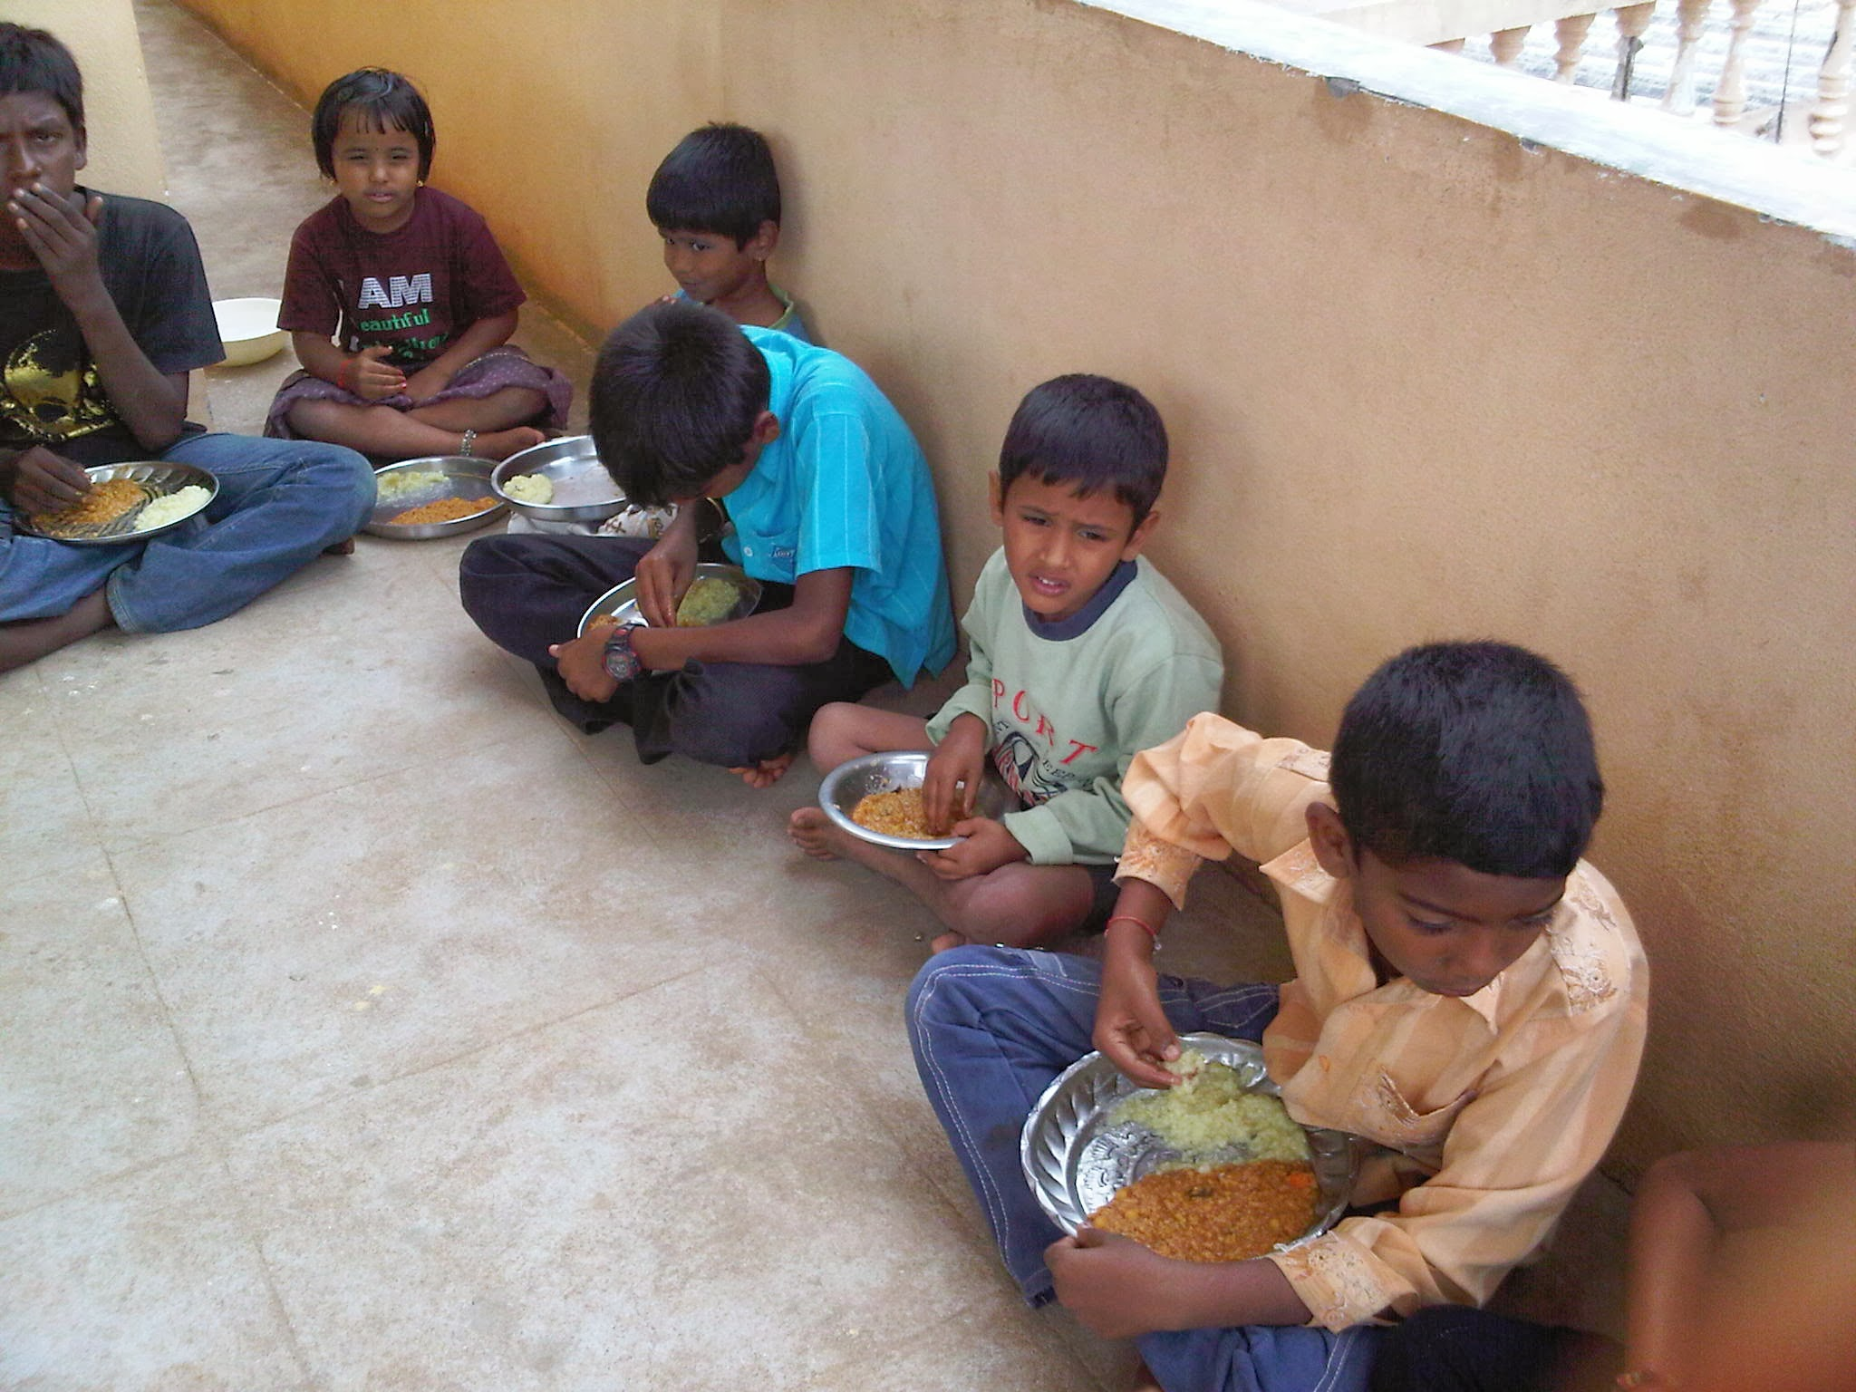
ISCON mid-day meals

Report on the progress of the 8th standard science class

By Hemant Chandrasekhara

I would like to start this report by saying that it has been a learning experience for all of us. In spite of my other commitments, I have been able to meet with the children on a regular basis. My interaction has helped me learn as much about children as they have learned from me.

I have found the children to be keen on learning. They are naturally inquisitive and determined to be competent in society. Most of them are also quite capable.
They absorb knowledge and information from various sources, like a sponge.
In the past year, I have noticed a definite improvement in their reading abilities –which could be due to the effectiveness of the other classes also.

The most positive aspect of this class has been my rapport with the children. Today, I am able to identify with each of them. I know their strengths and weakness. I have a better idea of what to expect when they are given tasks. There is a tendency to take advantage of this rapport leading to indiscipline, but I do not see it as negative. I think the positive aspect of the rapport is definitely worth the times that the class goes out of control.

Regarding the potential improvements, probably the top of the list will be my own ability to commit, due to my personal circumstances. Excluding that, things that require improvement could be inter-personal issues between the children. I find that some children get along better than others, thereby affecting the classroom dynamics.

The other potential improvement could be the facilities, specifically a dedicated science lab with classroom. If we could set this up, it would save a lot of time that is wasted in setting up experiments. From my side, I would need to improve my presentation. I would also need to find ways to delegate work so that more can be achieved.

Overall, I am very positive of the experience. I am determined to continue putting an effort towards the children’s science education, in the true sense.

Year: 2013-14
Volunteer: Aarati
Group Size: 10 (10 to 17 Yrs.)

During the academic period from June 2013 to March 2014, I have tried to make the children comfortable with the subject as such. My endeavor has been that their attitude towards Math’s changes from fear to liking. We covered some basic concepts including numbers-simple to more complex operations, application of BODMAS, techniques for faster calculation speed, fractions, HCF, LCM, simple equations etc.

In some earlier classes I also exposed them to various reasoning based games/puzzles like Sudoku, KenKen, Hidato etc. This helped in developing their interest in numbers. This also made them approach calculations as a fun based activity. Another advantage of these games is that they help immensely in developing analytical thinking.

I have made an attempt to deal with them on behavioral level also, trying to develop some soft skills like adjustability, team spirit, sportsman spirit, self-confidence, inquisitiveness and also having the courage to ask questions so as to clarify doubts and give up in case of doubts. I am glad at the headway made in all these areas as I have achieved a lot of participative interaction in class from each and everyone now. Hope to move forward on the same in the next session.

Year:2013-14
Volunteer: Deepa Bhat
Last year I have given my time to Vikasana:
- to interact with children of various groups,
Showed older group the Plastic Cow video to raise awareness on reduce,reuse and recycle plastics
Helped the older group with their studies
Accompanied smallest group to Bannerghatta national park
- to do paper work including report/email/audit,
- to followup with ASHA for site visit, and fund
- done some monetary contributions for transportation and participated in TCS 10K run last year to fund raise for mid-day ISCON meal as part of Responsys India Team.

Vikasana School – 2013-14
Volunteer – Sarang Chandrasekar
Group size – 11 kids (7 to 14 years)

This year on an average 11 kids from the school started coming to my colony (Trans Indus) once a week for a class away from school. We initially started with Nature Walks around the community. During this time they identified various trees, spotted different flowers, seeds, birds, stones and the terrain.

We identified certain places which needed planting and the kids did the planting under supervision after which a particular spot was given to them to “plan and make” into a garden. Kids divided themselves into groups and worked on:
- Planning the look of the garden.
- Procuring waste materials for use in the garden.
- Created ponds, pathways and niches around trees for growing flower plants.
- Learnt and multiplied plants. Made a mini nursery.
- Made a wooden bridge to walk across the pond (and similar spaces).

While developing the garden on a weekly basis they also did various crafty and artistic activities like painting terracotta wares, making wind chimes, paper craft, painting various waste material and creating sculptures out of them.

They also worked with Mr. Ram on musical activities (drumming) and sketching during their visit here.

Kids sometimes worked in groups and at times alone in the above-mentioned activities. Some were the planners, some managers and some the executors. Communicating in English was something they all did and managed conflicts with some help.

This experiment of being midst nature and working has been exciting for most as they do not want to miss any session

Here is my feedback about the kids who were regular:
Abhi – Plans well and very interested in doing the work. Is always interested in learning something new. Tends to boss a bit but is flexible too.
Anusha – Works very well. Very enthusiastic and doesn’t consider any work less than others. Questions and thinks.
Madhu – Better follower than planner. Enjoys some part of the work and does those with lot of enthusiasm.
Teja – Very focused with what he is doing. Tends to do only certain types of things he considers “manly”. Very hard working. Works better alone.
Hanumant- Very enthusiastic, hard working and focused. Wants to do everything
Manu- gentle as well as hard working. Listens well to instructions.
Puneet –Does what he is told. Cannot work alone and needs guidance.
Gautami – Works well with instructions. Does well in a group as well as alone.
Chinni – Enjoys being in nature and prefers certain works only. Works well alone and in a pair vs. a big group.
Malika – Focus could be better. Does the work but seems lost sometimes.
Chirru and Madhav – Both are very happy to be midst nature and would prefer free play to structured work.

The kids also prepared for and performed a puppet show and gymnastics. They are extremely open and not shy to perform in front of an audience.

