Summary
(Since this is my first site visit, please make allowance for rookie mistakes . Also please pass along any feedback/questions/comments)

Everyone I met (Manisha, Sangati Field Coordinators, Manthan teacher educator, Manthan students) seem to be driven, passionate, committed, enthusiastic and eager to make a difference. They made a very positive impression on me*.
Overall, I feel that the site visit was very informative. I feel that the organization is filling a very important void in the education system (and in general the society). Avehi Abacus has an uphill battle for both Sangati and Manthan programs and have various challenges in each of the programs. They have shaped the plans for the next 2-3 years but are very dependent on key support from Beat Officers and Principals. Also, their ultimate goal is to get Sangati and Manthan incorporated in the regular curriculum; that is the only way they feel these programs can be sustainable in the long run. It seems that the Trust that was supporting them is no longer going to support any urban organizations like Avehi Abacus and so they are relying very heavily on organizations like Asha to fund them.

*I got a feeling that they were definitely well-prepared for my visit, like schools are for a visit from a supervisor/school inspector. Manisha had the Sangati Field officers waiting for me, the field officers had their anecdotes and stories ready for me, the teacher educator had the students prepped for my visit and probably choosing only those students for my Q/A, who would praise the Manthan program. I guess every organization wants to put up their best when their sponsors (or potential sponsors) are visiting them. It did seem a little fishy to me when one of the Manthan students reiterated one of the exact same benefits of the Manthan program that the teacher educator had told me. I tried my best to ask probing questions and sometimes even challenge what each of them was telling me. All in all, the overall impression I got was while their answers might have been prepped, they did seem genuine.

Introduction about Sangati

My day started with meeting with Manisha at the Avehi Abacus (AA henceforth) office at Mahalaxmi in Mumbai. For a few minutes, she gave me an overview of the Sangati program, walking me through the 6 kits for the students between grade 5 to grade 7 (both inclusive). Her main focus was pointing out how the material in these kits differs from the regular curriculum and how these kits help in creating self, social, political and ecological awareness. The worksheets for these kits are developed in 8 different languages (since preparing the kits themselves in different languages is expensive, they are published in Hindi and Marathi). The students get “factsheets” which they keep for all three years (this also helps evaluating the progress made by the students from the 5th grade to 7th grade).
She listed the following as some of the challenges for the Sangati program:
- Changes in education administrative personnel
The administrative structure roughly looks like: EU->Deputy EU->Superintendent->Administrative Officer->Beat Officer->Principal. Currently, Sangati enjoys good support from the Beat Officers and so Principals have extended their cooperation. However, any change at the higher administrative structure can lead to changes in policy and may create hindrances and AA will have to spend effort all over again lobbying and garnering support for the Sangati program.
- Burnout of teacher staff, difficulty in sustaining motivation
Since Sangati is additional work for teachers (whose schedule is already packed with other non-teaching government activities like general elections etc), it has caused burnout. While a lot of teachers understand the importance and advantages of the Sangati program, it has been difficult to sustain motivation. It has become difficult to schedule for team workshops for teachers; 60% of the teachers have been trained in the workshops.
- Have consecutive year programs
Currently, Sangati has been sanctioned as a pilot program for one batch of students. There has been no indication that this will be done for consecutive year students or made part of the regular curriculum (Though one of the core members of AA was in a meeting the same day I was there to talk about making Sangati part of the regular curriculum)

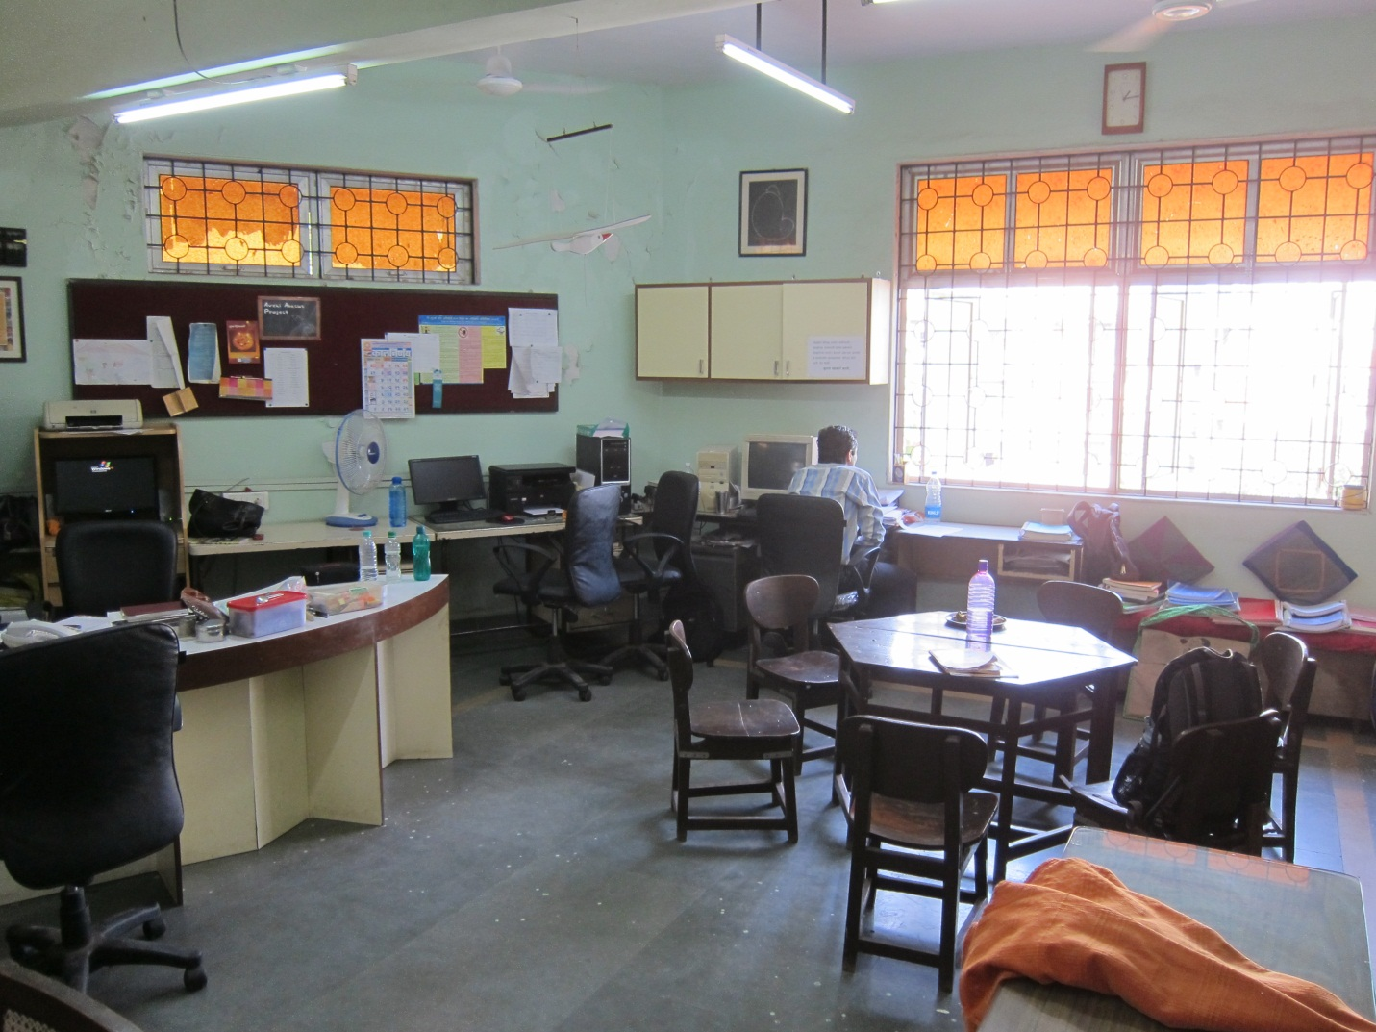
Figure 1: Avehi Abacus Office

Plans for Sangati
Next we discussed the plans for Sangati.
- Schedule workshops regularly to train teachers and try to get maximum attendance.
- Currently Sangati is rolled out to Municipal schools in Mumbai. AA is now looking to roll it out to Convent Schools. So far the talks with the Convent Schools have not worked out. AA is also looking at some Jesuit programs.
- AA feels that Sangati ultimately needs to be rolled out as part of the regular curriculum. Otherwise they feel it is not sustainable for longer periods of time for a small group of schools; their fixed cost for production of the Sangati Kits is quite high and the economics would only make sense for larger numbers.

Introduction about Manthan
The idea behind Manthan is to inculcate the core values of Sangati at the root level; the next generation of teachers, the D Ted (Diploma in Teachers Education) students. I was under the impression that Manthan is a more detailed substitute for the Workshops that are held for the in-service teachers. However, it’s NOT; it is more of training the teacher to think more openly, have a 360 degree view of the society, the educational curriculum, understanding the child students etc. The idea is that these future teachers understand these values and try to inculcate in the children whom they teach. Also, this course complements the regular curriculum and also helps simplify and understanding of the concepts in the regular curriculum.

Plans for Manthan

Current rollout
Manthan was initially rolled out to 4 private colleges at the Panvel DIET (District Institute for Educational Training). Out of that, one college is closed because of lack of funds. Currently it is a pilot program and so is only for one batch of students (not rolling or consecutive). So there is no continuity. This is a 2 year course with 25 sessions each year. There was a 2 day workshop held for six educators (Teacher Instructors) in Nov 2011. The syllabus was prepared by the core AA team. Their second year syllabus is not yet out.
The challenges with the current program are:
- Burnout of teacher educators
- Attrition: These teacher educators are paid really low salaries in these private colleges (surprisingly the public college teachers are paid more). Naturally, these teachers migrate to greener pastures. Also, 2 educators were lost because of closing of one of the schools.
- This program works for pilot kind of rollouts but is not sustainable at a larger scale.

Future plans
AA is targeting another pilot program in Pune from 2013-2015. The reason Pune was chosen was because of good working relationship and support of the Principal of the Pune DIET. They are targeting 20 colleges and trying to get a larger group of teacher educators for the workshop. Also, they are targeting more stable colleges. The larger group and stable colleges will help mitigate the risk of attrition; an issue that has caused a lot of inconvenience and wasted effort. This will definitely cause more taxing initially for the AA Facilitators since they will have to commute from Mumbai to Pune. Eventually, they plan to employ more Facilitators from Pune itself.

Interaction with Sangati Field Officers
While I was at the AA office, I met with the Sangati Field Officers, all of who were women. The impression was that they were really enthusiastic, passionate and enjoyed their interaction with the children. They don’t interfere with the teachings, they are observers and guides. According to them, what the children enjoy the most about Sangati were the games, crafts and drawing activities. (One particular game that they told me about was hitting the bottles with a stone game. The children were very eager to throw the stones at the bottles. At the end of the game, the children were told that each bottle represented for example, a mother, a baby, a little boy etc. This made the children cringe and they understand and profess that they will never throw stones at other people. This is great lesson for children living in the sections of the city where it’s not so uncommon to have riots). Also after they started sex education, a lot of girls are coming up to the field officers and asking about their problems, changes happening in their body. Some of the challenges that the field officers face is when parents/teachers have issue with the Sangati material. For example, in one of the Urdu schools, the parents of one child had issue with natural evolution being taught in the Sangati syllabus and their belief is that Allah and not natural evolution is responsible for the creation of mankind. Situations like this become a little tricky for the field officers to handle. Another challenge is sometimes some of the material might be a little overwhelming for the kids but the AV tools help the kids a lot in that regard. The children like Sangati and the field officers and even after passing the 7th grade when they meet the field officers, they remember them and affectionately call them “Sangati Madam”.
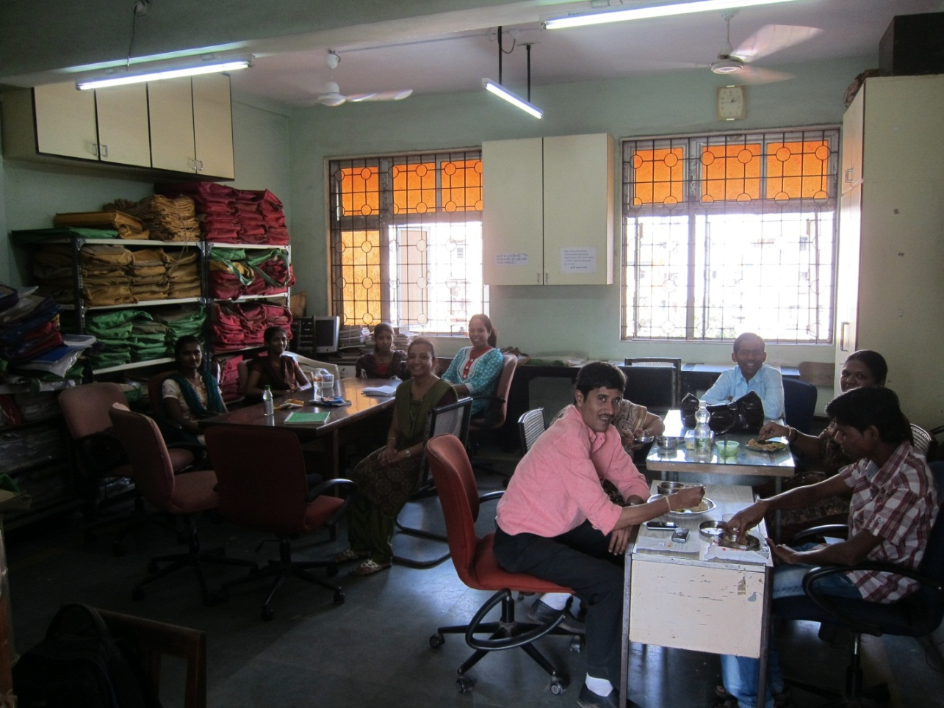
Figure 2: Field Officers and other having lunch

Manthan Session Report
Later in the afternoon, I attended one of the sessions at the Panvel DIET. The school is low on funds and that is reflected in the conditions in the school and the classroom. There are no chairs for students, a large hall in which around 80 students attend the Manthan training. There are regular power outages; so the microphone does not work and the instructor has to literally shout while talking to the students. Also, the blackboard is in poor condition with sometimes no chalk or blackboard duster available. The writing on the blackboard is barely legible.
The topic of the session on that day was related to discrimination based on caste. There was a lot of interaction with students. The students were constantly prompted to relate with real life examples and experiences. There was discussion around how casteism affects the different aspects of life such as social and political. Since the class is 2 hours, the students were getting a little bored and distracted. However, the educator tried telling them some funny stories to get them back on track. Also, parallels were drawn with some popular television series to make a point causing the distracted students to jump in the discussions. The educator read out an essay by an author of the lower caste and there was a question session after that which mostly involved analytical and practical sort of questions. One of the highlights was a healthy debate at the end of the class in which one of the students raised the contradictory question of why there is a Quota system for lower caste rather than the lower class people. It was based with own personal experience where she lost her seat in the engineering college to a rich girl (who had driven to the admissions office in a car), who had lower grades, was given admission to the engineering college because she was from a lower caste. This sparked a debate amongst the students in which even the back benchers participated. Manisha interrupted and explained the historical context of the reservation quota and how it was not envisioned to last so long and how it now the onus of the next generation of citizens (and not political leaders) to make that change happen.
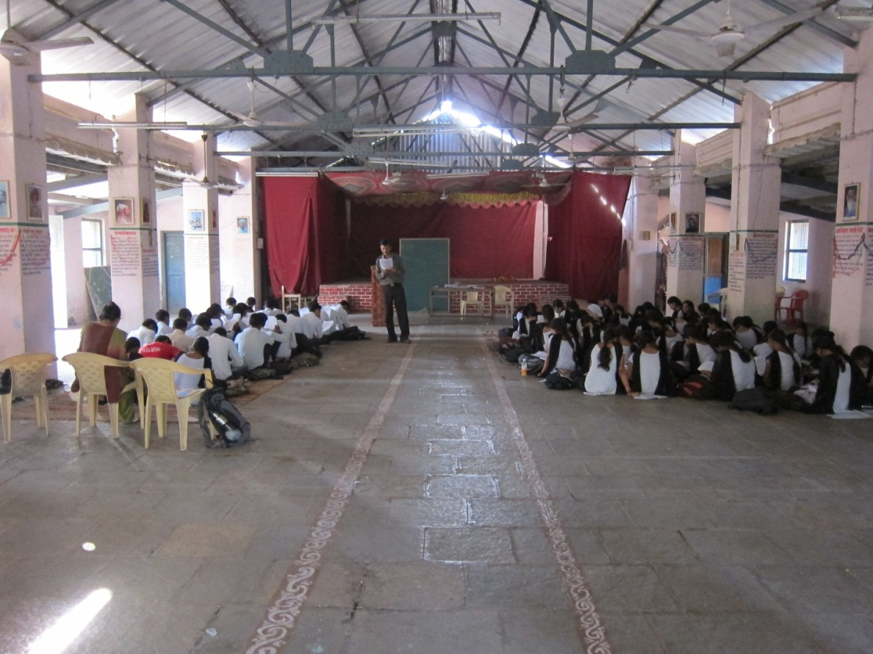
Figure 3: Manthan classroom at Panvel DIET

Q & A with students
I had asked to meet with 4 students (2 boys and 2 girls), two of who are passionate and two who are the “backbenchers”. I realized that I should have myself picked those students as it was not difficult to identify these candidates in the 2 hour session. I did manage to pull in a couple of back benchers who were leaving the class, by just asking them to join in our discussion. Anyways, I started the discussion in Hindi (I am not too good in Marathi) and asked them to converse with me in Hindi or Marathi whatever works for them the best. Here is the summary of the Q&A:
- Q: Why do you think this program exists?
A:
  - Self-improvement,
  - develop kids,
  - know the facts,
  - “self-realization”,
  - make change happen
- Q: What are the pros?
A:
  - Complements their curriculum well;
  - Helps them understand the concepts better.
  - Its not bookish knowledge,
  - Knowledge without reading.
  - Their opinion counts.
  - Know more about their culture,
  - Personality development.
  - Life lessons.
  - Improve thought process.
  - This is why they like to attend Manthan sessions even though it is not mandatory and there are no grades.
- Q: What are the things they would like to see improved:
A:
  - More Audio Video tools, more visual tools.
  - More activity based.
  - Shorter classes: instead of having 2 classes of 2-2.5 hours, they would prefer having 5 classes a week of 1 hour each.
- Q: What is the attitude of the other students:
A: They agreed that around 60% of the class is generally very passionate about Manthan. They conceded that not the rest is ranging from the “not very passionate” to “totally disinterested” with the latter being not more than around 5%).

Q & A with teacher educator
The teacher educator (Mr. Dinesh Chavan) was the field officer from AA. Because of the attrition of teacher educators, he also acts as a teacher educator. It would have been ideal if I could meet with a teacher educator who was not part of AA. His feedback was along the same lines as that of the students: how Manthan complimented the regular course work, how it has helped the teacher students with “out of the box” thinking. The negative feedback was around the length of the sessions. He mentioned that the Principal at the Panvel DIET has been very supportive and helpful. He passed along the positive feedback he had heard from the other teacher educators.

