Site visit of Avehi Abacus Project

6th Feb 2014

Aparajita Durga

Asha Seattle has supported Avehi Abacus project since 2000. I am an Asha Seattle volunteer and I visited Avehi in Mumbai for a day on Feb 2014. During such a short visit, I was able to get a glimpse of the work Avehi has been doing for decades. It was an eye-opening and moving experience for me.

Avehi main office in Mumbai
I reached the main Avehi office in Mahalaxmi, Mumbai around 10:30am. I was accompanied by my mother. We were greeted warmly by Simantini, who is the director of Avehi (she is in the picture below).
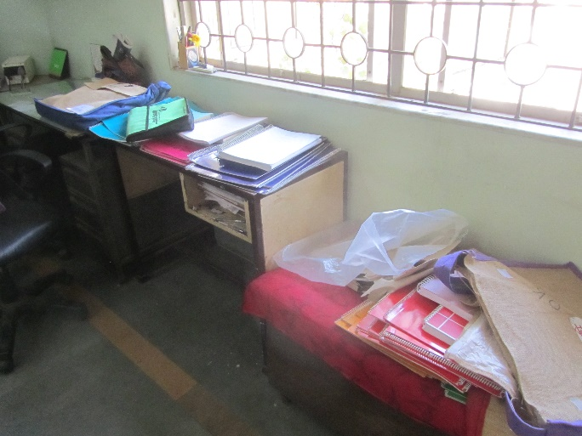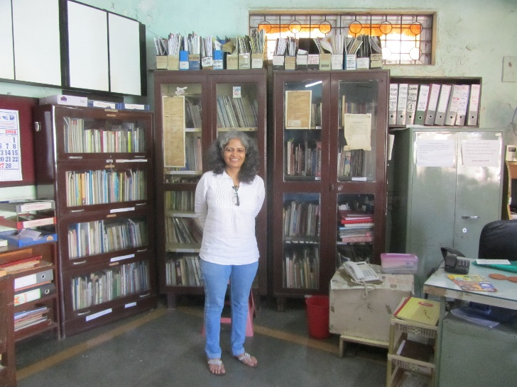
Simantini had laid out all the Avehi -Sangati materials. We spent the next 2 hours or so going over the materials. I had seen those before, but it was good to hear from Simantini and get more details. Sangati, is a rich curriculum package, comprising of a series of 6 teaching-learning kits with interlinked themes for the Vth to VIIth grade classes. This material is used by the teachers/students to supplement the regular courses in Mumbai Municipal schools, numbering around 900+. In response to the sexual violence towards women, they have also newly developed a kit “Saath-Saath” on gender parity for girls and boys in the same age range.
Sangati material is extremely well done, in thick glossy paper with large pictures and text. The content explains science concepts using practical examples, challenges gender stereotypes, encourages open discussions on taboo topics, builds social and economic awareness, and challenges social, structural injustices. It is strongly founded on social values to enhance level of society. Among its many impacts, it helps children express themselves and engages them in their education. My mother and I had good discussions with Simantini as we reviewed the kits.
There were 2 rooms which served as the office rooms for Avehi. I spoke to some of the staff members there. They worked in the office handling administrative work, as opposed to field representatives who were in the schools. We shared their home cooked meals for lunch and it was delicious.
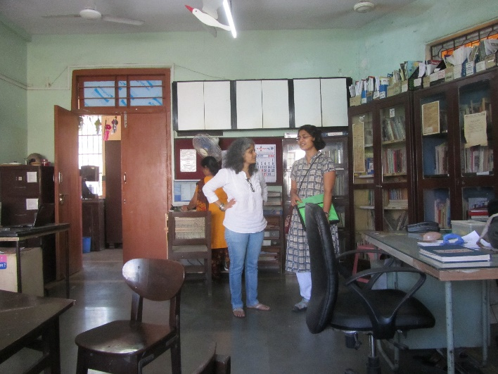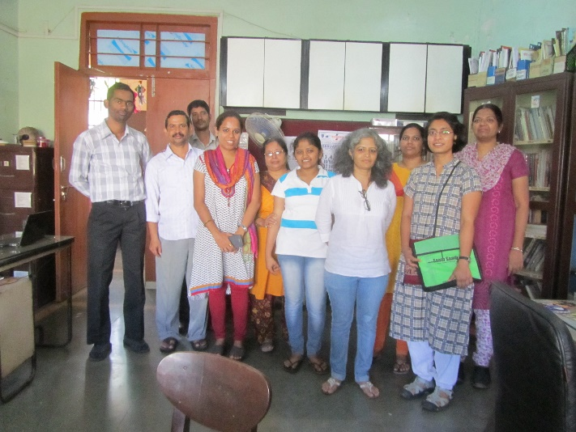

Visit to Worli School (Maharashtra No.3 School)

We left the main office after lunch, for the school at Worli. I think this school was selected because it was one of the closest. Manisa, who was one of the oldest Avehi staff, accompanied us. In majority of the MMC schools where Avehi works, the children stay in slum settlements, and face multiple deprivations such as lack of health and sanitation facilities, food insecurity and low-wage, often hazardous, work. One of the girls I spoke to in this school, helps her mother, who does household work in other people’s homes. Coming from such a background, it was touching to see many children very bright and eager to learn.
On that day, students of class 4 or 5 had set up a science exhibition.
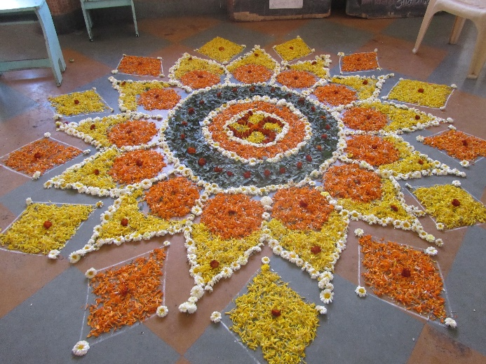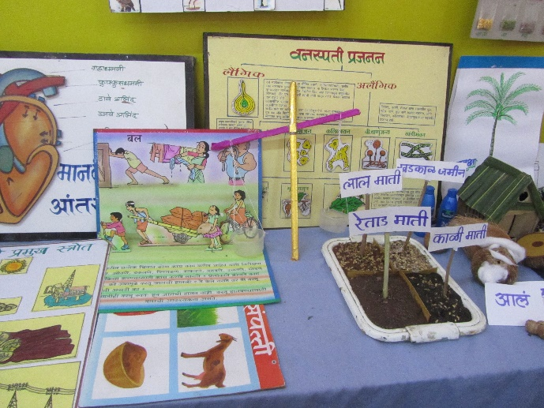
Above picture shows a “rangoli” done by the children. And interesting science exhibits made by them.
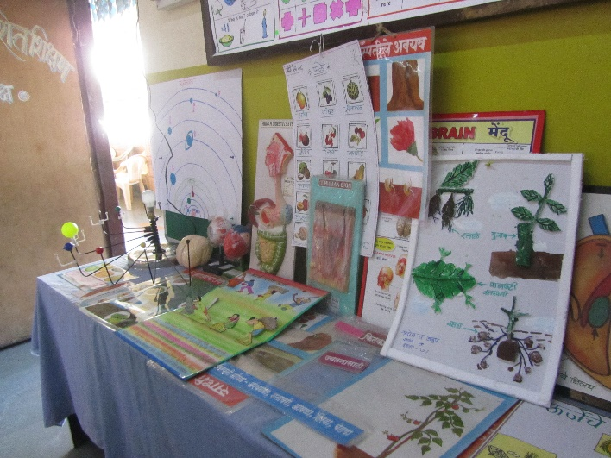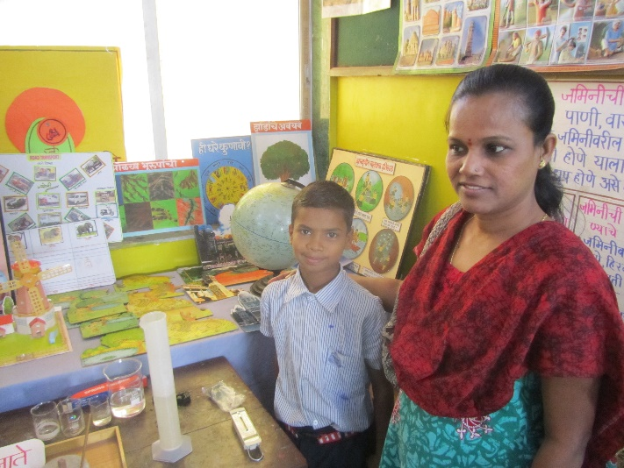
The children had created games to demonstrate principles of physics, chemistry, biology etc.
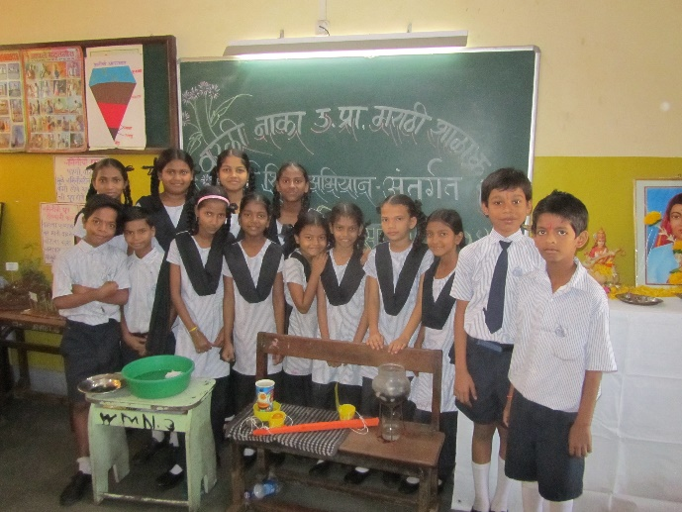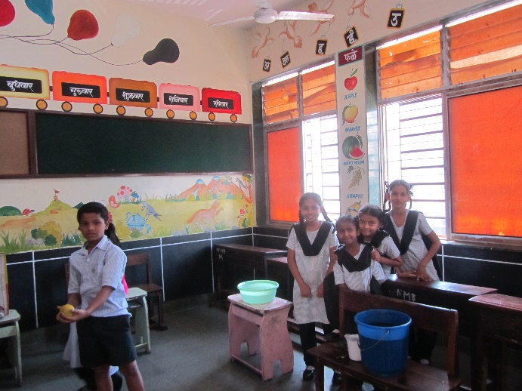
They all wanted to show their exhibits. I had to play some of their games as well.
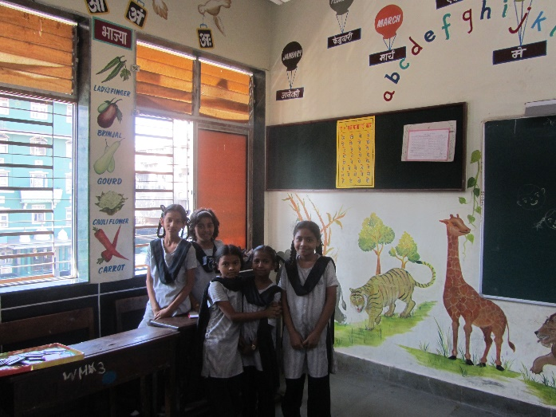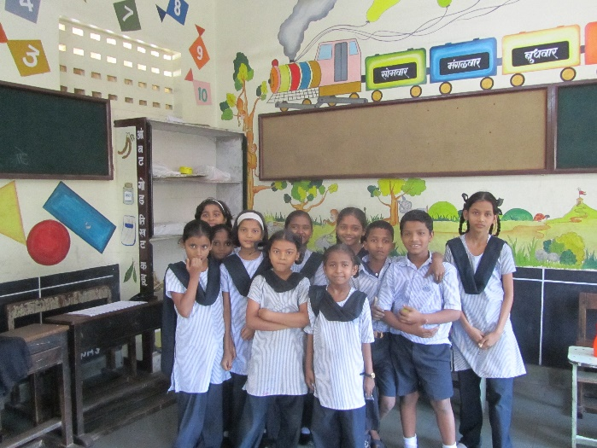
The room in which the exhibition was held was a model classroom, very nicely done with paintings and posters on all the walls. This was funded by Sarva Siksha Abhiyan (SSA). It would be a real pleasure to have many more classrooms like this one – however, this was the only one in this school building.
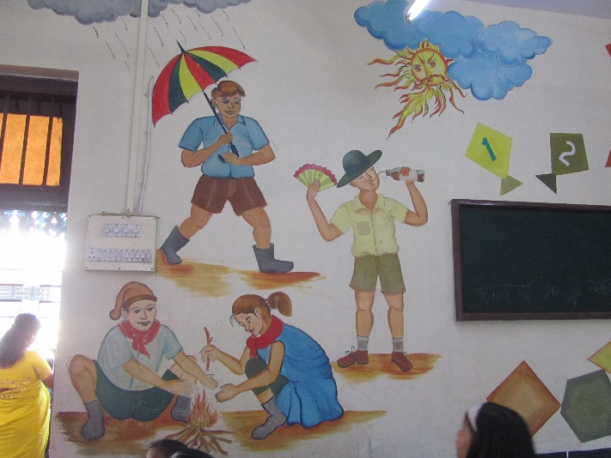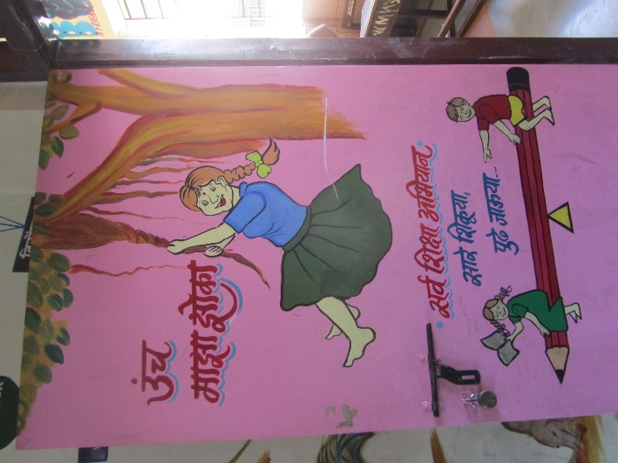
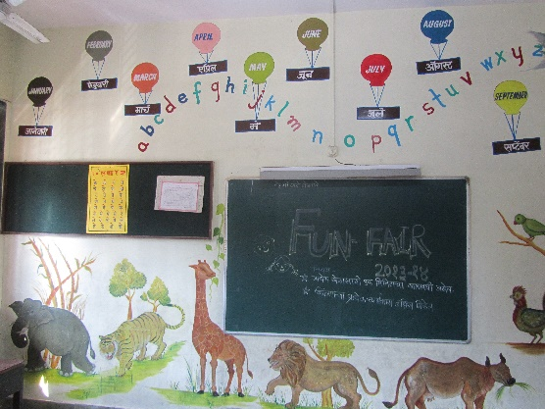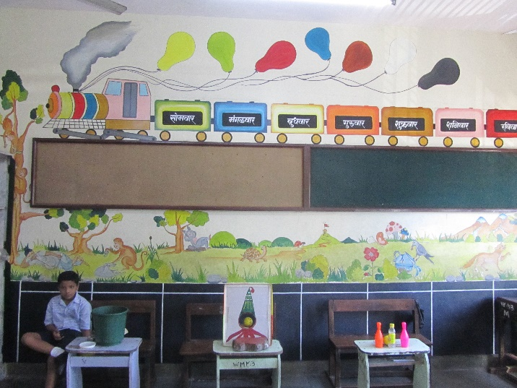
Next we went to attend a class where Sangati material was being taught. I sat in the class in front, to observe the students, though this was a Marathi medium class (and I don’t know Marathi). The way this works is, one Avehi field representative mentors the teachers in a school teaching the Sangati material. She will be observing the class while the teacher teaches and provide feedback later. In the class I attended, the teacher read from one of the Sangati kits, and asked questions. The children sitting in front-center were the ones who were really engaged; could be because they were able to see the material better. The teacher didn’t make much attempt to engage the children sitting on the sides.
After class, I chatted with the teachers and Avehi staff on the socio economic conditions of the children. They come from the lowest economic levels, often first generation learners. The girls especially, face huge challenges in the outside world and school is safe haven for them for some time.
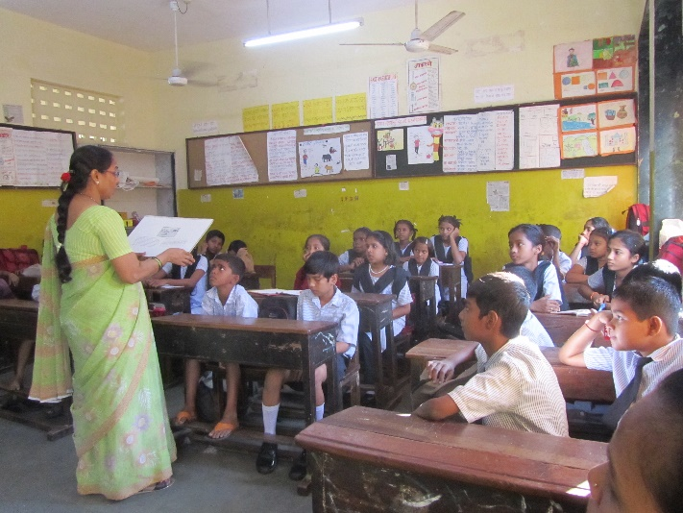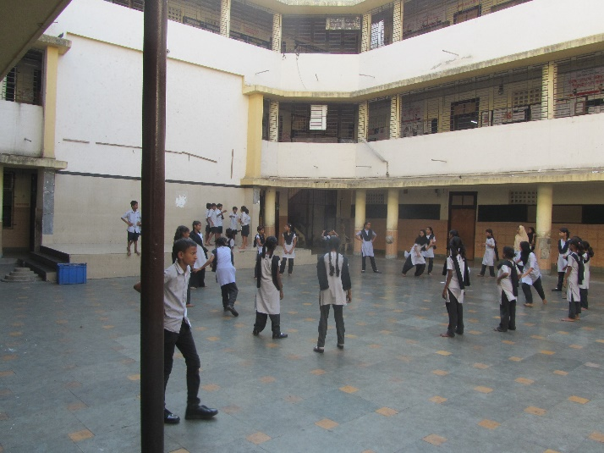
Soon it was time to leave as the school was over. While we were leaving the school building, I had the pleasure of seeing girls playing in the courtyard of the school building.

Concerns
In terms of the quality of materials and the outreach of Avehi, it is truly exemplary. However some questions arise on the implementation of the program:
- The teachers need to be motivated to learn, understand and teach the Sangati material. Since this is separate from the regular curriculum, they have to put in extra time and effort for this, and that can be a challenge.
- Some of the content may be radical for the teachers themselves. If the teachers have a certain idea and culture ingrained in them, and they don’t agree with the Sangati material, they will not be able to do justice in bringing about change for a better society (which is Avehi’s goal).
- In the school I visited, Sangati was being implemented only in class 6 (as opposed to having it in all the classes - 5 to 7 in that school). So, only 1 batch of students get that training from class 5 to 7; the next 2 batches don’t. Simantini later explained that this is because of lack of continuation of the teacher in the same class and insufficient personnel to monitor the program in all three classes simultaneously.

