Mahila Action (Pragathiki Bata School)
Site Visit Report
(Academic year 2012 - 2013)

Visited by:
Srinivas Padala
Email: srinivaspadala_2000@yahoo.com
Phone: +919985283407

Site visit Date: 20th March 2013

Current Project Stewards:
Satheesh Avvaru (avvarusatheesh@gmail.com)
Sudhakar Ravuri (sudhakarravuri@yahoo.com)

Project Partner Information:

Mahila Action
Pragatiki Bata School, Visakhapatnam, Andhra Pradesh, INDIA

Administrative Office:

Contact Person(s) : K.Swarna Kumari
Phone Number : +91 891 2732194
E-mail : ma_ngo@rediffmail.com; mango.vsp@gmail.com
Address : 47- 4- 1 / 4, Near Nehru Bazar, Sankaramatham Road,
Dwarakanagar, Visakhapatnam – 530016

School Location : Pragathiki Bata School,
D.NO 184, Shyam Nagar,
Tailor's Colony,
Near DurgaDevi Temple,
Madhurawada. Visakhapatnam, Andhra Pradesh, India

Note: The school is located approximately 15 km away from the administrative office.

Site visit primary information:

- Date of visit: 20th March 2013
- Was it a surprise visit?

No, it was pre-scheduled

- Accessibility of the location

In accordance with the objective of the project, the school is situated amidst slum
dwellings, which implies the primary aim is met with. I opine that this is an apt
location, so as to attain the goal of educating the destitute children.

- Attitude of the staff members?
All the members of the staff are highly cooperative. They did provide all the requisite information. In addition, they made clear about the functioning of the school, with the substantiation such as the school records including the staff and students’ attendance registers. Later on they let me have an interacting session with the students, during which I could evaluate the students’ receptiveness.

- Additional information about the objectives of the organization:

Preliminary Checks:

- Determine if the school is operating as stated (School timings: 9 am to 4 pm from Monday to Saturday)

Yes. The school is working from 9 am to 4 pm from Monday to Saturday

- Determine the number of students at the school by checking the attendance
register. (According to the 2012 – 13 proposal, supposed to be 50 children)

The number of students on roll is 47 excluding few drop outs in the current academic year.

- Please count the number of students on the day of site visit.

The number of students who attended the school on the day of visit, is 37.

- Determine the number of teachers/ staff by checking the attendance register.
(According to 2012 – 13 proposal, there should be 1 in-charge, 3 teachers and one ayah)

The number of staff is compliant with the proposal. There was one in-charge, three teachers and one ayah.

- Please list the teachers / staff attended the school on the day of visit.

Teachers: Ms. Ch. Pydi Raju (In-charge), Ms. B.Kalyani (Teacher), Ms. B.Sujatha Kumari (Teacher), Ms. V.Venkata Laxmi(Teacher)

Ayah: Ms.K.Padma

- Please comment on the cleanliness of the school premises

The cleanliness in the school premises is absolutely satisfactory.

Study Material:

- Determine if they are providing study material for the students
The students are provided with the study material.

- Please comment on the study material they provided. Is that good enough for the
Entire year and fulfill the students’ needs?

The study materials provided to the students are in accordance with the syllabus
of Andhra Pradesh Government. The study materials meet the academic needs
of the students.

School Building and facilities:

- Having two classrooms, kitchen and toilets? (According to 2012 -13 proposal, 2 classrooms, kitchen)

The school building is in accordance with the proposal

- The school is having the required table and desks, cupboard, teacher table and chairs, black boards, fans and tube lights?

Yes

- Simple kitchen, gas stove with two burners, mixie, pressure cooker and other necessary vessels?

Yes

- Please comment on the facility/space of the building.

The current space is sufficient for the functioning of the school.

- Are they providing milk every day?

Yes.

- Providing nutritious mid-day meals? Please comment on the quality of the food items

The students are provided with nutritious mid-day meals and the food is of good quality.

Awareness Programs (Child Rights):

- According to the 2012 – 13 proposal 1 seminar and 1 workshop for child rights awareness programs are being conducted. Please see if any documentation related to that and find out the dates.

I was informed about the child rights awareness programs and I received few pictures in this regard.

Vocational Programs:

- Sports materials: Throw balls, tennis court, skipping ropes, shuttle racquets and indoor games?

I came across the sports materials such as skipping rope, throwing ring and carom board.

Other observations:

- If possible, talk to students and ask them some basic questions (eg : maths); observe a teacher teaching in the class; notice what books / charts / other materials are in the class?

The students’ response is good and all the necessary charts and other instructional materials are present in the class.

- Please check the frequency of the parents’ meetings and meeting minutes

The frequency of the parents’ meetings is absolutely fine.

- If possible, talk to some parents and ask them how often the school has been open in the past month (if it was closed for certain period, why?); How often they send their children to the school? How often do their children get the food/ mid-day meals; What is their opinion about the school and teachers/ staff etc.

All the parents I’ve visited, responded positively in this regard. They are satisfied the teachers’ integrity.

Opinions:

- In the site visitor’s opinion, why should ASHA fund this project?

The project is beneficial to the children of the slum area. The cited children do get the education through the project, which is not possible otherwise.
- What are the reasons if any, does the site visitor see for ASHA not to fund this project?

There is no reason for ASHA to stop funding this project.

- What improvements, if any, would the site visitor suggest to the project?

As per my observation most of students are interested in vocational courses such as stitching, dance etc. I would recommend for the arrangement of the same, as they are beneficial to the students in their future.

Pictures of the site visit:

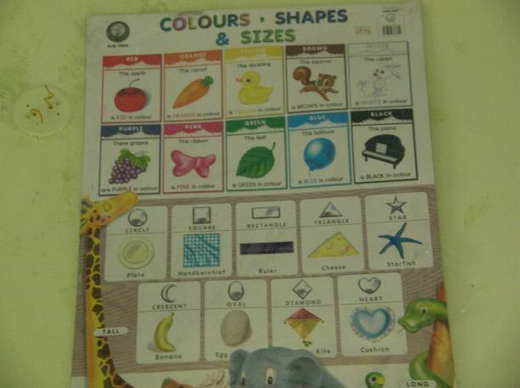
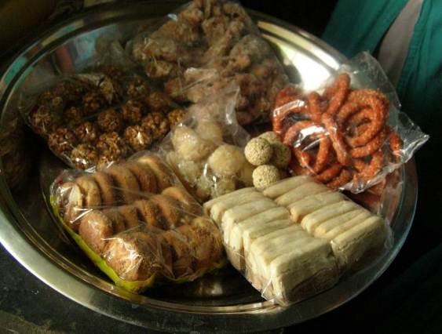

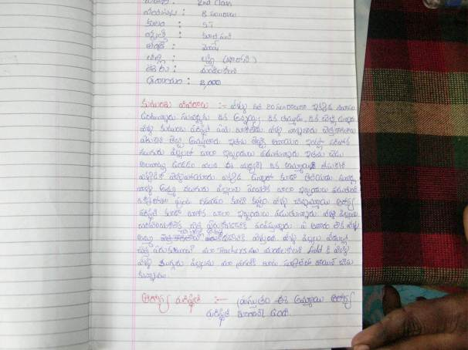
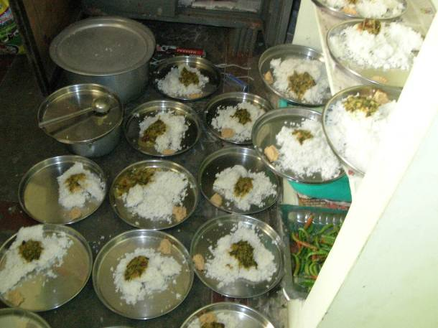

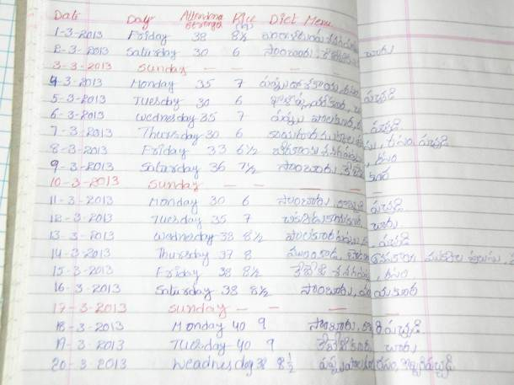
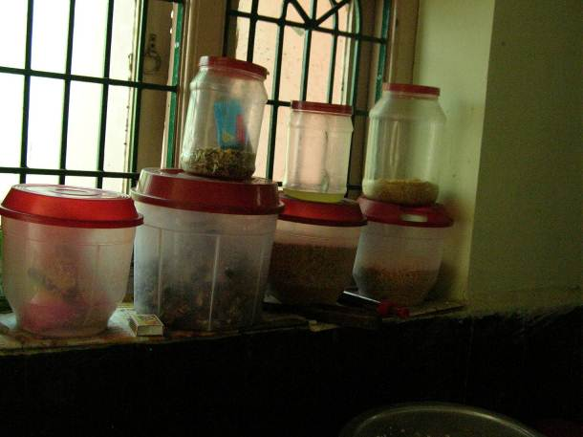
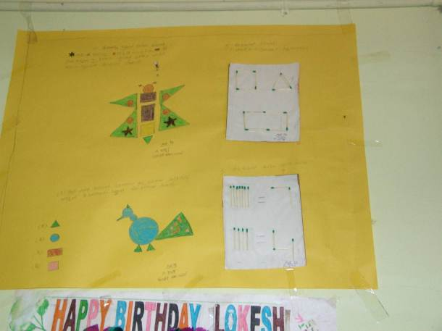
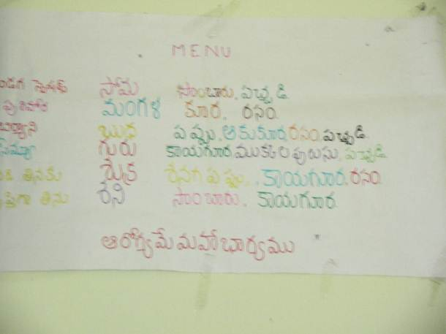
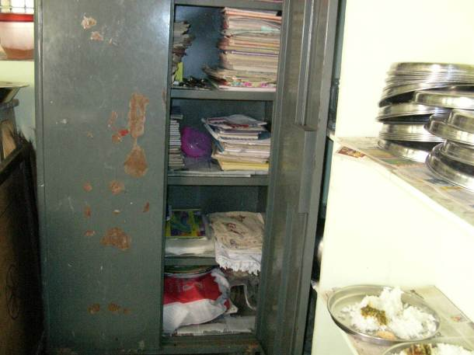
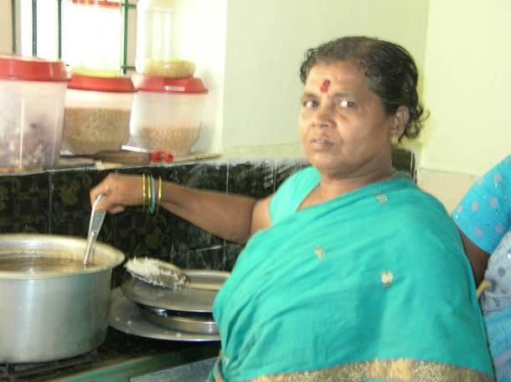

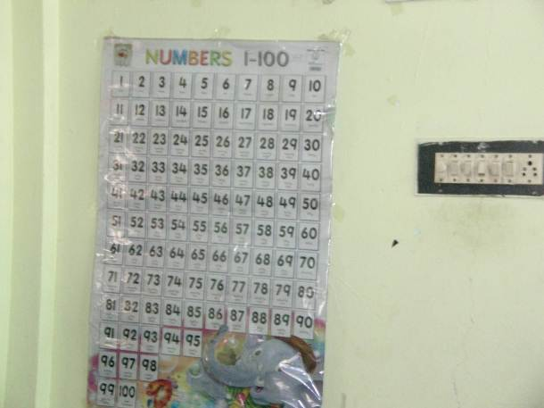
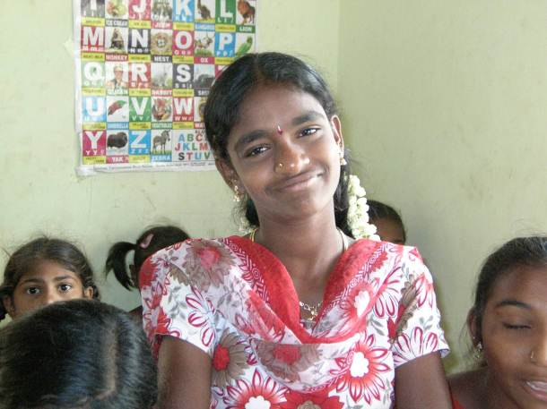

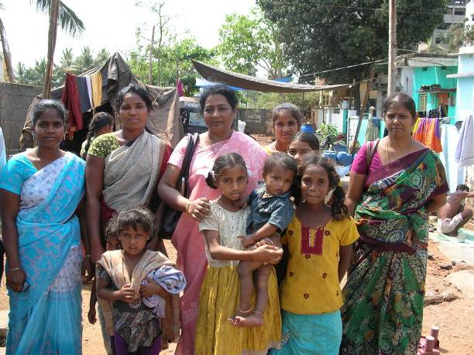
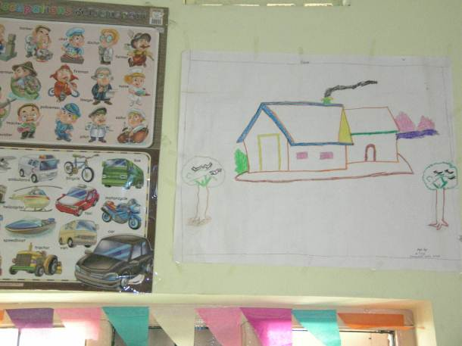

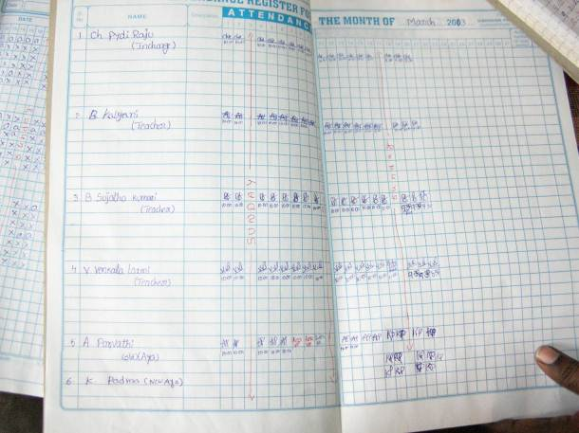
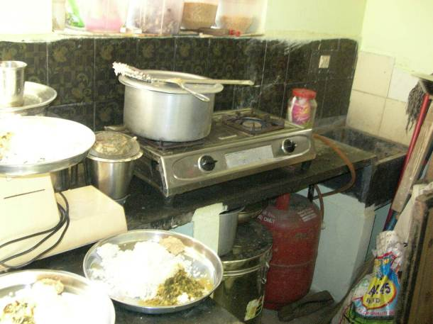

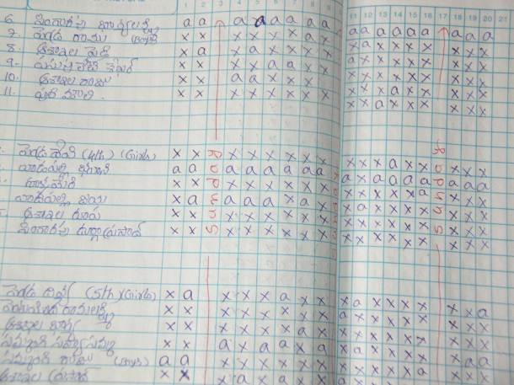
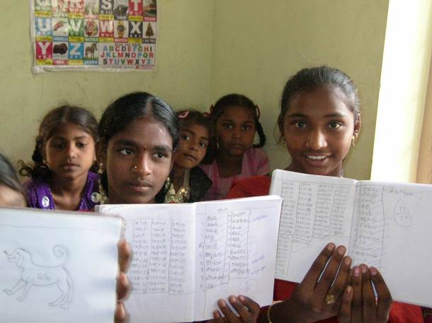
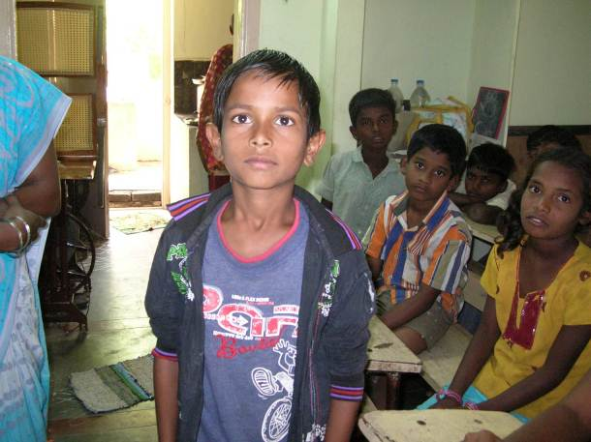
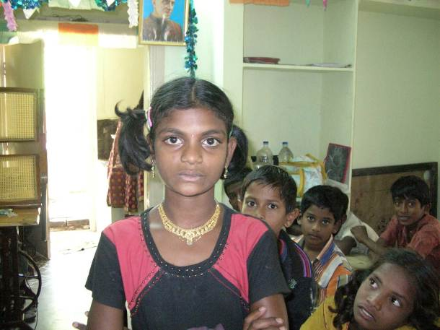
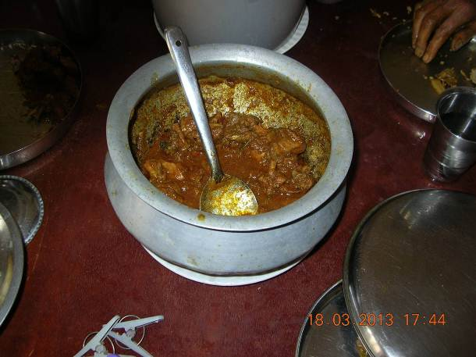
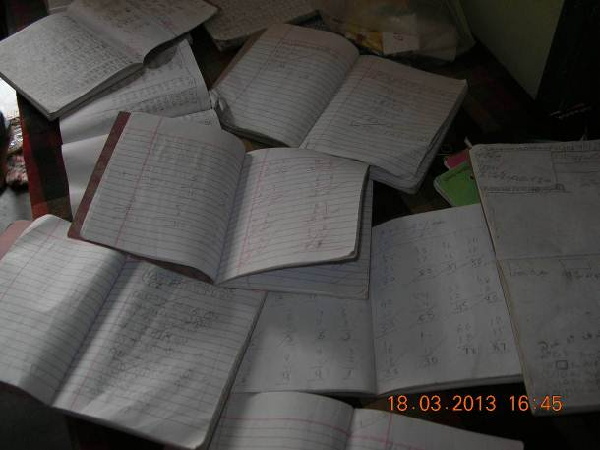

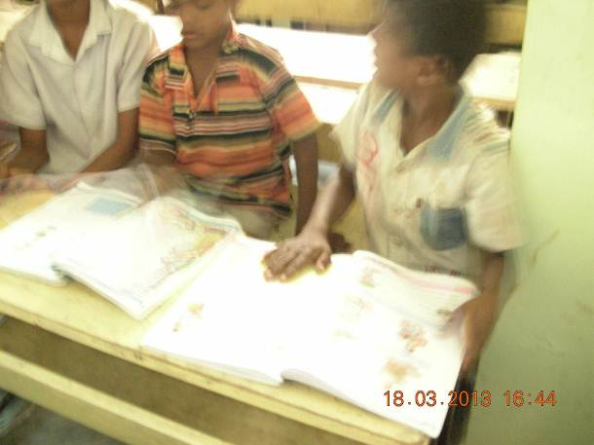
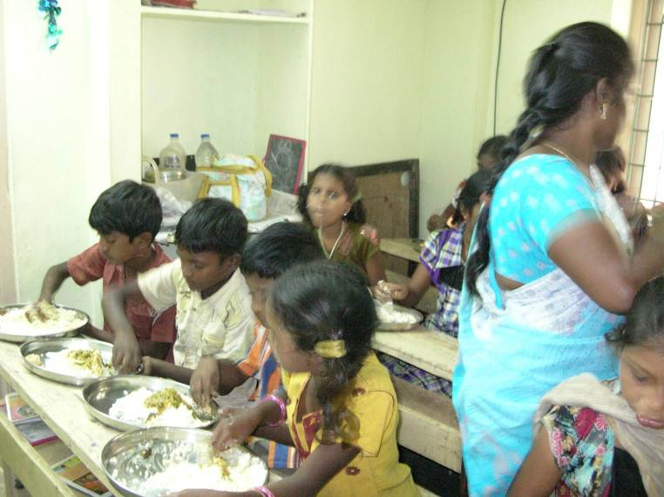
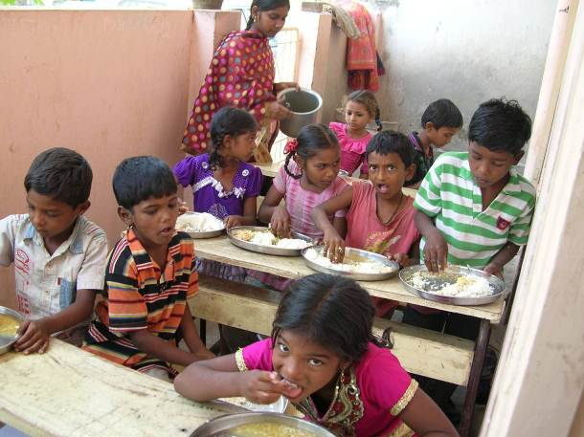
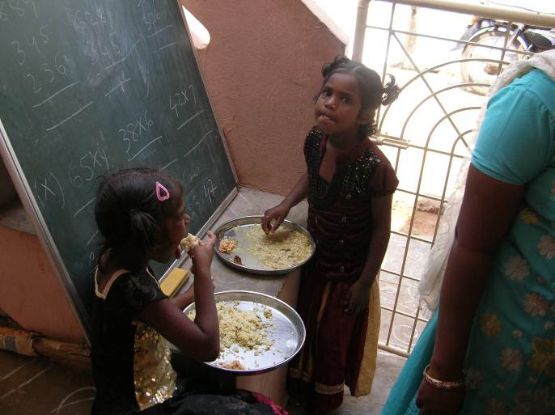

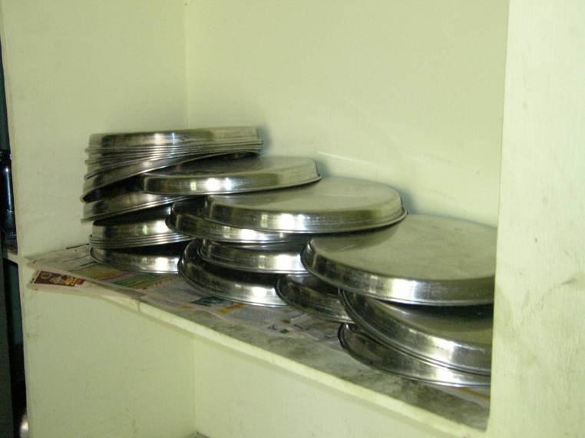

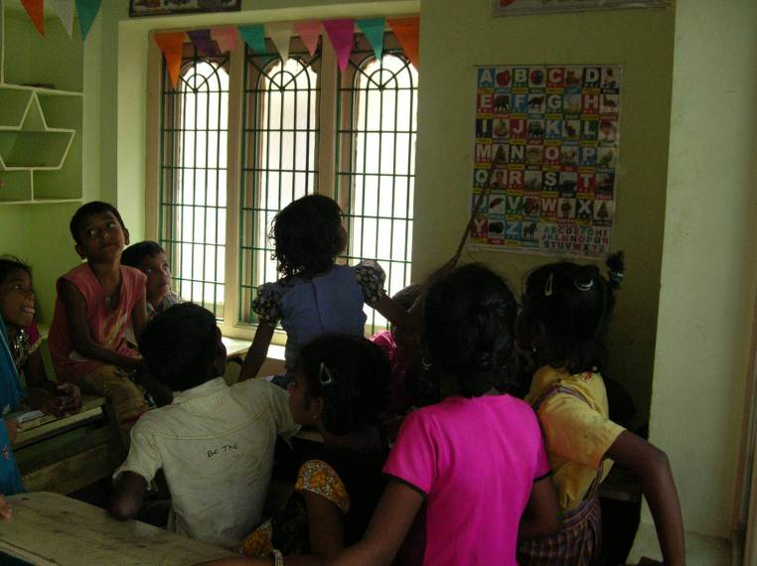

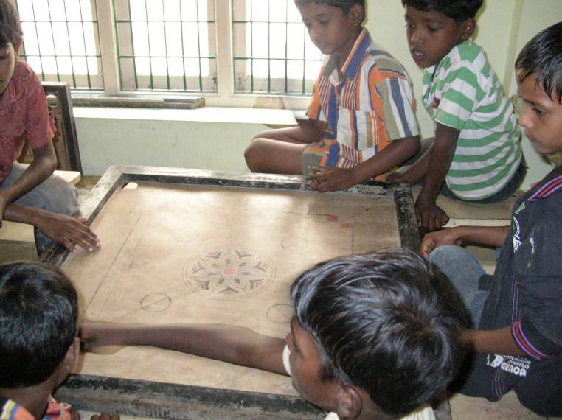
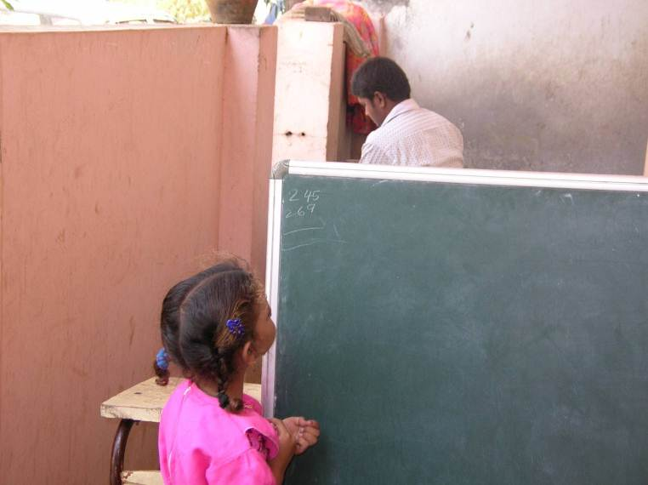
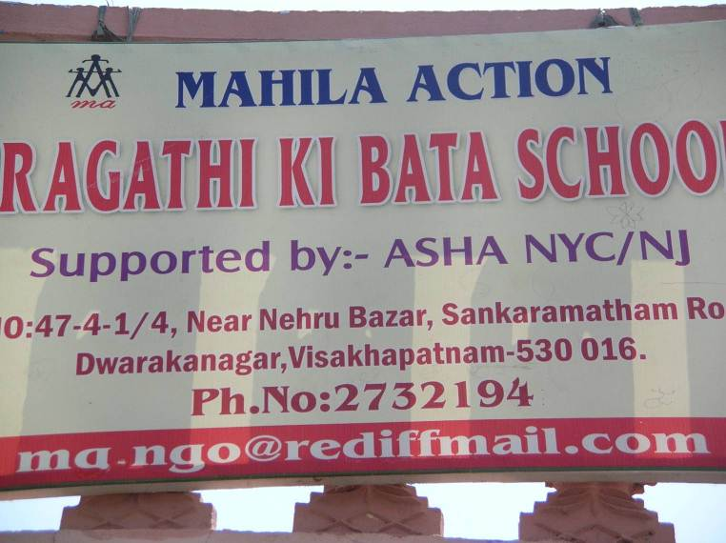
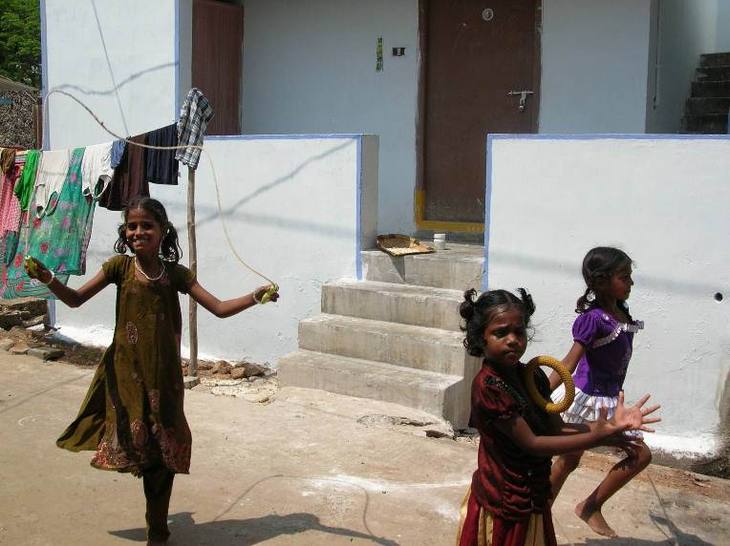
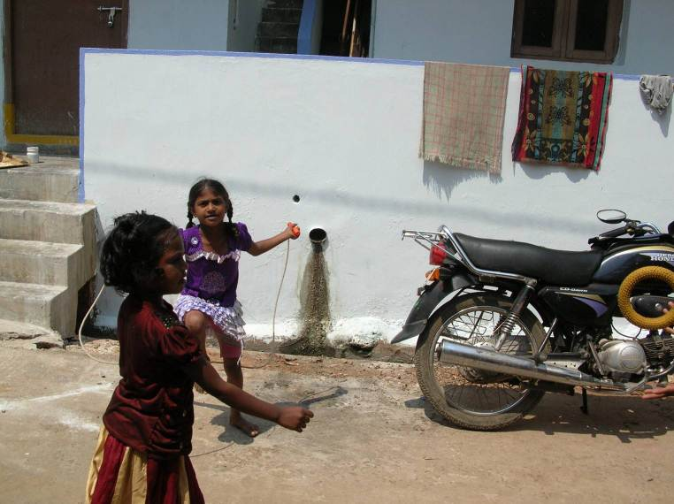
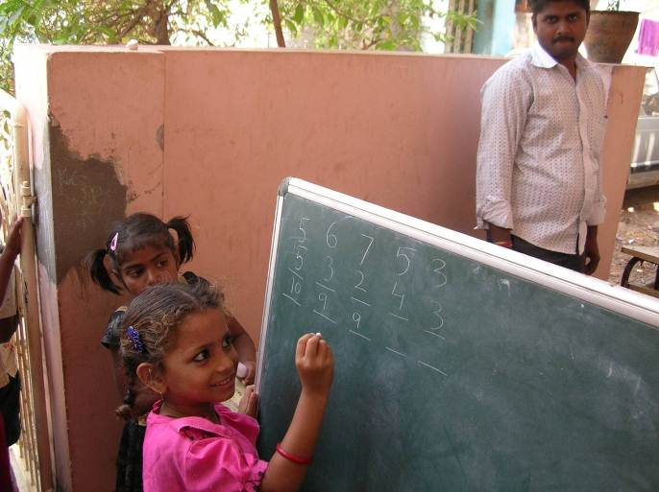

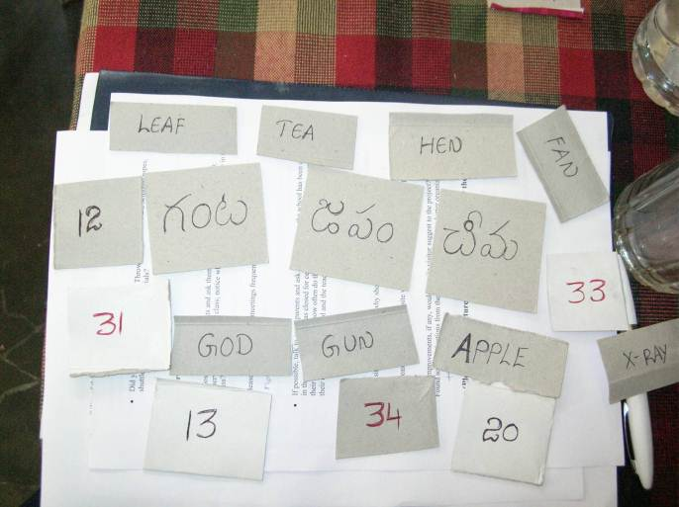
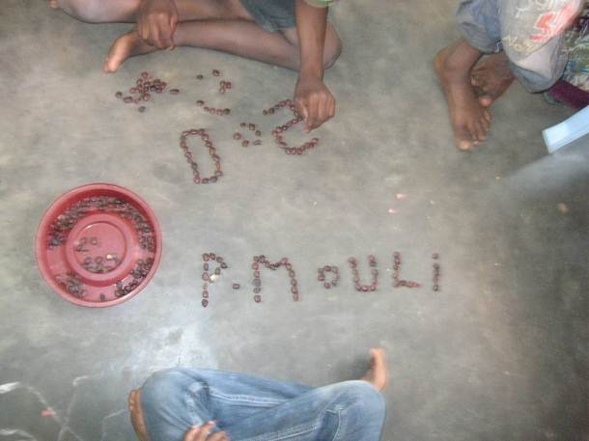
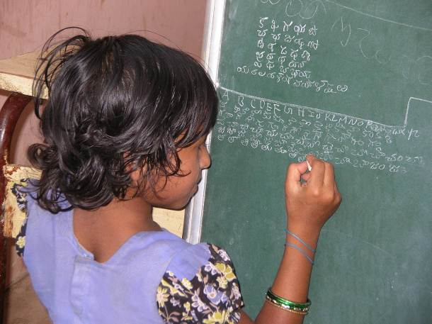
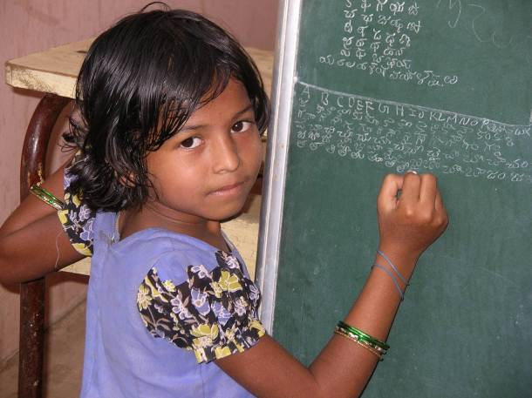

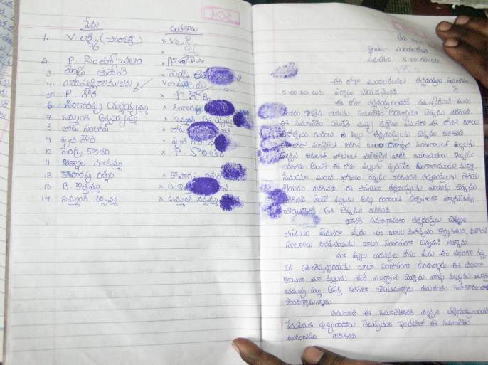
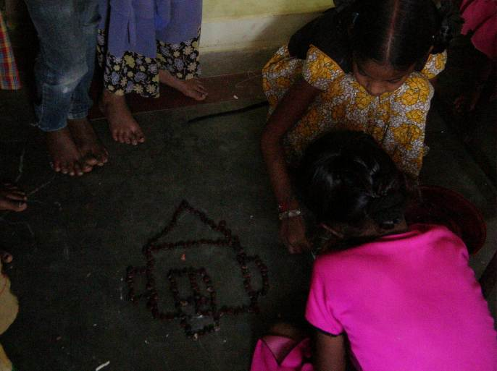

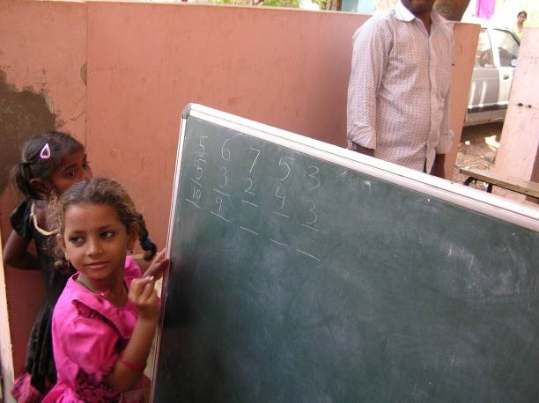
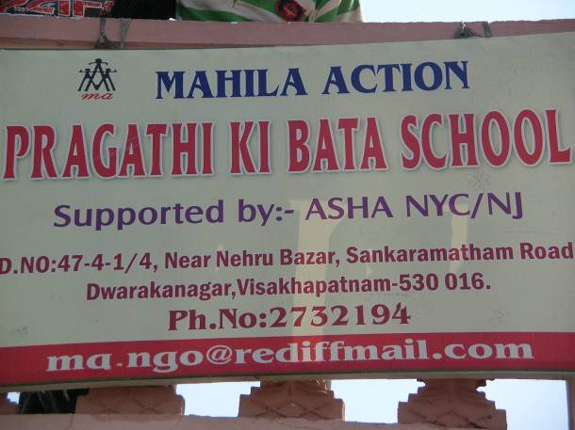

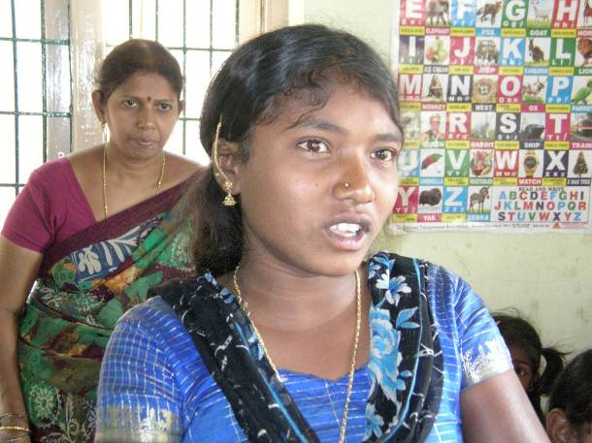
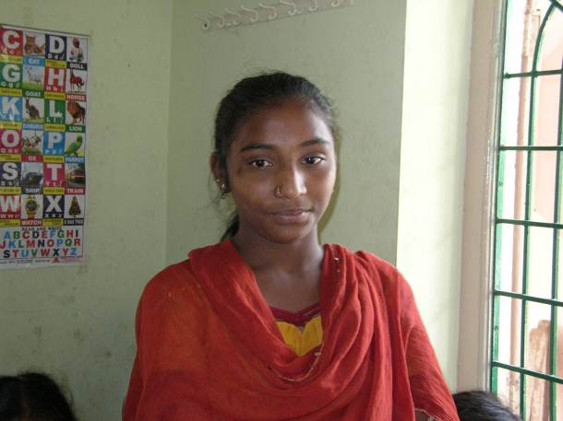

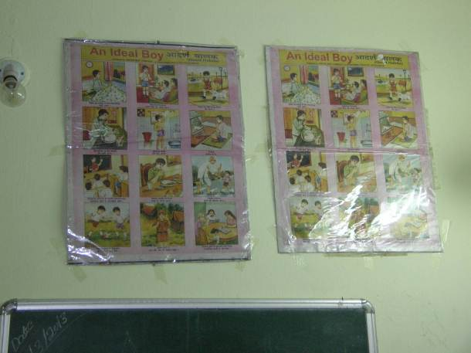
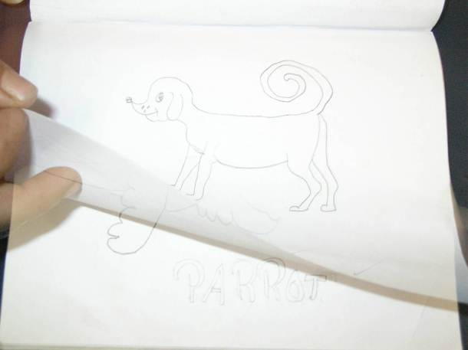

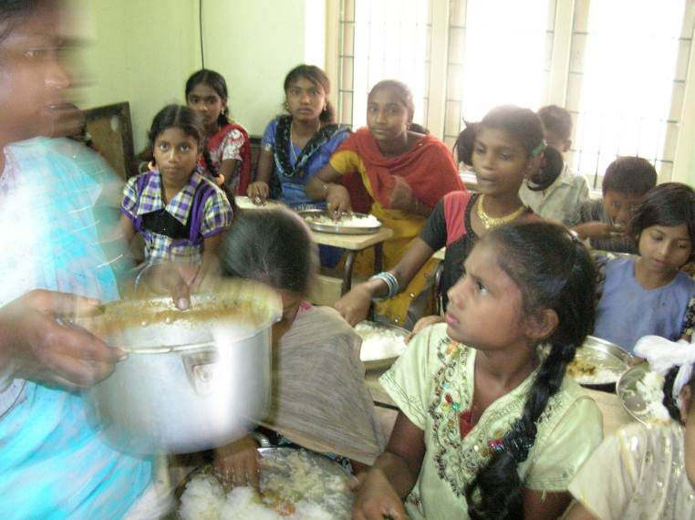
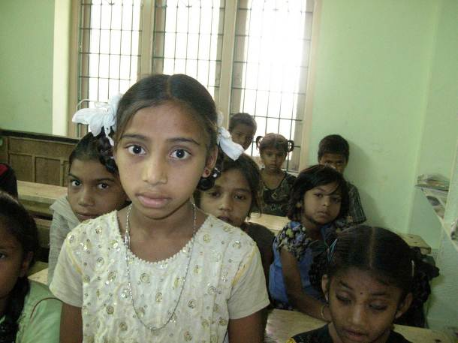

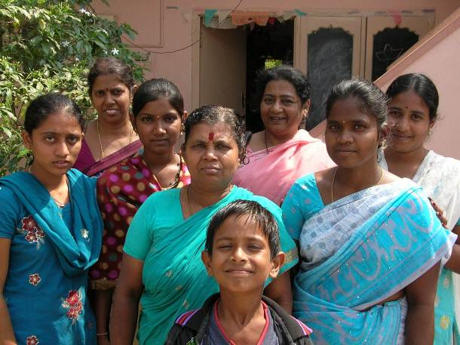
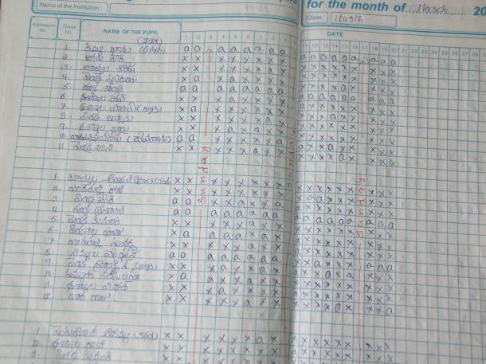
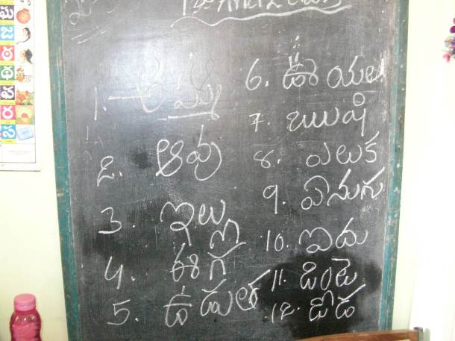

Pictures from Awareness Programs:



