Site Visit Report – March 6th, 2018

Rashi Dhall

I visited Astha Resource Center with my sister on March 6th, 2018 at 11:00 AM. My actual plan was to visit them on March 7th. The team at Astha had prepared for my visit, but I had to prepone my visit to March 6th due to personal reasons. The team at Astha accommodated my request, and hence I visited them on March 6th.
Mr. Hamza who takes care of finances, and the general management of the resource center welcomed me and my sister. The whole staff of Astha was present at that time, except for the founder Ms. Radhika.
The team had prepared a presentation of the work they did over last year at the resource center and at various other projects. Ms. Kiran who is one of the Special Educators did the presentation for us. The presentation was very insightful for me and my sister. My sister who was visiting Astha for the first time was also very impressed by the work Astha has been doing in the area. They also showed us the beautiful videos they have created for spreading awareness about disabilities and about Astha. Those videos really touched us.
Mr. Rakesh told us more about how Disability Helpline is going. They are still receiving up to 3-4 calls and 5-10 walk-ins per day. Focus here is to help the callers with required information along with documenting the information in a database as well. Another main aspect of Helpline is to network with other helplines and organizations in and around Delhi.
Ms. Kiran told us that last year they focused on Resource Building. As part of that, they built teaching learning module, parents training curriculum and also the short films which are being actively used for awareness.
There were 3 trainings done for capacity building of Staff. A training session was organized by Vishwas on Mental Health. This training was conducted in Astha Resource Center. Around 30-40 people attended this training. Then there was another 8-day training at Kamla Nehru College which was attended by Astha’s team members. There was another 2-day training at Lady Irwin college on Mental and Women’s health which was attended by Ms. Bharti.
Astha conducted a training for Neenv forces (a group of 32 community-based organizations) regarding various disabilities in children and how to deal with them. There have been requests to conduct more such trainings from individual organizations.
Astha team visited Gorakhpur to work with the children affected by Japanese Encephalitis. An organization in Gorakhpur which works with children contacted Astha. Astha team then visited Gorakhpur, and is working with another organization named Sarvahitkari to understand more Japanese Encephalitis and how it affects children. Astha is planning to do more visits to Gorakhpur to work with the children.
Lat year Asha gave Rs. 5 lakhs to Astha for roof reconstruction, and building the resource center according to BALA (Building as a Learning Aid) methodology. When I visited the resource center, I saw that the roof was completely reconstructed and painted. The whole of resource center’s roof was reconstructed. Modeling the resource center according to BALA is in progress. Astha team has had multiple meetings with the organization which will be doing the designing according to BALA. One thing they have finalized on is Sensory Garden.

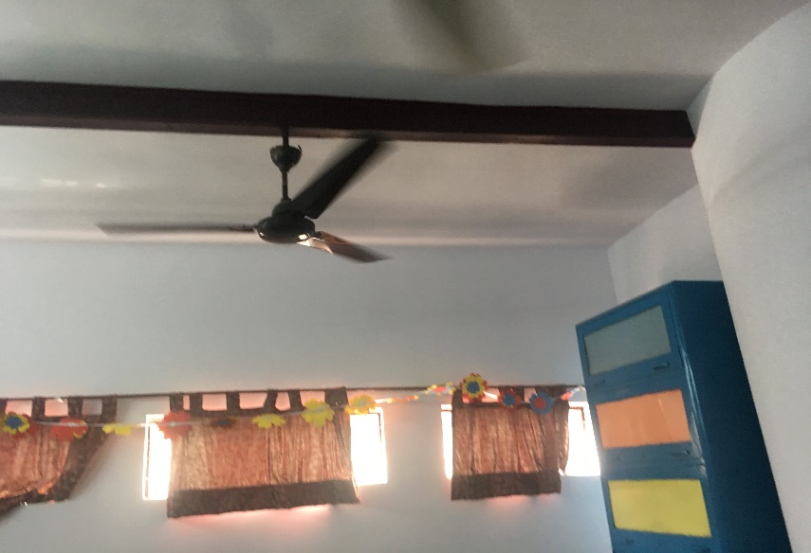

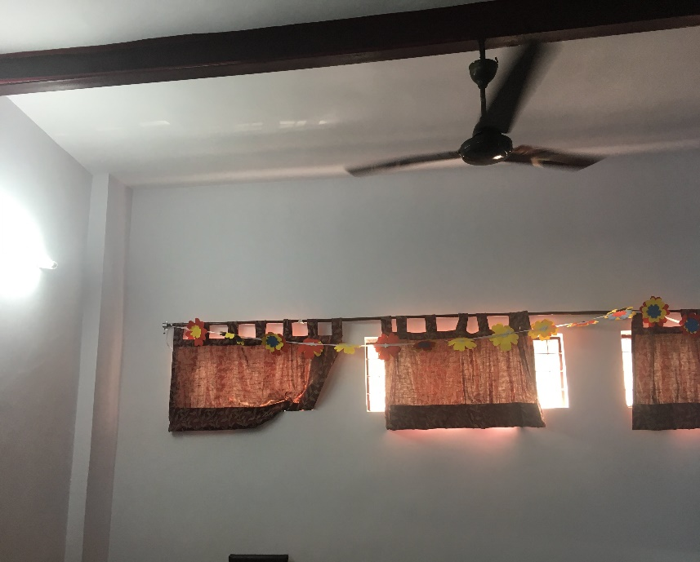

Astha team also told us about the Early Childhood Care and Development project they started in Okhla area. They had asked Asha to fund a part of this project, but Asha couldn’t last year. They have started this project with whatever minimal funds they had. This project targets all children in the age of 0-9 Currently it is a 4-person team working on this. They have inclusive activities for children where both disabled and normal children participate. The team is training mothers of disabled children as well. Some children are asked to come to resource center for follow ups. Currently the team is working with 40 children. They are trying to raise awareness about disabilities in the community. Out of them 6 children have joined school as well. Anganwadis are also asking Astha team to conduct training sessions for them.
Astha is doing an excellent job in helping the community, disabled children and their families by providing support and awareness. They are constantly looking at widening their reach to other organizations, areas outside Delhi as well. Examples of that are the help they provided for children affected with Japanese Encephalitis in Gorakhpur, conducting training for various organizations, etc. They are starting new projects like ECCD as well to work with children from ages 0-9 which is a very important time in a child’s growth.

