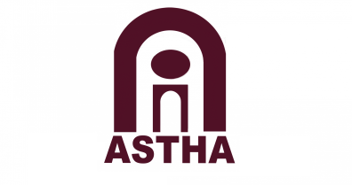
Resource Centre Proposal 2018
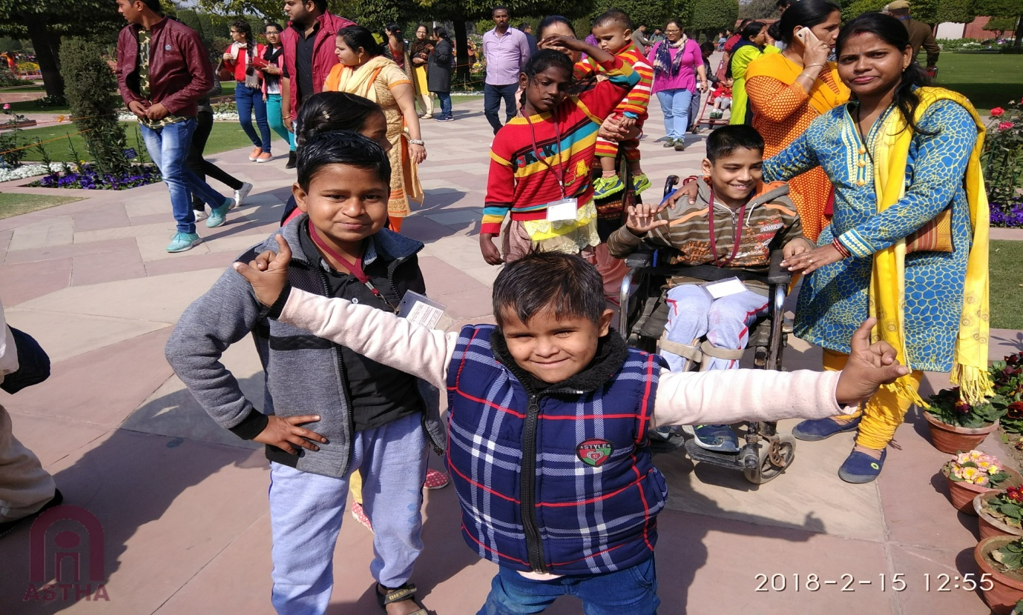

ASTHA, BASTI VIKAS KENDRA, BAL MUKUND KHAND, GIRI NAGAR, KALKAJI, NEAR GOVINDPURI METRO STATION, NEW DELHI-110019; TEL: 011-26449026, 011-26466251; EMAIL: aarthindia@gmail.com; National Disability Helpline: 011-26466250, Email: disabilityhelpline@asthaindia.inWEBSITE: www.asthaindia.in
Proposal Summary

KEY INFORMATIONS
Date of the Proposal: 21st March, 2018
Key contacts:
- Ms. Radhika Alkazi, Founder & Managing Trustee
Phone: +91-9811167293
Email: radhika.alkazi59@gmail.com
- Mr. Hamza, Asst. Director
Phone: +91-8447725213
Email: hamza@asthaindia.in

Board of Trustees;
- Ms. Radhika M Alkazi , Founder & Managing Trustee, AARTH-ASTHA; Founder & Director CRPD
- Ms. Sudha Vohra, Executive Director, AARTH-ASTHA
- Mr. Feisal Alkazi, Educational consultant, Theatre Director, Founder –Creative Learning for Change, an NGO working in the field of education
- Mr. Vivek Dhir, Managing Director, World Phone Ltd.
- Ms. Krishna Das, Trustee, Head of Programmes, Pallavanjali Institute for actualization of Individual Potential
- Ms. Gopi Devdutt Tripathy, Professor, Sociology Dept., Maitreyi College

Organization is registered under TRUST Act, in the name of ASTHA, vide registration number 1804 dated 12th April 1993. Organization also registered under the following:
- 80 G
- FCRA –Foreign Contribution Regulation Act 2010
- 12 A – Income Tax
- Persons with Disabilities Act
- National Trust Act

About the Resource Centre run by ASTHA
The purpose of starting the Resource Centre in 2011 was an extension of ASTHA’S commitment to strive for equal opportunities for children with disabilities as the rest of the children in the mainstream schools.
Resource centre provide in-house services where children with disabilities and their families can access information & services by developing resources. Resource centre aims to prepare the child in terms of creating a resource, technical intervention to develop cognitive, social, communication skills, working with parents, working with schools, working with hospitals. And to access education, preparation measures for getting admission in a mainstream school and preventing the children from dropping out.

As the years of experience have pointed, lack of information remains a barrier for persons with disabilities and their families in accessing services. ASTHA believes that information is the crux to empowerment and through Helpline we gather, collate and disseminate information. So, we are planning to conceptualize the Resource centre work with the Helpline. Service of Helpline complements the work of Resource centre by providing relevant and authentic information, referral service and counseling according to the needs of children / person with disabilities and their families.

Resource centre extend its services by reaching out to other NGOs in Delhi and nearby states like UP, Haryana, Rajasthan through trainings, sensitization workshops and information dissemination on various issues. Resource centre explore the possibility of having a therapy unit where families can come for assessments, referrals and therapy sessions.

This is complimented by ASTHA’s other programs that involves in community mobilization, strengthening of community groups, advocacy, research, critiquing of policies, information & knowledge exchange and working in partnership with the community to achieve to ensure inclusiveness and better quality of education.

Learning/Achievement/challenges for the last 7 years

Working in the Hospital for Early Intervention
Recognizing the importance of early intervention for children with disabilities, ASTHA resource center has collaborated with a team of developmental therapist, physiotherapists and special educators headed by Ms. Madhumati Bose (an early intervention specialist) in the Swami Dayanand Hospital, Shahdara. Since hospitals are the first point of contact for parents of children with any kind of special needs we felt that it was important to work there to reach the child and the parent at the earliest. The major aims of this collaboration are:
- To assess and identify the child’s impairment at such a young age and provide necessary multi-disciplinary rehabilitation service
- To ensure that the parents get the right information and inputs at this early stage when they have just found out about their child’s disability or have just started to observe something.
ASTHA team visits the hospital once a week for the full working day from last two years. We have started working with very young children where we are taking help of resource persons or professionals, depending on the needs of the child, to assess the impairment correctly and to design an Individualized Plan for the child. The same is then implemented on an individual basis in the centre. This year we plan to conduct workshops and trainings for parents coming to the hospital.
Colleting, coalatting
Collaboration with Orkids (an organization specializing in learning Disabilities)
Since ASTHA also collaborated with Orkids, an organization working closely with Children with Learning disabilities. The main focus is providing on educational inputs in order to improve the level of education. They run a ‘Mobile Resource Van’ which comes once a week and bring along their material to work with children. We started this as a pilot with a total of 5 children, but at present 10 children are attending this session. We are also planning to increase this number to 15 as many children attend and leave as per their needs.
The beneficiaries of this programme are:
- Families of children with disabilities, school authorities and other organizations through various workshops, trainings and meetings.
- Children with disabilities who are not yet enrolled in school due to several barriers
- Children with disabilities who were dropped out
- Children with disabilities who are going to school but are facing a lot of barriers
- Children with disabilities belonging to the Early Intervention category (0 to 8 age group)

Geographical Area of the beneficiaries of the project

The children are mainly from areas situated in South Delhi. The children also get referred from ASTHA’s National Disability Helpline as well as other organizations and professionals working in the field, these children belong to communities mostly other than urban slums in the South Delhi district. Planning to do intensive work for reaching out our services to neighbouring states like UP and Haryana.

Impact of our work with children with disabilities through the Resource Centre in 2017
This year we have seen numerous developments in our children and areas we are working in. Below are the highlights of our achievements this year:
- Number of children in age group of 4 to 6 has increased. How many children
- Children from areas from neighboring areas like Sangam Vihar have also joined in for regular sessions.
- Intervention program in Gorakhpur have started which includes working with local bodies and families of children of children with disabilities. details
- Training of other organizations working with children like Neenv Forces (sensitization :: ) which include organizations like Mobile Creches, Action India, etc. add impact of this workshop
- Training of parents of children other then students of Astha.
- Participation of parents has increased.
- Advocacy ?
- Staff capacity building
- Helpline ???
- Strengthened the parents for coordinating the programme

Proposed Activities for 2018-19
Resource Development
- Collection, Coalition and Dissemiantion of information about disabilities, provisions and various government schemes available and disseminating (visual & written) the information about available resources through our helpline.
- Kit and document development for various trainings related to the areas of disability like series on Activities of Daily Living, disability certification, adaptive and assistive technologies, sign language etc.
- Development of module and Teaching Learning Material for elementary education based on curriculum of primary schools. This year focus will be on adapting and developing the curriculum of class 1. Existing school textbooks will be reviewed for the selection of topics that are relevant for developing life skills, will be identified for developing module and teaching and learning material. Every individual has the tendency to forget, and proper use of Teaching and learning material helps to retain concept more permanently. Students can learn better when they are motivated properly through different teaching aids. It develops the proper image when the students use various senses to understand a concept. It creates the environment of interest for the children with disabilities as such materials provide various kind of exposure for learning as per their type of disability.
- Building capacity of staff and support staff on Child Rights, Inclusion, technical training through workshops that address the needs of staff. We will be organizing a series of Workshops on communication, various acts and schemes, information dissemination related to disability sector etc.
- In order to improve the quality of services offered as a resource centre, we plan on Building a Multi-disciplinary Team for our resource centre. They all would just come as consultants for children with disabilities. So plan on keeping either a developmental therapist or occupational therapist, speech and language therapist, orthotics and prosthetic technicians. These people would be on honorarium basis and we have another list of doctors, pediatricians and speech therapists, who would be referred to the parents according to the child’s needs.
- Identifying teaching strategies, learning styles and adaptations required for individual children and developing or procuring them.

Working with Children

Working with Hospital
- Providing information to parents about the disability certificate, school admission etc

Working with Parents
- Conducting Counseling Session with parents of CWSN as we are seeing increased number of non acceptance amongst parents. (Details
Working with School
- Identifying and Assisting children above 14 years (After 8 standard) in getting School certificate. (Law – open school)
- Sensitization workshop for school teachers on disability

Gorakhpur
Astha have started its reach in Gorakhpur last year and want to expand its reach further in that area. We are working with children who have suffered from Japanese Encephalitis and their families collaborating with local bodies based in Gorakhpur. We are planning to have own resource centre in that area so we can work more efficiently.

