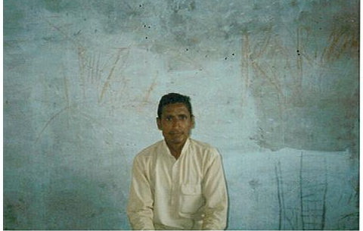
Bachav

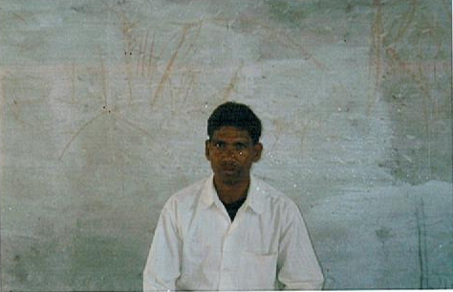

Shri Ram
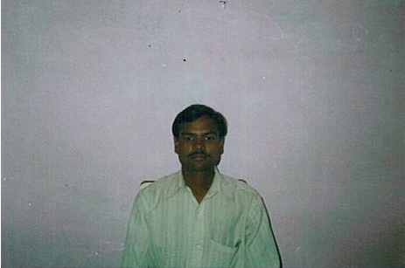

Heera Lal

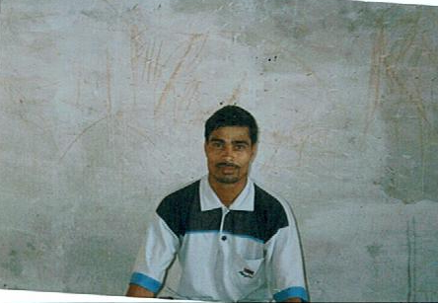
Shivanand
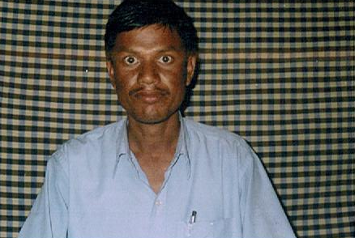

Haricharan

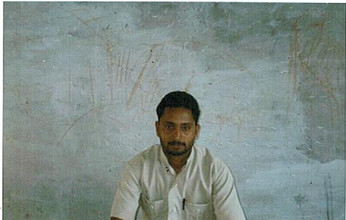

Amreesh
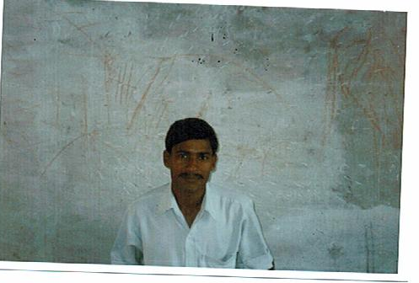
Vijay

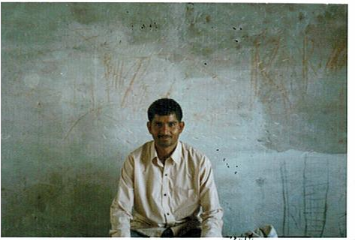
Ram Bali

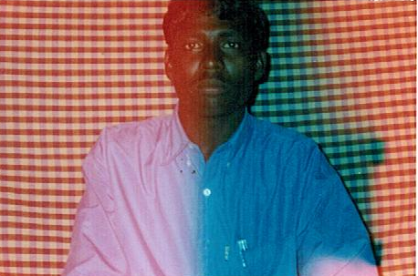
Ganesh

TEACHERS PROFILE:

S.L. | NAME OF TEACHER | QUALIFICATION | EXPERIENCE | VILLAGE
1 | VIJAY KUMAR | B.A. | 5 Years | LALTAPUR
2 | AMRESH KUMAR | B.A. | 3 Years | LALTAPUR
3 | GANESH KUMAR | HIGH SCHOOL | 2 Years | LALTAPUR
4 | TIRATH NATH | B.A. | 7 Years | LALTAPUR
5 | HARICHARAN | INTERMEDIET | 4 Years | JHUMARIYA
6 | RAMBALI | HIGH SCHOOL | 4 Years | JHUMARIYA
7 | SHIVANAND | HIGH SCHOOL | 5 Years | JHUMARIYA
8 | SHRIRAM | INTERMEDIET | 5 Years | JHUMARIYA
9 | KAULESHWAR | HIGH SCHOOL | 7 Years | AMDAHAN
10 | ANITA | INTERMEDIET | 6 Years | AMDAHAN
11 | BACHAU | INTERMEDIET | 6 Years | BODALPUR
12 | HIRALAL | HIGH SCHOOL | 2 Years | GORTUTAWA

