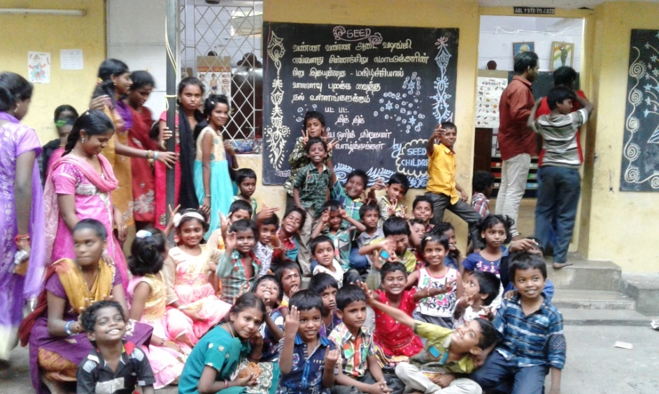
SOCIETY FOR THE EDUCATIONAL AND ECONOMIC DEVELOPMENT ( REGD )
SRIPERUMBUDUR 602105
REPORT FOR THE PERIOD 01.04.2016 TO 31.12.2016
Society for Educational and Economic Development (SEED)
Chennai – Banglore Highway, Near Nokia Main Gate, Venkatrangampillai Chatram, Sriperumbudur – 602 105
Tamil Nadu, South India. : 044- 27107341, 27107225, : 9444902322: seeduniversal@gmail.com

1 BACKGROUND/INTRODUCTION:
The institutional Based Rehabilitation Project run by ‘SEED ’ for the welfare of the children of LIFE PRISONERS, VICTIMS OF SERIOUS CRIMES LIKE MURDER and LEPROSY PATIENTS commenced its yeomen service activities in January, 1982. This project provides service to an approximate number of 188 Socially Disabled children of 4 – 20 years age group in the target area and runs its activities in Two villages of Sriperumbudur Taluk (Kancheepuram District) namely Venkatrangam Pillai Chatiram- (SEED – MAHATMA GANDHI PRIMARY SCHOOL ) and Irungattukottai village( Dr. J.C.KUMARAPPA INDUSTRIAL TRAINING CENTRE ) and in one village of Poonamallee Taluk at Thiruvellore District namely Utkottai village ( SEED – MAHATMA GANDHI HIGH SCHOOL ). The project is implemented with the direct support of 25 Professional and 6 non professional staff members who carry out grass root level, supervisory and managerial jobs. The project also takes support of the Well wishers, Local Community, Canara Bank, Ramachandra Medical College & Hospital, Income Tax Employees, Rajasthan Youth Association - Food Bank ( Metro ), Department of Social Defence, Directorate of Employment & Training & Education Department of Government of Tamil Nadu, Friends Of Social Service (FASS), Ramakrishna Mission, Friends City Welfare Association, other NGOs and Government Institutions in the target area. The project has the Partnership with Canara Bank Centenary Rural Development Trust, Les Amis De Soeur Immanuallee, ASHA – St Louis, Mandella Charity Works, Les Amis de SEED, Niranjan N Ratnakar.

II. HIGHLIGHTS FOR THE PERIOD FROM April 2016 TO December 2016
The main activity of SEED is to provide institutional care which will enable the children of Life Prisoners and Leprosy Patients to free themselves from their existing way of Life and lead a simple life with dignity.
The children for the academic year 2016-17 belong to various categories as mentioned in the table below:
Project location | Categories of children supported
 | Life prisoners’ children |  | Leprosy disease patients’ children |  | Orphan Children |  | Single Parent ‘s children |  | Tsunami affected children |  | Children belonging to below poverty families. |  | Total
 | Boys | Girls | Boys | Girls | Boys | Girls | Boys | Girls | Boys | Girls | Boys | Girls
Sriperumbudur | 6 | 8 | 3 | 3 | 1 | 2 | 6 | 7 | 8 | 3 | - | - | 47
Utukottai | 20 | - | 5 | - | 6 | - | 21 | - | - | - | 11 | - | 63
Irungattukottai | 2 | - | - | - | - | - | - | - | - | - | 71 | - | 73
TOTAL | 28 | 8 | 8 | 3 | 7 | 2 | 27 | 7 | 8 | 3 | 82 | - | 183

III . SEED –SRIPERUMMBUDUR CENTRE ;
During this period (April, 2016 to December 2016), 20 children have been enrolled at SEED’s Sriperumbudur Centre:
During this period, 6 Children of Life Prisoners, 5 Children from single parent families and 9 children from the families come under below poverty have newly been joined in SEED.

IV. SEED – UTKOTTAI CENTRE ( HIGH SCHOOL PROJECT ):
During this period (April,2016 to December,2016), 19 children have been enrolled at SEED’s UTKOTTAI Centre
( HIGH SCHOOL PROJECT ).
During this period, 6 Children of Life Prisoners, 8 Children from Single parent families, 2 orphan Children and 3 children from families come under below poverty have newly been joined in SEED.

SEED – IRUNGATTUKOTTAI ( INDUSTRIAL TRAINING CENTRE )
During this period ( April,2016 to December,2017 ) 40 children have been enrolled at SEED’s Irungattukottai Centre ( Dr.J.C.Kumarappa Industrial Training Institute).
HIGHER EDUCATION :
- S.Arunkumar , whose father died , mother working as a coolly , obtained 452 out of 500 in SSLC Public examination – March 2016, conducted by the Government of Tamil Nadu. Now studying in Higher Secondary Couse at SRV Boys higher Secondary School , Rasipuram, Namakkal District with the help of SEED

- M.DAVID , Guardian Life Prisoner at Cuddalore Central Prison, obtained 225 out of 500 in SSLC Public Examination – March 2016, conducted by the Government of Tamil Nadu. Now, he is studying in Higher Secondary Course.
- K.KATHIRVEL, whose father died, Guardian life prisoner, mother working as coolly, obtained 300 out of 500 in SSLC public examination – March 2016, conducted by the Government of Tamilnadu. Now studying in SEED Dr.J.C.Kumarappa Industrial Training Institute, Irungattukottai – Mechanic ( Motor ) Vehicle Trade with the help of SEED
- S.PRABHU, whose Father died, Mother working as coolly & guardian Leprosy Patient, obtained 260 out of 500 in SSLC Public Examination – March 2016, conducted by the Government of Tamilnadu. Now studying in Higher Secondary Course.
- R.RAGHUL , whose mother died & father working as coolly, obtained 312 out of 500 in S.S.L.C. Public Examination – March, 2016, conducted by the Government of Tamil Nadu. Now, he is studying in Higher Secondary Course.
- M.SANTHOSH , whose father Leprosy Patient & Mother house wife , obtained 288 out of 500 in S.S.L.C. Public Examination- March 2016, conducted by the Government of Tamil Nadu. Now, he is studying in Higher Secondary Course.
- M.SHANMUGAM , whose father affected by Leprosy & Mother House wife, obatained 365 out of 500 in SSLC public examination – March 2016, conducted by the Government of Tamilnadu Now, he is studying in Higher Secondary Course.
- R.SHIYAM , Father deserted the family & Mother working as cooly, obtained 254 out of 500 in SSLC public examination – March 2016, conducted by the Government of Tamilnadu. Now, he is studying in Higher Secondary Course.
- R.VADIVEL , whose Father affected by Leprosy & Mother working as cooly, obtained 314 out of 500 in SSLC public examination – March 2016, conducted by the Government of Tamilnadu. Now, he is studying in Higher Secondary Course.
- G.Vignesh , whose Father Life Prisoner at Coimbatore Central Prison & Mother working as cooly , obtained 367 out of 500 500 in SSLC public examination – March 2016, conducted by the Government of Tamilnadu.
- P.Vinoth , Orphan child, obtained 213 out of 500 in SSLC Examinations – March 2016 , conducted by the Government of Tamilnadu. Now, he is studying in SEED’s Dr.J.C.Kumarappa Industrial Training Institute at Irungattukottai Village in Electrician Trade with the help of SEED.
- C. Amul, a single parent child, has successfully completed her Higher Secondary Course & obtained 891marks out of 1200 ( May 2016 ). Now, she is studying Diplomo in General Nursing and Midwifery Course at Dr. Durgabai Deshmukh General Hospital and Reserch Centre, R.A.Puram, Chennai 600 028 with the help of SEED.
- B.Umamaheeswari, whose mother died at her early childhood , has successfully competed her Higher Secondary Course & obtained 855 marks out of 1200 ( May 2016 ). Now, she is studying Diplomo in General Nursing and Midwifery Course at St. Isabel’s School of Nursing , Chennai 600 004 with the help of SEED.
- D.Sowmiya, a destitute child, has successfully competed Higher Secondary Course & obtained 756 marks out of 1200 ( May 2016 ). Now, she is studying Diplomo in General Nursing and Midwifery Course at St. Isabel’s School of Nursing, Chennai 600 004 with the help of SEED.
- S.Janani, whose father Life Prisoner at Trichy Central Prison, has successfully competed Higher Secondary Course & obtained 761 marks out of 1200 ( May 2016 ). Now, she is studying Diplomo in General Nursing and Midwifery Course at M.A.Chidambaram School of Nursing, Chennai – 600 113 with the help of SEED.
- V.Durgadevi , whose father Life Prisoner at Trichy Central Prison, has successfully comepleted her Higher Secondary Course & obtained 811 marks out of 1200 ( May 2016 ). Now, she is studying Diplomo in General Nursing and Midwifery Course at Dr. Durgabai Deshmukh General Hospital and Reserch Centre, Chennai 600 028 with the help of SEED.
- D.Santhiya, a destitute child, has successfully comepleted Higher Secondary Course & obtained 753 marks out of 1200 ( May 2016 ). Now, she is studying Diplomo in General Nursing and Midwifery Course at Dr. Durgabai Deshmukh General Hospital and Reserch Centre, Chennai 600 028 with the help of SEED.
- R.Jayalakshmi, whose father Life Prisoner at Cuddalore Central Prison due to death of her mother, has successfully comepleted Higher Secondary Course & obtained 646 marks out of 1200 ( May 2016 ).
- C.Anjali, a single parent child, has successfully comepleted Higher Secondary Course & obtained 656 marks out of 1200 ( May 2016 ). Now, she is studying Diplomo in General Nursing and Midwifery Course at Dr. Durgabai Deshmukh General Hospital and Reserch Centre, Chennai 600 028 with the help of SEED.
- R.Sumithira, a single parent children, has successfully completed her 10th standard and secured 345 out of 500 ( May 2014 ) in S.S.L.C. Public Examination. Now, she is studying Diploma in Modern Office Practise at Dr. Dharmambal Government Polytechnic College for Women , Chennai – 600 113 with the help of SEED.
- V.Mutulakshmi, whose father Life Prisoner at Trichy Central Prison, has successfully competed her Higher Secondary Course & obtained 977 marks out of 1200 ( May 2016 ). Now, she is studying B.Sc. Nursing Dgree Course at M.A.Chidambaram College of Nursing , VHS Campus, Chennai – 600 113 with the help of SEED.
- R.Kesavaraj , Father Leprosy patient & Mother died, has successfully completed his Higher Secondary Course & obtained 1088 marks out of 1200 ( May 2016 ). Now, he is studying Bachelor of Physiotheraphy Degree Course at Madras Medical College, Chennai.

A GLANCE OF INDUSTRIAL TRAINING INSTITUTE:
- On 28th & 29th , July 2016, All India Trade Test was conducted by National Council for Vocational Training, Ministry of Skill Development , Government of India in which 24 students in second year, have appeared as follows:

S.No. | Trade | Students appeared | Students passed | Percentage
1 | Fitter | 12 | Commencement of All India Trade Test 2016 for all Trades by the Govt. Of India. .
2 | Electrician | 07
3 | Mechanic (Motor Vehicle) | 05

SPECIAL EVENTS in INDUSTRIAL TRAINING INSTITUTE:
- We have conducted the Parents meeting on 14.05.2016 ( Saturday ) and discussed about the students Performance, Attendance Percentage & Discipline ..
- In our Industrial Training Centre, New admission for 2016 – 2018 batch for all trades ( Motor Mechanic Vehicle, Fitter, Electrician and Electronic Mechanic was started during the month of July, 2016.
- Received application and certificate for 24 students for 2016 – 2018 batch..
- M/S Yazaki Wiring Technologies Pvt.Ltd., provided Uniform , shoes and also stretching charges to our ITC Staff members .
- Campus Interview in INDUSTRIAL TRAINING INSTITUTE:

- Campus interview was conducted in our Dr. J.C.Kumarappa Industrial Training Centre to recruit our students for placement in the following companies.
Texelq Pvt. Ltd., Chettipedu
Valluvar Enterprises , Sriperumbudur
- On 17.06.2016, Roca Paryware Company conducted Campus Interview in our Industrial Training Centre.. 14 Senior students from all trades attended.this interview in which 13 students were selected and letter of appointment was issued to them.
- On 21.06.2016, Asst. Manager Mr. Murugan from Asian Paints visited our ITI for making Interview for Senior students.
- On 02.07.2016, staff interview for all Trades was conducted by Electrical HOD, Government Central Polytechnic College , Chennai, Mr.Thiyagarajan and our ITC Secretary.
- On 06.07.2016, CRO for Electrician Trade Practical Training was purchased from Jayam Electronics . This equipment is most useful for Electrician trade trainees and for their practical exam.
- On 08.07.2016, Examination time table was received and informed to all students.
- On 01.07.2016, Counseling for new students with their parents was conducted and they were informed about the joining date and rules and regulations.
- On 16.07.2016, new tools and measuring instruments were purchased for practical purpose of Fitter Trade.
- On 22.07.2016, All India Trade Test for Second semester ( I Year ) started for Fitter, Electrician and MMV Trade. Examiner and observer came to conduct the Test.
- On 23,24,25.07.2016, All India Trade Test - Practical Examination was conducted for all trades ( Second Semester 1st Year )
- On 28.07.2016 and 29.07.2016, fourth semester practical examination ( 2nd year ) was conducted for all trade students . Examiner and observer came to conduct the practical examinations and valuation for practical examination was given by them .
- During the month of August 2016, All India Trade Theory Examination for Juniors and Seniors was conducted from 1st August to 6th August.
- On 22.08.2016, new admission for the academic year 2016 – 2017 was conducted and 40 students were admitted based on Government Policy and Rules for all trades as per details mentioned below :
- Fitter Trade 16
- Electrician Trade 10
- MMV Trade 14
- On 27.08.2016,Toyota Company staff came to our ITC for giving training for placement purpose and also for making alteration in Electrician Lab and Welding Shed .
- On 01.09.2016, Mr. Suman AVP and M.Jayaraman Asst. Manager of Yazaki Wiring Technologies Private Ltd. & Mr. Thiyagarajan Retd. Deputy Director of Employment & Training have visited our Industrial Training Institute and discussed about the improvement in students curricular & co-curricular activities.
- On 07.09.2016, advertisement in Daily Thanthi was given for the purpose of recruitment of new staff for all trades.
- On 09.09.2016, Re - Painting of Electrical Lab and Rewiring of Electrical Test board were done by M/s Yazaki Wiring Technologies Private Ltd.
- On 19.09.2016, Interview for selection of New Instructor for All Trades in our ITC was conducted by Mr. Thiyagarajan ( Retired Deputy Director of Employment Training )
- On 26.09.2016, consolidated mark sheet was obtained from the Regional Joint Director, Department of Employment & Training, Government of Tamilnadu for the students, who had completed their course in the year 2013 – 2015.
- On 27.09.2016, Rotary Club of Chennai Port City Charitable Trust donated RO Water purification system.

VII. CELEBRATIONS :
- On 15th of July, 2016, we have celebrated National Leader
Kamaraj’s Birth Day as ‘’EDUCATION DEVELOPMENT DAY’’ because he offered FREE EDUCATION to all the children till end of Secondary School Education while he was the Chief Minister of Tamilnadu State. During this celebration, we conducted Oratorical , Singing, Drawing, Competitions and also Sports Competitions such as Running, Sack Race and Musical Chair and distributed prizes to the winners. R.Parameswari , VIII Std, whose Father is a Life Prisoner in Trichy Central Prison got First prize and T.Ananthi , XI std (Fatherless child and mother is Cooly got Second prize in Oratorical Competition. In Drawing Competion, D.Ammu , I Std, an Orphan girl, got First prize and E.Barani, V std., (Father Life Prisoner at Cuddalore Central Prison) got Second prize. In singing competition K.Swetha , V Std. (Both parents are Life Prisoners) got First prize and N.Kavin , IV Std., ( Mother Life Prisoner) got Second Prize. In RunningCompetition, M.Hariharan, V std,(Father Leprosy Patient and Mother Cooly) got First prize and M.Saravana Kumar , a destitute child got second prize in Search Race Competition, K.Maareeswaran , IV Std, (Below Poverty Line)) has got First Prize and D.Balakrishnan , II Std , an Orphan child, has got Second prize. In Musical Chair Competition, C.Mahalakshmi , III Std , (Fatheless girl), got First prize and M.Vignesh .(Father Leprosy Patient and Mother Cooly) has got Second Prize.
- On 15th August, 2016, India’s70th Independence day was celebrated both in Sriperumbudur & Utkottai Centres. At Sriperumbudur Unit, Town Panchayat Chairman Mrs. Parimala Kumar took part as Chief Guest and hoisted National Flag and she delivered speech about Independance Day and emphasized the need to remember the Freedom Fighters and our Great Leaders. Cultural Programmes were conducted by the Staff and Students. Bharathanatiyam was performed by R..Agalya , VII Std , (Father – Leprosy Patient ) Group dance was performed by Primary School Boys.At Utkottai, Mr.Gnanasekaran of M./s Tata Value Homes participated as Chief Guest of the fuction and hoisted our National Flag. Chief Doctor of Govt. Primary Health Centre- Nemam, President of Kuthampakkam Village Panchayat had also participated. Student did March Fast and Cultural Programmes were also conducted.
- On 5th September 2016, ‘ Teachers’ Day ‘ was celebrated. Our former President Dr.S.Radhakrishnan made a request to the society to celebrate his birth day as ‘Teachers Day ‘ , because, he worked as a Teacher in his earlier stage. As a mark of respect to his advice, his birth day is celebrated as Teachers’ Day in all Educational Institutions through out the country, every year. Students spoke on the value of Education and importance of the roll played by the teachers in the development of their students. At Utkottai Centre ‘Teachers Day’ was celebrated in a grand manner. Students have greeted teachers and gave Bouquets. Students spoke about the services of our former President Dr.S. RadhaKrishnan for Students Community.
- On 29th September 2016, important dignatories from ASMAE, Mr. Jean Frederic Goelier- Asmae Board Member, M/s Adrian Sallez, Louis Maire Prison,Thierry and France Libreton have visited our Sriperumbudur and Utkottai Centres. Cultural progaramme of the children made them to be deliteful. They have also interviewed with the children of both the centres of SEED .
- On 2nd October2016, Staff and Students celebrated ‘ Gandhi Jayanthi’ ( Mahatma Gandhi’s Birth Day) in a grand manner. Headmistress has given a thought provoking Gandhiji’s Freedom Struggle and the need for celebrating his birth day. M.Poovarasan IV std (Father Life prisoner & Mother Cooly) acted as Gandhiji and
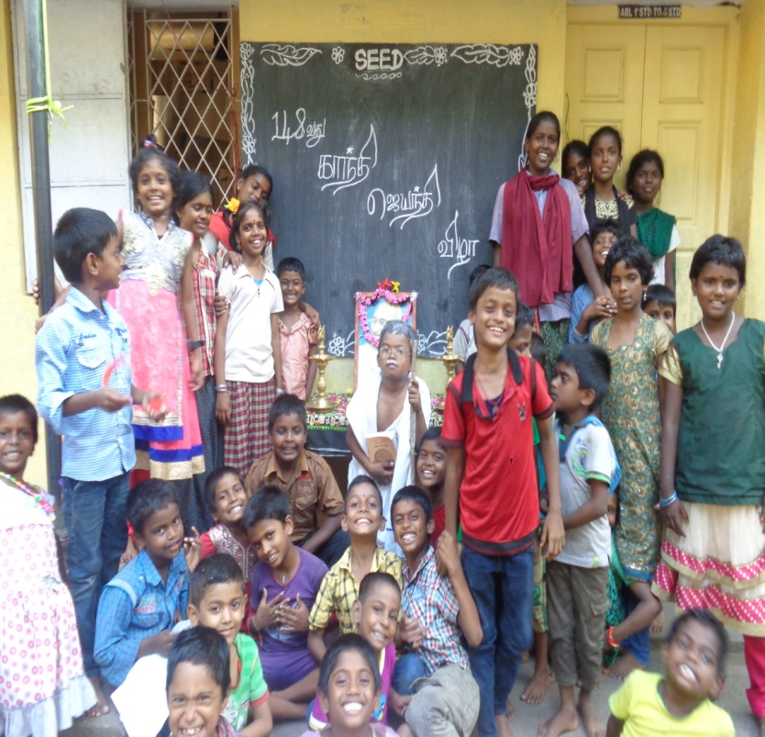
- spoke few words about Gandhiji. Similarly, the following students have also spoken about Gandhiji (a) K.Maareeswaran , IV std , S. Iswarya Lakshmi , N.Kavin , IV std, D.Ammu ,V std sang songs on Gandhiji. Running Race Competition was also conducted. S.Ananda Karthikeyan , 2nd Std, D.Balakrishnan , 3rd Std. and P.Tharun, 1st Std., have won 1st, 2nd and 3rd prizes respectively. In Action competition , K.Swetha ,4th Std., D.Ammu , 5th Std and K.Maareeswaran , 4th Std, have won 1st, 2nd and 3rd prizes respectively . In Numerical Master Competition, M.Monisha, 11th Std. and S.Sivaranjani, 10th Std., have won 1st, nd 2nd prizes respectively . At Utkottai Gandhi, Gan dhi Jayanthiwas celebrated and old students have also participated in the function. Dr.Ashokamani, Vice President of SEED has presided over the functionand grace the occassion .
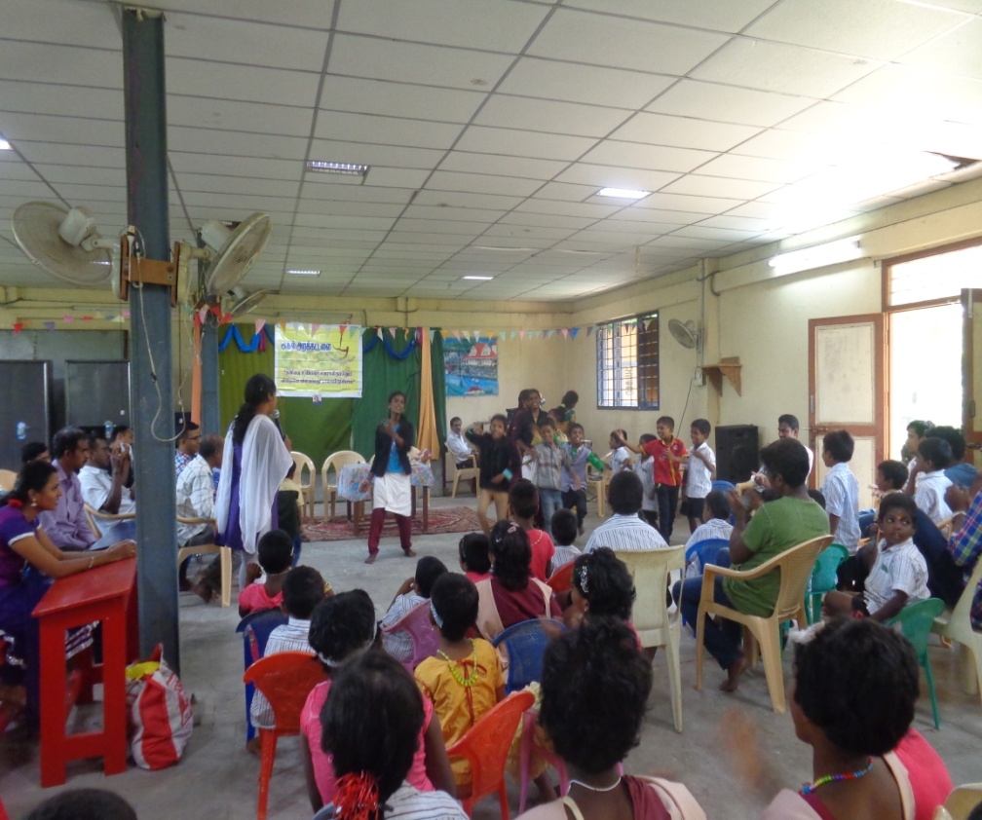
- On 10th October, 2016, Ayuthapooja (Festival of worshiping the instruments & tools helping human beings in performing their routine work ) was celebrated in both in Sriperumbudur & Utkottai Centres. On that day, we all made the premises clean and tidy and all the instruments & tools were cleaned and kept for worshipping. S.Kannan (Asst. Accountant) explained the concept of celebrating this festival of Instruments to the students.
- On 15th October 2016, former President of India, Dr.A.P.J.Abdul Kalam’s birth day was celebrated at ‘SEED’ Visitors from ‘AGAL TRUST’ - Chennai have joined in the function. Quiz programme was conducted. Dance, Oratorical and Singing Competitions were also conducted. Golden words of Dr. Kalam were remembered on this memorable occasion. At Utkottai Centre, our former President of India, Dr.A.P.J. Abdul Kalam’s birth day was celebrated on 25.10.2016 as a ‘ Knowledge day ’.
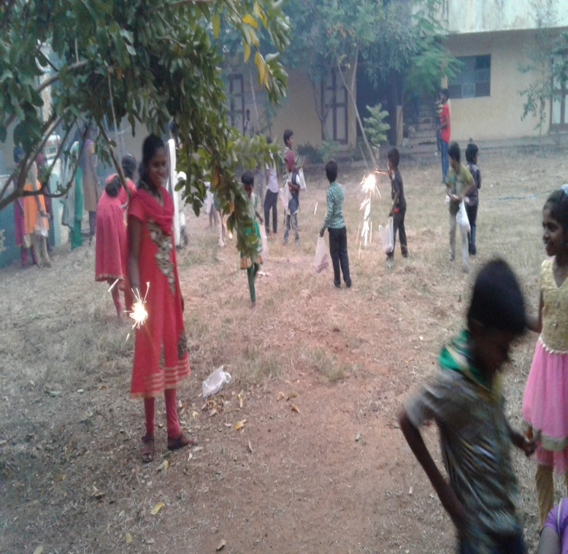
- On 29th October, 2016, ,we celebrated Deepavali festival ( Festival of Lights ) with all our children and staff of Sriperumudur and Utkotai Centres. Mr N.Selvarajan , General Manager, Canara Bank, Head Office, Bangalore, has visited ‘SEED’ on this occasion and blessed the children of ‘SEED’. In the evening, all students.of ‘SEED’ gathered together in the Sriperumbudur Unit Play Ground and fired crakers after wearing new dress on this memorable occasion.
- xiv) On 02.11.2016, ‘ FASS ‘ (Friends association of Social Service ), a social service in Sriperumbudur, conducted the following competitions at our Sriperumbudur Project on account of Children’s Day Celebration on 14.11.2016 : Oratorical Contest, Drawing and Arts Competitions.In Oratorical Contest, the following children were selected for participating in the Final Competition : M.Poovarasan, IV standard, (Father Life prisoner at Trichy Central Pprison : Mother Cooly), got 1st prize in Qualifying Round .
In Drawing Competition, the following children were selected for
participating in the Final Competition:
A.Thirunavukarasu, III Std , (Father Life prisoner in Coimbatore Central Prison :
Mother Cooly) , and M.Nithish Kumar, V Std (Father deserted the family: Mother
Cooly) got 1st and 2nd Places in the Qualifying Round.

In Arts competition the following children were selected for
participating in the final competition:
1.K.Maareeswaran , IV standard , (Parents are Below Poverty Line) ,
2. D.Ammu ,V standard , ( Both parents not alive )
3. E.Bharani , V standard, (Father Life Prisoner:
Mother Expired), got 1st,2nd & 3rd places respectively in the
Qualifying Round.

On 04.11.2016, S.Nisha , (IX std), ( Grandfather- Guardian is a Life Prisoner in
Madurai Central Prison ) has been selected in the Qualifying Round for Inter – School
Oratorical Competition on thetitle ‘GENITICALLY MODIFIED FOOD AND FOOD SAFETY‘
at Government Girls Higher Secondary School . S.Naveenarasi (VIII std) has been
selected in the Qualifying Round for Oratorical Contest on the Title of “CHANDRA
GUPTA MAURIYA” –at Goverment Girls’ Higher Secondary School.

X On 14th November,2016, ‘ Children’s Day ‘ was celebrated (Birth Day of our First
Prime Minister of India, Pandit Jawaharlal Nehru ) in Both the centres . At Utkottai,
Cultural Programmes were conducted and Quiz Competition was also organized.
G.Ayyappan &R.Hariharan have got 2nd prize and G.Manikandan & V.Suriya won 3rd
prize in the quize programme.
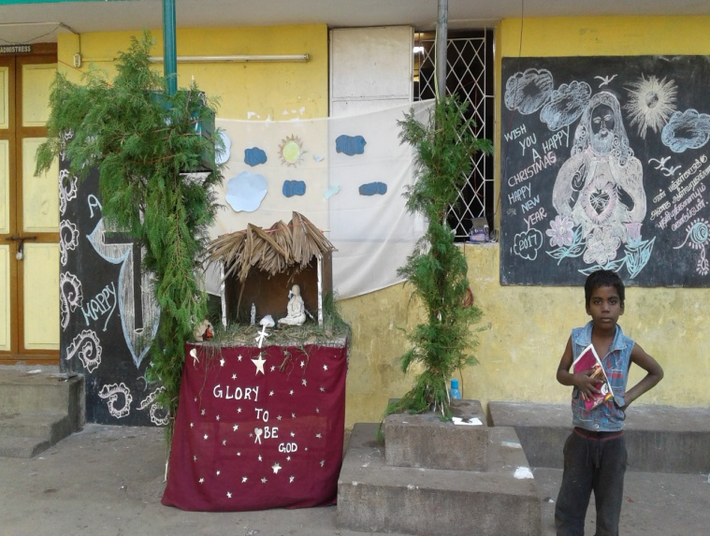
XI) On 17th November ,2016 , Clean India Event was
observed at Utkottai and Sri Venkateswara
Engineering College Students have explained the
students how to keep our surrounding and body to be
clean.

XII On 25th December 2016 Christmas Festival was
celebrated grand manner in our SEED Ceyrac home,
Sriperumbudur centre. Children were enjoyed in the
Christmas activities of making Xmas hut.

VIII. Medical Support provided to children:
.
- On 14th June 2016, General Health Check up was done for all the students in Primary School at Sriperumbudr in ‘SEED’ Ceyrac Home by Government Hospital, Sriperumbudur.

- On 27th June 2016, Pileria Test ( Blood test ) was done for the students of SEED’s Sriperumbudur Unit by the PILERIA ERADICATION DEPARTMENT. Medical Camp was organised by the Health Inspector from Government Primary Health Centre Madhuramangalam, on 17.08.2016 at our Sriperumbudur Unit . All children were given an opportunity for ‘ Health Check – Up’ by the dedicated Medical Team who came from the Govt. Primary Health Centre, Mathuramangalam.

- Medical Camp was organised on 22.08.2016 by Primary Health Centre Mathuramangangalam. . T.T. Injections were administeredand General Preventive Medicines were also given to the needy poor children of Sriperumbudur Centre. Teachers emphasized the importance of Health through their lecture ‘Health is Wealth’ .

IX . MEETING:
- “ Parents meeting ” was conducted on 1st Sunday of Every month in both the centers of SEED in which the progress of the children were discussed including their achievements in education and extra-curricular activities and also their overall development.

- “ Staff Meeting ” was conducted on 2nd Saturday of Every month in both the centers of SEED and various activities of all the projects of ‘ SEED ’ and the problems faced by the staff, children and the organization were discussed and suggestions were offered from all corners and solutions were found out to solve the problems.

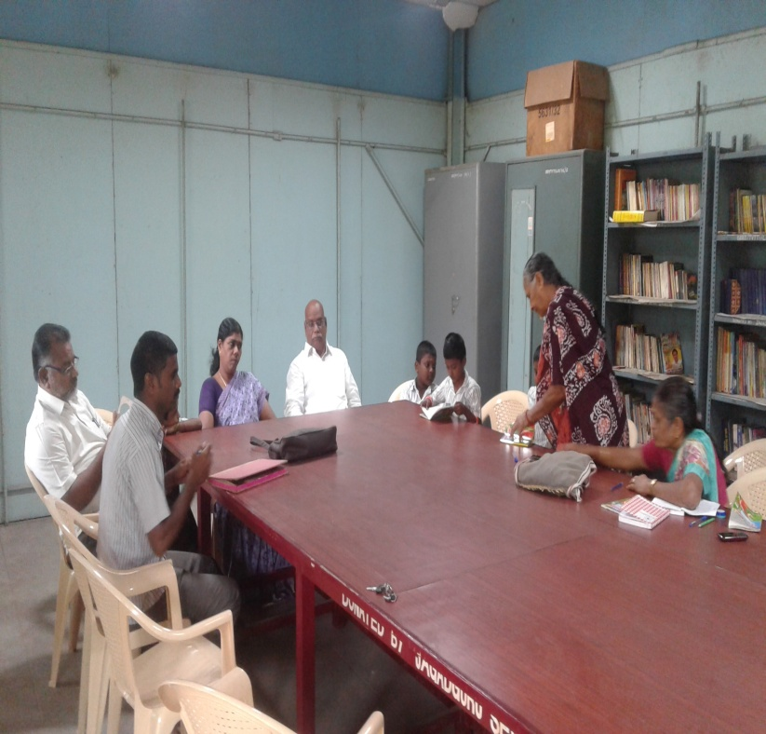
- On 30.11.2016, Home Management Committee Meeting was held at SEED’s Sriperumbudur Centre in which the District Child Protection Officer along with the following Committee Members took part:
- Zaheerudan Mohamad, CWC Member, Kancheepuram District
- G.Renuga, CWC Member, Kancheepuram District
- Thiru M.S. Syed Rawoof , Probation Officer, Kancheepuram District
- S.Sambathkumar – Protection officer, District Child Protection office, Kancheepuram
- R.Nagarathammal, Joint Secretary, SEED
vi) Rajalakshmi , Head mistress
vii) Rajaselvi, House Mother
viii) K.Sweetha - 4th standard, K.Mareeswaran - 4th
std., S.Iswariyalakshmi - 2nd std.,
S.Deivanayagi - 1st standard , M.Monisha - 11th std., T.Ananthi -11th std. and R. Parameeswari - 8th standard
- Students’ Representatives of SEED’s Sriperumbudur Home

X. KEY SUCCESS :
INDUSTRIAL TRAINING INSTITUTE – IRUNGATTUKOTTAI:
At Irungattukottai village, 85 Cents of land with certain infra – structure facilities such as work sheds were donated by Canara Bank Centenary Rural Development Trust in the year 1992.
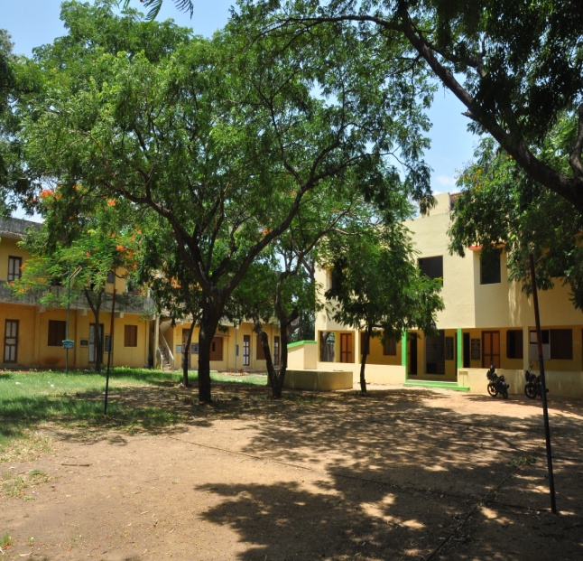
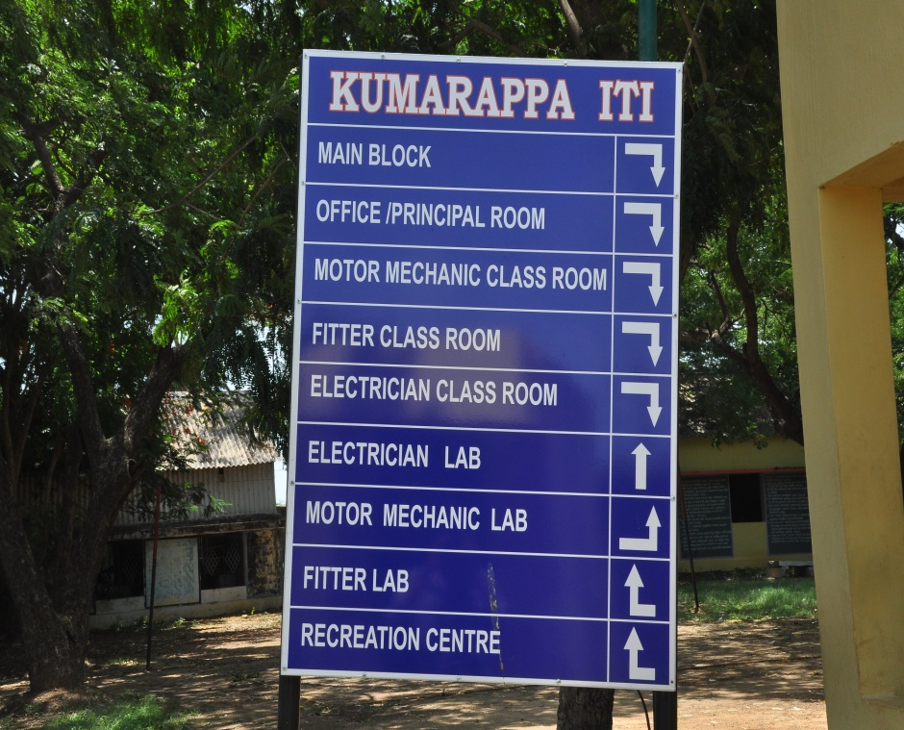
* In this place, ‘ SEED ’ started a Special and Free Industrial Training Institute in the year 1997 which was recognized both by the State and Central Governments . This Institute was named after DR. J.C.Kumarappa , who was close associate to Gandhiji during freedom struggle and who was claimed as ‘Father of Rural Industries ’ in India.
* In this Institute, Industrial Training was imparted in the following trades:
* FITTER - Two years course
* ELECTRICIAN – Two years course
* MECHANIC ( MOTOR VEHICLE ) - Two years course
  - ELECTRONIC –MECHANIC – Two years Course
  - CUTTING & TAILORING - Girls only – One year

* In each trade, 20 candidates are admitted as per the norms, prescribed by National Council for Vocational Trades, Ministry of Skill Development, Government of India
* This institute is giving intensive skill training to the children of LIFE PRISONERS, VICTIMS OF SERIOUS CRIMES LIKE MURDER and LEPROSY PATIENTS and also for the children who have lost their parents, so as to enable them to stand on their own feet.
SRIPERUMBUDUR & UTKOTTAI CENTERS:
* One of the SEED children, whose father is a Life Prisoner, secured 475/500 in his school final examination (10th Standard – SSLC) and got admission in a renowned institution in the State of Tamilnadu for his higher studies.
* One of the SEED’s children has successfully completed her Postgraduate Degree in Nursing and now, working as faculty in Sri Ramachandra Medical University in the College of Nursing.
* Two children from SEED are doing Engineering Degree Course in a renowned Engineering College in Tamil Nadu. Among these two children, one child’s father Life Prisoner and another child lost his parents in his childhood and they are in Aeronautical Engineering ( III Year ) and Mechanical Engineering ( II Year ) respectively.
* One of the children from SEED, whose father was a Life Prisoner due to death of his wife, has got Doctorate in Marine Economics and is presently working as Associate Professor in a renowned University in Tamil Nadu.
* One SEED’s child is in Canada and got PR there; another child from SEED, now, is working in Tanzania in Africa and one more child is an engineer in Dubai and one boy, whose father Life Prisoner due to death of his mother, is Quality Engineer in Hyundai Motor (India) Ltd and this list may expand because most of the children in SEED excel in some field . Even the average and below average students in SEED are good in drawing or gardening or vocational training.
* Among all the child care institutions in Kancheepuram District, Tamilnadu State, SEED had been included as one of the members of the District Child Protection Committee apart from the high level Government Officials like District Collector, District Judge, District Child Protection Officer, District Child Welfare Officer and Chief Educational Officer. This committee is taking important decisions in implementation of child rights, Juvenile Justice Act, etc. Hence, it is a recognition given to SEED for its human service rendered for the socially deprived children for more than three decades.
* In the fourth consecutive year, “SEED” has been included as one of the governing body members in BOARD OF STUDIES in ADVANCED INSTITUTE OF TEACHER EDUCATION ( an Autonomous Institution for Teacher Education ), Government of Tamil Nadu along with scholars in the field of education and academicians to form the syllabus and curriculum which paves the way to SEED to recommend to include Child Rights, Child Participation, Evils of Alcohol & Tobacco as part of the syllabus, because teachers can only induce these important aspects in the minds of the children from their childhood onwards.
* One of the SEED children, whose father is a Life Prisoner, secured 475/500 in his school final examination (10th Standard – SSLC) and got admission in a renowned institution in the State of Tamilnadu for his higher studies.
- During this academic year (2016-2017), 8 girls have got admission in Diploma in Nursing & Midwifery, one girl has got admission in B. Sc. (Nursing) and one boy has got admission in Bachelor of Physiotherapy on merit.
XI.UNIFORM DISTRIBUTION
2 Sets of New School Uniform were provided by us to our children at the beginning of the academic Year ( i.e. ) June 2016. The students regularly wear the uniform during the school hours.
- XII. COMPETITIONS :
- On 07.08.2016, our Primary and High school boys and girls have participated in the Competition conducted by an N.G.O., ‘BOOMI’, in which nearly 5000 children from all the children’s Homes took part and our SEED children obtained the following prizes :
3 | Name of the child |  | Class | Programme participate | Awards won
1 | D.Rajv Gandhi |  | 10th std. | Dance | 2nd prize
2 | V.Suriya |  | IX Std. | Dance | 2nd prize
3 | G.Manikandan |  | 9th std. | Junk Art Competition | 2nd prize
4 | S.Nithsh |  | 6th std. | Clay Article Making | 1 Prize

- * 2. On 09.10.2016, Our High school students had participated in YMCA dance proramme, conducted by the District Child Protection Office, Kancheepuram District.
Mahathma Gandhi High School, Utkottai
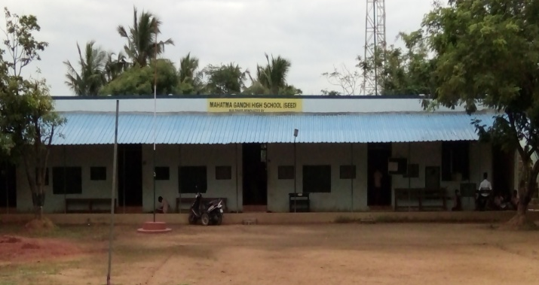

Details of varies Activities and Competitions held in the School:
2016-17
June 2016: 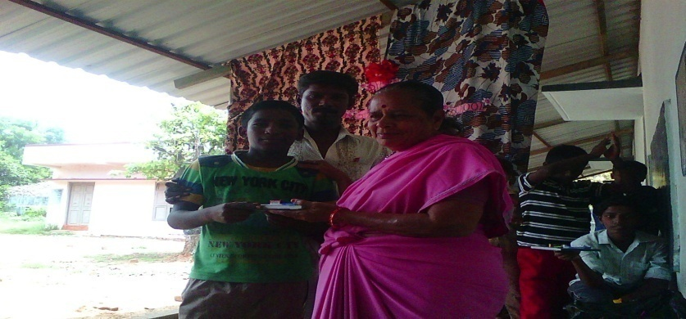
11.06.2016: Inauguration of literary Association.
Literary association of
Mahatma Gandhi High School, Utkottai was inaugurated by R. Vasantha kumarai, Head Mistress for the Academic year 2016-17.R.Subash X std was elected as secretary and S.Ramar of IX Std was elected as Asst. secretary .The following children gave a speech on the topic “ MY SCHOOL “.
R. Vaseegaran – 6th Std , S. Loganathan – 7th Std, V. Suriya - 9th Std & R. Dillip - 10th std.
18.06.2016: Elocution Competitions- both in English & Tamil
The literary Association organized an Elocution completion both in English and Tamil on the topic “OUR ENVIRONMENT” in which the following children won the prizes:
S. Loganathan VII- Std- I Prize, G. Iyappan VIII- std- II prize, R. Dilip X- std – I Prize & V. Surya IX- std- II Prize
25.06.2016: Essay Writing – both in English & Tamil
Topic: My Favorite National Leader
The literary association activity was held on 25.06.2016 in the school premises. Essay Writing competition was held in English and Tamil on the topic “My favorite National leader”. The following students were the prize winners.
Tamil:
Nithishkumar VI- std – I Prize, Vijayprathap & Loganathan – VII- std- II Prize, G. Manigandan IX-std- I Prize & G. Gunalan- X Std- II Prize
English:
G. Iyappan – VIII-std – I Prize, R. Mohankumar – VIII –std- II- prize, V. Surya – IX-std- I-Prize &
D. Rajvgandhi- X- std- II- Prize.

15.07.2016 Thiru. Kamarajar’s Birthday
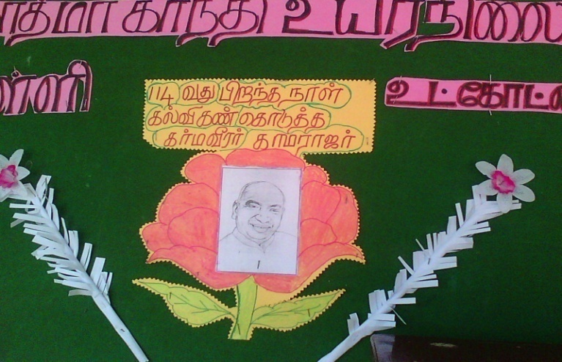
Former Chief Minister of Tamilnadu, Kamarajar’s 114th birthday was celebrated in the school premises. Various competition were held for the students. The name of the competitions and the winners are as follows.
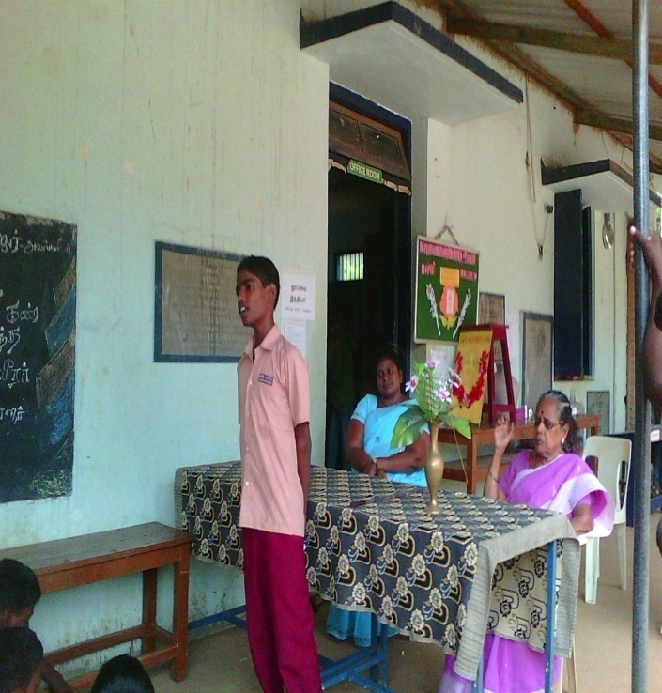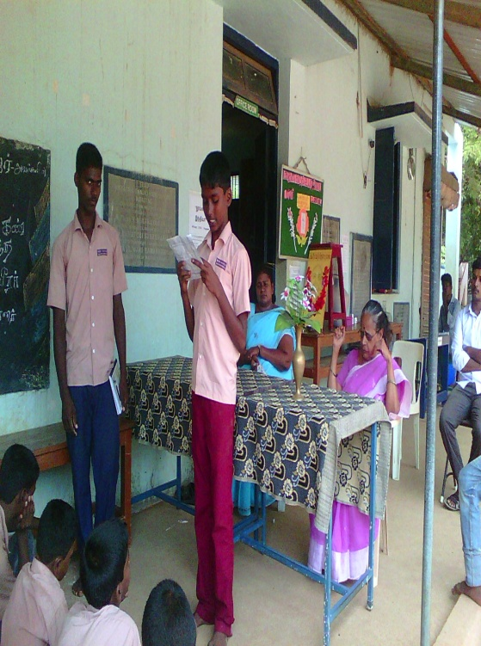
- Handwriting
- Drawing
- Elocution
- Essay – both English and Tamil
- Dance
- Drama
- Singing
Prize Winners:
Handwriting:S. Nithishkumar-VI-std- I-Prize, R. Nelson blessing – VII-std- II Prize, S. Saravanan- VIII- std- I- Prize, D. Ajith- VIII- std- II-Prize, S. Simmarajan-IX std-I-Prize, D. Rajvgandhi-X-std- II Prize & G. Gunalan- X std- II-Prize
Drawing;
S. Nithishkumar- VI- std-I-Prize, R. Sivaprakash- VI-std-I-Prize,R. Nelson blessing – VII-std-II-Prize & S. Saravanan-VIII-Std-II-prize
Elocution Tamil:
S. Loganathan-VII-std-I-Prize, G.Iyappan-VIIIstd_IIPrize, R. Dilip-Xstd_I-Pirze, G. Manikandan- IX-std- II-Prize & Thirukannan-VII-sts-II-Prize
English:
R. Nithishkumar-VI std-I Prize, G. Harikaran- VIII-std- II-Prize, D. Rajivgandhi-X-std-I-Pirze
V. Surya-IX-std-II-Prize & D. Santhosh-IX-std-II-Prize
Essay Writing Tamil:
M.Kumaran-VII-std-I-Prize, Thirukannan-VIII-std-I-Prize, G.Iyappan-VIII-std-II-prize &
S. Santhosh-VIIIstd-II-Prize
English
R. Dilip-X-sts. –I-Prize, K. Subash-Xstd-II-Prize & V. Surya-IXstd- III-Prize
Singing:
R. Vaseegaran VI-std- I-Prize, S, Loganathan VII-std- II-Prize, T. Kanmaniraj IXstd- I-Prize &
M. Vijayakumar IX std- II-Prize .
Tree Plantation Day
Tree plantation day was orgainised by the students on 23.07.2016.They planted saplings in and around the school premises.
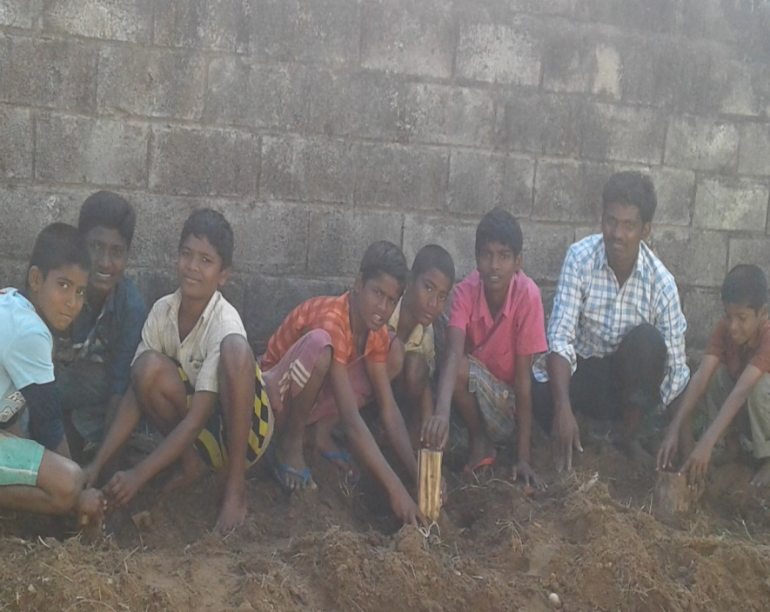
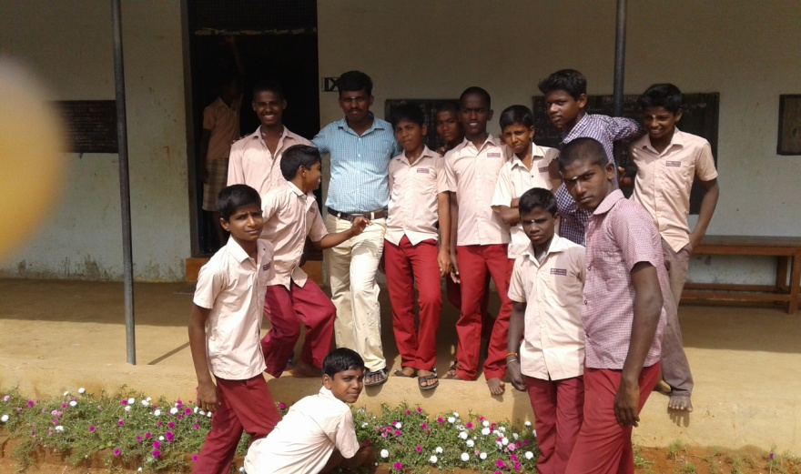

Saplings were planted in and around the school and hostel Premises
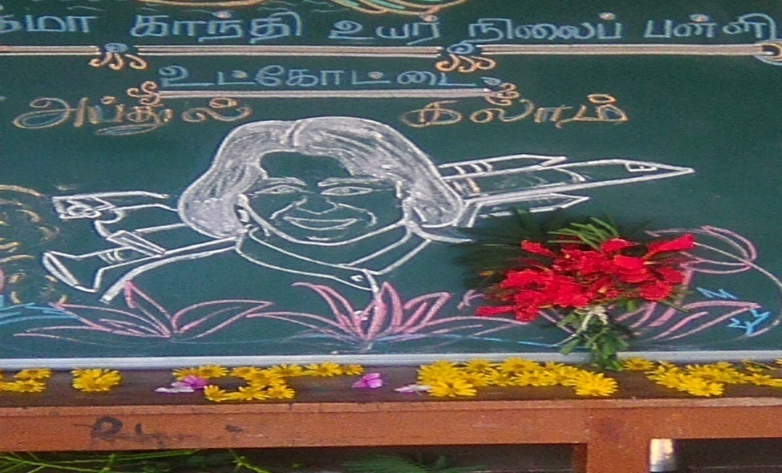
Dr.AbdulKalams 1st Memorial Day
Former President of India , DR.Abdualkalam’s 1st memorial day was observed in the school on 27,07.2016. A.Sanjay of X std and P.Sathish of IX std drew the picture of Dr.kalam on the board and the teachers and the students paid their homage with flowers.Speech and painting competitions were organized by the literary Association and name of the prize winners as follows.
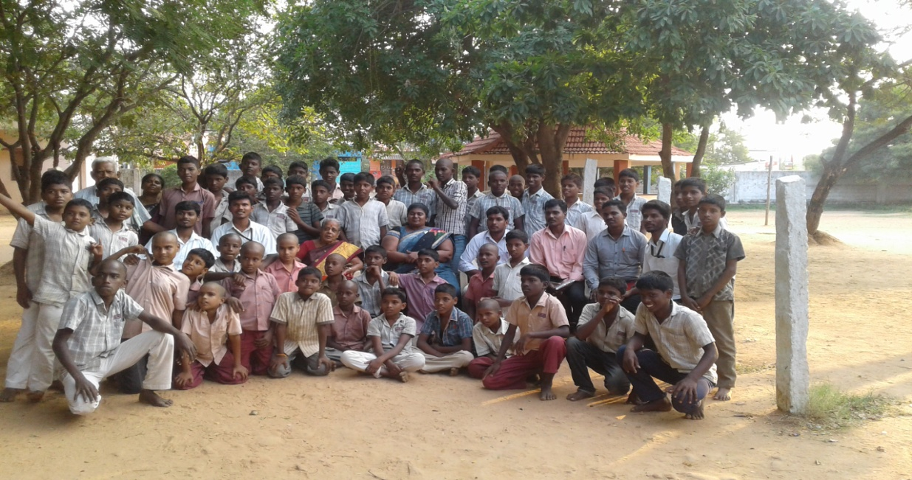
Competitions held;Speech&painting
Winners;
Speech:
G.Iyappan VIII std I prize
T.Thirukkannan VIII Std Prize
p.Tikkaram X Std I Prize
G.Maniganden IX Std II Prize
Painting;
S.Saravan VIII Std I Prize
D. Siva parkash VI Std II Prize
K.Gowthaman X Std III Prize

P.Sathish IX Std I Prize

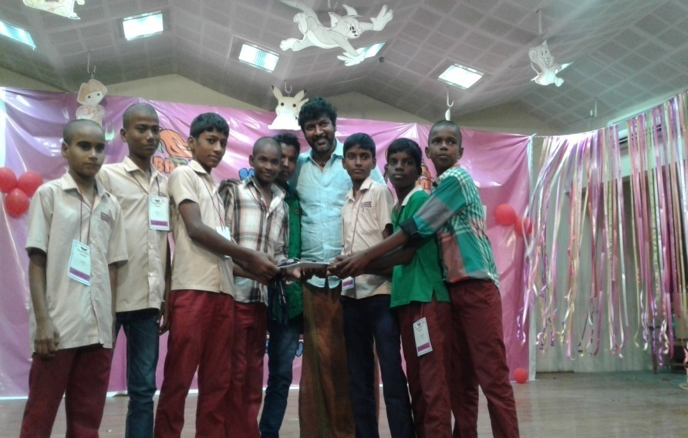
.
Independence Day Celebration - Colorful March Fast held by the Students group wise.
Independence day celebration was hold in the our school premises.Thiru Gana segaran of Tata Value Homes was the Chief Guest.He hoisted the flag. Colorful March Fast was organized by the Students. The Chief Medical Officer of Primary Health Center - Nemam and the President, Kuthampakkam Panchayat Union were the guests of honor. The Chief Guest and the Guests of Honor were honored with garlands and shawls. Independence Day Speech and & dance program were organized by the students.
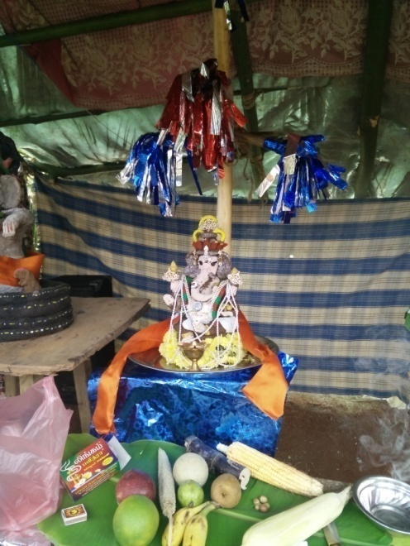
TEACHERS’s DAY:
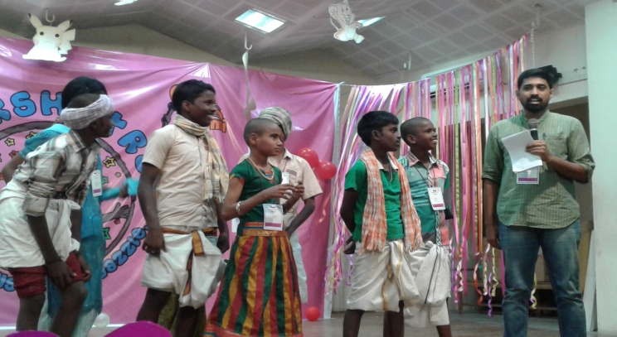
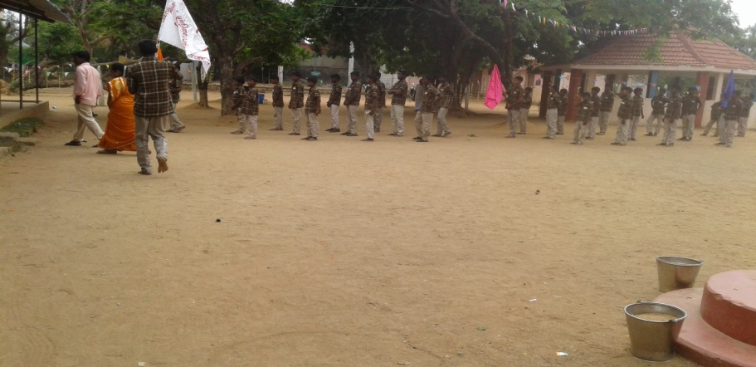
On 05.09.2016, Teacher ‘s day was celebrated and the students gave speech on the former President of India, Dr.Radha Krishnan and the noble services of the teachers.

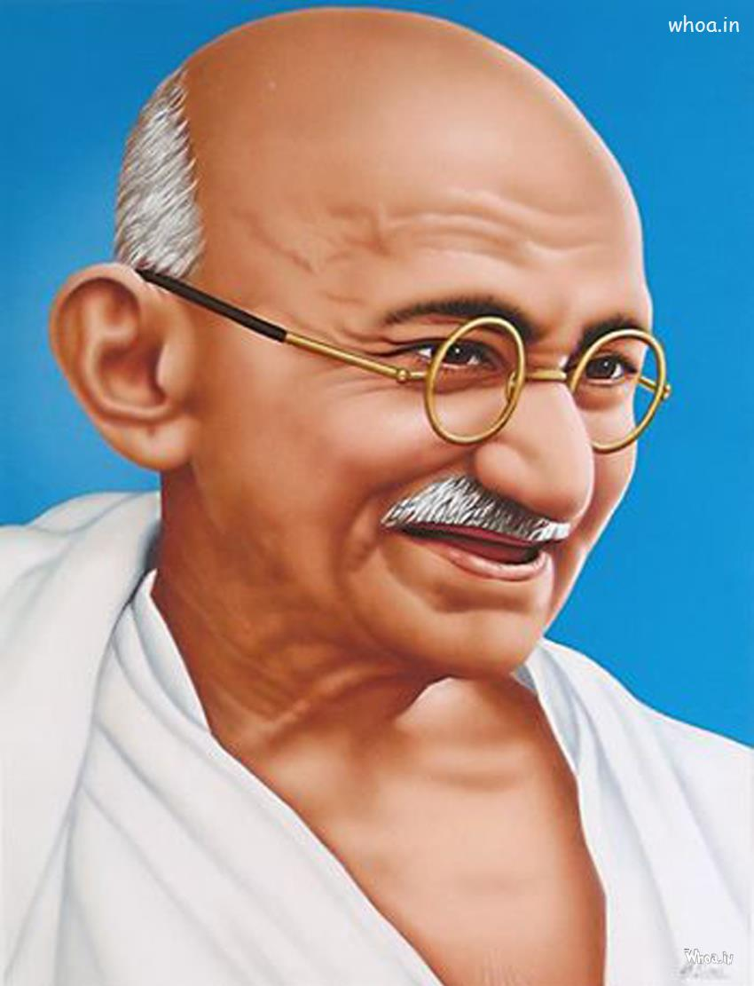

02/10/16; Gandhi Jayanthi,
During Gandhi Jayanthi Day Celebration, Alumni Association of SEED meeting was held in the school premises. Dr.Ashokamani, Vice President of SEED presided over the function.

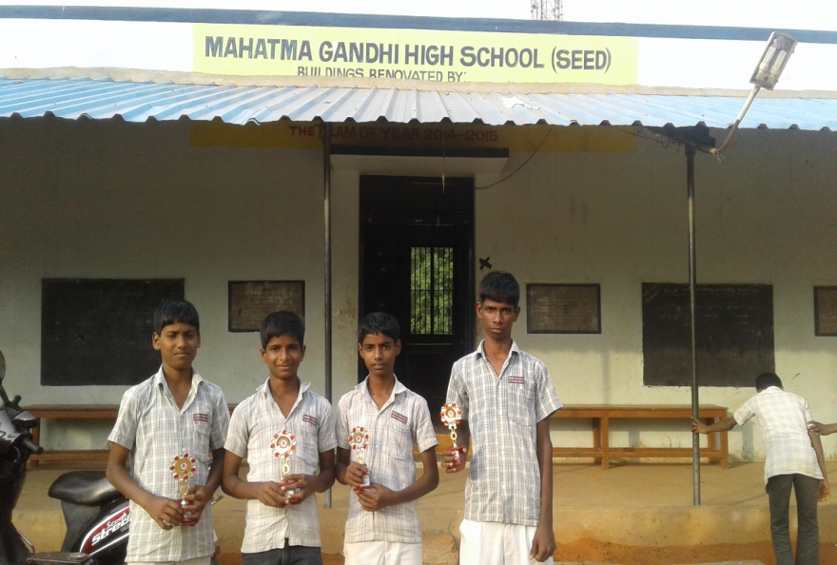

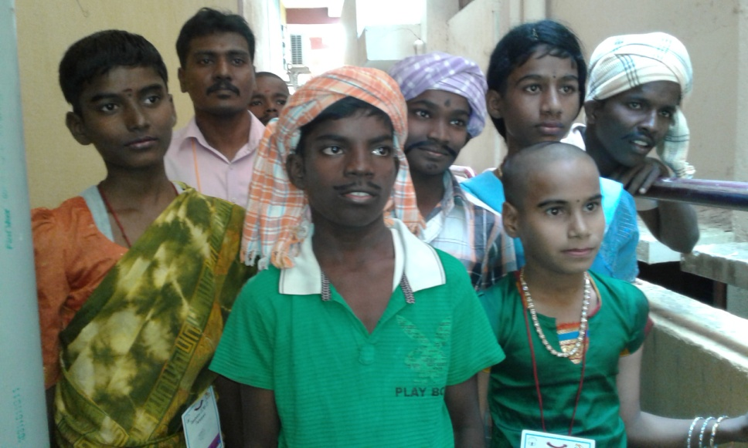

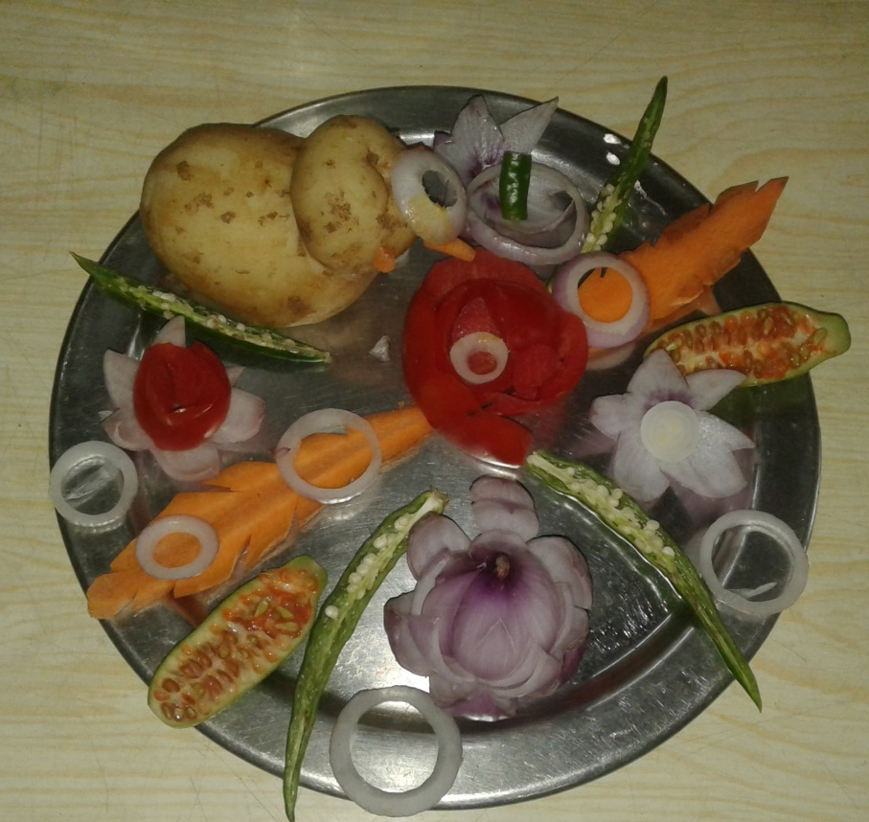
CHILDREN’S DAY CELEBRATION:
Children’s s day was celebrated in our school premises. Dr.Shanmuga priya and Dr.Anjali from Saveetha Medical College Hospital participated in the function. The students gave speech on Pandit Jawaharlal Nehru, the first Prime Minister of India. Drawing and singing competitions were conducted and the following students received the prizes.

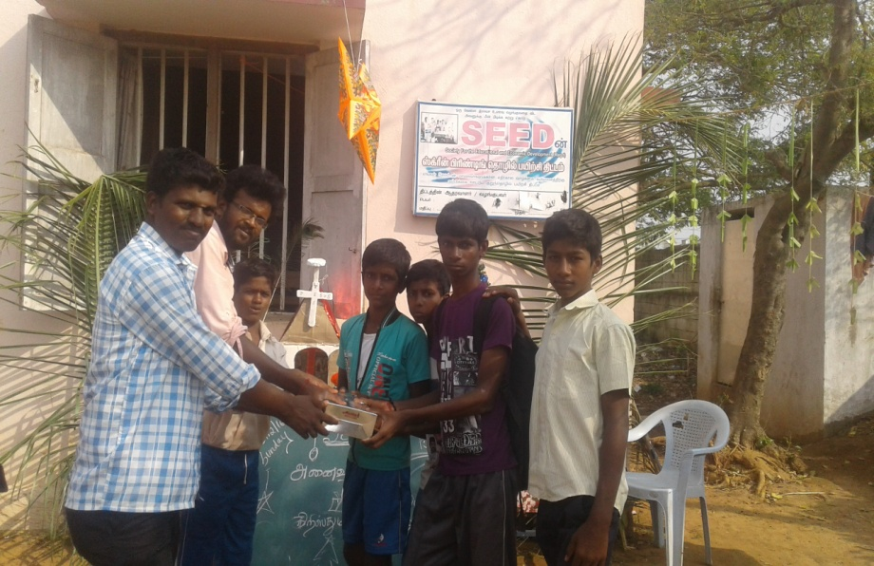
Singing Competition:
M.Kumaran VII Std – I Prize , 2.E.Sathish.VIII Std II Prize
3.S.Narendran IX Std I Prize & 4.A.Sanjay X Std II Prize
Drawing Competitions,
1.subash VI std I St prize, 2.R.Balaji VII std II Prize., 3.S.Ramar IX Std I Prize & 4.P.Sathish IX Std II Prize

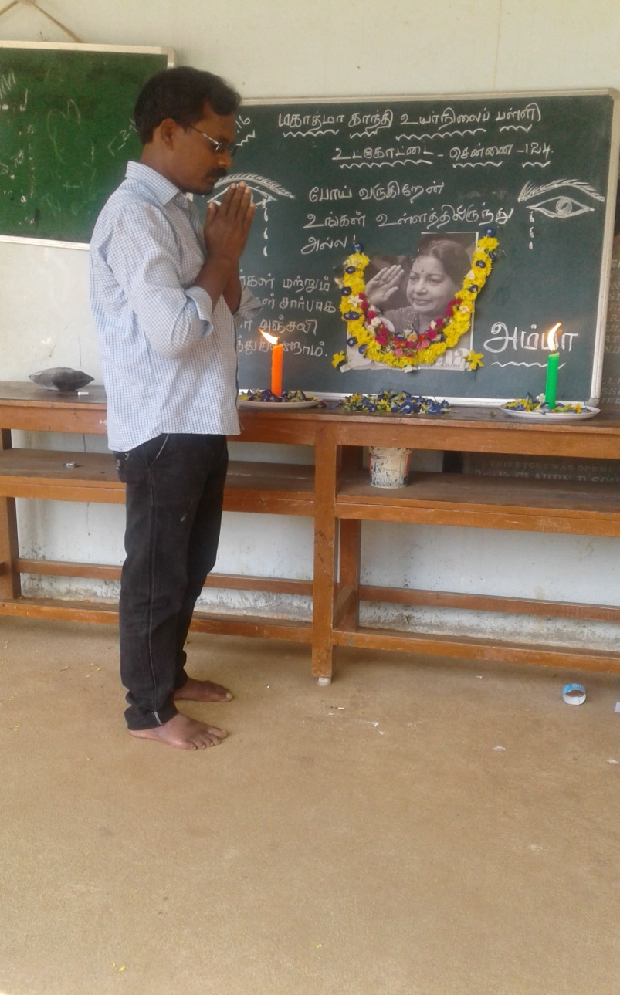
09/12/16.Homage paid by the students and teachers and warden, cooks and watch man to the Chief Minister. J.JAYALALITHA.
A Tearful homage was paid to selvi.J.Jayalalitha Chief Minister of Tamil Nadu by the teachers, students, warden cook and watchman of our school in the school premisesaa

New year Celebration at the School:
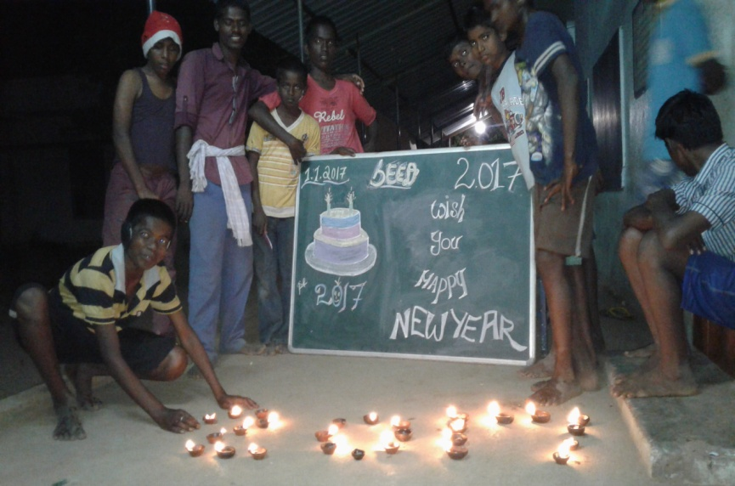
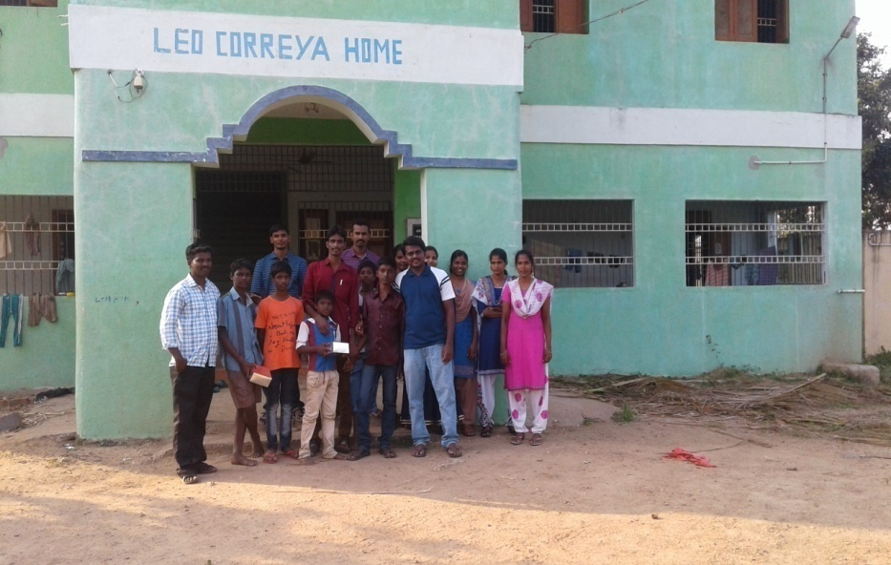
RUNNING RACE BY CHILDREN
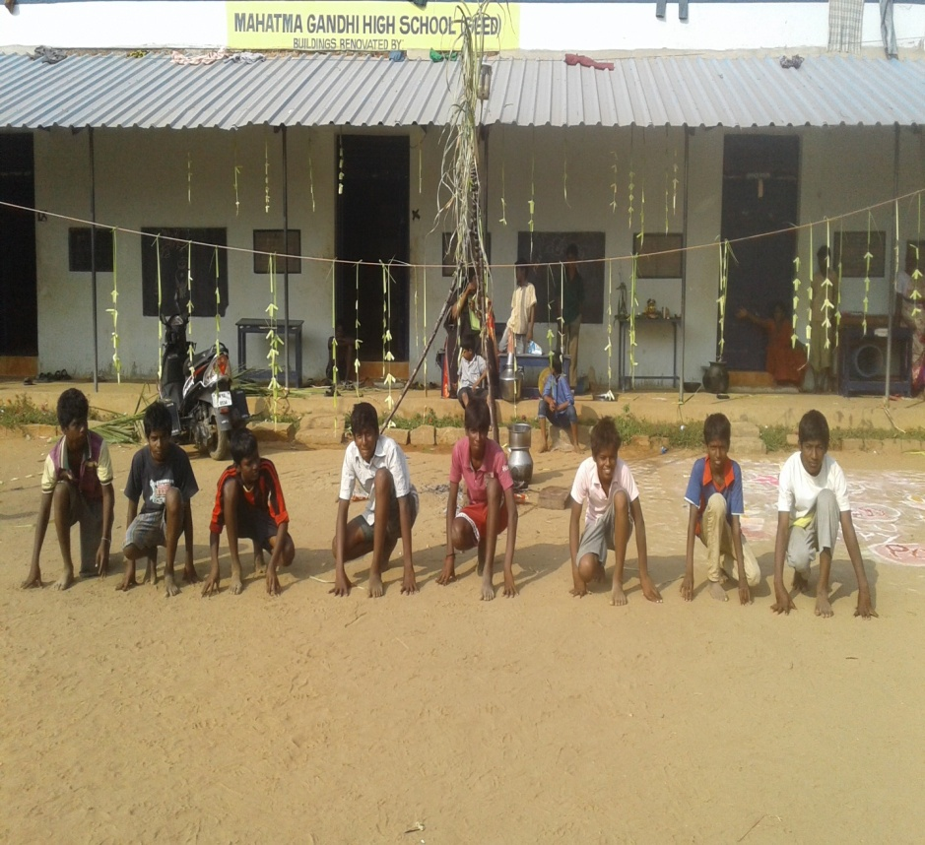

SEED – LEO CORREYA HOME – UTKOTTAI
In addition, the school was visited by the by Dy.Collector Divyasri, Thiruvallore Dist., 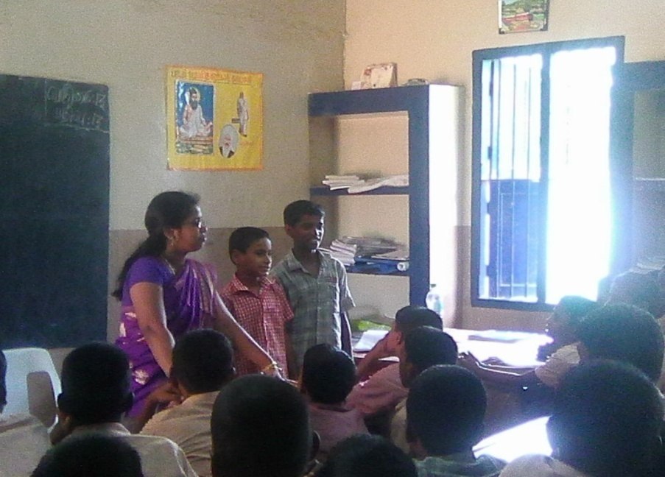

- TRAINING PROGRAMME :
- Students of our ITC need Training in CNC Machine. Hence, we have approached M/S AIEMA - CNC Training Centre in Ambathur Industrial Estate and students were selected for this weekly two days programme .

- 7 High school Boys and Girls students have gone for Model making training at’Birla Planetorium’ on 26th May-2016.
- 12 High school Boys and Girls students have gone for Model making training at Birla Planetorium on 28th May-2016.

XV HELPING HANDS

- 3 Table, 3 Chairs and 3 Cubboards purchased for the SEED Mahatma Gandhi Primary School class room with the help of ASHA – ST LOUIS.

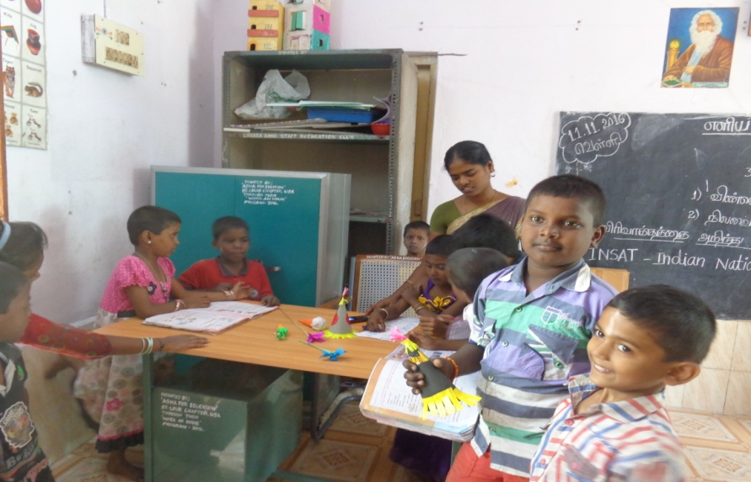
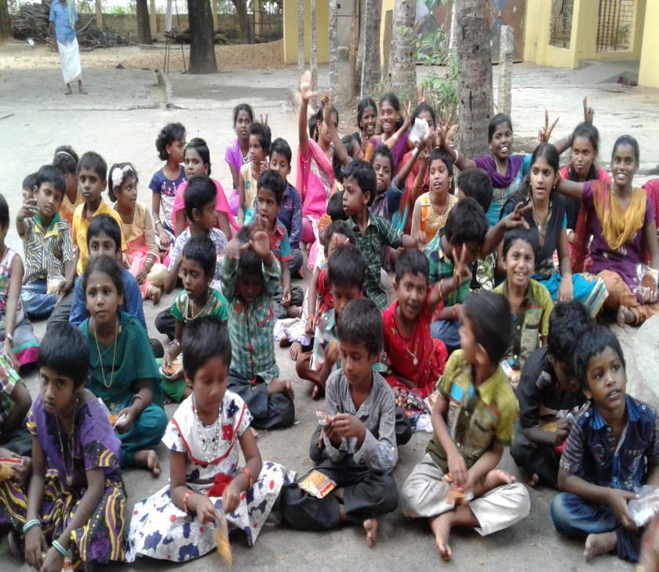
- RO water plant was donated & installed by Rotary Club of Chennai Port City in SEED – Dr. J.C.Kumarappa Indutrial Training Centre

- A set of New Colour dress provided by T.Nagar Batminton Club to our children during Deepavali Festival, 2016 .

- In the month of October 2016, painting work was done by Dell Company through Hope Foundation for our Mahatma Gandhi Primary School and Hostel building

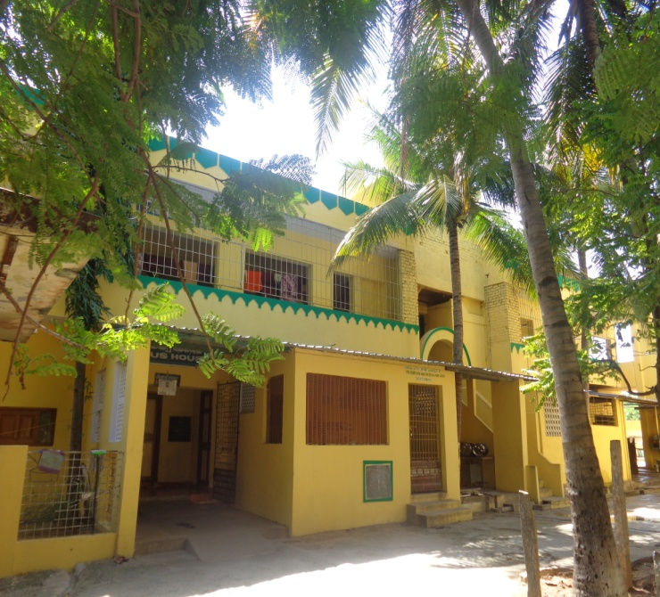
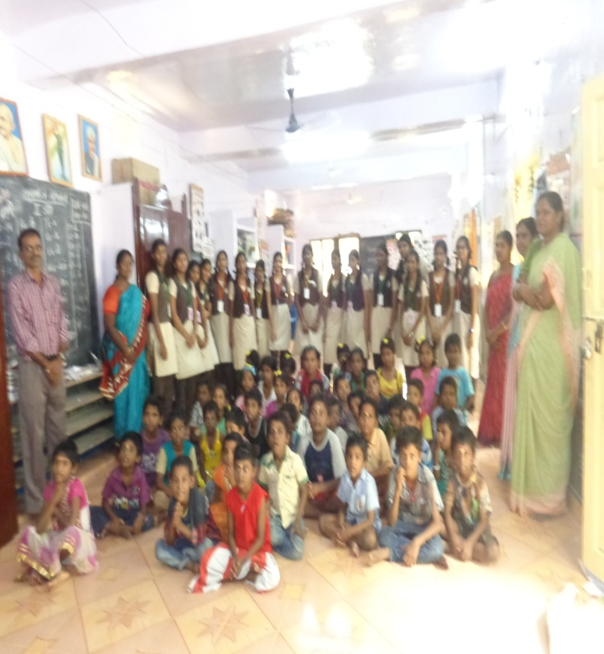

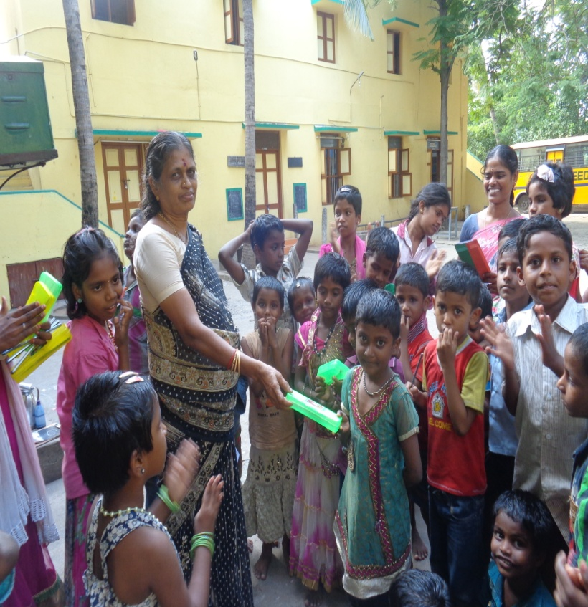

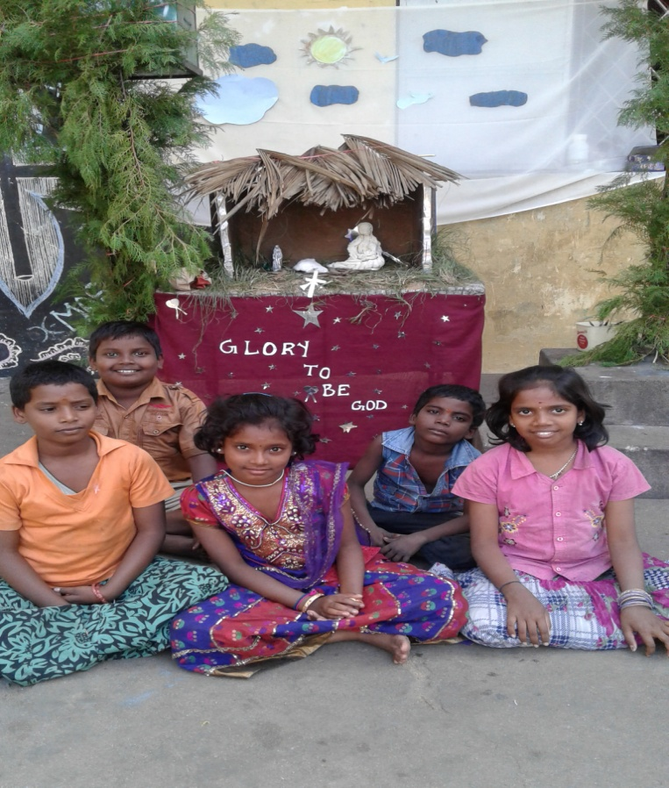
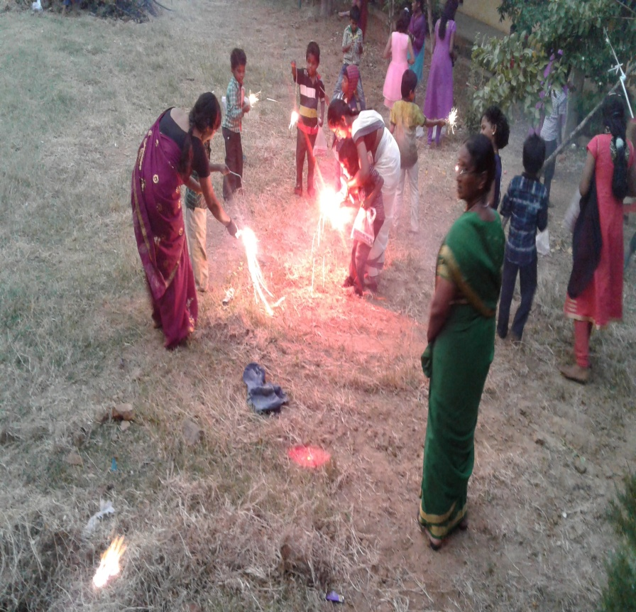
Deepavali Festival Celebration X- Mas Celebration
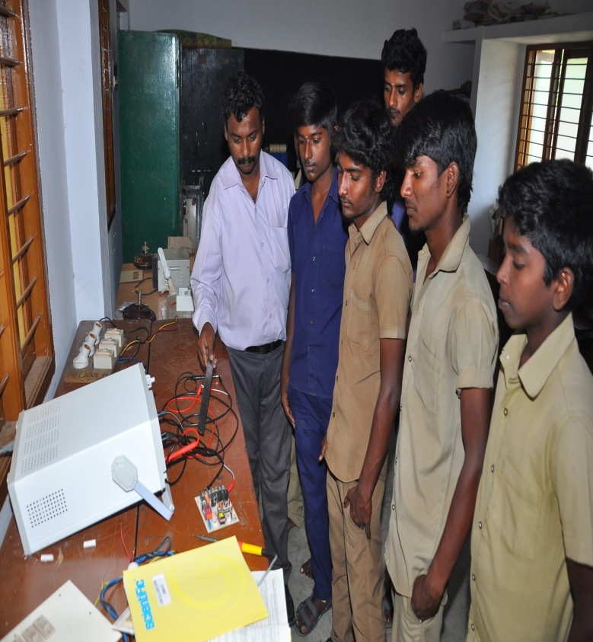
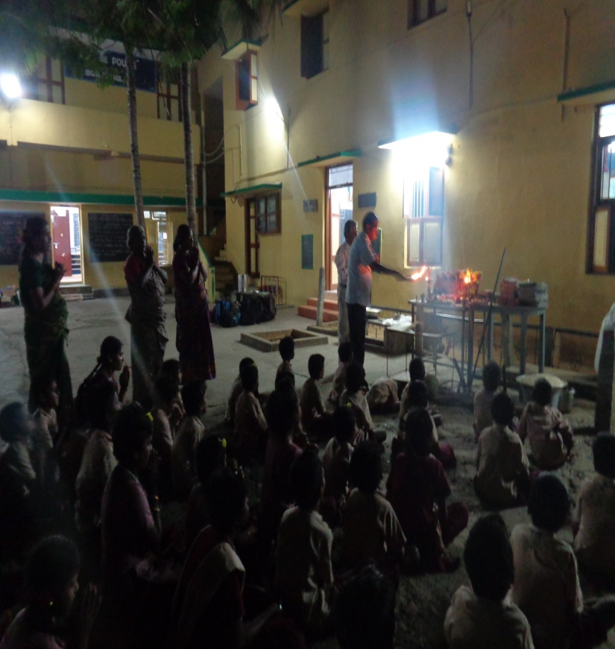

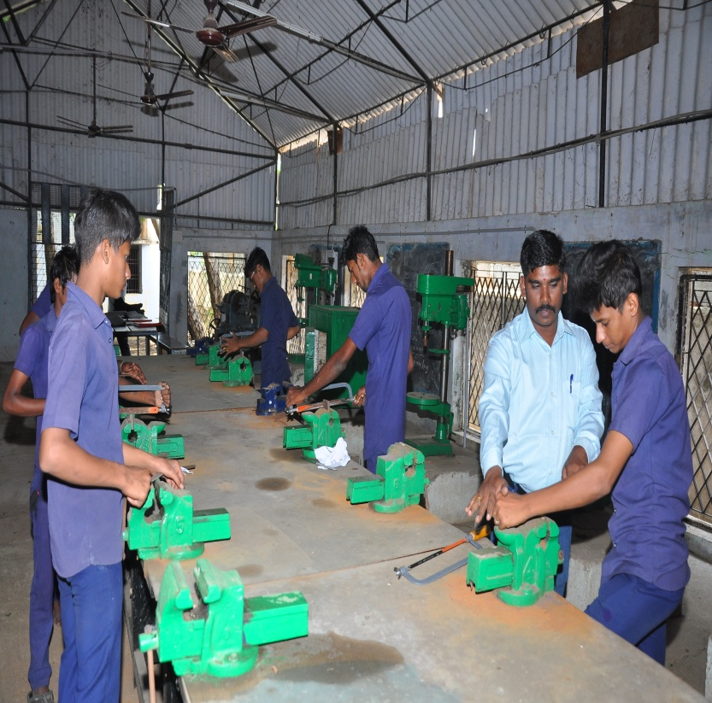
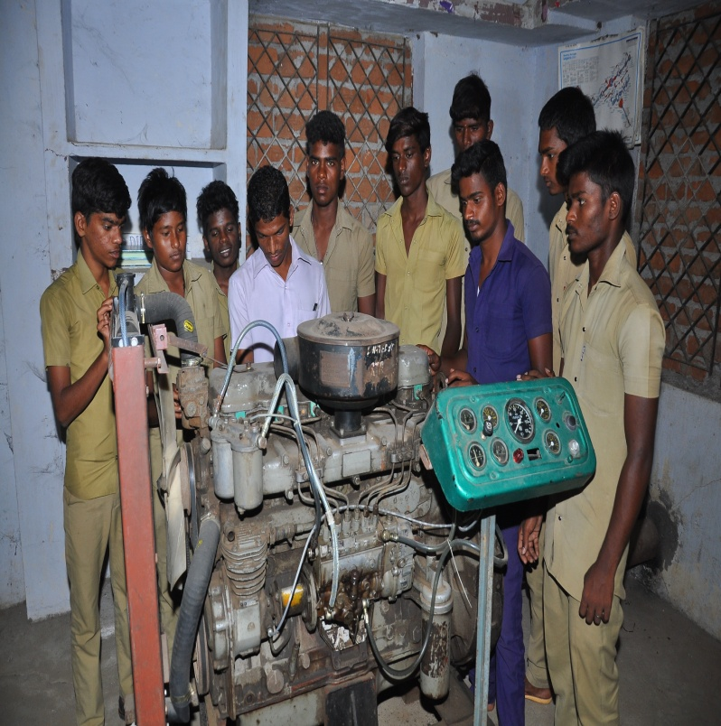
Pooja Festival – Saraswathy Pooja ITI – Electrician Trade – Practical Training

ITI – Fitter Trade – Practical Training ITI – Mechanic Motor Vehicle – Practical
Training

