Uniform Distributions at Sangamam and Pearl

July-Aug 2023
(by Rajaraman Krishnan – Volunteer at Asha Chennai)
Click here to see photos from these distributions.
Providing an additional set of uniforms from Asha is something we take up if we have additional funds in some projects. Like student excursions etc., these are not essential but will help a lot in making the school a more welcoming place for the children. The uniforms given by the government for most part is adequate but not of a very good quality. They barely last one year. We had last distributed these uniforms in early 2020 just before the Corona outbreak. Some of the schools wanted to distribute it after the new year starts. Thanks to the Covid, they could distribute the uniforms only when the schools reopened in Oct 2021. The children are still wearing it now.
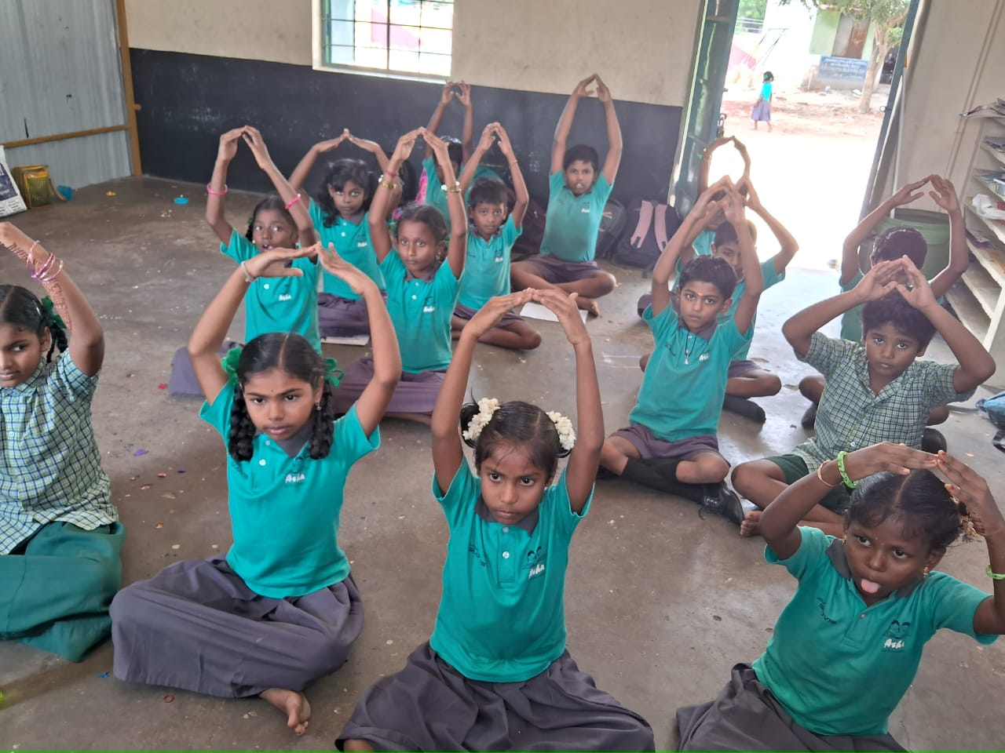
This showed us the importance that the schools and the parents place on this uniforms. We decided to do the same this year. As there was extra funds available for Project Sangamam we decided to do it there. Qbrik ???, a company run by one of our volunteers, decided to fund the uniforms at Pearl and Thulasi. This most of our rural projects were covered.
We decided on the following,
- T-shirt and shorts for class 1 to 5 boys.
- T-shirt and skirts for class 1 to 5 girls.
- T-shirt and pants for class 6 to 8 boys.
- Chudidhar set for class 6 to 8 girls.
After evaluating some samples we decided on red colour for the T-shirts and dark grey for the shorts/skirts/pants. This chudidhar sets were going to be white and grey. We placed the order with Shanmuga Apparels. At project Thulasi, the orders were given to a local tailoring group. The distribution was to be held later.
A tailor from Shanmuga Apparels visited a few schools in Thiruvallur to get a mix of the sizes of the various dresses that would be required for all the classes.
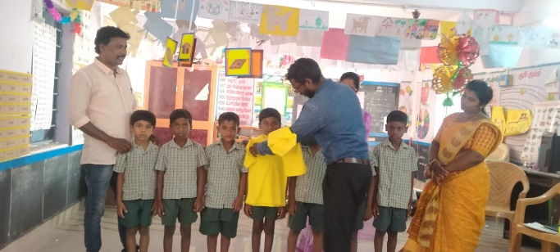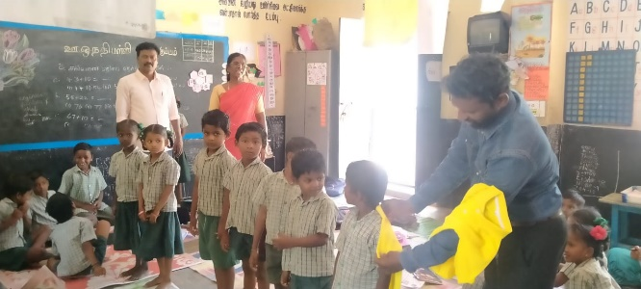
At all the projects we placed orders for about 5% less than the strength of the schools in 2022-23. We did that with the idea that we will place an order for some extra sets after the first distribution. We can order for the specific sizes which are required in larger number. But this year the enrolment at the govt schools were quite bad and the number of students had dropped back to the pre-pandemic levels. It doesn’t look like we will need to place order for any extra set of dresses. At Sangamam the total strength this year is about 5200 against 5500 last year. At Pearl the strength is about 2540 against 2700 last year.

Distribution at Project Pearl
Shanmuga Apparels delivered the dresses to our Project Pearl office 12 July, 2023. These were already separated by schools. Our coordinator Murugan delivered these uniforms to the schools over the next 3 days.
On 22nd July a group of about 10 employees from Qbrik came to the Pearl project area and distributed the uniforms at the following schools: Kayathar South, and Koovachipatti.
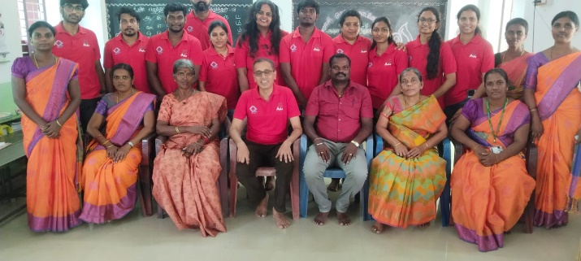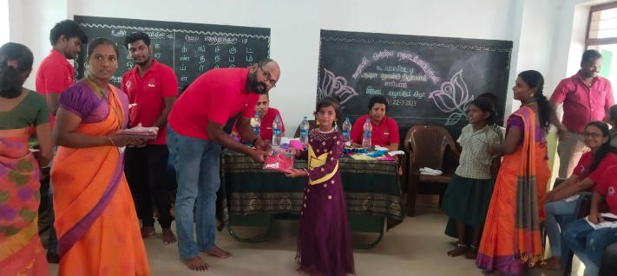
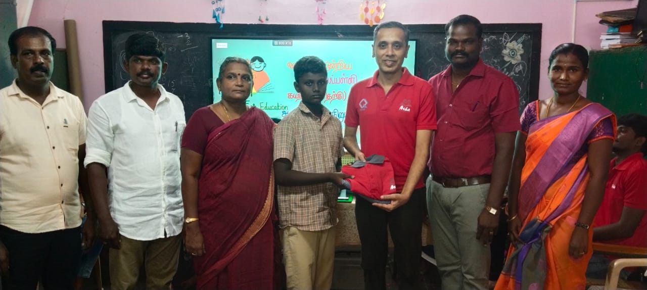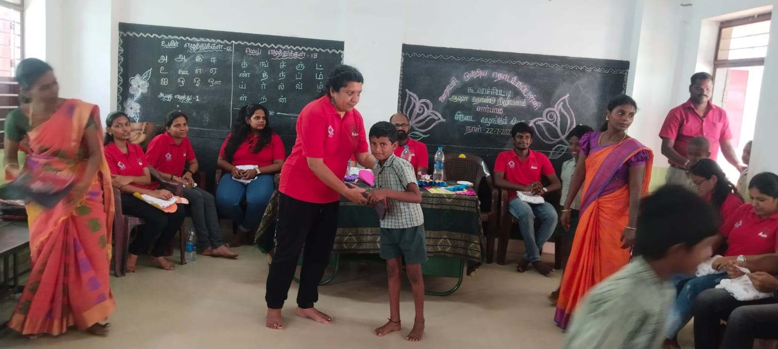
The staff from Qbrik also spent some time interacting with these children and also visited our RTC at Kayathar in the evening before returning back to Chennai that evening.
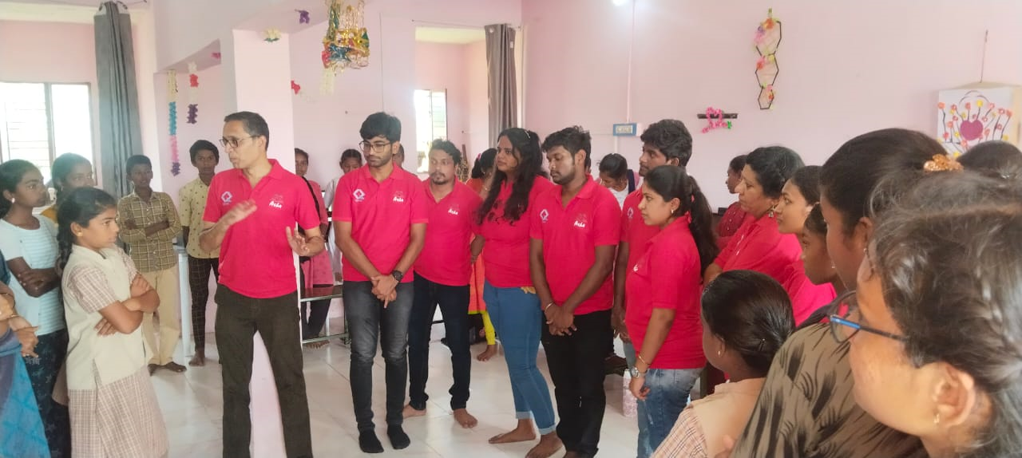
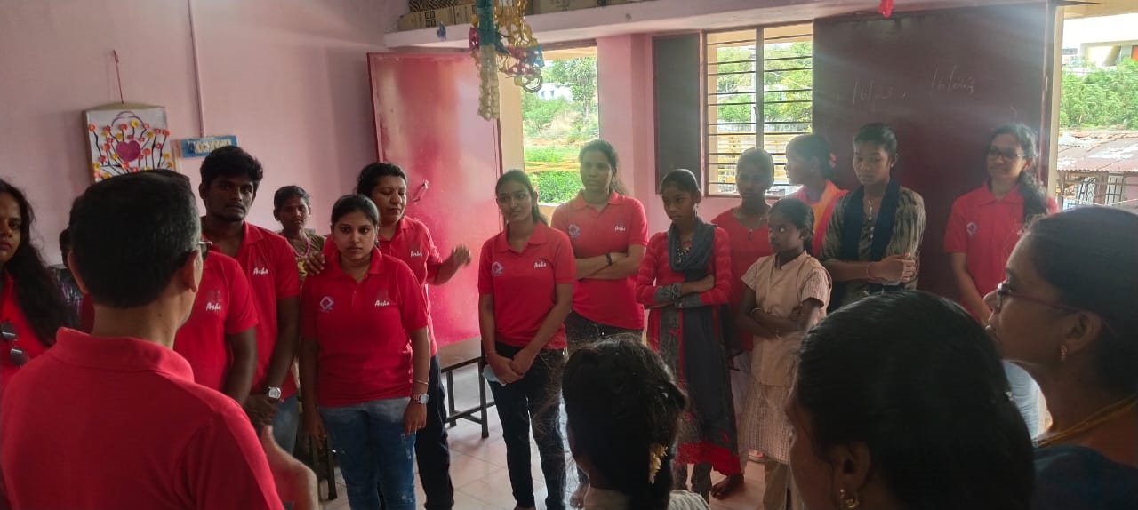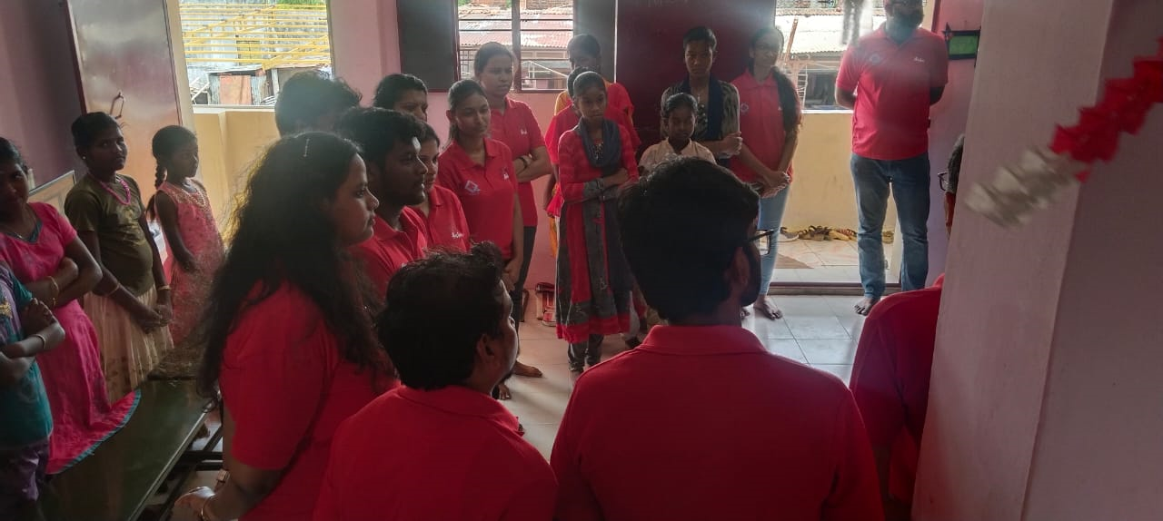

Over the next few days Murugan and the teachers completed the distribution at all the Pearl schools.
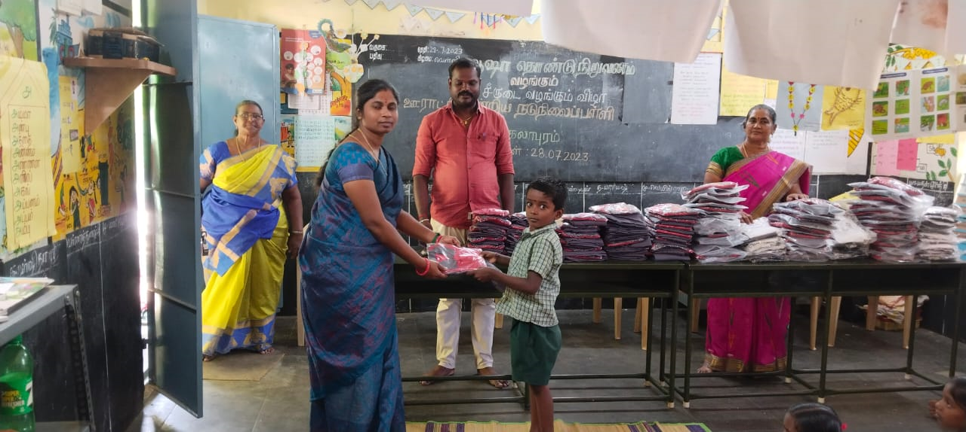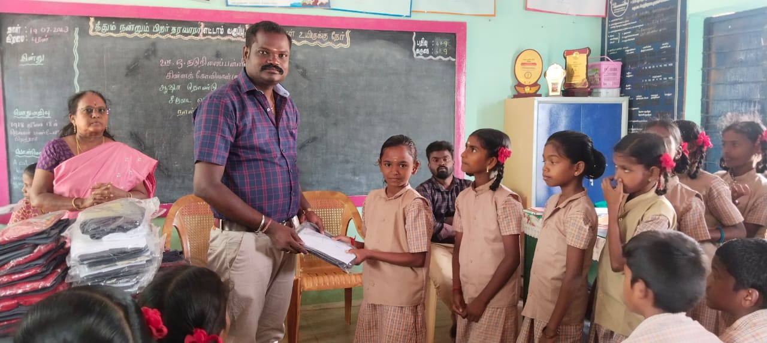
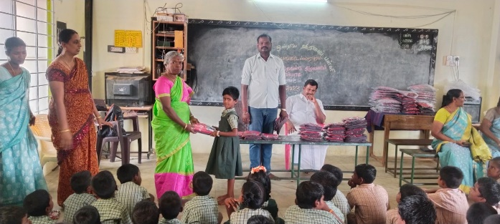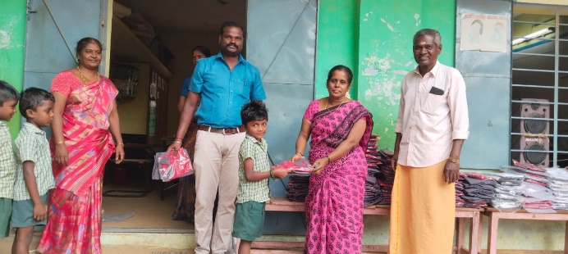

Distribution at Project Sangamam
At Thiruvallur Shanmuga Apparels delivered the dresses directly to the schools along with our project staff on 1 August, 2023. The deliveries started on August 1st and continued till August 10th. Adjusting the excess and deficit dresses between schools is still taking place and is expected to get over in the next couple of days.
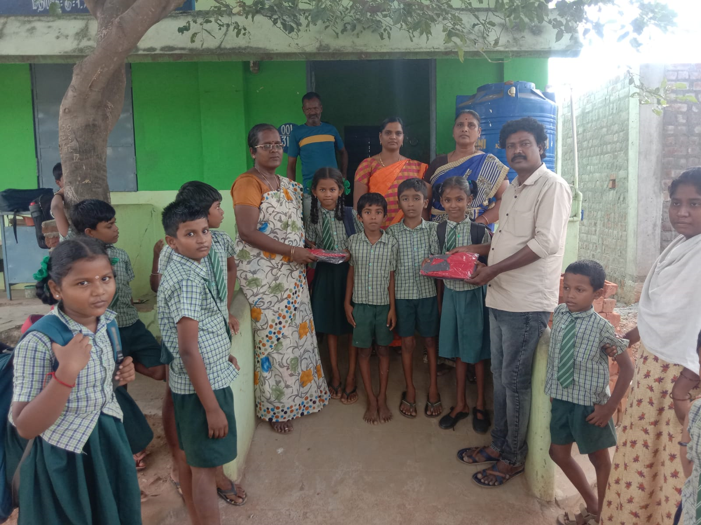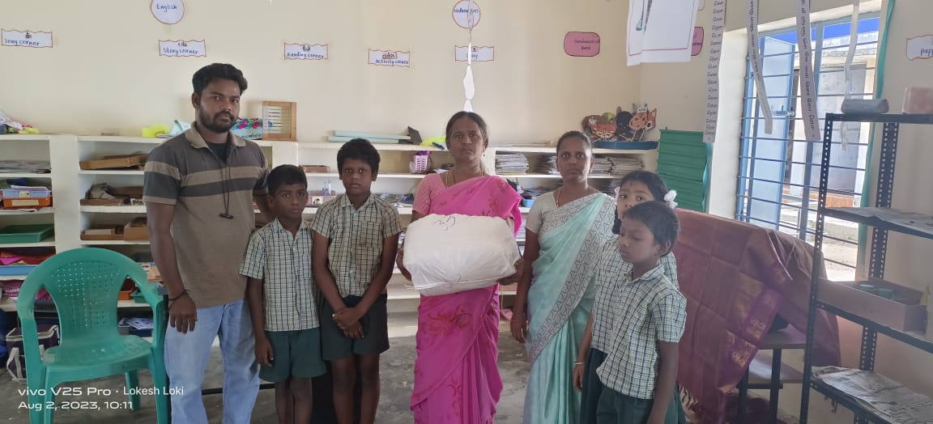
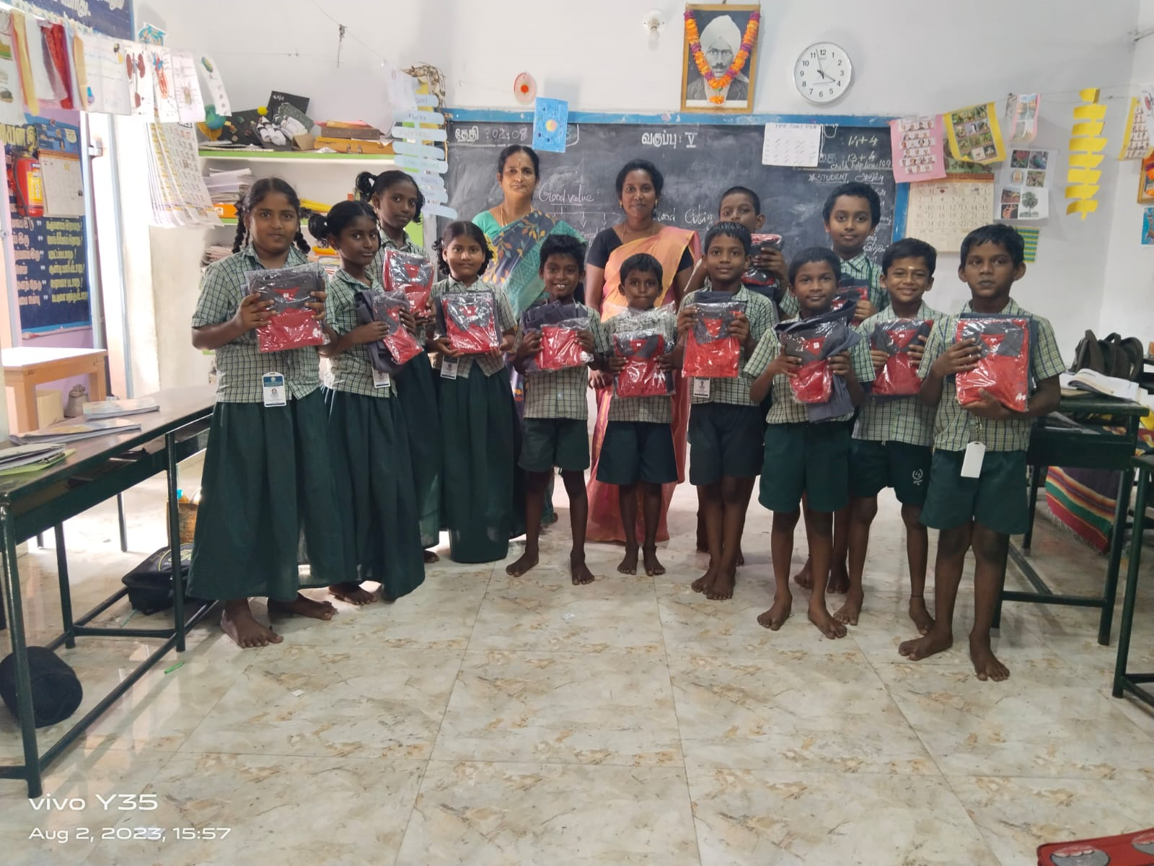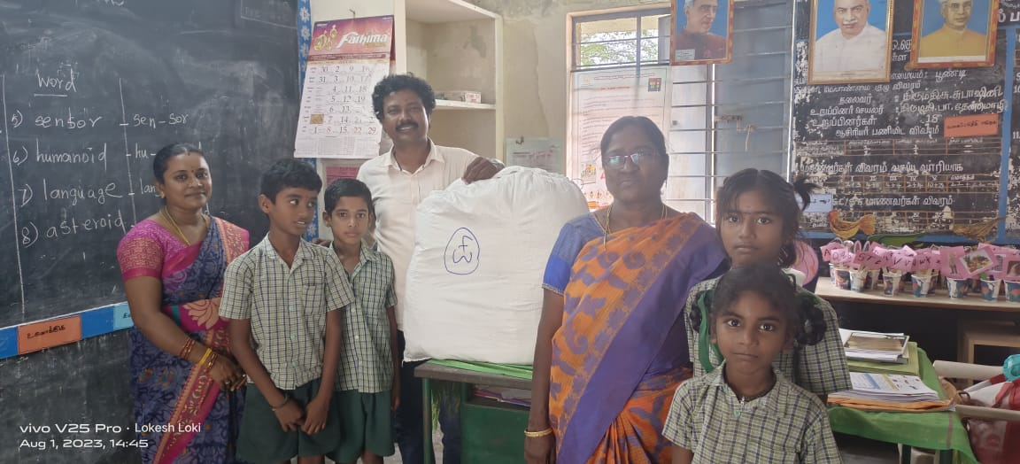
I was also there on Aug 3rd and 4th. I distributed the dresses to the children at the following schools: Kosavanpalayam, Kuppammal Chathiram, Gandhigramam and Thomur on Aug 3rd.

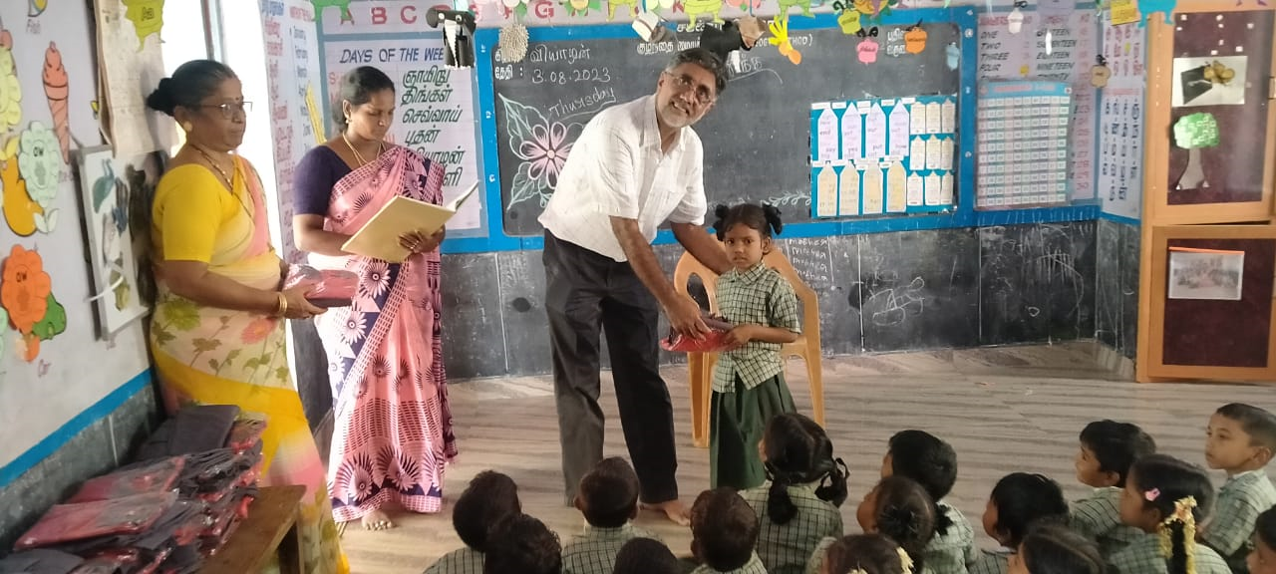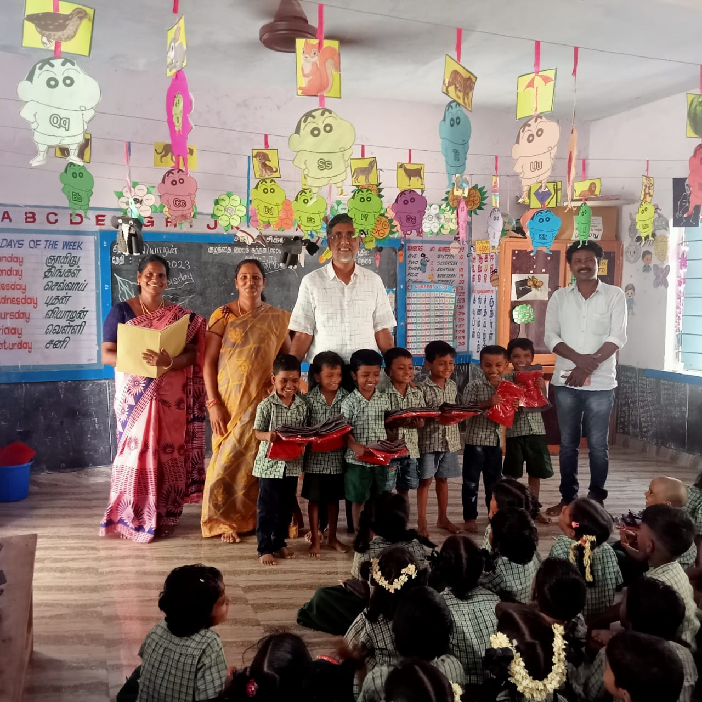

On Aug 4th the children at the following schools were wearing the dresses we had distributed. I also got to take a couple of group photos with them in their brand new dresses at Ammambakkam and Sadhurangapettai.
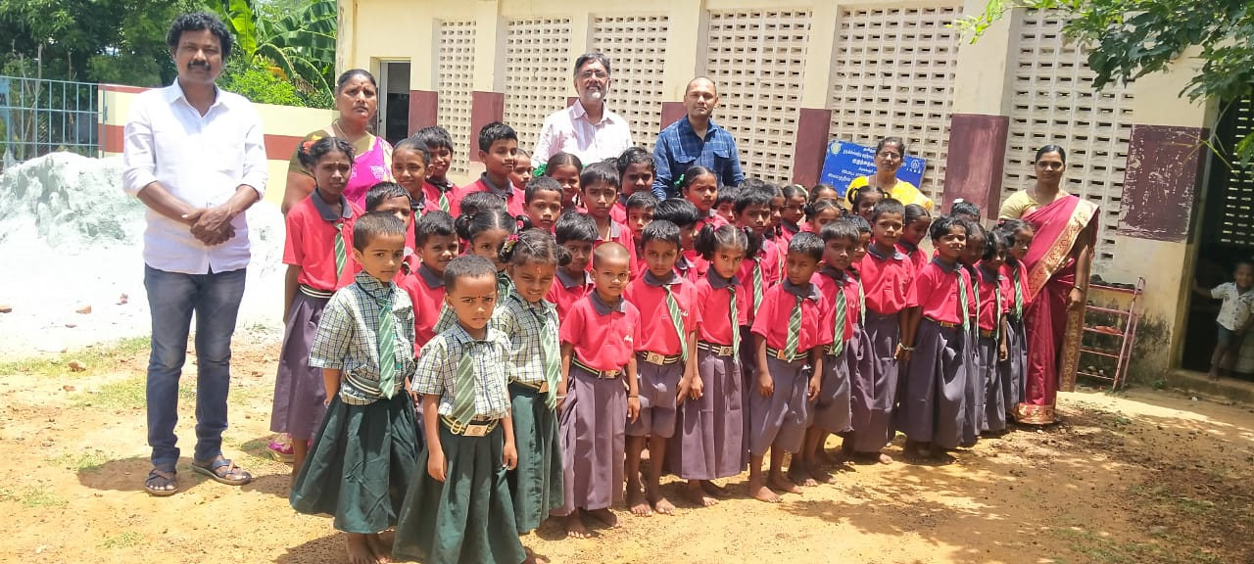

The distribution of the dresses to the children was handled by our teachers along with the government teachers till Aug 10th. They also posted several group photos of the children wearing these dresses.

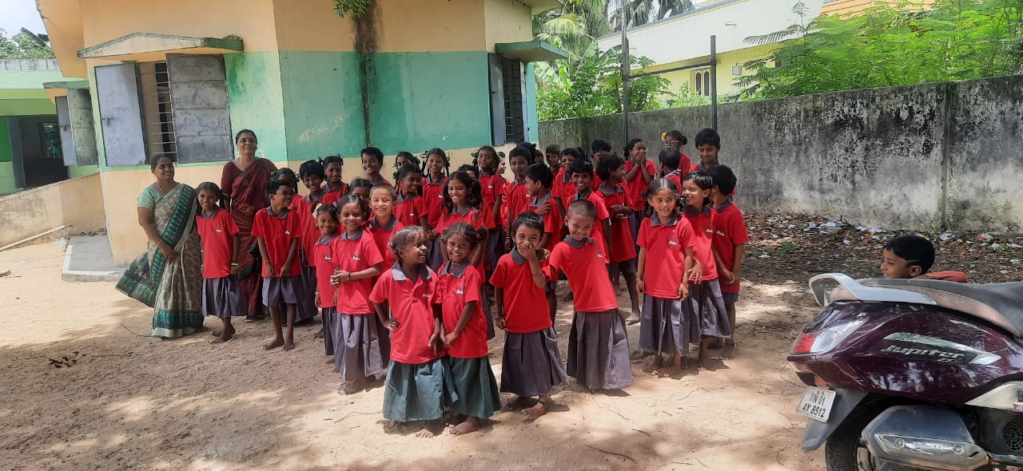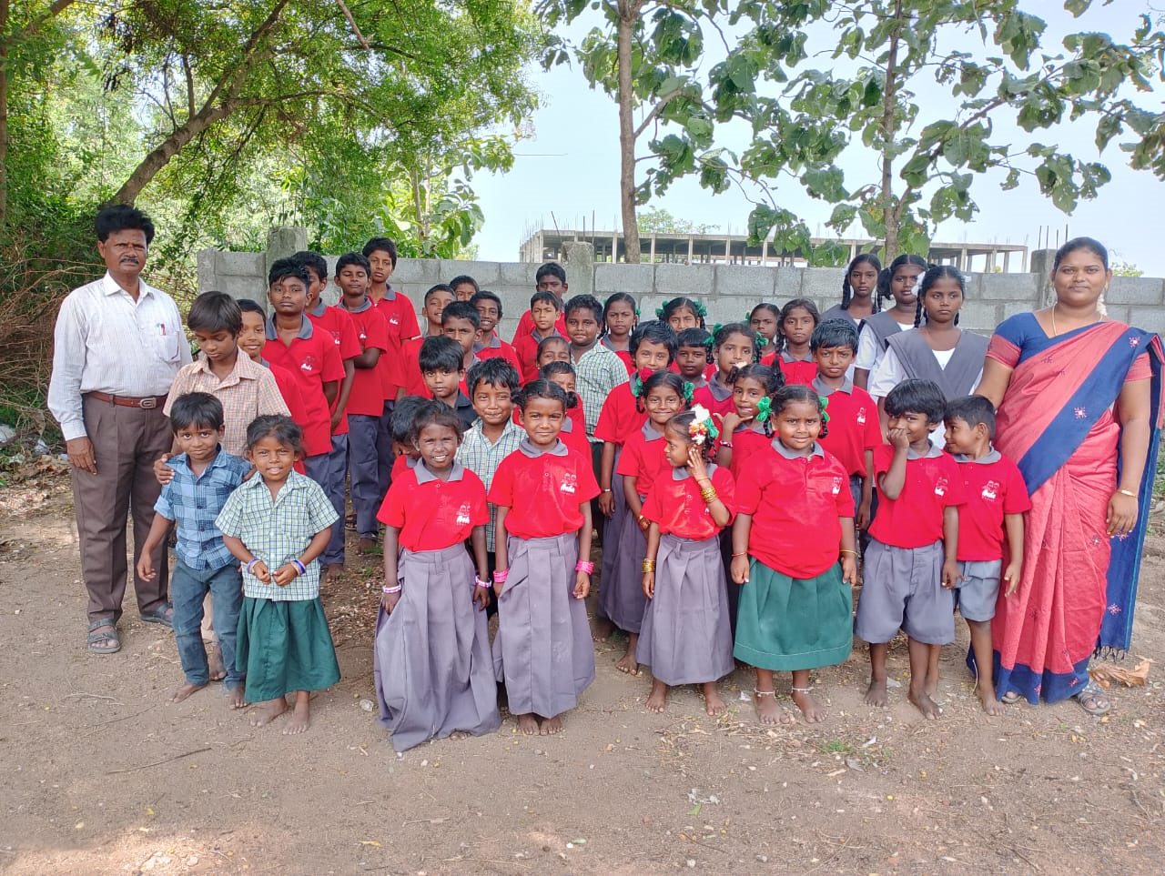

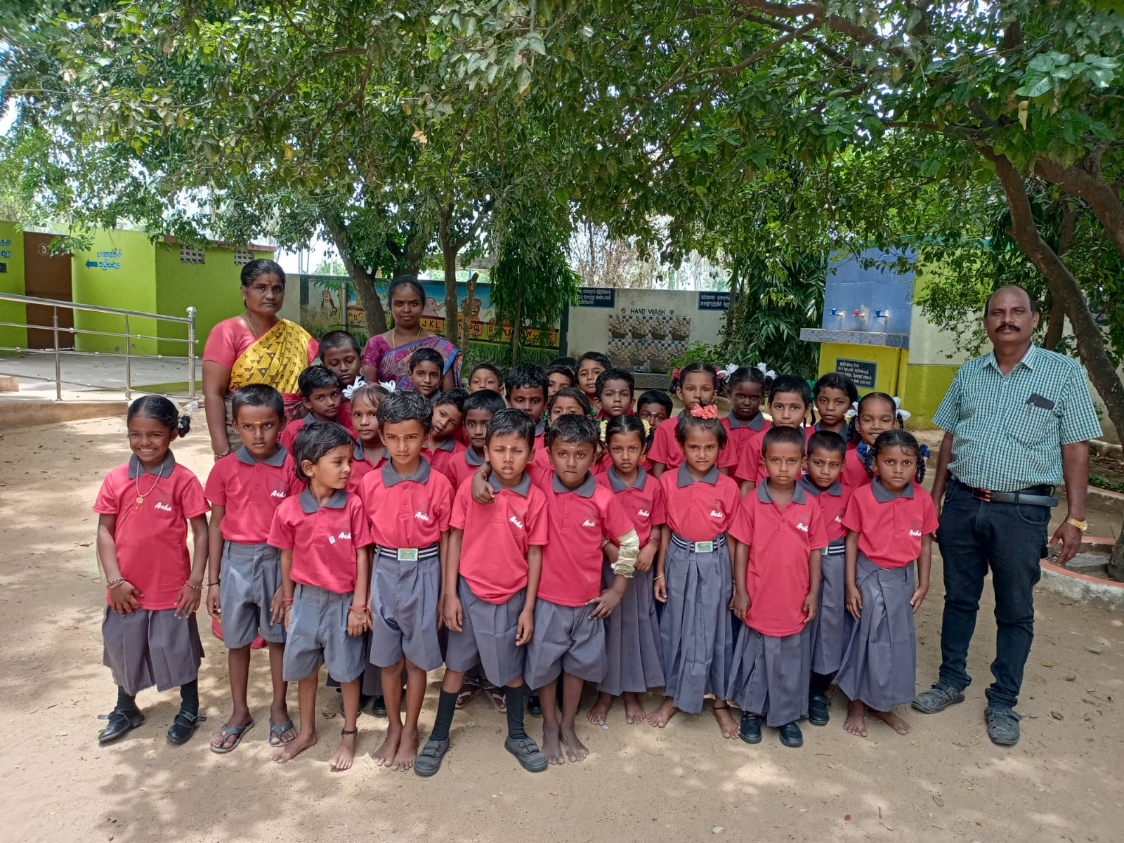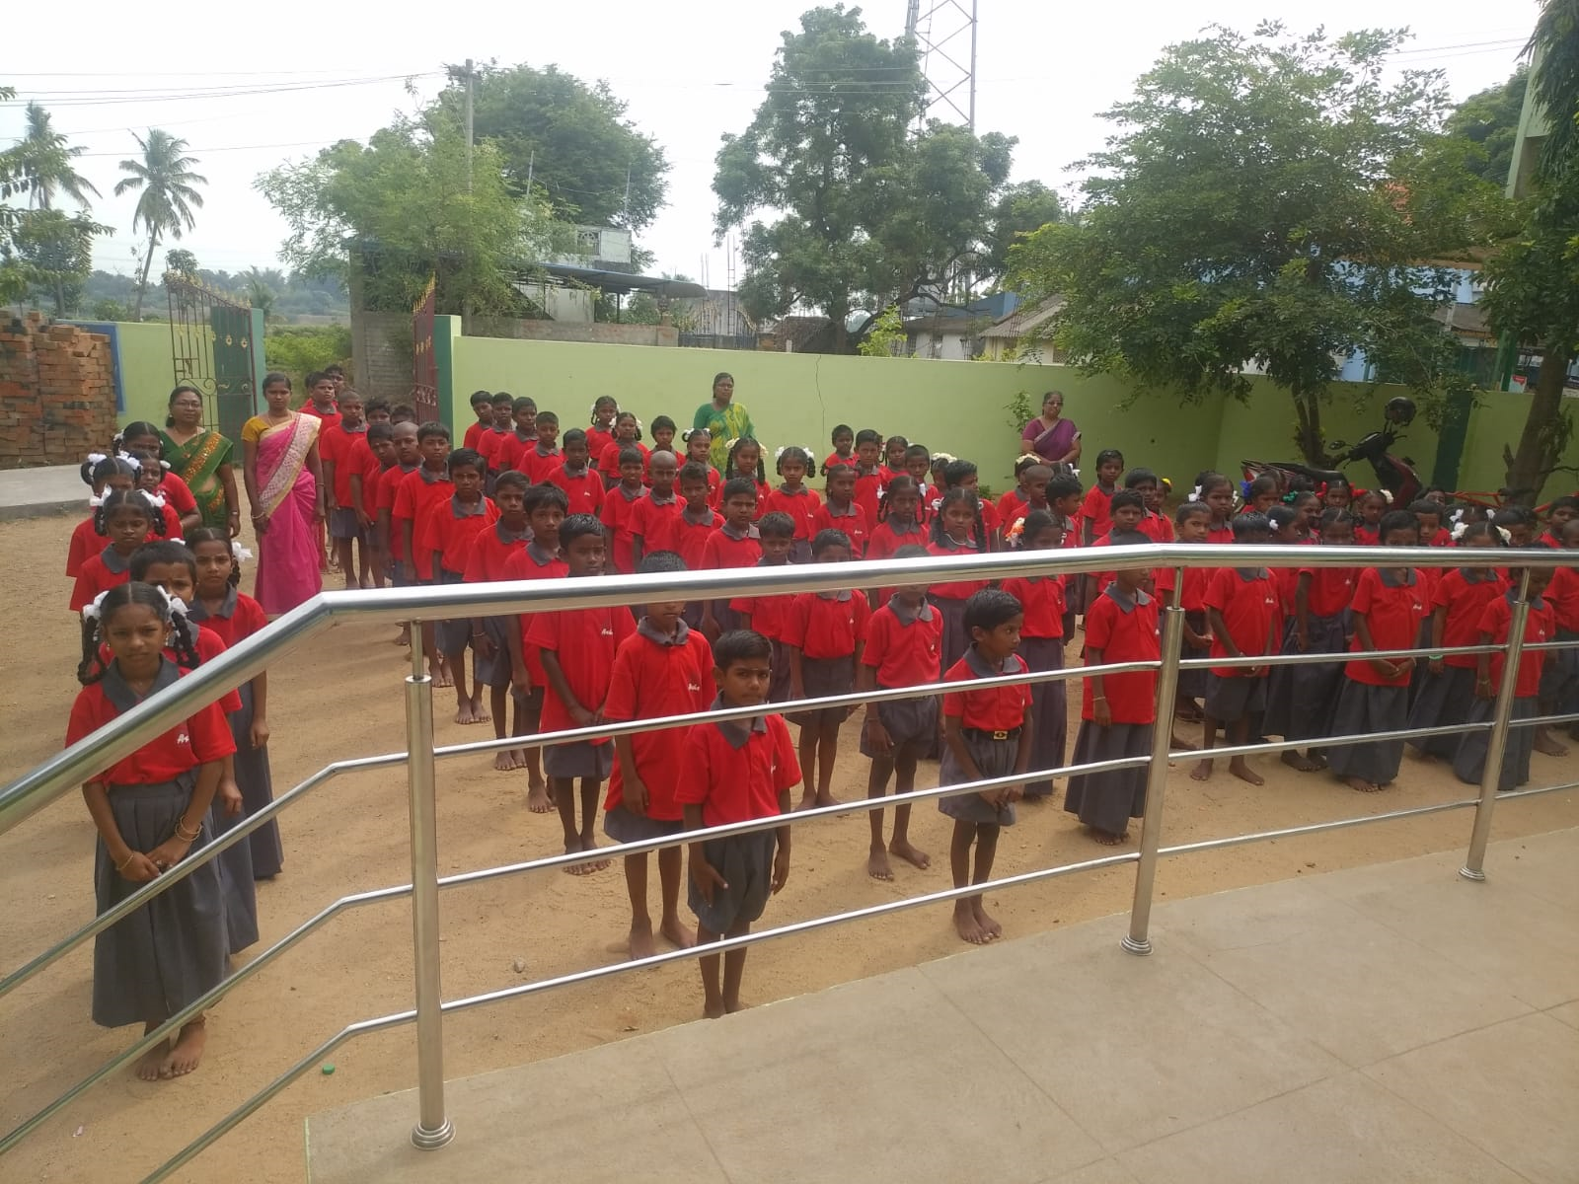

Feedback
The feedback on the dresses have been largely very positive. In personally talking to the children, they also liked the red colour T-shirts a lot. The schools have already adopted a schedule to include this dress as the uniform for one of the days. We are seeing that regularly in the KaradiPath classes and other photos coming from our schools.
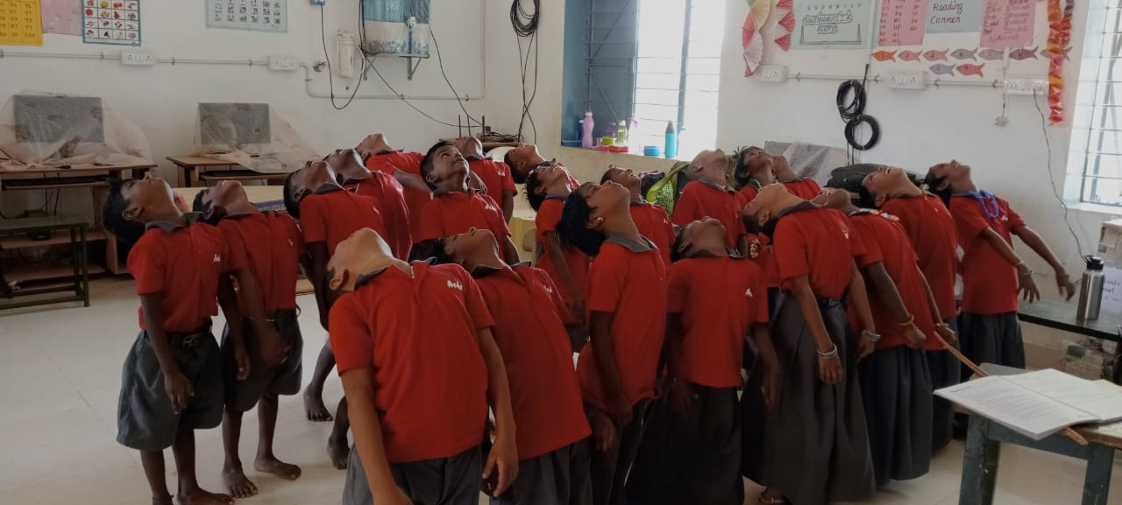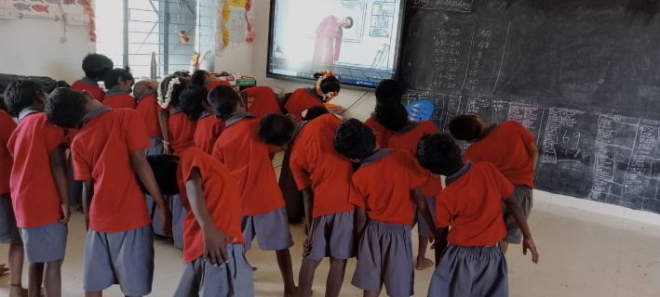
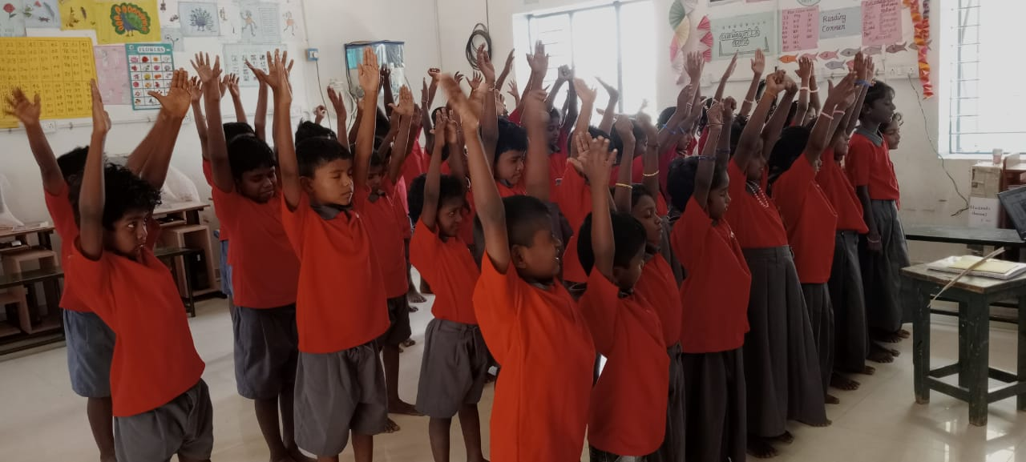
Couple of other points we have heard include,
- The skirts can be a little shorter. The initial set of schools that the tailor from Shanmuga apparel visited insisted that the skirts be long. I think Shanmuga Apparels also erred on the longer side (which only increases their cost).
- Some expressed the thought that track pants and sports shirts can be given especially for 6th to 8th boys and girls. We have seen these pants and shirts in the dry-weave kind of materials. But these are really not intended for wearing the whole day sitting inside a class on a hot day. We felt our choice would be better. Further in some of the places the HMs felt girls will not wear pants and T-shirt. Therefore, we had chosen the chudidhar set. This can be revaluated.
On the whole this was welcomed by the schools, children and parents as we had hoped.
Independence Day Celebrations

