**Proposal for KOLOTAN; Shaping Chaos Into Cosmos, a community school Project in North 24 parganas District**

By

Kolotan Trust

### GENERAL DATA

Name of the Organization : Kolotan

Mailing Address : Vill- Taraberia, PO- Padmalavpur, PS- Amdanga, North 24 parganas, West Bengal, Pin- 743126, India

**Mobile:**+91- 7605827070;

**Email**: [yourkolotan@gmail.com](mailto:yourkolotan@gmail.com)

Contact Person : Sujoy Sarkar

(Designation–Secretary)

Mob: 9674383824

Email: [sujoy.sarkar415@gmail.com](mailto:sujoy.sarkar415@gmail.com)

Organization’s Legal Status : Registered under…… Registration Rules 1962, Ara- III,

Govt. of West Bengal

Registration number : IV- 6763

FCRA Registration :RegistrationNo– 147111195

Income Tax Exemption for Donations :80-G and FCRA

PAN Card number : AADTK7350E

Project Title : **Kolotan; Shaping Chaos Into Cosmos**

Project Location : Santoshpur, MIrhati, Amdanga, 24 pgs (N)

Beneficiaries : Poor, deprived and vulnerable primary students in particular, and underprivileged residents of rural and tribal population in general

Grant requested : **Rs. 12,87,000 (Rupees Twelve Lakhs Eighty Seven Thousand Only)**

Time-frame for use of requested funds : 12 Months

Dreaming is an indication of liveliness. When it comes from the needs of society, it becomes the goal of life. And if people meet who dreamt the same, it makes an institution.

KOLOTAN is nothing but the dream of happier life for all, especially for children; the future society.

A few students of Teachers’ Training Course felt that the Educational system should be modified. The way of teaching should be more lively and enjoyable to the students. Then the students will be interested to learn and it will make them a good human being. Thus they must be able to form a proper democratic society for all.

Some people who were thinking the same, were agreed to support them and formed KOLOTAN. It means the chirps of many birds together.

**Vision**

A cohort of passionate educators inspired by Rabindranath Tagore's vision established Kolotan in 2019. They were driven by a shared urge to reshape education for rural children, aiming to nurture holistic growth in individuals connected to both their environment and global community.

**Mission**

* Education free from silos as far as practicable.
* Education intertwined with life, not a detached abstraction.
* Non conventional holistic education affordable for all sections of the society.

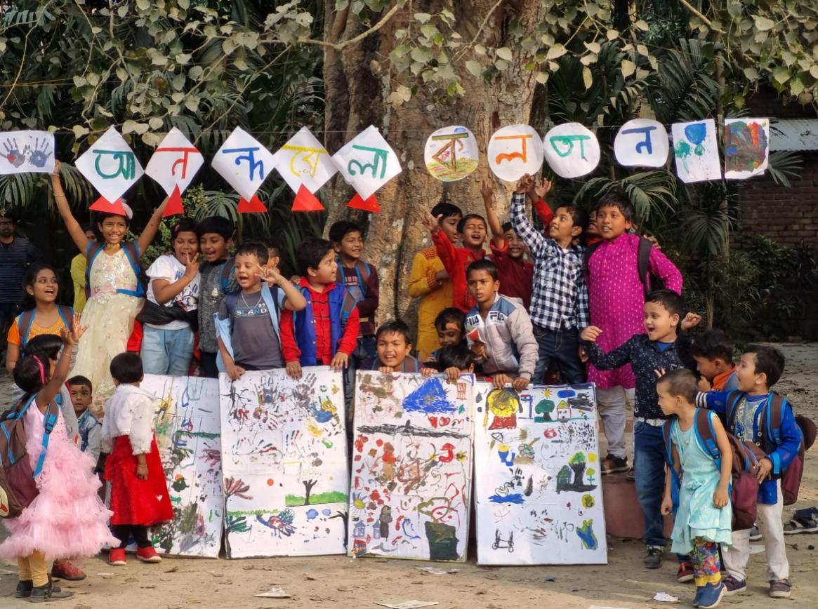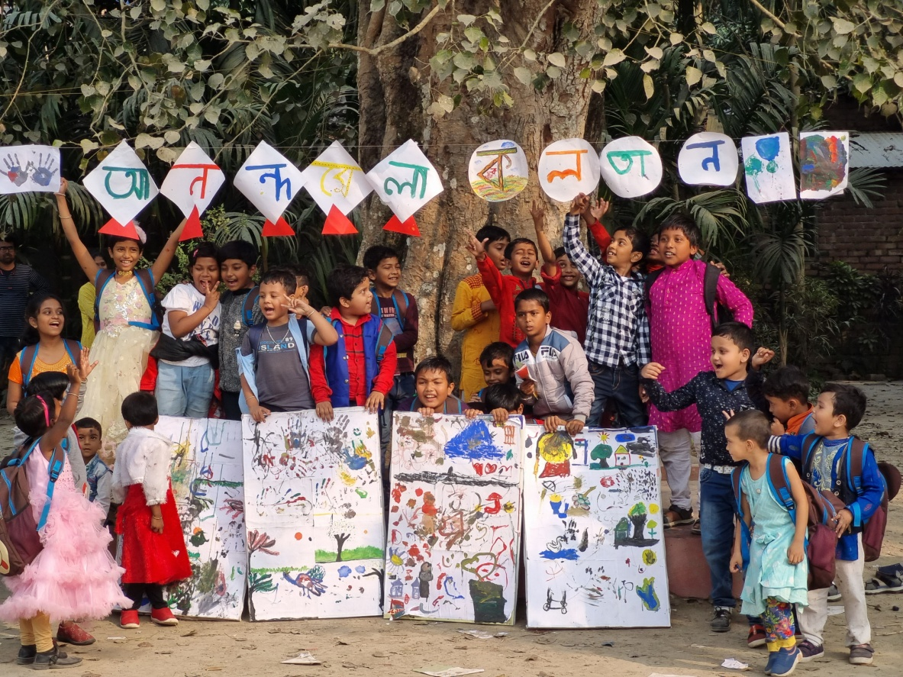

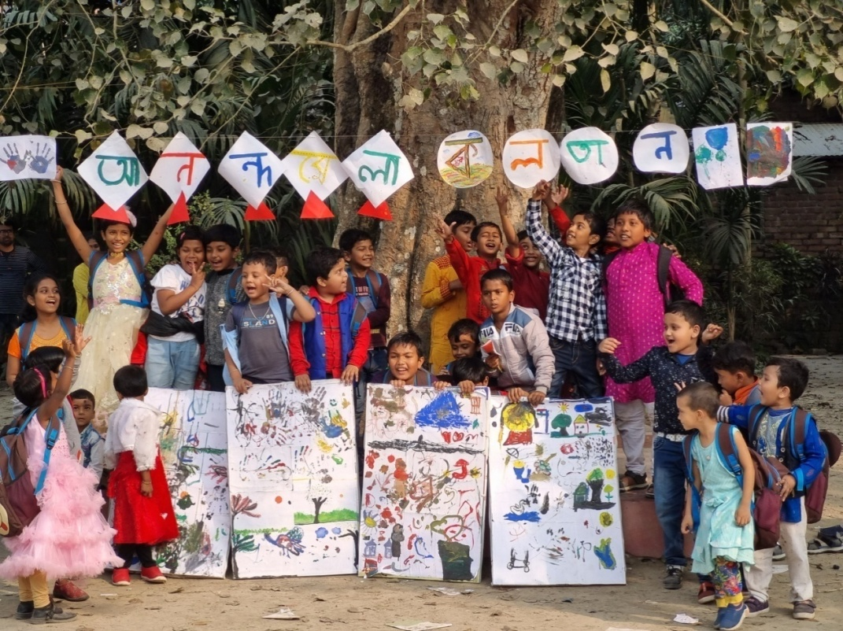

**Ongoing Projects**

1. **KOLOTAN; Shaping Chaos into Cosmos**

A Co-educational Community School

Vill- Santoshpur, PO- Mirhati, , PS- Amdanga North 24 Parganas

This is an institution for education and culture. Every child has innate potentialities and possibilities to discover and establishthemselves as an individual. KOLOTAN nurture and shape those probabilities which are in a scattered form to help the pupil sound own voice.

**Project Vision**

Our vision is to nurture each child to be a good human being in life.

**Project Mission**

* Help people develop love for learning.
* Provide a broad, balanced, personalized yet creative curriculum.
* To create an awareness among the learners of their social responsibilities and equip them with skills to adopt the changing needs of global environment.
* Help the students to grow high aspirations.
* Allow children to have a voice and make a difference.



2. **Haate Khori; Bhalobese shekhar Bornomalay:**

Vill- Santoshpur, PO- Mirhati, , PS- Amdanga, North 24 Parganas

A coaching centre for the students of class -I onwards to enjoy learning through different scientific way.

3. **Wings; Let your Dream Fly:**

Vill- Santoshpur, PO- Mirhati, ,

PS- Amdanga, North 24 Parganas

A coaching centre for the students to make English easy and happier. Also help the students to communicate with the outer world easily.

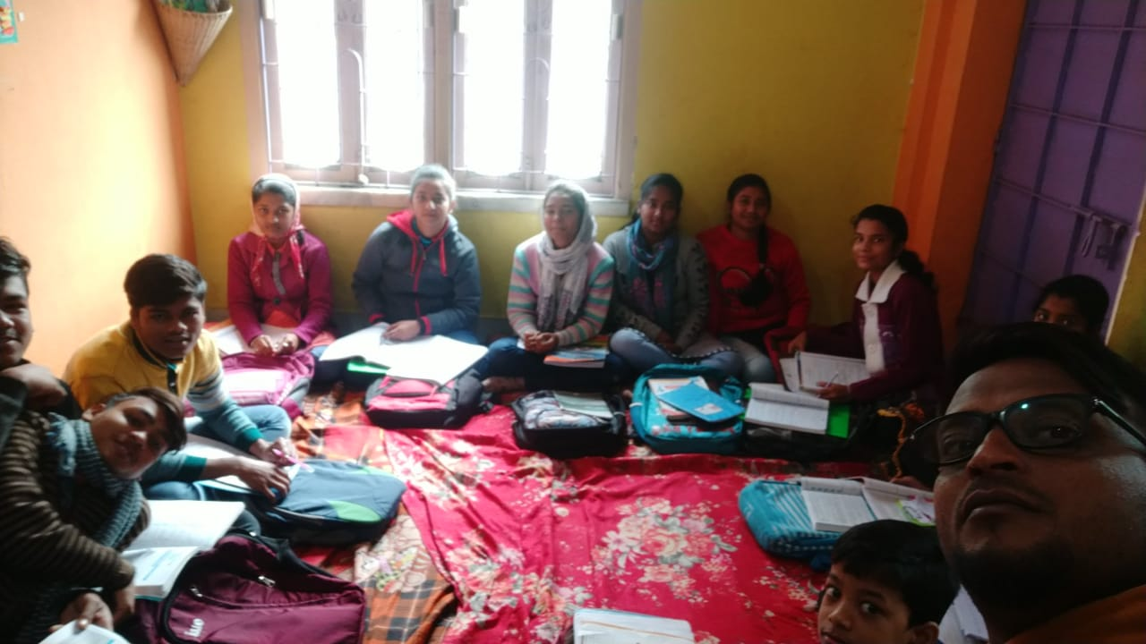

4. **Art Workshop :**

KOLOTAN organizes an Art Scholarship Competition every year. 10 students from three groups achieve the scholarship.

**5. Cultural events:**

KOLOTAN organizes many cultural events throughout the year.

**6. Awareness Program for Parents:**

KOLOTAN organizes awareness programs regularly for the guardians. It helps the guardians to nurture the children.

**7. Environmental awareness:**

KOLOTAN feels the need to aware people about the necessity of saving the environment. So that many environmental awareness program are organized by Kolotan.

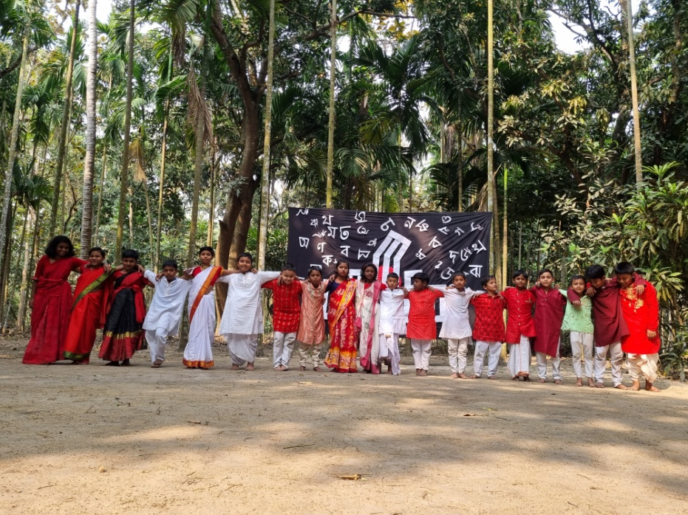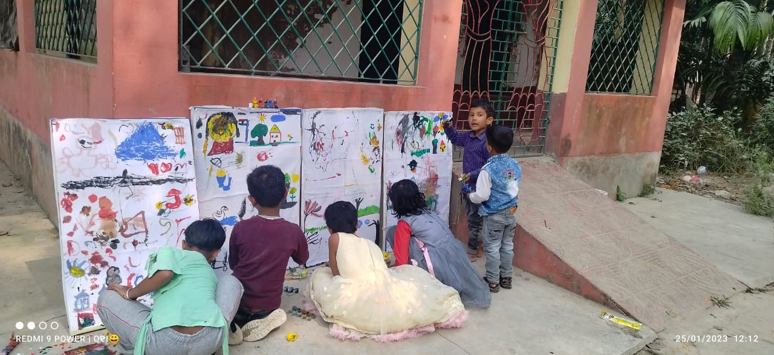

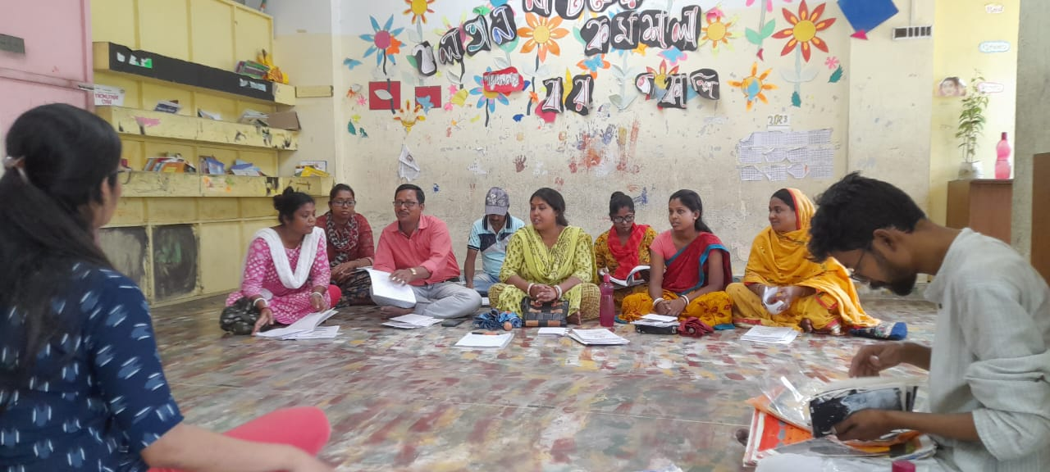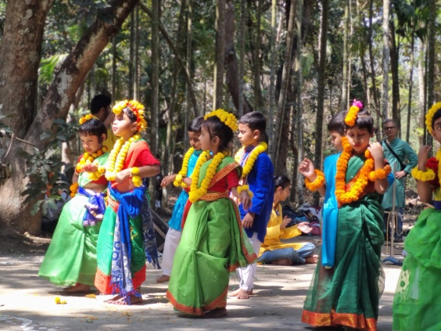

**8. Sumangali :**

Sumangali is a sister concern of the Kolotan Trust which strives to improve the living conditions of local women by providing employment to the local artists. Sumangali was built with the tripartite honorable ideas- the first being women empowerment in the rural area of Amdanga and its adjacent areas, secondly, to help revive the extant artforms native to the region, and finally, in order to sustain the whole process, to find and generate market for the products produced via locally sourced raw material, thus further contributing to the development of the local economy.

Mission:

* To research and identify local extant artforms.
* To find skilled artisans to pass on their skills to the next generation.
* To locate and educate aspiring artists, especially women, and provide them with the necessary skills to turn their passion into economically viable endeavors.
* To hold workshops and awareness programmes within the local low-income community to help empower them.
* To resuscitate the dying artforms for the next generation.
* To make a contribution to the local economic growth.
* To create a market for the unique handicrafts of the region at a competitive market value.

Vision:

* To ensure that the unique handicrafts and skills don't die away with the passing generation.
* To ensure that women empowerment takes place in a sustainable way.
* To establish a market for these niche products that are held at a higher esteem.
* To provide livelihood for passionate skilled and artisans.
* To establish a sustainable development of the local economy.

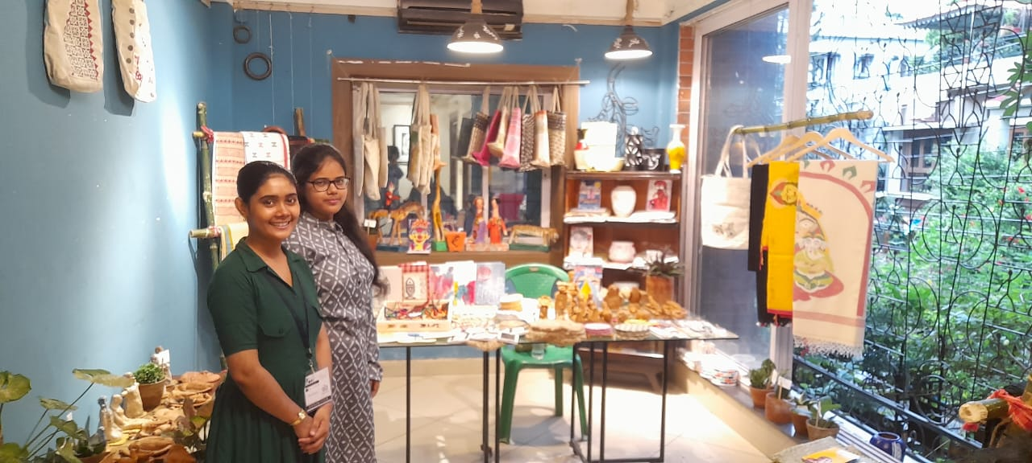

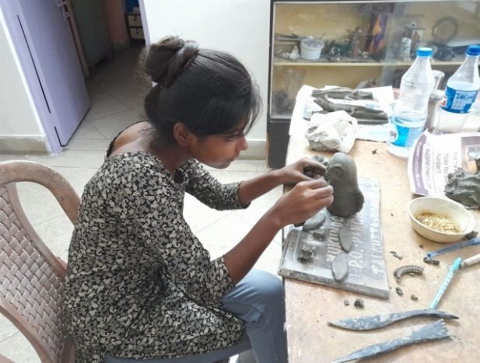

**Why different**

Kolotan is a space for children to give expression to their imaginations and encourage free thinking. Kolotan intents to offer thoughtfully designed quality education to children from diverse background.

Following are the features that make Kolotan different from others educational institutions:

* In Kolotan children are always free to ask questions and provided enough flexibility to choose their work. Hence classes are not very structured.
* Kolotan does not believe in compartmentalizing different subjects and interweaves them effectively to ensure joyful learning. Art, craft, music, clay modeling, language, math and science are interwoven with equal importance.
* Children learn to connect with nature routinely rather than occasionally.
* Kolotan strives to connect discussions in class with daily life situations, seasonal changes and social awareness.
* To address the issue of mental health the teachers in Kolotan are in constant touch with the families of the children.
* Children of senior classes are often given the responsibility of taking care of their juniors to create a good bonding among different age groups.

Kolotan ensures children to be self- reliant without imposing any regimentation on them.

* The teachers/facilitators regularly assess the children but grades are not awarded as Kolotan does not encourage competition .A detailed report on the child's overall development is given to the guardian twice a year.
* The fee structure has been kept low to make it accessible to marginalized children too.
* **Target group:** Students of class Play Group (3 yrs) to Class V (10 yrs) from 8-10 km radius come to join the classes. We are promoting a new class every year. It will be till class XII.

**Venue-:** Rented building

* **No. of students-:** 85 students
* **No. of Teachers-:** 13
* **Time and Days-:** 10:45 in the morning – 4:30 in the evening for 5 days a week

**Grant Request:** We are requesting the following funding from Asha for Education, Danbury Chapter to partly fun our expense for the school staff, parents’ awareness program and Annual Book purchase. This fund will greatly benefit Kolotan for a sustainable future.

|  |  |  |  |  |  |  |  |  |  |  |  |  |  |
| --- | --- | --- | --- | --- | --- | --- | --- | --- | --- | --- | --- | --- | --- |
| 2025-2026 Fund request for Kolotan from Asha for Education, Danbury Chapter | | | | | | | | | |  | | | |
|  | | | |  |  | | | |  |  | | | |
|  | | **Item** | | **Quantity** | | | | **Months** | | | | **Monthly** | | **Annually** | | |
| 1 | | Rent for the school premise | |  | | | | 12 | | | | 20000 | | 240000 | | |
| 2 | | Electricity bill | |  | | | | 12 | | | | 2000 | | 24000 | | |
| 3 | | Staff Salary | |  | | | |  | | | |  | |  | | |
|  | | Pre Primary Teacher | | 2 | | | | 12 | | | | 10000 | | 240000 | | |
|  | | Primary Teacher | | 1 | | | | 12 | | | | 10000 | | 120000 | | |
|  | | Math Teacher | | 1 | | | | 12 | | | | 15000 | | 180000 | | |
|  | | Geography Teacher | | 1 | | | | 12 | | | | 21000 | | 252000 | | |
|  | | Attendant | | 2 | | | | 12 | | | | 6000 | | 144000 | | |
| 4 | | Awareness programme for parents | | 1 | | | | 1 | | | | 2000 | | 2000 | | |
| 5 | | Annual Book Purchase | |  | | | |  | | | |  | | 25000 | | |
| 6 | | Drinking Water in drums | | 100 | | | | 12 | | | | 50 | | 60000 | | |
|  | |  | |  | | | |  | | | |  | | 1287000 | | |
|  | | | |  |  | | | |  |  | | | |
|  | | |  | | | |  | |  | | | |  | | |
|  | | |  | | | |  | |  | | | |  | | |
|  | | |  | | | |  | |  | | | |  | | |
|  | | |  | | | |  | |  | | | |  | | |
|  | | |  | | | |  | |  | | | |  | | |
|  | | |  | | | |  | |  | | | |  | | |
|  | | |  | | | |  | |  | | | |  | | |
|  | | |  | | | |  | |  | | | |  | | |
|  | | |  | | | |  | |  | | | |  | | |
|  | | |  | | | |  | |  | | | |  | | |
|  | | |  | | | |  | |  | | | |  | | |
|  | | | |  |  | | | |  |  | | | |
|  | | | |  |  | | | |  |  | | | |
|  | | | |  |  | | | |  |  | | | |
|  | | | |  |  | | | |  |  | | | |
|  | | | |  |  | | | |  |  | | | |
|  | | | |  |  | | | |  |  | | | |
|  | | | |  |  | | | |  |  | | | |
|  | | | |  |  | | | |  |  | | | |