Pathri (Haridwar) Site visit report 25th August 2004 (Wednesday) by Mehar (Asha Munich).
mehars@gmail.com, 49 89 66655421 (H), 49 1782014396 (M)

The site visit to pathri was done on 25th August and was announced at a short notice. Friends of Doon were aware of my visit to Pathri in August but we never gave them the date of the site visit. On Saturday 20th August I called Mr. Sameer Ghosh for the first time and informed them of my visit on Monday. His first reaction was its too short a time and if possible I should visit the school next weekend. For me it was not possible and gave him 3 days window and he agreed for Wednesday (25th August).

My second call to Mr. Ghosh was from Almora on Tuesday to inform my arrival time in Haridwar. Mr. Ghosh did some arrangements and asked the headmaster of school Mr. Manwal stayed overnight in Haridwar to receive me. I reached Haridwar at 7:30AM and we took a taxi and reached the School at around 10:00AM. Pathri is around 25 km from the Haridwar main station. I was in the school for three hrs and interacted with headmaster, teachers and students from most of the classes.

I reached Haridwar with the impression that Gujjar’s are tribal community who are poor and are not integrated into the society, they are not mannered; don’t know the importance education, etc. My first impression was that whole of the set up where Gujjar’s are rehabilitated is quite modern in terms of the construction of houses, school building, access to electricity, animal shelters, grocery shop etc. What I came to know from after some interaction is that they use to live in forest and most of the families had the cows and buffalos in large numbers, many of them with 80-100 cows. They use to survive by selling the milk to the cities and had decent amount of exposure from city life. After rehabilitation government gave them big houses and some acre of land which according to them is not sufficient for the large no. of animals and because of this most of them are now left with few (5-10). Either efficient administration or active role of NGO is important in teaching them new methods, technical knowledge on how to survive on agriculture and sustain same number of cows (50-100). FOD is involved in giving them some kind of training from Hisar Agriculture Institute and some dairy institute in Haryana. They did it once and are planning to do it more frequently so that Gujjar’s are learn some skills and sustain themselves in much better way.

We know that Indian society has too many divisions and I found this setup classical example of the divided. At one hand we have Indian Government, other hand we have highly educated sincere dedicated people in FOD who can be easily put into upper middle class. The third is middle or lower middle class who are headmasters and teachers involved in the school. The last one are the Gujjar’s who according to most of the above are tribals, never exposed to cultured life, are uneducated etc. I found this divide to be the serious problem in the functioning of the school and other activities for Gujjar’s. FOD is based in Dehradun and the school is 120-130km away in Haridwar. FOD makes the visit to school 2-3 times in a month and most of the day today activities are in the hand of Headmaster of the school. FOD interacts with the state government in Dehradun and running around and administrative work is handled by the Headmaster of the school. He is a key/nodal person in implementing the most of the ideas or work of FOD. Other thing is he is the only source of information to FOD and this makes him quite powerful and can have serious implications if he decides to do some thing wrong. Other impression I got during my couple of hours stay is that Mr. Ghosh does not take much interest in day today activity or rarely get himself involved in the local problems. Point to not is Mr. Ghosh is 75 years old and he is not the main person involved in the school. Other person from FOD XYZ is more involved in day today activity or is mainly responsible for the school functioning. He was not in Dehradun so could not meet him.

Other thing which I noted is Mr. Ghosh commands very high respect from the Gujjars community and they told me everything is running because of him. He came to school at 12:00 and lot of Gujjar’s came to know he in school and in few minutes large number of them gathered with there problems and wanted to have discussion with him. Other interesting thing I noticed is that headmaster has little respect from the community and headmaster also does not give much respect to the community from the beginning of my trip I found him making statements like they are uncultured, uneducated don’t know this, don’t know that etc. This is not surprising in Indian context but is important if Asha is involved. We should look into that the persons working with some community should not underestimate, under evaluate, and demean the people whom Asha is supporting.

About the headmaster

It’s important to write few things about him because he is the key person in running the school and plays most important role in the successful running of it.

Few of the observations

- He is retired headmaster from government school whom FOD hired for functioning of the school
- He stay in the Gujjar’s colony on weekdays and visit home on weekends
- He is nodal point between community and the FOD
- Handles the administrative work of the school, runs around in government department to get work done.
- Runs the school, decides the curriculum, activities of the school.
- Found him to be typical government headmaster who is doing decent job what FOD asks him to do
- Suppose to interact with families to convince them to send kids to school

As he is key person he is very crucial person for the running of the school and shaping the environment and implementing the ideas of the Asha and FOD.

- My impressions if headmaster is more socially aware he can make good impact on the community and can achieve 100% literacy in the community.
- Can make sure that every kid get education which is just not remembering some tables but develop more into confident, high esteem individuals.
- As he is old man who did teaching in government school few of the things implements by him in the schools are

Child beating: Its not just simple beating its quite serious and it happened in front of me with kid of class one who is just 4-5 years old. The beating was not normal one or two slap but good hard hitting from the teacher for few minutes. We should make sure that this practice is stopped immediately

No sports activity in the school: the idea of the headmaster is why sports, when I emphasizes the importance then he said we are doing to and this is the ground where they play. He insisted that students play but when I asked him the groud is full of long grass where they play he had no answer and he said we are thinking of introducing one class in a week. Asha should insist on introducing 3-4 class of sports in a week and we should make sure that girls learn bicycle etc.

- Other things which are common to any government school is high drop out rate, low interest/motivation in kids, rote learning, dull restrictive environment.

If some how teachers/headmaster/FOD make effort to improve the quality of education my personal believe is drop out rate will reduce, kids will enjoy it, and school can be an extended family of the community. They should put more effort to increase the day today participation of the community in the school. Currently one teacher is from the community

Other things to note

- In Uttranchal government is much more efficient and less corrupt if you compare with other states in north India.
- Government has done quite a good amount of work like every kid is getting Rs 150 per month as scholarship. Government has started giving the books to the school (still not to all classes).
- School is in need of more space for the classes. Some of the classes are divided into to accommodate all the classes
- FOD should push government to implement the Mid day meal scheme.
- FOD should push the government to build some more rooms and personally I think Asha should not fund it.
- Some of the teachers are qualified to be teachers means they have degree.
- FOD is already working with government to transfer the school. If govt take over the school then what will happen to the teachers and what is the best strategy needs to be discussed.
- FOD made a point that financial year from them starts from March so money transfer should be done in keeping that in mind. If transfer is not done with that they find it difficult to spend the money in same financial year.
- Asha should spend more money to give training to teachers. They should learn the modern way of teaching and should be sensitized to the cultural issues so that they don’t fall into trap to demean the kids.
- As the administration is good and responsive Asha should get out of the project asap. Tome frame can be from 1.5 years to 3 years.
- While transferring the school to government Asha and FOD should get into agreement to have say in the day today activity of the school. Asha and FOD should be in the some body where the suggestions from us are taken care by the government.
- Asha should not come of the school completely. What I mean is we should stop funding it but should have some kind of vote on new issues and ideas or major changes in the school. This needs details discussion with FOD and government.

Finally

- It’s a good effort from FOD who worked with the government to looks into the problems of Gujjar's and worked as mediators to solve the problems faced by the community.
- Good effort from FOD who took lot of interest to establish the school and are successfully running the school for many years.
- Effort of Asha especially Silicon Valley chapter is also appreciable as without the support of Asha the school may not be have been a reality.

Well spent money, a successful project but more involvement from Asha is required to improve the day today functioning.

I have missed some of the points in the report when ever you have meeting to discuss the project just give me call I will explain the things in more detail. If you have some questions just drop a mail or give me call

Some of the photographs

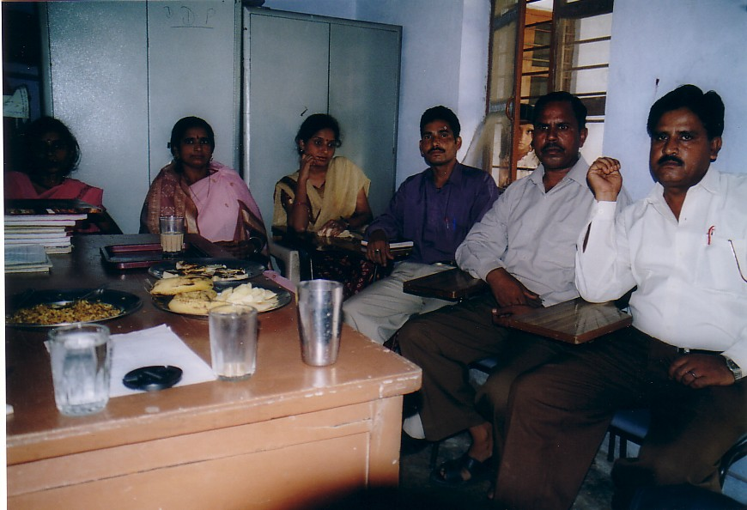

Teachers from the School

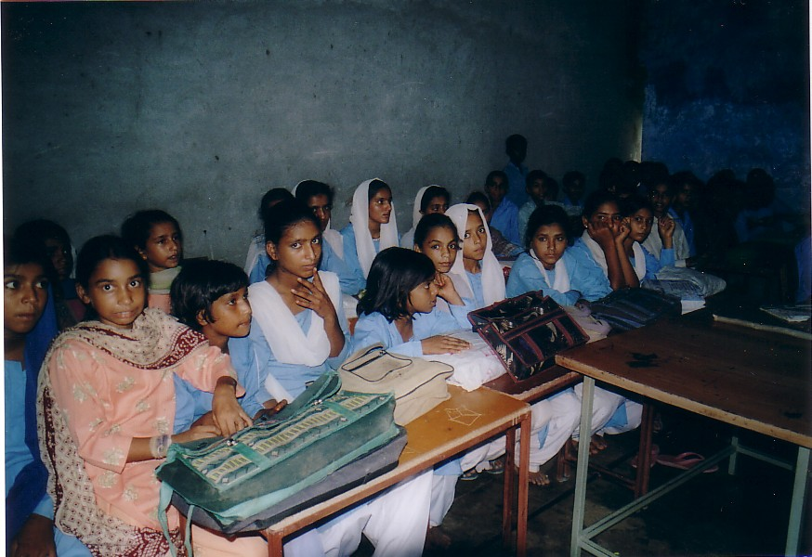

A class can see the partition of the class with cemented wall

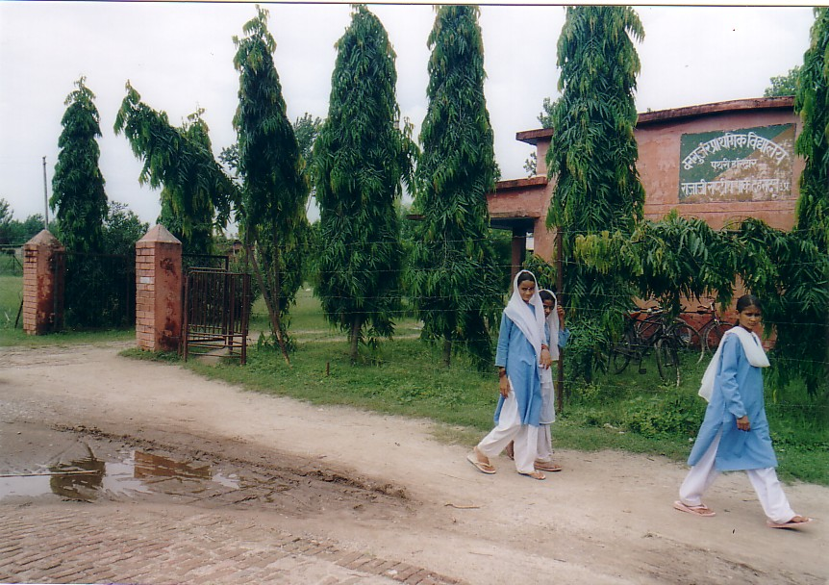

Entrance of the school

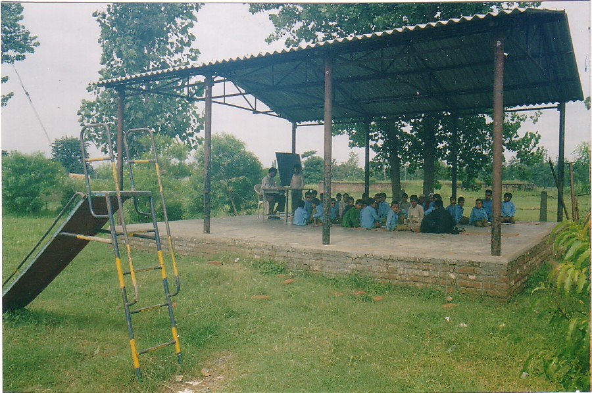

Class one in shade (school is short of rooms)

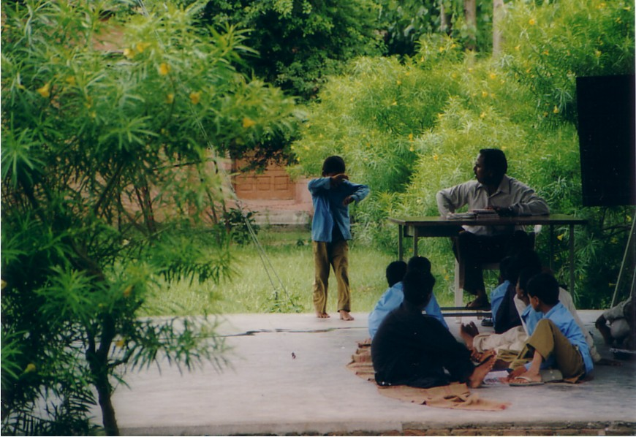

Child beating class one

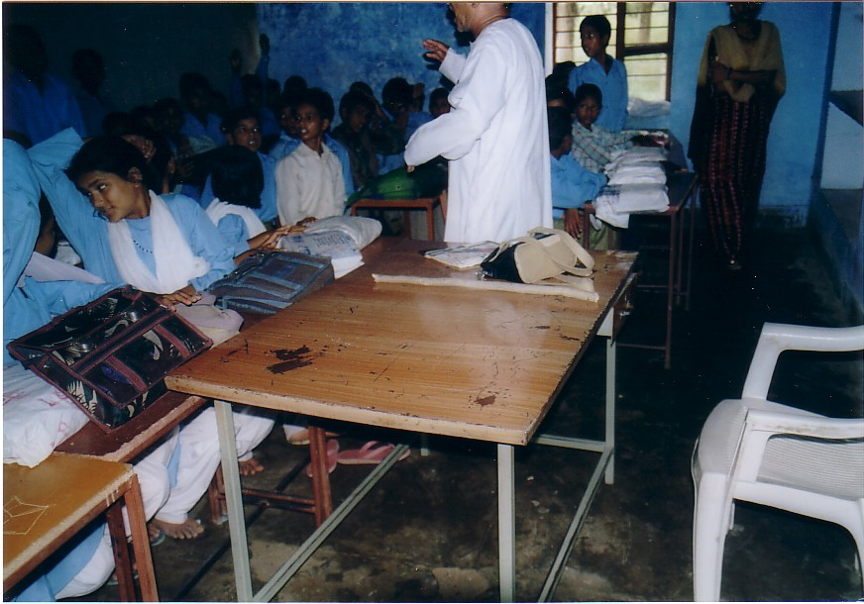

Fear is standard technique to control children

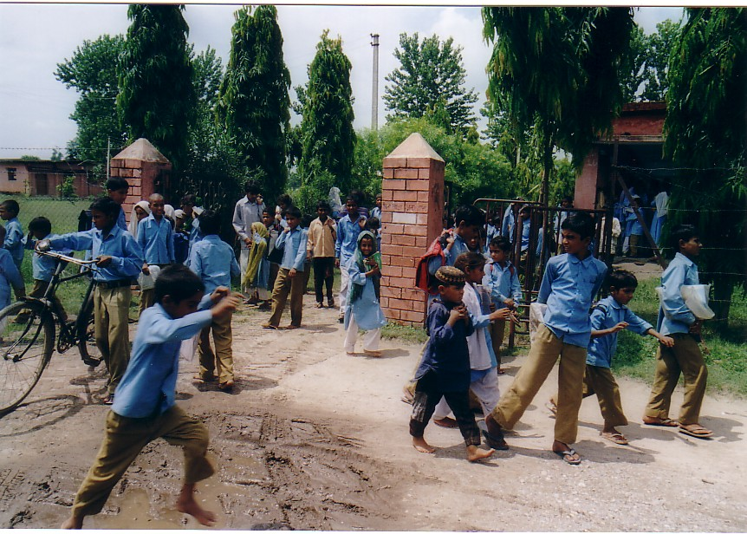

Freedom from the School

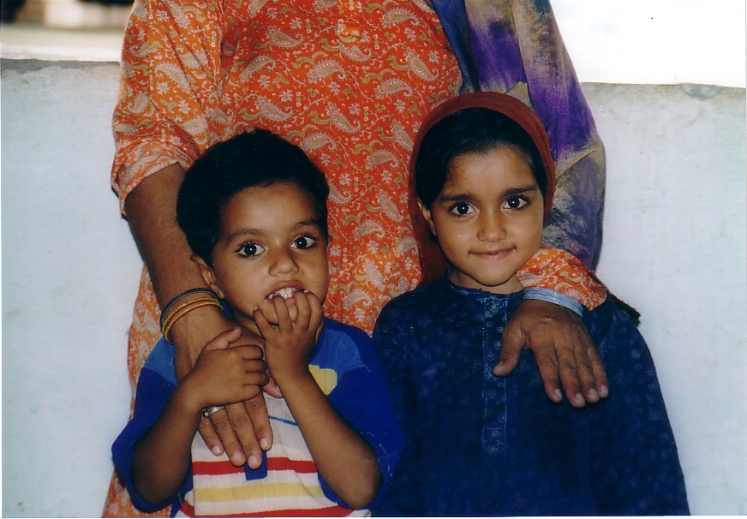

Many kids not in school

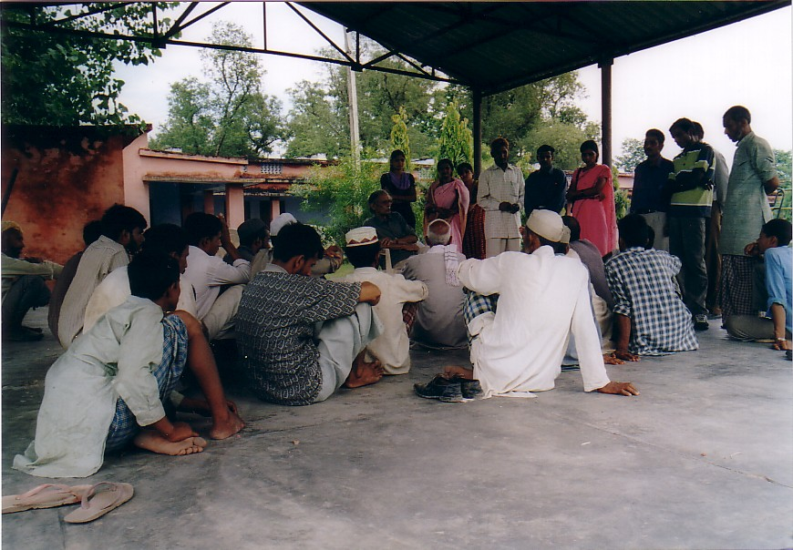

Gujjar’s with long list of complaints: Mr. Sameer Ghosh in the centre

