Asha Greater Kansas City Chapter Covid Relief support Proposal

Project Name: Sirisha Rehabilitation Centre | Date Received:
Referred By: | 01/22/2020

 | Project Contact Information | Asha Contact
Name | Mr. M.SOMESWARA RAO | Raji Muppala
Contact | 011-91- 9441413161  9397646210
Address | Sirisha Rehabilitation Center  D No: 3-57, Veerankilock,  Pamidimukkala,  Krishna Dist., Andhra Pradesh,  Pin Code – 521250 | Kansas city Chapter
Phone | 011-91- 9441413161  9397646210  C
Fax
E-mail | srcpamidi@gmail.com | rajichavali@gmail.com

Sirisha foundation supports children with intellectual and development disabilities (CWIDDs). Currently got 2 centers at Vuyyuru, and Veeronkilock, Krishna Dist. A.P.
Early invention center for kids ages 0-6 and Special School cum Vocational Training Centre at school follows the pattern of Special Education as designed and approved by Ministry of Social Justice & Empowerment, Government of India, New Delhi. In both the centers support 120 kids.

Sirisha team provides service to 25 children at their home who unable to come to their school. This project is funded by Asha for Education (Chapter: Kansas City)

Sirisha team served food to 25 elderly people during COVID crises. Asha for education provided funds to support elderly people. This is the proposal to continue the support elderly people for the month of February and March 2021.
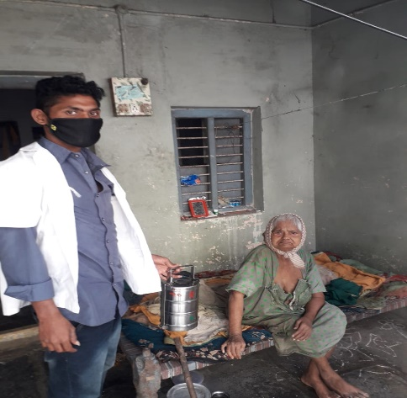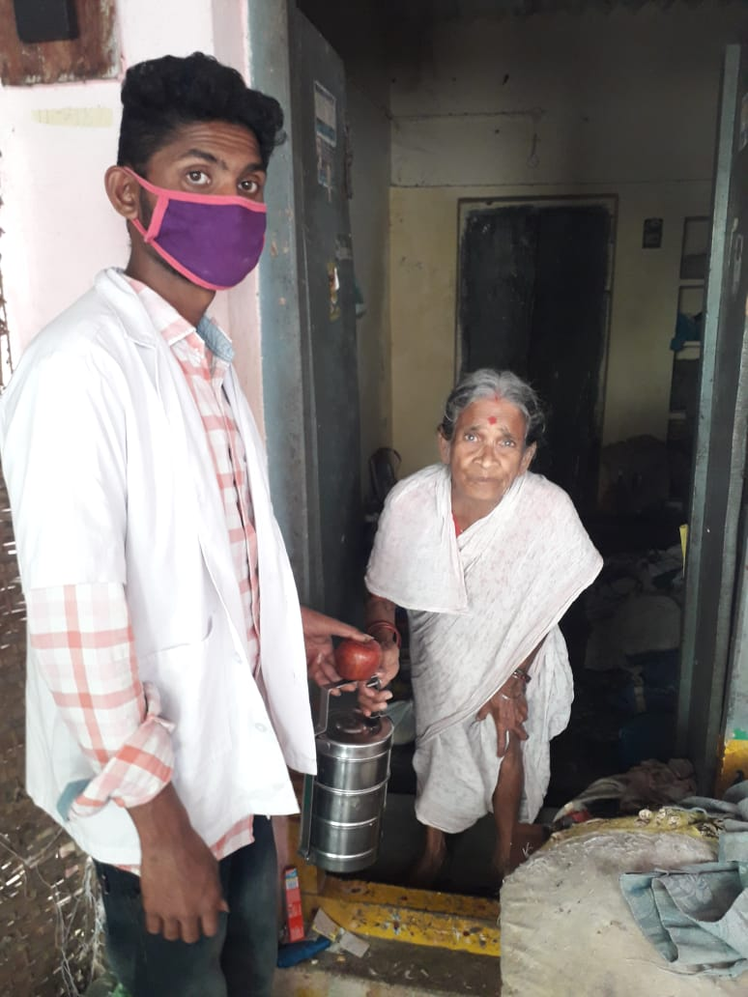

Proposal is to provide food for 25 people @ ₹ 100 per day per person for the month for Feb and March 2021 , total amount of ₹ 1,50,000.

Number of people | Cost per day
25 | ₹2500
Total amount to serve 25 people for 60 days | ₹ 1,50,000

