Report for the period from August 2019 to January 2020 at Rajatalab Sangamam.

With the objective of providing computer knowledge to the students in Government primary schools, ASHA Trust aligned with schools in and around Rajatalab to impart computer education to children. In addition in all schools our Computer teachers teach them some Maths, English and General Knowledge using GCompris and other tools. We are currently working with 6 primary schools. These schools were picked up after understanding their needs and the number of students in each school.

A brief about the activities in each school is summarized below.
Harsos Primary & Higher Primary School - strength of 742 students:

The program of computer education in Harsos Primary School commenced from January 2019. Ajay our ASHA teacher is working as a computer teacher here. Initially he worked 3 days a week from August to December 2019. Children were given computer education, but beginning from January 2020 every day of the week computer education is being taught to children here.Computer education commenced in Higher Primary school ( Stds VI to VIII) in January 2020.
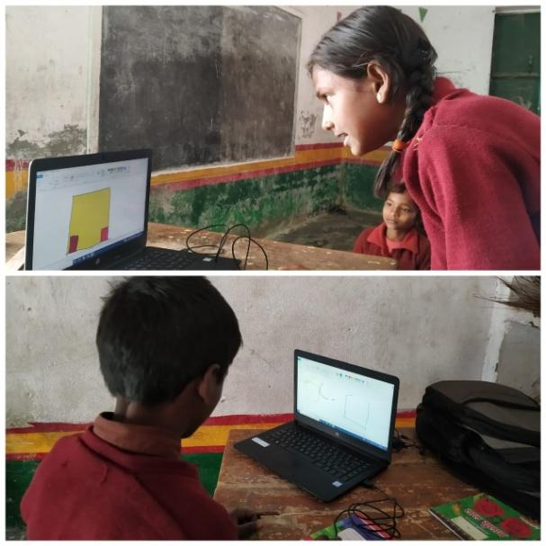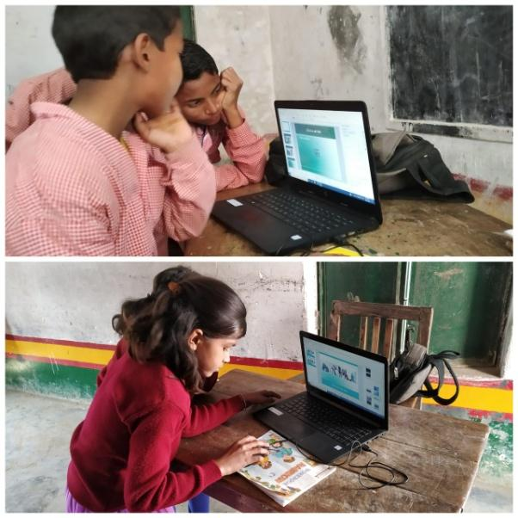
(Hands on experiences for the children help them understand concepts better.)

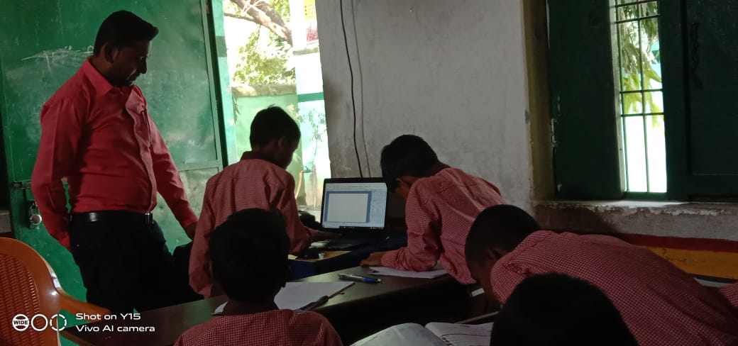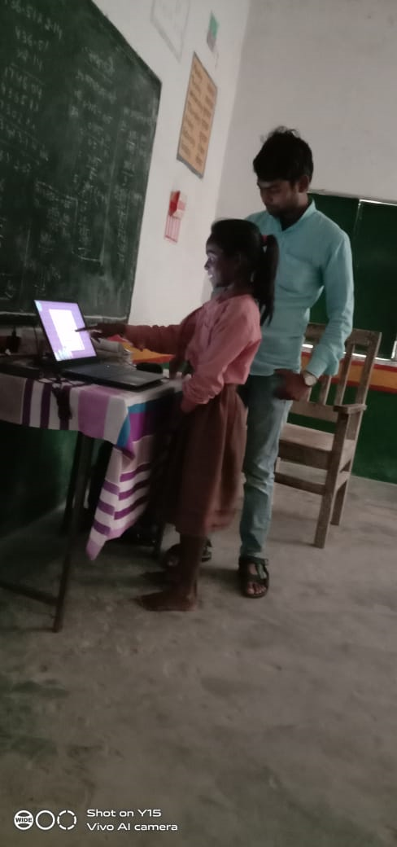

Mehndiganj Primary School-strength of 313 students:
The program of computer education in primary school Mehndiganj commenced in January 2019. Ajay has been working as a computer teacher since January 2019. But Rohit took over from Ajay from September 2019. Three days a week children are taught computers. The teacher also takes efforts in explaining general knowledge concepts through computers.

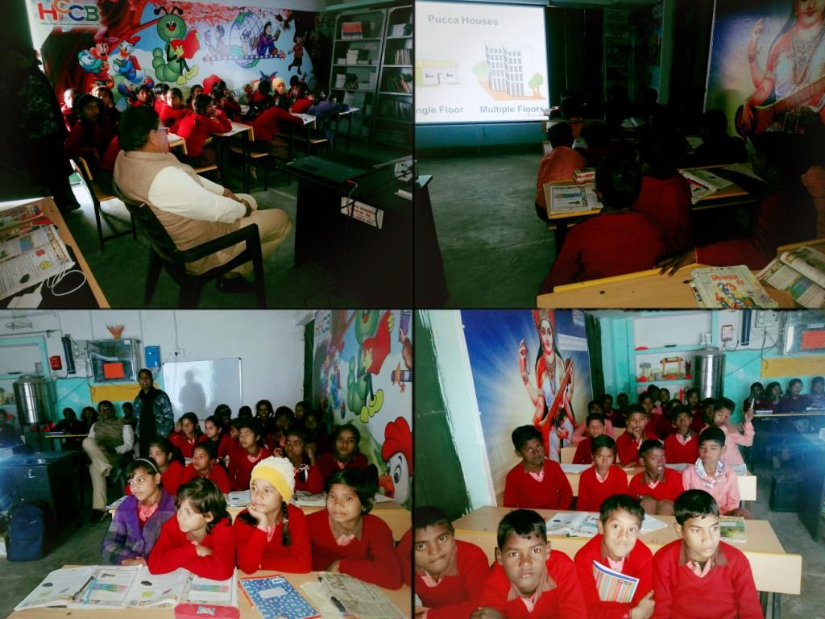
Ganeshpur Primary School- School-strength of 108 students:

The program of computer education in primary school Ganeshpur commenced from September 2019. Here Rohit is working as a computer teacher. Three days a week children are taught computers.

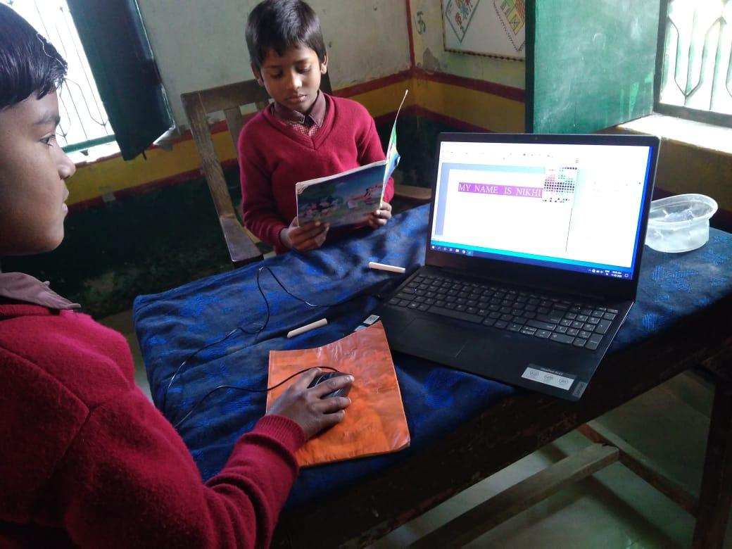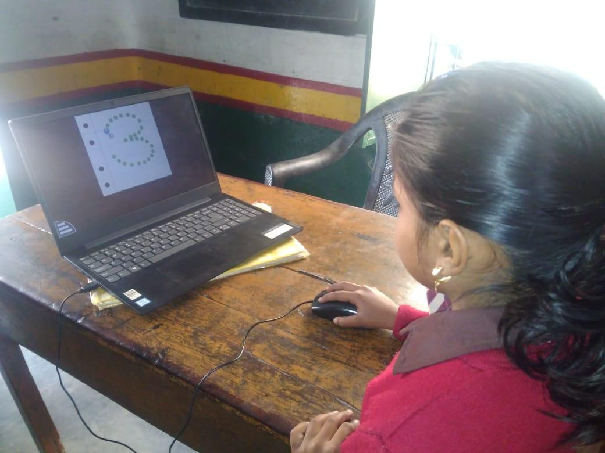

Jagatpur Primary School- School-strength of 124 students:

The program of computer education in primary school Jagatpur commenced in September 2019. Here Ms Gunjan is working as a computer teacher. Here three days in a week children are taught computers.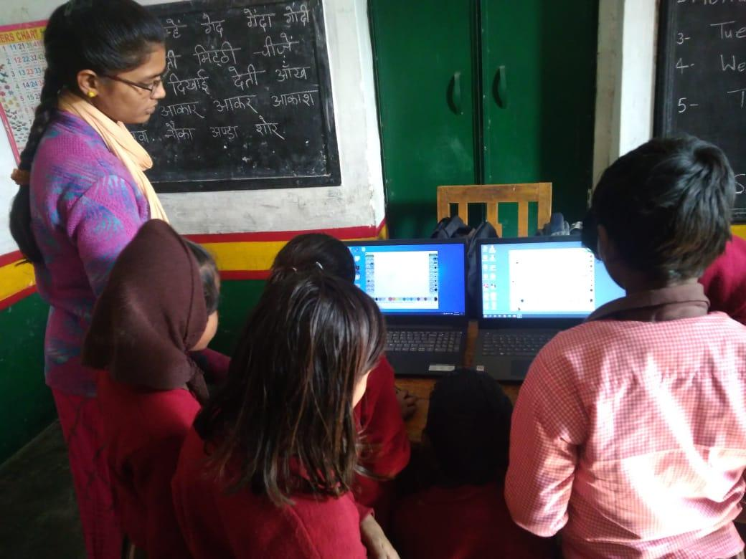 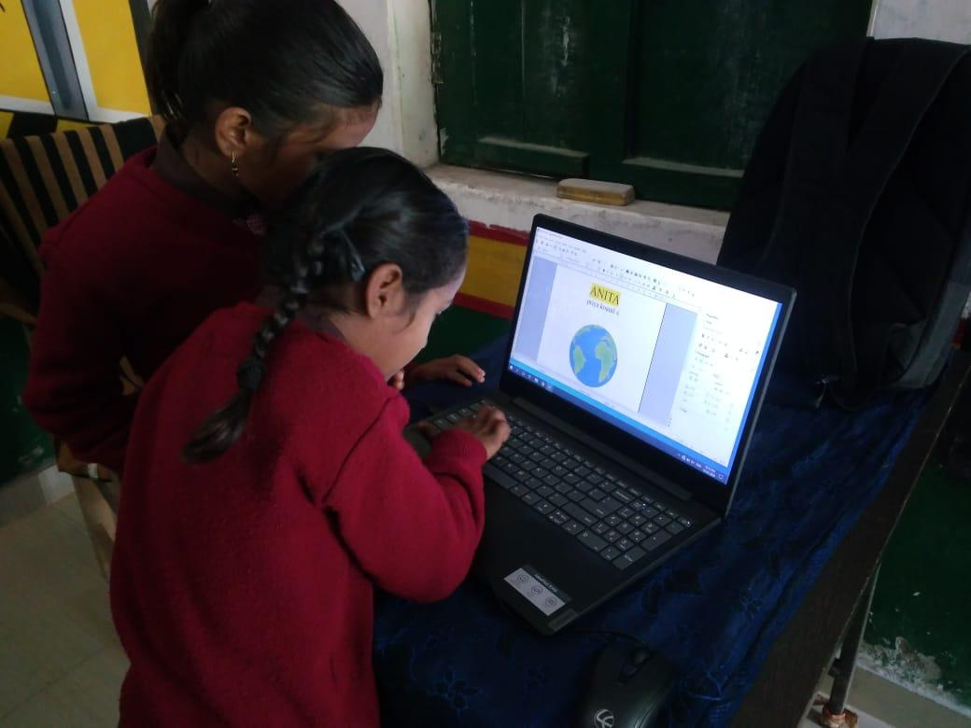

Hardattpur Primary School- School-strength of 152 students:

The program of computer education in primary school Hardattpur commenced in September 2019. Gunjan is working as a computer teacher here. Three days a week children are taught computers.
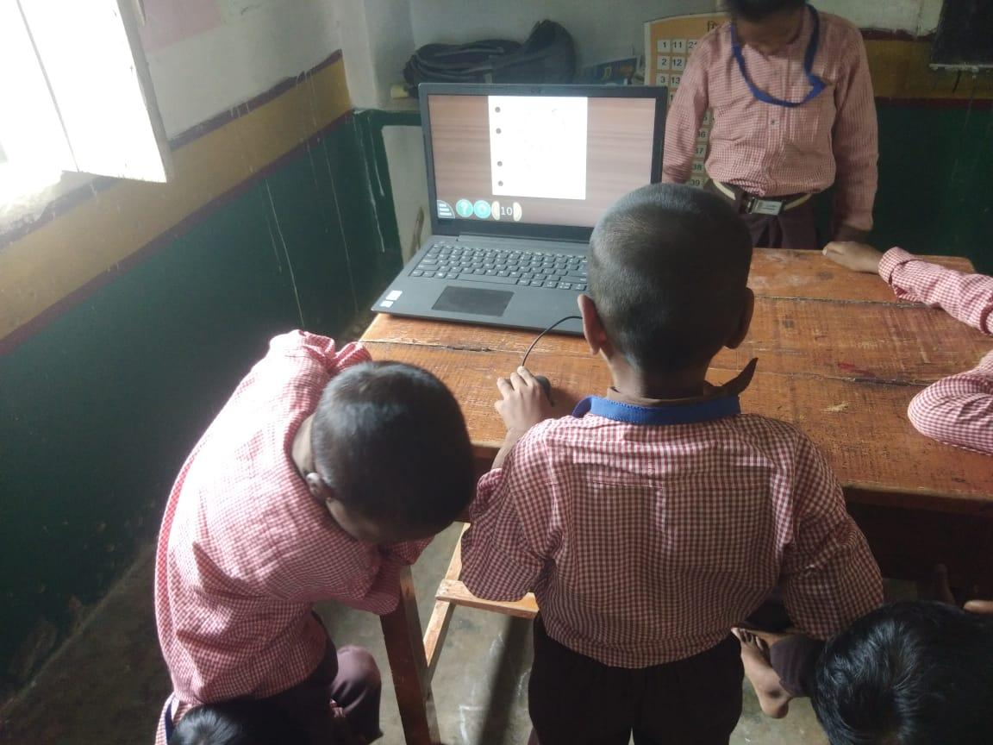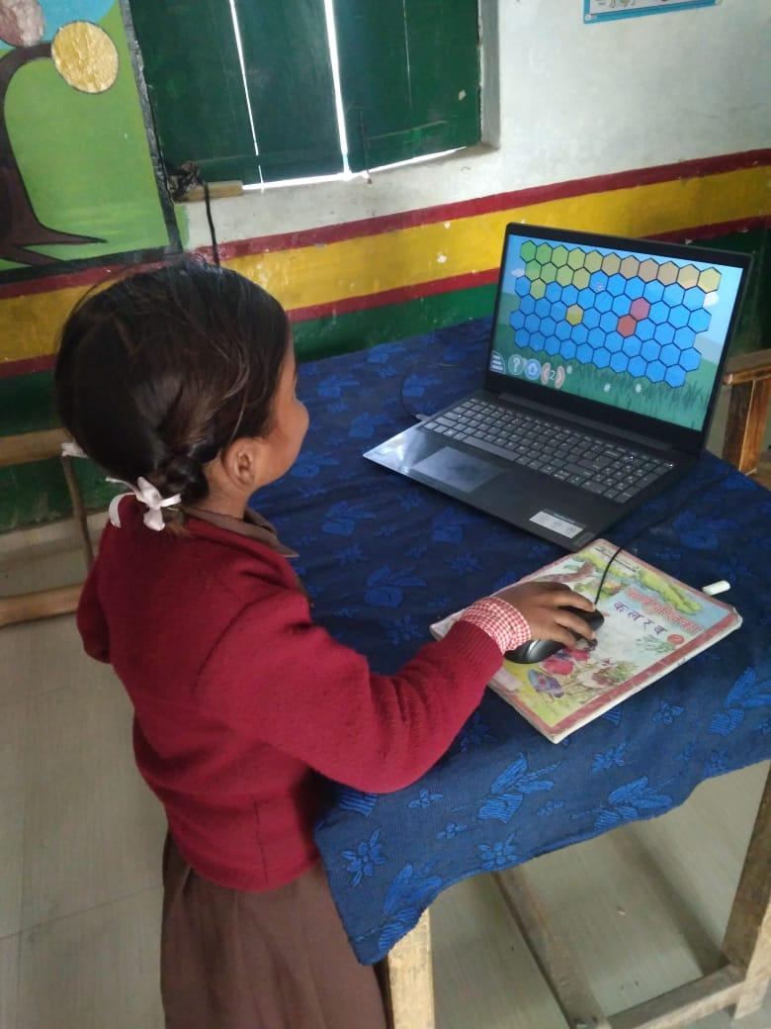

Harpur Primary School - School-strength of 169 students:

Computer education program in primary school Harpur commenced in September 2019. Ajay was working as a teacher from September 2019 to December 2019, but from January 2020 Alihasan joined us who is taking care of this school. Three days a week children are taught computers.

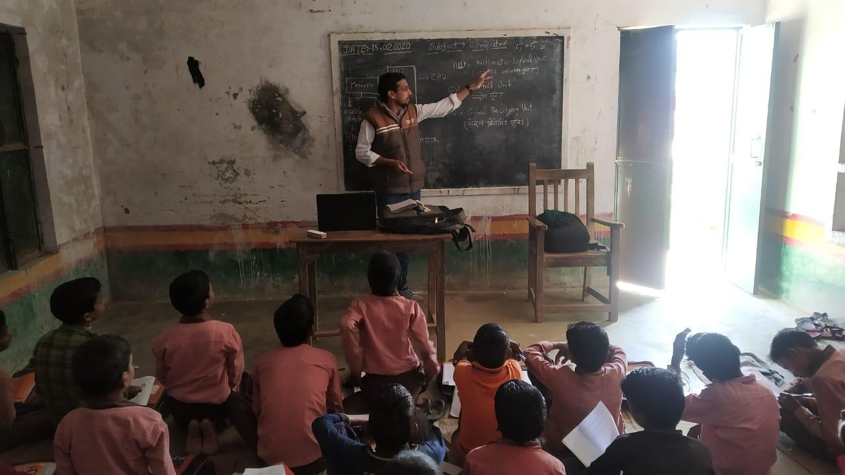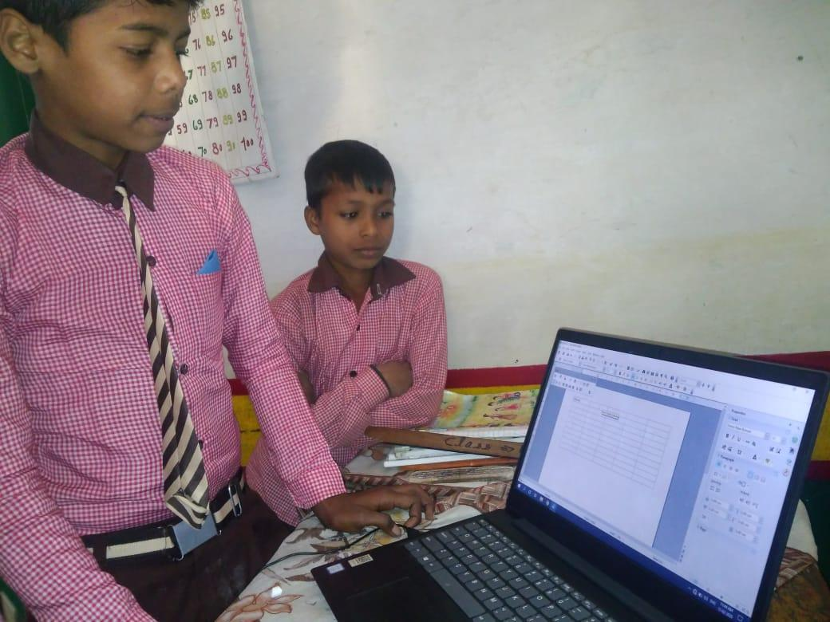

Highlights from August 2019 to January 2020:

- Ajay was the only teacher who was working since January 2019.
- Two additional computer teachers Rohit and Ms Gunjan were interviewed and inducted in the month of August 2019.
- From September 2019 all teachers are teaching three days a week in two different schools.
- On 15 September 2019 all the teachers visited Chennai for teacher training. September Teacher Trainings at Asha Chennai.
- This was also an opportunity for the teachers in the North to interact with the teachers in the South and understand the methodologies followed in the South. These have helped them in up scaling their knowledge and were able to provide new and improved methods of teaching. They were exposed to GCompris and Open Office.
- Teacher-cum-coordinator Alihasan was interviewed and selected in December 2019 and he has been inducted from January 2020 on the payrolls.
- From January 2020, Alihasan teaches in Harpur three days a week, and the other three days he goes to different schools and coordinates with the other teachers.
- Periodic meetings are held with all the teachers in Rajatalab, to discuss problems faced by them in the schools while teaching. They are briefed and the problems are addressed amicably.
- All teachers prepare their monthly reports and share it with the Chennai Volunteers.
- All the teachers reach the school by 9 am and go back home after the school is closed.
- The Mentor mentee program to help the teachers with spoken English is conducted every week on Sundays and the participation and learning is good.
- Teachers are given weekly assignments in English and they will reach out to the Mentor for any assistance in solving these assignments.
- None of the schools in the Rajatalab Sangamam project had any computers in the school which could be used while the teacher is conducting Computer class. This was a major drawback as the no of students were very high and the no of laptops were only one or two.

Upcoming Activities and highlights for Rajatalab Sangamam in March 2020:

- We could get as donations a few computers from FORD India out of their CSR budget and these have been shipped to Rajatalab for distribution to the schools supported by us. This is expected to be done before the end of March 2020. This will help the teachers in providing more hands on to the students.
- All the teachers from Rajatalab Sangamam project are attending a training program along with the teachers in Tamilnadu in Chennai from 18th March 2020 for 4 days. During this visit they will also visit the schools supported by ASHA Chennai chapter in Thiruvallur and Chennai to understand the teaching concepts.

2020-2021 plans for expanding our computer education as part of Rajatalab Sangamam:

- Few more schools are in the cards to be added to the list of schools supported by Rajatalab Sangamam project in the coming year.
- Additional teachers may also be recruited for this.
- Two volunteers from Chennai propose to visit Rajatalab by the end of March 2020 to visit the schools and take this forward.

