A balwadi in every village within reach of every child
The Vanasthali Rural Development Centre, Pune opened doors in 1981 to work in rural child education. Its founder, Nirmalatai Purandare, was a social activist.
Vision: The child in the city is groomed into the process of education. Play groups that are conducted for children in the age bracket of 3 to 6 years mold the child to function as a member of a group and ready him for the process of learning. However, this preparation for socialization, so to say, is almost always absent in villages. Because primary education is compulsory, the child is picked up at the age of 6 and put into a school. But he has neither been groomed to accept schooling nor is he ready. Consequently, the dropout rate is high in the subsequent years. What we need is a grooming ground for the rural child, similar to what his urban counterpart has.
But who will teach him? City teachers do not find it feasible to travel all the way to villages to teach. Hence the best way out is to provide local residents some minimum training, and urge them to take on the mantle of teaching. And we decided it has to be the woman taking on this role, as educating a woman is often the path to educating her entire family too. That was how the idea of the 'Balwadi teacher' took root.
Madhura: I visited the Vanasthali main office in Pune on May 25, 2017 and subsequently went to see the balwadi training center in Somatane (2 hours from Pune in Talegaon district). The school was on summer break, but the teachers came just to meet me even though there was no electricity that day due to load shedding and the Balawadi was very hot and humid. I found the workers to be dedicated, sincere and very passionate about the children and the vansthali mission. The women who had taken training and now played the role of teachers had a new confidence and fulfillment in addition to bringing some income as well as having a place for their own children under 6 to get a solid foundation. They explained what they teach, how they teach using all DIY teaching aids that they proudly used and treasured. They claimed that the children showed remarkable difference in focus, interest in nature and science and language proficiency after they attended VRDC balwadi and it truly instilled the love of learning in them. They showed me arts and crafts, workbooks and science experiments – I was so impressed! Sushama Sathaye who sent the proposal to PPI has been working in pure volunteer capacity for the past 2 decades. She came with us and was saying that VRDC work is grass roots, and earnest. It is run on a shoe string budget only because of the will power of the social workers and teachers. It is not glamorous, but she hopes PPI will see that and consider a renewal of its funding which has been a life saver for them.

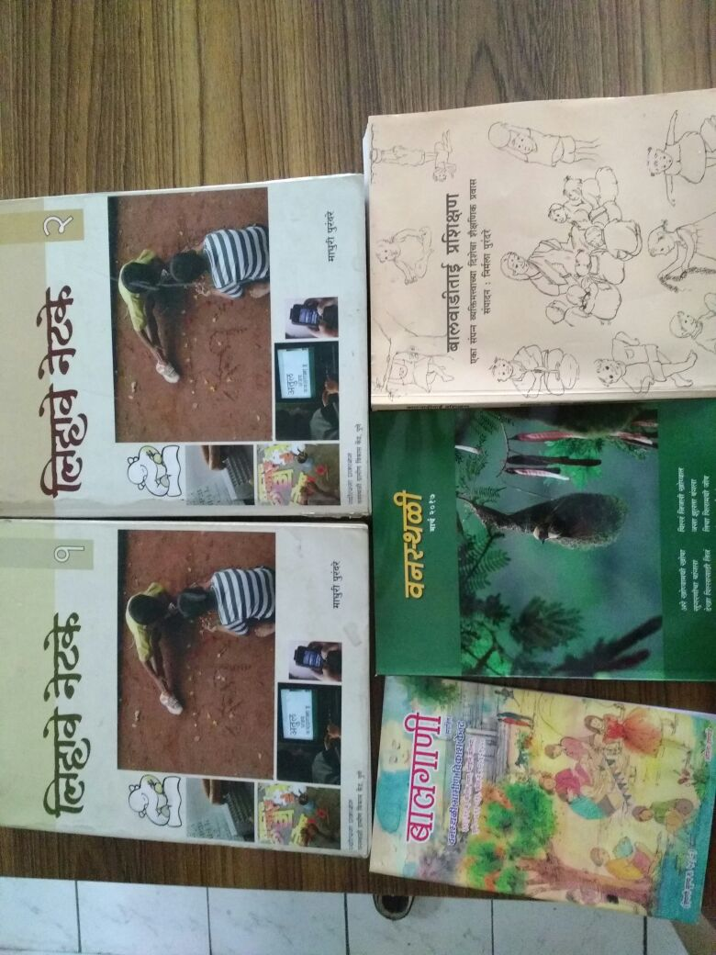 | 