Proposal for vehicle (TATA MAGIC – 4 WHEELER)
for Sirisha Home based Rehabilitation Project
supports children with intellectual disabilities
KRISHNA DISTRICT, ANDHRA PRADESH.
Date 11/10/2018

 | Project Contact Information | Asha Contact
Name | Mr. M.SOMESWARA RAO | Raji Muppala
Contact | 011-91- 9441413161  9397646210  c
Address | Sirisha Rehabilitation Center  D No: 3-57, Veerankilock,  Pamidimukkala,  Krishna Dist., Andhra Pradesh,  Pin Code – 521250 | Kansas city Chapter
Phone | 011-91- 9441413161  9397646210  c
Fax
E-mail | srcpamidi@gmail.com | rajichavali@gmail.com

Asha for education Kansas city chapter supporting Sirisha Rehabilitation Centre (SRC) home based project since April 2018

SRC is doing the Project Work in two Mandals namely Vuyyuru and Pamidimukkala of Krishna District, Andhra Pradesh and the location sketch is shown below.
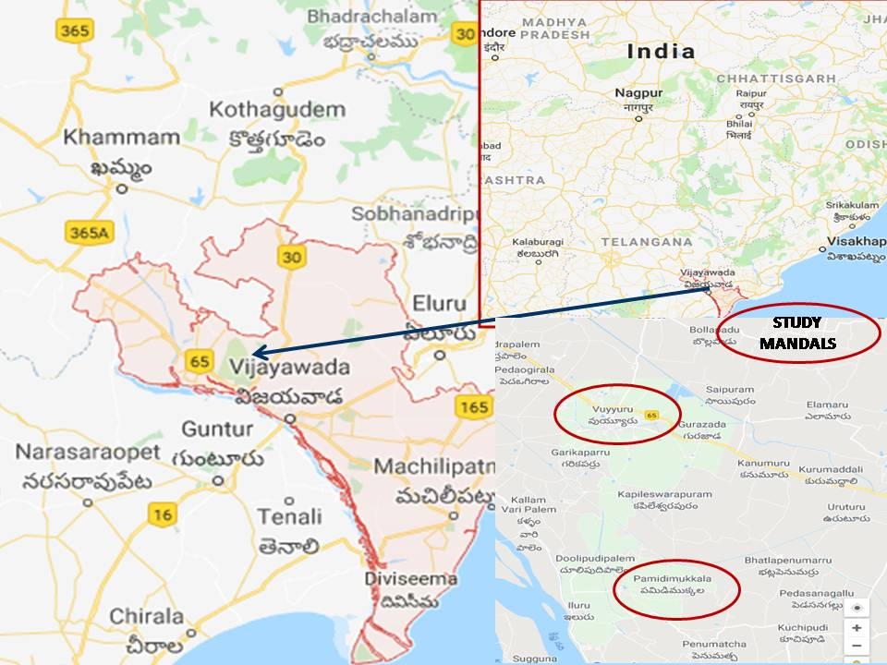

Since beginning from the month of April 2018, the team consisting of Special Educator, Physiotherapist and other supporting Staff have mapped 20 villages, identified 25 Children with Intellectual Disabilities (CWID) and providing need based Educational and Rehabilitation Services and Supports (which are mostly individualized) in the presence and association of Parents & other Family members.

Since beginning, the team is utilizing the available public transport facilities to reach the home of the each child and providing need based services and supports.

Such mode of transport is taking lot of time and energy of the team for travel and certainly it limits the time to spend with the Child, Parents, Family members, Community Members, and other Stakeholders. This is one of the key limitations while working the targeted Children with Intellectual Disabilities.

In such circumstances, the team having its own transports facility will help to overcome the above limitation and thus to spend more time with the targeted groups. At present, SRC is not having its own Vehicle to spare for this Project.

In view of this situation, the team of Asha Home Based Project needs separate Vehicle. Certainly having a separate Vehicle for Asha Home Based Project will have several advantages and some of them include:

- The time frame can be fixed as per the convenience of the Parents who are (including mothers) mostly the bread winners (daily wage laborers in Agriculture & other areas).

- More time can be spent with the Children, Parents, and Family Members.

- Frequency of the visits can be increased depending upon the need of Children and Parents.

- It also give scope to meet the Community Members, Community Workers, Health Workers, Schools Administration & Staff, team of local Panchayat, and other groups of the local Village.

- The Team Members can save lot of time and energies which otherwise can be spared for children and other activities of the Project.

- The Team Members can feel more secured, assured, responsible, and accountable with better evidence based supports and documents.
- The Team Members can move to attend the urgencies of the Children depending upon the vulnerabilities of the situation.

- The Transport facility can be provided to the Children and Parents to attend specialized Educational, Care and Rehabilitation Services at the Centers of SRC.

- The Children and Parents can be supported for attending Medical Camps organized by SRC, Government, Hospitals or any Private Agency.

- The Children can also be supported to make them part of the Cultural, Recreations, Sports, Games, and other Community Celebrations as part of Therapy and initiative of moving towards inclusion and mainstreaming both at Home and Community.

- Also supports to organize need based Awareness Camps at Communities, SRC and other such indentified places.

- More areal extent (10 to 25%) can be explored, mapped and covered for the purposes of the Project.

- More number of such children can be reached (around 40) with need based service and supports.

- It also supports more and more Professionals and other local members to advocate and facilitate for: removal of barriers – for creating accessible environments at Home & Community; and Prevention of the Causes of Disabilities – for initiating Disability Free Communities.

- And several such advantages and consequences to work with the Children, Parents & others and finally to fulfill the targets of the Project more effectively and efficiently.

Proposal funding to purchase vehicle of TATA MAGIC (4 Wheeler)

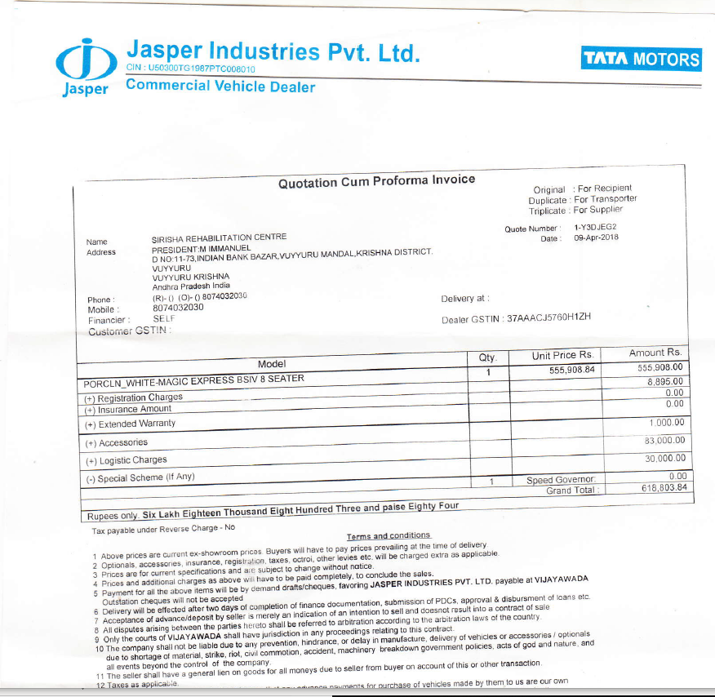

- What amount are you requesting from Asha, and for what specific purpose?

Funding to buy Vehicle – INR 6,18,000 Rs

IMPORTANT: For Asha-GKC Use Only

To be filled by project steward:

2. What is the total amount approved in Indian Rupees and for what time period?

Salaries from March 2018 to Feb 2019

Year | Amount
1 | INR 6,18,000

