Name : Venkateswara Rao Gattineni
Email: gattineniv62@gmail.com
Phone No: 91 9177246487
Date: 3rd March 2025

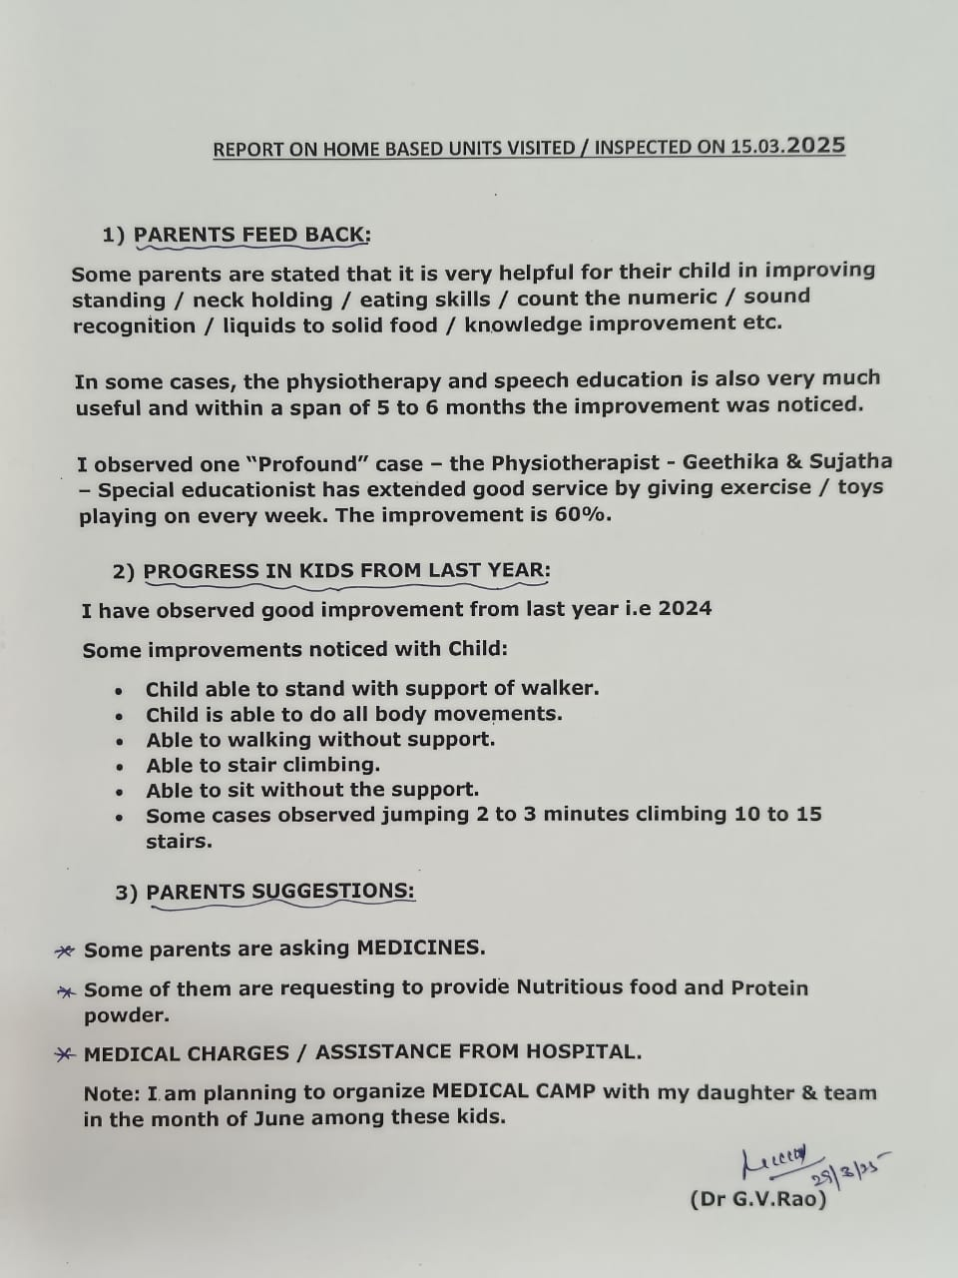

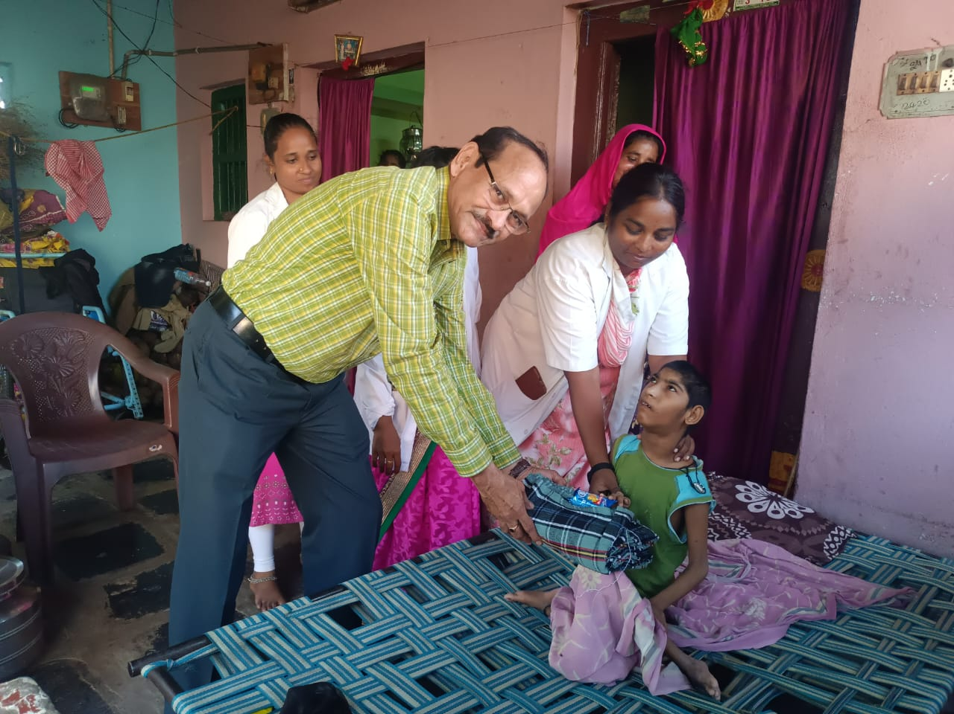
Child Name: sk. Nageena
Village: nepalli
Category: multiple disability

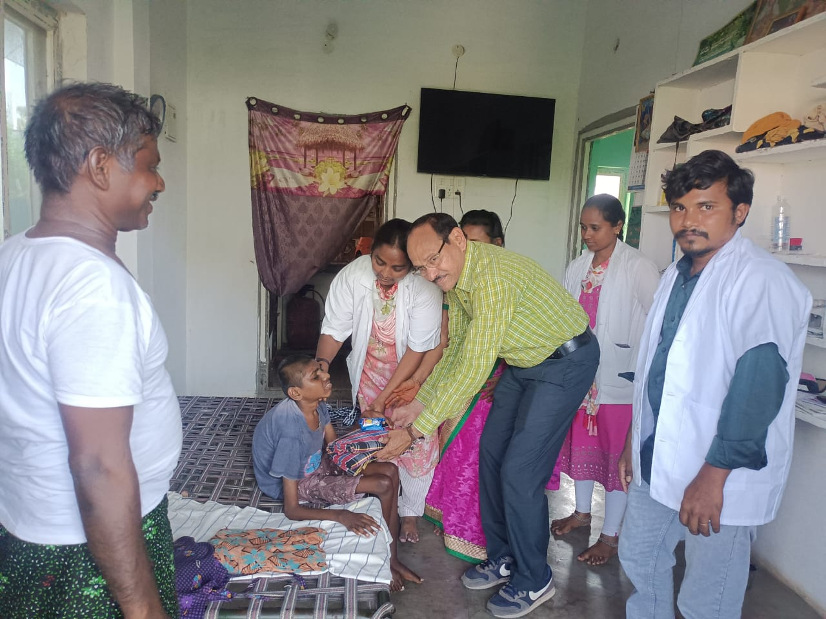

Child Name: Akshay
Category: multiple disability
Village: Gurajada

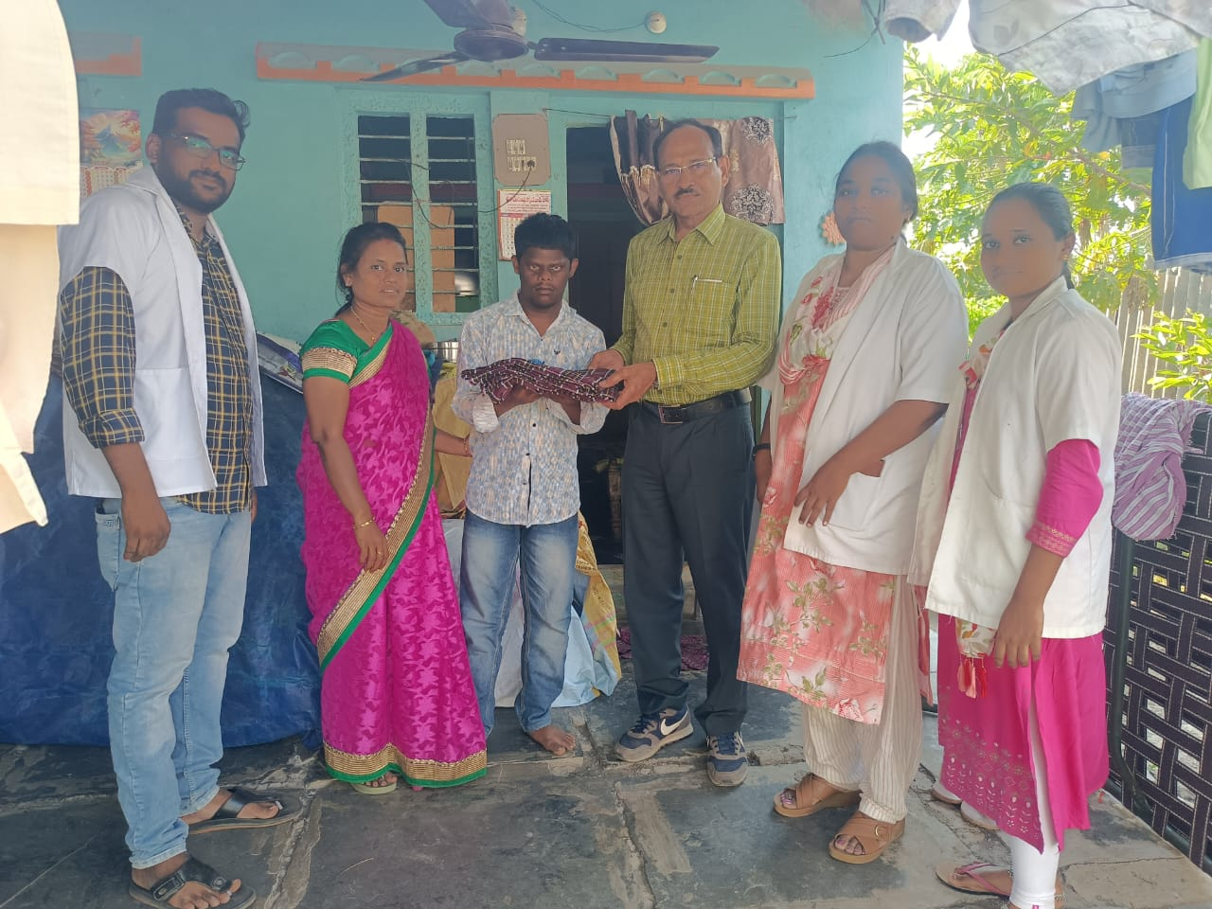

Child Name: Yeshwanth
Category: Downs syndrome with intellectual disability
Village: Gurajada

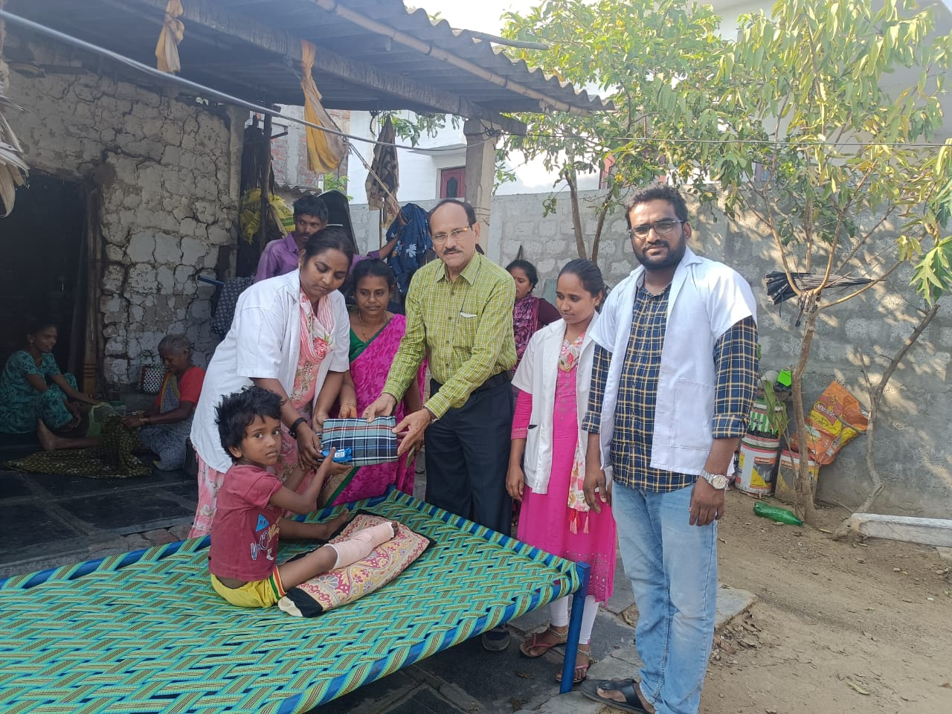

Child Name: Yeshwanth
Category : Multiple Disability
Village: Reddy palem

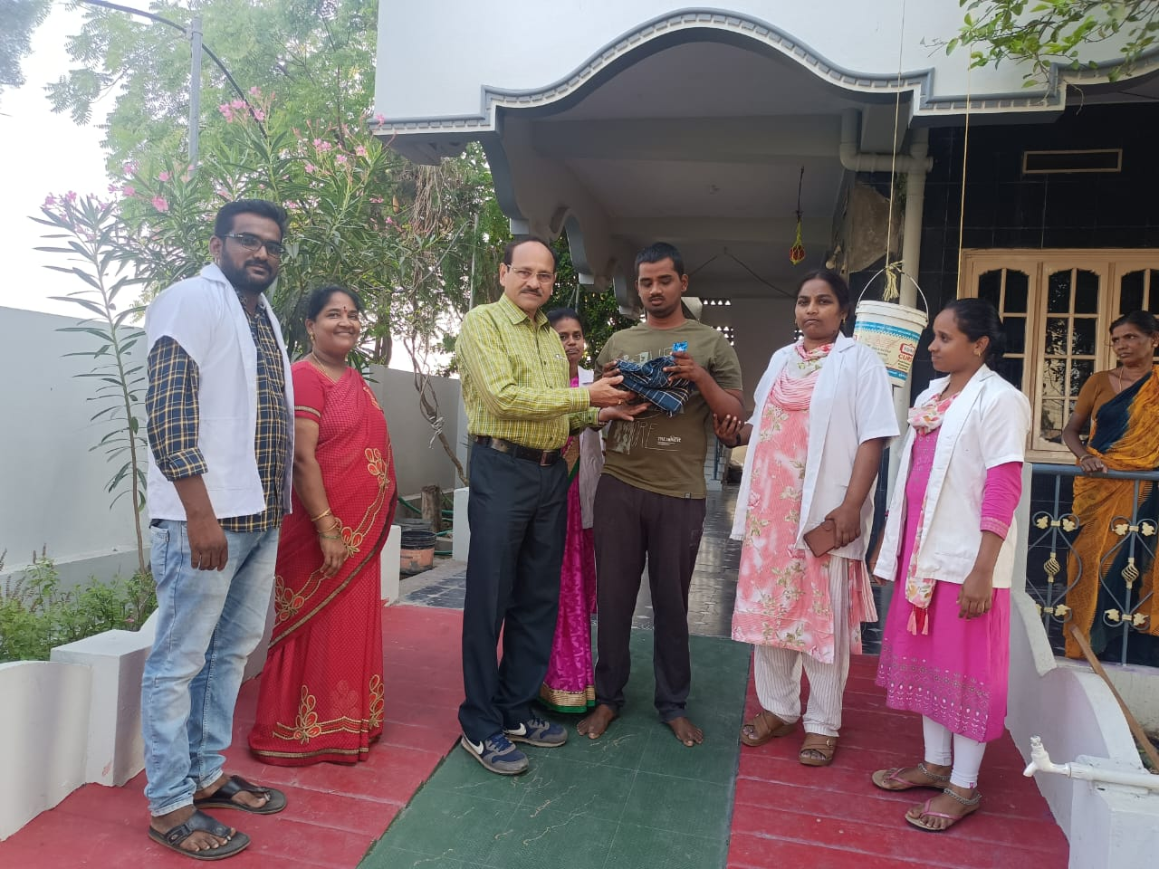

Child Name: K.Sai
Village: katuru Road
Category: ADHD

