SIRISHA REHABILITATION CENTRE
3-57, Veerankilock, Pamidimukkala, Krishna Dist., A.P -521250.

Name of the Scheme : SIRISHA HOME BASED CENTRE FOR CHILDREN’S WITH MENTAL RETARDATION

Name of the Organization : SIRISHA REHABILITATION CENTRE

Name and Address of the Project : Sirisha Home Based Centre, D No: 3-57, Veerankilock, Pamidimukkala,
Krishna Dist., Andhra Pradesh, Pin Code – 521250.

Year : 2019-20

LIST OF BENEFICIARIES
S No | Name Of the Beneficiary | D.O.B | Gender | Category | Father Name  &  Address | Type of Disability | Economic Status | Photo | 2018-19  Achieved Goals | 2019-20  Feature Goals
1 | Vemulapalli Devi Sri Chandana | 07.04.07 | F | BC | V Sri Lakshmi,  Neppali,  Kankipadu,Krishna Dt., | MD  (CP+MR) | BPL | 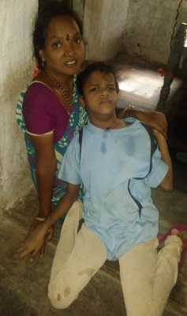 | Physiotherapy :  1.Sit with support,  2.Shoulder Movement Increases  Special Education:  1. Press the Ball,  2.Put the ring tower, | Physiotherapy :  1. Stand withSupport by using Calipers  B-L HKAFO  2.Cross Siitng  Special Education :  1. Dressing- Remove Nicker.  2. Eating-Food with Spoon.
2 | Vadepalli Pavan Kumar | 05.12.15 | M | BC | V Bangaru Naidu,  D No:3-16-1,  Kobbarit thota,Vuyyuru | MD  (CP+MR) | BPL | 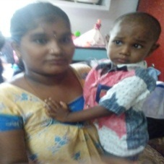 | Physiotherapy :  - All Mile Stones Developed  - Right Upper Limb Movements Increases  Special Education :  - Throw The Ball  - Identify The Body Parts(Hands,Legs,Head)  - Able to Keep the Ring Tower | Physiotherapy :  - Gait Training  - Eating Food with Right Upper Limb  Special Education :  1.Dressing-Wear Nicker  2. Identify The Body Parts(Nose,Ears,Eyes)
3 | G.Soundharya Kumar  Teachers are going weekly twice. Mom is happy | 21.10.2006 | M | SC | G.Sambaiah,  Harizanawada,  Pedda Ogirala,  Vuyyuru(Md),  Krishna Dist., A.P.  Ph No:7893224424  Mom - Alakya | MD  (MR+CP) | BPL | 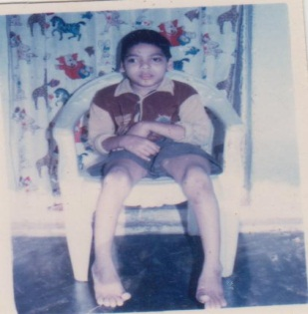 | Physiotherapy :  - Spasticity release of Both upper limbs.  - Postural Development  Special Education :  - Able to Keep the Ring  - He Can Press the Ball | Physiotherapy :  1. Spasticity release of Both upper limbs fully.  2. Shoulder movements becomes Normal  3. ROM – Wrest  Special Education :  1.Eat food by him self with help of others.  2. Putting ring tower.
4 | Kaithepalli Karthik | 05.10.2014 | M | SC | K.Shanthi,  Pamidimukkala,  Pamidimukkala(Md),  Krishna Dist., A.P.  Ph No:9505893250 | MD  (MR+HI) | BPL | 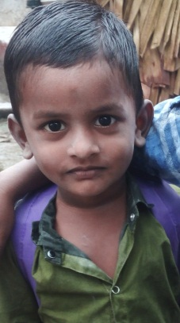 | NEW ADMISSIN  April,2019 | Physiotherapy :  No Need.  Special Education :  1.insert the beads into the thread.  2.wore nicker by her self.
5 | Aruli Aruna Kumar Teachers going weekly once. Mom observed improvement | 25.04.2007 | M | SC | A.Venkateswara Rao,  Kolavennu,  Kankipadu(Md),  Krishna Dist., A.P.  Ph No:9290492326  Mom - Mariam | MD  (MR+CP) | BPL | 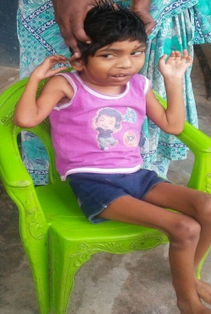 | Physiotherapy :  1.Rolls over Flat Surface.  2. Spastcity Released for both upper lower limbs.  3.Sit with Support  Special Education :  1.he responds we calling with his name  2.press the ball  3.sit with support  4. able to hold the ring to putting ring tower. | Physiotherapy :  1.Lower limb Movements increases n develop indiaul movements.  2.Moving on CP walker traing.  3.Sitting without support for 1 min  Special Education :  - Keep ring tower  - Developed him to eat food like biscuit n chocolate.
6 | Ambati Dasaran Sai  Teachers are going weekly 3 days parents are happy | 29.10.2014 | M | OBC | A.Satish  Yakamuru,  Thotlavalluru(Md),  Krishna Dist., A.P  Ph No:9392119869  9703604598 (ratnaveni) | MD  (MR+CP) | BPL | 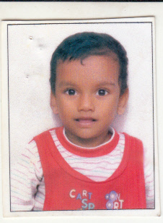 | Physiotherapy :  - Spastcity Releases aductors of both lower limbs.  - Able to sit without support  - Able to stand with support  Special Education :  1.able to put ring tower  2.keeping pegboard(Body parts)  3.brush him self by help of parent and teacher  4.tounge exercise. | Physiotherapy :  1.Able to stand with support for 30 min n 2.gait training with help of calipers.  Special Education :  1.wore nicker by him self  2.keeping pegboards(fuits)  3.he can express words like mother n father
7 | Gochipala John Victor | 26.10.2013 | M | SC | G.Madhu,  Gandigunta,  Vuyyuru(Md),  Krishna Dist., A.P.  Ph No:8142885829 | MD  (MR+CP) | BPL | 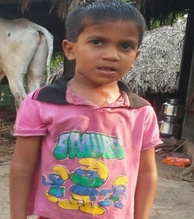 | Physiotherapy :  1.Seliavation controled by 20%.  2.Tounge Tie operation done with Other doctors.  3.Tounge excercises.  4.Right shoulder movements bocomes normal.n right lower limbs heeal strike n heeal off Phases should be doing.  Special Education :  - Wore nicker by him self  - Throw the ball  - Keep ring tower  - Matching red color  - Tounge excersise  - To control dribbling saliva | Physiotherapy :  1.wrest movement developed at the grade of 2.  2.Gait Phases Training  Special Education :  1.eat food by him self  2.idetify the some body parts n keeping pegboard.
8 | Alooru Venkata Naga Jaswini  Kid able to do Brushing– 4 teachers, 3 times per weekly, mom happy | 08.10.2008 | F | OBC | A.Tirumala Srinivasa Rao  Punadipadu,  Kankipadu(Md),  Krishna Dist., A.P.  Ph No:7997650861  Mom name – Nagamallika | MR | BPL | 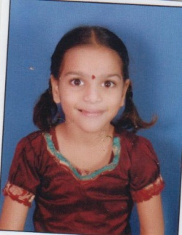 | Physiotherapy :  Special Education :  1.keep ring tower  2.able to brush by the help of parents n teacher  3.throw the ball  4.wore nicker by her self  5.insert the beads into the thread  6.to control the dribbling seliava. | Physiotherapy :  Special Education :  1.eat food with help of teacher n parent  2.put cupset
9 | Dodapathi Meghana | 10.10.2003 | F | SC | D.Durga Rao,  Punadipadu,  Kankipadu(Md),  Krishna Dist.,A.P.  Ph No:7780290602 | MD  (MR+CP) | BPL | 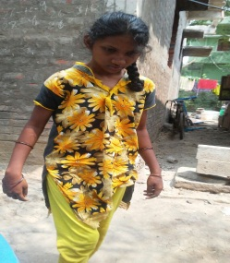 | Physiotherapy :  1.shoulder ROM increases  2.Elbow flextion n extention movements should be Grade3  Special Education :  1.keep ring tower  2.brushing with help of parent n teacher  3.throw the ball  4.wore shirt by the help of parent n teacher | Physiotherapy :  1.Elbow Spastcity releases  2.Hipp movements should be improved  3.Gait Training  Special Education :  1.wore shirt by her self only  2.insert beads into the the thread
10 | Suravarapu Krishanth | 09.05.2016 | M | BC-D | S.Sobharani,  Near Srinivasa College,  Vuyyuru(Md),  Krishna Dist.,A.P.  Ph No:9963775403 | MR | BPL | 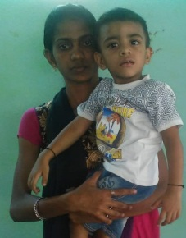 | New Admission  In April,2019 | Physiotherapy :  1.Milestones Developed  Special Education :  1.Hold the Objects  2.Respond to the sound and his name  3.Eat Food
11 | Banda Jaswanth Teachers are going monthly 4 days , mom also take kid monthly 2 times. Mom is very happy | 01.07.2011 | M | SC | B UmaMaheswara Rao,  Harijanawada,  Dodapadu,  Thotlavalluru(Md),  Krishna Dist., A.P.  Ph No:9866298712 | MD  (MR+HI) | BPL | 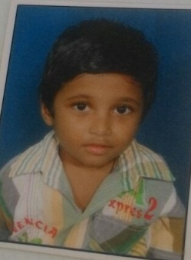 | Physiotherapy :  Special Education :  1.wore dress by him self  2.brushing by him self  3. write english alphabets.  4.counting the 1 to 10 numbers.  5.he can say amma,nanna,akka,anna.  6.he can identify the red n yellow colors. | Physiotherapy :  Special Education :  1.identify the blue n green colors  2.express words i.e., eyes,nose,mouth,ears  3.single digit additions.
12 | Kolle Balu | 22.04.2007 | M | SC | K.Srinu,  Harizanawada,  Kolavennu,  Kankipadu(Md),  Krishna Dist., A.P.  Ph No:8297761543 | MD  (MR+  Musculer Dystrophy) | BPL | 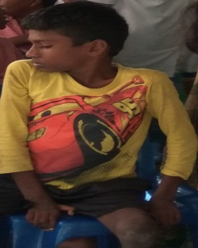 | Physiotherapy :  - Able to do the movements of both upper n lower limbs.  - Upper limb- finger should be in flexed position in –child should be extend finger at grade2  - Lower limb- both ankles should be in plantar flexed.  Special Education :  1.single digit additions  2.write the name n village name  3.throw the ball  4.identify the body parts  5.identify the red n yellow colors | Physiotherapy :  1.lower limb-ankle movements increased by grade 2.  2.By using ankle foot orthosis.  3.Giat Training  Special Education :  - Identify the blue n green colors  - Write his house address
13 | Koppu NaniBabu | 12.09.2001 | M | SC | K Srihari,  D No:1-36C,  Punadipadu,  Kankipadu | MR | BPL | 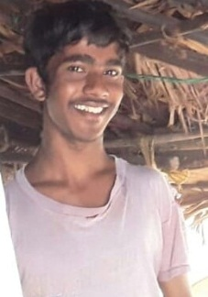 | Physiotherapy :  Special Education :  1.wore shirt by him self  2.throw the ball  3.identify the money coins(1,2,5)  4.insert the beads into the thread  5.keep pegboard(vegetables)  6.clean the lunch plate | Physiotherapy :  Special Education :  1.change Rs.5 coin  2.insert the thread into the needle.  3.identify the colors  4. garden work( water to plants)
14 | Konatham Akhil | 25.08.2012 | M | SC | K.Srinu,  Harizanawada,  Kolavennu,  Kankipadu(Md),  Krishna Dist., A.P.  Ph No:810663113 | MD  (MR+CP) | BPL | 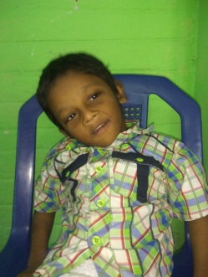 | Physiotherapy :  1.Moving rolls on Flat surface.  2.Holding Neck with support.  3.able to do move both upper n lower limbs independently.  4.Sit without support in Chair.  Special Education :  1.he respond when we call him with him name.  2.sit with support  3.able to hold the ring  4.press the ball | Physiotherapy :  1.Sit without support atleast 5 min by using bobath approch  2. Standing with support for 1 hour by using standing frame.  Special Education :  - Eat food like biscuit n chocolate  - Keep ring tower
15 | R.Sai Kumar | 21.08.2004 | M | BC | Appalaya Naidu  Janatha Bazar,  Near Srinivasa College,  Vuyyuru(Md),  Krishna Dist., A.P.  Ph No:9951330112 | MD  (MR+CP) | BPL | 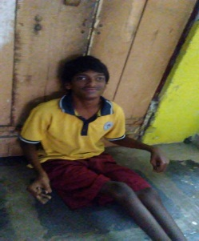 | Physiotherapy :  1.Spastcity released by operation done by the birds hospital.  2 abkle to crawl n sit to chiar independently by commending verbally  Special Education :  1.stand with support  2 put ring tower  3.brush by the help of parents n teacher  4.throw the ball | Physiotherapy :  1.Stand with support for 1 hour by keeping standing frame.  2.Stand without support.  3.Parallel Bar Trainging.  Special Education :  1.brushing him self only  2. food by him with help of others  3.put cupset  4. he can express sentence level
16 | Dokku Pujitha Sri  Teachers are going, weekly 1 time, 4 teachers. Teachers teaching girl to wear her cloths . Mom is happy | 13.12.2006 | F | BC | D. Radha Krishna,  Near Indian Bank,  Vuyyuru,  Krishna Dist., A.P.  Ph No:7382905528  Mom – Lakshmi  9573703375 | MR | BPL | 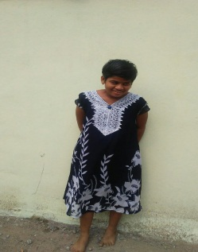 | Physiotherapy :  Special Education :  1.putting ring tower  2.wore shirt with help of parent n teacher  3.keep pegboards(Body Parts)  4.identify the body parts(head,eyes,hands,legs)  5.she can say simple to words level(amma,Nanna,akka) | Physiotherapy :  Special Education :  1.wore shirt her self only  2.identify the body parts(nose,ears)  3. she can say simple to words level(pappa,babbu,attha)  4.putting cupset
17 | Yekula Nikil | 06.06.2014 | M | SC | Y.Rajendra Prasad,  Laku Road,  Kankipadu,  Krishna Dist., A.P.  Ph No:8106624065 | MD  (MR+CP) | BPL | 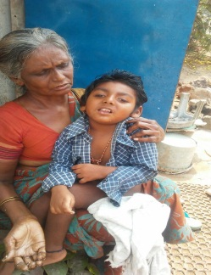 | Physiotherapy :  1.Spastcity releases for both upper n Lower limbs.  2.able to rolls on flat surface  3.Postural development  Special Education :  1.sit with support  2. respond to sounds(toys n visil)  3.press the ball with help | Physiotherapy :  1.Postural Development from Supine to sideline  2.sit with support atleast 1 min.  Special Education :  1.hold the object  2.respond when other call him with his name  3. eat food small pieces(biscuit) with help.
18 | Abdul Vajeed | 17.03.2012 | M | OBC | Ad.Vaheed,  Mazid Road,  Vuyyuru(Md),  Krishna Dist., A.P.  Ph No:9849393115 | MR | BPL | 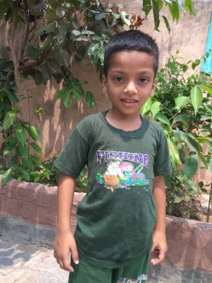 | Physiotherapy :  Special Education :  1.putting cupset  2.idetify the body parts(head,hand,legs,eyes)  3.wore shirt with help  4.identify the bathroom  5.throw the ball | Physiotherapy :  Special Education :  1.put ring tower  2.wore shirt him self only  3.identify the body parts(nose,ears)  4.eat food with help  5.express the words(Amma,Nanna,…etc.)
19 | Kodali Rithvika | 15.06.2014 | F | SC | K Rajani,  Harizanawada,Vuyyuru | MD  (MR+CP) | BPL | 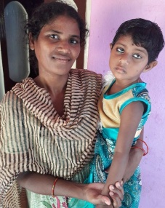 | Physiotherapy :  1.able to crawl sit n stand without support  2.Dificulty in walking  3.Gait traing by using Parallel bar by using sticks.  Special Education :  1.throw the ball  2.keeping ring tower  3.say words (amma)  4.keep pegboards(Body Parts)  5.tounge exercises | Physiotherapy :  1.Gait Phases Traing by using rollator.  2.Eating with right upper limb individually.  3.Wrest movements increses  Special Education :  1.wore nicker by him self  2.identify the body parts(head,legs,hands  3.express the word nanna  4. putting cupset  5.keep pegboards(fruits)
20 | Vemula Siva Nagaraju | 18.11.2012 | M | SC | V China Gopi,  Punadipadu,  Kankipadu(Md),  Krishna Dist., A.P.  Ph No:7745612389 | MD  (MR+CP) | BPL | 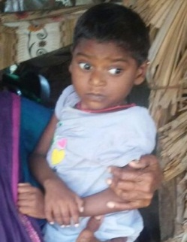 | Physiotherapy :  1.poatural development  2.rolls on flat surface  3.Holding Neck with support Ncek coller.  4.Able to sit with support by corner sit.  Special Education :  1.sit with support  2.respond to the sounds(toys,visil)  3.respond when we will call him with his name | Physiotherapy :  1.Postural Development  2.Holding Neck  3.Able to stand by keeping in sand upto axilla.  Special Education :  1.hold the object  2.pick up the objects
21 | Vaddadhi Vijay Ram | 22.06.2014 | M | SC | V Nukambhika  D No:3-74,  Kolavannu,  Kankipadu Md,  Krishna Dist.,A.P.  Ph No:6303800773 | MD  (CP+MR) | BPL | 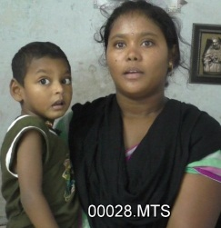 | Physiotherapy :  1.able to respond commands  2. spastcity releases of both upper n lower limbs.  3. holding neck properly.  4.rolls on flat surface  Special Education :  - respond when we will call him with his name  - Press the ball  - Hold the ring  - Tounge exercise | Physiotherapy :  1.standing with support of windows by 1 hour.  2.sit without support by holding arms.  Special Education :  1.put the ring tower  2.eat food likeBiscuit and chocolate
22 | Tellakula Neha Sree | 27.07.2015 | F | BC | T NagaVeena Kumari,  Vuyyuru,  Vuyyur(Md),  Krishna Dist., A.P.  Ph No:8330979757 | MD  (MR+CP) | BPL | 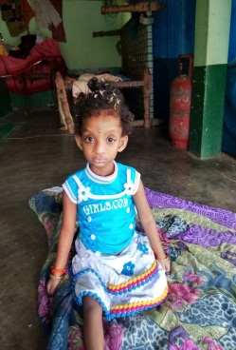 | Physiotherapy :  1.rolls on flat surface  2.able to crawl  3.able to sit  4.able to independently stand with support of her mother or therapist.  Special Education :  1.respond to the her name and sounds(toys,visil)  2.tounge exercise  3.hold the thin ring | Physiotherapy :  1.Stand without  Support  2.base of support decreases for using standing without support.  3.Gait Training by using rollator.  Special Education :  1.hold the object  2.pickup the object  3.finger toothbrush grinding with teeth.  4.eat food like biscuit with help of parent.
23 | S.Venkata Sai | 23.07.2018 | M | BC | S Sarada,  Naidu Brahamana Street,  Kankipadu(Md),  Krishna Dist., A.P.  Ph No:9603208560 | CP | BPL | 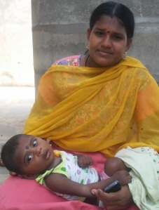 | NEW ADMISSION  April,2019 | Physiotherapy :  1.Rolls on Flat Surface  2.Able to Crawl  3.Able to sit  Special Education :  1.Respond to the Sounds
24 | Shaik Nagina  Techers are going weekly one day , 4 teachers , They help kid to do exercise. Teachers stay for one hour. Mom is very happy | 24.05.2009 | F | OBC | Sk.Masthan,  Neppali,  Kankipadu(Md),  Krishna Dist., A.P.  Ph No:8897624077  Shakila | MD  (MR+CP) | BPL | 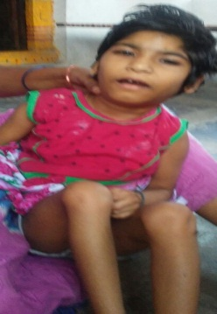 | Physiotherapy :  - Able roll over the flat surface  - Able to neck control with support of Neck coller  - Spastcity releases for both upper n lower limbs.  Special Education :  1.respond to the her name n sounds (toys,Visil)  2.hold the ring for put the ringtower | Physiotherapy :  1.Neck control fully by using swiss ball excercises  2. I trained the child should be able sit n stand with support by commending verbally.  3.sit without support by holding arms tio the bed atleast 5 min.  Special Education :  1.eat food like biscuit and chocolate  2.pickup the objects  3.sit with support by CP walker  4.with helpof teacher putting a ring in the tower.
25 | Janaganadham David | 04.02.2012 | M | ST | J.Srinu Kumar,  Harizanawada,  Punadipadu,  Krishna Dist., A.P.  Ph No:7337286617 | MD  (MR+CP) | BPL | 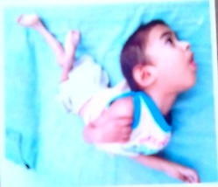 | Physiotherapy :  1.Body allingment should be keeping on erect position  2.Holding with support of Neck coller.  Special Education :  1.respond to the sounds(toys,visil)  2.respond when we will call him with his name | Physiotherapy :  1.rolls on flat surface  2.Postural development  Special Education :  1.hold the object  2.pick up the objects
26 Karri Rajeswari 11.06.2002 F ST K.Kalavathi, Kolavennu, Kankipadu(Md), Krishna Dist., A.P. Ph No:9949363674 MR BPL Physiotherapy : 1.Shoulder(ROM) becomes Normal. 2.wrest Movement-Grade3 Special Education : - Wore shirt by her self - Clean her lunch plate - Identify the body parts - Throw the ball - Put cupset Promote to Special school | Karri Rajeswari | 11.06.2002 | F | ST | K.Kalavathi,  Kolavennu,  Kankipadu(Md),  Krishna Dist., A.P.  Ph No:9949363674 | MR | BPL |  | Physiotherapy :  1.Shoulder(ROM) becomes Normal.  2.wrest Movement-Grade3  Special Education :  - Wore shirt by her self  - Clean her lunch plate  - Identify the body parts  - Throw the ball  - Put cupset | Promoted to Special school

Male :: 18 Female ::07 Total :: 25 Category :: (Gen + OBC) :: 11 SC :: 13 ST :: 01

MD :: 19 MR :: 5 CP :: 01

PRESIDENT

