SIRISHA REHABILITATION CENTRE
3-57, Veerankilock, Pamidimukkala, Krishna Dist., A.P -521250.

Name of the Scheme : SIRISHA HOME BASED CENTRE FOR CHILDREN’S WITH MENTAL RETARDATION
Name of the Organization : SIRISHA REHABILITATION CENTRE
Name and Address of the Project : Sirisha Home Based Centre, D No: 3-57, Veerankilock,Pamidimukkala,
Krishna Dist., Andhra Pradesh, Pin Code – 521250.
Year : 2025-26
LIST OF BENEFICIARIES
S  No | Name Of the Beneficiary | D.O.B | G  e n d er | Cat ego ry | Father Name &  Address | Type of Disability | Ec on o mi c St  at us | Photo | 2024-25  Achieved Goals | 2025-26  Feature Goals
1 | Vemulapalli Devi Sri Chandana | 07.04.07 | F | OBC | V Sri Lakshmi, Neppali, Kankipadu, Krishna Dt.,  Ph No:7337046616 | MD (CP+MR) | BP L | 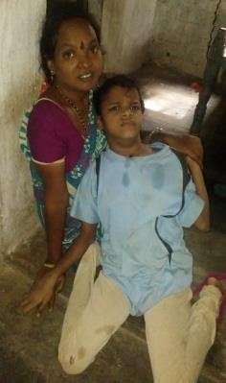 | Physiotherapy:  Child can be able to kneeling and get into this posture Stand with support by walker Special Education:  1.peg board keeping Social skills: Namaste | Physiotherapy:  it with out support  Able to sit to standing with out support  Standing on walking frame Walk with support  Special education Ring tower  Social skills : say hai and bye Special education: Peg board- Animal body parts  Motor Skills: Eating Mixing the food
2 | G.Sounharya Kumar | 21.10.06 | M | SC | G.Subaiah, Harizanawada, Pedda ogorala; Vuyyuru Md, Krishan Dt,  Ph no:7893224424  Mother: Alekya | MD (MR+CP) | BP L | 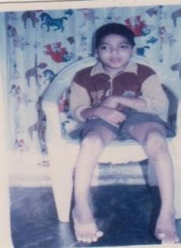 | Physiotherapy:  - To enhance hand functions  - Hand dexdremity improves  Special Education:  - Peg board- vegetables  Social skills: Say ”Bye” | Physiotherapy: Lowerlimb strengthening Able to do active movement. Special education:  Cath the ball  Peg boards-fruits

3 | Aruli Aruna Kumar | 25.04.07 | M | SC | A. Venkateswara Rao,  Kolavennu, Kankipadu(Md), Krishna Dist., A.P. Ph No:9290492326  Mom - Mariam | MD (MR+CP) | 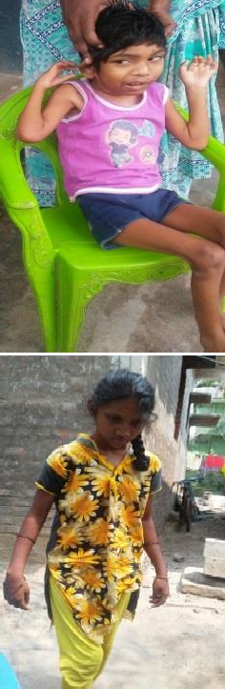  BP L |  | Physiotherapy:  - Any to facilitate development of proper position of the body  - Body posture developed  Special Education:  1.Cognitive-Touch-Smooth rough | Physiotherapy:  Sit with support for 5 minutes
4 | Dodapathi Meghana | 10.10.03 | F | SC | D.Durga Rao, Punadipadu, Kankipadu(Md), Krishna Dist.,A.P. Ph No:7780290602  9985141799 | MD (MR+CP) | BP L |  | Physiotherapy:  - To improve gross motor activities  - Stand on tip toe to reach for an object at a height  - To improve upper body strength &stability ded Special Education:  - Special folding  - Peg board- Animal body parts  Motor Skills: Eating Mixing the food | Physiotherapy: Postural correction Spinal exercises.  Special education: Vegitable identification Dressing pant wearing
5 | Ch Rajesh | 01.01.07 | M | ST | Ch Koteswara Rao, Chinapulipaka, Thotlavaluru, Krishna Dist.,A.P. Ph No:9849515664 | MD (MR+CP) | BP L | 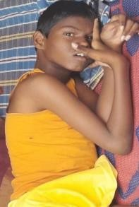 | Physiotherapy:  - To improve Gross motor activities  - Moving from lying on stomach to siting position  - Stand with support by tyre  Special Education:  1.Motor Skills: Peg board | Physiotherapy:  He can ableto do all active movements of both lower limbs upper limb  Able to hold objects for verbal command.  Special education:  Self-help skills:mixed the food Motor skills:catch the ball.  Communication skills:hai.,bye

6 | Karri Rajeswari | 11.06.02 | F | BC | K.Kalavathi, Kolavennu, Kankipadu(Md), Krishna Dist., A.P. Ph No:9949363674 | MR | BP L | 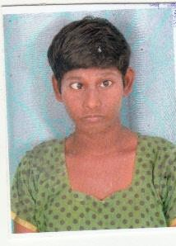 | Physiotherapy:  - To improve Sensory integration  - Walk Upstairs & Down stairs alternating feet  - Touch the wall for balance shoulder  Special Education:  1.pre vocational -Greeting  card making | Physiotherapy:  Shoulder: PNF techniques do actively  Special education:  Pre-vocational: cover making. Cloths  Cleaning the room
7 | Shaik Nagina | 24.05.09 | F | OBC | Sk.Masthan, Neppali, Kankipadu(Md), Krishna Dist., A.P. Ph No:8897624077  Shakila | MD (MR+CP) | BP L | 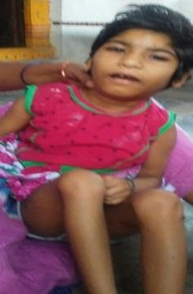 | Physiotherapy:  - Postural stability of the head when lying prone in forearm  - Rolls on flat surface  - Pirof prone with arms held extended in air accurate stabilizers  Special Education:  - cupset  - Ring tower | Physiotherapy:  Sit with support for 5 minutes  Special education:  Cath the ball  Social skills-hai,bye  Fine motor skills-peg board
8 | L.Rupeswar Vivekanadh a | 19.03.2014 | M | BC | S/O Siva Krishna indra nagar yenamalukudur u  Ph 8008448808 | MD (MR+CP) | BP L | 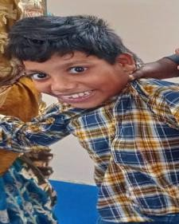 | Physiotherapy:  1.To improve mile stones 2.Facilitates motor development  - To Release spasticity of 60Ft UL&LL.  Special Education:  - Ped board-body parts  - Colour concept | Physiotherapy:  Both lower limbs adductor spasticity release  Surgery planning taken to Virds hospital chinna Tirupati  Right upperlimb movement Range of motion exercises  Special education: Functional writing-writing Reading-house  Number concept-1 2 3
9 | Munduree Yoshitha Brahmani | 21.11.17 | F | BC | Munduree Vasudeva rao DN-23  Venkatapaya veedi Ashok nagar Vijayawada  9553674567 | MD (MR+CP) | BP L | 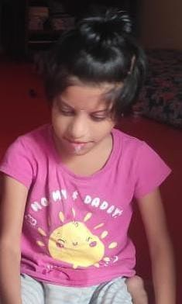 | Physiotherapy:  - Facilitating Motor development.  - Postural Stability of head when lying prone-Hands &knee during galling  - Half Kneeling hand support  Special Education:  1.Ped board-body parts | Physiotherapy:  Able to sit with support  Sit to standing with support Gait training  Special education:  Recreation skills:catch the ball  Communication skills:babu,papa,atta

10 | G.Alekhya | 05.08.18 | F | BC | Syam babu Ashok nagar  vijayawada8ph 885407619 | Locomotor | BP L | 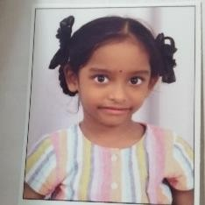 | Physiotherapy:  - To prevent deformity of both Ankles.  - Serial casting techniques | Physiotherapy:  Surgical correction needed Ankle strengthening exercises. Special education:  Functional reading- a to z letter identification.  Number concept-1 to 5  numbers identification
11 | Tellakula Neha Sree | 27.07.15 | F | BC | T Srinivasa rao, 7-21/1,  Bus stand back side, Kunapareddy nagar, Vuyyuru, Vuyyur(Md),  Krishna Dist., A.P. Ph No:9346846264 9030256209 | MD (MR+CP) | BP L | 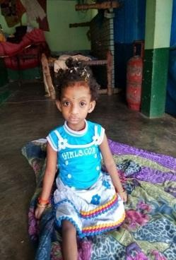 | Physiotherapy:  - Facilitate motor integration  - Stand without support for 5min  - walk with support at 5 min Expressive -commands words  -Ra,Po  Special Education:  1.Sensory Integration | Physiotherapy:  Frenkles exercises  Able to stand with out support by 1 minute  Special education: Vision therapy Holding therapy
12 | Choragudi Alisa grace | 31 -12-2022 | F | BC | Gurajada ,Krishna dt,Andhra Pradesh  Ph 6281837684 | MR | BP L | 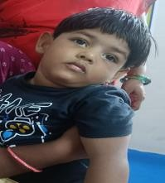 | Physiotherapy:  1.Able to sit with support able to sitting to standing position  Special Education:  1.beads  Saying Namaste , tata, Nanna, Amma | Physiotherapy:  neck holding  Postural development by supine - side- prone lying activities.  Special education:  Recreation skills:catch the ball  Communication skills:babu,papa,atta
13 | V.Hemanth | 18.11.19 | M | BC | Vempati Hemanth reddy c/o:Pentayya  2-144,BC colony tadanki  9581748870 | MD  (CP + MR) | BP L | 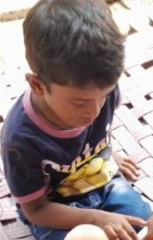 | Physiotherapy:  1.To enhance hand functions postural correction sclerotic posture  Special Education:  1.Social skills-she can says “Namaste” Motor skills: beads | Physiotherapy:  Surgical correction of right lower limbdone  External fixation Able to walk normal  Special education:  He can identified vegitableslike tamota ,brinjal etc.  Writing –a,b  Reading-a b c d letters

14 | Chelli Saaramma | 01.01.98 | F | SC | 6-124  Edupugallu kankipadu  8790998740 | MD  (CP +MR) | BP L | 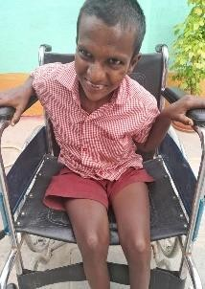 | Physiotherapy:  - To improve motor  - Sensory integration  - To improve gait training .  Special Education:  - beads  - Paper folding greating cards | Physiotherapy:  Able sit to stand with support of one finger  Standing without support for 1 minute  Gait training  Walking with walker with support for 10 steps  Special education:  self help skills:-lower cloths wearing  social skills:-names
15 | B.Ramtej | 18.01.20 | M | OC | s/o:Ratan Jyothi 4-99, opp  panchayathi office main road , mantada  78920661663 | MD  (HI +MR) | BP L | 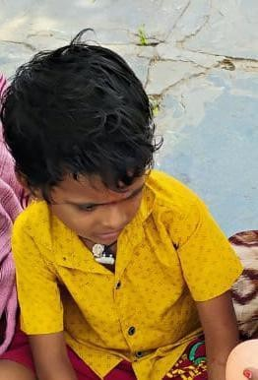 | Special Education:  1.beads  Saying Namaste , tata, Nanna, Amma | Special education:  Recreation skills:catch the ball Communication skills:babu,papa,atta Self-help skills:shirt wearing
16 | P.Akshay | 01-01-2009 | M | SC | M.Nageswara rao H:No-3-11  Gurazada pamidimukkala Krishna  8790723446 | MD  (CP+ MR) | BP L | 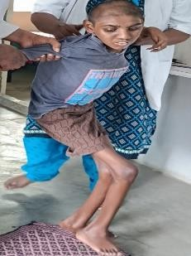 | Physiotherapy:  - To release spasticity of both  LL& UL  - To improve sitting with support  Special Education:  1.Social skills-Namaste | Physiotherapy:  gait training with support of walker  Special education:  Recreation skills:catch the ball Communication skills:babu,papa,atta Eating skills:-mix the food
17 | K.Saikumar | 01.01.2000 | M | OC | k.sai kumar s/o:Venkateswara rao  8-166  Katuru road vuyyuru  9392633351 | MR | BP L | 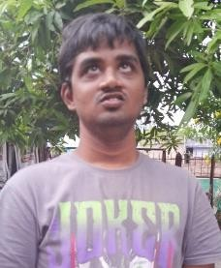 | Physiotherapy:  1.To enhance hand functions  Special Education:  - String the beads  - Social skills -Namaste | Physiotherapy: vestibular development  Special education: Personal skills: Dressing-pant  Motor skills-vegetable peg board  Prevocational-papper folding

18 | Raviteja | 01.01.1998 | M | BC | c/o;K.Ramesh d/no:11-154 Indian bank bajan vuyyuru  ph 9553828865 | MR | BP L | 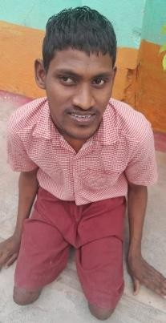 | Physiotherapy:  - To improve both lower limits range of motion  - To release spasticity of both LL&UL  Special Education:  1.String the beads , dressing Social skills: Namaste , bye | Physiotherapy: sitting to standing by proprioceptive method  Special education: Functional writing: Writing-weak names Number concepts
19 | Kamdru Yeswanth | 29.05.2000 | M | SC | S/O Kandru chetraji  ,gurajada ,Krishna dt  Ph 9885347494 | MR | 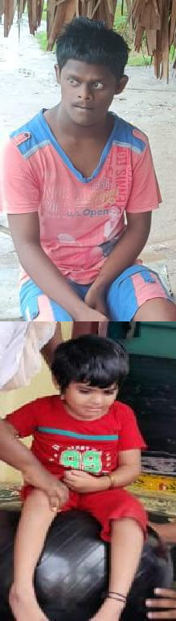  BP L |  | Physiotherapy:  1.To improve hand functions  Special Education:  1.String beads  Social skills: saying Namaste | Physiotherapy:  vestibular and proprioceptive development
20 | Sk. Nousheen | 09.09.2019 | F | BC-E | SK.Rasool  Near high school Thotlavaluru vuyyuru  Ph 73969951 | CP | BP L |  | Physiotherapy:  1.Able to sit with support able to sitting to standing position Special Education:  1.Motor skills – Tower blocks Social skills-she can say Namaste | Physiotherapy: postural correction for  standing by calipers of both lower limbs  Spinal correction.
21 | T.Ajay | 10-06-02 | M | SC | T.Tirupathi Rao, Chinna Ogirala, Vuyyuru (Md). Krishna Dt.,A.P.  Ph 9440522386 | MR 90% IQ-24 | BP L | 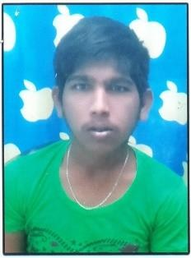 | NEW ADMISSION | Physiotherapy:  - Able to sit with support able to sitting to standing position.  - frenkles exercises Development of upper limbs. Special Education:  1.Motor skills – Tower blocks  Social skills-he can say Namaste,Bye

22 | T Sai Kumar | 17-10-01 | M | SC | T.Tirupathi Rao, Chinna Ogirala, Vuyyuru (Md). Krishna Dt.,A.P.  Ph 9440522383 | MR 90% IQ-18 | 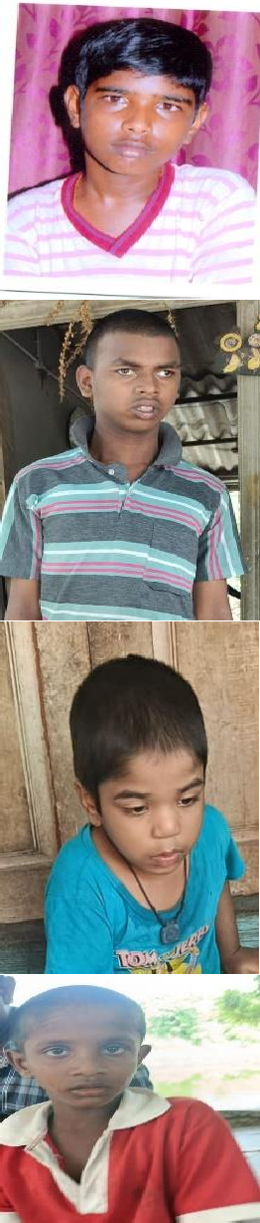  BP L |  | NEW ADMISSION | Physiotherapy:  - Able to sit with support able to sitting to standing position  - frenkles exercises development for upper limbs.  Special Education:  1.Motor skills – Tower blocks  Social skills-he can say Namaste,bye.
23 | Mannem avinash kumar | 22-05-2011 | M | Sc | Veedla donka,kankipadu lakulu  Ph 9392228993 | MR | BP L |  | NEW ADMISSION | Physiotherapy:  1. vestibular development  Special Education:  1.Motor skills – Tower blocks  Social skills-he can say Namaste,bye
24 | Pattan Sameer Khan | 30-09-20 | M | BC | Gurajada,Krishna dt  Ph 9381178867 | MR |  |  | NEW ADMISSION | Physiotherapy:  1. cognitive and proprioceptive development.  Special Education:  1.Motor skills – Tower blocks  Social skills-he can say Namaste,bye
25 | Jhon yesu | 01-01-2018 | M | sc | Chinnapulipakka  ,kankipadu md  Ph 9951698410 | MD | BP L |  | NEW ADMISSION | Physiotherapy:  1.Able to sit with support able to sitting to standing position  Special Education:  1.Motor skills – Tower blocks  Social skills-he can say Namaste,bye
Male :: 12 Female ::13 Total :: 25 Category :: (Gen + OBC) :: 12 SC :: 9 ST :: 01 OC::3 MD :: 18 MR :: 06 LOCOMOTOR :: 01
