Asha Greater Kansas City Chapter New Project Proposal Template

Project Name: Sirisha Rehabilitation Centre | Date Received:
Referred By: | 09/21/2022

 | Project Contact Information | Asha Contact
Name | Mr. M.SOMESWARA RAO | Raji Muppala
Contact | 011-91- 9441413161  9397646210  c
Address | Sirisha Rehabilitation Center  D No: 3-57, Veerankilock,  Pamidimukkala,  Krishna Dist., Andhra Pradesh,  Pin Code – 521250 | Kansas city Chapter
Phone | 011-91- 9441413161  9397646210  c
Fax
E-mail | srcpamidi@gmail.com | rajichavali@gmail.com

Part I: Information about your group/organization
Please feel free to attach any additional sheets and/or information such as brochures, press reports etc.

1. Name of the group/organization requesting funds. Sirisha Rehabilitation Centre (SRC)

2. When was the group established? 2004

3. Briefly describe the motivation for starting this group.

Sirisha foundation supports children with intellectual and development disabilities (CWIDDs). Currently got 2 centers at Vuyyuru, and Veeronkilock, Krishna Dist. A.P.
Early invention center for kids ages 0-6 and Special School cum Vocational Training Centre at school follows the pattern of Special Education as designed and approved by Ministry of Social Justice & Empowerment, Government of India, New Delhi. In both the centers support 116 kids.

Home Based Educational Project Asha for Education (Chapter: Kansas City) started supporting from March 2018:
Villages: In this project, priority has been given and identified Nine Villages as: Vuyyuru; Gandigunta; Ekamur; Peddaairala; Neppalli; Polavennu; Punadipadu; Boddapadu; and Kankipadu.
25 numbers of CWIDs have been identified and started providing the services of the Project.
4. Name the key people running the organization and describe their background

- Dr M. ANUSHA: SISTER – Administrator:
- M. Immanuel: President.
- M. Ratna Bayamma: Mother – Founder – Special Educator – Financial Manger.

5. Briefly describe the aims of your group.
The aims of the group targeted for the present project of Community / Home Based Rehabilitation (C/HBR) are very specific matching to the dynamics of the CWIDDs and Home & Community which vary from one to another. Some of the key aims of C/HBR includes:
- Early Identification: Supports for the early identification of CWIDDs with better connectivity with parents, community members, health workers, social workers, health care centers, panchyat, and others at Community.
- Assessment, Screening and Certification: Helps for Categorization of Disability, Severity of Disability by the internal team and facilitation for Disability / Medical Certification by the Government Hospital.
- Special Education (6-18y): Provide Special Education with preparation for skill development by way of pre-vocational activities.
- Vocational Training (above 18y): Skill development for improving employability both in open market and /or self employment which includes self help groups (SHGs).
- Inclusion: Both Socially and Economically for independent living with equality, dignity and respect in an accessible, friendly, and rights-based environment like their normal counter parts.

The aim of the groups is to work for the training and rehabilitation of the CWIDDs in the model of empowerment so that they will better access for their needs and thus to move towards independent living within the family / community with equality & dignity as a right.

6. Does your group have any religious or political affiliation? If yes, please describe the type of affiliation and the reason for it.
NO. SRC is a voluntary service organization.

- What non education-related community development activities are your group involved in?

By definition, “CBR is the strategy within the community development for the Rehabilitation, Equalization of Opportunities, and social integration of all people with disabilities” CBR reflects that is it the model of multisecotral and multi-disciplinary approach. In addition to the training and rehabilitation of the CWIDDs, CBR also focus on several aspects of community development (CWIDDS will be the essential part of these activities) and some of them includes:

- Awareness on Health Care, Nutrition, Water, Sanitation, Hygiene, Pollution and other aspects of clean, green, and healthy environment.
- Information cum Facilitation for Acts, Policies, Schemes, & Benefits, which includes utilization, monitoring and evaluation.
- Need and Facilitation for the creation of Accessible Environments with spaces for all.
- Awareness cum Facilitation for the prevention of the causes of disabilities for moving towards disability free community / society.
- Recreational, Sports and Games for better connectivity, strength, and harmony.
- Capacity building of the community for better living with sustainability and thus to address their needs & challenges with ownership.
- Other need based activities of the community from time to time which vary from community to another.

8. Does your organization have FCRA (Foreign Contribution Regulation Act of 1976) clearance from the Indian government? This is required for you to receive foreign funds. If yes, please provide FCRA details. If no, have you applied for Prior Permission (one time acceptance of foreign funds)? If yes, when was the application submitted?

YES. Got registered and clearance from Indian Government.
FCRA Registration No. 010260293 Date: 22nd August 2016
Bank Name & Address: ANDHRA BANK,
VEERANKILOCK BRANCH, VEERANKILOCK PAMIDIMUKKALA MANDAL, KRISHNA DISRTRICT. ANDHRA PRADESH. PIN CODE: 521250
Account Number: 060011011000182
IFSC Code: ANDB0000600 SWIFT Code: Andhra Bank MICR No: 520011666

Part II: Details about your educational project/s

- List the school/s run by your group, and their locations. If you are requesting funds for only a few of several schools, please specify which one/s.
- Community Based Rehabilitation (CBR) for CWIDDs - Requesting funds
- Early Intervention Centre for CWIDDs (IBR) - Vuyyuru, Krishna District, AP.
3.Special School cum Vocational Training Centre (IBR) – Veerankilock, Pamidimukkala Mandal, Krishna District, AP.

- Who owns the school legally? Is it the organization or trustees or an individual. Please provide details.
Organization (SRC)

3. Location of school/s Urban Rural Other
The CBR Project is situated at Veerankilock, a RURAL part of Pamidimukkala Mandal, Krishna District, AP.

4. Specify the type of education provided (e.g. basic literacy, vocational training etc.).
The Education provided at CBR is the combination of Normal Education and Special Education (designed & approved by Rehabilitation Council of India, Under Ministry of Social Justice & Empowerment, Government of India), New Delhi. In addition to the Rehabilitation Service & supports (to minimize the impact / limitations of disabilities), the education provided under CBR for CWIDDs includes: basic literacy, protection & safety, vocational training, skill development, facilitation for employment, design & development of livelihoods as self employment, group employment (self help groups – SHGs), facilitation for micro entrepreneurships, use of technologies, and other aspects with effective monitoring and evaluation tools.

5. Please tell us about your teaching techniques (conventional vs. alternative).

The teaching techniques developed for the CWIDDs under CBR model are the combination of conventional and specific following the concept of individualized educational program with better match to their skills and IQ. All such techniques are child centric with the ratio of 1:10 as their IQ is much less compare to their normal counterparts. Several teaching techniques were developed by the Disability Professionals and well accepted. For some of the border cases of CWIDDs, conventional teaching techniques will be used to enhance their educational qualifications as per the guidelines of Government. In this, teachers qualified and trained in Special Education (approved by Government) will take up the teaching of CWIDDs.
.

6. What is the literacy rate in your local community? Please give a breakdown between boys and girls if possible.
In the selected villages for the present project of CBR, no such service centers are available and stay thus quite away from the opportunities of getting themselves as literate

7. Describe the socio-economic background of the children and their parents (e.g. education, occupational). If any of your students are employed, please tell us about that as well.

Economically, many parents come under the category of BPL (Below Poverty Level – where their income limit is less than Rs.60,000/- per annuam).
Occupation wise, parents of CWSNs are daily wage laborer in the sector of agriculture, construction, industries, and other seasonal sectors.

- What are the admission criteria for the students to join your school? Have you ever turned away students? If so, why? How many children attend your school currently? How many teachers do you have? How many full time students? How many part time teachers? How much is the fees? Is there an admission one time fee? Do you have parent teacher meetings (parent involvement)?

The admission of CWSNs is based on the vulnerabilities of disabilities and their needs including their parents / family. At present 116 CWIDDs are getting the services and supports at Institute (IBR) covering above cited two Schools / Centers / Projects. In addition, 125 CWSNS will get matching services and supports at their Home (HBR) and Community (CBR).

9. In addition to education, does your group provide any other services to the children in your schools (e.g. food, health care, clothing, etc.)?

Food, Health Care, Clothing, Sports & Games,✓ Cultural Activities
10. How do you perceive that education will improve the lives of the children in your village?
The combination of Education both Normal & Special along with training, rehabilitation, skill development will open several opportunities to improve the lives of CWIDDs with better connectivity with family and community. Such strategies and interventions of SRC have been accepted by the Government, Professionals and other Stakeholders by way of National Award.
11. Does your school have:

Its own building(s): Yes No Number
Number and type of classrooms (e.g. Pukka): 3

Yes No Yes No Yes No
Toilets Playground Toys
Chairs & Tables Blackboard Library
Drinking water Electricity Computers
Laboratory Teaching aids (e.g. books/slates)
12. What is the age group of the children currently enrolled in your school(s)?

Early Interventions: 0-6 years. Special Education: 6-18 years. Vocational Training: 18-21 years.

13. How many employees are employed at your schools?

SRC has engaged the services of Special Educators (Special Teachers), Rehabilitation Professional, Medical Professionals, Physiotherapist, Psychologist, Psychiatrist, Speech & Communication Therapist, Office Staff, Supporting Staff, and Volunteers. The details of the manpower employed by SRC in various Schools / Centers / Projects are as follows:

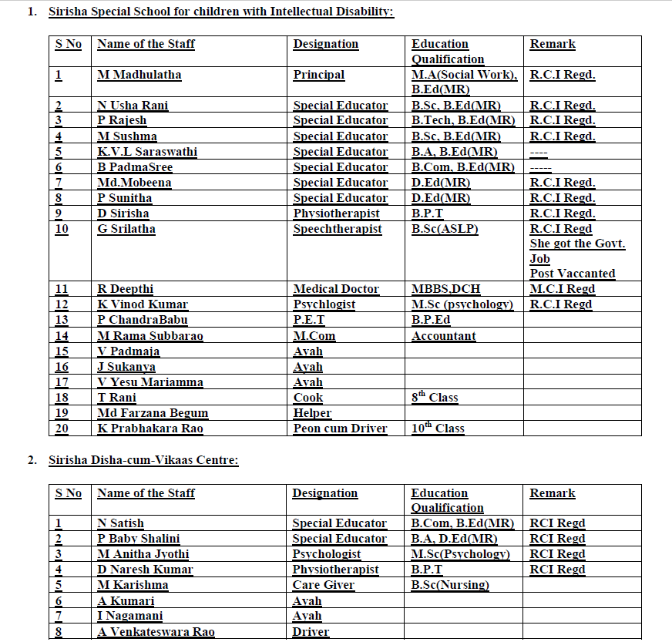

14. Average distance the children travel to attend your school

15 KM
15. Please answer this if your school has existed for atleast 5 years. How many children have gone through your program in the past five years and what are they doing currently? Please tell us about their future education possibilities. How would you visualize their future employment possibilities?

Yes. Organization is running several schools/projects/centers since its inception 2004 and certainly having existence for more than 5 years. The children who got admitted into our schools / projects / centers are having very less IQ (in an average 20 to 45% only) as they are associated with intellectual and developmental disabilities. These children need training and rehabilitation on life cycle basis. The details children who successfully completed the training and left each center are as follows

Early Intervention (0-6 years): 86 Nos. Out of them 64 have gone to Special School of SRC only. The remaining 22 are dropouts due to health problems, transfer of their parents, migration, and other vulnerable situations.
Special School (6-18 years): In addition to 64 children, who came from the project of Early Intervention, 112 children have joint this school from time to time and total admitted into this School are 186 children. During this process of training and rehabilitation, many could not complete (68 children) due to issue like: health, transfers, ageing of parents, low priority due to dependency other family members / grandparents, forced to be the orphan or abandoned, and other challenges & vulnerabilities. 118 have successfully completed education cum training at Special School. Out of 118 children, 73 children have joined their family business/ livelihood activities, and remaining 45 children have joined Vocational training or skill development
Vocational Training / Skill Development (above 18 years): 45 children joined this Centre and successfully completed training in various trades and prepared them for either for self employment (with parents) or group employment (self help group with 5 to 10 parents). Out of this group, 5 are working with the organization as special employees on remuneration basis and others (40 children) have joined with their family business / occupation / livelihood activities and other such income generation activity. As such children engaging in generating income by joining their family members is not sustainable, organization is planning to start Training cum Production Centre on the mode of Cooperative Society with better protection and safety. Such arrangement is also required to answer the concern of every parents that “what will happen to the child after us?” which forces organization to develop Life Care Centers (LCCs) with legal frame.

Home Based / Community Based Services (all age groups): The students who are coming to get the services and supports at center needs facilitation at their home and community for better monitoring from time to time. In addition to these children, several such others who are reaching the organization will also get the matching services and supports. At their home / community.

16. Do you help your students with their future education efforts after they have completed school? If so please describe your efforts.
YES. After the completion of training, rehabilitation and education, organization helps them to plan for their future training / skill development / education. Our team also makes visits to their home and community. These efforts includes: support & guidance for further education mostly on distance mode, updating for skill development, preparation for income generation activity / livelihoods, facilitation for self employment / group employment, creating opportunity to work with organization as an employee, and other need based services / supports / facilitation matching to the individual’s skills & requirements.

17. Do the students who have studies or graduated get involved in the school afterwards and help the next batch? YES. Some of the students who are engaged in open employment / self employment / family occupation will come and supports their juniors. In view of their challenges and vulnerabilities such chances are very much limited but organization encourages the selected individuals.

18. Are there any other schools (Kindergarten/Balwadi, Elementary school, High school) in the area? If so, please list the schools and the range of classes each of them offers.YES. But all such schools centers will work for the normal children. SRC work with the children with intellectual and developmental disabilities. The Government will depend on NGOs to work for such children.
19. Is your program different from that provided at these schools? Please explain.
Our program is working with children with intellectual and developmental disabilities is entirely different from that of the normal children, such schools / centers will not admit these children.
20. Why are the children in your school/s not attending government/other schools in the local area?
The children in our Schools / Projects / Centers are with intellectual and developmental disabilities. They cannot attend the Government / others School situated in the area and all such Schools are not ready or prepared to take these children with special needs.
21. Do you try to involve the parents of the children in the running of the school (e.g. in setting the syllabus etc.)? Please specify.
YES. Organization involves the parents / siblings / other family members of the children at all the states including: early identification, screening, assessment, interventions, training in activities of daily living (ADLs), Behavior Modification & Learning, Special Education, Vocational Training
22. What are your expansion plans for the future
Organization has got need based future vision matching to the needs, vulnerabilities and skills of the children with intellectual and developmental disabilities and some of them include:
To develop Community Based Rehabilitation Centers
23. Any additional details you would like to provide to us

The Outcome and Impact achieved in respect of 25 CWIDS who have got the benefit of Training, Rehabilitation, Services, Supports, Referral Services during last 12 months duration (April - march 2019) is significant and some reflections include:
- Better Awareness on the Causes & Consequences of Disabilities in day to day life and growth cm development.
- Therapeutic Services covering: Physiotherapy, Speech & Communication, and other matching supports.
- Supply of Aids & Appliances and Supporting Devices.
- Better and Effective Participation of the Parents, Family Members and Community Members.

Tata express vehicle was provided by Asha for Education, USA which is very useful in fulfillment of our aims and objectives and targets to serve the rural and remote area disability children, for better improvement in their physical and mental health. Teachers able to take suitable equipment and tools to provide better service. CWID kids and parents able to attend camps organized by Sirisha rehabilitation center.

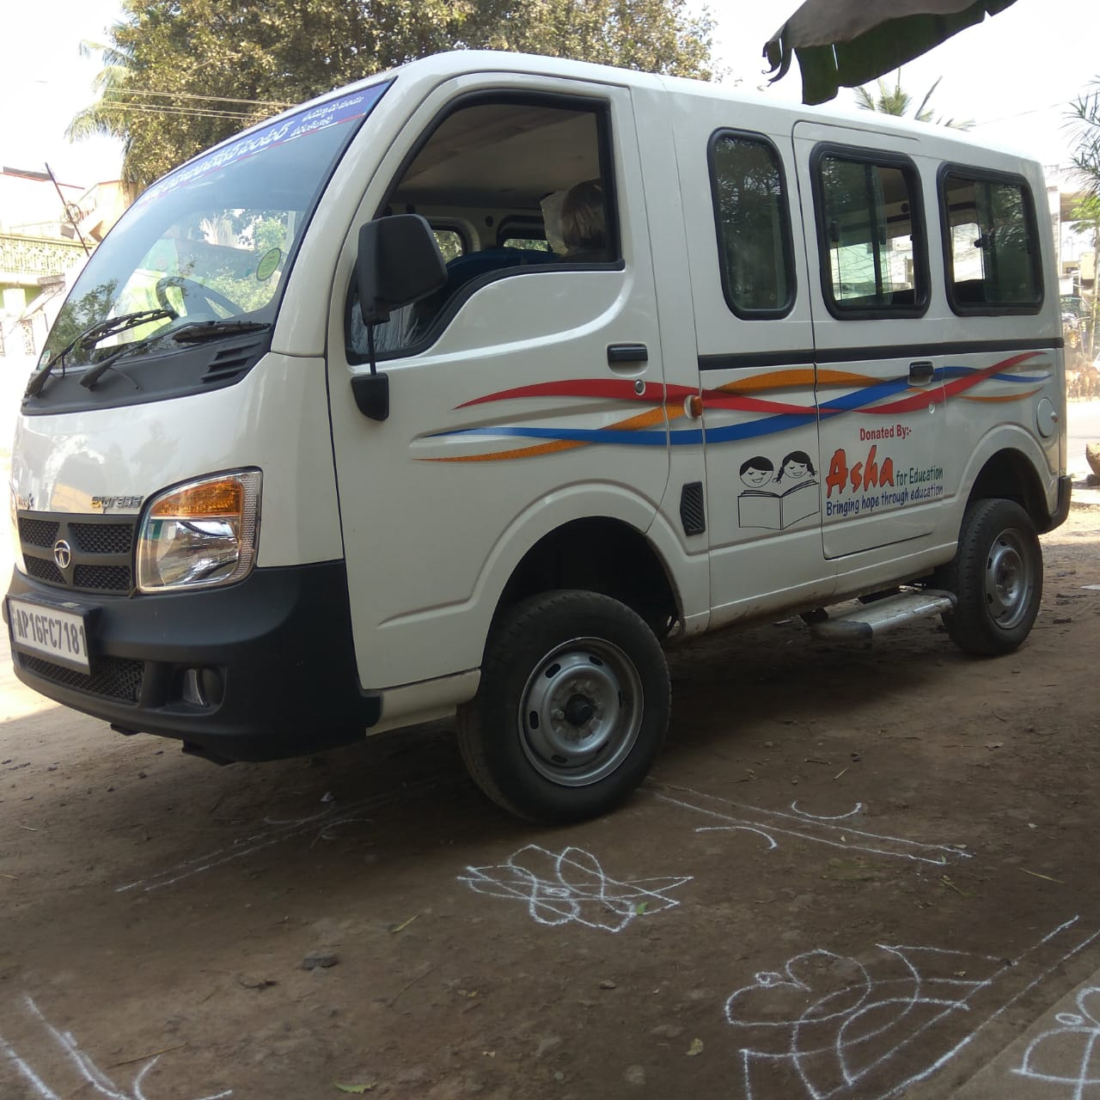

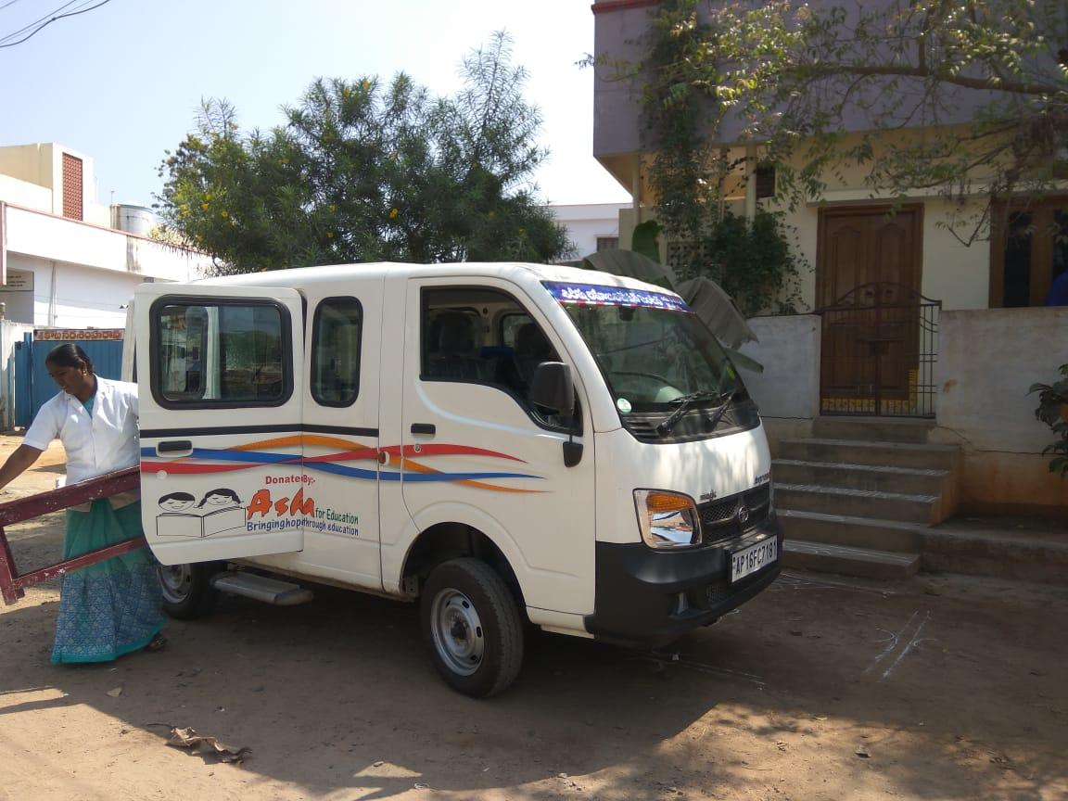

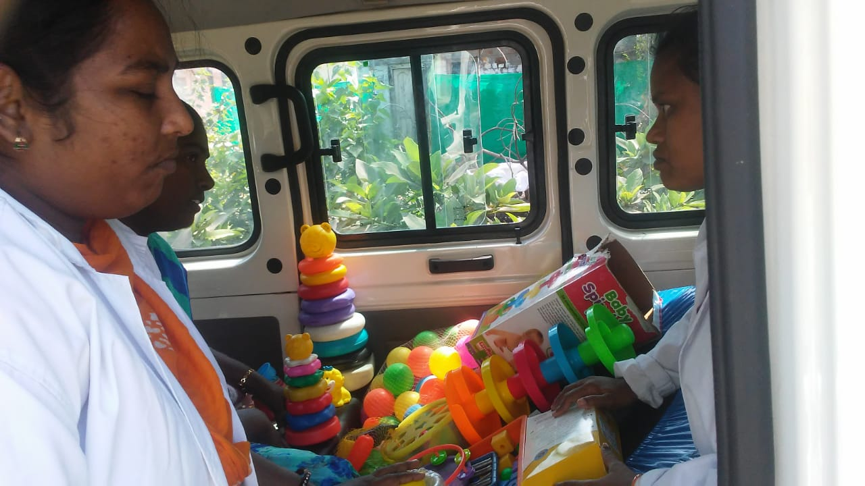
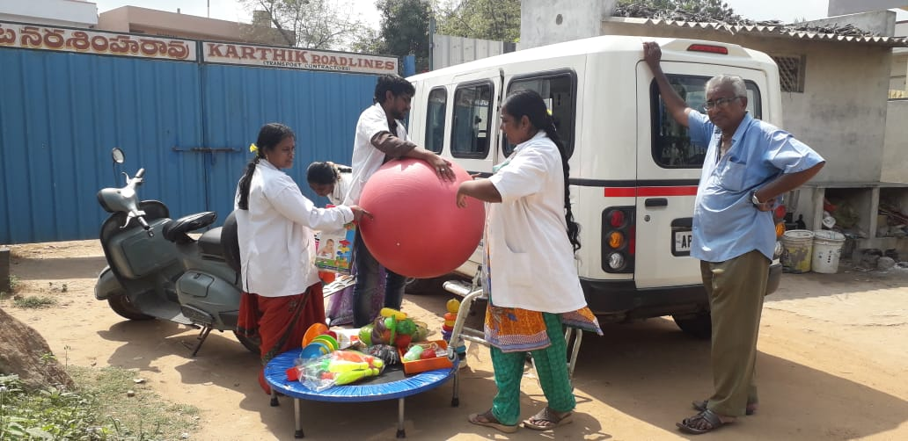
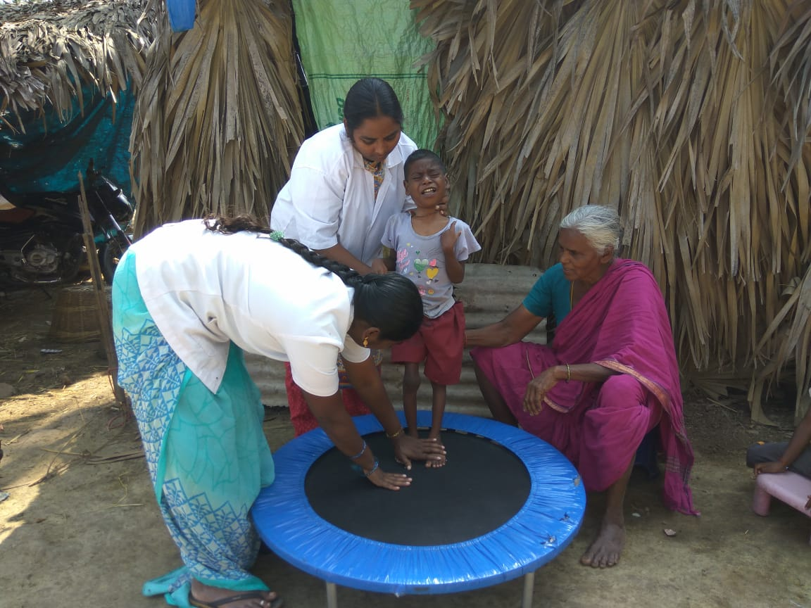
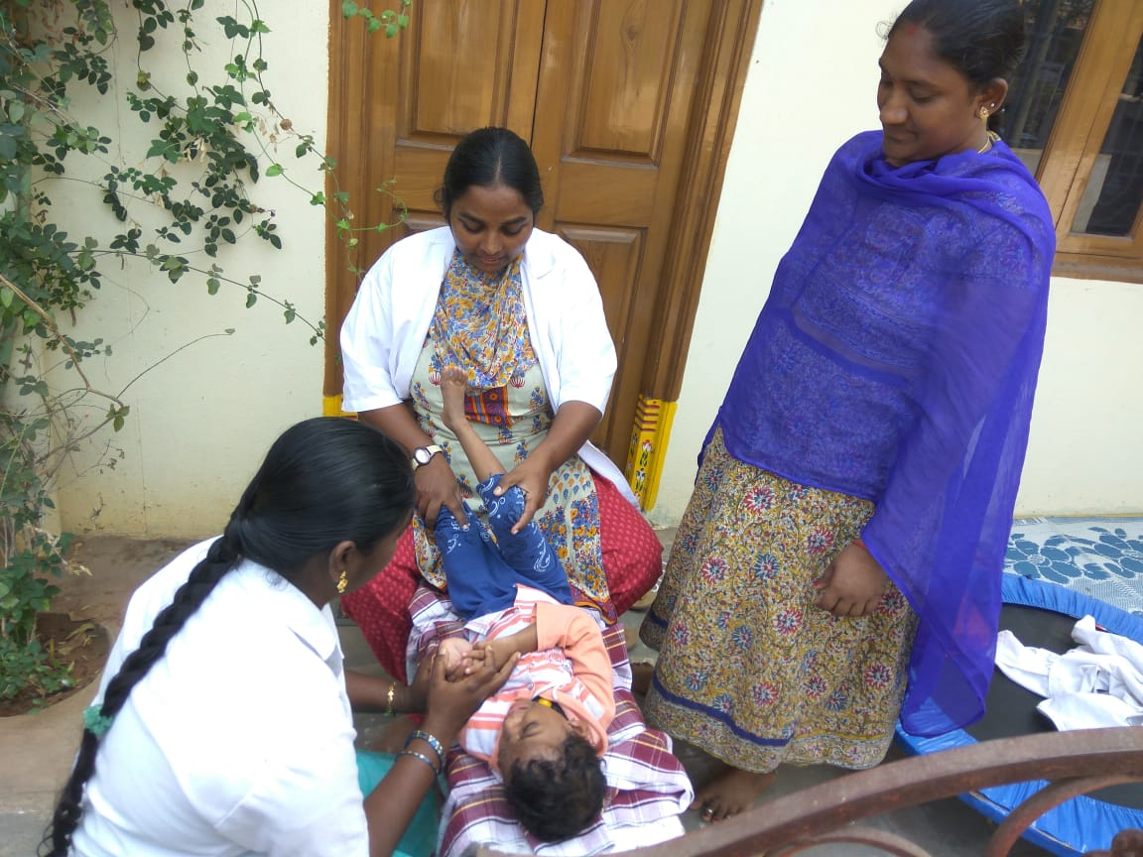

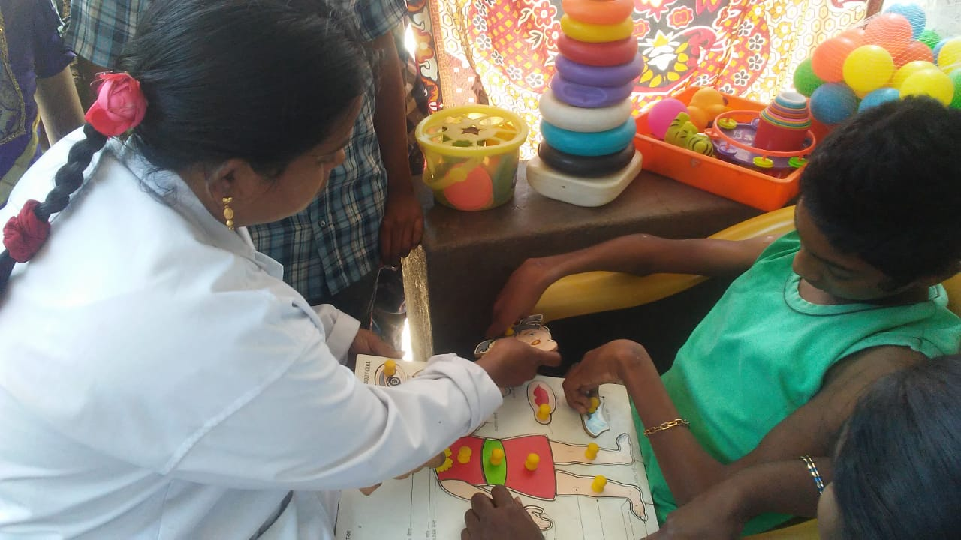

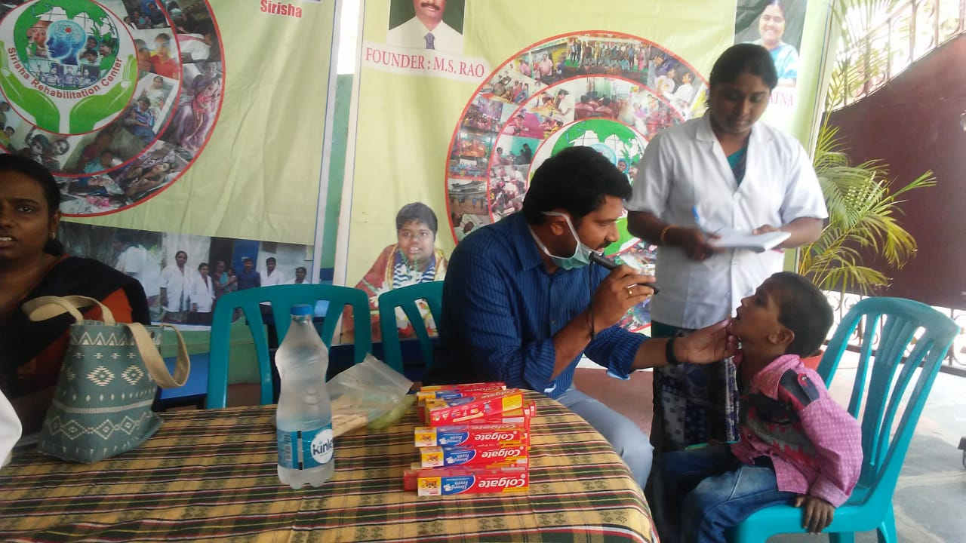

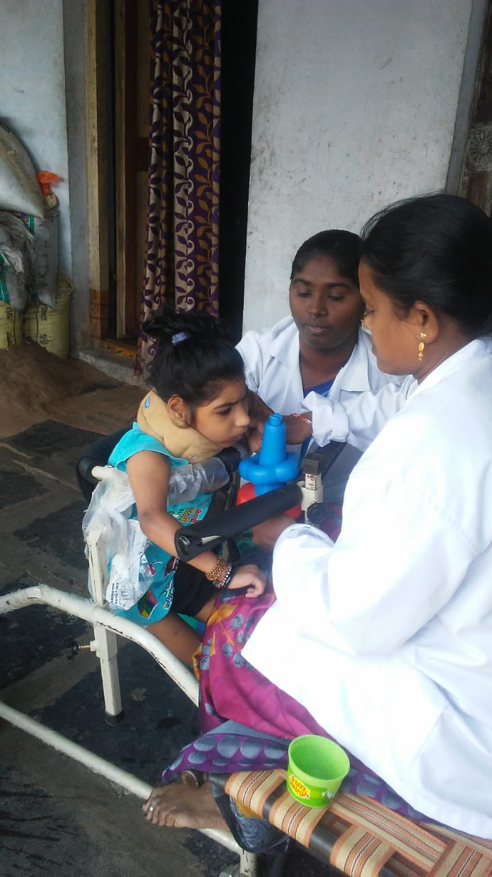

24. If possible, please provide us with the contact information of two individuals from your community (not related to the school) who can describe the impact of your program.

S.No | Name | Contact Information
1 | N .LAKSHMINARAYANA | CELL NO –09392445973  grcnln@gmail.com
2 | M. SOMESWARA RAO | 9441413161  srcpamidi@gmail.com

25. Asha for Education requires reports from its projects every six months to continue funding. Please provide the contact information for the person from your group who will be responsible for these reports.
Name | P RAJESH
Address | 3/57, VEERANKILOCK,KRISHNA DIST,  ANDHRA PRADESH  PIN-521250
Phone | 08676-282829
Mobile | 91-8074032030

Part III: Financial Details
Please feel free to attach any information such as annual reports, budgets etc.

1. What sources fund your group’s activities at present? List the sources and the current and future funding from each of them. If these funds are meant for a specific part of your group’s activities, please describe those restrictions.

Local donations and some funds from Government

- Please provide us with details of your projected budget for one year:

This is one time request

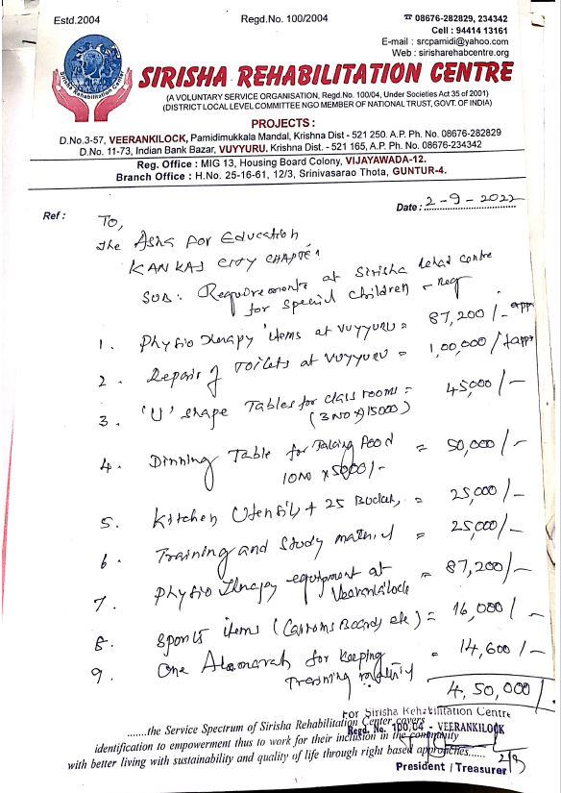

Support Students every year:

Beneficiary Name | Study Details | Support Needed | Contact Number
Junapudi Mahesh Babu | B.Tech (ECE) - 2nd Year in Gudlavalleru Engineering College, Gudlavalleru. | Rs. 39,000/- | 7337226336
Vuyyuru Nithya Sri | Intermediate completed | Rs. 20,000/- | 8125251676
A.Sai Deekshit | Degree – 1st Year | Rs. 20,000/- | 9963839620
 |  | Rs. 79,000

- What amount are you requesting from Asha, and for what specific purpose?

Description | Amount | One time/Every year
School equipment, training materials, renovate bathrooms, kitchen utensils | 4,50,000 | One time
Student fees | 79,000 | Every year

IMPORTANT: For Asha-GKC Use Only

To be filled by project steward:

1.What parts of the above budget was approved?

Description | Amount | One time/Every year
School equipment, training materials, renovate bathrooms, kitchen utensils | 4,50,000 | One time
Student fees | 79,000 | Every year

2. What is the total amount approved in Indian Rupees and for what time period?

Expenses for April 2022 to March 2023

Year | Amount
1 | INR  529,000

3. Please list out the first year’s goals of this funding (ie. what are the metrics by which we will measure the progress of this project? Please try as much as possible to list out objective things that can be measured.)

One Kid promoted to Sirisha special school from home-based program

Please find kids details who are getting benefit through this program.

Home Based Beneficiaries List 2022-23

