Asha Greater Kansas City Chapter Covid Relief support Proposal

Project Name: Sirisha Rehabilitation Centre | Date Received:
Referred By: | 06/25/2020

 | Project Contact Information | Asha Contact
Name | Mr. M.SOMESWARA RAO | Raji Muppala
Contact | 011-91- 9441413161  9397646210
Address | Sirisha Rehabilitation Center  D No: 3-57, Veerankilock,  Pamidimukkala,  Krishna Dist., Andhra Pradesh,  Pin Code – 521250 | Kansas city Chapter
Phone | 011-91- 9441413161  9397646210  c
Fax
E-mail | srcpamidi@gmail.com | rajichavali@gmail.com

Sirisha foundation supports children with intellectual and development disabilities (CWIDDs). Currently got 2 centers at Vuyyuru, and Veeronkilock, Krishna Dist. A.P.
Early invention center for kids ages 0-6 and Special School cum Vocational Training Centre at school follows the pattern of Special Education as designed and approved by Ministry of Social Justice & Empowerment, Government of India, New Delhi. In both the centers support 120 kids.

Sirisha team also provides service to 25 children at their home who unable to come to their school. This project is funded by Asha for Education (Chapter: Kansas City)

Sirisha team provided grocery to many families with the support of Asha for education covid round1 funding. Few pictures enclosed below:

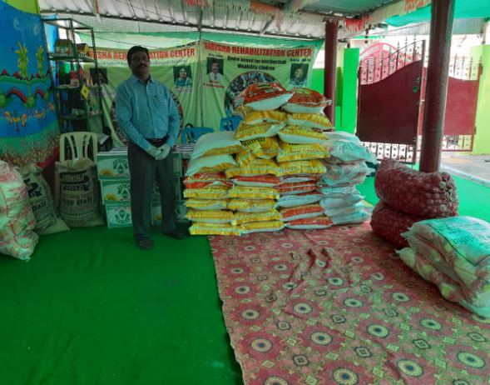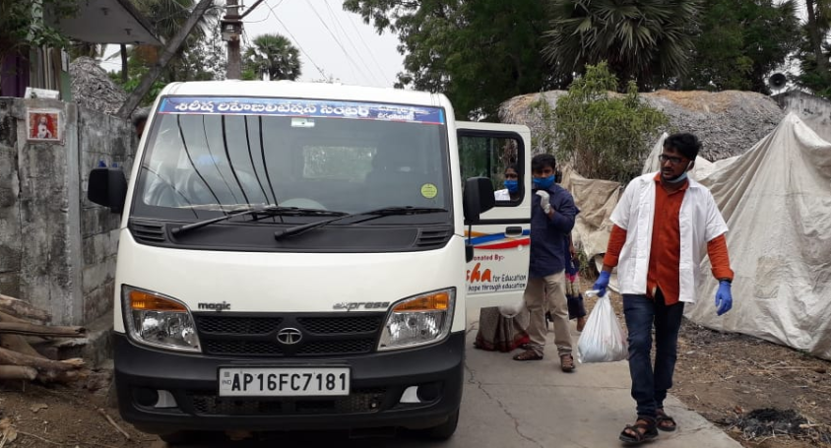
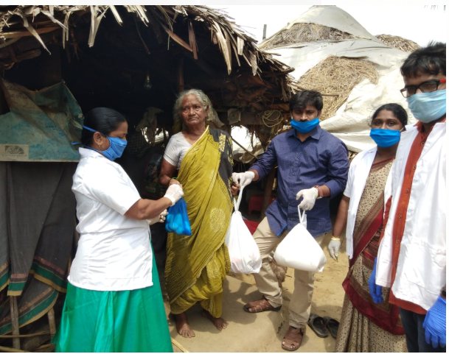

Sirisha team cooking food and dropping to 25 old people. Sirisha team need funding to feed these 25 old people for next two months. Pictures provided below.

Number of people | Cost per day
25 | ₹2500
Total amount to serve 25 people for 60 days | ₹ 1,50,000

Proposal is to provide food for 25 people @ ₹ 100 per day per person for 60 days , total amount of ₹ 1,50,000.

