Site visit report of Nayantara
Prat Das Kanungo

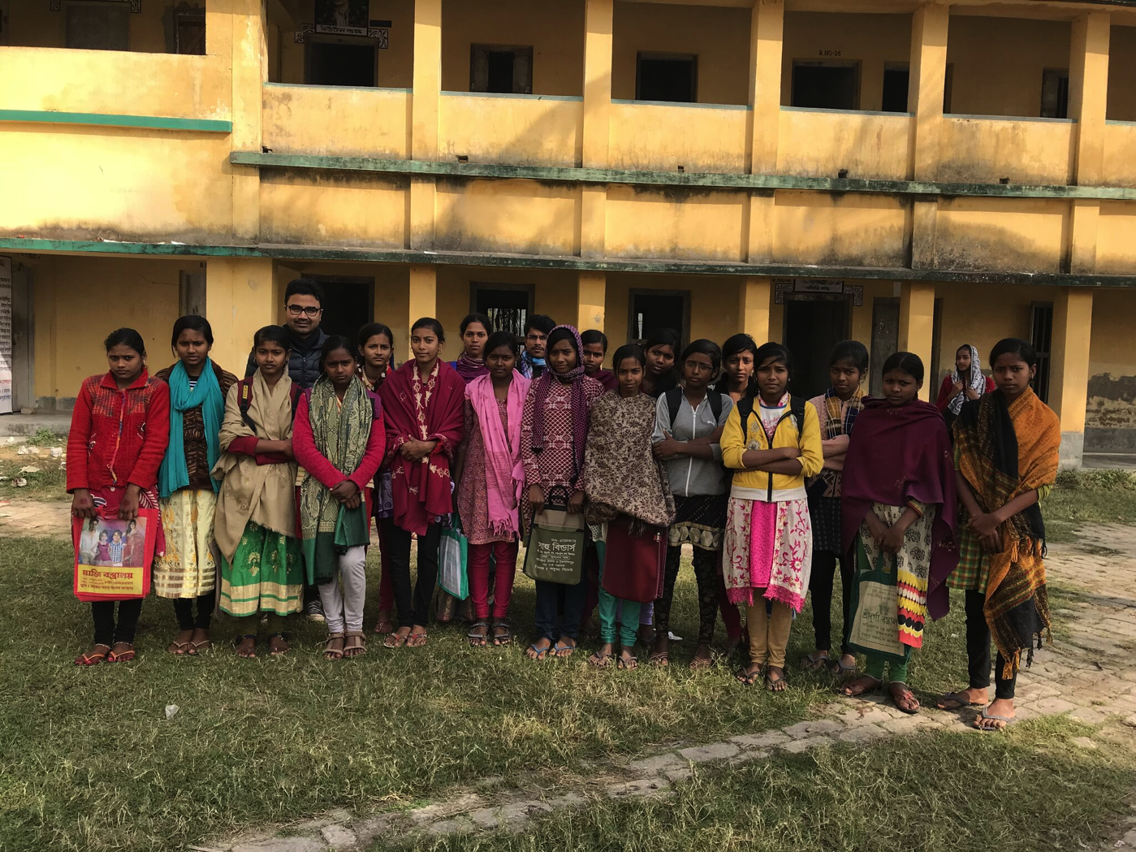
Nayantara girls with Prat on the ground of the government school at Mahabatnagar

Supporting Asha chapter: Asha Zurich
Visit done by: Prat Das Kanungo from Asha Zurich
Project Partner: Sabuj Sangha
Visit Facilitator: Arunabha Das and Ansuman Das
Location: Nandakumarpur and Mahabatnagar village in Sundarbans (3 hours from Kolkata)
Date of visit: 04-06. January 2018
Asha Zurich’s funding started from: July 2017
Project brief (as per Asha page): To support the education of 20 girls in the frame of The Nayantara Project (Girl Child Sponsorship Project) in the educational center in Nandakumarpur village of Mathurapur

Project description (as per Asha page):
- To ensure education of Girl children up to XII i.e. completing 18 years of age.
- To enhance the competency level of children.
- To develop ICT skills and access wider sphere of knowledge.
- To build awareness on health & hygiene and encouraging for ecological restoration.
- To stop early marriage and adolescent pregnancy and its related complications.
- To prevent child labour and child trafficking.
- To develop knowledge of life skill & cognitive aspect.
- To empower them by means of giving vocational trainings

The visit was divided into five parts

- Visit to the tuition center and interaction with the girls
- Home visit to some of the girls in the community
- Observation of their physical education class
- Looking at the accounting books
- Meeting with the staff members

They are briefly described in the following.

1. Visit to the tuition center and interaction with the girls
Visit to the tuition center took place in the morning of January 5. Sabuj Sangha supports two classes of 20 girls in two villages. The Asha supported girls are in the village of Mahabatnagar, which is about 5 kilometers from Nandakumarpur, the head quarter of Sabuj Sangha.
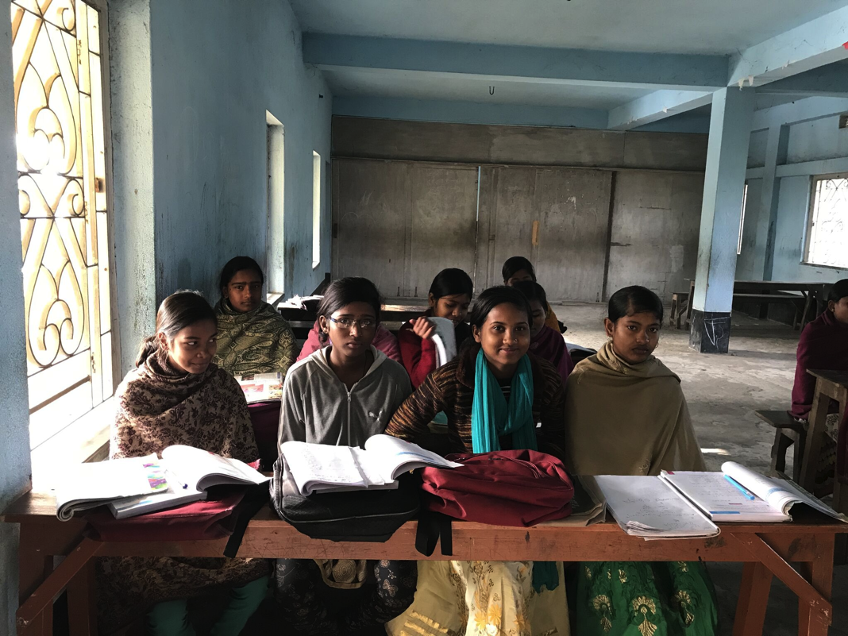
Nayantara girls in their tuition class room
The tuition classes take place in the government school of the village there. The first thing to be noticed is the poor condition of this school. Classrooms are in really bad conditions and the lobby is very dirty. Sabuj Sangha is trying to move the class to the primary school, which is apparently cleaner.
The students get tuition in math, science and English. At the time of the visit, the math class was going on. 17 out of 20 girls were present. The students greeted me and subsequently I proceeded with individual interviews. All girls confirmed that they receive daily breakfast, monthly hygiene kits, and periodically books, pens, pencils etc.
The interview outcomes are tabulated in the following table with a photo of the respective girl.

Name | Picture | Family background | Comment
Angana Sahu | 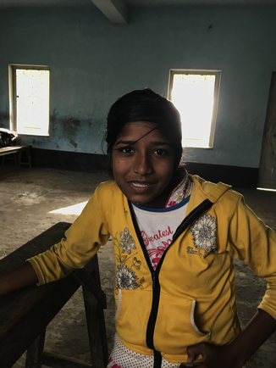 | No study guidance in family.  No pressure to get married yet. | Finds the tuition helpful.  Misses very few classes.  Wants to be a nurse.
Susmita Das | 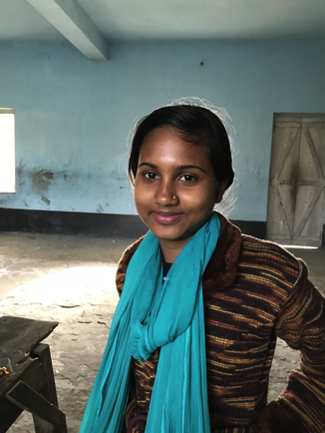 | Gets some study guidance at home. | Finds the tuition helpful.  Comes on a bicycle.  Missed once or twice.  Wants to be in service industry.
Srabani Jana | 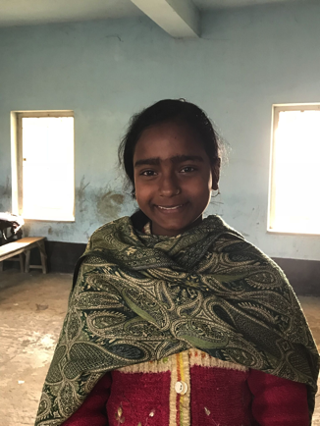 | No study guidance at home. | Finds the tuition helpful.  Comes on foot (30 min).  Wants to learn computer skills.  Wants to become a doctor..
Malati Jana | 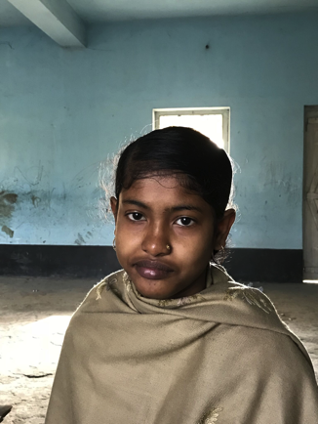 | No study guidance at home. | Finds the tuition helpful.  Wants to be a footballer. Plays with her brothers.
Swati Adak | 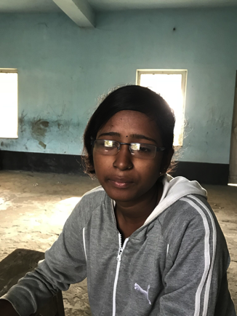 | Some guidance at home. | Finds the tuition helpful.  Comes regularly on bicycle.  Wants to be a nurse.
Tanima Khanra | 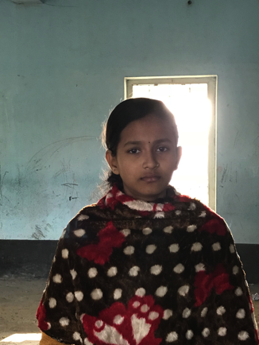 | Parents laborer.  Gets some extra study guidance in other subjects from another tuition. | Finds the tuition helpful.  Comes on a bicycle.  Wants to be a nurse or a doctor.
Jayashri Hatua | 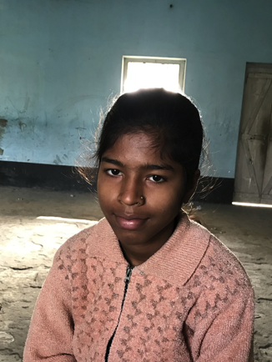 | Father laborer, mother primary school teacher.  Some study guidance at home. | Finds the tuition helpful.  Comes on a bicycle.  Wants to be a policewoman.
Susmita Majhi | 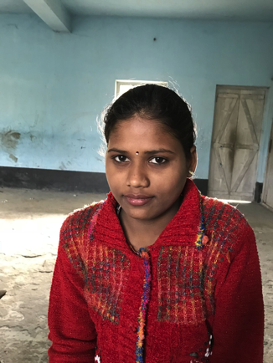 | Father fishery worker, mother housewife | Finds the tuition helpful.  Comes on a bicycle.  Wants to be a nurse.
Diptikanak Khatua | 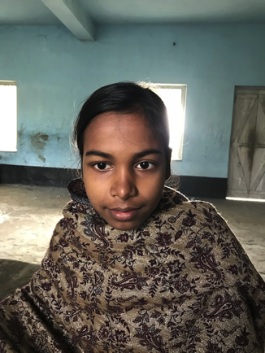 | Parents farmer.  No study guidance at home. | Finds the tuition helpful.  Comes regularly on foot.  Wants to be an English teacher.
Shibani Das | 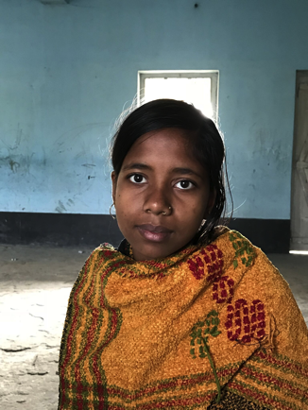 | Father migrated to a city.  No study guidance at home. | Finds the tuition helpful.  Comes on a bicycle.  Wants to be a doctor.
Mamata Khatun | 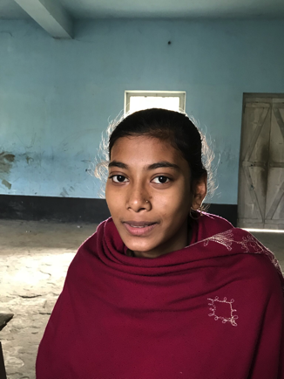 | Parents farmers.  Gets some extra study guidance in other subjects. | Finds the tuition helpful.  Comes on foot.  Wants to be a teacher.
Sukanya Nayek | 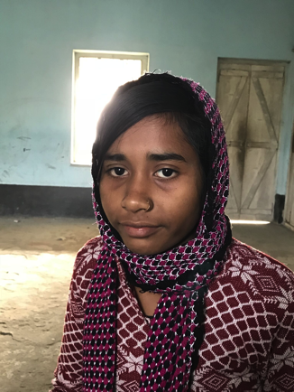 | Parents farmers.  No other study guidance at home. | Finds the tuition helpful.  Comes regularly on a bicycle.  Wants to be a doctor.
Suparna Pal | 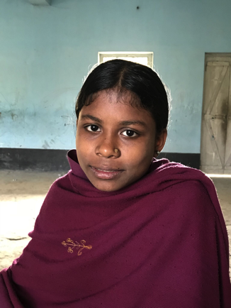 | Parents laborer.  No other study guidance at home. | Finds the tuition helpful.  Comes regularly on foot.  Wants to be a teacher.
Tanushree Bera | 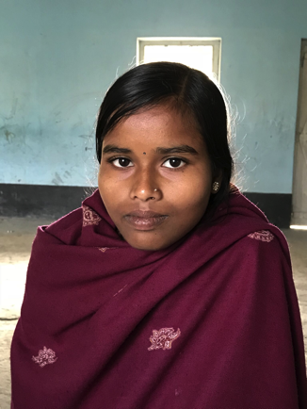 | Parents farmers.  Gets some extra study guidance in other subjects. | Finds the tuition helpful.  Comes regularly on a bicycle.  Wants to be a doctor.
Saharabanu Khatun | 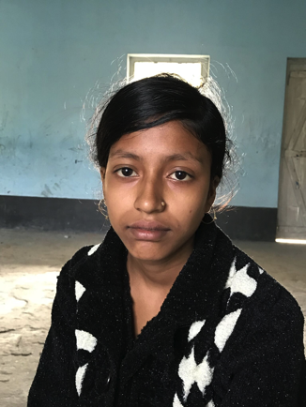 | Father working in Kolkata.  Mother farmer.  No other study guidance at home. | Finds the tuition helpful.  Wants to be a nurse.
Radharani Majhi | 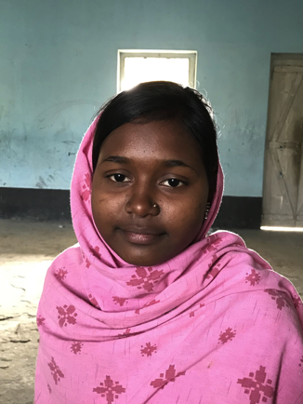 | Parents fishermen.  Gets some extra study guidance at home. | Finds the tuition helpful.  Comes sometimes on a bicycle, sometimes on foot.  Wants to be a nurse.
Debi Jana | 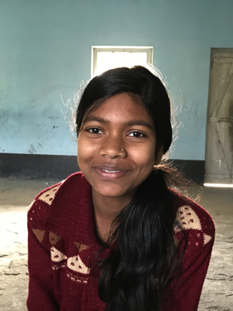 | Parents small village shopowners.  No other study guidance at home. | Finds the tuition helpful.  Comes on foot.  Wants to be a teacher.
Samina Khatun | 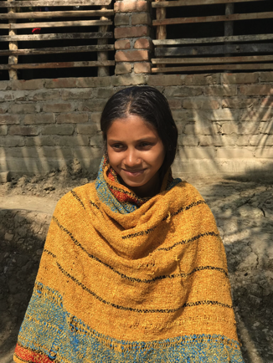 | Father in Kerala, mother not working.  No other study guidance at home | Finds the tuition helpful.  Can not ride bicycle.  Nayantara center a bit far from her house, so she misses sometimes.

2. Home visit to some of the girls in the community
After visiting the class, I visited home of Swati Adak, Suparna Pal and Samina Khatun. Swati’s parents live in Delhi. She and her sister are taken care of by their uncle and aunt. Uncle was not at home. I also met the aunt, who assured that there is no pressure on Swati to work for their business or to get married.

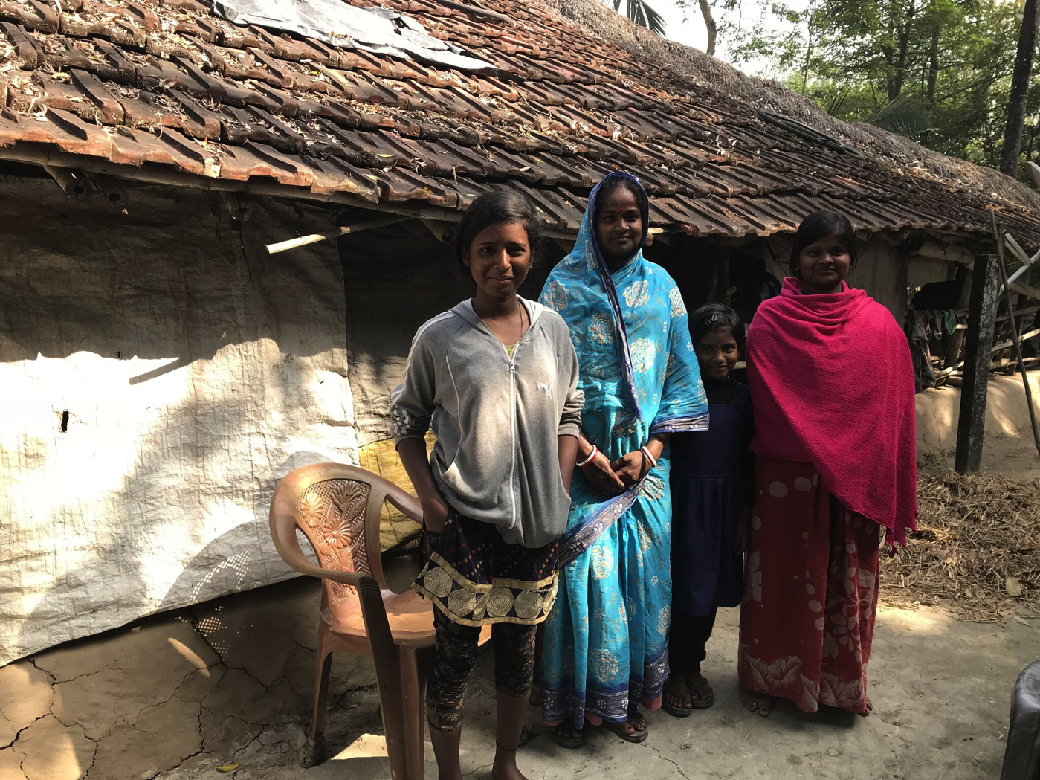
Swati with her aunt and two sisters

Suparna lives with her parents. Her father is a farmer, mother also helps out in farming. However, they do not ask her to work with them. They are also not pushing her for marriage.

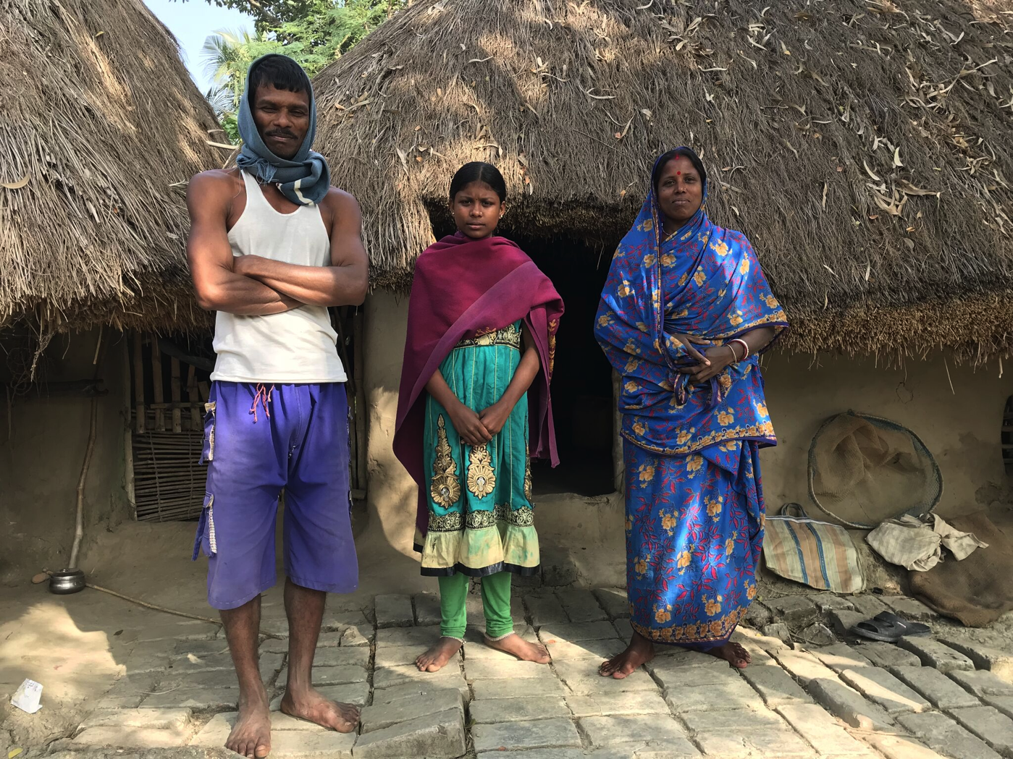
Suparna with her parents

Samina’s father works as a laborer in Kerala. She lives with her mother, grandmother and brother. Her elder sister is married off after high school, but her mother wants Samina to continue studying. In the community very few women go to school, so the obstacles are really high.

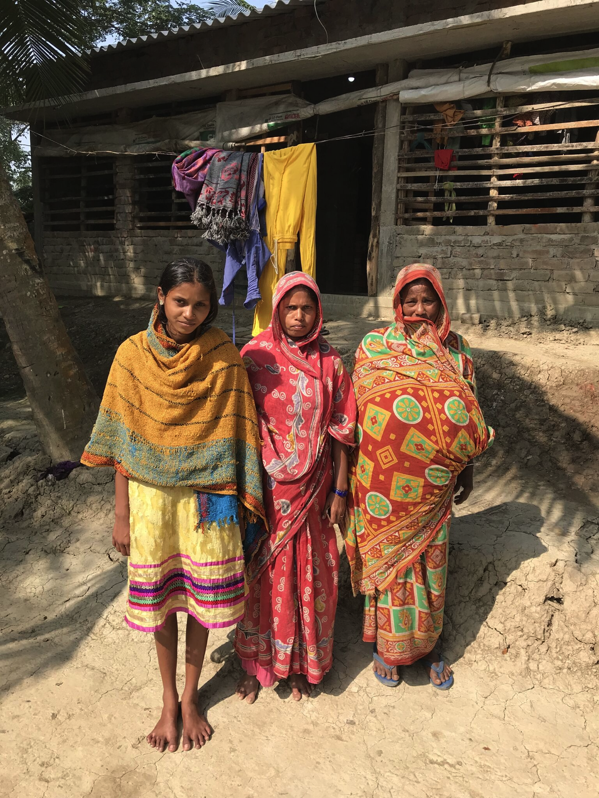
Samina with her mother and grandmother

3. Observation of their physical education class
On January 6, 2018 I observed the physical education classes of the girls which was taking place in the football field of the Mahabatnagar High School. It was like an aerobic class. The trainer is well known in the village. He did some warm up drills and subsequently proceeded to do some choreography. The songs used spread communal harmony, sisterhood and dignity of labor.

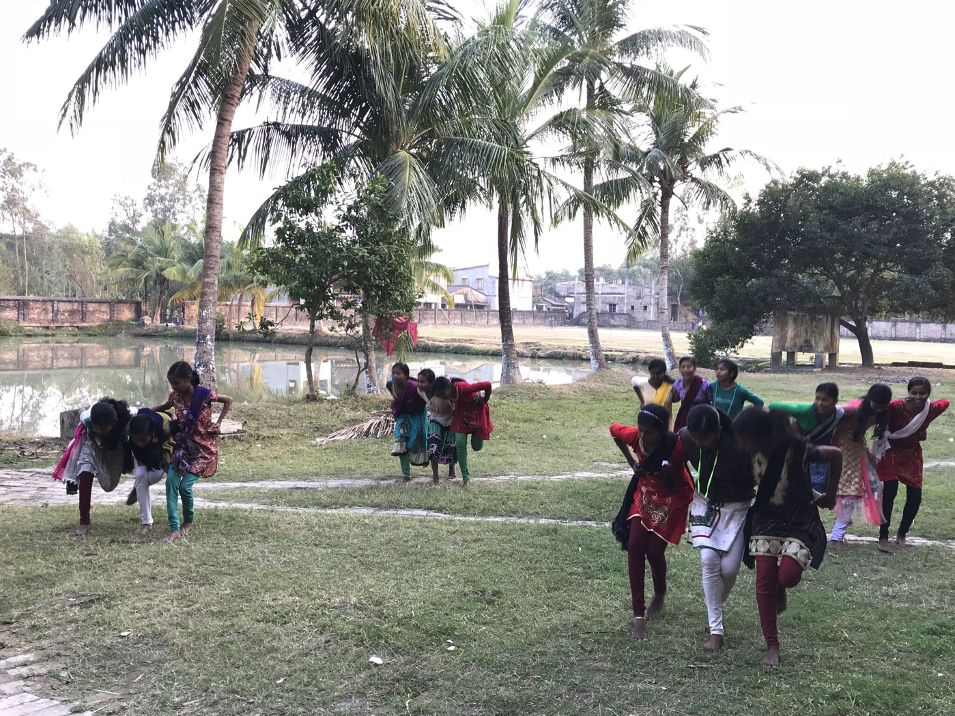
Nayantara girls in their physical education class

4. Looking at the accounting books
A special meeting was arranged with the project’s accountant Koushik Patra on January 5. He explained to me how the project expenses are tracked. As mentioned above, Sabuj Sangha is running two Nayantara classes, one in Nandakumarpur which is supported by individual donors and another one at Mohabatnagar which is fully supported by Asha Zurich. Asha supported project has a separate cost center, and dedicated staff on their payroll. For food and stationary and medical items they have fixed vendors. A couple of examples are provided in the following.

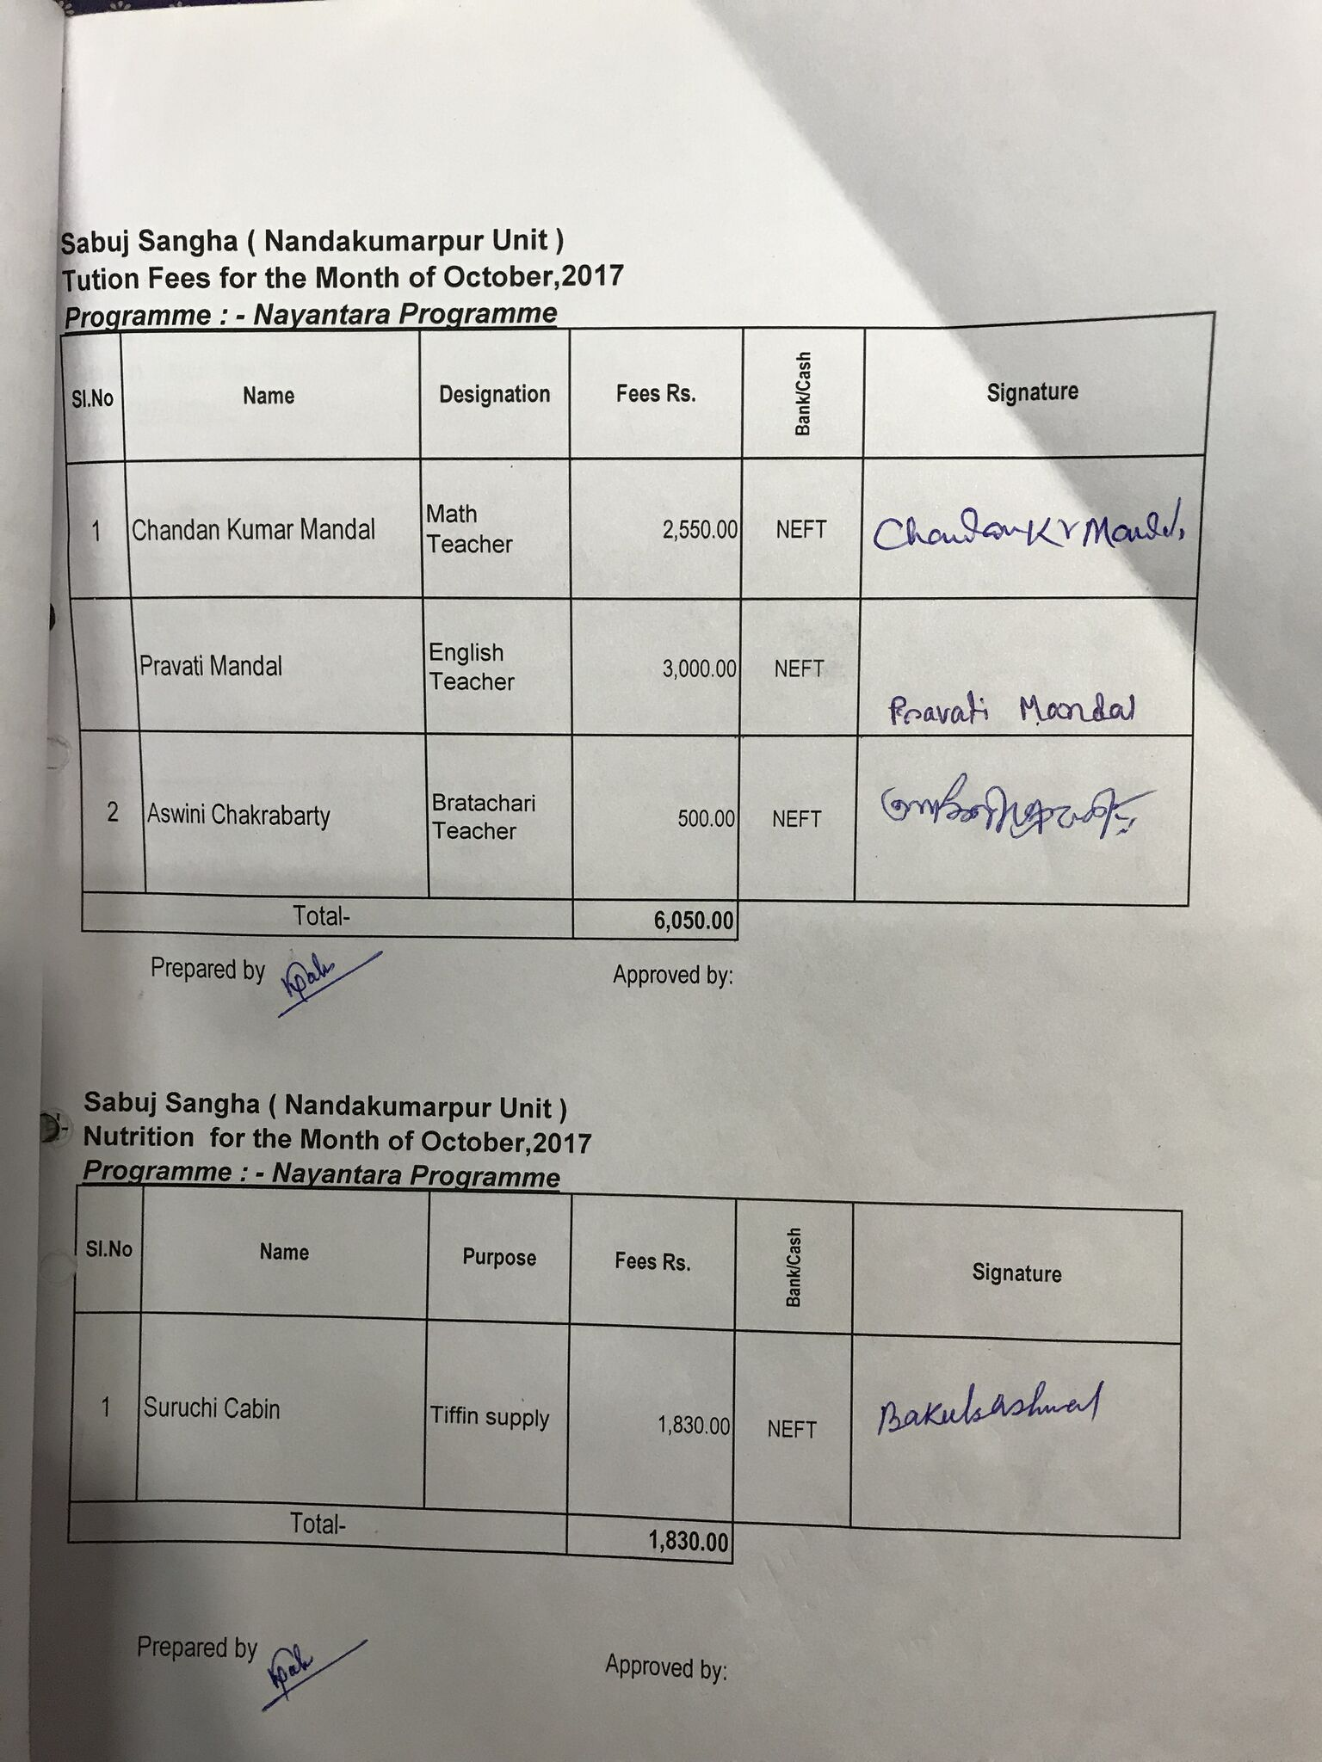
Tracking of teachers salary and food bills
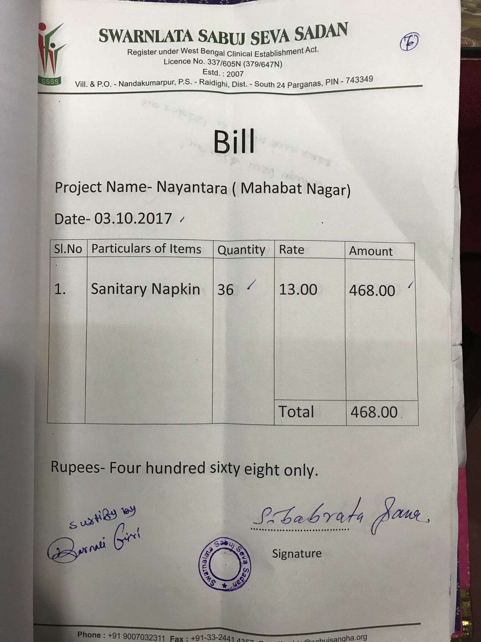
Tracking of sanitary pads provided in hygiene kit

5. Meeting with the staff members
In the afternoon of January 6, 2018 I met with all staff members of Nayantara. I collected their feedback and have summarized them below.

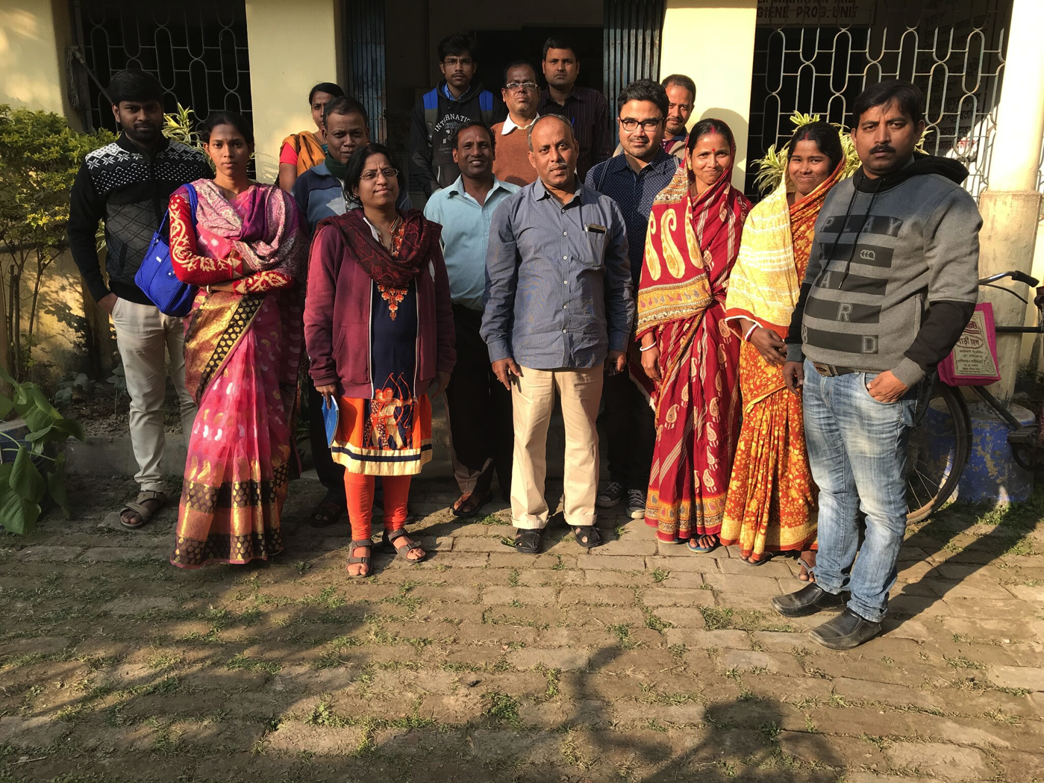
Nayantara and Notun Alo staff with Prat

Chandan Kumar Mondal (KSSN school and Nayantara teacher)
Feedback:
- Nayantara girls who come from the KSSN school of Sabuj Sangha perform better than the ones from the government school.
- Government school teachers are often teaching wrong math techniques.
- Girls are doing better and getting confident after tuition.
- Some geometric models can help teach concepts.

Ashwini Chakraborty (Physical Edcuation teacher)
Feedback:
- Girls were very shy in the beginning. So classes were held indoors.
- Eventually most of them shook off their apprehension and he started the classes outdoor.
- Some are still shy and are skipping classes.
- Right now he is giving them training only once a week. Twice a week could be better.
- Some training equipments can help.

Baranali Giri (Community Mobilizer)
Feedback:
- Girls are progressing well.
- Parents are happy and let the girls study.
- One girl performed poorly. Barnali went to her home but could not find her or anyone from her family. Probably she was helping out with work.
- The environment of the tuition center needs to improve.
- A cabinet or a room to store the stationary items given to the girls at Mahabatnagar can help. Now she is carrying them from Nandakumarpur to Mahabatnagar every time.

Subrata Maiti (Science and Math teacher)
Feedback:
- The school environment where the tuition classes are held is not nice. It is dirty, quite cold in the winter (no window panes) and a lot of garbage is dumped just outside of the classroom. In addition, the school staff who control the school premises, do not behave well with the girls.
- The time they spend in class is too short. 3 days are not enough to give individual attention to all 20 girls in math and science.
- They are neglected at school because teachers think that they are getting extra support from Nayantara.
- If possible the classes should be moved to the primary school , that have better class rooms.
- A white board would be good. The black board of the classroom is in very poor condition.

Pravati Mondal (English teacher)
Feedback:
- She has observed improvement in English level of the girls over the past one year. They have also shaken up their fear.
- Girls who are from the KSSN school run by Sabuj Sangha are much better in English than girls who come from the government run school.
- Some reference books in English would be good for improving their reading skills.
- Some visual teaching aids can help.

My Feedback and summary
The Asha Zurich supported Nayantara class of 20 students seemed to be quite successful over the past six months. All girls interviewed acknowledged the differences the tuition has made in their confidence level and in their improvement in the actual school performances. Families seemed very supportive as well. The teaching staff and community mobilizers seemed to be quite sympathetic. An extra value addition to the girls is done by giving them a monthly hygiene kit including a sanitary pad, which is otherwise out of their affordability. The finance and accounting of the project is also very transparent.
As rooms for improvement, I suggest the followings.
Firstly, a better classroom for the tuition should be found. The current one is really in bad condition.
Secondly, I recommend some exposures to computers for them, using the computer lab of Sabuj Sangha KSSN school.
Finally, I saw a difference in attitude among the girls who go to Sabuj Sangha’s KSSN school and the ones from the Asha-supported Nayantara project, in spite of coming from similar background. This difference comes from going to the government school in Mohabatnagar, which apparently does not empower them and uses faulty outdated teaching methods. Therefore, these girls probably need extra classes.
Overall I am quite satisfied with the progress of the project and recommend funding for another year.

Resources
All photos and documents of this site visit are available at https://www.dropbox.com/sh/kbgcj0qgyroq86a/AADdX_OP3LH0GR1eC1eKPa-Pa?dl=0

