Chetanalaya: Purdue volunteer Rohil’s friend Surabhi Yadav visited Chetanalaya. Here is the report in her own words: “I visited Chetanalaya center in New Delhi on 10th of April 2017. As a part of the visit, I explored their administration unit, a learning room for young children, and a playschool for infants and small kids. The person-in-charge, explained me about the working of each section and the overall objective of Chetanalaya's work.

Located in the middle of a socially backwards ghetto, it appeared that the NGO is running its centers with great resilience and effort to bring some fundamental changes for a healthy community. The volunteers are teenagers from the community who have actively taken the responsibility of addressing various social problems in their neighborhood. I got a chance to attend one of their meetings in which a team comprised of both girls and boys were deciding their next steps for pursuing the MCD for cleaning their colony. They also read their minutes of meeting from the previous meeting to help me understand the structure of the meetings. We had a good discussion on possible ways to bring change in a setting where most of their family and friends resist change. This meeting was a glimpse of the NGO's work in youth empowerment and activism. The overall infrastructure of the administration unit was decent and was equipped with required amenities.

I then visited a classroom for boys from the age group of 4 to 8. All the boys were from the slum and confident enough to have an engaging conversation. On prompting, they shared the stories and poems they have learned. The boys seemed to like the place as mentioned during the conversation.

The next stop was a playschool for infants. There were around 20 infants sleeping in that room with three female caretakers. These kids belonged to families which had working parents. Their parents worked as daily wage laborers or ragpickers. As stated by the caretakers, the parents pick up their kids at the end of the day. The food is provided by the parents. The room was clean and had some toys for the kids to play.

All in all, the first impression of the organization was good. The socio-economic condition of the slum appeared to be very grim. Most of the families there seemed to be just above the poverty line. The biggest strength of the organization is its location, which makes them a part of the community and thus helps them connect the community members and the changemakers strongly. And in some cases, help make the changemakers from within the community.”
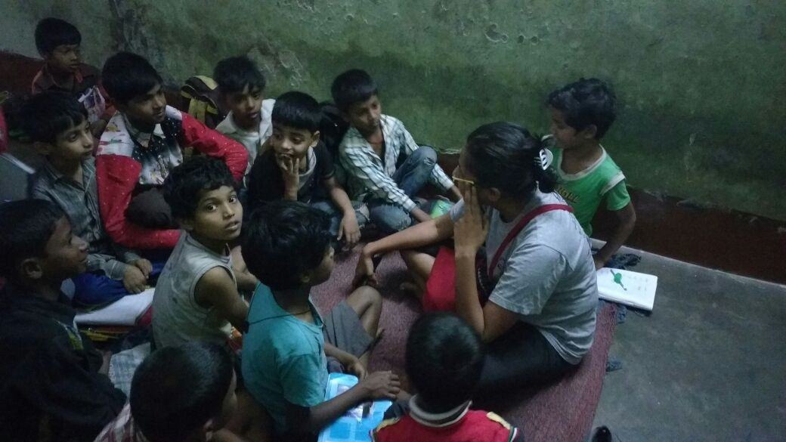
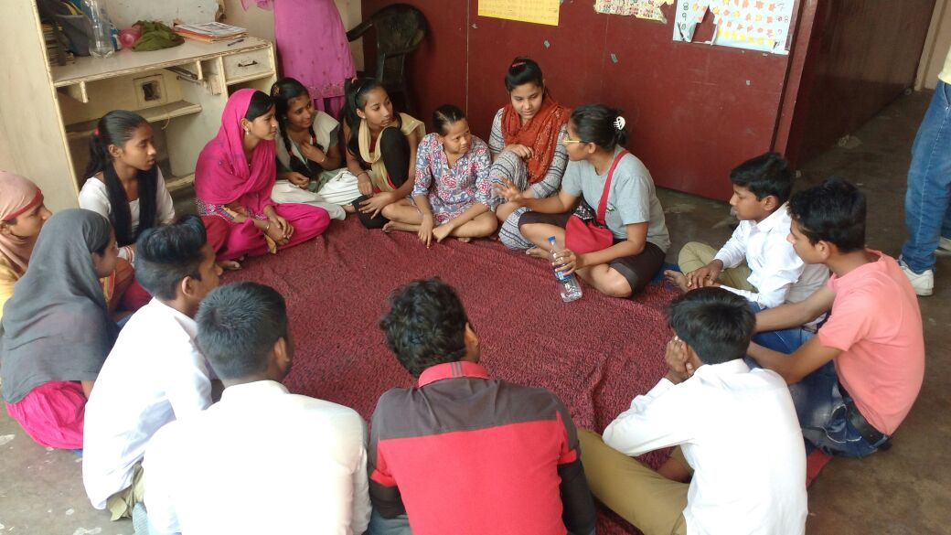

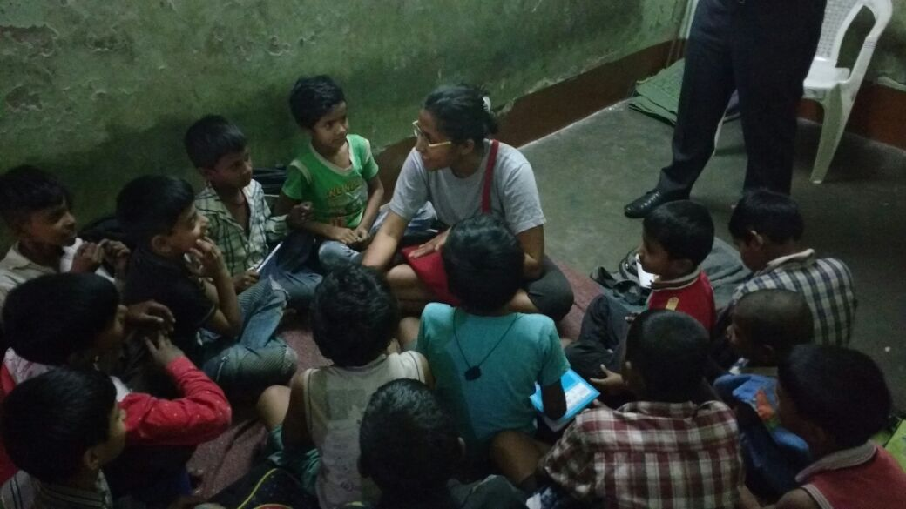

Follow up questions from Surabhi and answers:
Q. " They also read their minutes of meeting from the previous meeting to help me understand the structure of the meetings. We had a good discussion on possible ways to bring change in a setting where most of their family and friends resist change."
what was the discussion?
Ans. - get deeper clarity on what does the process of change look like. This will help these youngesters become patient with it.
-rely more on conversations than forceful implementations of newer ideas in the community
- brainstorm on creative ideas to get people come on same page by dialogue.
Q. like what?
deeper clarity for whom? what does the process of change look like?

Ans. street plays, community-baithaks
These were ideas suggested by me. We didn't brainstorm on the ideas but the process.
deeper clarity among the members of the youth committee
Q. So how do they achieve this now? Any other problems?
Ans. They push local people now instead of discussing. Their activity to bring change among people is almost null because of resistance from the mohallawalas/family. So they simply pick up topics which can be solved by outside help. For example – For cleanliness, instead of making people understand the importance of cleanliness, they are after MCD for help. But they know, that unless everyone in the community doesn’t stop throwing the garbage outside their houses in the narrow lanes of the colony, nothing will change. Other problem is that the girls are married off immediately after 10th. And no dialogue has been able to be successful with community members so far. The youth committee members end up being tagged as rebels and usually beaten by their family members for when they push for change.

Shades of Happiness: SOH site visit was done by Purdue volunteer Neha Gupta and details of her visit in her own words are as follows. “I visited Shades of Happiness (SOH) foundation in June 2015. SOH conducts weekend classes in St. Columbus school situated in Gol market, New Delhi. I visited on a Saturday morning. The school had provided 4 classrooms to SOH. In one of the classrooms, the students from age group 6-15 were learning bottle painting. Other classroom had a dedicated group of students studying mathematics under the supervision of a volunteer. Similarly, the third classroom had science class going on. There were around 40 students present in the school. My interaction with volunteers was very satisfactory as they themselves were students of DELHI UNIVERSITY pursuing their undergrad. There were a least 10 volunteers present. Overall volunteer to student ratio was good.

I interacted with students of various age groups. A girl aged 14 had recently cleared her class 10 boards with 7.2 GPA. Her father is a mason and her mother was a maid who cleaned utensils in nearby colony. The girl aspired to be a Charted Accountant. She has been a student with SOH for over 6 years. I was told the SOH head CHRIS ANTHONY frequently meets her father to convince him to let the girl pursue her dreams and update on her academic performance. The girl was also going for tuition classes as she belonged to a government school and the school teachers didn’t teach well. SOH bears all expenses of tuition classes and keeps record of academic performance of each student.

Another student named Akshay is pursuing his B Com Honors from Zakir Hussain College. He is one of the students associated with SOH for a very long time. Akshay also belongs to a very poor family and is getting all type of academic and career help from SOH.
Overall, my site visit was quite satisfactory. I was happy to see the enthusiasm of the team as they were all putting in their best to help these students. SOH focuses on providing academic help by providing tuition classes for which SOH bears the expense. Specialized classes are conducted in St. Columbus’s School during weekends for English speaking, skill enhancement, personality development of these students with the help of volunteers. The students are also provided refreshments like biscuits, energy drink etc. during the weekend classes.”

