Samerth Talim Kendra
Day care centre for children with special needs
Six monthly progress report submitted to ASHA
1st January 2017 – 30th June 2017
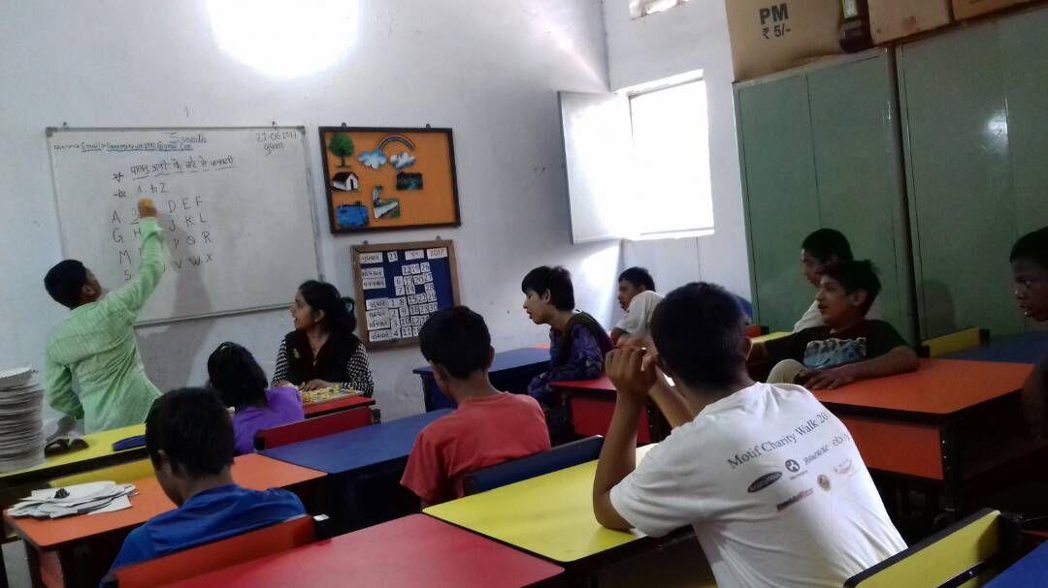

General information
- Name of the organization: Samerth Charitable Trust
- Project title : Day care center for children with special needs
- Project location : Juhapura, Ahmedabad, Gujarat, India
- Contact person: Ms. Gazala Paul, Managing Trustee
- Contact information: SAMERTH TRUST,
Q- 402, Shreenandnagar part -2,
Vejalpur, Ahmedabad – 380051
Email: samerthtrust1992@gmail.com/ Website : www.samerth.org

A . Introduction: Samerth Trust is a not for profit organization registered under the Bombay Trust act 1961. Set up with a mission to work with the poor and the marginalized, Samerth has been working towards their rights and entitlements since it was set up in 1992. Samerth actively works in Ahmedabad (On education, women empowerment and strengthening marginalized communities by facilitating government schemes/services/entitlements provided for them), Kutch ( Water security, livelihood, education and Women Empowerment) & Chhattisgarh ( Education, Water security, Livelihood and Tribal empowerment).
Professional Qualification: Samerth Talim Kendra is registered with the Social Defense Department under section 52 in the ‘Equal opportunities, protection of rights and full participation act for persons with disabilities – 1995’.The Kendra is also registered with the ‘Delhi National Trust’ and the ‘Society for welfare of the mentally retarded’ (SWMR).Samerth Talim Kendra is also part of SRMS (society for rehabilitation of mentally retarded) network. Apart from trained professionals such as physiotherapist, speech and sensorial therapists, coordinator & teachers for the Kendra are professionally trained in special education as well as have undergone several up gradation courses from BPA (Blind Peoples Association).

Since 2006, Samerth runs a day care centre for the mentally challenged children. The center came about as a result of an ongoing demand from the community as well as an in depth research by the Samerth team on the need and lack of services for the disabled in the Sarkhej, Vejalpur, Makarba areas of Ahmedabad. The focus was on communities belonging to the poor minorities, marginalized & migrant sections of the society. High levels of pollution, lack of nutrition due to poverty and lack of awareness, consanguineous marriages and lack of prenatal and post natal care are some of the reasons leading to disability.

This year, Samerth day care centre or Samerth Talim Kendra as it is popularly called celebrates its decadal journey and looks forward to providing better, improved and more scientific services to its children. As we look back, we realize that there is a pattern to the profile of children coming to the centre. Most belong to extremely poor families living in slums or shanties, suffer from 70% and above disability – leading to multi disability and have been spurned by other institutions due to their high dependence.

The care giving program at the kendra is based on internationally recognized, evidence based teaching methods which are implemented in a positive, child-centered, and consistent manner to expand their repertoire of skill and experience. These include Picture Exchange Communication System (PECS), Social Stories, Alternative and Augmentative Communication (AAC), Sensory Integration, Use of Technological Devices and Educational Software, Structured Environment and Daily Schedules, Individualized Education and Therapy Plans and Learning through computers has helped our children make remarkable progress.
The journey has been full of ups and downs with sporadic funding pattern and has largely been supported by Samerth’s core funds. The erratic funding deterred Samerth team a few times, but the community has been unrelenting in its support and belief in kendra. Community members visit the centre regularly, support staff in times of shortage to care for the children. Each of Kendra’s exposure visits are marked by community members (even those whose children are not part of the kendra team) joining in to help the staff, some have started giving little donations to the centre. We now have a strong team of Kendra well wishers and volunteers who rise during trying times.
Total Number of Children at the Kendra since inception in 2006: 157
Progress till date : 10 admitted in normal school, 16 admitted in special school, 4 working and have become economically self sufficient to a great extent. 35 have become physically independent after coming to the centre.

B. ASHA and Samerth

ASHA partnered with Samerth by the end of year 2016, and the support has greatly helped Kendra to improve on its services, hire dedicated caregivers, and invest in scientifically backed and medically approved equipments for games & activities. In the last six months 48 children and a community of 50,000 people directly benefitted from ASHA Support.

The following have been some changes that the Kendra has been able to implement with support from ASHA.

- Specially designated caregivers: The Kendra now has two teachers – (Syra Pathan & Pooja Patel) on board, who have undergone Government recognized Diploma course in Special Education and Mental Retardation. Both have worked in Prakash & Gujarat Kelvani Mandal and have experience in dealing with children with special needs. Their addition to the team has given the Kendra staff an exposure to the current and more scientific ways of teaching and care giving our children. Apart from them, Saba teacher as support staff & Fatema Chopra as art & craft teacher have been inducted in the team.

- Regular Therapies: Physio, Speech, Audio & Psychotherapy: Need based therapies are now provided regularly to the children. Dr. Tabassum for Physiotherapy, Dr. Malav for Psycho therapy and Dr. Lalit Deore & Dr. Riddhi for Speech therapy are being consulted. Their regular, protocol based intervention has led to a great improvement in the children.

- Alternative Augmentative Communication: Augmentative and alternative communication (AAC) includes all forms of communication (other than oral speech) that are used to express thoughts, needs, wants, and ideas. We all use AAC when we make facial expressions or gestures, use symbols or pictures, or write. Sumithra Prasad, well known councilor, motivational speaker and a champion of disability rights and care giving techniques was recently invited for a workshop with the Kendra staff and community. She introduced the staff to AAC and its importance for children/adults with speech impairment. The staff has then undergone a basic training for in depth understanding of AAC and has also taken support of Ayesha Maniar – a computer expert and teacher who herself suffers from Cerebral Palsy. Combined with technical knowledge on the subject,
experienced staff and an inside view from Ayesha on the issues faced by the disabled and their care givers, the Kendra staff has strarted the process of developing individual AAC material for 31 of its children – suffering from speech impairment. Each child will
Things that the kid likes – to be translated in language spoken at kid’s home and Hindi
be profiled according to
his/her physical, mental, psychological, social, needs and charts will be made accordingly.

- Improved assessment techniques: Previously, each child was assessed with its care giver at the centre, parent/guardian & medical expert. These techniques have now been improved and made more scientific. Now six areas of development have been broken into smallers goals.

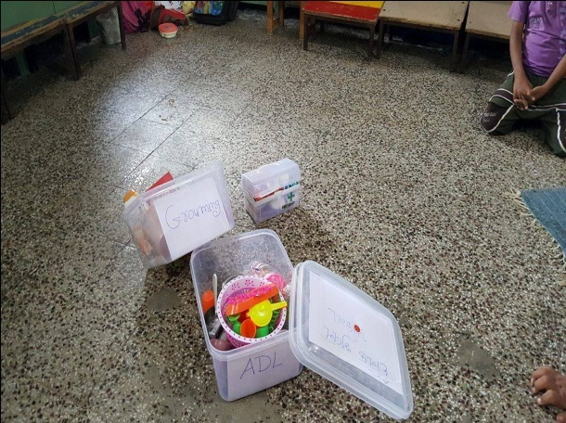 | 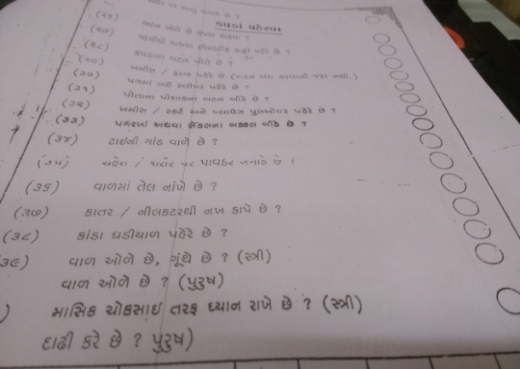
Individual kits for each aeas and the format accompanying each kit

Each of the six areas viz, Motor skills, ADL(Activities of daily living), Linguistic skills, reading/writing skills, Social skills, Pre vocational skills are now assessed through scientifically developed kit and questionnaire ( with each area addressed in minutest detail). This is done when the child is admitted to the kendra and then followed up quarterly. This has helped the teachers understand the child minutely and plan a more customized educational and care giving strategy.

- Improved goal setting of each child: Based on the above assessment technique, goal of each child is set – according to the areas. Sometimes a child has goals in all the areas, sometimes many goals in one or two areas. A goal chart then is made of each child and each of his goals that are then analyzed vis a vis the child progress in four ways of prompting vis- indicative, through words, physically and finally independently.

- Home visits made goal based: Training with caregivers was undertaken on the importance of home visits and issues to be covered during the visit. An yearly chart was made of each child, based on the need and requirement. This has now formalized the home visit activity with each child’s home visited – the issues/ exercises to be discussed.

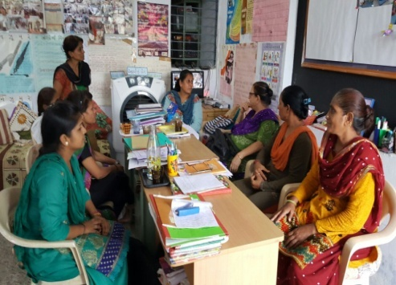
- Personal counseling of parents/ care givers of children at home on their sexual behavior: The teachers and care givers of the centre have found it challenging to cope with a few children on account of their sexual behavior. As the hormonal changes kick in, the children find it difficult to control their urges. Sumithra Prasad was specially invited to the kendra, to have a one on one session with the teachers to help them understand and handle such situations with patience and calmness. As a result of close monitoring of children who exhibit deviant sexual behavior, it was realized that it is important to have a one on one session with the parents too. It has been noted that sometimes parents/care givers – believing that these children do not understand/observe much, behave in explicit ways in front of the children. This has a negative impact, especially since the children have not had any kind of education on sexual behavior or have hopes of finding a romantic partner. Certain behaviors are also indicative of sexual abuse. Opening up a communication channel to discuss such issues with the parents has helped them understand and be vigilant about such issues. We have invited Sayeda Syed for supporting us in this activity. Ms. Syed has had a 32 year experience in the field – having worked with BM Institute of Mental Health & Uthhan.

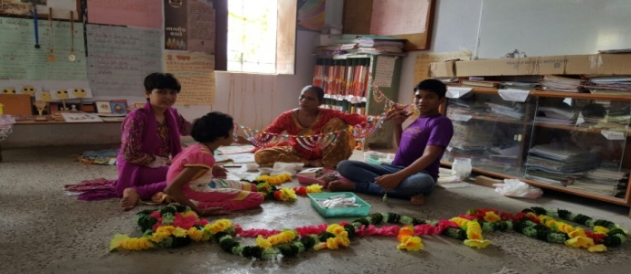
- Focus on Vocational Training: Since the last two years, the Kendra has been extensively focusing on making few children who have mental and physical capabilities economically independent to the extent possible. Apart from the pre vocational activities, the kendra has also made a group of children, engaging them in vocational training – involving in making earrings, torans (wall hangings), key chains, envelopes, packing material etc. With intense focus on livelihood generation, for the first time kendra has encouraged a few parent groups combined with kendra children to start entrepreneurial activities. As a part of capacity building and promoting neighborhood leaders, Samerth has trained 30 women in leadership training and has facilitated Roshni Mahila Sangathan – a group to stand for their rights and encourage economic activity. Members from the group along with kendra children have come together to start entrepreneurship activities. After in depth discussions based on skills set of the group (adults and children – with relevant discussion with their doctors), marketability of the product, involvement of kendra children in activities to be under taken in the enterprise, four groups have been formed. The enterprises selected are disposable plastic plate making, roti making & Jewellery designing. After discussing a detailed business plan, we have initiated the activities in the three enterprises.

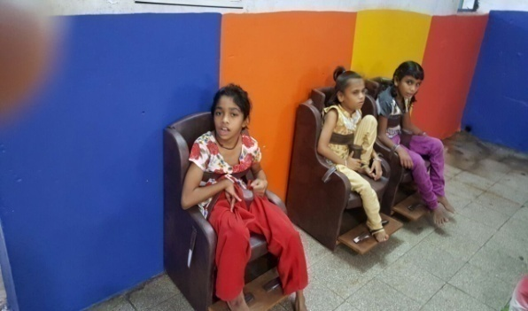
- New improved equipments & games: There have been new additions in the play room as well as equipments this year! We have been able to add furniture, specially designed for our children, so now instead of sitting on the floor, they proudly sit on their new chairs. Apart from that we have also added new indoor activity a games, and add a special chair for Children with Cerebral Palsy which is designed for optimal health and function.
Special CP Chair

Thus the ASHA support has had a sharp impact on the quality of services provided a t the Kendra. From 42 children in 2016 -2017, the kendra now works with 48 children in 2017- 2018. Moreover, 10 children have shown remarkable improvement in their behavior – some as high as 2 levels in six months!

C.

Currently the types of disabilities faced by children are :

Sr. No. | Types of Disability | Girls | Boys | Total
1 | Mentally Retardation | 8 | 18 | 26
2 | Cerebral Palsy | 5 | 2 | 7
3 | Down Syndrome | 4 | 7 | 11
4 | Low Vision | - | 1 | 1
5 | Hearing Impairment | - | 1 | 1
6 | Hearing/Speech impairment | 1 |  | 1
7 | Speech impairment |  | 1 | 1
 | Total | 18 | 30 | 48

Extent of disability:
Disability percentage | No. of Children
50% above Disability | 9
70% above Disability | 32
90% above Disability | 4
No certificate of 3 new children | 3
Total | 48

Physio, speech & Psycho therapy details
Sr. No. | Speech Therapy Details |  |  |  | Sr. No. | Physio Therapy Details
1 | 4 to 12 years Children Details |  |  |  | 1 | 3 to 12 years Children Details
 | Girls | Boys | Total |  |  | Girls | Boys | Total
 | 5 | 8 | 13 |  |  | 7 | 8 | 15
2 | 12 years above |  |  |  | 2 | 12 years above
 | Girls | Boys | Total |  |  | Girls | Boys | Total
 | 5 | 10 | 15 |  |  | 5 | 12 | 17
Total | 10 | 18 | 28 |  | Total | 12 | 20 | 32

26 (17 boys and 9 girls) children underwent Psychotherapy. We also undertook a teacher’s training in basic psychotherapy principles and exercises to be undertaken in dealing with children with different issues.
A strict protocol – impact based therapy plan is followed for each child. Goals are defined for each child and at the end of every quarter, those goals are evaluated and reasons for not achieving are investigated. If the exercise plan needs to be changed, intensified, further medical examination needed, proper follow up at home etc is investigated. Most children showed improvement due to various therapies, attaching feedback of parents of the following children – as to the changes they have been able to observe in their child in the last six months.
C.1 Impact of Physiotherapy as expressed by mothers

Sr. No. | Child’s Name | Impact | Mother’s name
1 | Mansuri Imran Salimbhai | decrease tightness in Muscles | Mansuri Mehjabin
 |  | Improved Back Muscle Strength
 |  | increased Muscles Strength & both Limbs
 |  | Walking stance has Improved
 |  | Slight Changes in gripping can be seen
2 | Ghanchi Ikra varisbhai | Reduction in calf & Hamstring Muscles tightness Result is Keeping heel on ground while walking | Ghanchi Samina
 |  | Reduce Lower limb tightness
 |  | improve upper limb Muscles Strength & Gripping of hand
3 | Malek Taslim Dastagirbhai | Increase in Muscle strength & Flexibility | Malek Bilkis and his grandfather’s feedback
 |  | Improved Balance & Co-ordination
 |  | Grip of both hands improved
4 | Siddiki Saad Asif Ahmed | Increase in Muscle Strength in lower limb | Siddiki Sultana
 |  | Improvement in Balance & Co-ordination
 |  | Improvement in Walking Postures
 |  | Can do Functional Exercises more comfortably than before

C.2 Impact of Ear canal cleaning: Two children were advised for ear cleaning by Audiology experts. After the cleaning, the children showed remarkable impact. Impact in their caregivers’ words described in the table below:

Name | Scanning/Audiology Impact | Feedback
Malek Mehfuza Faridmiya | Her eyear canal was blocked with wax. This is the first time there has been any kind of clean up. Earlier she would say individual words, now she can say full sentences. | Malek Rajiya (mother)
Kalyani Azaruddin Sirajuddin | After clean up he responds to us and also follows instructions. We used to think he was partially deaf so would talk very loudly with him, but now he can also hear normal sound range. | Kalyani Nasrin (sister)

C.3 Speech therapy impact

Sr. No. | Child’s Name | Impact | Mother’s name
1 | Malek Atira Mo.Rafik | After undergoing exercises like blowing the candle and sucking through straws, she can now chew her food. Earlier she would have very soft or churned food, now she can eat normal cooked food. | Malek Samina
2 | Ghanchi ikra Varisbhai | Till last year she could not speak anything. Now she has started saying a few words like bhu for water. | Ghanchi Samina
3 | Shaikh Shahid Mo.safi | Earlier he would eat soft food, now he can chew food and eat properly. | Shaikh Fatima
4 | Shaikh Sifa Yunusbhai | Earlier she could not say anything, now she can copy words | Shaikh Yasmin
5 | Momin Muktasid Asifbhai | In this quarter he has started speaking small sentences - earlier expressed through individual words. | Momin Jayeda

Activity with Parents and guardians of the children of kendra
- Individual parent counseling: Individual Parent counseling has been found very effective for the progress of the child. It is important for the parent to be on board with their child’s development & progress and repeat the activity at home or else the retention is very low. When a child displays divergent behavior, counseling session is conducted with parents to understand the atmosphere at home and to sensitize the parents towards the special needs of these children and the precautions one has to take in dealing with them. Also they need to be continuously sessions we inform the parents about the importance of conducting a health check up of these children and encourage them to do so every three months.

- Home visits: Every child is visited at home once a quarter to observe the family environment so that Kendra team can understand the needs of the child and modes of counseling the parents. Home visit of each child is done every month – these are times when the teachers can do one on one interaction with parents. They are also times to understand the problems and tensions faced by parents – impacting the child directly, it helps teachers to understand the issues faced by child and his un explained behavior. This is extremely important as most of these children are unable to communicate succinctly and hence often misunderstood.

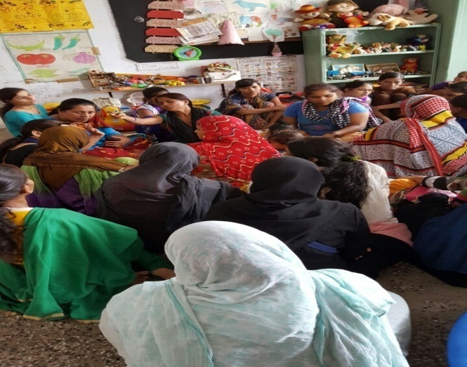
- Parent teachers meet: Once every three months a collective – teachers meeting is organized at the Kendra. It is a forum for parents to voice their common issues, discuss and find solutions. General information about government/ non government schemes are also discussed here. Discussions on medical care, problems related to consanguineous marriages are also discussed. Cross learning amongst parents is encouraged.

With other stakeholders:
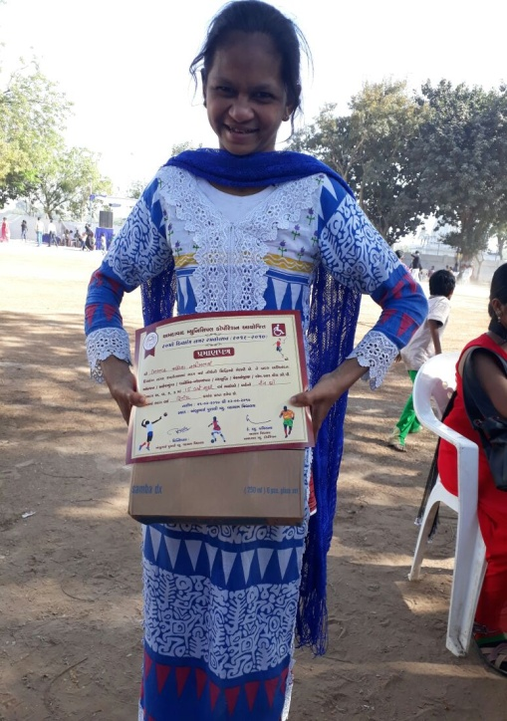
As a policy towards working, learning and networking with like-minded NGOs and government agencies to further its goals and augment its reach, Samerth extensively works with SWMR, BPA (Blind Peoples Association), Polio Foundation, Unnatti, Uthan, Prabhat , Krishna mm,Vatsalya to make sure that the needs of special children are paid due attention and their development is ensured. Our children participate in various activities and competitions held by these organizations.
Active liasioning with the government (Special MahaKumb, Social justice and Empowerment department, Women and child development department, education department, Nagar Ramotsav etc ) ensures that Kendra staff is in the know of the latest schemes/ change in policies for its children.
Sabiya – who won prize at Nagar Ramotsav- proudly showing her certificate

Annexue 1 Levels, progress and plan or each child at kendra for the year 2017 -2018
Level 1
Level 2
Level 3
Level 4

Sr No | Name | Gender | No. of years at the center | Age | Type of disability | Current level in the year 17-18 | plan for year 2018-2019
1 | Malek Avesh Mohammad Hanif | M | 6 | 18 | Down Syndrome + Mentally Retarded | 4 | 4
2 | Peer Saniya Mohammad Zakir | F | 9 | 20 | cerebral palsy + Mentally Retarded | 4 | 4
3 | Mansuri Imran Salimbhai | M | 8 | 19 | Mentally Retarded | 4 | 4
4 | Hingora Shahnavaj Mohammad Fakeer | M | 7 | 18 | Down Syndrome + Mentally Retarded | 4 | 4
5 | Gaji Minhaj Hanifbhai | M | 6 | 18 | Down Syndrome + Mentally Retarded | 4 | 4
6 | Neelgar Sabiya Shakilbhai | F | 9 | 17 | Mentally Retarded | 4 | 4
7 | Saiyad Aftab Anvarbhai | M | 4 | 12 | Mentally Retarded | 3 | 4
8 | Saiyad Sadaab Maheboobbhai | M | 7 | 13 | Mentally Retarded | 3 | 4
9 | Shaikh Sakib Mohammad Salim | M | 4 | 13 | Mentally Retarded | 3 | 4
10 | Ansari Kaif Mohammad Irfan | M | 5 | 13 | Hearing Impairment | 3 | 4
11 | Kureshi taiyabba Mohammad Shahhed | F | 2 | 13 | Mentally retarded | 2 & 3 | 4
12 | Diwan Yasmin Dilavershaa | F | 5 | 19 | Hearing & Speech Problem | 3 | 4
13 | Sumra Saleha Abbasbhai | F | 4 | 10 | cerebral palsy + Mentally Retarded | 3 | 3
14 | Pathan Nilofar A.Muttalib | F | 8 | 19 | Down Syndrome + Mentally Retarded | 2 | 3
15 | Prajapati Parth Vinodbhai | M | 7 | 20 | Mentally Retarded | 3 | 3
16 | Shaikh ArhaN Mohammad Yusuf | M | 3 | 6 | Down Syndrome + Mentally Retarded | 3 | 3
17 | Saiyad Kaif Ajimuddin | M | 9 | 12 | Low Vision + Mentally retarted | 3 | 3
18 | Shiddiki Saad Asif Ahmad | M | 2 | 12 | Down Syndrome + Mentally Retarded | 3 | 3
19 | Mansuri Najnin Raeesbhai | F | 2 | 15 | Mentally Retarded | 2 | 3
20 | Ansari Sharif Mohammad Shakil | M | 4 | 13 | Mentally Retarded | 3 | 3
21 | Shaikh Sahil Yusufbhai | M | 7 | 14 | Down Syndrome + Mentally Retarded | 3 | 3
22 | Vadadriya Riyaz Husenbhai | M | 2 | 12 | Mentally Retarded | 3 | 3
23 | Ansari Sehbaz Shabbirbhai | M | 3 months | 17 | cerebral palsy + Mentally Retarded | NA | 3
24 | Shaikh Hasnen Mohammad Hanif | M | 4 | 14 | Mentally Retarded | 2 | 2
25 | Shaikh Saniya Gulamnabi | F | 3 | 9 | Down Syndrome + Mentally Retarded | 2 | 2
26 | Momin Fatima Abdul Rajjak | F | 2 | 23 | Mentally Retarded | 2 | 2
27 | Pathan Ayaz Aslamkhan | M | 2 | 13 | Mentally Retarded | 2 | 2
28 | Shaikh Saniya Ilmuddin | F | 7 | 13 | cerebral palsy + Mentally Retarded | some activities of level 2 | 2
29 | Ghanchi Ikra Varisbhai | F | 2 | 8 | Mentally Retarded | 2 | 2
30 | Hudani Inara Sohilbhai | F | 2 | 7 | Mentally Retarded | 1 | 2
31 | Momin Muktasid Asifbhai | M | 5 | 10 | Mentally Retarded | 2 | 2
32 | Vadadriya Aspak Husenbhai | M | 5 | 16 | Mentally Retarded | 1 | 2
33 | Ghanchi Parvej Rafik Bhai | M | 2 | 15 | Mentally Retarded | 2 | 2
34 | sheikh Shezeen Imran khan | F | 2 | 10 | Mentally Retarded | 1 | 1
35 | Sheikh Rizwaan raisuddin | M | 2 | 6 | Mentally retarded | 1 | 1
36 | Pathan Mohmed imran khan | M | 2 | 8 | Mentally retarded | 1 | 1
37 | Bhatiyara Rehman Gulamhusian | M | 3 | 17 | Mentally retarded | 1 | 1
38 | Malek Taslim Dastagir | M | 1 | 8 | Down Syndrome + Mentally Retarded | NA | 1
39 | Pathan Faizan Parvejkhan | M | 4 months | 9 | mentally Retarded | NA | 1
40 | Shaiyed Aksha Yasin Ali | F | 4 months | 13 | cerebral palsy + Mentally Retarded | NA | 1
41 | Kalyani Azaruddin Sirajuddin | M | 4 months | 7 | Mentally Retarded + Down Syndrome | NA | 1
42 | Meman Sahil Fakir Mohammad | M | 3 months | 17 | Mentally Retarded | NA | 1
43 | Mansuri Rukhsana Usman | F | 3 months | 35 | Mentally Retarded | NA | 1
44 | Sabji Faroz Mubarak Mo.Badrubhai | M | 3 months | 7 | Mentally Retarded | NA | 1
45 | Lalivala Umar Arshadbhai | M | 2 months | 13 | cerebral palsy + Mentally Retarded | NA | 1
46 | Sarveiya Abrar Sohil bhai | M | 2 months | 2 | Speech Problem | NA | 1
47 | Malek Atira mohmed Rafikbhhai | F | 1 month | 4 | Down Syndrome + Mentally Retarded | NA | 1
48 | Malek Ashiya | F | 1 month | 3 | cerebral palsy + Mentally Retarded | NA | 1

