Work An Hour (WAH) Project Proposal

Project Name: Nari Gunjan – Science and Maths Camp at Aavishkaar |  |  |  | Date Received:07/04/2017 0707/04
Referred By: Rohil Jain

 |  | Project Contact Information | Asha Contact
 | Name | Science & Math Camp
 | Contact | Sandhya Gupta | Rohil Jain
 | Address | Manasvihaar, VPO Kandbari  Palampur, Distt. Kangra  HP 176061, INDIA | 45 N. Salisbury Street, Apt 9  West Lafayette, IN – 47906
 | Phone(s) | 011 91 9816314756 | +1-765-476-6982
 | Fax |  | -
 | E-mail  Web Site | ladki.danapuri@gmail.com; aavishkaar.palampur@gmail.com  www.narigunjan.in; www.aavishkaar-palampur.org  www.fb.com/AavishkaarPalampur; www.fb.com/FriendsofNariGunjan | rohilsjain@gmail.com

Part I: Information about your group/organization
Please feel free to attach any additional sheets and/or information such as brochures, press reports etc.
- Name of the group/organization requesting funds.
Nari Gunjan

2. When was the group established?
Nari Gunjan was established in 1987 by Sudha Verghese, and the organization was registered in 2000-2001.

3. Briefly describe the motivation for starting this group.
Nari Gunjan was founded by Sudha Varghese who moved from Kerela to Bihar to serve the most underprivileged people. She learnt about the Musahar community and its plight, and decided to live with the community and create change. This community is lowest in the caste structure, extremely poor, landless, lives outside and far away from towns. They generally do not have access to quality education, healthcare and even clean water. The literacy rate of this community is less than 1%. Nari Gunjan believes in empowering women through education, and making them aware of their fundamental right to equality and justice.

4. Name the key people running the organization and describe their background
S.No | GB Member Name | Profile
1 | Sudha Varghese | Founder of Nari Gunjan
2 | Sandhya Gupta | Board member of Nari Gunjan; Founder Aavishkaar

5. Briefly describe the aims of your group.
Nari Gunjan aims to empowering women through education, and making them aware of their fundamental right to equality and justice.

6. Does your group have any religious or political affiliation? If yes, please describe the type of affiliation and the reason for it.
No Affiliation

7. What non education-related community development activities is your group involved in?

Nari Gunjan works on a lot of community development activities in addition to education. This includes women’s self-help group, vocational training, legal literacy and aid, childline, youth centers

8. Does your organization have FCRA (Foreign Contribution Regulation Act of 1976) clearance from the Indian government? This is required for you to receive foreign funds. If yes, please provide FCRA details. If no, have you applied for Prior Permission (one time acceptance of foreign funds)? If yes, when was the application submitted?

FCRA#031170361
Nature: Economic Educational Social

Part II: Details about your educational project/s
Nari Gunjan in collaboration with Aavishkaar: Center for Science, Arts & Technology, Palampur, HP will be doing science and math camp for girls and teachers of Nari Gunjan and also to support fellowship for students or teachers from other organisations in need of financial support. Some details about the proposed camp:

Title: Science and Math Education

Goals: (a) To make science and math interesting, exciting and fun for students from Nari Gunjan and other low income communities
(b) To improve science and math capability of teachers working in Nari-Gunjan and other under-served communities

Duration/Time: between December 2017 and November 2018

Description

- 30 Day Science and Math Camps The aim of this project is to provide basic hands-on math education to students of underprivileged communities in India.
This project will take this basic science and math education to Nari Gunjan Dalit girls
through Aavishkaar. This project has two main components:
o Training at Nari Gunjan hostel sites in Danapur and Gaya in Bihar. Aavishkaar will conduct workshops in Patna and Gaya in Bihar for students as well as teachers of the schools.
o basic hands on camp: 20 participants and two facilitators of Nari Gunjan will come to Aavishkaar campus for a month long science and math camp. The camp will also have several indoor and outdoor activities inbuilt in the program, including a backpacking trip in the mountains.
o The Nari Gunjan community would be exposed to experiential hand-on science and math learning at deeper level. Most of the education so far has been rote memorization.
o This project will also help develop a learning & teaching aid library at both Patna and Gaya hostels of Nari Gunjan.

- Humari Kaksha is a 7-day workshop for teachers of middle and high school working in science and math education. This will help develop good conceptual understanding, provide exposure to hands on experiments/teaching aids.

Project Cost: USD 12,097

Part III: Financial Details

Overall Cost Details

 | # of participants | Cost INR | Cost USD (1 USD = 67 INR)
30 day Science Math Camp for Nari Gunjan Girls | 22 | 531,700 | 7936
7 day teacher training workshop - Humari Kaksha | 25 | 278,800 | 4161
Total | 47 | 810,500 | 12,097
Cost Break Up Details
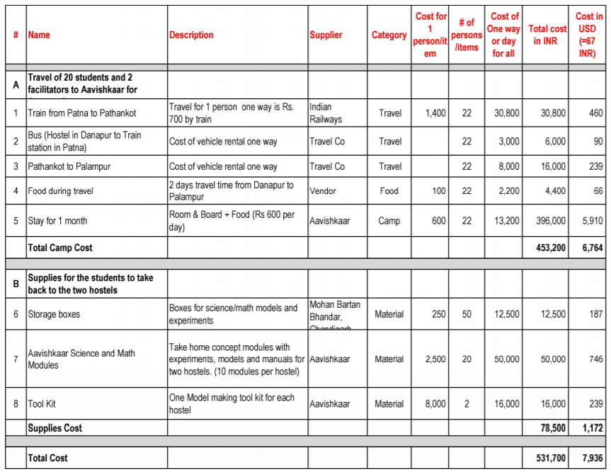

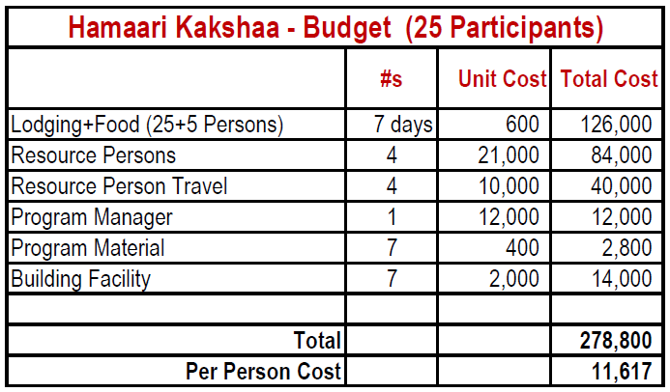
Total Cost USD (1 USD = 67 INR) = 4161
Per person USD = 173
