Site Visit Report

Asha Purdue

Basic information
Date of the site visit: 2nd Jan 2020
Name of the Project: Aavishkaar, Palampur
Was your site visit announced? Yes, it was planned.

 | Project Contact’s Information | Site Visitor’s (Your) Information  (Volunteer conducting the visit)
Name | Sandhya Gupta | Surabhi Bhadauria
Address | Aavishkaar, Palampur, Himachal Pradesh | Purdue University, West Lafayette
Phone(s) | 9816314756 | 7657759123
E-mail | info@aavishkaar-palampur.org | Surabhi203@gmail.com
Affiliation to project | Cofounder | Project Steward
Affiliation to Asha | Project Partner | Volunteer

PART A: Particulars about the organization and its environment (cross-validation of information presented in proposal)

- What is the main ideology of the organization behind the project?
Nurturing curious, creative, critical thinking citizens of tomorrow.

- How old is the organization?
Aavishkaar was founded in February 2014.

- How and why was it founded?
Sandhya Ji and Sarit Ji witnessed the culture of education in India when their daughter started going to school. They started accompanying her and observing how education was more about memorizing lessons and not understanding them. It induced a fear in students and studies were anything but fun to them. So, both of them took the initiative to start Aavishkaar where they could teach science and math through hands on activities and let children develop their own reasoning behind these concepts.
- What are the different focus areas of the organization? (give a rough estimate of the % of their total effort/funding)
- Community development: 20 %
- Education: 80 %

- What is the administrative structure of the group (e.g. Board of Directors/Grassroots-based/Volunteer based)?
Team at Aavishkaar has Sandhya and Sarit (Cofounders/teachers), Danish (Public Relation), Sonal (Teach for India fellow and Fellowship program coordinator) and Yashika (Finances) and Aavishkaar fellows. They also have one person working for the mess along with two caretakers and Roshan Lal for building the infrastructure at Aavishkaar.

- When was the project of interest started?
Aavishkaar started the fellowship program in year 2018.

- What is their vision about the future of the project?
The vision of the project is to encourage Science and Math in under-served communities (Nari Gunjan and others). Each Fellow train with Aavishkaar on conceptual understanding through hands-on experiences using models and experiments. The goal is to make learning of science and math a joyful experience for our school community and to spread the culture of science and scientific investigation.

- What were the initial challenges faced by the organization and by the founder when starting the project? How did he/she overcome them? Who helped them through the initial stages?
The initial challenges faced by Aavishkaar were building relationship with nearby schools and making space in school’s curriculum for interactive classes by fellows. Since Aavishkaar is not a big organization and is located remotely, it becomes a challenge for them to get quality people.

- Has the organization ever approached the government for funding? If so, what was the outcome? If not, why not?
Aavishkaar has worked with Delhi, Himachal Pradesh and Telangana government for teachers training for which they got paid by the government.
- Currently, what are the main problems the organization faces for running this project?
One of the fellows mentioned that they would want to train more and more teachers so that collectively they could teach more students but since there are limited no of fellows it is not possible to go beyond a certain limit. One area of improvement suggested was the documentation of these camps classes so that they don’t have to start over again for each camp which they had started documenting from this camp.

PART B: The beneficiaries and the community
(Information to be gathered from parents and children)
- Are there any Government Schools in the area? (Circle one)
  - Yes

- If yes, how far are the Government Schools from the community?
They are all at a walking distance from Aavishkaar.

- When you visited, how many children were present in the class?
When I visited, Aavishkaar was conducting a Hamari Picycle camp for students from age group 11-14 years old. There were about 30 students in that class.

- Do the children seem to enjoy coming to school? (Site visit volunteers observation)
Yes, the children seem to enjoy coming to the camp.

- What portion of children from the local community (approx.) attends this school? What portion of children does not go to ANY school? Where do other children in the community go to school?
In each camp, about 50 percent of students are from the Kandbari village or nearby villages itself. All of these students attend a regular school.

- What is the main motivation for the students to attend school?
The sheer joy of learning through practical experiences. In one of my interactions, a student also mentioned that her regular school asks her to memorize everything without explaining properly and she really wished that her school was like Aavishkaar. She also said that “there was nothing that I used to take home doubtful”. Another students had mentioned that if they didn’t understand something, the teachers tried to explain it in a different way and used simpler terms to explain these concepts so that students didn’t get confused with the terminology.

- What do the children feel about the school? Do they feel happy to come to school every day? (Question posed to the children to gauge their replies)

During my interactions with students, I could really sense an excitement and confidence in them. They all had stories to tell about what they learnt there and how they solved various design challenges given to them. Even though, these children were from different backgrounds and cities, the camp and the group activities really helped them bond together.

PART C: Details about the project and its staff
(Information to be gathered from students and staff)
- How far is the project site from the main town/village? How do the children commute? (foot, bus, etc.)
Project site is in the village Kandbari and all the children/fellows walk to Aavishkaar for camp or classes.

- Are the children charged fees for attending school? (Either school or bus, etc.)
The children are charged fee for their camps which involves all the inhouse camp expenses including food and stay. About 50 percent of the students are also given full or partial scholarship by Aavishkaar to attend the camp. Children from the government school are given full scholarship.

- What infrastructure and facilities are available at the project site you visited? (eg. Furniture, buildings, toilets, library, sports, hostels, mid-day meals etc)
Aavishkaar has one library+classroom and mess as their main building. During their camps, students and fellows stay together at the homestays of the Kandbari village. The classes are a mix of outdoor and indoor sessions. I really liked the outdoor class with a view of mountains and a fresh breeze of a winter morning.
- Is the building permanent or temporary construction? Is it owned or rented? What is its physical condition? How are they being maintained at the condition?
Buildings at Aavishkaar are permanent construction sites which are owned by Aavishkaar. They are all in good condition and at being maintained well.
- What is the medium of instruction? Is this the student’s mother tongue?
The medium of instruction is primarily Hindi at Aavishkaar.
- What is the mode of teaching in the school? (Check the appropriate choices)
  - Formal (State Board, Central Board etc) upto _________ grade (LKG, 5th etc)
  - Non-Formal Education (NFE), do the students also attend formal school?____
Aavishkaar fellows teach at 7 government schools on weekly basis (4 times a week). There are about 45 schools in the nearby blocks and fellows go to these schools as well on a program basis (science festival, create awareness, etc.). So, it a mix of both formal and non-formal education.
- If Non-Formal Education, how many of the children also attend formal schools in the area? If none, does the project plan this for the future- either by setting up formal schools or by setting up a process to send children to mainstream schools?
All the children attend a formal school either in private or government schools of nearby area.
- If Non-Formal Education, does the organization create its own study material (books, games)? Or does it use NCERT/NIOS books?
Aavishkaar uses NCERT to cover the topics taught in schools and then they develop their own modules for these topics.
- How many staff or volunteers are involved in the project? (Full-time/Part-time/Volunteers) What are their roles? Give breakdown by roll (eg. 2 full-time teachers, 1 full-time volunteer teacher, 1 cook, 1 administrator, etc.)
All the human resource working at Aavishkaar work full time. Sandhya Ji and Sarit Ji are main coordinators. Sonal is the fellowship program coordinator. Yashika manages the finances at Aavishkaar. Danish takes care of public relations and Roshan Lal is the model builder. There is one cook and two care takers. Other than these people, there are 5 fellows and 2 volunteers.

- How many of them are from the local community?
Roshan Lal and two caretakers are from the local community.
- How many of the staff are women? What are their roles?
There were 6 women working at Aavishkaar. There were 3 fellows, one stem associate, one volunteer and Sandhya ji herself.
- What is the education level/teaching experience of the teachers? What is their background?
All of them have a bachelor’s degree in some discipline while some of them were also postgraduates.
- What is the motivation for the teachers to work in this project (eg. pay, service, etc.)? What are the other employment opportunities that they have in the town/village?
The main motivation for the teachers and fellows to work in this project is to bring about the change in the teaching methods by shifting the focus from teaching to learning. They thoroughly enjoy the process of creating the hands-on modules for exploring various topics.
- How long have they been with this project/organization?
Danish and Yashika has been with Aavishkaar for about 3 years. Sonal has completed one year and Roshan Lal has been with Aavishkaar from 2014.
- Does the organization train the teachers?
  - Yes
- If yes, how do they provide the training?
The organization conducts various teachers training workshops and camps at Aavishkaar and other places. The fellows go to places in different states (Nari Gunjan in Bihar, Parijat Academy in Assam, Govt school, etc) all around the year for such workshops.
- Where do they live, and how much they travel to work here?
All the people working at Aavishkaar live in the village itself and travel on foot.
- How much is the staff paid? Are they happy with their salaries?
The Aavishkaar fellows are paid INR 15000 as their monthly stipend.
- How often do the main founders/organizers/volunteers visit the center? Do they do only administrative duties or spend time at the grassroots as well?
The cofounders and other staff visit the site almost every day. Sarit Ji and Sandhya Ji themselves take classes on science, math and design problems along with fellows.
- Were you able to look at actual work of the students? Homework/classwork/tests, etc? Comment.
Yes, I was able to look at the actual work of the students. I saw them solving the design problem and detective activity using logical reasoning and discussion with their peers.

PART D: Financial resources of the organization
(Feedback from the person conducting the site visit)
- What are the different sources of funding for this project? (different agencies/Govt)
Asha Purdue and Asha UCSD fund the fellowship program at Aavishkaar.
- What is the annual budget?
Every year, Aavishkaar tries to take 4 fellows and the total annual budget for this program is $12,410.
- What is the largest portion of their expenses (salaries/infrastructure/etc.)?

Salary of fellows is the largest portion of their expenses for this project.

PART E: Comments
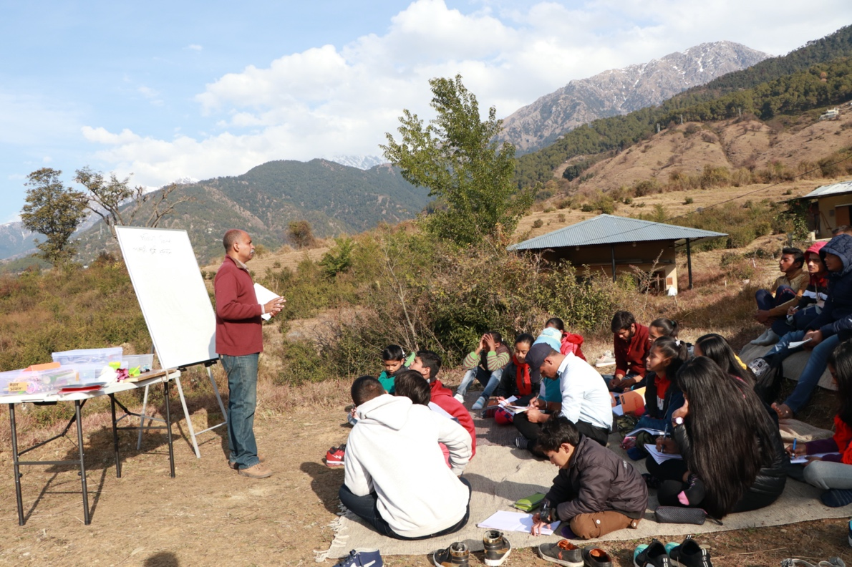

Sarit Ji teaching a class on concepts of sound and energy

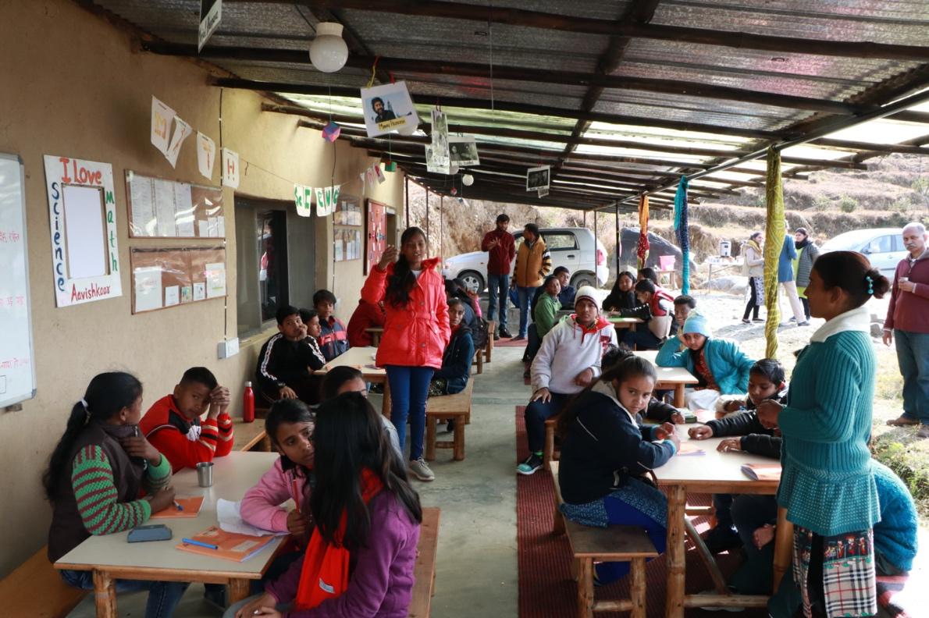

Babli (one of the Aavishkaar’s fellows on the right) teaching a class on shapes and their projections

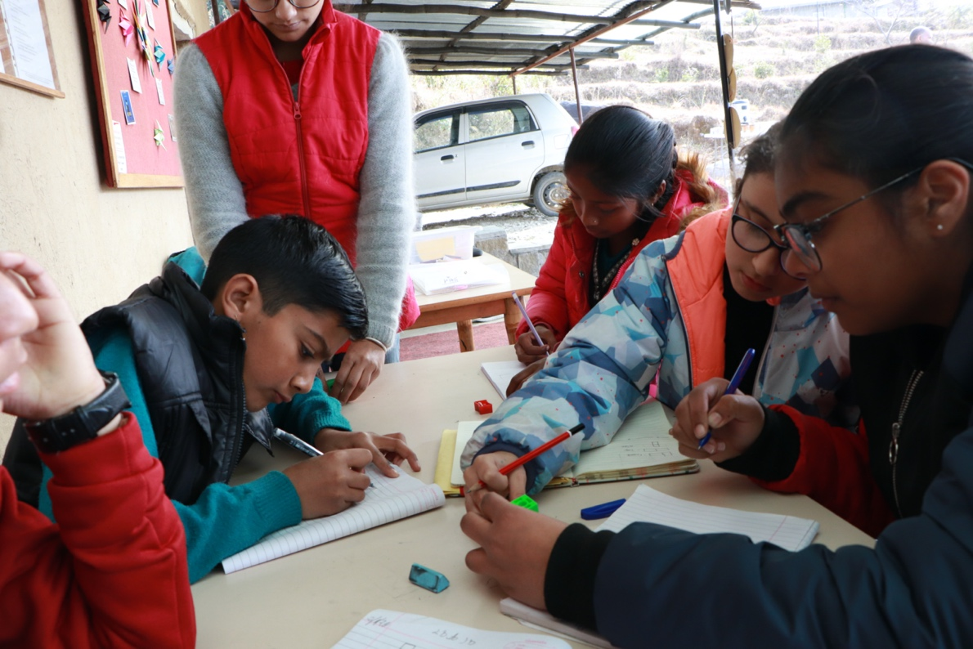

Students trying to understand these shapes using a block puzzle
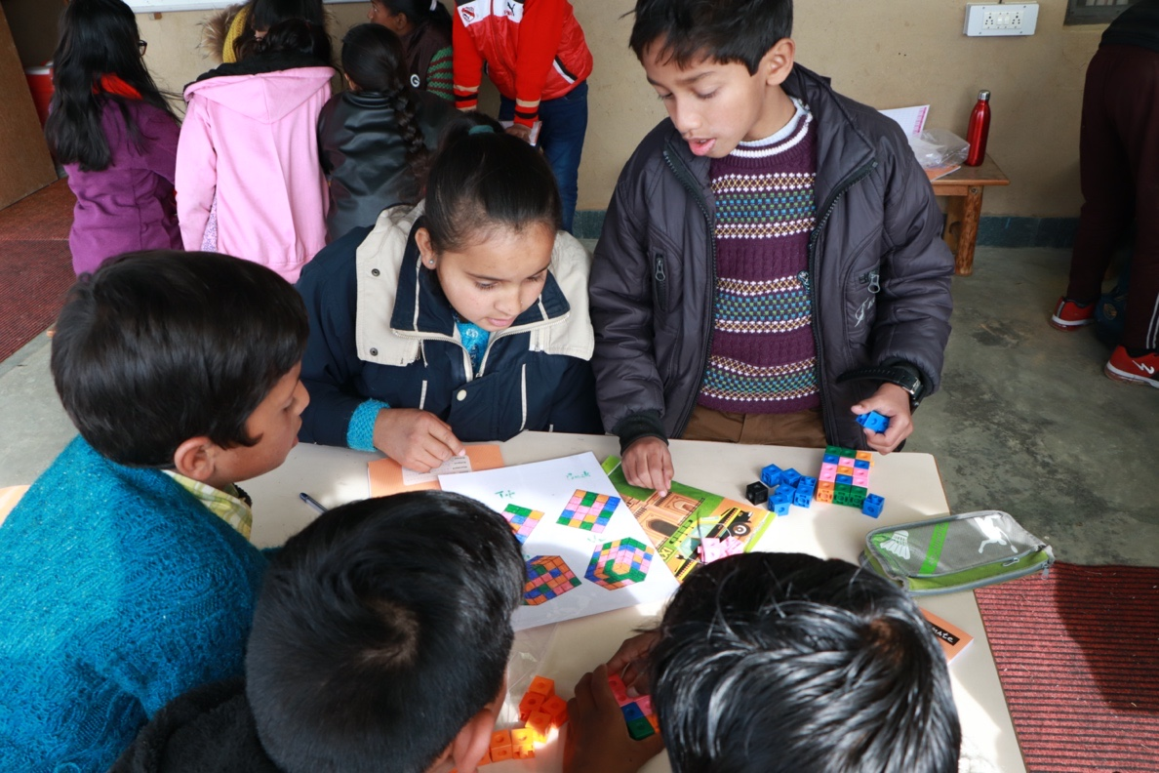

Another group trying to understand these shapes using a block puzzle

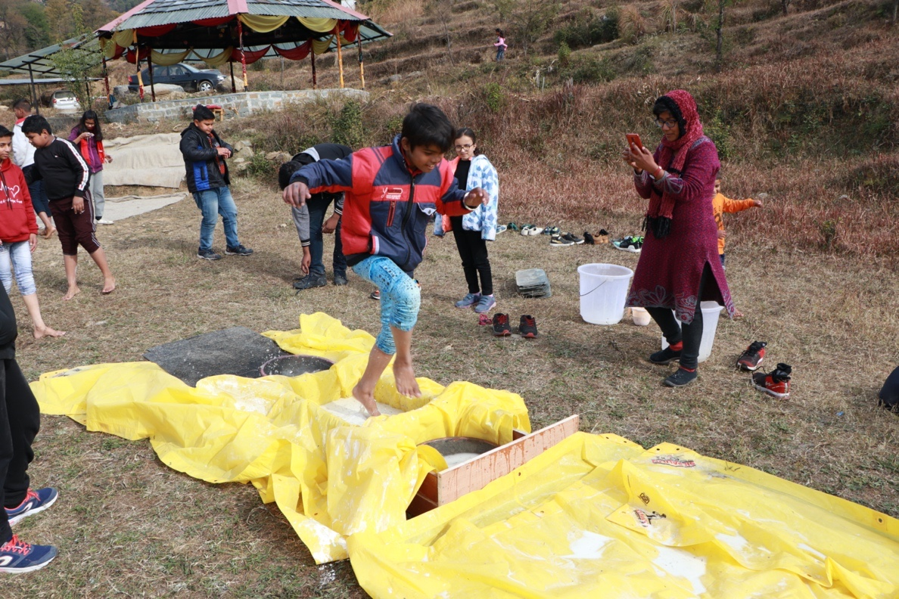

Students doing the corn starch and water experiment by walking over the tub filled with corn starch at different pace.
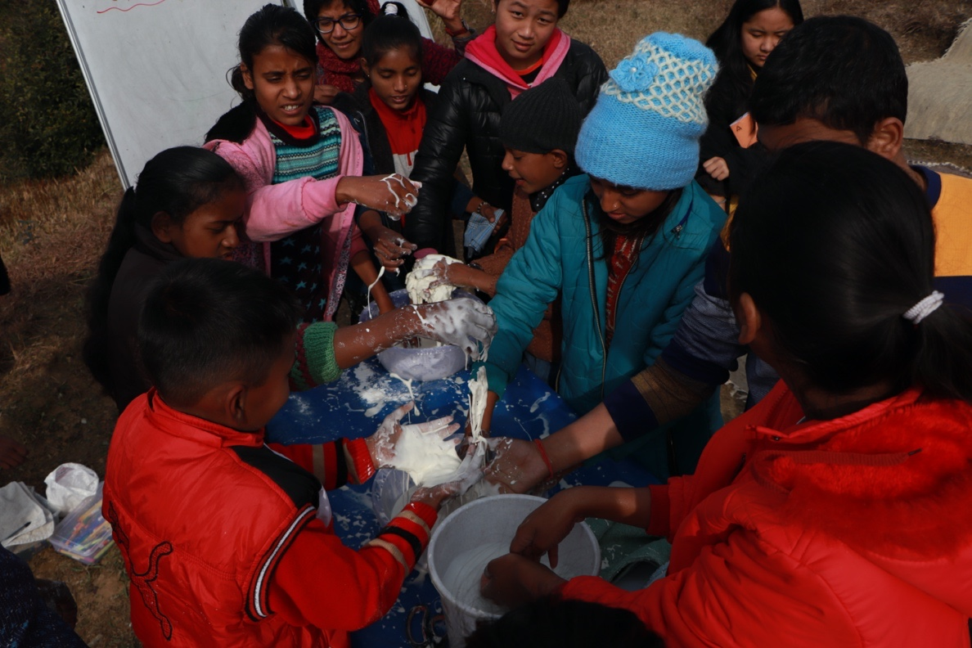

Students playing with corn starch and water

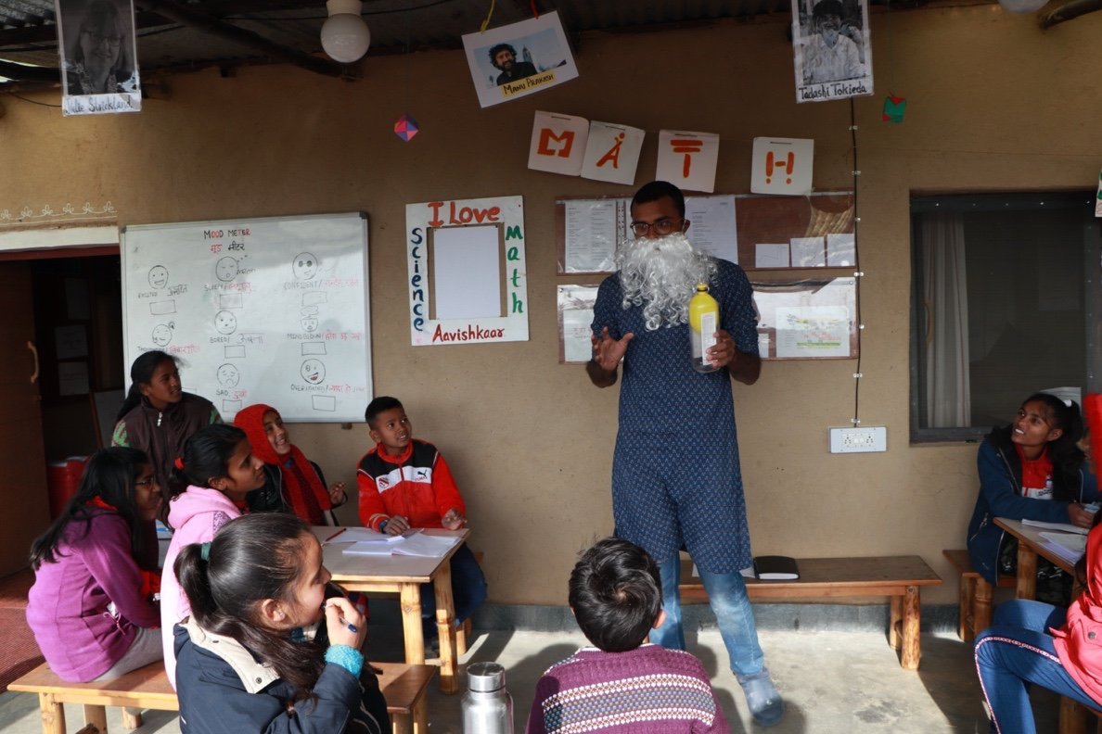

Students learning about magic from science perspective.
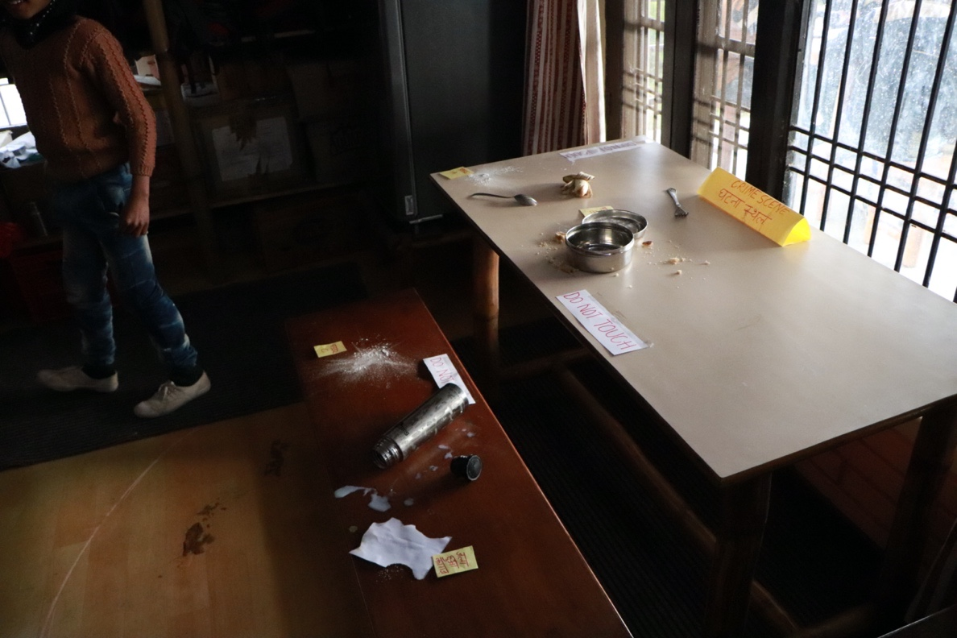

Crime site for the detective activity. Students were given clues and had to figure out who stole the food.

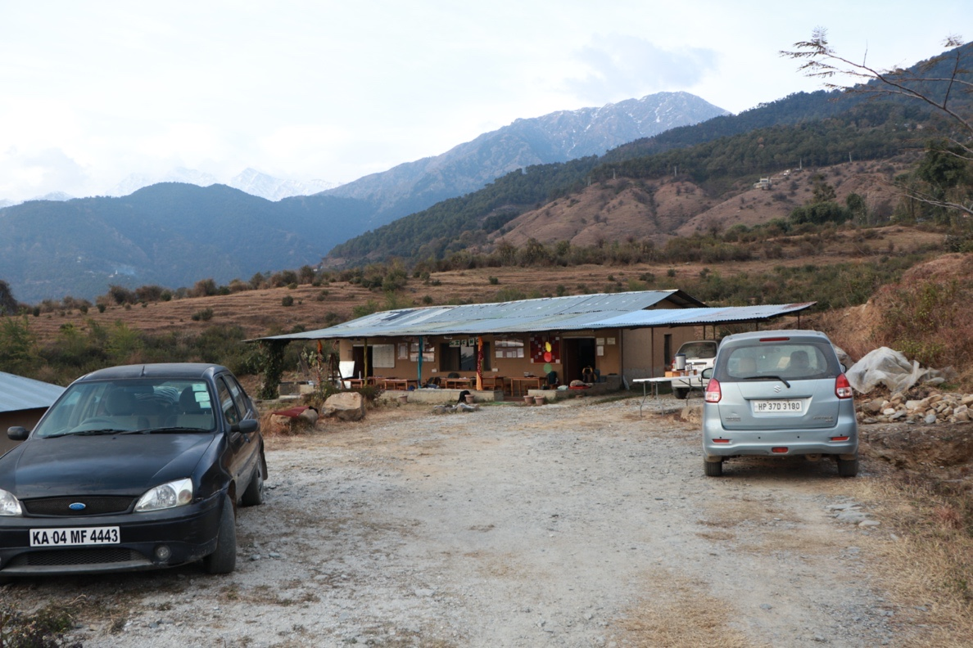
Aavishkaar’s Library
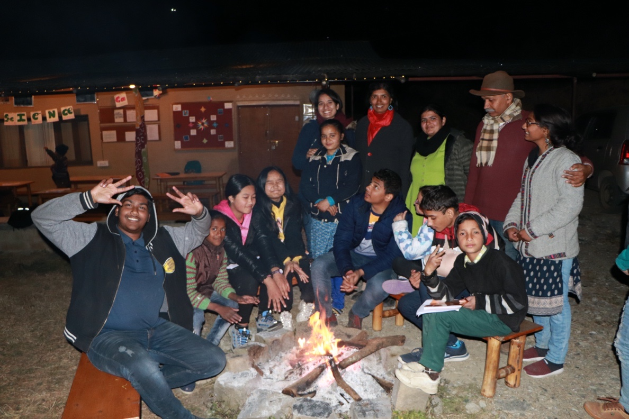

Bonfire at night!

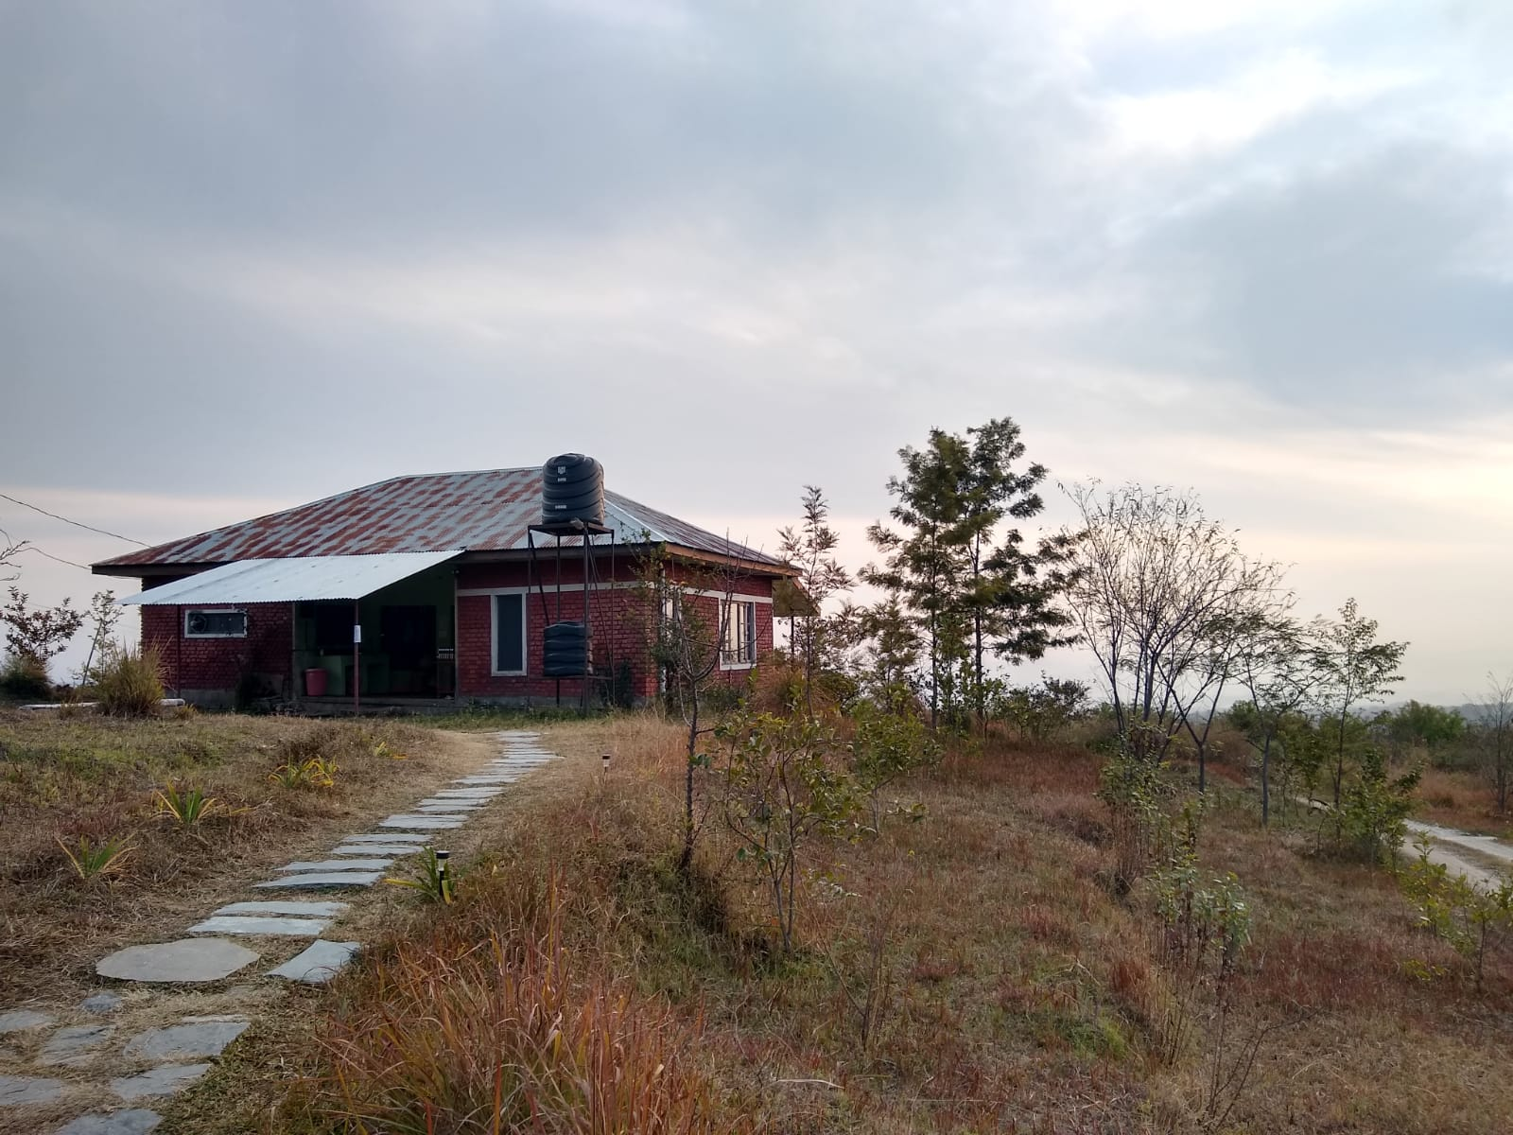

Aavishkaar’s Mess
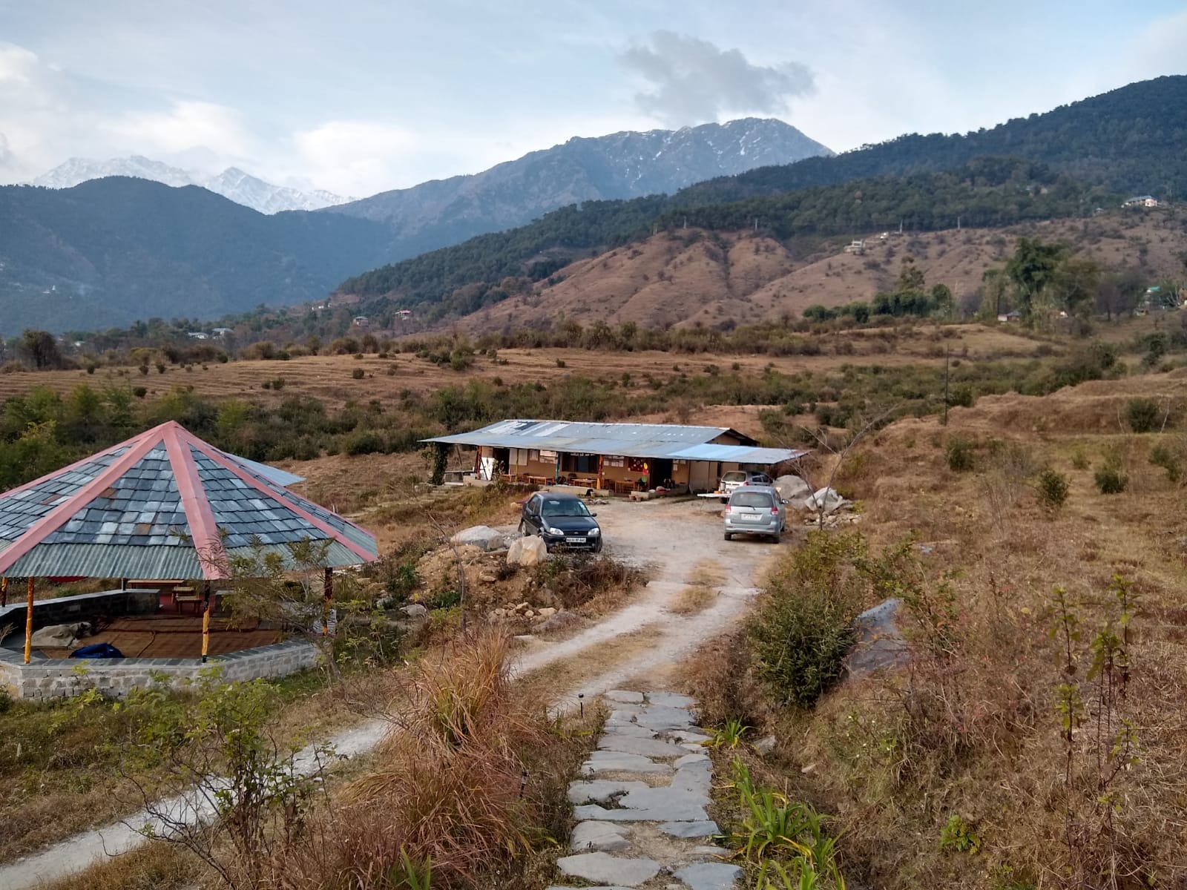
Wide angle view of library and open classroom

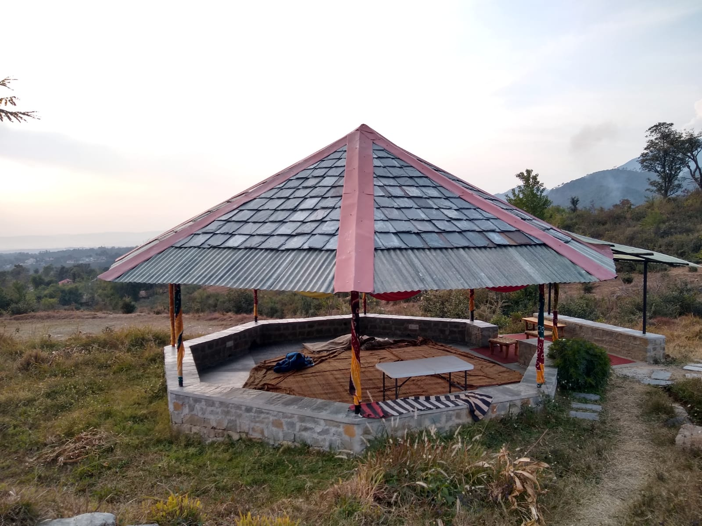

Open classroom

