New Project Proposal Template

Project Name: Nirmaan Vidya Helpline |  |  |  | Date Received:
Referred By: Praveen Abbaraju

 |  | Project Contact Information | Asha Contact
 | Name | Nirmaan Vidya Helpline
 | Contact | Chandra Sekhar Putchakayala
 | Address | H.No.12/A, PS Nagar, Vijayanagar Colony, Masab Tank, Hyderabad – 500057.
 | Phone(s) | +91-9052858856
 | Fax | -
 | E-mail  Web Site | chandrasekhar.puch@nirmaan.org www.vidyahelpline.org | www.nirmaan.org

Part I: Information about your group/organization
Please feel free to attach any additional sheets and/or information such as brochures, press reports etc.
1. Name of the group/organization requesting funds.
Nirmaan Organization
2. When was the group established?
2005

3. Briefly describe the motivation for starting this group.
Nirmaan, which was initially known as My INDIA is a thought that emerged from the usual discussions on national issues that used to take place in the hostels of BITS, Pilani. During one such usual discussion, few participants put up a thought that the idea of every citizen working towards a common goal of making India a developed Nation can alone solve the problems that the nation is facing. That powerful thought gave the birth for our organization which is now called Nirmaan.

Then, the plan was to craft a robust strategy to create a platform where everyone can work towards the common goal. Started with a very small number of around five to six members with its several initiatives like Gyanbodh, an evening school for underprivileged, libraries in villages, awareness programs in the campus on conservation of natural resources etc. in a short time, it gained the confidence of fellow BITSians and the faculty and gathered all likeminded people for the cause. Apart from initiation of such programs, soon after My INDIA was started, its members met and participated in discussions with various professors, businessmen and eminent social workers to craft a strategy for the organisation.

It took around one year of time to identify that three factored education and creation of livelihood opportunities as the focus areas, to craft such strategy and to give a proper vision to the organisation. During this one year time, all its initial members who are called the members of founding team put numerous night outs faced many hardships to take the message of My INDIA to the BITSians, to the faculty and the beneficiaries around Pilani.

4. Name the key people running the organization and describe their background
S.No | GB Member Name | Profile
1. | CHANDRA SEKHAR .P  President | - Chandra Sekhar Putchakayala is an alumnus of BITS, Pilani and has 4+ years of corporate experience and 4 years of full time experience in development sector. With his passion to provide access to quality education to masses, he quit his lucrative job from JP Morgan, Mumbai, and has been serving as CEO of Vidya Help Line project, providing career counselling to more than a lakh student.  - Under his leadership the project has scaled up from a single centre with about 3 employees to 4 centres across two states with 35+ full timers. He is also the Founder and CEO of Ed-Lead, a social enterprise providing services to medium income schools at affordable prices.  - He has presented his projects and views in various National and international forums and brought great opportunities to the Organization.
2. | VIJAYA LAXMI  Vice President | - VijayaLaxmi Manne has 5 years of corporate experience in IT and Health Sectors. She has incubated and run livelihood/social projects in various capacities at Nirmaan Organization, since its inception.  - Passionate about entrepreneurship, she is the Founder and CEO of Root Impact, a social enterprise that provides value based affordable products and services to the Bottom of the economic pyramid. She also provides consulting services to other NGOs and social ventures.  - Vijaya is an Electrical and Electronics engineer from BITS, Pilani and a full time MBA in Strategy & Leadership and Marketing from the Indian School of Business, Hyderabad.

3. | MAYUR PATNALA  General Secretary | - Mayur Patnala (2002A4A7405) is a full time Social Worker and is passionate about Social Innovation. is Co-founder & CEO of Nirmaan Organization (www.nirmaan.org) started in Pilani in 2005 which works in government schools, career counselling, livelihoods etc., with 700+ volunteers from BITS,Pilani, Goa and Hyd campuses along with 3 corporate chapters, which impacted over 1 lakh lives.  - Previously, in his role in Government of Andhra Pradesh as State Mission Manager, Rajiv Yuva Kiranalu, Skill Development Mission, trained 5000 economically backward youth and employed 2500 of them.  - He is also Founder & President of Yuva Varadhi (www.yuvavaradhi.com), a federation of Youth Social Clubs in 30+ colleges which sensitized 600+ youth towards social causes. He served as a member of BITS.AID as well.  - He is a graduate of BITS-Pilani (Pilani campus) in B.E.(Hons) Computer Science and B.E. (Hons) Mechanical and award winner of BITSAA 30 under 30 in Community Service category. He currently lives in Hyderabad, India.
4. | NAGESH PALLA  Treasurer | - Nagesh Started as a volunteer for various NGOs, with good grassroots experience and driving many projects impacting lives. Ahead of his MCA, out of his social passion, he moved to the social sector and sought a full time employment in Nirmaan and is now serving as the Governing Board member of Nirmaan. It has been 5+ years of full time engagement with Nirmaan serving as executive board of Nirmaan Organisation. He has also been on the board of another NGO, Yuva Varadhi.
5. | RAJESH TAMADAPLLY  Executive Member | - Rajesh Tamadapally is a Prime Minister's Rural Development Fellow (PMRDF) working in the most development deprived and naxal affected areas of the country.  - He is an alumnus of Bits-Pilani. He has 7 years of corporate experience.  - He has 1 year of full time experience in development sector (before joining PMRDF) during which he initiated two new chapters and supported expansion of existing projects.  - He has 5 years of volunteering experience during which he lead & nurtured various teams, projects & programs across sectors.
6. | NARESH.P  Joint Secretary | - Naresh is an alumnus of JNTU University and has done his masters in BIO technology in US. His passion for innovation in health care made him start a company and is currently the Founder and CEO of 8C Health care private limited company.
7. | B. AKASH  Executive Member | - Akash is a Prime Minister's Rural Development Fellow (PMRDF) working in the most development deprived and naxal affected areas of the country. He is an alumnus of Bits-Pilani and had 5 years of experience in the development sector

5. Briefly describe the aims of your group.
- To provide and facilitate quality education to the underprivileged children and youth and thus empower them with character and confidence.
- To create livelihood opportunities to the financially/socially backward, yet motivated, unemployed people especially the youth
- To promote social leadership among the youth through exposure to grass roots challenges, volunteerism, active citizenship, participative community development and implementation of social projects
- To solve grassroots problems through social innovations; primarily in the fields of Education and Livelihoods

6. Does your group have any religious or political affiliation? If yes, please describe the type of affiliation and the reason for it.
No

7. What non education-related community development activities is your group involved in?
Nirmaan mainly works on three verticals; Education, Livelihoods and Social Leadership. Under Livelihood operations we have 2 key projects: Vocational training centre (VTC) and Youth employment program (YEP). Vocational Training Centre was initiated in 2010, with an aim to provide skills and confidence to women from economically backward families and help them achieve economic and social independence. A 3 month training program is carried out for women from financially constrained families. The selected women beneficiaries can choose to be trained in vocations like Tailoring, Embroidery, Bag Making and Mehendi. The training is carried out on a daily basis by experienced faculty. After completion of the training, trainees are certified by a recognized government organization. In YEP, unemployed youth are trained on essential employability skills like Soft skills, Computer skills, communication skills etc.,
8. Does your organization have FCRA (Foreign Contribution Regulation Act of 1976) clearance from the Indian government? This is required for you to receive foreign funds. If yes, please provide FCRA details. If no, have you applied for Prior Permission (one time acceptance of foreign funds)? If yes, when was the application submitted?
YES, FCRA Registration Number: 010220268

Part II: Details about your educational project/s

Introduction to Vidya Helpline (VHL) Project:
Vidya HelpLine is one of the flagship projects of Nirmaan Organization, providing career guidance to students and dropouts. So far the project has supported more than 1.6 Lakh rural students and dropouts through various innovative services such as toll free Tele- counselling and career counselling workshops. The project is also scalable and replicable in nature and is currently operational with 14 lines in 7 centres.
Vision: “Every student to obtain excellent guidance and appropriate ways to obtain monetary support to pursue the right education of their choice”
Need: It is observed that a rural student faces the two major hurdles while choosing and pursuing a right career:
- Lack of “relevant information on demand” to make a life changing decision.
- Lack of monetary and/or family support to pursue a career of his/her choice.
A need assessment survey has been conducted; the results of which were as follows:
- 67% of the students had no goals set.
- 72% of the students were exposed to just 4 career opportunities: Doctor, teacher, lawyer, and police.
- Only 10% of the students had guidance that could lead them to their dream goals.

  - Why Vidya HelpLine (VHL) for career Guidance?
- VHL is the largest platform for career counselling for this target group across entire India working in 4 states (Telangana, Andhra Pradesh, Assam and Odisha)
- 5 years of Expertise in career guidance with passionate team from diverse backgrounds.
- 70,000+ students from 800+ Government schools from 12 provinces of India have been made to dream big through these workshops till Oct 2015.
- The project is also able to influence the policy level amendments on career counselling in the states of Telangana and Assam.
- Received awards from various partners including Tech Camp grand Challenge awarded by US Consulate in association with Microsoft and Samhita, testimonials from several partners, etc.,

The model is highly scalable and has an ease of replication and operation as the need for the project exists everywhere across the globe

Objectives of VHL:
- To guide students in their careers to take up right choice of career
- To provide information about various aids like Scholarships, training institutes, loans, etc., to continue their education
- Access to free, direct and authentic information and guidance on demand
- To show opportunities to students for them to grow to their full potential.

Key services of Vidya HelpLine project:

Toll free-Tele-Counselling:
The toll free service of Vidya HelpLine assists student callers in queries related to career guidance, admissions counselling, examination results, scholarships, education loans, training institutes etc. So far, over 2,50,000+ call queries have been addressed, as on September 2015.
Tele-Counselling Operational Model
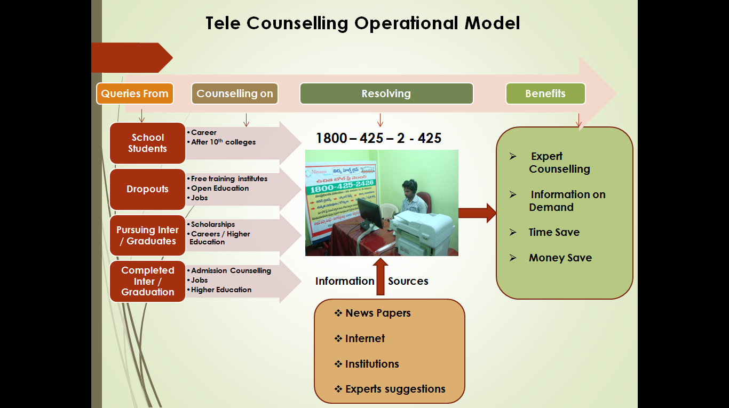
    - Goal Setting and Career counseling workshops:
Goal setting and Career Workshop is a face to face counselling wherein the trainers directly reach out to the students and inspire them to aspire for greater heights in life there by making them DREAM BIG. A huge spectrum of opportunities is then laid before them to choose. The purpose of conducting career workshop and Skill building workshop is to ensure that each and every child Grade 10 sets himself a goal not out of ignorance or need but out of interest and conscience.
The objectives of these workshops are:
- Goal setting
- Importance of Dignity of Labour.
- Exposure to key career opportunities.
- Personalized career counselling-charting maps to the dream careers.
- Connecting students to tele-helpline centre for life time counselling.

It takes 3 Hours to conduct a workshop for about 60 students and each school. The Workshop includes personalized Career Baseline and end line, Inspirational session followed by exposure to hundreds of career options, scholarships, colleges etc., so that each student is able to choose a career and lay a career road map by himself/herself at the end of the session. Each student would also be provided a booklet, career chart, assessments etc., explaining about several courses / careers and scholarships.
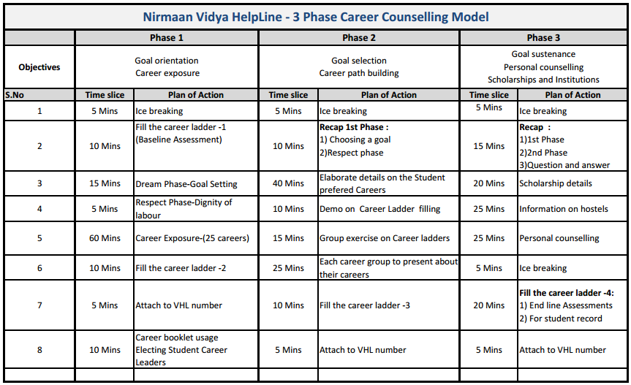
The models have been a huge success in the states of Telangana and Andhra Pradesh and it has been replicated in the states of Odisha and Assam. [Appendix-3]
  - Qualifications of staff involved with the project:
The project’s core team comprises of professionals hailing from diverse backgrounds of management, engineering, psychology, teaching, pharmacy, journalism, social sector etc., they are also supported by volunteers from several corporates. The minimum qualification for any resource is a graduate with good academics and passion to help the disadvantaged sector.
  - Proposed Project Deliverables:
The current proposal is to organize 3-phase Career Counselling workshops in 25 Government Schools for under privileged students assisting 1500 children largely from rural backgrounds building their career thereby making them dream BIG!
Measuring the outcomes:
- Short term – The students fill a base line and the end line at the end of each workshop. These are analysed by the research team and inferences are made based on that.
- Long term – Once the students complete their 10th grade, a sample of students is tracked to analyse which course / college etc., the student pursues and the results are analysed.

Expected outcomes:
- 90% (1350) students set their goals out of their interests and abilities
- 80% (1200) students build their own career road map
- 75% (1125) students are aware of where to study (college), which course and scholarship options for them to purse higher education

Part III: Financial Details

Below is the total funding required to carry out the operations for one year.
Total Amount – 6,49,550 INR (Six Lakhs Forty Nine Thousand Five Hundred Fifty Rupees only)
Total Beneficiaries | Total
Total no. of Students | 1500
Total no. of Workshops | 75
Amount in Rupees
Total Expenses | Rs. 6,49,550
Expenses per student for all 3 visits | Rs. 433
Expenses per Workshop | Rs. 8,661

**Detailed split of finance is given below

3-Phase Career counselling workshops in 25 Government Schools reaching 1500 Students
Expenses | Details | Per Unit | Per Month | Total in INR
Career Booklet, base line & end line forms, etc., | A booklet providing details about various courses available after 10th Standard, the fees particulars, location, admission procedure, opportunities available in that course etc., This is given to each student.  [Avg 60 students per School X 25 Schools= 1500 students] | 25 | - | 37,500
Career chart and career banner | A chart briefing all the career options and career route map and a 6*4 feet banner to be pasted in 25 Schools | 400 | - | 10,000
Travel and daily allowance | Resource persons along with volunteers to travel to areas to conduct 75 workshops [75 visits by a min of 2 persons] | 1,200 | - | 90,000
Career Notice Boards | Notice Boards (2*3 size) are kept in schools and regular notifications will be provided to students in 25 schools | 1,200 | - | 30,000
Voice & Text messages | Voice & Text messages are sent regularly for the students on Admission counselling, Scholarships, Notifications and Information related to careers  [12 times for 1500 students, costing Re.1 each] | 1 | 1,500 | 18,000
Stationery and miscellaneous | Folders for each school, stationary, coordination with principals, permissions etc., [75 visits] | 200 | - | 15,000
Systems | 1 Laptop for conducting career counselling workshop | 30,000 | - | 30,000
Resource persons | Remuneration for resource to conduct and monitor career workshops | - | 30,000 | 3,60,000
10% Admin charges | Management, finance and administrative expenditure. | - | - | 59050
Total Career counselling workshops |  |  |  | 6,49,550
Appendix 1: Material provided at workshops to students:
Stationery | Provided to | Particulars
Career Booklets | To all students | Books enclosing information on Careers, course, Colleges, Scholarships
Goal and Path forms | To all students | Baseline test for the assessment of students
Career Charts | 3 per school | A quick overview of career spectrum
Career Notice Boards | 1 per school | Notice Boards to schools for regular career related notifications
Career chart banner | 1 per school | A live size career chart for display in school

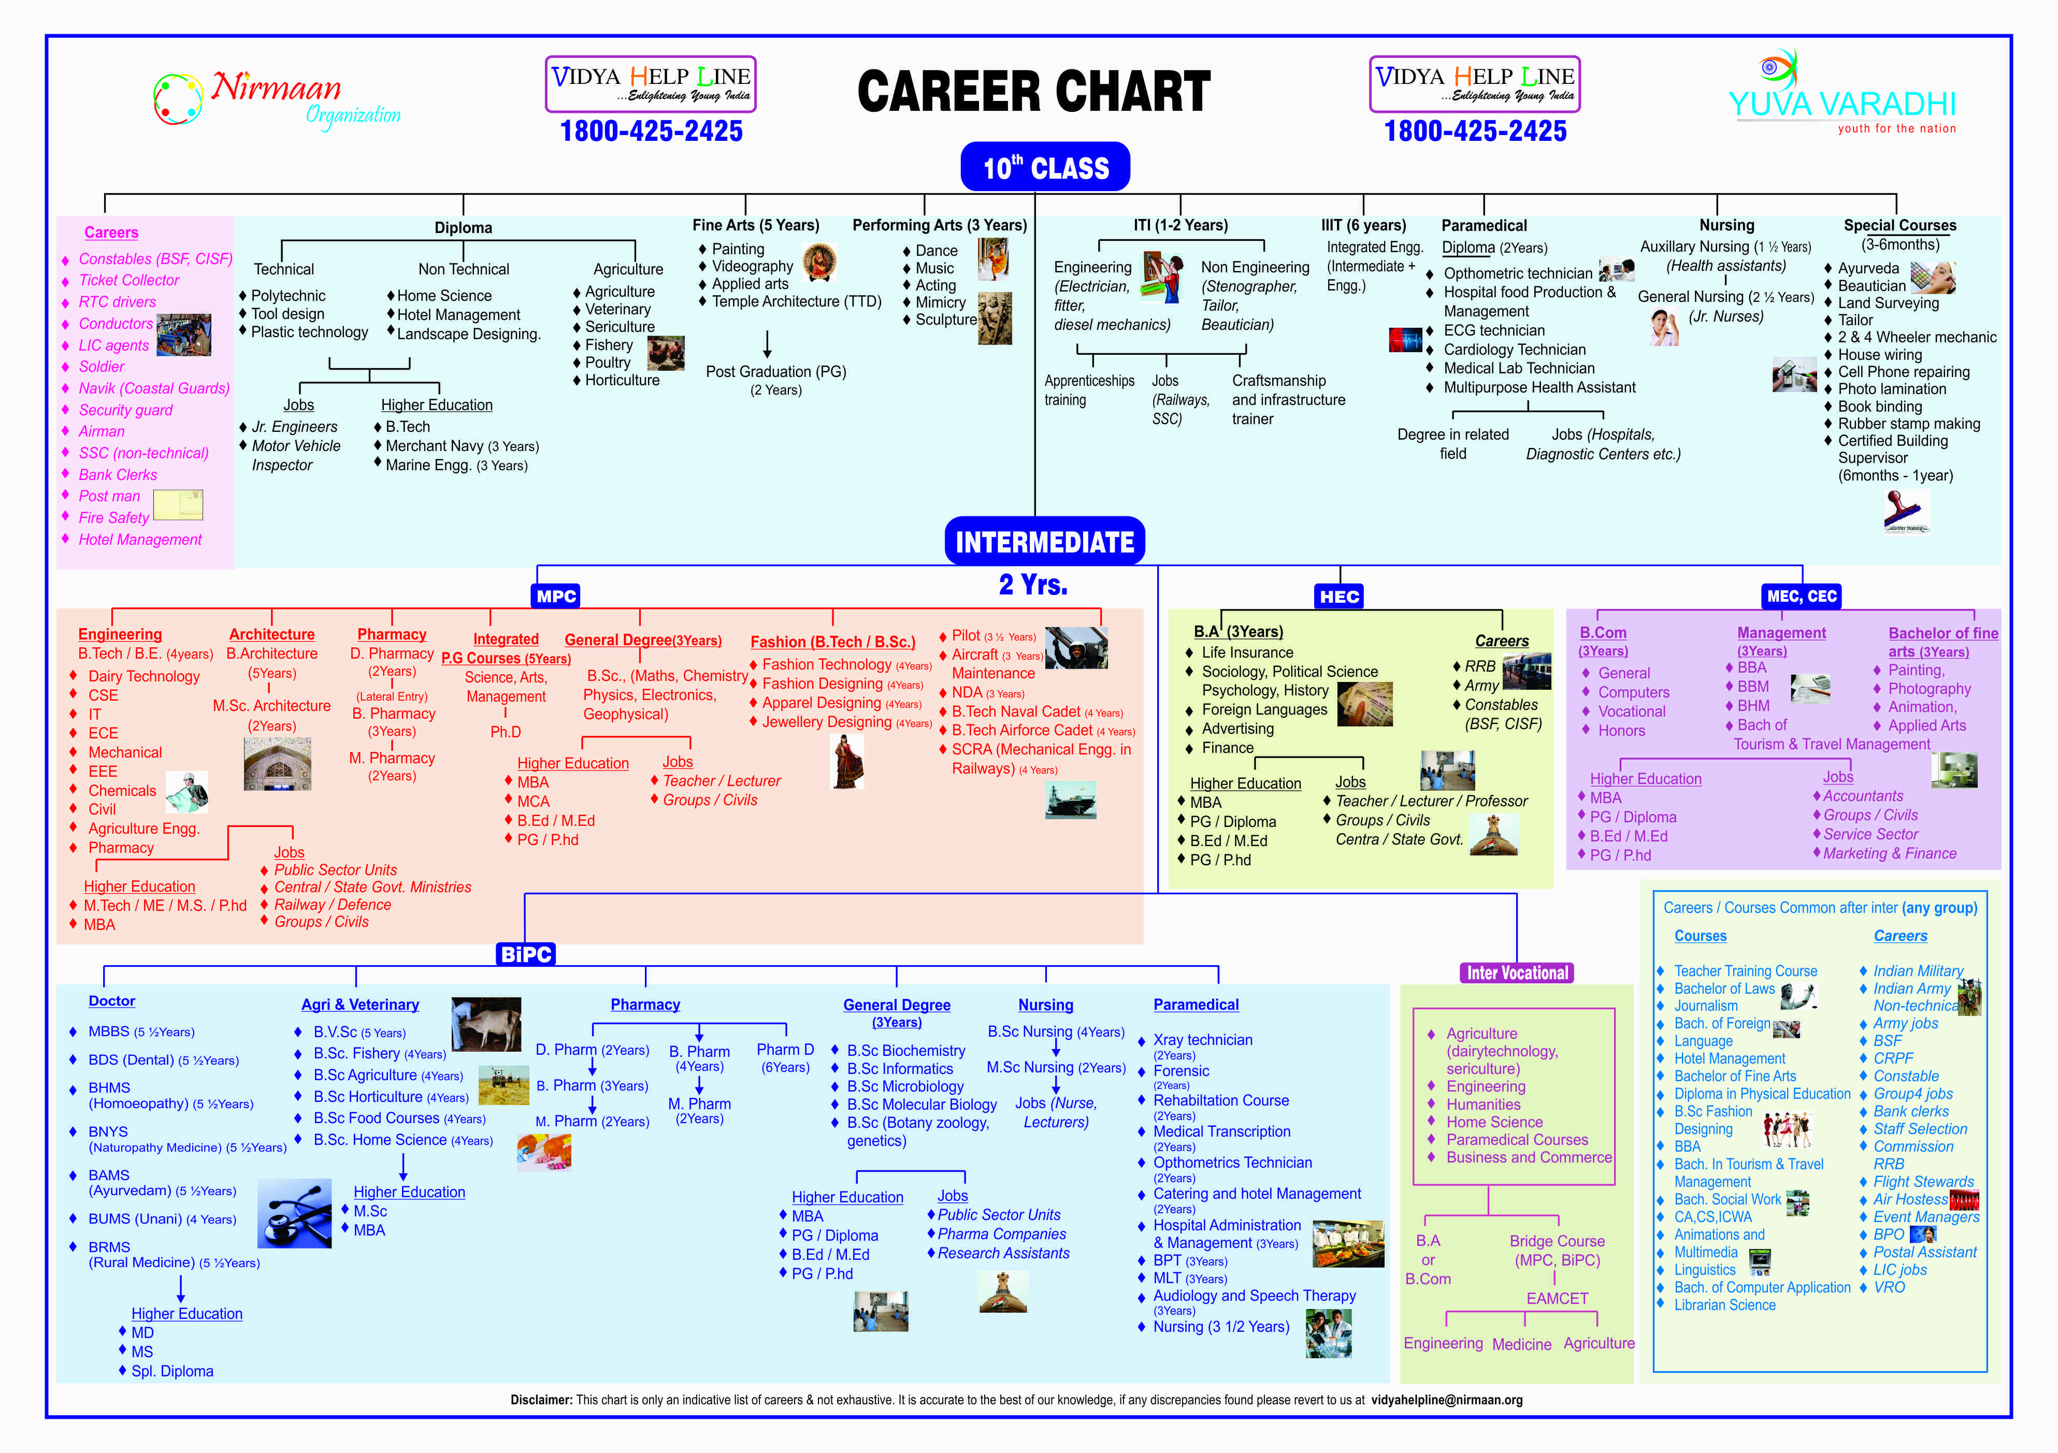
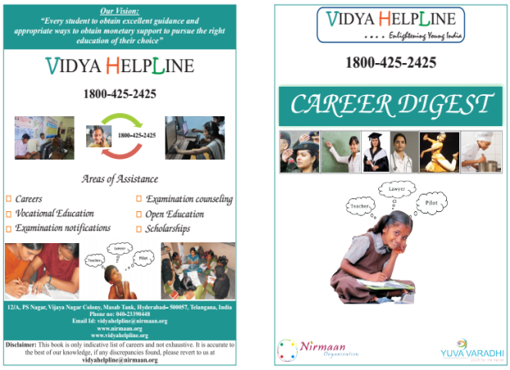
Career Chart: A student friendly career chart in Local Language for a quick reference.
Career Digest: An exhaustive material on various career opportunities.

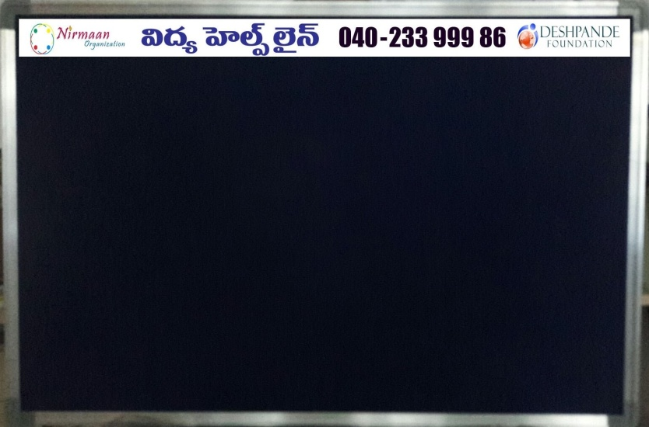
Career Notice Boards: Notice Boards placed at schools for regular career related notifications

Appendix 2: Pictures from Career Workshops
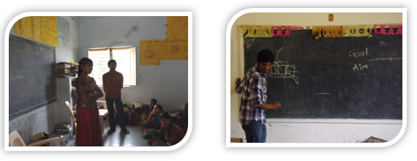
Goal setting session –Importance of goal in life, assisting in choosing a goal
Ice breaking session

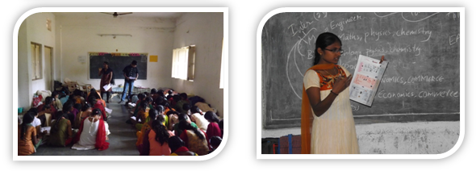
Motivation Session: Inspiring students to aspire for greater heights in life.
Career Exposure Session: Students being exposed to various career opportunities using career chart

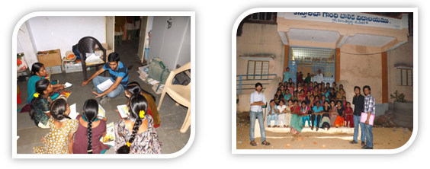
Personalized Counselling: Routing career charts to the dream careers of the students
Group shot at a school in Medak district.

