Site Visit Report of Notun Alo
By Anju Das Kanungo
Supporting Asha Chapter: Asha Zurich
Project partner: Sabuj Sangha
Visit facilitator: Arunabha Das & Ansuman Das
Location: Nandakumarpur village in sundarban
Date of visit: 12/03/2022 - 13/03/2022

Project brief: Asha supports a residential school for 35 underprivileged boys. The boys learn traditional
Reading writing up to class five. From class six they go to the nearest high school.

The visit was divided into 4 parts
- Interaction with the boys in the dormitory
- Individual assessment of basic learning skill.
- Looking at the accounting books.
- Meeting with the staff members.
1&2: Interaction with the boys in the dormitory
At present there are 33 boys staying in hostel. The dormitory rooms are clean. Each boy has a separate bed. The bedsheet, pillow and blankets are also clean. The boys are happy with the arrangement. There is a friendly atmosphere. But their educational knowledge is not up to the mark. Their general knowledge is very poor. Due to the Covid situation their general knowledge has further decreased. I told the new supervisor Atanu Halder to look after it. Some boys are very good in drawing and painting. Most of the boys like playing football.
3: Looking at the accounting books.
The accounting books are transparent. For food and stationaries, they have fixed vendors. The person in charge of the accounting keeps it updated.
4: Meeting with the staff members.
Atanu Halder: Supervisor
He joined here on 23rd February 2022 so he could not give proper feedback of the boys. He said so far he saw the boys are disciplined and obey him.
House Mother: Vacant
At present there is no house mother. As the previous house mother Ranjana Chakraborty left this project till date no one has filled the position. I told Arunabha to fill the post as soon as possible, because these children need more supervision.
Bakul Shashmal: Headcook
Assistant: Radha & Rikta
The food is good. Boys like it. They get fish on 5 days, egg one day and meat one day. They also get milk and seasonal fruits.

My Impression
Overall, the boys are happy here. They love this home and do not want to go to their parental house for good. Some boys draw and paint pictures very well. Some are interested in acting, dancing, gardening etc.
But their knowledge in English, math & in general stuff is not up to the mark. I told Atanu to look after it. They need a TV set for news update and entertainment.
Amphan Tornado Effect
Due to the Amphan tornado huge loss occurred there. They have repaired the damages with the help of rehabilitation fund given by Asha Zurich. As per Arunabha’s statement some fund of rehabilitation amount is still remaining. He showed me a vacant place where a classroom will be made.
Status of Students during Covid
All the classes were stopped during the Covid outbreak. But they got the tuition classes in the hostel after 3 months. The teacher took exam for assessment. A score sheet was shown to me. All students are promoted to the next class. Obviously, there is a wide variation of knowledge among the students. But it is a common incidence throughout India.
Summary
To conclude, I am satisfied with the Notun Alo project of Sabuj Sangha. Boys come from very poor family and in most cases, they are the first-generation learners. All the staffs have sympathy for the boys. They want them to become self sufficient and be a good citizen. So, I recommend funding for another year.

Photos
Dormitory
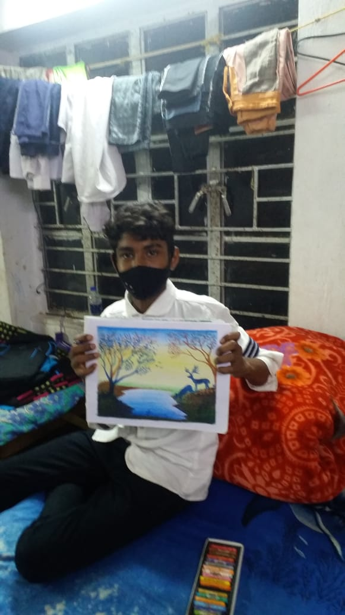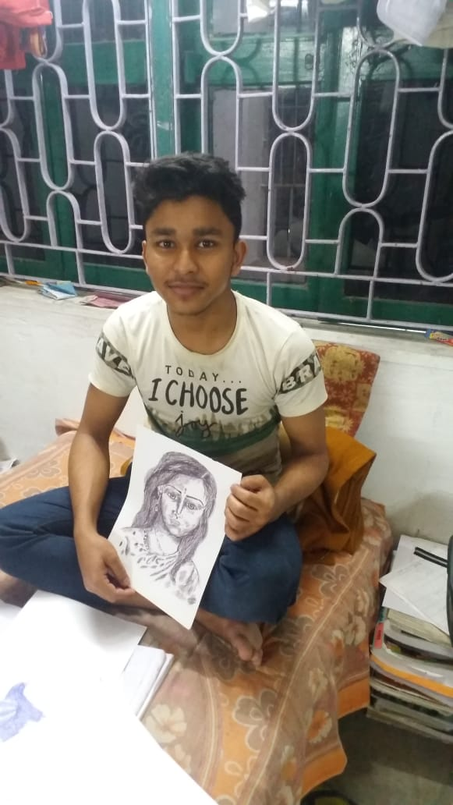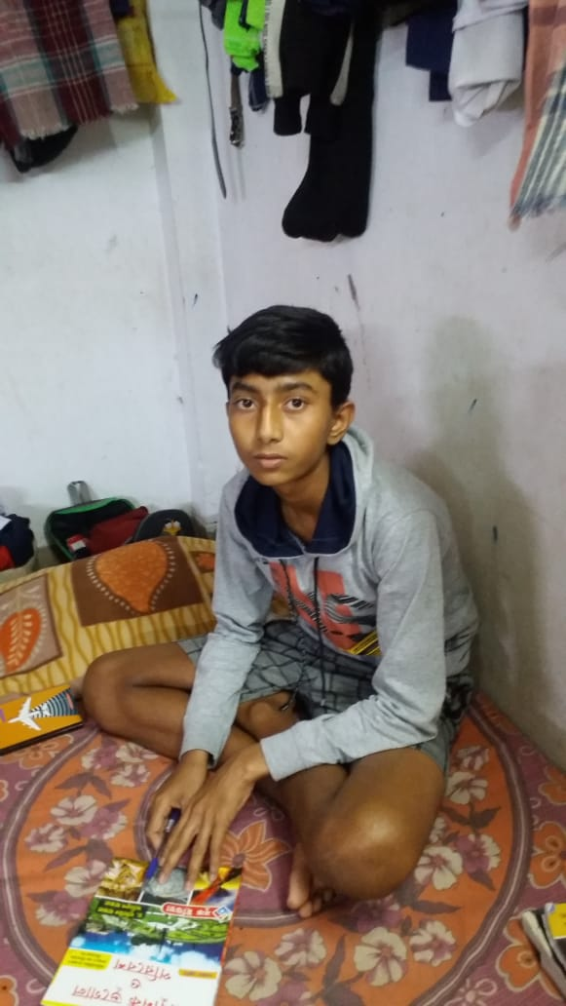

New Kitchen
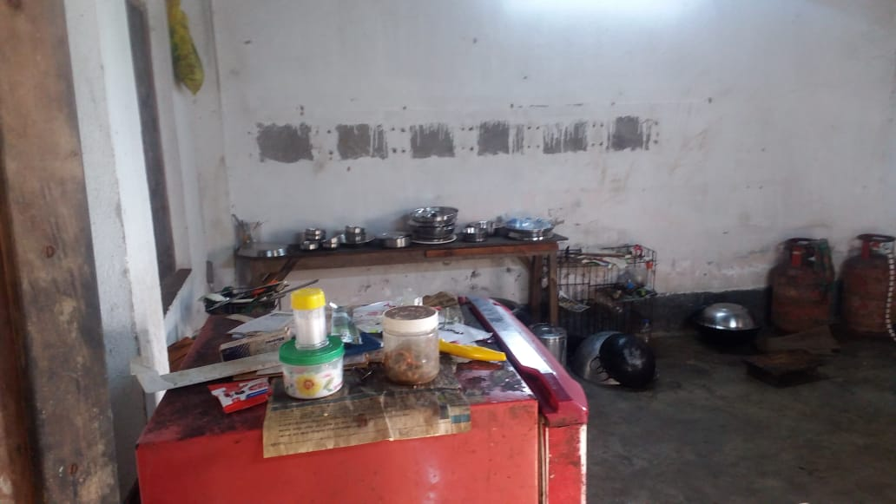

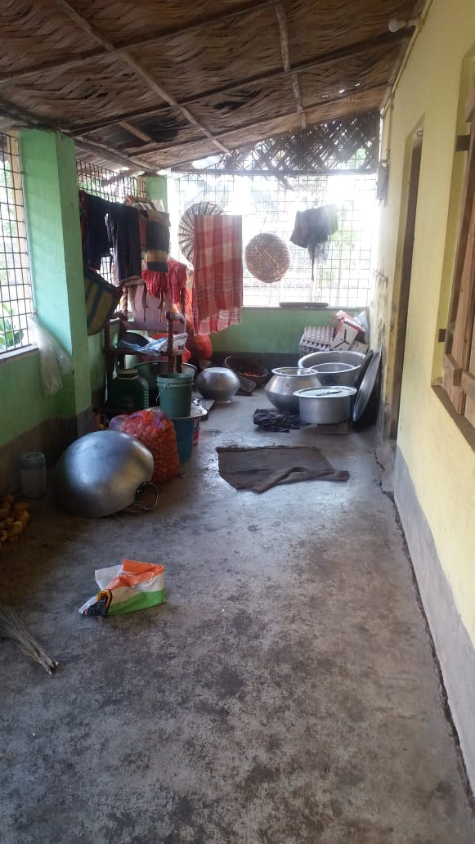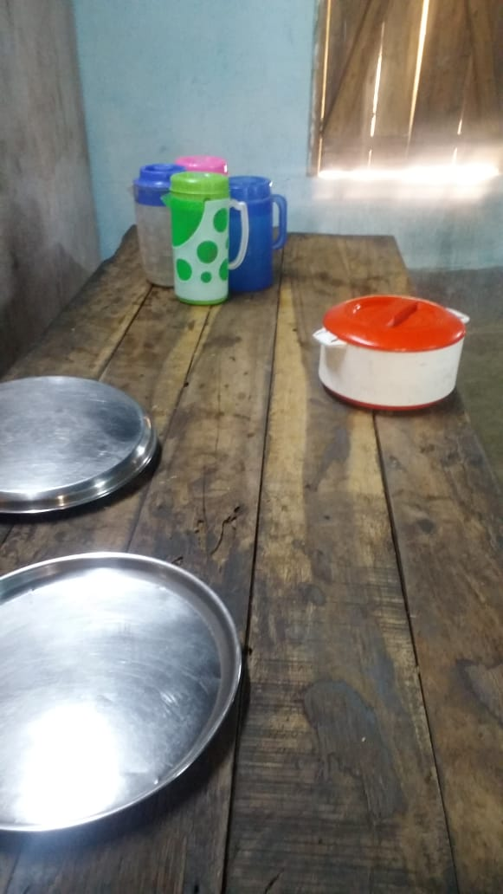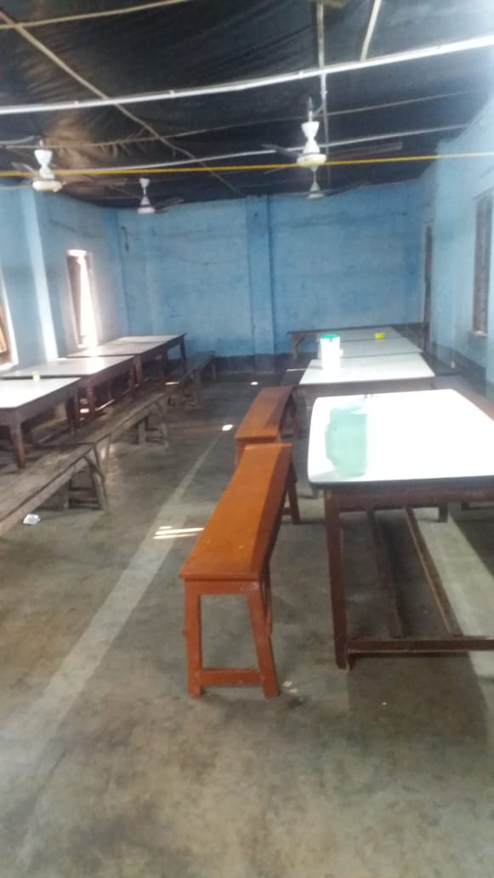

School
