NJSS Visit – Asha for Education – September 16, 2016
By Padmanava Sen (Asha Bangalore volunteer, padmanava.sen@gmail.com)
I have spent 3 days in Rajatalab (25 km from Varanasi) to visit Nandlal Master’s work. 15th September, I have met Chance India kids. On 16th September, I have visited the students of Asha Samajik School at Nagepur village. I have also talked to the teachers of the school. I have played simple games related to Math with the students and asked them simple questions in Hindi and English. The answers were satisfactory and the student knowledge seems to be par or better than what I have seen in Government schools in the same classes.
The school building looks very good with two stories and 2nd floor have a shaded area where trainings can be done. Some rooms are very big to accommodate special activities for students. The teachers showed me the I-cards that are being issued to students. Also now private books are introduced to overcome the issues of procurement of Government books.
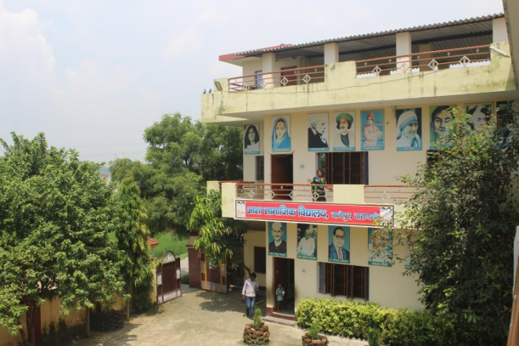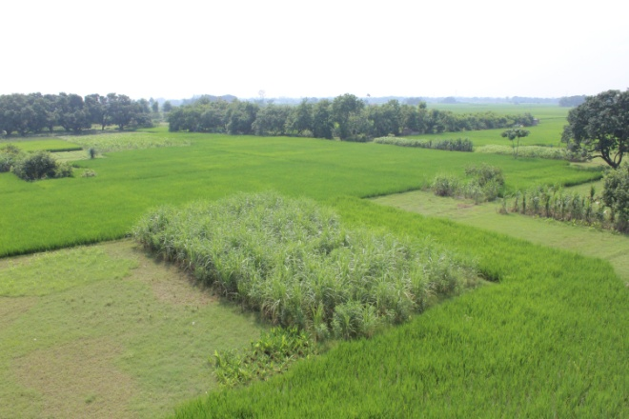
School and surrounding farmlands
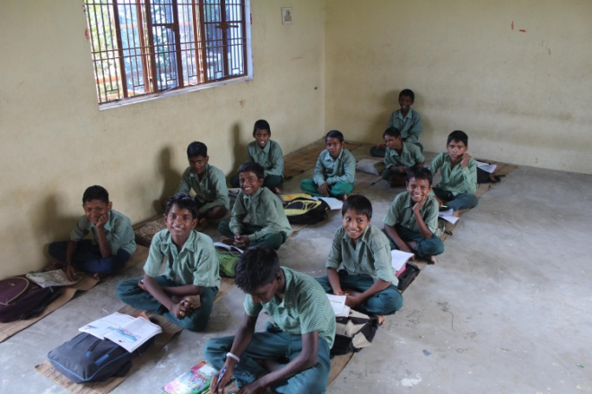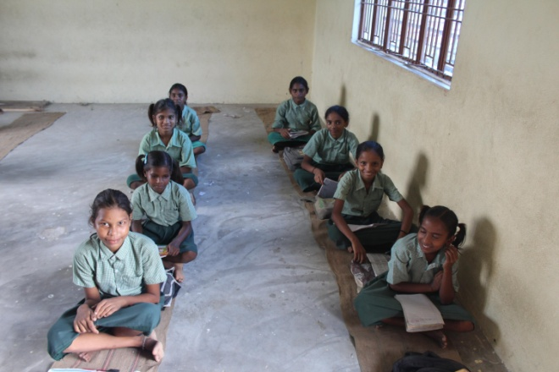

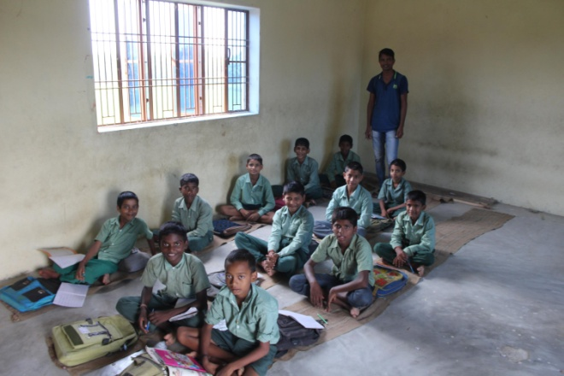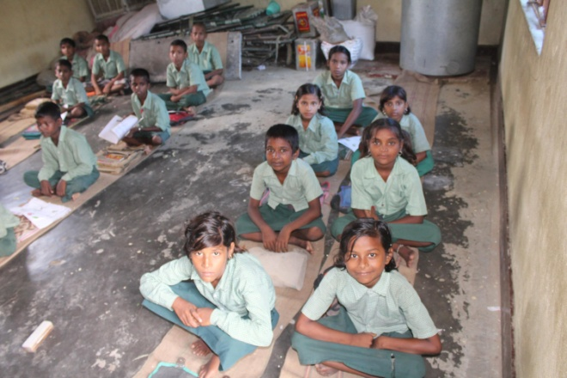
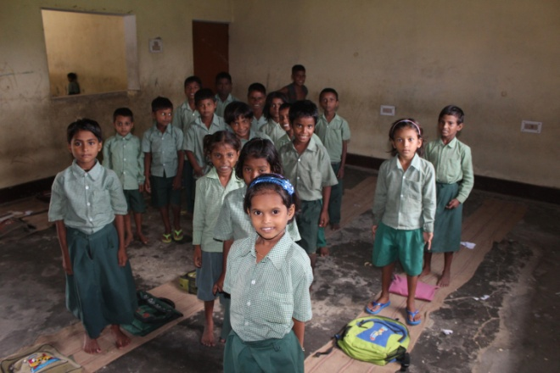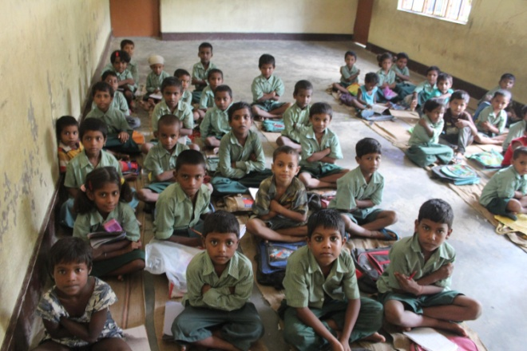
Students in the Asha Samajik School, Nagepur
Later I visited Harsosh village school. Panchmukhi, a teacher in Nagepur school took me to the second school. The teachers were conducting the school under a big tree and usually during monsoons or severely cold days - they move it to a nearby place. The students seem to enjoy their classes in the open and the villagers have built an enclosure as well. Some kids sang songs and recited poems. The teaching methods were very good as much as I can see in the boards. I spent time with kids and then had a separate discussion with the teachers. They mentioned the issues of books, the need of permanent structure, need for travel allowance for two teachers who come from a distance.

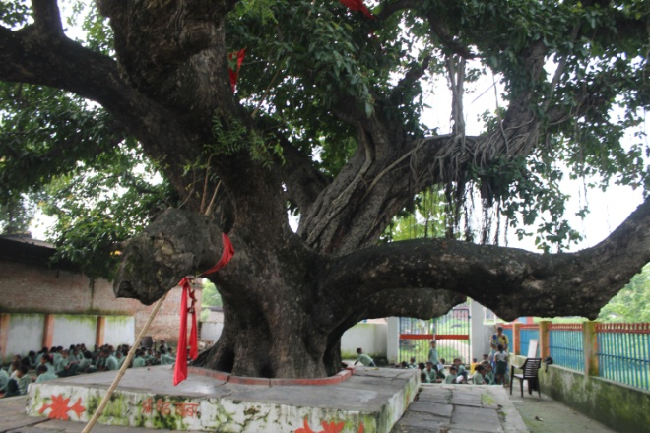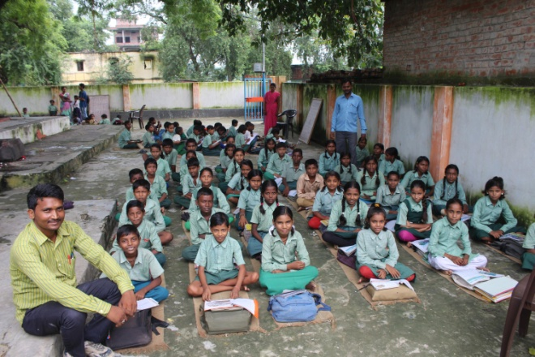
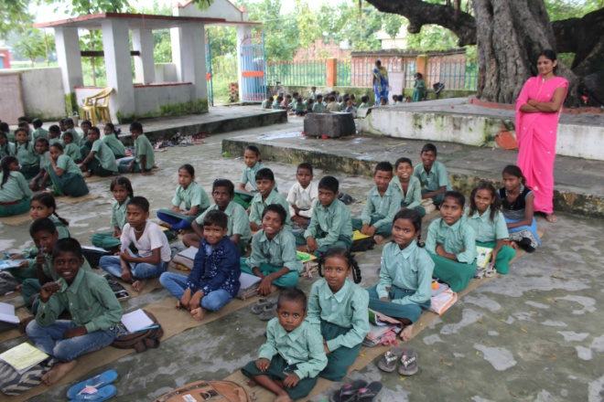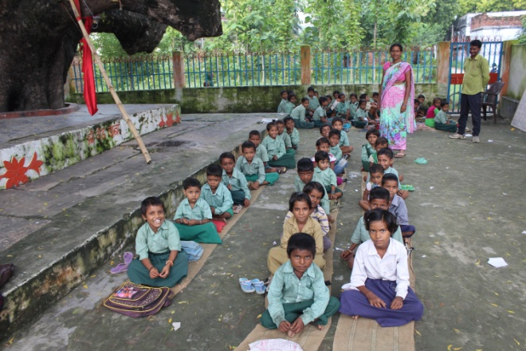
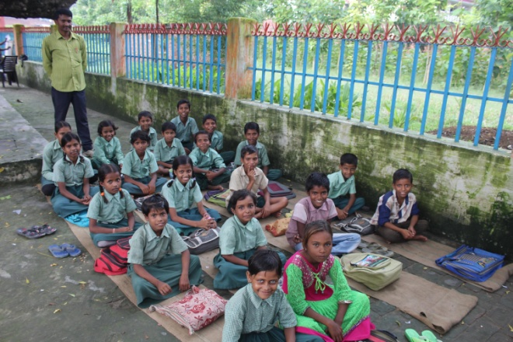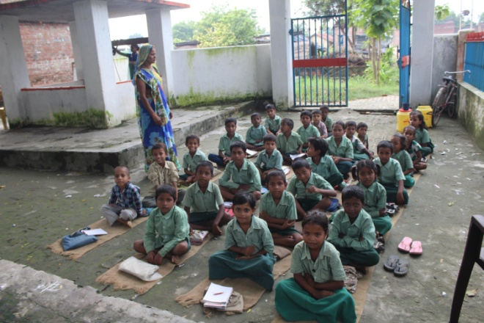
Harsos School and its students

