Proposal for extra circular activity to the play school children
Exposer visit to Vishakhapatnam:
- The interior kondh children never visited Vishakhapatnam – their district head quartier – and most of them not see (physically ) train and traveled in it. Because they live in forest they did got have an opportunity to see the sea too.
- We are contacted Airport authorities of Vishakhapatnam, requested them to allow our children to watch the airplanes landing and takeoff, and they agreed.
The activity:
- 80 children selected from 20 schools and plus with their teachers, 100 participants will reach first day night to SR Sankaran Sramika Vidya Sikshana Kendram at Atcheyepeta.
- Second day all the participants will reach Vishapatanam airport and observe the airplanes landing / takeoff.
- All the participants will reach Vishakapatanam Zoo and after the program proceeds to Beach, night they will reach Atcheyepeta for dinner. We are planning food and snacks to the children at Vishakapatanam town.
- Next day they will visit the Anakapalli railway station and travel in local train (passenger) from Anakapalli to Kasikota and they will proceed to G.Madugual
For three days we planning to book 6 Jeeps (from G.Madugual)
Last year visit photos:
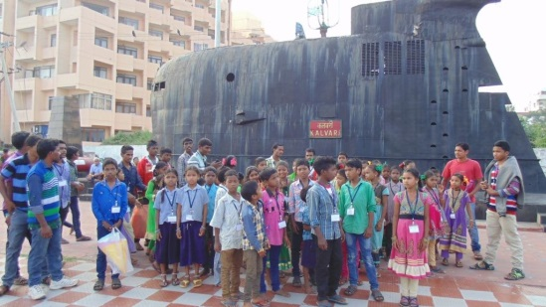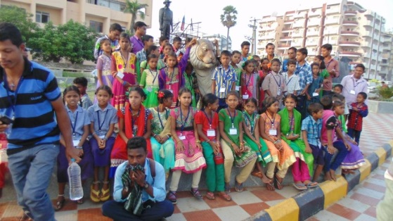

Proposed budgets
S.No | Head | Details | Sub –total (Rs) | Total | Remarks
1 | Travel | Jeep Rents Rs 10,000 x 6  (including diesel & rent) | 60,000-00 | 60,000-00 | For three days  G.Madugula to Vishaka to G.Maduguala
2 | Food and Accommodation | For one meal Rs 60 x 120 members x 4 meals | 28,800-00 |  | 80 children, 20 teachers and Jeep staff , others = total 120
 |  | Tiffin Rs 30 x 120 x 2 | 7,200-00
 |  | Snacks Rs 50 x 100 | 5,000-00 | 41,000-00
3 | Accommodation |  | 5,000-00 | 5,000-00
4 | Fee at Zoo in Vishaka | Rs 50 x 100 | 5,000-00 | 5,000-00
5 | Stationary |  |  | 2,000-00
6 | Misalliance |  |  | 3,000-00
 | Total Expenses for trip |  |  | 1,16,000-00
 | Admin Charges (10% of the costs) | Includes charges for the NGO who receives funds, book keeping and auditing |  | 11,600-00
 | Grand Total |  |  | 1,27,600-00

Three day workshop of TLM (Teachers Learning Material) :
- More visual material in the school enhance the children learning capacity and also create an color full environment inside the school.
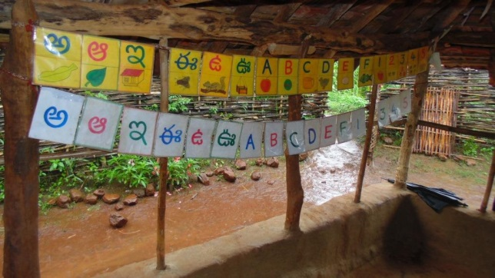

Visula material in Goyagunta school . with lowcost material one can prepare many tyips of color full visiual material to display in the school. to devleop the skill ( preparing such material) and also prepare materail we want to ogranize a three day workshop to teacheres
We request ‘Sodana’ organization resouce personal to particpaten in this workshop and they agreed.

Proposed budgets
S.No | Head | Details | Sub –total (Rs) | Total | Remarks
1 | Travel | Rs 350 x 25 Persons | 8,750-00 |  | Including Resource persons
2 | Food & Accommodation | Rs 350 x 25 | 8,750-00
4 | Materials | Per school Rs 1500 x 20 | 30,000-00
5 | Resource persona fee | Rs 1000 x 3 days x 2 persons | 6,000-00
 | Total |  |  | 53500-00
 | Admin Charges (10% of the costs) | Includes charges for the NGO who receives funds, book keeping and auditing |  | 5350
 | Grand Total |  |  | 58,850

- Exposer visit to Vishakhapatnam: 1,27,600-00
- Three day workshop of TLM (Teachers Learning Material) : 58850-00
Grand Total Rs 1,86,450/-
With Regards
P.Ramalakshmi

