Field Visit Report to The Brick School
26 December 2016

One day field visit was made to the Brick School on December 26, 2016 run by Kumarappa Institute of Gram Swaraj. ASHA for Education “Seattle Chapter” is supporting this project for last one year; this visit is to see the progress made so far.
Background: A small initiative of educating the children of migrant labourers working at brick kilns in Garudwasi area of Chaksu block (Jaipur district, Rajasthan) was initiated in the beginning of 2014. A humble beginning with one school with 30 students at Mahadev Brick Kiln in 2013-2014 increased to four schools (175 students) in 2014-2015 and finally to 10 schools (600 students) covering 12 brick kilns in 2015-2016. All this was made possible by support from well wishers and friends such as ASHA for Education, Pankaj Jain and others.
Present Status: During the session 2016-2017 ten schools (informal learning centres) are opened in twelve brick kilns in Chaksu area of Jaipur district Rajasthan. The twelve brick kilns where the schools are opened are as follows:
1. Mahadev Brick Kiln, Thikariya Gujaran, Kothkhawada, Jaipur
2. LBC Brick Kiln, Badh Murlipura, Garudwasi, Kothkhawada, Jaipur
3. LBT Brick Kiln, Ralavata, Thikariya Gujaran, Kothkhawada, Jaipur
4. LBU Brick Kiln, Ralavata, Thikariya Gujaran, Kothkhawada, Jaipur
5. Kamal Brick Kiln, Badh Murlipura, Garudwasi, Kothkhawada, Jaipur
6. RBK Brick Kiln, Badh Murlipura, Garudwasi, Kothkhawada, Jaipur
7. RNB Brick Kiln, near water tank, Garudwasi, Kothkhawada, Jaipur
8. Rama Brick Kiln, Badhrajpura, Garudwasi, Kothkhawada, Jaipur
9. Mata Brick Kiln, Badhrajpura, Garudwasi, Kothkhawada, Jaipur
10. Aman Brick Kiln, Dharampuri Road, Thikariya Meenan, Kothkhawada, Jaipur
11. IBC Brick Kiln, Ralavata Mode, Thikariya Gujaran, Kothkhawada, Jaipur
12. Taj Brick Kiln, Dharampuri Road, Thikariya Meenan, Kothkhawada, Jaipur
Visit was made to Ram/Mata Bricks School and LBT/LBU Bricks School. Discussion was held with teachers, students as well as their parents. The parents and students were happy with the school that it has been set up at their brick kiln, if it would have been to some other place they would not have sent their children to school. Some of the children are coming to school for the first time.
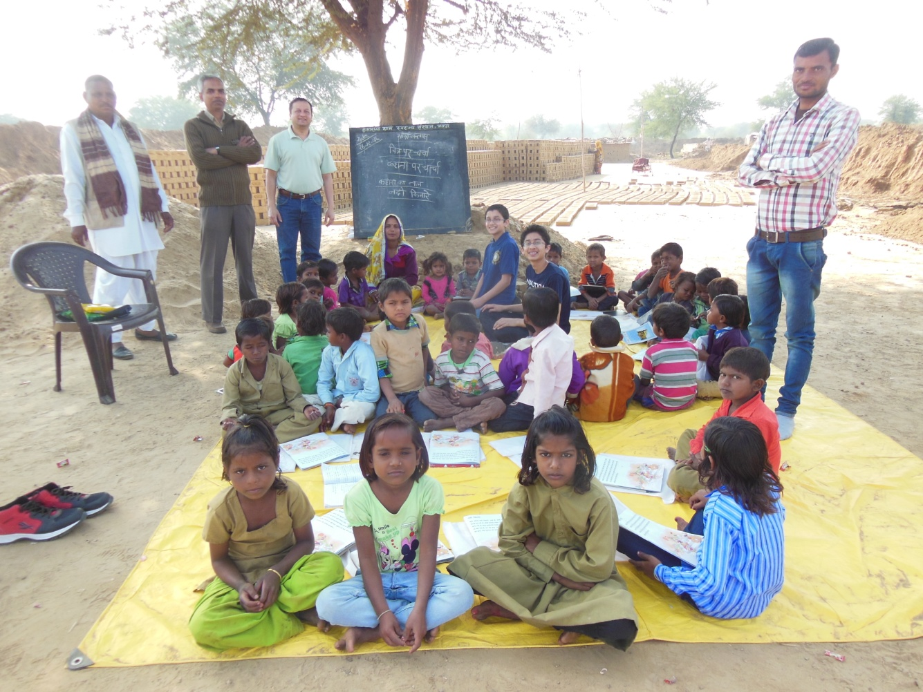
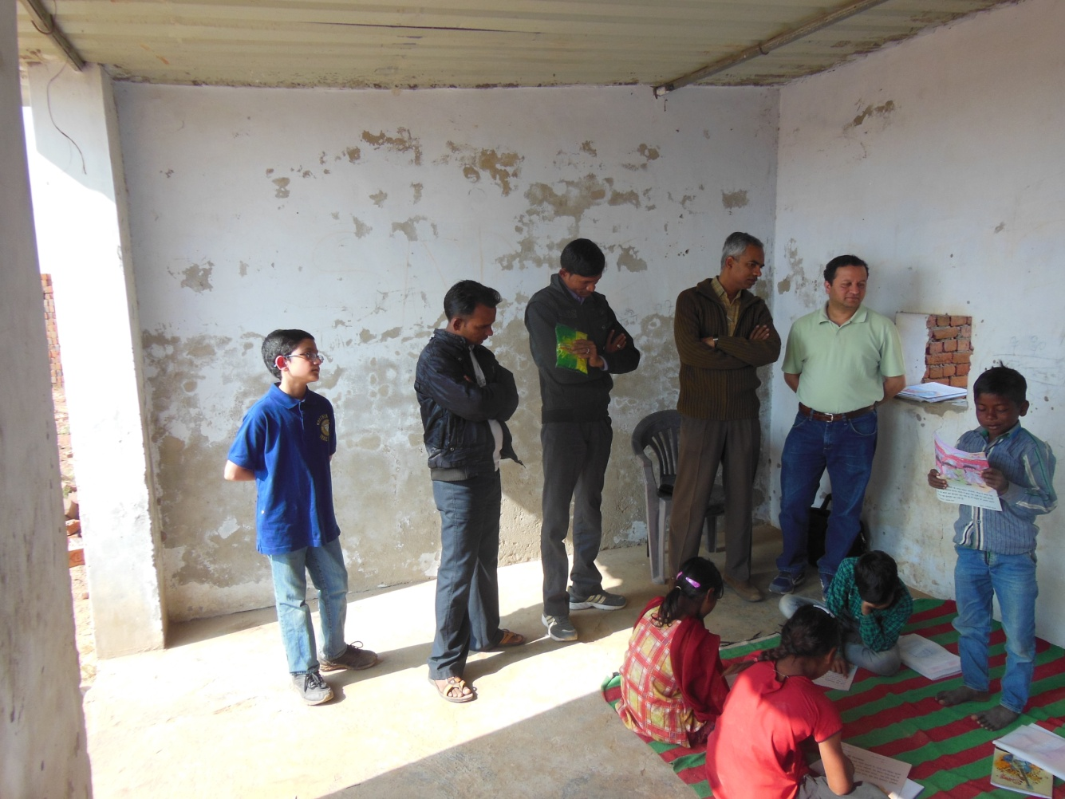
Nineteen teachers are posted in 10 schools; one teacher is available for approximately 25 students. The details of teachers appointed and no. of students enrolled are as follows:
S. No. | Name of Brick Kiln | No. of students enrolled | Name of Teacher | School Started
1. | LBT / LBU Brick Kiln | 58 | Pramod Bairwa  Foranta Gurjar | January 2017
2. | Kamal Brick Kiln | 50 | Neeru Devi  Hanuman Singh | November 2016
3. | RBK Brick Kiln | 47 | Savita Sharma  Chandra Mohan Sain | December 2016
4. | RNB Brick Kiln | 60 | Ramjilal Bairwa  Vinod Bairwa | December 2016
5. | Aman Brick Kiln | 42 | Santosh Meena  Badri Narayan Rana | December 2016
6. | IBC Brick Kiln | 37 | Santara Bairwa  Pooranmal Meena | December 2016
7. | Taj Brick Kiln | 32 | Pritam Singh  Kamlesh | December 2016
8. | LBC Brick Kiln | 37 | Samodri Meena  Mohanlal Bairwa | January 2017
9. | Rama/Mata Brick Kiln | 61 | Asha Devi  Dinesh Bairwa | December 2016
10. | Mahadev Brick Kiln | 19 | Anita Jat | December 2016
11. | Total | 443

Based on previous years experience two teachers are needed in one school, one for learned students and one for beginners. The students have been divided into two groups (i) beginners and (ii) learned. Beginner group is the one who does not know how to read and write and are new learners, this group also includes aanganwadi children who are less than 6 years of age and come with their elder brothers and sisters. In the Learned group the student knows how to read and write and is studying in class 1, 2, 3.....

The detail of students who are regularly coming to school is as follows:

S. no. | Name of Brick Kiln School | Aanganwadi i.e. playgroup (less than 6 years) |  | Group 1-2  (age group 6-8) |  | Group 3-5  (age more than 8 years)
 |  | Boys | Girls | Boys | Girls | Boys | Girls
1. | LBC | 4 | 2 | 6 | 7 | 9 | 9
2. | Kamal | 5 | 2 | 16 | 9 | 9 | 9
3. | RBK | 4 | 8 | 6 | 5 | 12 | 12
4. | Aman | 7 | 2 | 8 | 8 | 11 | 6
5. | Rama/Mata | 3 | 2 | 30 | 13 | 10 | 3
6. | Taj | 2 | 3 | 8 | 9 | 7 | 3
7. | Mahadev | 0 | 1 | 6 | 1 | 7 | 4
8. | LBT/LBU | 11 | 6 | 12 | 8 | 11 | 10
9. | IBC | 2 | 3 | 11 | 4 | 9 | 8
10. | RNB | 2 | 2 | 9 | 18 | 14 | 15
11. | Total | 40 | 31 | 112 | 82 | 99 | 79

Total boys – 251
Total girls - 192
Grand Total - 443

Collaboration with PRATHAM Rajasthan: PRATHAM is a national level organization working on providing quality education to children in rural areas. Support from PRATHAM Rajasthan office is being taken for teacher training, course content and monitoring of students and teachers. With their cooperation a four days teacher training was organized before the session started between 14-17 October 2016. 25 teachers participated in this training program. A pilot of course material, teacher training and monitoring schedule was done for about a month in the local schools, this helped in the planning for the new session.
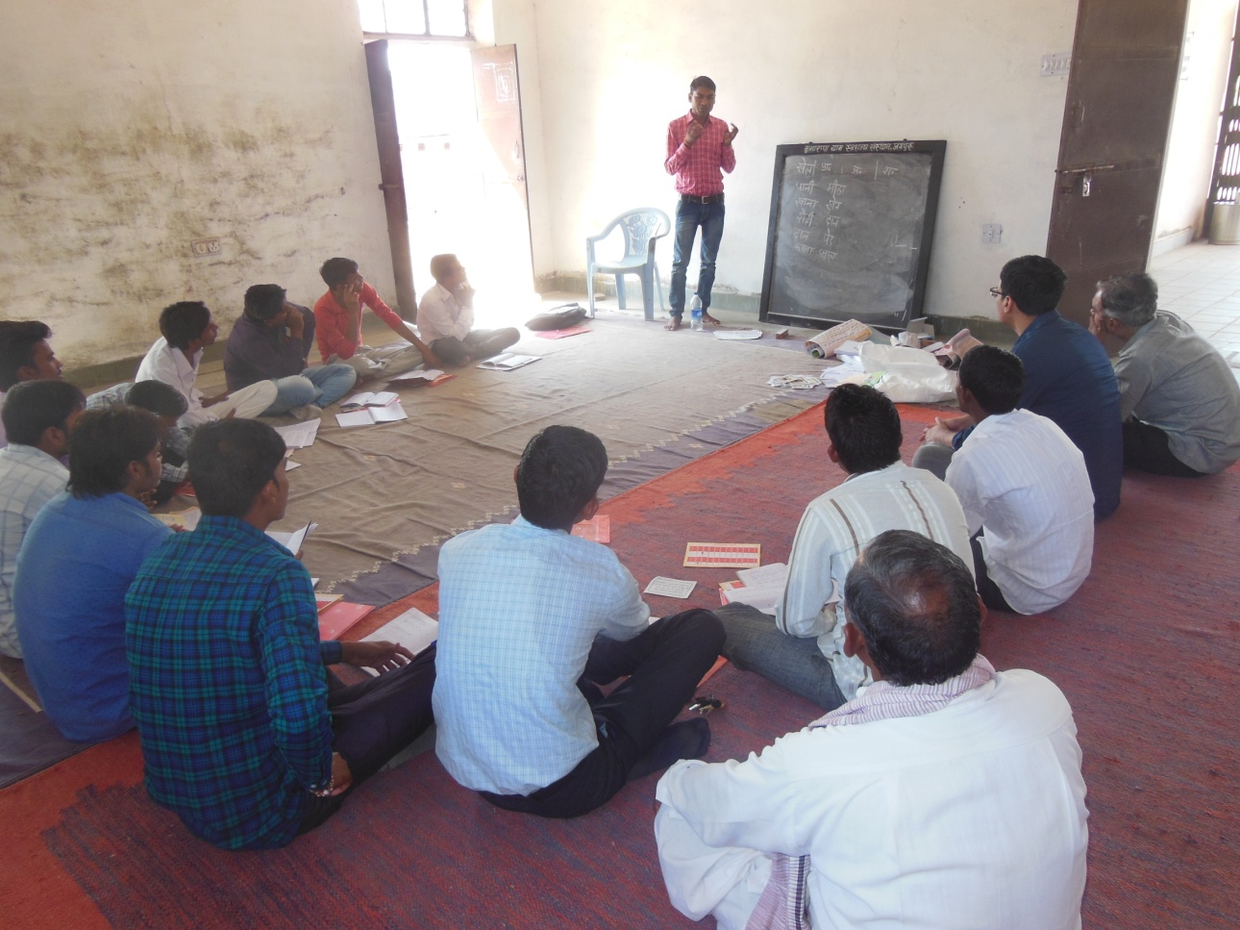
Teacher Training in collaboration with PRATHAM
