DEEPALYA VISIT- PANCHSHEEL VIHAR

Date of visit: 01-12-2016
People involved: Noopur, Shikha Pal and teachers from the Deepalaya centre
Address of the Learning Centre: Ramditti J R Narang Deepalaya School
B-65, Panchsheel Vihar,
Opposite Trivenicom Complex
Sheikh Sarai - I, New Delhi 110017
Hours Spent: 1 hour
Key points from the Visit:
- The centre bore a changed look from the outside, as there has been some renovation lately, mostly with the painting and some Teaching Learning Aid added as part of the window. (see pic)
- The class where Asha for Education programme is run, is housed in the basement. The classroom has adequate number of desks to seat the children comfortably. There are about 25 girls enrolled in the class.
- Most of these girls have never been to school and are in the age range of 6-10 years. Three of the older girls have dropped out of school for various reasons.
- Remedial classes are run in the afternoon for girls who have been mainstreamed into the government schools. Help is provided with understanding certain concepts and also giving them an experience of diverse range of activities.
- The teacher handling the classes currently, Achala, has been there for two months and is a Deepalaya alumnus. Jyoti, another teacher helps out with the evening classes and also with community visits.
- Individual files are maintained for each child, which incorporates their admission and family details and the work that they do in terms of drawings and worksheets.

Observations and Interactions
- The classroom space had a few charts but needs to have more of the student work put up for it to give an inviting look.
- The teacher was busy correcting notebooks when we entered classroom. Most of the students were engrossed in individual work. Some of them, especially younger ones, were walking around in the classroom when I entered.
- All the students were able to introduce themselves in English, no matter the age, which was a positive sign.
- The seating arrangement would have made it difficult for the teacher to implement Multi Grade Multi Level Teaching strategies. Working in groups also seemed difficult because of the same.
- The centre coordinator shared that getting students to enrol and stay on is a big challenge faced by the programme. Due to difficult life circumstances, students may join but have a tendency to drop off after a few days. She referred to a couple of students having dropped out. Even after hiring a new person, this remains a challenge.
- She shared that about 80% of the student’s enrolled into the programme get mainstreamed into a nearby government school. But these students also require some kind of follow up to ensure they don’t drop out of the formal schooling system.
- The staff, both the coordinator and the teacher felt that they have made a positive impact on lives of 30-35 girls and given them exposure they haven’t had earlier. They also felt that some of the students who were reluctant to join in the beginning, have over the time started enjoying coming to the centre and have taken a keen interest in studies.
- They also shared that one of the most difficult yet satisfactory aspect is working with the parents. Most of the time, parents take time to understand the need for education, but change in the attitude of the parents is the actual change.
- The centre coordinator also shared that trainings for the teachers take place in collaboration with an organisation called Unmesh. These trainings are held every three months or so.

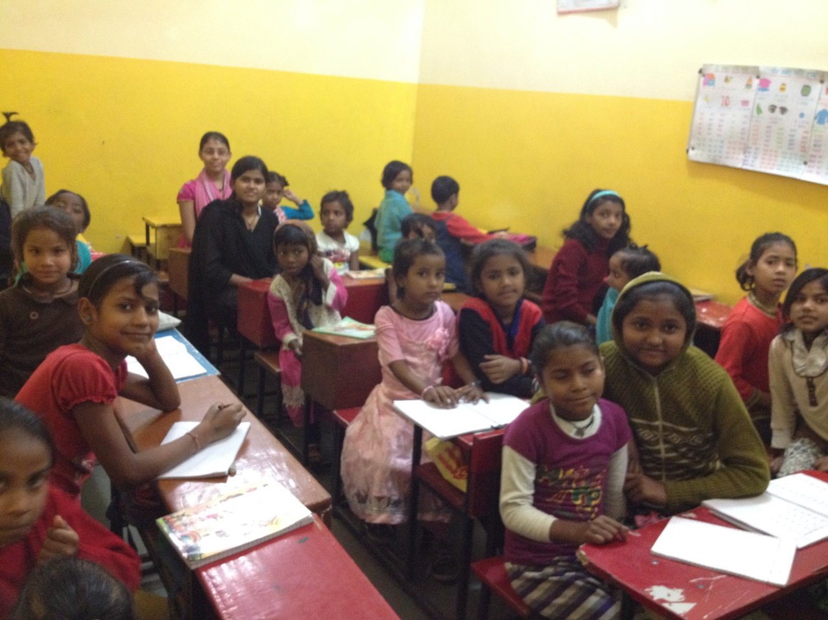
Students in the Asha classroom

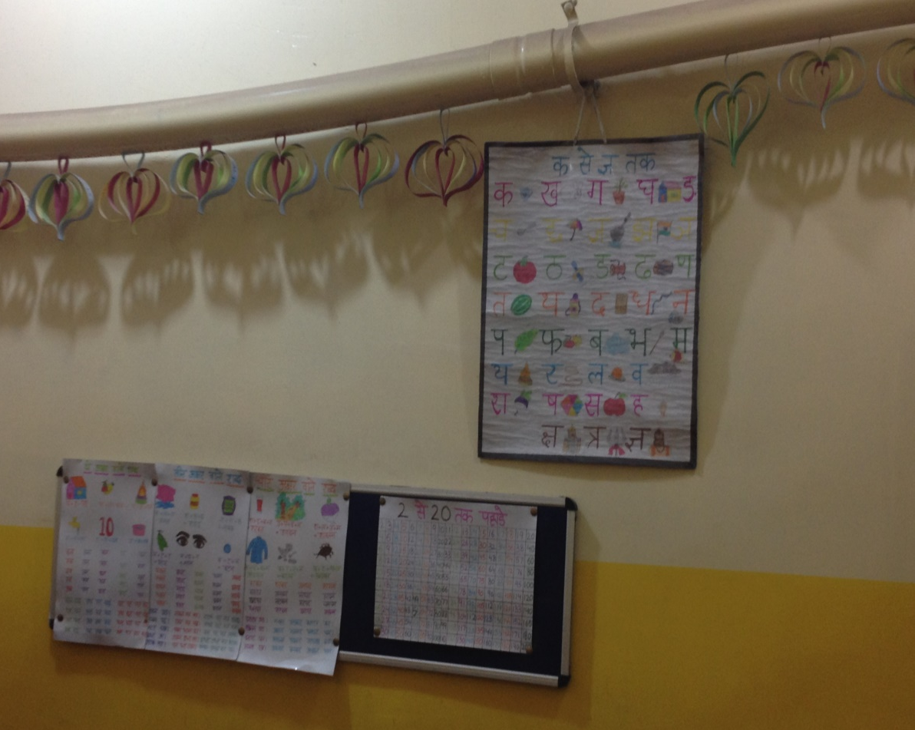
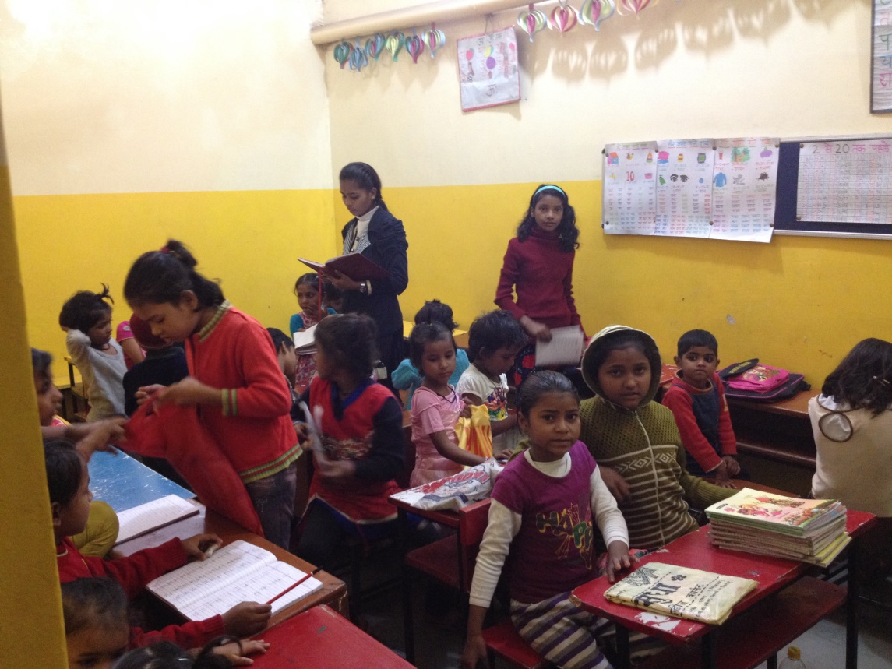
Classroom in session with the teacher

Present display in the classroom

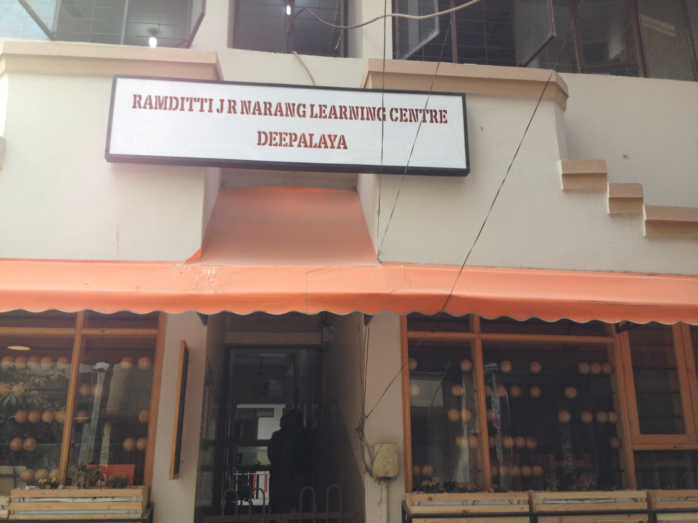
Entrance to the centre

