Manigal Kottur Report 2018-2019
Manigal Kottur was started in 2015 to bring the area’s gypsy children into the school system, retain them and improve their learning levels. The project has made considerable progress in this direction and more and more gypsy parents are sending the children to school rather than to work.
The teachers posted by the project undertake interactive teaching methods and give personal attention to the gypsy children inside the school. They start from where the child is and build learning accordingly. The special inputs and the space given to them to explore and express themselves with their peers is making the children get interested in schooling.
The Primary school –
The school has a strength of 350 children. The enrolment and attendance of the gypsy children in the primary school has steadily improved over the years. This year, at the beginning of the academic year, 27 gypsy children were in the rolls in the primary section. A few migrant children from Manipur, Nepal and Bihar also joined the gypsy children in the special class for drop outs. These migrant children, entered the school neither knowing Tamil nor English. The teachers had to begin from scratch. The two project teachers have been handling this diverse group of children from classes 1 to 5. The children are taught in small sub groups and a variety of materials are used to speed up learning and improve the confidence levels of the children.
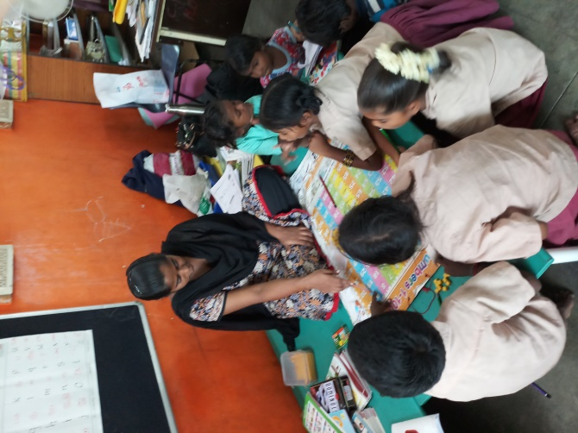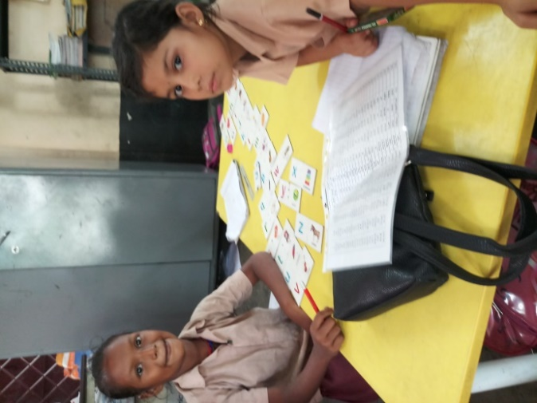
After the first quarter, the school authorities suggested that the project teachers undertake remedial coaching classes for a few slow learners from classes 3-5 along with the gypsy children. Some gypsy children who were regular and who have progressed well in the past few years and the new entrants of class 1 were sent to their respective classes to learn from the class teacher.
REMEDIAL CLASS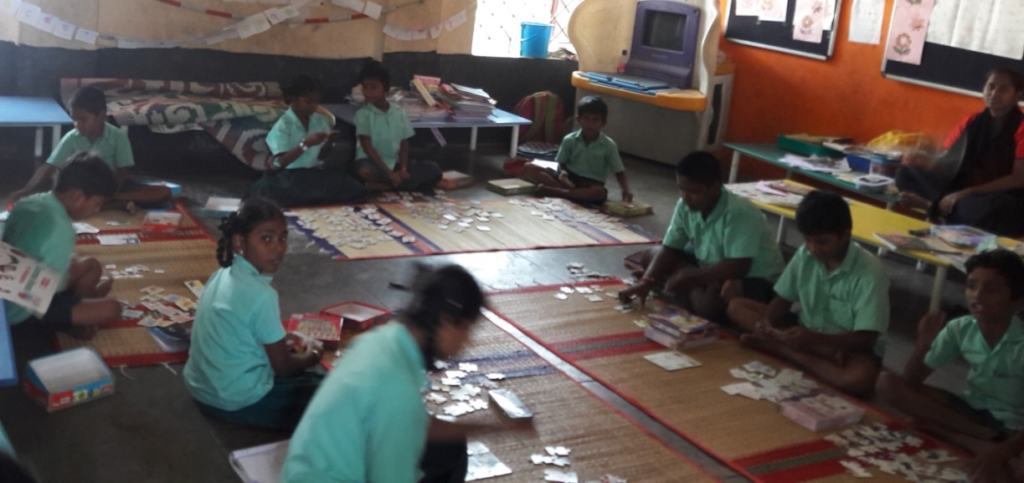
This mixed group worked well for a for a while. The Tamil children brought in from other classes responded with eagerness to the special attention given to them. Small group teaching helped them to progress faster. However the gypsy children integrated in their respective classes had started losing interest and had problems in their classes. A few wanted to be with their siblings and peers and when not allowed they started dropping out of school one by one.
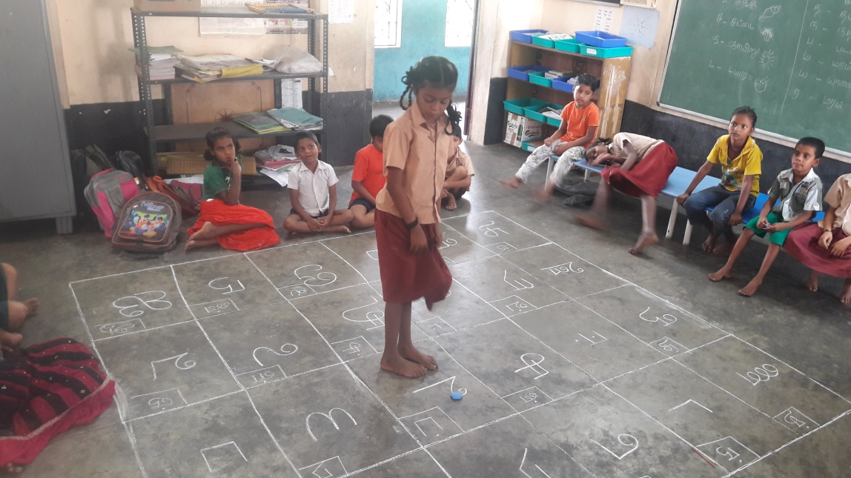
The attendance of the children came down substantially in the second quarter and the teachers were mainly attending to the Tamil children who came for remedial classes. The efforts made by the project in the past years for educating the gypsy children was coming to nothing and we were going back to where we began in the first place. The concern of the project was taken up with the school authorities and it was agreed that the drop out children be brought back to school and allowed to study with the project teachers once again. The old arrangement helped to bring back many of the gypsy children except five children. The learning process of the children in the second term was disturbed temporarily, but in the last term, the focus was brought back and the children progressed.
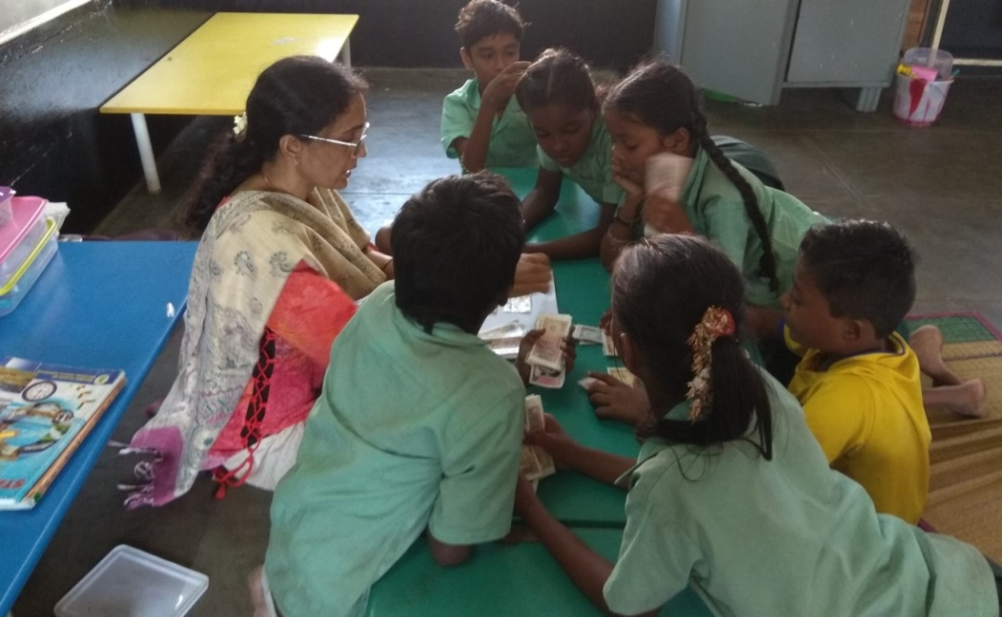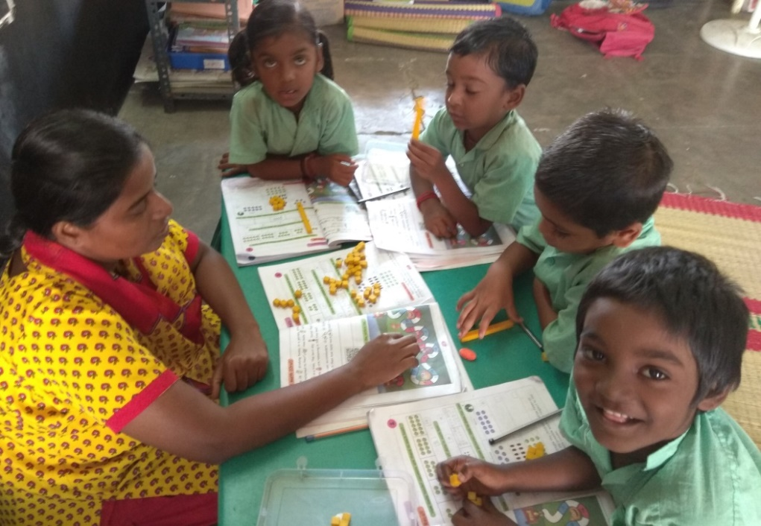
The gypsy children are used to a lot of freedom and interesting activities in their colony. They are easily bored and are often restless which makes them problematic in any class or for any outsider volunteering to teach them. The children’s ability to focus is essential to make progress in learning and this ability is improving gradually. The project teachers are able to make some smart moves and gather their attention skillfully which makes them more successful in teaching the gypsy children. Ramya has settled down and focuses on her work amidst all disturbances. Karthik though restless is settling down slowly and is able to focus at times. Sivan Raj and Madhavan like to run around all the time in the classroom. Over time, children are able to exercise some control over their behavior when necessary and are able to pay attention to the learning concepts. The initial and transition phase that the children spend with the project becomes crucial for continuation of the gypsy children later on in the school.
Support to other children of the primary school - The project requested Shereen Broido, an English teacher from Vidyodaya school to give inputs In English and she chose to work with class 2 children of the school. She undertook a variety of activity based learning round the year once or twice a week. During her visit she also works with the project teachers for a couple of hours and helps them in introduces learning concepts to the children. These classes have been helpful for the school and the project.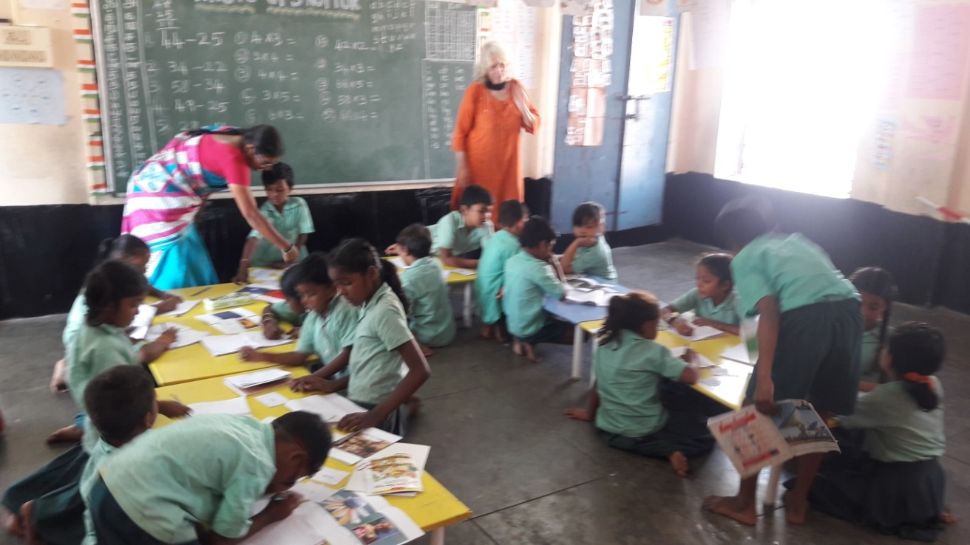 ENGLISH CLASSES
ENGLISH CLASSES
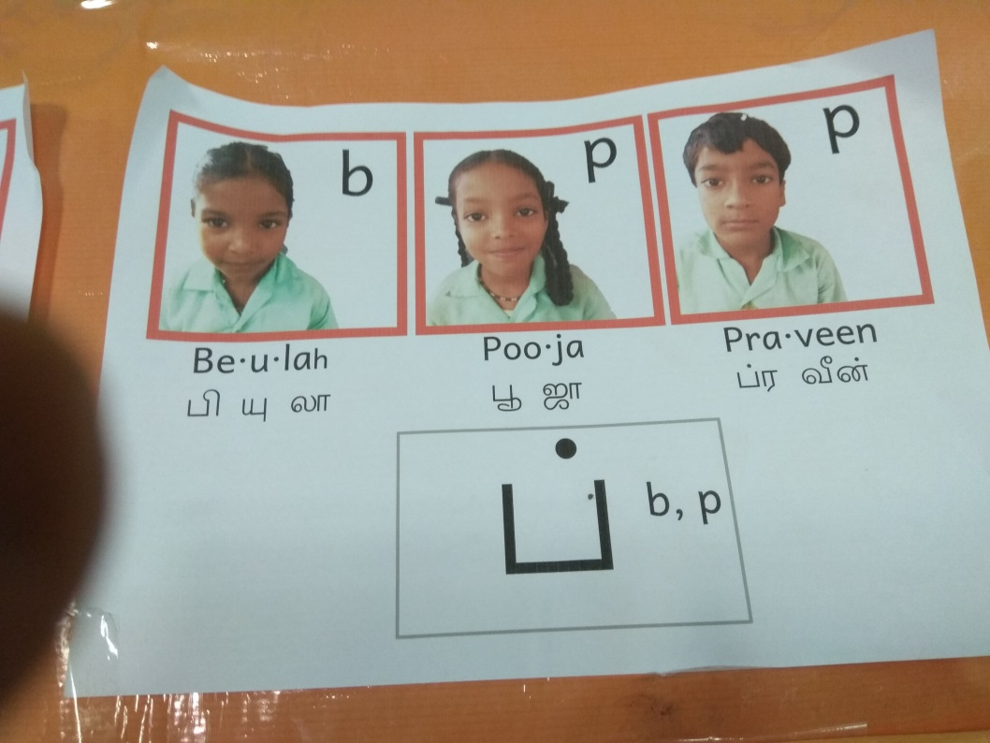
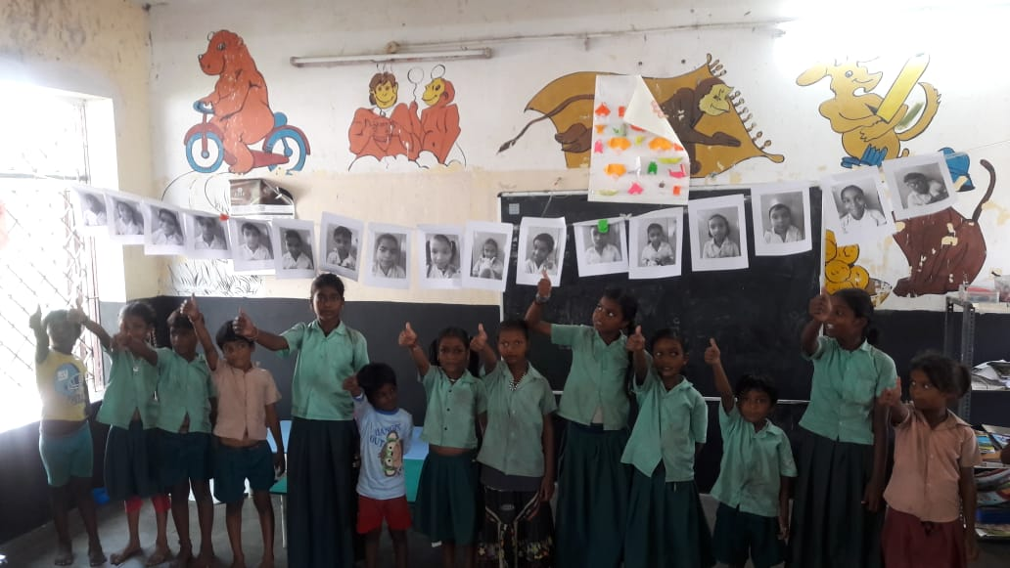
Craft classes were conducted from time to time for the children of the school.
Teaching and learning materials, mats and sports materials were given to the school .
The project teacher Sridurga off and on assists the school in the audio visual room by playing educational programs for various classes or helps the teachers use the facilities at the audio visual room.

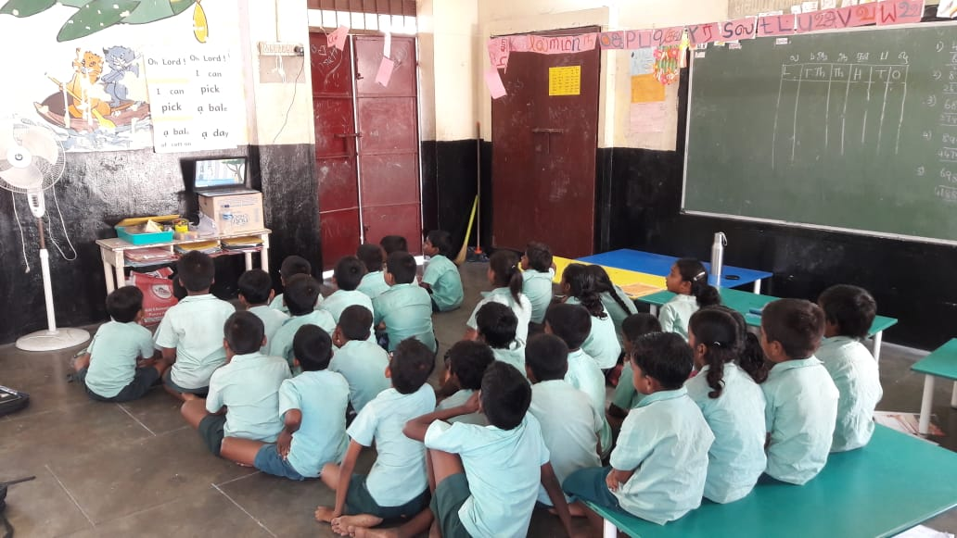
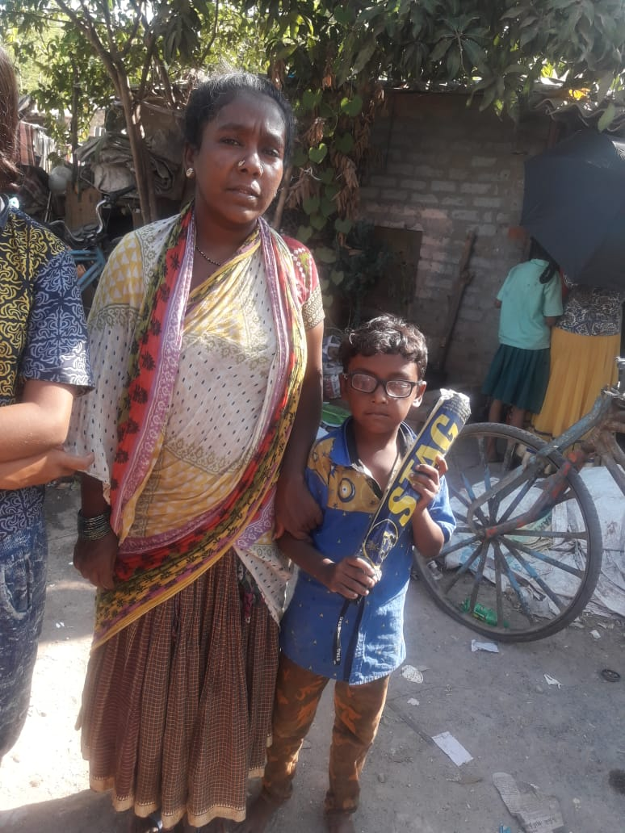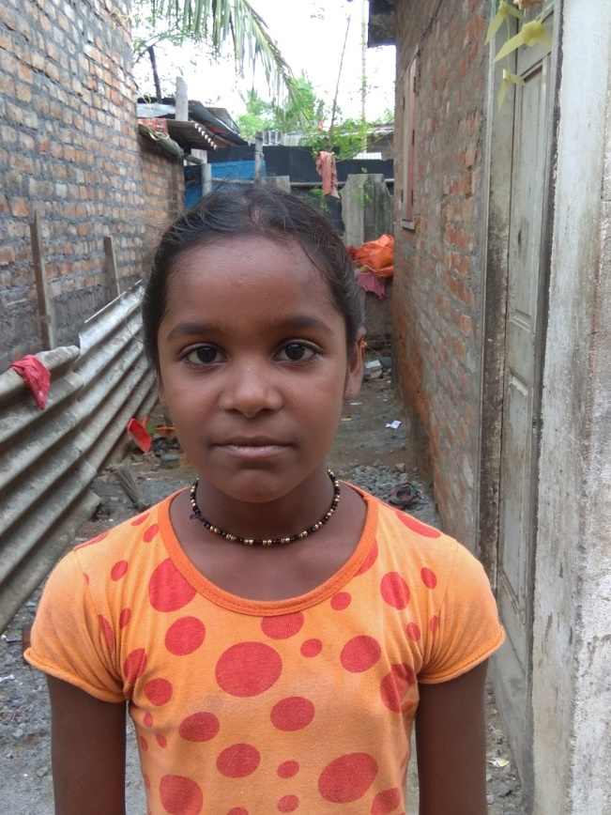
RAHUL RAMYA a Regular student.
Assessment
The gypsy children and other drops are assessed regularly by the SSA team twice a year. The children have performed well in the tests given by them.
Ms Shereen Briodo, volunteer of the project interacted with the primary children on a one to one basis and made an assessment of their English levels. She has given feedback to the teachers on strengths and weaknesses of each so that the teachers could plan learning activities accordingly in the future.
The volunteers and project teacher of the high school, Geetha Natarjan had assessed the Maths levels of children off and on. Special inputs and worksheets were suggested for a few lagging behind.
Other activities at Primary -The children are also showing improvement in their behaviour and cleanliness. They have become friendly with their classmates in remedial classes. Children are gaining communication skills and confidence and are actively participating in dramas and dances on stage. They also participated in various science and sports activities. Rahul, one of the children with vision problems is being given special attention and being is helped to learn with materials which have large prints. Children went for a picnic which they enjoyed thoroughly.
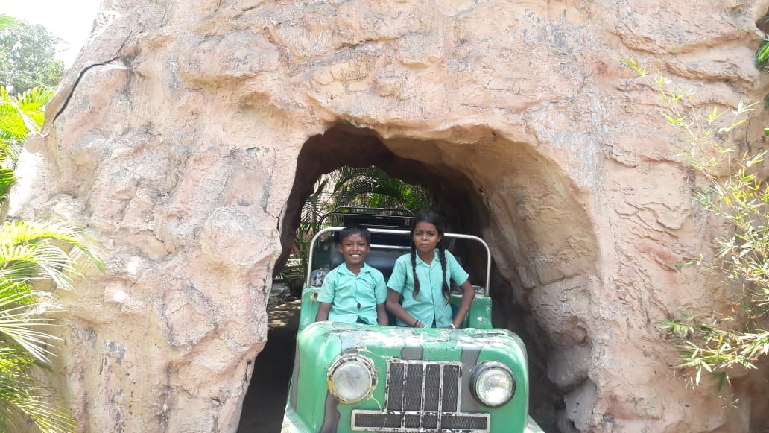CHILDREN GOING FOR OUTING
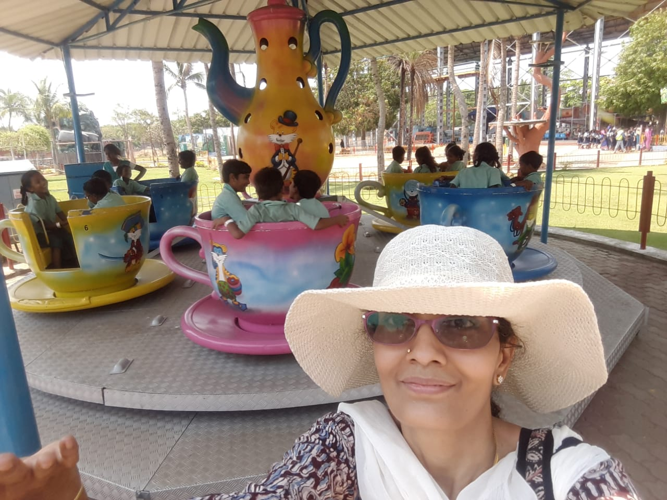
Middle and High school
There are 246 children in the middle and high school. The school had been offering education in both English and Tamil medium. The primary school was converted into an English medium school a few years back. Once they completed primary school, majority of the children were placed in English medium and a handful of children were placed in Tamil medium. The gypsy children too were placed in Tamil medium because of their frequent absenteeism and low learning levels. Though the school had both the mediums, there was only one class and the Tamil medium children were also sitting in the English medium section. Only this year for the new batch of 6th, English medium was offered to all the children.
At the middle and High school too this year, the project teacher had been asked to conduct remedial classes for those lagging behind from class 6-9 along with the gypsy children. Out of the list of 40 children given to the project teacher, a smaller group of 10 children from Tamil medium was chosen. These children and the gypsy children were given learning inputs, together, in small batches. With special inputs the children of both the groups are showing good progress. A volunteer, Lakshmi, helped with spoken English classes for a few children of class 7, in the first term.
The school had also asked the Ms Geetha Natarajan to help a class 10 student who had dyscalculia. The child was required to write her exam with a scribe and she needed one on one coaching. The project teacher attended to her at her home in the last term. The child has successfully completed class 10.
.
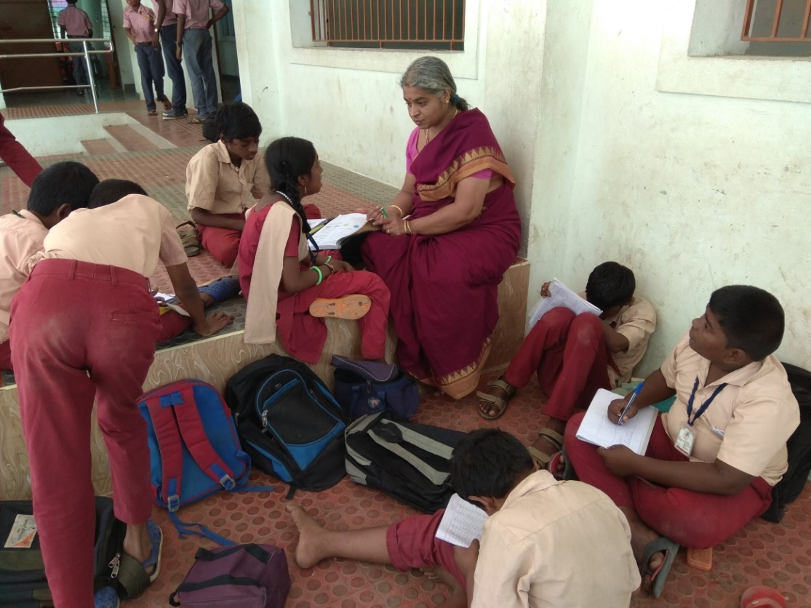 REMEDIAIL class for Middle school children
The gypsy children in the middle school are showing progress. The BRTs who interact and evaluate the children have reported marked improvement in their performance in Math and Tamil. Their attendance too is improving except on Fridays when most children in higher classes stay away. The project teachers have to undertake special drives or offer incentives to persuade them to attend on Fridays.
The gypsy children have started participating in various events and the school too is encouraging them. They participated in sports events and one of the children, Dhanush won first prize in shot put. Vennila in class 7 got a prize for proficiency this year. Dhanush was appreciated for 100 percent attendance. The children also gave a dance performance during school function. The HM and other teachers are extending all help and are encouraging the gypsy children to attend school.
Older children
In 2018, one gypsy girl- Simaran appeared for class 10 and passed the board exam. In fact she was a drop out in 9th and rejoined school after two years. She made special efforts to catch up with learning, cooperated with the project teacher and completed her schooling even though she was much older compared to other children. The Kottur school ends with class 10 and children migrate to the school in Alwarpet for continuing education. Simaran’s parents were unwilling to send her far away from the colony and hence she could not continue her education. Some vocational options were also shown to her at the beginning of the academic year but these did not materialize.
Durgappa who discontinued after 9th was sent to a computer course, which he completed with interest.
The LkG section
This year only two children got admitted to the LKG section though there are a large number of preschool age children in the gypsy colony. Even these two dropped out in the middle of the academic year. Entry at the LKG becomes crucial for settling the gypsy children. Later entry makes it difficult for them and the school. The focus of the project had been on the drop out children in the primary and hence the needs of LKG children could not be attended to, this year.
Interactions with parents
The project teachers meet the parents in the colony periodically to discuss about late coming, absenteeism and other problems related to the school. The project teachers act as a link between the school and the community.
The teachers had also organized the parents and children and helped them procure Aadhar cards which is a requirement of the school.
In the last quarter, tuition classes for drop out children is being conducted in the colony by Uma Maheswari of the project.
Gypsy children were also periodically supported with geometry boxes, pencil boxes, lunch boxes, inner garments and slippers and other supporting materials required for learning.
The gypsy children’s engagement with school is improving and the learning levels of gypsy children is steadily improving. School is becoming accessible and acceptable with the project teachers being around to take care of their special needs and encouraging them.
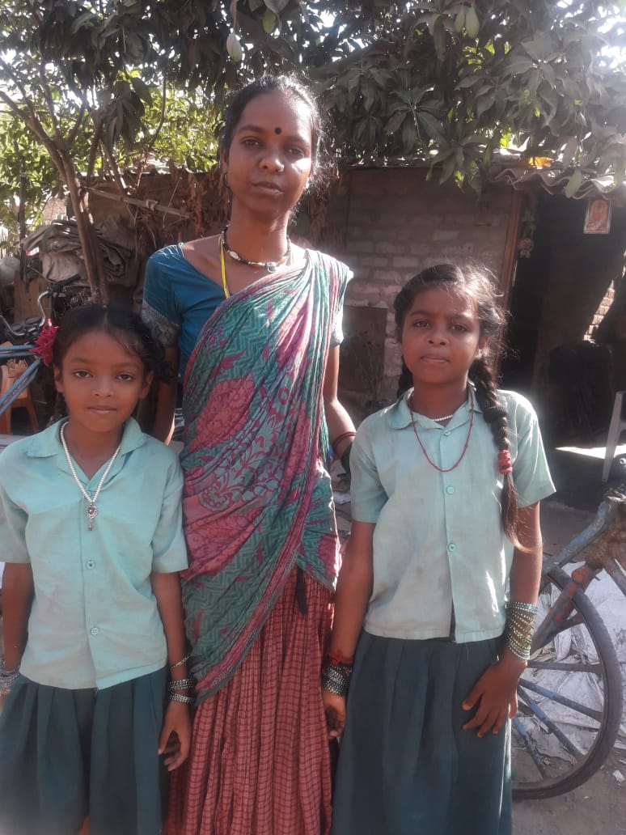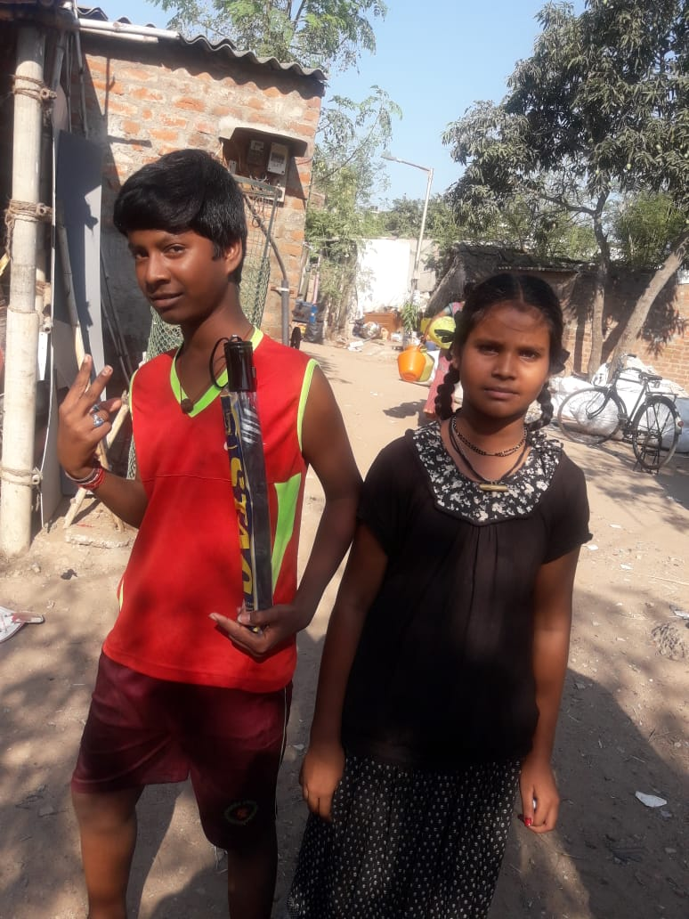
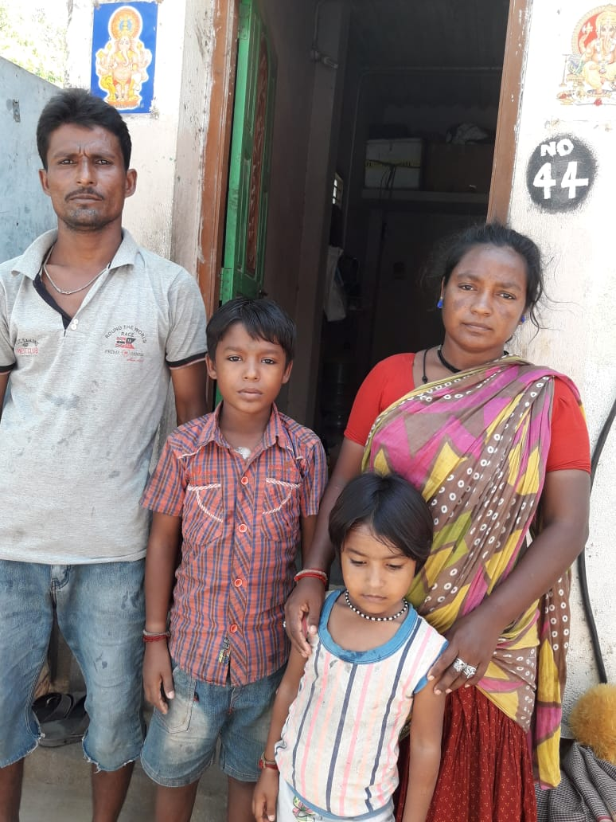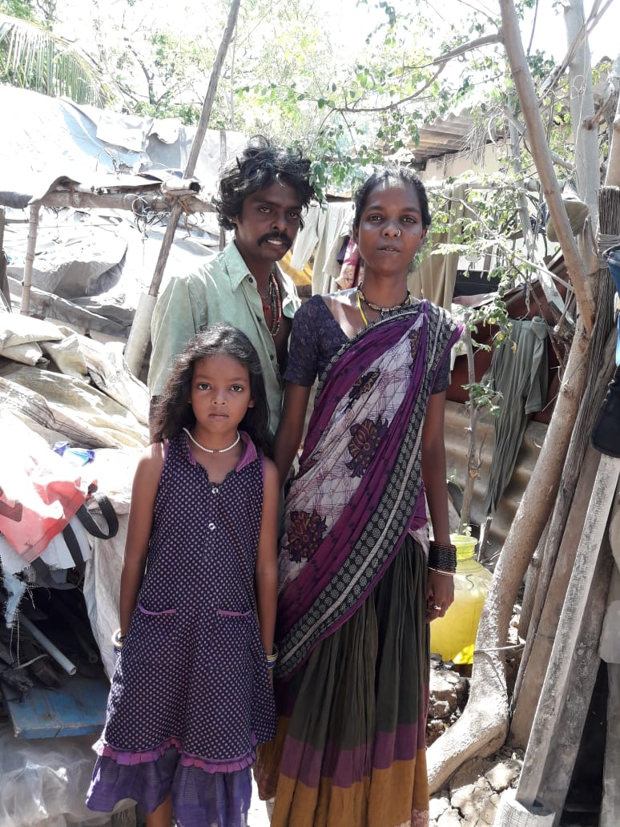

SIMARAN who completed 10th 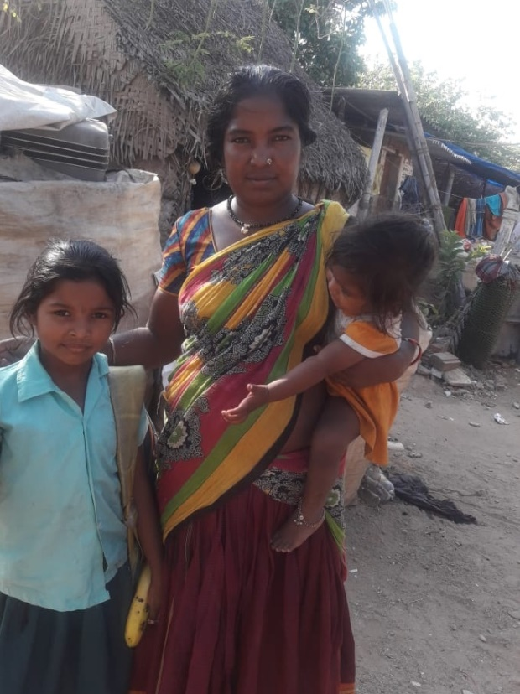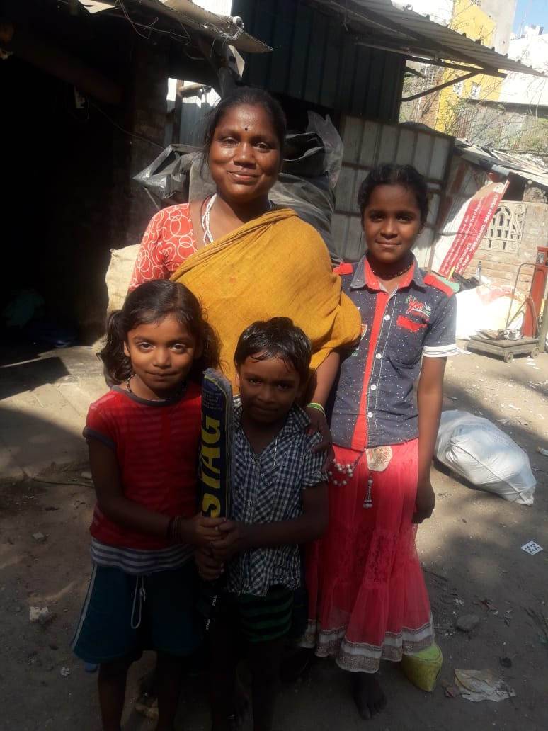

S
S

