Site visit report - Asha for Education, Seattle Chapter

Project Name: Society for Health and Educational Development (SHED)
Organization Contact: Hiren Saikia, Secretary, Sonapur, P.O Digaru, 782401, Assam, shedschool@yahoo.in
Project Webpage: https://ashanet.org/project/?pid=1214
Name of Site Visitor: Nabanita Majumdar
Affiliation of Site Visitor: Project Steward
Date(s) of Site Visit: September 14th, 2024

Please check the following that you were able to ascertain during the site visit.

Most of these have been covered in the site visit and budget report.
- Operations
- What does a typical day look like for the children in school and hostel? What about weekends?
- General well-being of the children - do they look happy there in the school ?
- Quality and nutritional value of food being served in the hostels.
- Is the learning and progress of the students on par with expected level
- For special needs, customized plans for each student?
- Girls - boys ratio, hostel facilities, wardens, safety?
- What do the children who graduate from the project do?
- Staff and Teachers - do they think it is a great place to work?
- Is the student list accurate on the field vs. what has been shared ?
- Is the teacher and support staff list accurate on the field vs. what has been shared?
- Is attendance being taken for both students and teachers/ support staff?
- Drop out rate of students?
- How do they recruit the teachers and support staff?
- Is there a nearby school or project working on a similar focus area ?
- Do they deny access to education for a student from an underprivileged background?

B. Financials
- Is the project partner maintaining a good record of all transactions?
- Is the project partner doing cashless transactions?
- Are the salary payments being made on time?
- Are the salaries in line with the budget line-items?
- Does the project partner have accounting software or is it vouchers and handwritten ?
- Any new programs being added?
- Any new hiring needs?
- Attrition rate of support staff and teachers?
- Sources of funding ?
- Is the project partner charging fees for beneficiaries?
- Is the fee nominal and in-line with the region?
- Do they have dropouts because of a student not being able to afford the tuition?

- Surveys
- Please check with a few students on the project
- Teachers and Support Staff
- Parents of students
- Other board members

- Next Years
  - How has Asha support helped them?
  - Plan for the next 5 years?

Any comments or concerns from the site visit that is a matter of serious concern for Asha? - No

Would you recommend support for the project? - Yes

School Overview
SHED was founded in 2007 by Lanu Aimol and currently run by Hiren Saikia. It is a residential school for children with special needs/disabilities and has classrooms, boarding and associated facilities. In addition to hostellers, SHED also provides schooling to day scholars with special needs, and to evening students, who attend local government schools and come after their regular school gets over. The integrated school gives a chance for children with special needs to mix with regular children that promotes the well-being of all the children. Asha for Education, Seattle chapter has provided support to SHED since 2014.

Goal and Mission:
To provide a safe and positive environment for children with special needs. Care and rehabilitation, education and proper healthcare so that they can lead lives with dignity and better quality.

Site Visit Write up and Observations
I visited SHED on the morning of September 14th, 2024. As it was a Saturday, there were no classes or day scholars on that day. However, I met all the resident students as well as all the resident staff and caretakers.

Highlights
- New Girls Hostel Tour
- Facility Tour
- Meeting with all resident staff

Felicitations
As always, they never fail to always give us a very warm and touching welcome. They welcomed me by offering the Gamucha (intricate hand-woven traditional towel which is offered as sign of respect in Assam) as well as handmade flowers and decorative items that were made by the kids from recycled items.

This time they have also started making handmade jewelry which they gifted me.

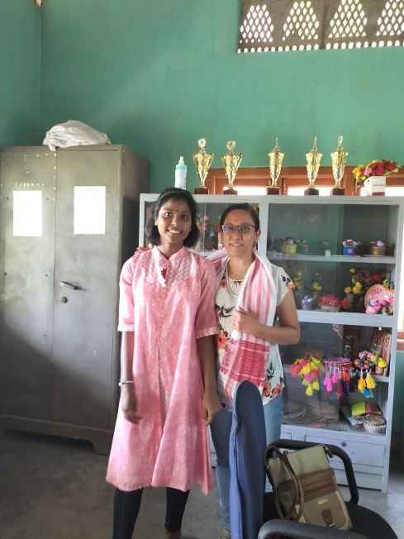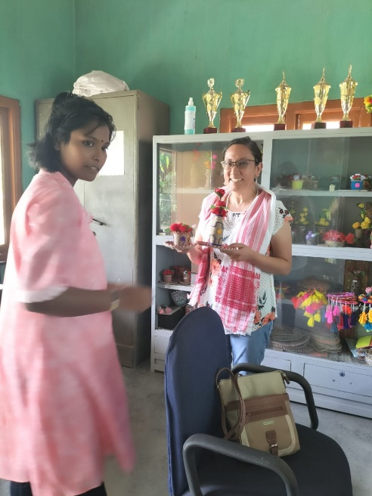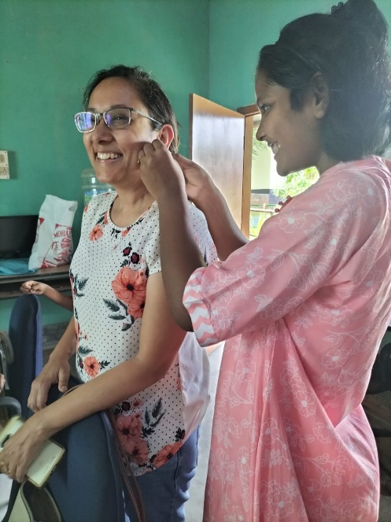

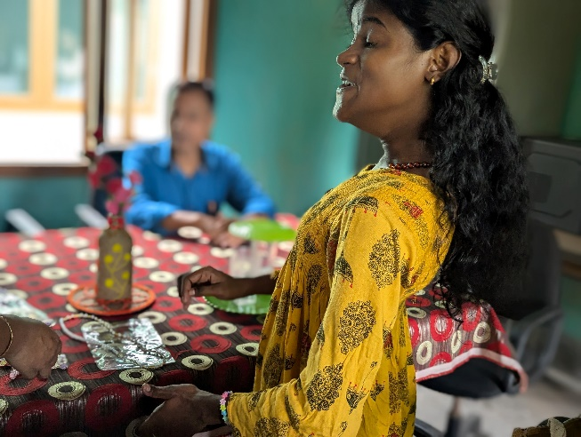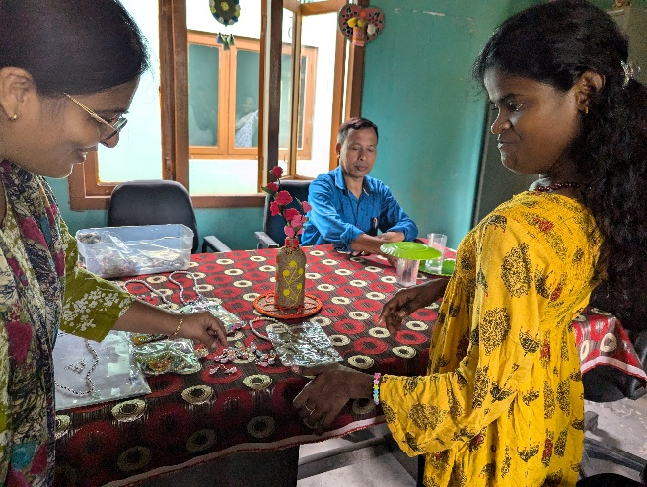
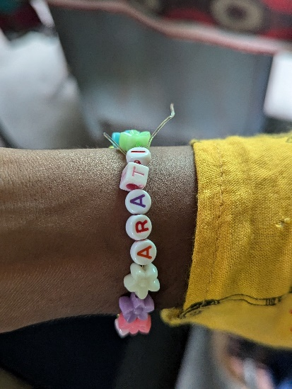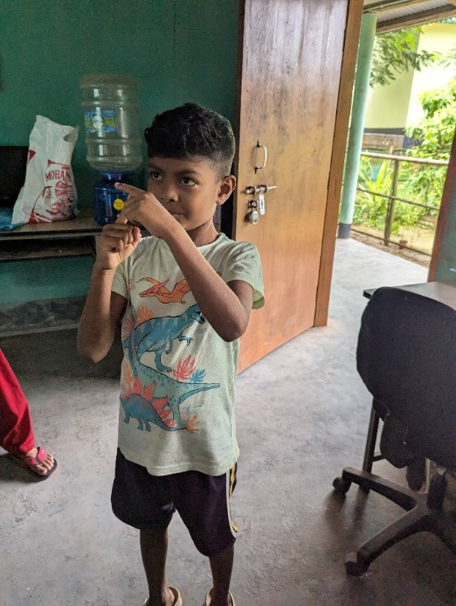

Arati excitedly showed me the personalized bracelet she had made

Handmade Items as Part of Vocational Training and Fundraising

They have really expanded on their existing collection and come up with good ideas.

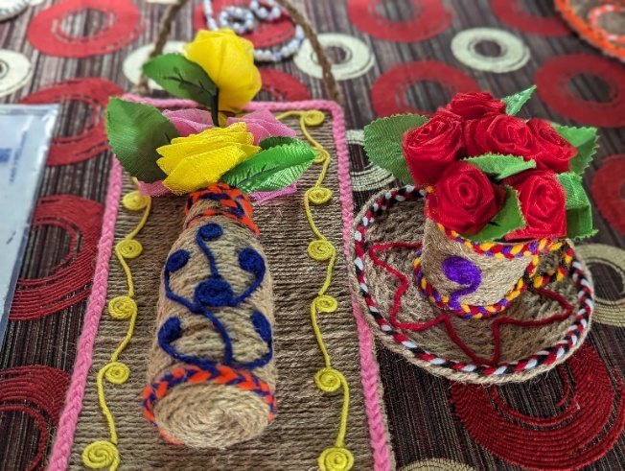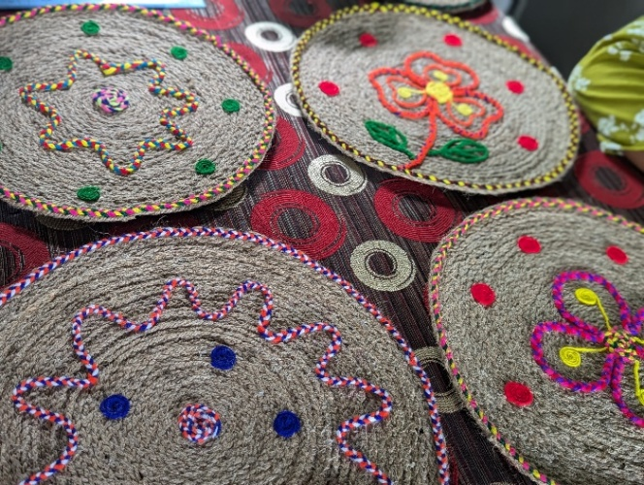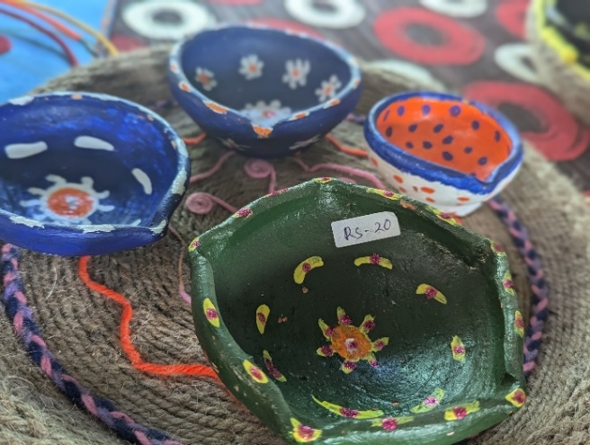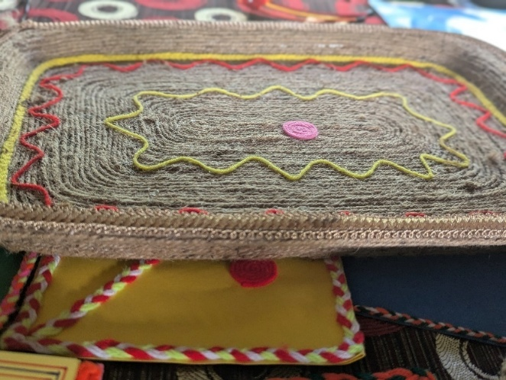

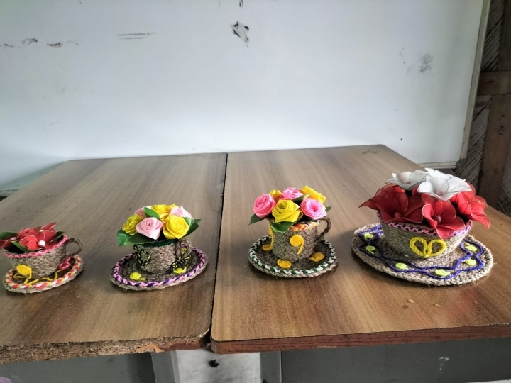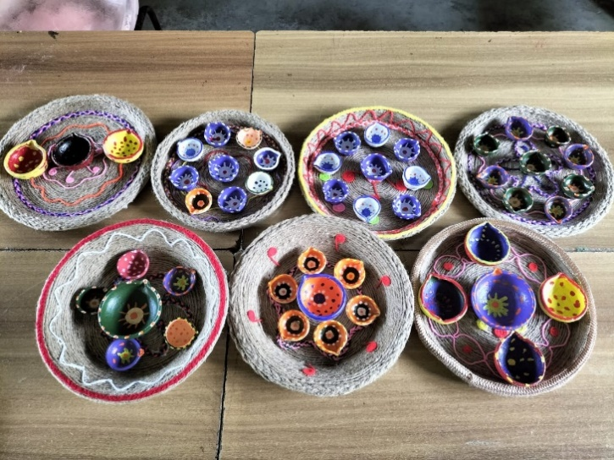

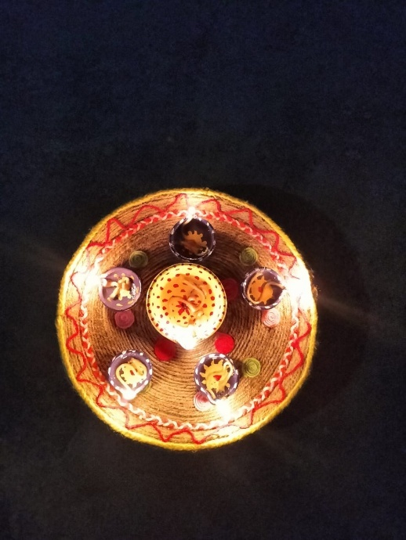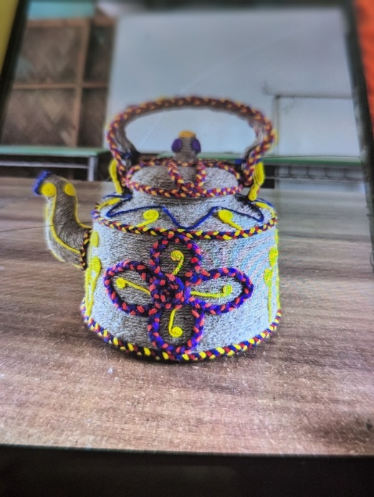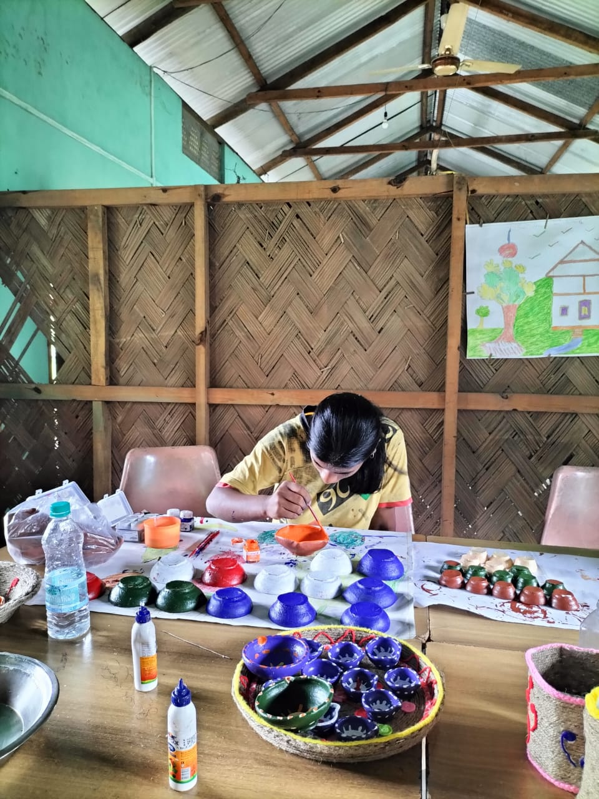

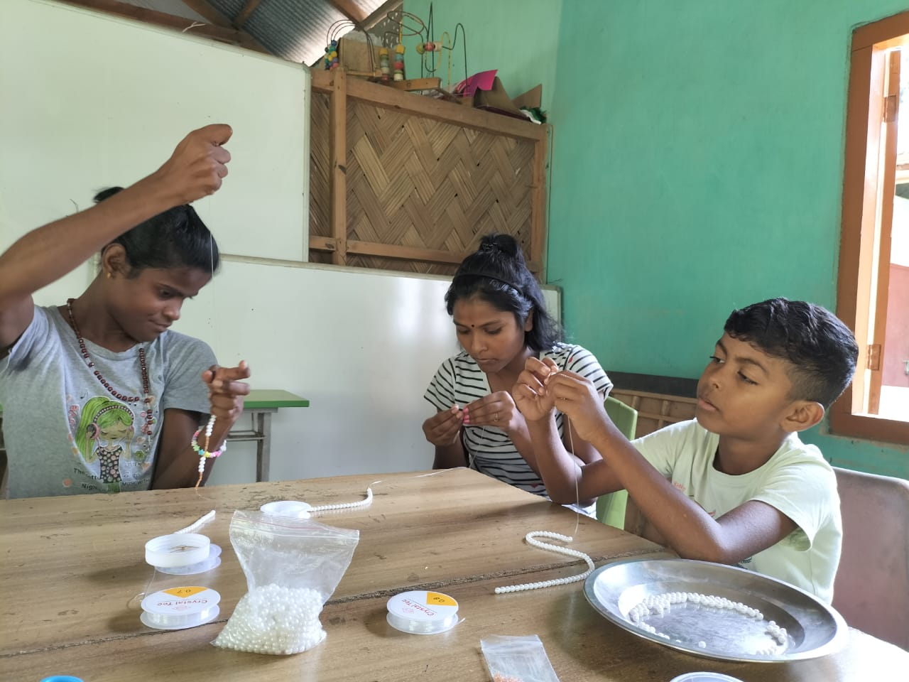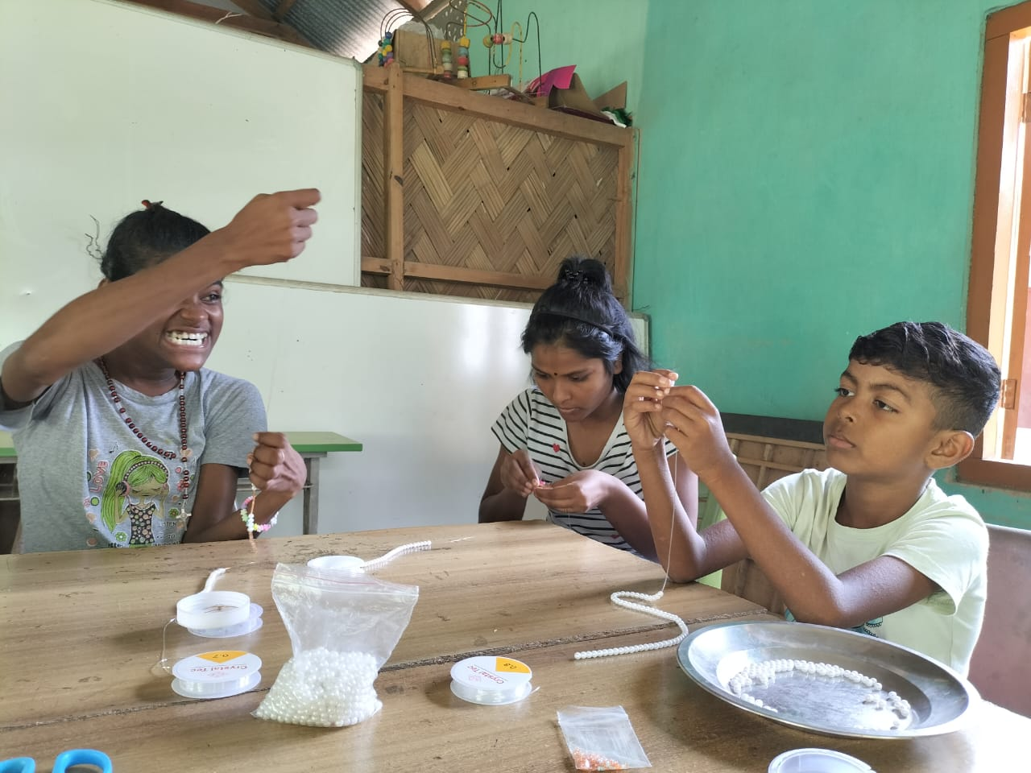
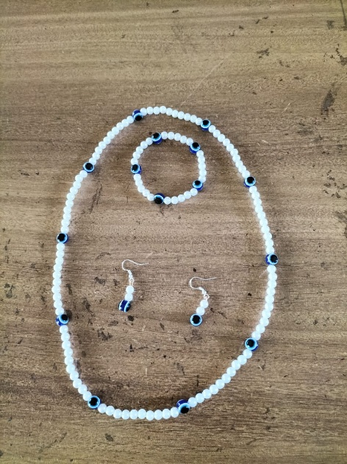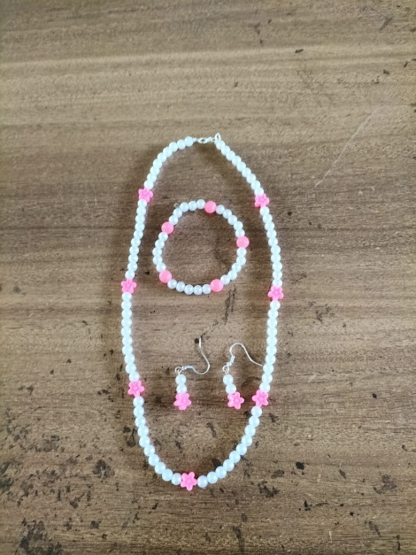\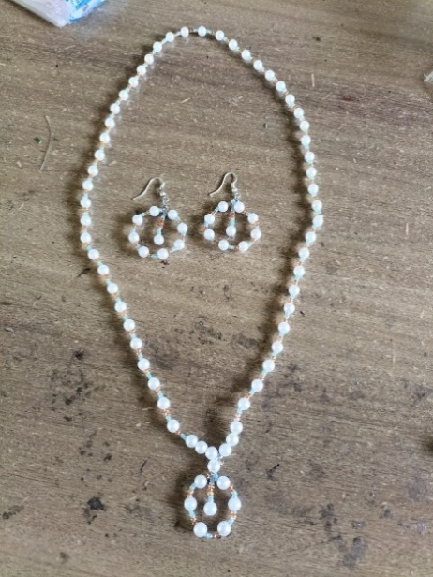

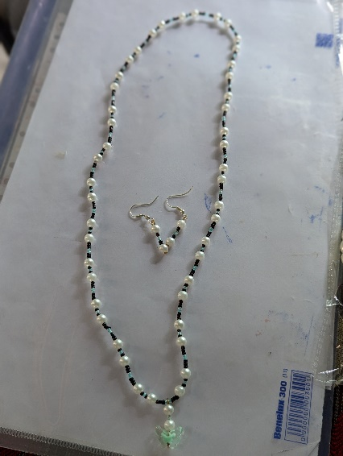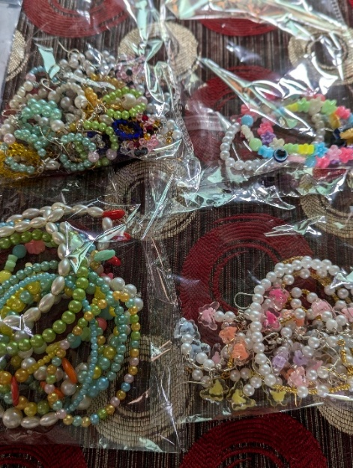
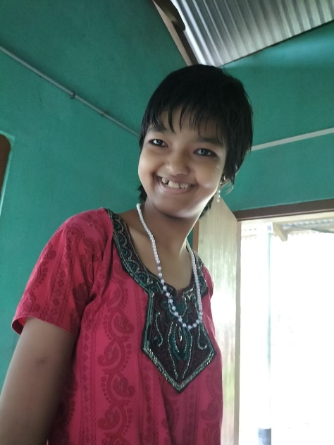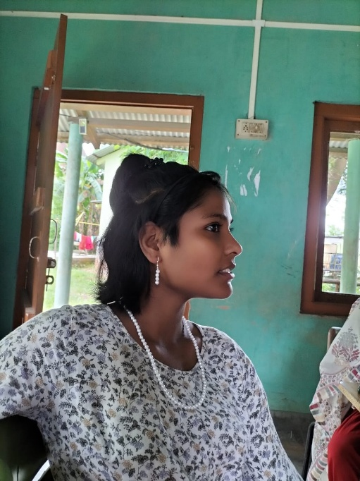
The girls personally create and then model the jewelry
Other Skill Development Opportunities:
I discussed the possibility of other kinds of training that be provided to give the kids the ability to secure a job in the future. One was an idea about ironing that was given by another similar project from ASHA. However, I was told that there is a danger of giving a heated iron to these kids.
They also mentioned that not every kid can be given the same type of job and training due to their varied level of disabilities. They also currently help in all the chores in the schools which gives them training and exposure to various kinds of work. It also builds connection and camaraderie.

Girls Hostel

The Highlight of the visit was the girl’s hostel, the construction funds for which was donated by Ms Anita Sra. The hostel is now fully complete and occupied. It was nice to see that they had created a very welcoming space.

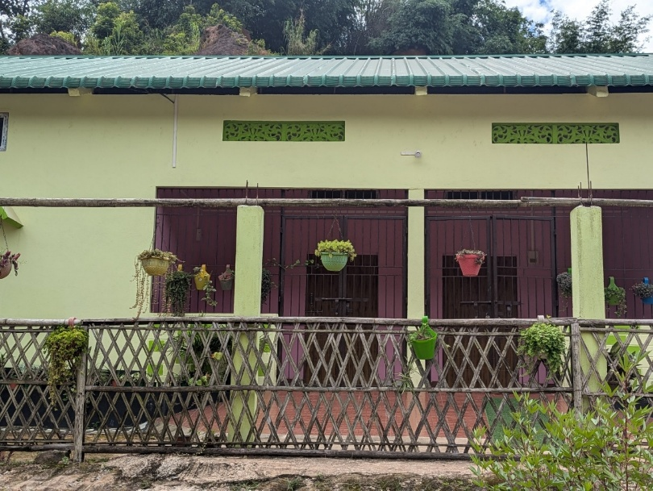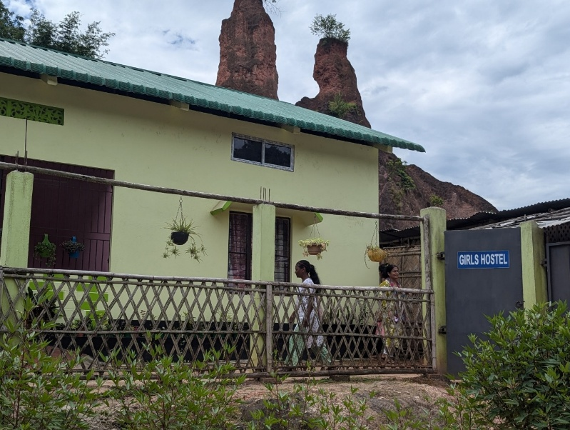

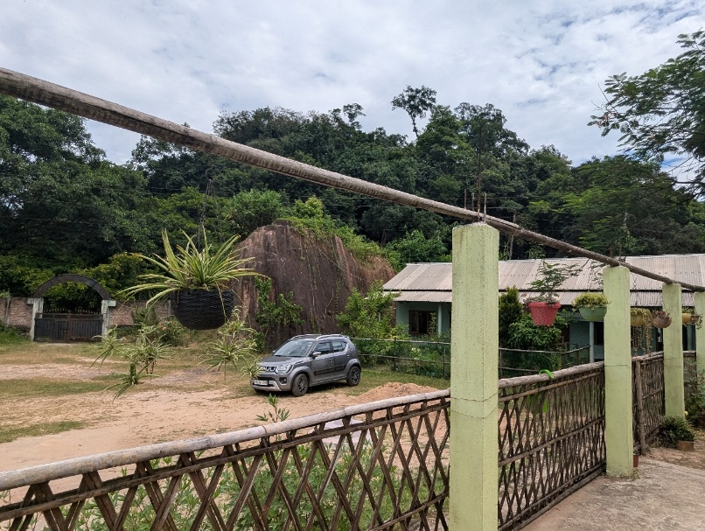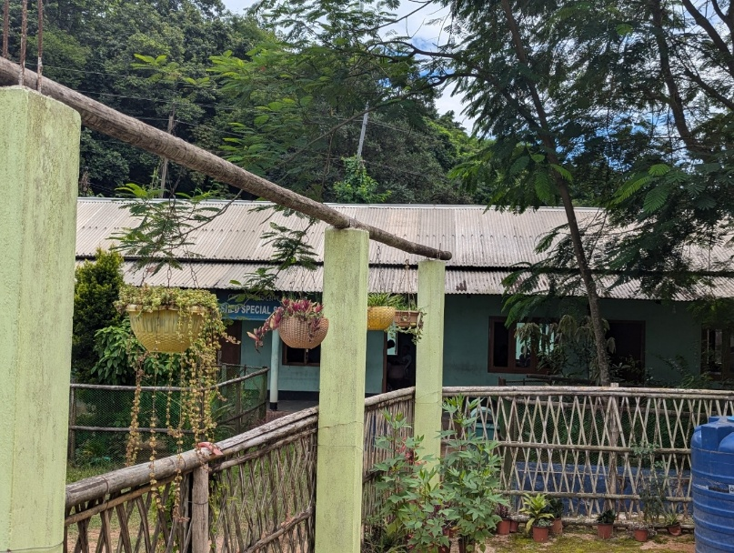

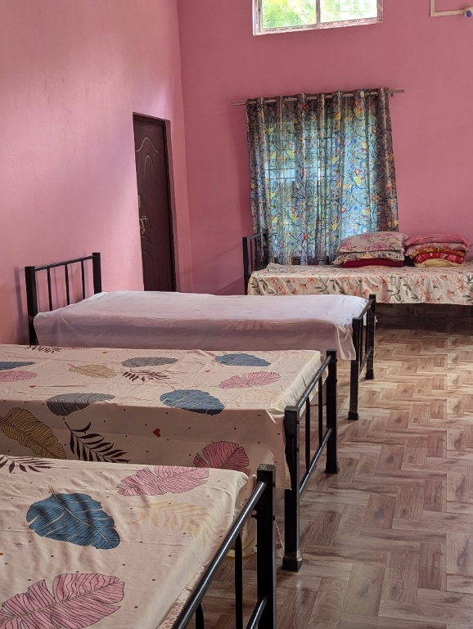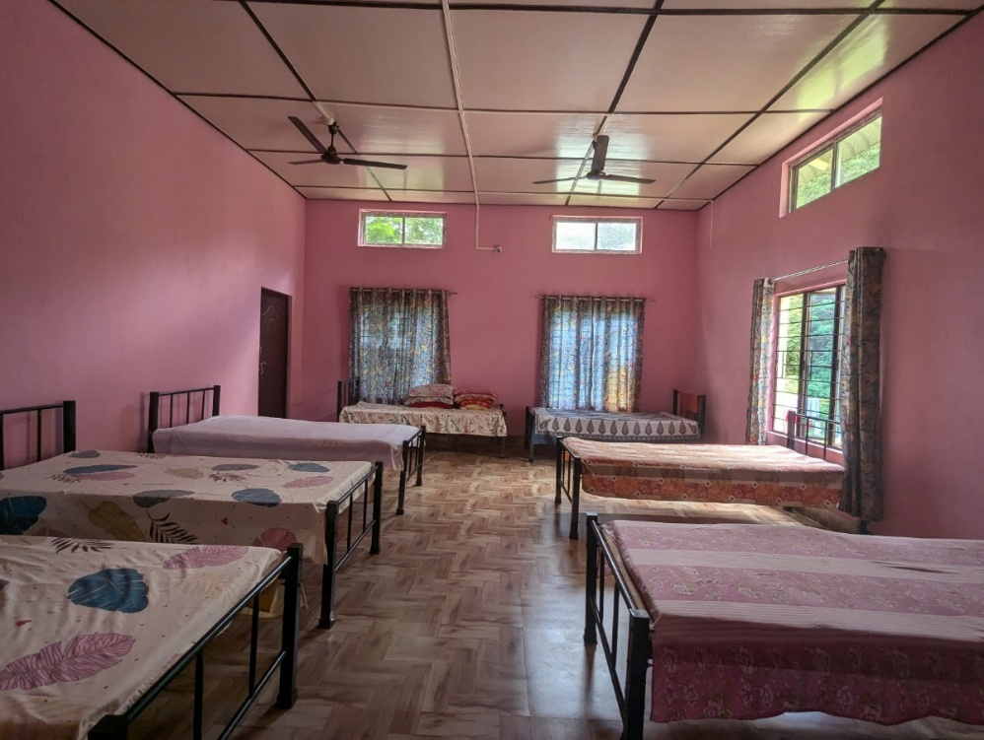

The beds were all donated by the Rotary Club.

They made many improvements to these rooms based on the experience of their earlier hostel. They made sure that the ceiling is high enough so that the children cannot climb up and touch the ceiling fan. These are very practical realities of managing a hostel of students with disabilities and I am glad that they take extra care of the needs of the children.

There are 3 teachers/caretakers who stay full time with the girls in the hostel.

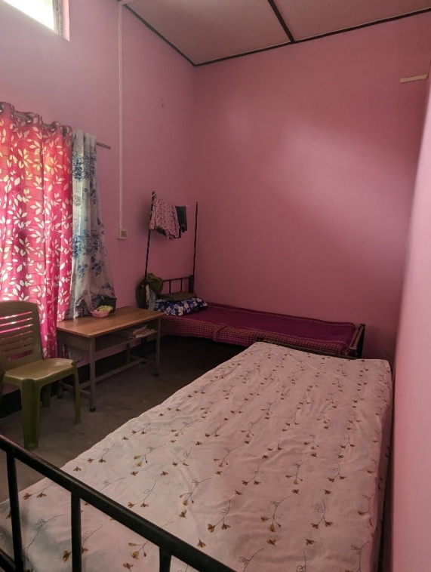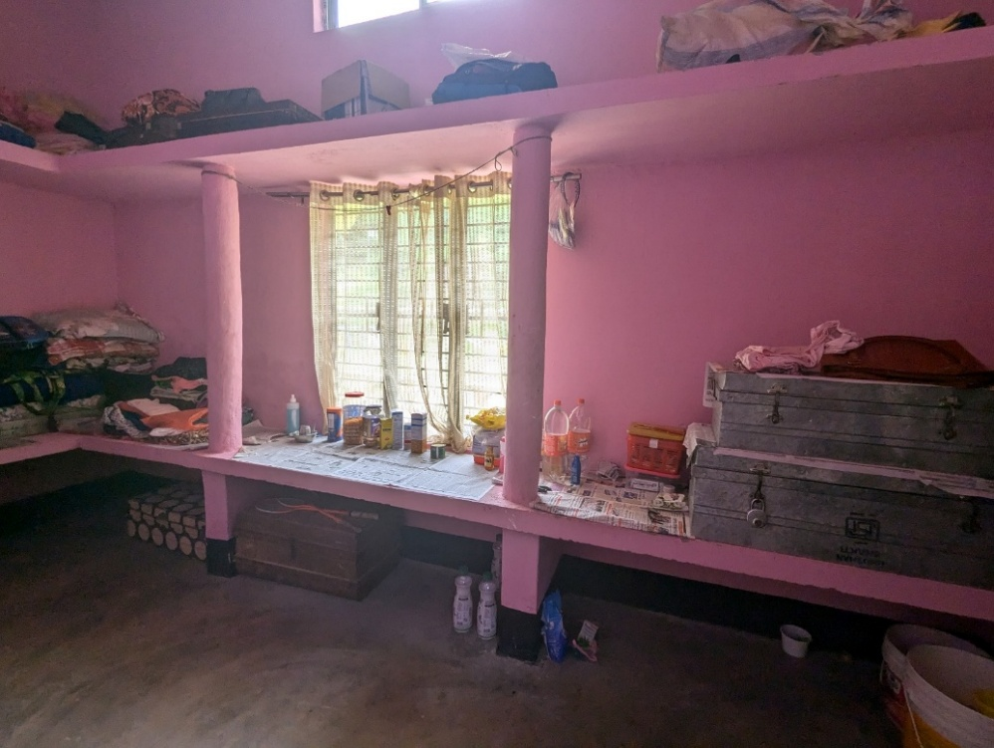

Teachers Room/Additional Guest Room Storeroom

The Covered verandah is also a good upgrade from their previous hostel which was thoughtfully done as it provides a safe place for arts and craft and other activities.

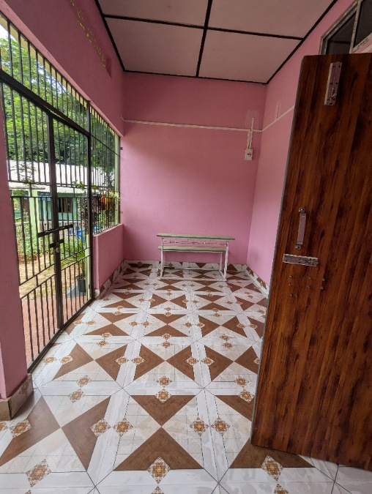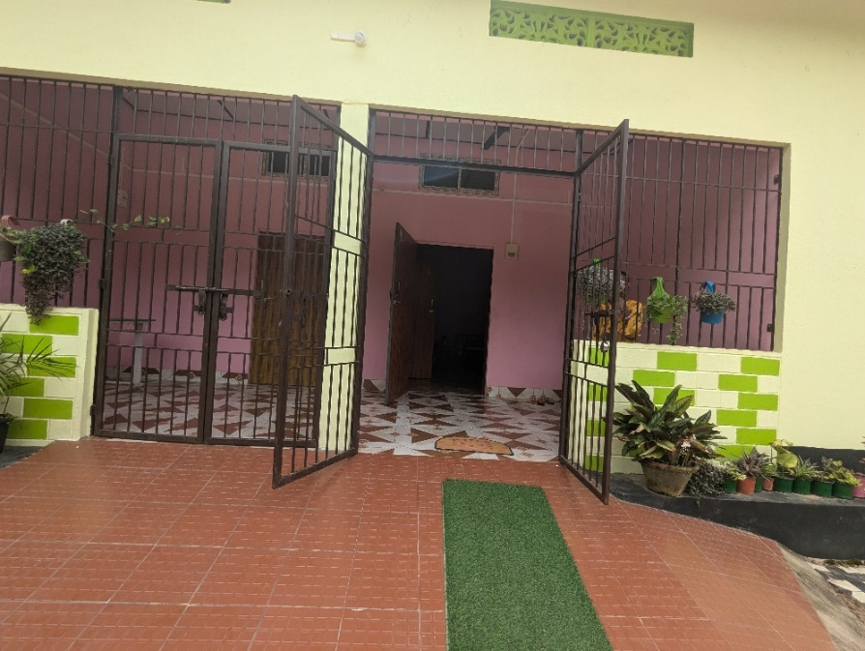

The students are evidently very happy here and excited about showing me the new space. The intent of the new girls hostel is to increase the ratio of girls vs boys in the school and we hope that the purpose will be achieved in the near future with this beautiful place and that we see more happy faces like this in the supportive envt.

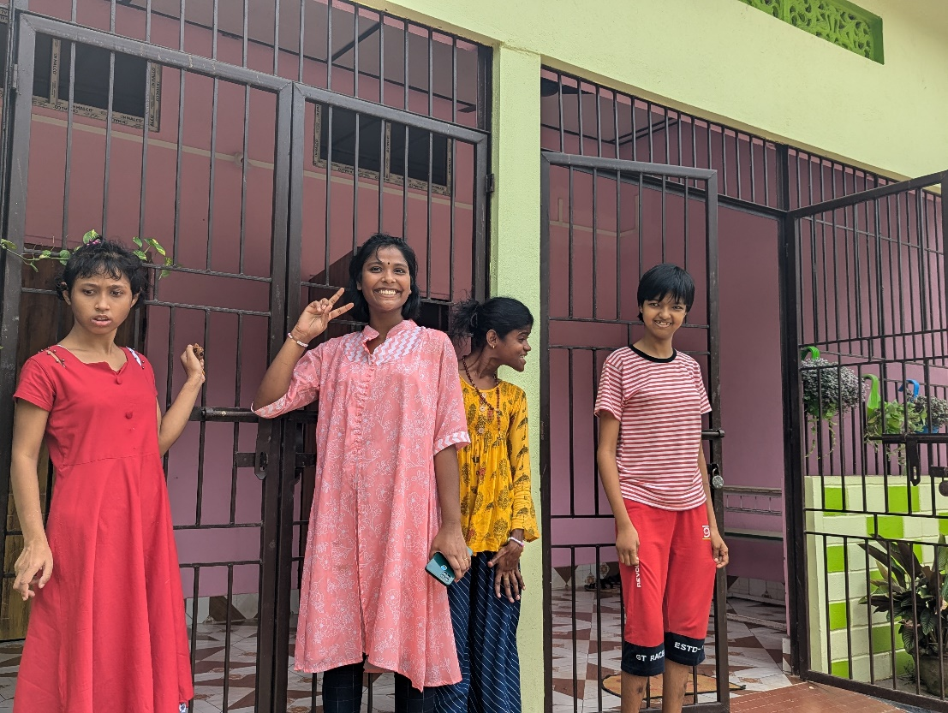

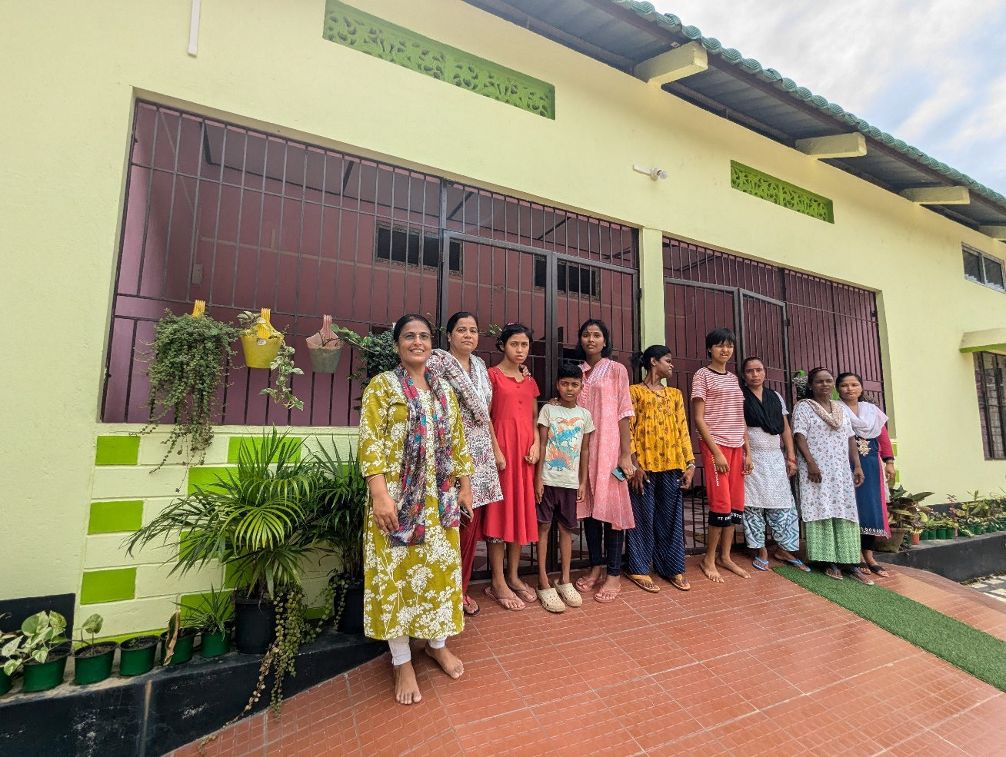

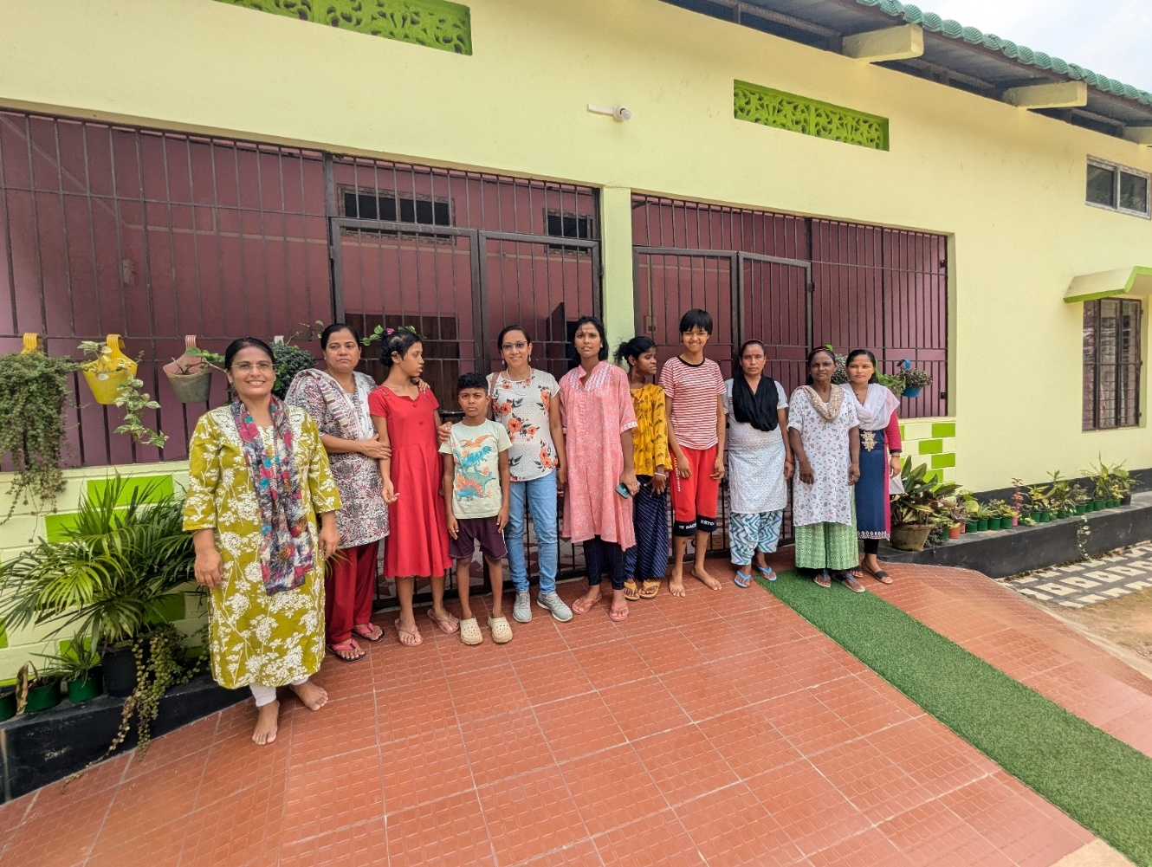

Garden at the Back of the Old Hostel

With Banana Trees, Ash Gourd and lots of other local plants

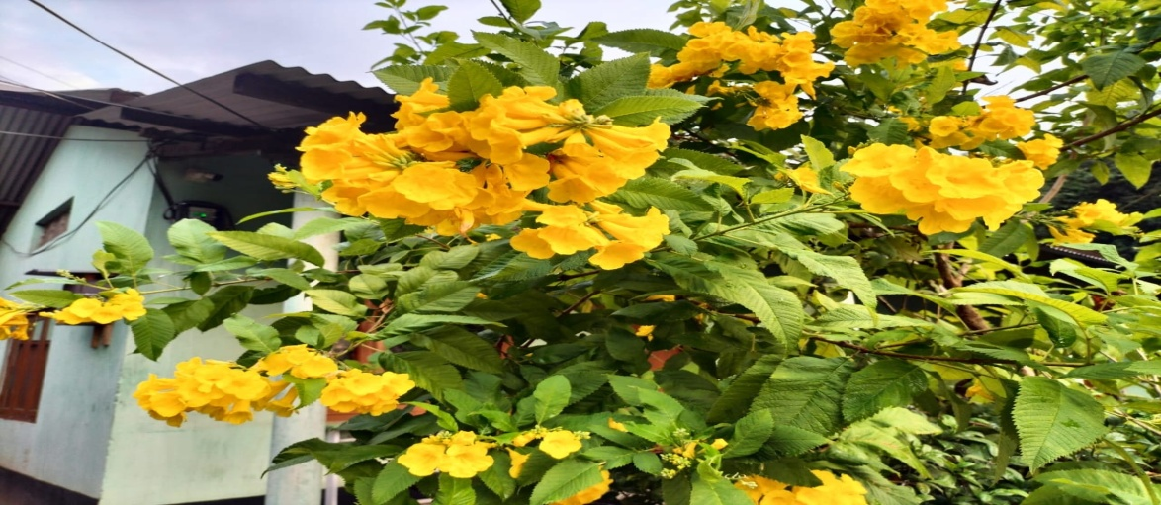
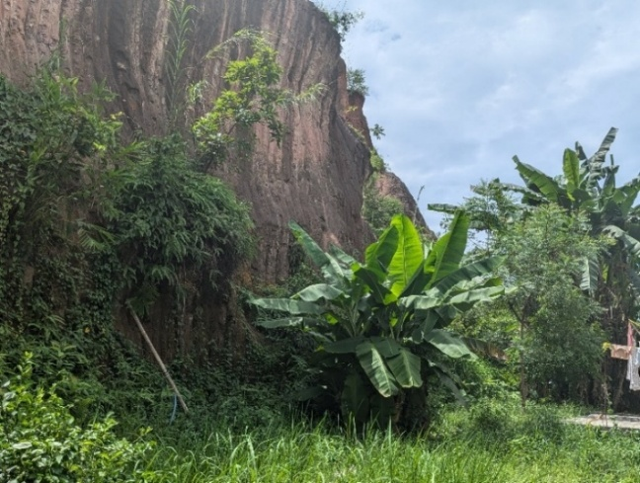
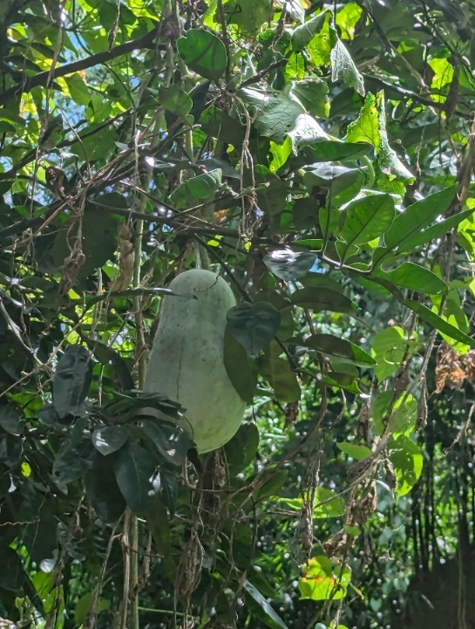

Boys Hostel
The older girl’s dorm which was vacated needs repairs before they can use it to move the younger boys to that room. Apparently, the elder boys bully the very younger ones, even if unintentionally, so it is more feasible to separate them out.

Activity Updates (Provided by SHED)

Regular classes being held.
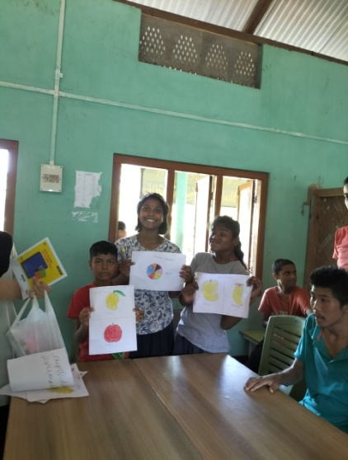
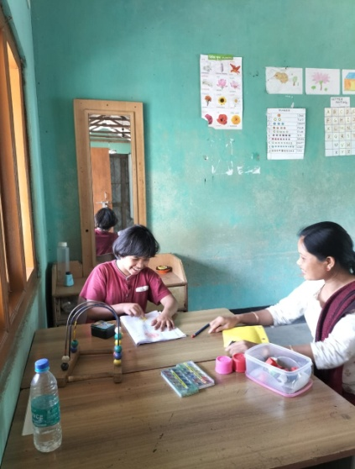
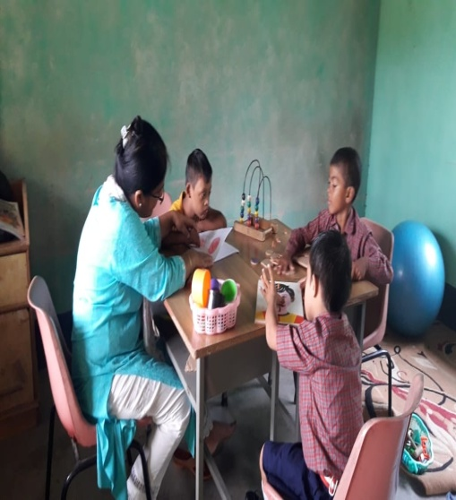

5 MSW (Master of Social Work) DonBosco Students Doing Internship in SHED

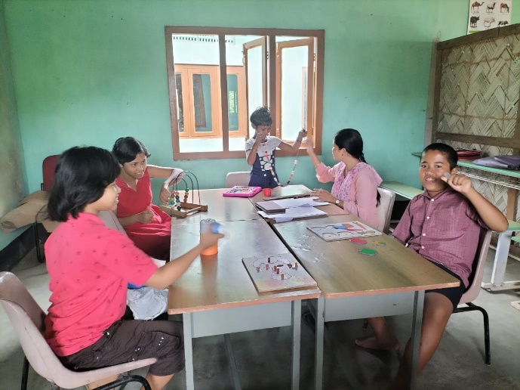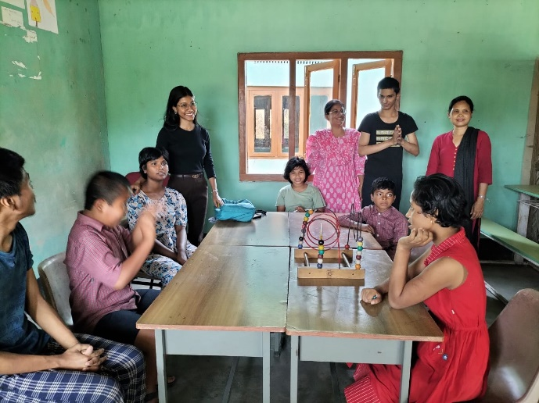
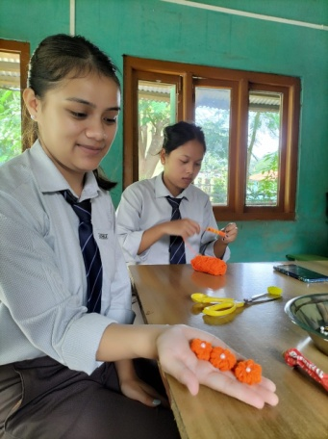
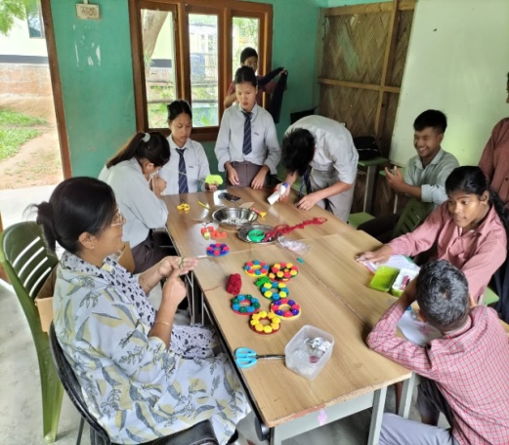
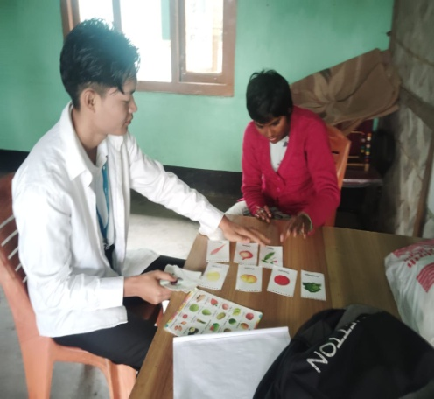

SHED attended a Pre-Diwali function on October 29 at the invitation of Don Bosco University and raised some money by displaying and selling handicrafts.

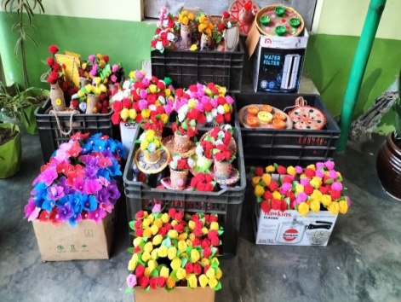
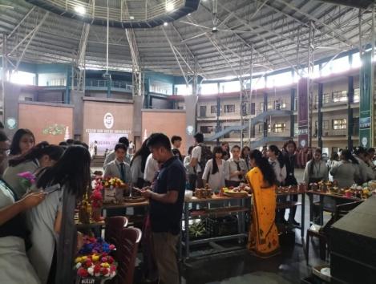
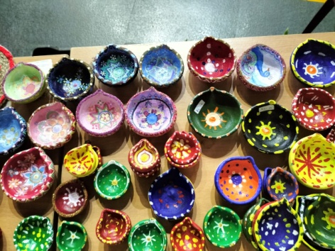

On November 05, Dalmiya Cement Authority donated some sports equipment to SHED Students.

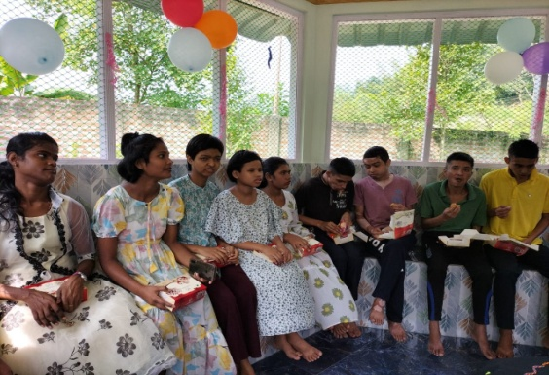
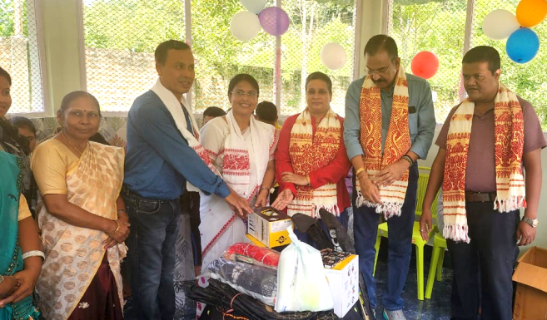

SHED Students are making clay diya for sale for Diwali.

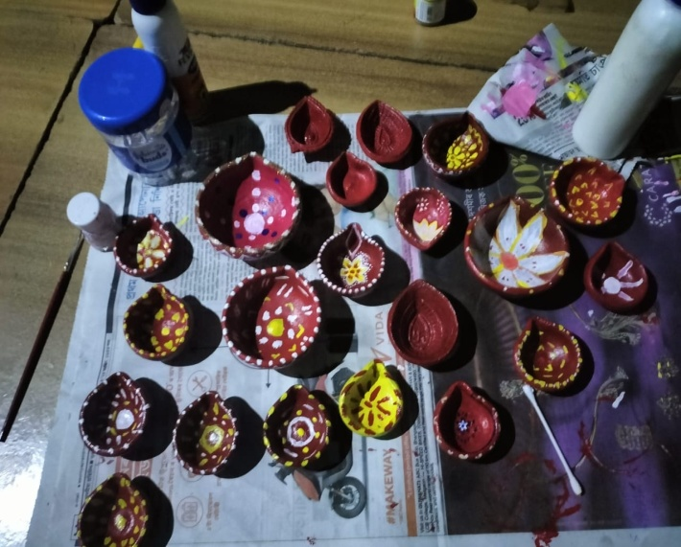
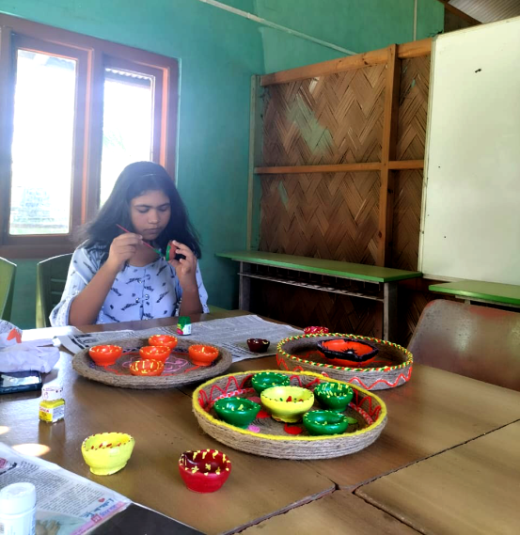

Other Celebrations:
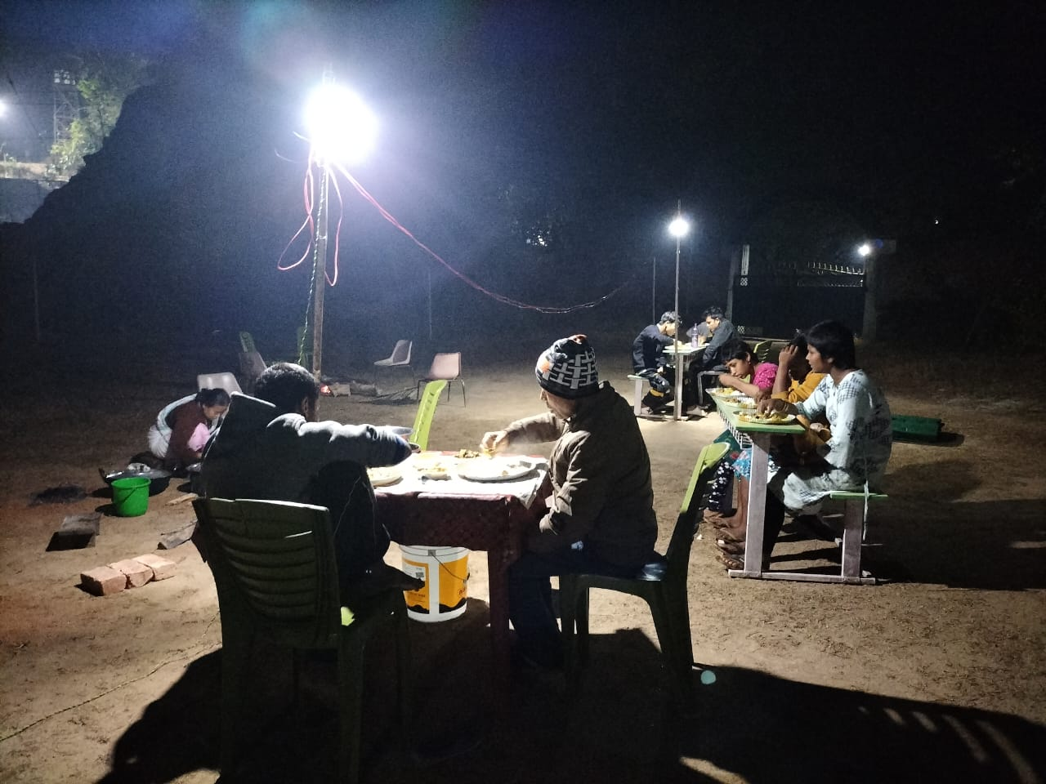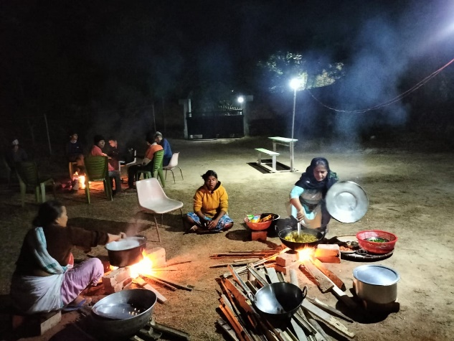
Community Feast During Magh Bihu

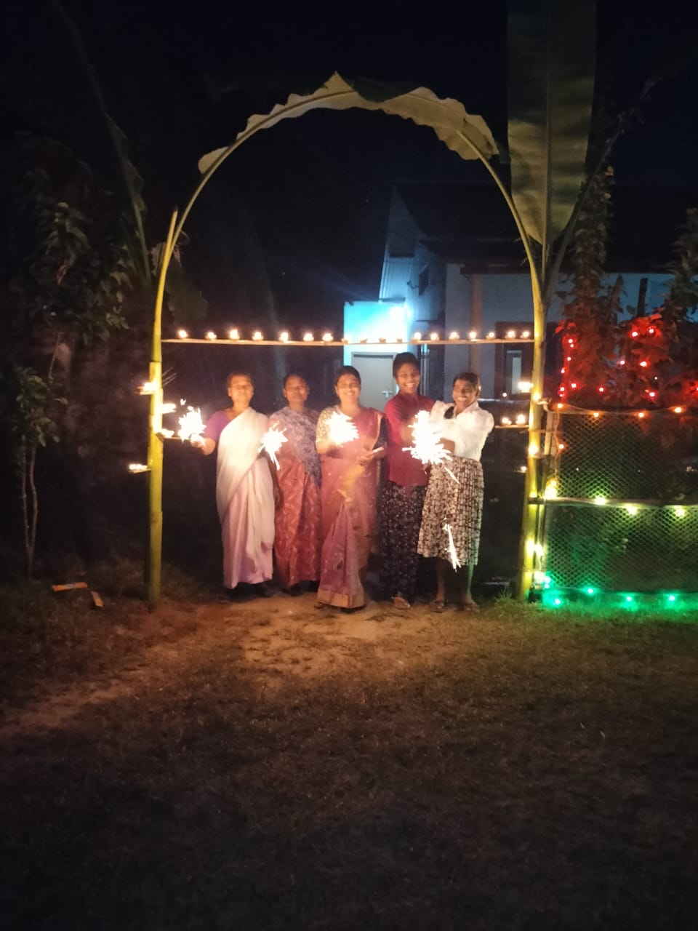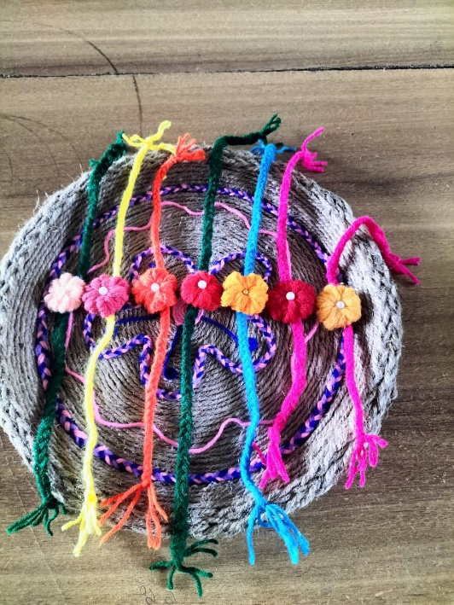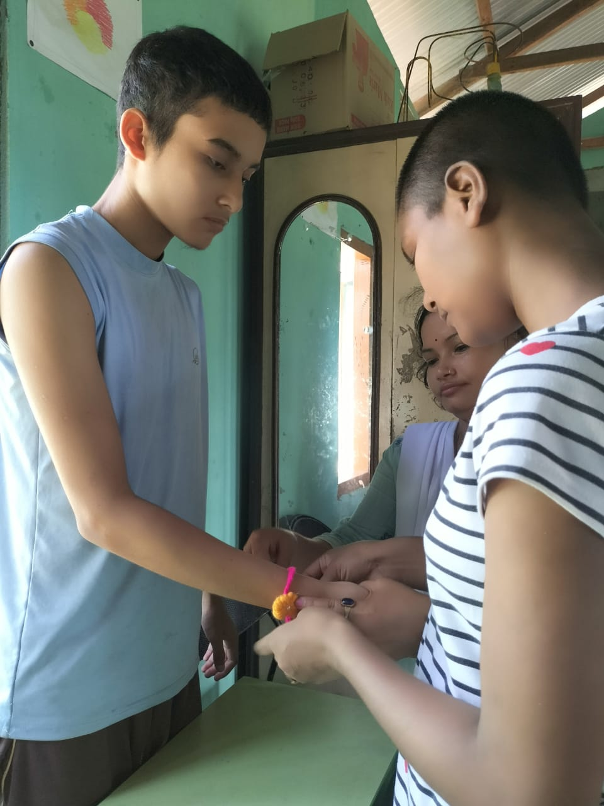
Diwali Celebrations Handmade Rakhis Girls Tying Handmade Rakhis

Infrastructure Improvements
A new gazebo style visitor room was built with the donation of Quther Saleh, Son of Wahid Saleh Sir from Netherlands.

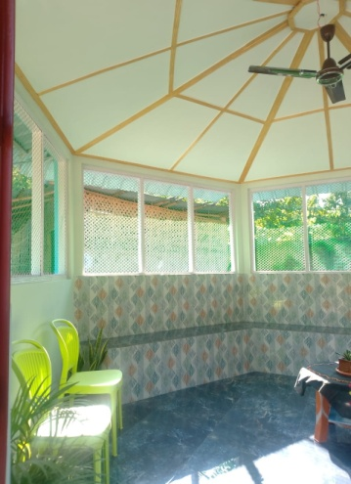
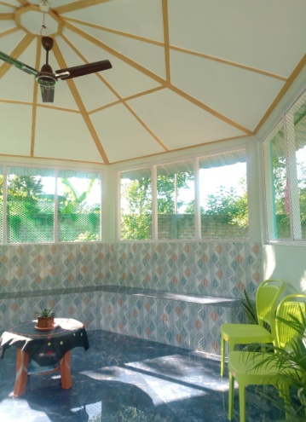
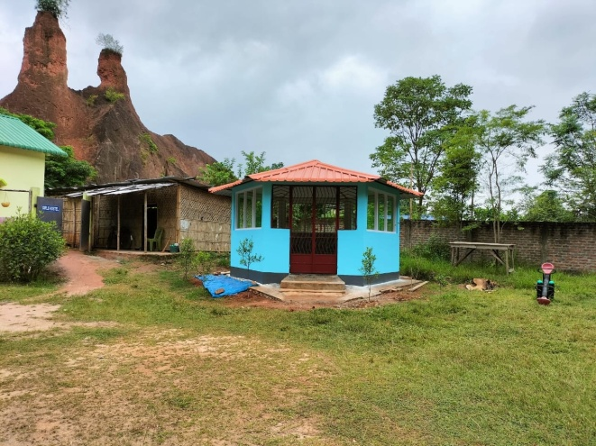

Inauguration of the New Girls Hostel On Nov 2023 by my parents

