Site visit report – Society for Health and Educational Development (SHED) -­‐ Asha for Education, Seattle Chapter

Organization Contact
Society for Health and Educational Development (SHED) Mr. Lanu Aimol
Sonapur, Rajiv Gandhi Nagar, P.O Digaru, Assam, 782401, INDIA Telephone : +
Email: shedschool@yahoo.in

Site Visit Contact and Dates
Site visit was conducted by Amit Rajkhowa, Asha for Education, Seattle Chapter Volunteer e-­‐mail arajkhowa@yahoo.com
The site visit was conducted on February 5th 2017.

Site Visit Write up and Observations

I visited SHED with my family on Sunday, February 5th 2017.
SHED is a residential school for disabled children with classrooms, boarding and associated facilities. In addition to hostellers, SHED also provides schooling to day scholars, who are disabled, and to evening students, who attend local government schools and come after their regular school gets over. SHED was founded in 2007 by Lanu Aimol.

Lanu picked us up in Guwahati and we drove for about an hour to get to Sonapur where the SHED facilities are located. We were received by Hiren Saikia, Secretary (volunteer), and the Head Special Ed teacher Mrs. Madhumita Baruah.

SHED has an ongoing program of Community Awareness events that are held twice every month. The day we visited was one of the Community Awareness event days. Since it was Sunday, there was no school and the classrooms were converted to a temporary hall. A large group of people was in the hall waiting for us. The people there consisted of students’ parents and local villagers.

The goals of the Community Awareness event are to educate the nearby community about people with disabilities and the SHED school, and to enable the parents to meet the teachers and discuss progress and initiatives, as well as to just socialize.
Lanu asked me and my wife to say a few words to the group.

We met with a couple of parents. Their feedback was that their child likes the school and the interactions with the similar students without feeling out of place. They prefer to come to school versus staying at home. Hence, they were visiting even on Sunday.

After meeting the parents, we went to the office and met with all of the teachers and the staff.
We met the teachers first, asked how they were doing, and whether they had any needs or issues. We also met the other staff members, such as the care givers and the cooks.

The key feedback received from teachers and staff were:
- Everyone we met was very appreciative of the support provided by Asha and thanked us many times.
- They brought up need for a new gate and fence.
  - The current fence around the school and boarding facility is just a thatched wall that is falling apart in many places.
  - Because many of the students have mental disabilities like cerebral palsy, autism etc, it is very hard for the staff to keep eye on the children all the time when they are in the playground. This creates a security hazard. Also there is a pond near the school and it would create a dangerous situation if any children got out and fell into the pond.
  - They requested support to put a pukka wall and proper gate.
- Lanu mentioned that the current salary for the teachers and staff are fine but much lower than other non-profits nearby and in Guwahati. Care givers spend 24/7 with the boarding students and have a very challenging job for the salary they get. SHED lost 2 Special Ed teachers and 2 care givers in the last year due to this reason. Also 2 of the care givers (who we met) were single mothers with small children and an increase in salary across all the staff would be very appreciated.

We then toured the facility: dining area + kitchen, multi-purpose room + training/sewing area, boys hostel rooms, girls hostel room. We also surveyed the compound, the fence and gate.

In general the children seemed happy to be there. They were playing around just like any normal children.

We met with a few of the hostellers. Given that all of the hostellers are disabled, they were shy in talking to us. A few did come forward and we talked to them briefly.

- Arati Ekka – Arati is 14 years old with Cerebral Palsy. She has been with SHED for some time. She is intelligent and can do limited reading and writing. She is independent in “self-help skills”
- Anuj Kumar Bora - He had originally joined Parijat Academy, a school for low income families. He could not cope there, so he came to SHED and is now independent in “self-help skills”
- Sunny Goswami - Sunny is 17 years old with severe autism. Sunny was rejected from other schools in Guwahati in 2011. He is now self sufficient and independent in “self-help skills”.

Below are some of the photos I took during the visit :

- Community Awareness Event. Classrooms have been converted to a large hall for this event that is held twice a month

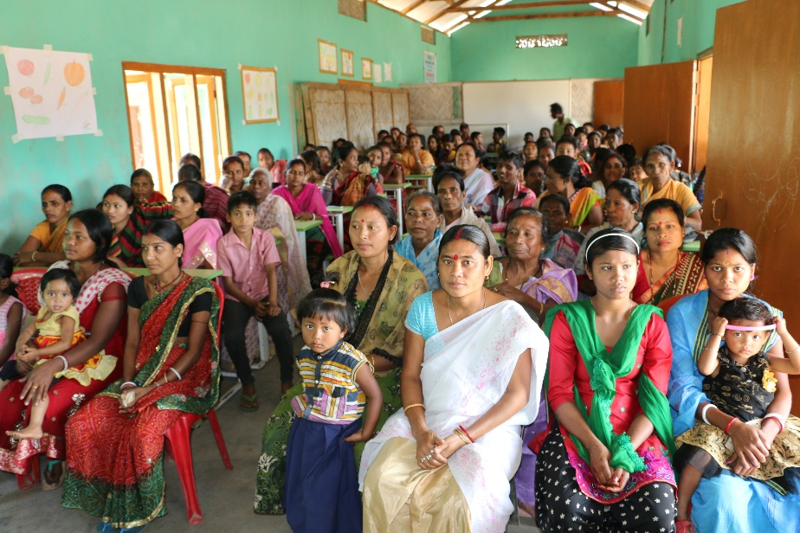

- Lanu Aimol (red shirt), Mrs Madhumita Saikia (head Special Ed teacher) and Hiren Saikia (Secretary) in the Kitchen-cum-dining hall
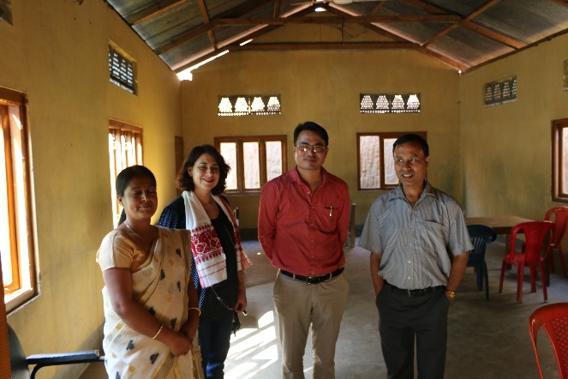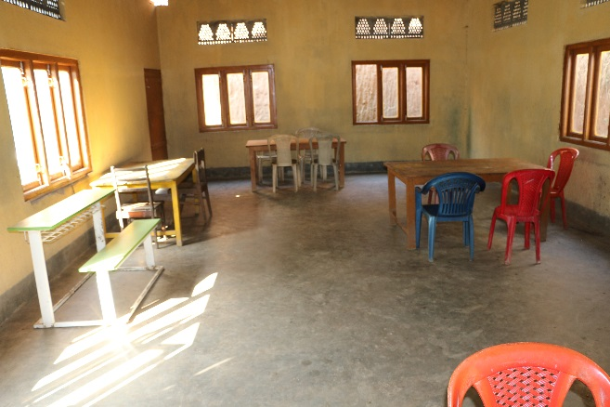

- Kitchen (which is on the other side of Kitchen-cum-dining room) 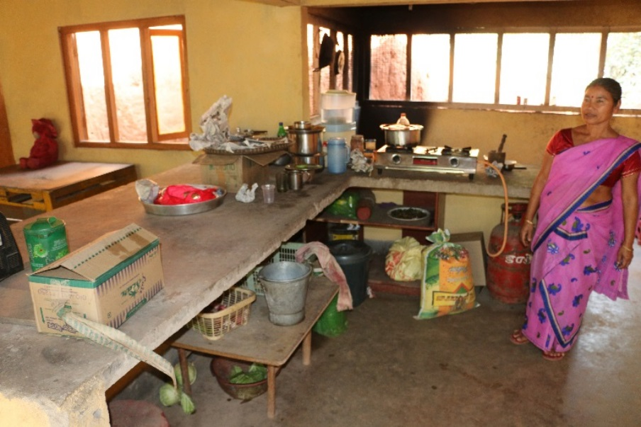

- Part of Multi-purpose room has sewing machines for training

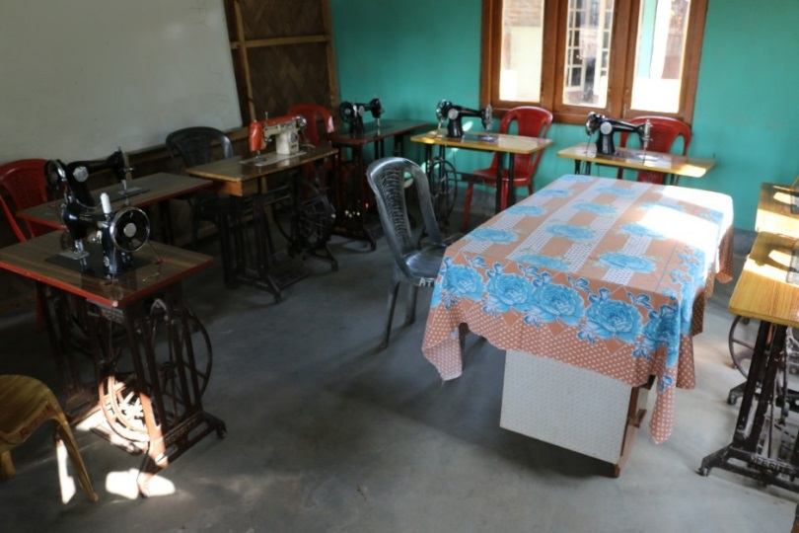

- Some of the hostellers we talked to during the visit

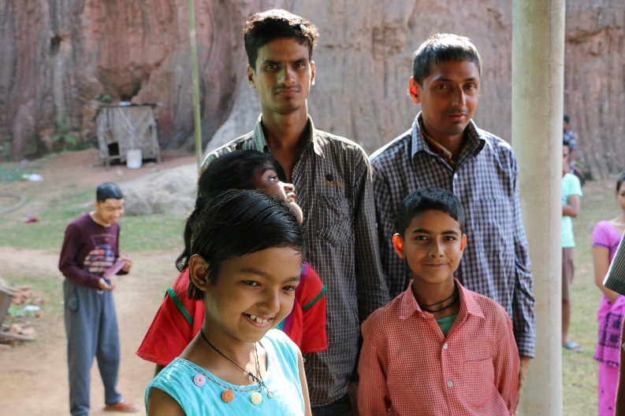

- Fence is made of thatched material in dire need of replacement for safety reasons
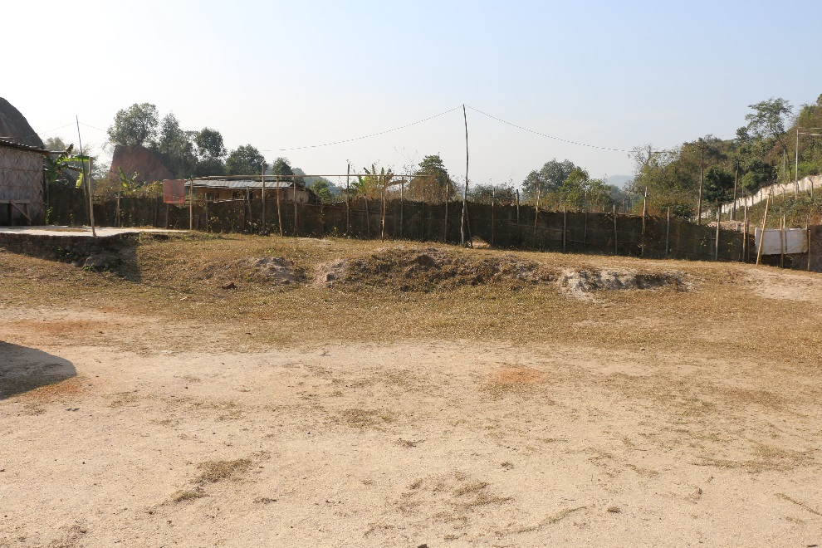

- Gate in need of replacement
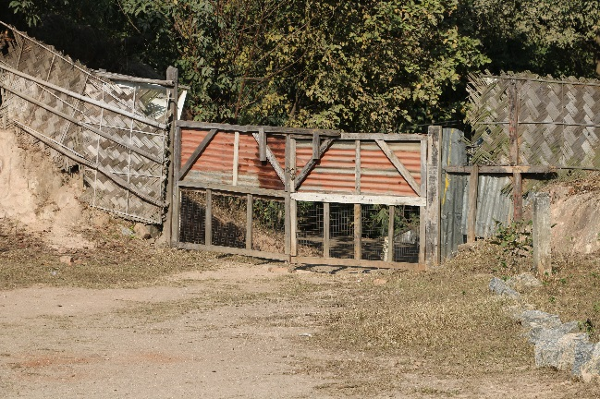

- Boys and Girls dorm rooms

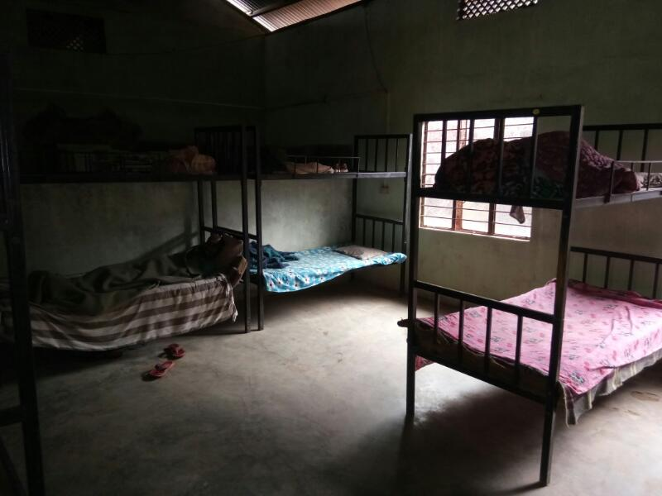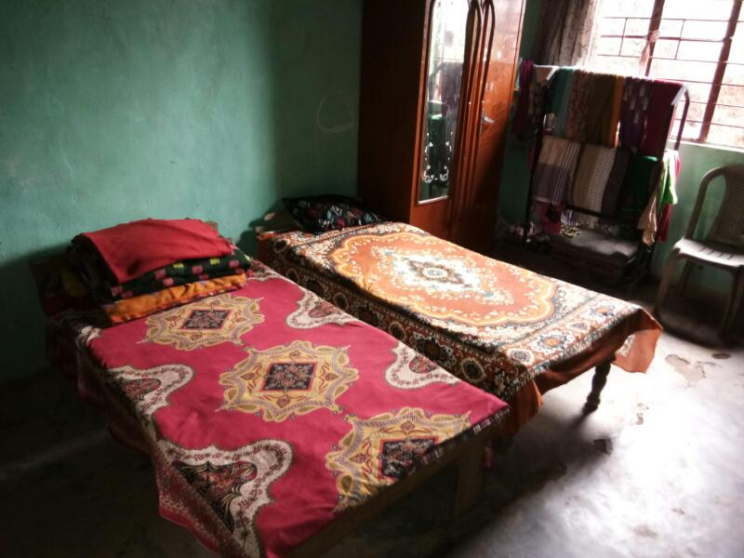

- More pictures of students and people outside the school rooms after the Community Awareness Event was over

