2015 Site visit report - Dhrupad Sansthan - Asha for Education, Seattle Chapter

Organizational contact:
Dhrupad Sansthan
Behind Van Nidhi Nursery,
Suraj Nagar, P.O. National Judicial Academy, Bhadbhada
Bhopal, Madhya Pradesh, 462 044, INDIA
Telephone: 011 91 94250 06681
E-mail: dhrupad.sansthan@gmail.com
Website: dhrupad.org

Site visit conducted by:
Dr. Brian Q. Silver
Executive Director, International Music Associates, Washington, DC, established
1982 (surbahar.com); concert performance on the sitar, and promotion of Indian
classical music through concert management, teaching, lecturing, and writing.
Former Ethnomusicologist and World Music Curator, Voice of America,
Washington, DC, 2007-2012; (Chief of VOA Urdu Service, 1986-2007)
Associate Professor of Urdu and Indo-Muslim Studies, Harvard University,
1974-1983 (including yearly courses on Indian and World Music)
E-mail: PanOrient@aol.com
Cell phone: 202 399 3399

General observations were made during my residency at the Dhrupad Sansthan from December 2014 through February 2015, and from interviews conducted from 21 February through 3 March 2015

Buildings/grounds/facilities:
- The Sansthan has 2 buildings, one residential (three stories with 16 student rooms), and another building (two stories) for classes, practice, and performances.
- The buildings are well maintained and the grounds continue to be beautifully kept, with an elaborate garden and fruit-producing orchard, as well as numerous ornamental trees (see photos at end of report).
- Both buildings are professionally designed and constructed, having a visionary architecture and highly functional layout.
- The Sansthan is located outside a village several kilometers from the city of Bhopal, in an area with neither noise nor air pollution, and is surrounded by farmland, a nursery, and only occasional houses—a most peaceful setting conducive to the teaching and practicing of music.
- There is a common dining area, and a common kitchen with a full-time cook preparing three hot meals daily.
- Each of the 16 rooms can accommodate up to 3 beds, and each room has an attached bathroom.
- The residential building has mandatory night quiet hours, outside of which some students practice in their rooms. The teaching building has additional rooms in which students can practice when classes are not in session, and is at sufficient remove from the residential building that students may practice quietly late in the night and in the early hours of the morning—traditionally the most suitable times for practicing Indian classical music—without disturbing those who are sleeping, and allowing for a 24/7 practice schedule to suit individual convenience and preference.
Classes:
- The three teachers at the Sansthan teach in three separate classrooms.
- The teaching usually takes place in a small group setting (5-10 students), but the instruction is individual. Each student learns from listening to others while awaiting her/his own turn, in one-on-one instruction which generally lasts 20-30 minutes. After they have had their lesson, students may leave to practice on their own, or remain to listen.
- The pakhawaj (barrel-drum) classes sometimes include group drumming to improve the students’ sense of tempo, timing, and coordination.
- The Gundecha Brothers are superb teachers, in addition to being world-class performing artists of international merit (with over three dozen CDs to their credit) who have received numerous awards, including the Padmashri—a much-coveted honor given by the Government of India to citizens of outstanding accomplishments.
Interview highlights:
In late February and early March, I conducted interviews, four in English and the rest in Hindi-Urdu, with 12 of the residential students and five of the meals-only students. Here are some noteworthy observations that I extracted from the interviews:
- Without exception, all the students feel that their lives have been positively transformed by their experiences studying with the Gundechas and by their life at the Dhrupad Sansthan. In fact, several likened the experience literally to that of being “in Paradise” (translated from the Hindi/Urdu.)
- The students were unanimous in their praise of the Brothers’ discipline and dedication to teaching. That commitment was clearly evident during the three months I was in residence at the Sansthan: though the Gundecha Brothers are often on tour, their commitment to teaching is such that they taught every day they were in Bhopal during those three months, including weekends, even on days when they arrived in Bhopal in the morning or departed in the evening.
- All of the students interviewed are from a diverse number of Indian provinces, in both the North and the South.
- The students represent a range of economic backgrounds, including a number from rural and farming families, or small towns.
- While a handful of students come from families with a semi-professional background in folk and devotional music (though none classical), others come from an extended family with some appreciation of classical music, and some have parents with no significant musical interests or experience.
- Similarly, a number of students I interviewed had learned some aspects of music (including one who had studied in a musical university), both folk/devotional and classical, prior to joining the Dhrupad Sansthan. Others had no musical background whatsoever, but decided nonetheless to learn Dhrupad after experiencing some sort of epiphany or serendipitous encounter with music—and, in particular, directly with the Gundecha Brothers, either in broadcast or in live performance.
- Following upon the previous point, it is to the Gundecha Brothers’ credit that they are willing to accept the novice (and as just noted, deeply inspired) students after at least one of the Brothers has conducted an audition to confirm a native musical aptitude, and subject to a trial period after which, in the amusingly concise summary of one student, “they would tell us to stay, or would tell us to leave. . . . “
- As might be expected, there was a mix of parental approval (happily, in a majority of cases) as well as disapproval of the students’ choice to follow a musical path. As for financial support, while I was unable due to cultural sensitivities to ascertain the exact financial condition of individual students, it was clear the large majority came from families of very modest, or even more meager, means.
- Virtually all of the interviewees hope to continue their pursuit of music into the future beyond their tenure at the Sansthan (usually four years in residence)—some having already given commendable public performances; most hoping to adopt music as a paying profession; and if that should prove not to be practical, at least to maintain music as the major creative and spiritual focus of their lives.
- There is a wide diversity in formal educational backgrounds among the students, some having only a secondary education at most, and others having graduate and post-graduate degrees in a wide range of fields—surprisingly, only a few in music. In fact, a few had given up well-placed and well-paying employment to pursue music despite the obvious financial consequences and challenges of trying to survive as musicians.
- It was clear from the range of students interviewed that the Gundecha Brothers are also to be credited for their liberalism in teaching a number of women—women having traditionally been excluded from Dhrupad performance, both vocal and instrumental. I was particularly impressed with the young women I interviewed who are learning to play the pakhawaj—a pursuit not to be undertaken lightly given the vigorous physical demands of performing on that august instrument.
- As further proof of the Brothers’ progressive social philosophy, interviewees among the women also included two differentially abled students—one partially blind, and another clearly facing significant emotional challenges. The latter young woman’s good-natured reception by her fellow students is yet additional evidence of the remarkable atmosphere of acceptance cultivated throughout the Sansthan by the Brothers.
- In addition to studying Dhrupad vocal music, and percussion on the pakhawaj, a number of the interviewees are learning such instruments as the rudra vina, the surbahar, the bansuri (bamboo flute), and the Indian violin—all in Dhrupad style. This encouragement to learn instruments (particularly the latter three) not traditionally associated with the Dhrupad idiom further demonstrates the depth and breadth of the Gundecha’s strong commitment to propagating the traditions of Dhrupad beyond conventional boundaries.
- One constructive suggestion made by an interviewee was that advanced students, with suitable preparation, might be asked to teach some classes (particularly at the beginning level, and to foreign students on brief visits) to lessen the teaching burden on the Brothers themselves, and to fill in when the Brothers are away, both as teachers and in supervisory roles.
Summary
The Gundecha Brothers’ educational techniques and strategies, developed over more than two decades of careful thought and experimentation, are designed for the most effective teaching possible of a wide range of students, combining the best of intensive individual instruction with the observational benefits of group sessions, as noted above, all in a traditional residential setting—the Gurukul—which is a distinct rarity in the Indian music world today. It is no exaggeration to say the Brothers are currently the most effective and accomplished teachers of Dhrupad in the world, with an impressive array of students from all over India, as well as from more than two dozen foreign countries, including the U.S. A number of their students have advanced to the fully professional level, performing both throughout India in major festivals, and internationally, as evidenced by three U.S. tours by their alumnae over the past three years.
—Dr. Brian Q. Silver
Residential hall:

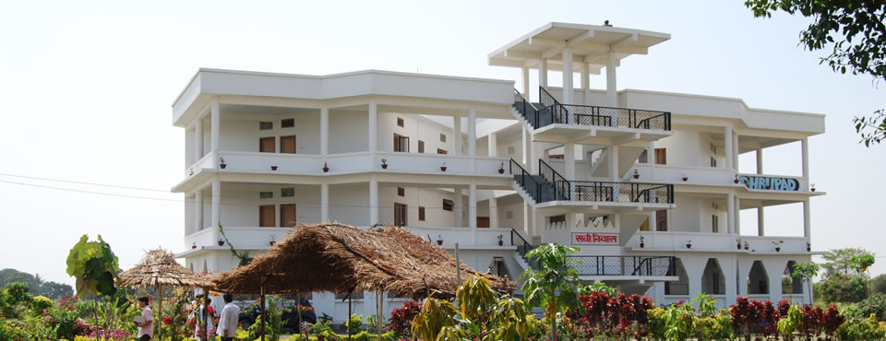

Classrooms, library, and performance hall:

